External Analysis Models
Wed, Sept 11, 2013
Critical Success Factors
- Achieving financial performance
  - What is it: Making a profit
  - Is it just about making money: market share, grow profit, compare to your competitors
  - You earn a profit but that you are competitive and better then your competition
- Meeting customer needs
  - Providing good customer service
  - Providing a good product
  - Giving the customers what they want now and anticipating what they want
  - Understanding your customers
  - Related to achieving financial performance (meet customer needs = more money)
- Building quality products and services
  - Setting standards for quality and meeting them
  - Reliable useable and safe products
  - Ford Focus vs BMW (don’t have to be better then the competition)
  - Producing a level of quality and service that gives them value for their dollar
  - Related to meeting customer needs (good quality = more customers)
- Encouraging innovation and creativity
  - Creating products for the future and anticipating what customers will need/want
  - Creating customers wants
  - Innovative on how you produce it (cheaper, more ethical)
  - You can be innovative and creative with the way your produce quality products
  - People will want to buy “new” products, therefore financial performance
- Gaining employee commitment
  - Committed employees to the company
  - Best quality employees and passionate employees
  - Will stay for a long time
  - Proud to work there and will stay
  - Gained by respect, incentives, value them
  - Good employees will want to create new products that are innovative and creative
  - Google offices!!
- Creating a distinctive competitive advantage
  - Being better than the competition
  - A unique space among the competition that you can product/they cant imitate
  - Holding patients, have more money, better employees, key supply component
  - Maintain the advantage

Diamond-E Framework

Resources
Strategy
Organization
Management Preferences
Environment

- Shows relationships between business and environment
- Shows internal organization and the environment and the two are connected
- Management Preferences
  - What your managers prefer and the way they manage the organization
  - Set standards for how employees will work
  - Come up with strategies and ideas
  - They have bias and this influences how they perceive the environment
  - **CASE ANALYSIS ALWAYS CONSIDER THE DECISION MAKERS PREFERENCE (THEIR MANAGER STYLE)
- Organization
  - Culture, capabilities and the leadership
  - Management preferences influences culture (they set the tone)
  - Culture: determines the unspoken rules, how they do things
  - What managers are strong in is what they develop in the organization
  - SWOT: strengths, weaknesses (organization) opportunities, threats (environment)
- Resource:
  - Financial, psychical and human resources
  - These determine what they are capable of doing (cant create products without a factory and people)
  - Bias of management determines what resources they acquires
- Strategy: What opportunities the business is pursuing
  - Determines needed resources, organizational capabilities and management preferences
  - Any variable can either driver or contrast strategy
  - If there a risky strategy, managers have to be risky as well
  - **CONSERVATIVE VS RISKY**
  - The critical linking variable in the model (connects organization with the environment
  - First task – deal with the strategy-environment linkage
  - When looking at the environment, you have to look at todays conditions and TOMORROWS conditions
  - Assess forces at work and their implications (ie driving, looking ahead)
- Principle Logics – consistency or alignment
  - Consistency internally leads to performance (internal capabilities risk are not consistent with the strategy you are trying to execute)
    - Each variable impacts and is impacted by the rest
    - Have to have resources and mangers to implement strategy
  - Alignment externally ensures strategy right for the given environment (strategy isn’t right for given environment) – impossible to have perfect alignment
    - Doesn’t matter if you have a good strategy but it will mean nothing if it isn’t right for the environment
  - Warning: Environment is always changing
    - Is it in alignment with environment?
    - Is strategy consistent with internal variables?

External Analysis
- Process of scanning and evaluating the external environment
- How manger determine opportunities (positives external trends or changes) and threats (negative external trends or changes)
- Firm faces multiple environments;
  - General environment; affects all businesses (interest rates)
  - Specific environment; affects industry participants (competition)

How to do External Analysis
- General Environment
  - PEST model – political, economic, social/demographic and technological factors
- Specific Environment
  - Porter’s 5 forces, 5 important of competitive pressure and intensity; predicts profitably of industry
- Look for data, statistics, trends, forecasts, expert opinions, etc

PEST – General Environment s
- Political-Legal
  - Laws, regulations (Australia: cigarette packages were all the same color; cell phone industry)
  - Taxes (personal and corporate, tobacco and alcohol taxes, personal taxes means less money for us to spend on other stuff)
  - Trade agreements or conditions (NAFTA, remote controls being duty free in USA, cheaper to expand into USA)
  - Political system (USA; let businesses do there thing. Canada; more involved, more rules and regulations, more competition from government [ie alcohol and hospital])
  - Political stability (Canada, USA; stable politically, organizations like that because it is predictable)
  - Government can create incentives, constraints or support/bail out when needed (banks were bailed out)
  - Affects uncertainty, risk and constraints/costs faced by firm
  - **HEADLINE THAT REPRESENTS A NEW LAW THAT CAN BE A THREAT/OPPORTUNITY**
- Economic Factors
  - Economic growth – aggregate output (total quantity of goods/services), GDP (total cost of the products) and standard of living (Affects our standard of living)
  - Trade balance – importing vs exporting (More import then export, then there is trade deficit, export more the import then there is a trade surplus)
  - National debt – government borrowing (the more debt there is, they are competition with us to borrow money, affects interest rates)
  - Economic stability – inflation (price of stuff goes up but income stays the same, purchasing power goes down)
  - Interest rates – time value of money (high interest rates, costs more to borrow money and expand, as consumers we buy less [housing, credit card])
  - Exchange rates (Canadian dollar is high, Canadians are happy because they can purchase things cheaper, Canadian manufactures trying to sell in the USA)
  - Influences costs, potential sales and financial uncertainty
- Social Factors
  - Customs, values, attitudes and demographic characteristics – society, thy are different from one region to the next (gun laws in the states)
  - Includes customer preferences – (ex: Big Mac, smoking)
  - Influences worker attitudes and behaviors – it is personal pride whether or not your company does well, some places 9-5 is the norm, sometimes its later
  - Influences stands of business conduct – bribes, kickbacks are the way you do business, other countries you will be charged/fired
    - Ethics, social responsibility, stakeholders, management – how sensitive should I be to the environment, managers come from that society or society puts pressure on managers
    - They can change (ex: smoking in movies)
  - **Affects how we live, work, consume and produce**
- Technological Factors
  - Internet affects buying, selling, communication – our buying/selling habits
  - Information technologies affects information access, inter-firm cooperation’s, cycle times – closely linked with suppliers and buyers then ever before (ex: no user manual, its on the internet), production time is smaller, paying employees
  - Computer technologies have changed our products and how we design and build – (ex: car model used to take years, now it takes months because of computers)
  - Not limited to computers and information – ex: Swifter, mechanical pencils
  - Affects what we produce/what it can do, affects how we produce and how we sell
  - Demands constant learning and scanning - technology changes very quickly, you have to scan the environment to see what changes are coming and anticipate them or you will fall behind, look at trends
- Three important issues facing Canadian Businesses:
  - The value of the Canadian dollar – (economic) high dollar means consumer is happy, we have more purchasing power on non-Canadian products (when we go shopping in the states), exporters to the US are not happy because they are more expensive there
  - A skilled labour shortage – shifting towards the knowledge economy, we still need people to fix and build things
  - The natural/physical environment – (social factor) we value the natural and physical environment, we want companies to be environmentally friendly
- Questions:
  - Do the economic conditions support my business? – interest rates, consumers spending, can you afford it?
  - What legal protection do I have or laws do I have to consider? – consumer safety laws for products, patents, regulations
  - What demographic and social trends affect my business and how? – what trends in society **making something electronic – ex: e-readers**
  - What technological forces affect me now and in the future? How do they assist or constrains? – technology changes quickly
  - What opportunities or threats does the environment possess? – opportunities/threats
  - **How does the environment affect you? Not how you will affect the environment**

Porter’s 5 Forces – Specific (industry specific) Environment
POTENTIAL ENTRANTS
SUBSTITUTES
SUPPLIERS
BUYERS
INDUSTRY COMPETITORS
Rivalry Among
Existing Firms
Caveat: Power and influence of each force will vary by industry

- The power and influence on each factor varies by industry
- How they affect industry profitability, the pressure they apply, more pressure = less profitability
- Suppliers:
  - Fewer suppliers (not a lot of competition, so they have more power AKA higher price), high switching costs (it is harder to switch suppliers, less likely to switch), low attractiveness of substitute suppliers (substitutes are not as good), high threat of forward integration means (supplier might choose to buy a competitor) = increase bargaining power for supplier (position of power on price) – all create pressure
  - Bargaining power increases costs of inputs
  - Solution: Use strategic alliance (form a buying consortion with your competitors) or internal supply (buy a supplier or a controlling interest)
- Potential Entrants:
  - Can cause big changes (competition forces price down, increases the cost of winning customers over, can introduce new technology that can be disruptive)
  - Ease of entry = more intense competition
  - Solution: create or use barriers = capital intensity (cost a lot of money to get started ex: cars), technology (highly specialized technology), know-how (specialization), regulatory approval (“P” of PEST, cell phone companies, banking industry), brand loyalty (strong connection with products, ex: Apple), access to distribution (ex: grocery product, getting it into a grocery store)
- Substitutes:
  - Many substitutes = increased competition
  - Butter vs Margarine, bikes vs skateboard
  - Puts ceiling on price you can be charged (ex: no monopolies)
  - Pressure increases as price of substitutes and switching costs decline
  - Ex: people owning cars in Toronto, take TTC instead
  - Solution: Make buyers believe you are unique; lock them in (contracts on cell phone companies)
- Buyers:
  - Few or concentrated buyers (bargaining power goes down, have to chase buyers), standardized products (where they think they are all the same, Ex: socks, milk, eggs), low switching costs (harder to switch to a different product, Ex: new game system), discretionary purchases (don’t really need it, luxury goods) = increased bargaining power for buyer
  - Reduces price that you can demand
  - Solution: Alliance with other firms (selling as a group, ex: gas); strong marketing
- Rivalry among existing firms
  - Results in price competition and increased costs (more competition = lower prices; have to spend more on advertising etc, tug of war among equals)
  - Most powerful of 5 forces
  - Causes:
    - Many competitors of equal size/capability (increased intensity)
    - Growth rate of industry (are there new customers?)
    - Consumers switching costs (lower = more competition, end of a cell phone contract)
    - Products are commodities (don’t distinguish between one or the other) or are perishable (includes technology)
- Value:
  - Predicts industry profitability (choose industry’s that are going to have the best/easiest profitability)
  - Helps determine whether a firm should enter a particular industry
  - Helps determine whether and/or how firms can carve out an attractive position in the industry
- Airline Industry
  - Least profitable industry known to man – 0 star industry
  - Intense price competition
  - Always new entrants
  - Generic technology
  - Suppliers have bargaining power (airbus, Boeing, Rolls Royce)
  - Substitutes are cars, trains, or shipping goods another way
  - Unionized labour
  - **VERY STRONG IN THIS INDUSTRY**
- Soft drinks
  - Profitability industry - 5 star industry
- Questions:
  - Is the industry a realistic place for a new venture?
  - Can we do a better job than incumbents (someone already in the industry) at avoiding or diminishing factors that suppress industry profitability?
  - Is there a unique position we can pursue?
  - Is there a superior business model that incumbents would find hard to duplicate? (Distinctive competitive advantage)
- Some library databases:
  - Standard and Poors NetAdvantage –
    - Provides Industry Trends, Industry Ratios, and lots of key industry data
  - GMID – market share data by company and brand; industry growth data
  - Marketline – five forces analysis and SWOT
  - FPInfomart – Canadian data

Benefits of an External Analysis
- Makes managers proactive
  - Looking into the future
  - Knows when an opportunities or threats are coming
- Provides information used in planning
  - That research that you do will help you in the future
  - You will build on it
- Helps organization gets needed resources
  - Need to execute strategy with right resources
  - You have time to make sure you have the resources in place
- Helps organization cope with uncertainty
  - You never know what is going to happen tomorrow
  - What you plan to do you actually get to execute it
  - Protect yourself against threats and work with opportunities
- Improves consistency and therefore performance
  - You are able to develop a strategy that is aligned with the environment
  - Everything is consistent with your strategy

Challenges of External Analysis
- Time consuming
  - It is worth the time
- Forecasts and trend analyses imperfect
  - Ex: weather forecast
- Rapidly changing environment hard to keep up with

Understanding Entrepreneurship
Sept 23/13

Questions to think about
Entrepreneurship
- What is the difference between a new venture, small business and entrepreneurship? Are they mutually exclusive?
- What role does the “P” of PEST play in entrepreneurship and why does it choose to do so?* (what role does the government play?)
- What is the entrepreneurial process and what influences it and why (the environment, if there are no opportunities then it is hard to being the process)? How are its elements and principles similar to the Diamond-E (strategy has to be in alignment and consistency with the process)?
- Where does the process begin (Entrepreneurship), why does it begin there (they have to identify the opportunity and access the resources) and what determines if the process will be successful (that everything is in alignment)?
- What are the components of opportunity recognition (coming up with an idea and making sure it is a good idea)? Why is screening important (shows if you have a good idea)?
- How do you know if you have a good idea? (3 points)
- Apply the screening process to a product or service
- What choices does a firm have for accessing resources? What are the characteristics of each option?
- In What ways are traditional and social entrepreneurship similar?
- What is the different between a charity and social business
- Who are the stakeholders in a social business
- Identify a social business and describe how the key facets are illustrated in it

Definitions
- New venture – recently formed commercial organization that sells goods/services
  - Less than 5 years, product or service
- Entrepreneurship – identifying an opportunity and accessing resources to capitalize on it
  - Large corporations do it to to remain in alignment with the environment
- Small business – owner managed, no dominant in market, less than 100 employees
  - Contribute more than 26% annually to GDP**
  - Provide more jobs than large businesses
  - New ventures lead in new products and services
  - 97.8% of all businesses in Canada are small

Entrepreneurial Process

Access resources
Identify Opportunity
Entrepreneur

- Influenced by PEST
  - From the external environment that opportunities come, and that you are going to chase
  - PEST exists in the environment
- Successful only when the entrepreneur, opportunity and resources match
  - Alignment and consistency
  - What is on the inside has to match on the outside (environment)
  - Entrepreneur:
    - Determines where resources (money and human resources) will come from and what strategies to use
    - Also fits with organization because they provide leadership and sets the culture
  - All three have to be in alignment
  - Identify opportunity that makes sense for him/her
    - To execute that opportunity you have to have the resources to implement it
    - Then the resources circle back to entrepreneur, resources influence what the entrepreneur sees as an opportunity
  - Failure is not a loss, you learn lessons and what went wrong
- Begins with entrepreneur identify an opportunity then accessing resources

Opportunity Recognition
2 parts:
- Idea generation:
  - Often paradigm shifts
    - Challenging social norms
    - Storing car with the engine at the front
  - Originate in events relating to work or daily life, hobbies, chance happening
- Screening
  - Weeding out bad ideas
    - Not a good idea unless it makes money
  - Saves time and money
  - Ensures you have a viable idea with a competitive advantage
    - How is your product different in a valuable way? (People are willing to pay money for it)

Three Step Screening Process
- Screening for viability and competitive advantage. You know you have a good idea when:
- Idea creates or adds value for the customer
  - Solves a problem, meets a need
  - Customer is willing to pay for it
- Idea provides a competitive advantage that can be sustained
  - Product is unique in a valuable way/better than pother’s
    - How is it different and better from existing products and substitutes?
    - Are differences valuable to customers?
    - Is it something that existing firms can easily do or may want to imitate?
      - Can the idea be protected legally?
- The idea is marketable and financially viable
  - Are there enough customers who will buy it? What is the market demand?
  - Who are the competitors and what are the forces that affect profitability?
  - Is the market growing (more customers), shrinking (less customers), concentrated (few companies, hard to break into), fragmented (where there are a lot of smaller business who all have a little market share)?
  - NVP - **HOW ARE YOU GOING TO GROW?**
- Safety point – does this idea have low exit costs?
  - Longer time to profitability or greater up front investment needed = riskier venture

How to Screen for NV Project
- Use PEST analysis to assess environment – is it supportive of your idea?
  - SO WHAT?
- Use Five Forces to determine ease of entry and profitability of industry
- Use Five Forces, PEST and market exploration to ensure uniqueness of idea
- Use research of market (library databases) to evaluate how big your market is and whether it is growing, shrinking or stagnant
  - You want a growing market
- Research expert opinions in the industry
  - Library databases
- Identify and discuss how key trends in the environment and the industry affect your idea (ie represent an opportunity for you)
  - Look into the future
  - Expanding in the future, how are you going to grow the business?

Evaluating your Business Opportunity

Criterion | Highest Potential | Lowest Potential
Product | Changes way people live, work, learn, etc.; recurring revenue | Incremental improvement only; one-time revenue
Customers | Reachable – physically available as well | Loyal to others; unreachable
Value added | High – switching costs | Low; minimal market impact
Market structure | Imperfect; fragmented competition – small market shares | Highly concentrated, mature – very few large competitors, customers are more likely to be loyal, they control the suppliers , established markets
Market | Large and growing | Small and/or declining
Incumbents’ Production capacity (company that exists already within a given market) | At or near full capacity (they cannot produce any more) | Undercapacity (haven’t reached production maxes, can produce more)
Barriers to entry | Low, competition slow or napping, have or can gain protection, have needed networks | High, competition stiff, can’t gain protection, hard to tap needed networks

Developing the Opportunity
- Business concept can often change from original
  - Incorporate information and research
  - Incorporate experiences and customer feedback
  - You can modify your idea after preliminary report, but if you have to change drastically talk to your TA
- Once business concept finalized, move to business plan
  - Concept will be ”tweaked” as business plan evolves

Accessing Resources
- Bootstrapping – doing more with less
  - Make do with a few resources as possible
  - Use other peoples’ resources where possible
  - Find/use free stuff
- Financial resources – Debt vs. Equity financing
  - Debt = interest and control (borrowing money ex: VISA)
    - Sources – financial institutions, suppliers
  - Equity = no interest, less control (sell a portion of the ownership, Dragons Den)
    - Sources – savings, love money, private investors, venture capitalists

Social Entrepreneurs
- Generate social value while operating with the financial discipline, determination and innovation of private sector businesses
- Its not about the money its about the people
- Help overcome market inequities/failures
  - How? Entrepreneurs seek innovative solutions to the world’s toughest problems
  - Often in areas of education, health, environment
- Social value as the primary objective
  - Economic value is a by-product
  - KEY DIFFERENCE
  - Achieving “social performance”
- Results in companies with social missions
- Form of business can vary
  - Importance of attaining social value proposition through the legal business form (not-for-profit, for profit, charity)
  - You don’t have shareholders that you give dividends too
  - Any money that the business generates as profits goes back into the business to create more social change
- Accountability to community stakeholders
  - Rather than only investors/shareholders (for profit is for stakeholders)
- Importance of bootstrapping and self-sustainability – charity vs. social business
  - Charity dollar has only one life, when you give it it’s gone
  - Social business dollar is recyclable and is used over and over again to create more value

Traditional Entrepreneurship | Social Entrepreneurship
Value defined economically – high net profit (return to investors) is primary | Social value proposition – social benefit is primary
Social benefit may be created as by-product of economic value | Economic wealth created as by product and allows for self-sustainability
Serving markets that can afford the new product or service | Target underserved populations; cannot afford (financially or politically) to achieve the benefit on their own
Social involvement in the form of “CSR” initiatives | Social motives at the core of the business (not limited to CSR)

Learning Objectives Summary
- What is entrepreneurship and how is it related to small business and new venture creation?
- Rose of small and new businesses in the economy
- Process and key elements
- Opportunity recognition
- Screening for viability and competitive advantage
- Accessing resources
- Social entrepreneurship - what is it?
- Comparing social and traditional entrepreneurship

Technology
Sept 30/13
Questions to think about:
- What is technology and where does it come from?
- Identify a specific example of how technology creates opportunities and threats with respect to management processes and how these opportunities and threats impact a firms ability to achieve the critical success factors
- How is the greater independence of companies and workplaces both an opportunity and threat?
- What is the significance of technology standards? Why/how do standard wards sometimes threaten the survival of companies?
- What factors help determine the winner in a standards war? In other words, what can a company do strategically to position itself to win a standards war?

Learning Objectives
- How is technology related to the 5 forces?

PEST – Technological Factors
- Elements
  - Internet affects buying, selling, communication – how we buy, sell, who we sell too, who we can communicate with
  - Information technologies affects information access, inter-firm cooperation, cycle times – what we access, how we access it, affects information privacy, how companies cooperate with other organizations, cycle times are shorter
  - Computer technologies have changed our products and how we design and build
  - Not limited to computers and information
  - **Affects what we produce/what it can do, affects how we produce and sell, how we manage and run organization
  - **Demands constant learning and scanning

What is Technology?
- Advancements in equipment and its uses
  - Often substitutes for/magnifies human efforts – what technology does
  - Includes human knowledge (things we know how to do), work methods (how we do work), equipment (assembly lines), business processing systems (receiving orders paying employees)
- Includes information technology
  - The various devices for creating, storing, exchanging and using information
  - Consumers use it daily, i.e ATM, shopping
  - Companies use it to gather and share information and execute activities

Where does technology come from?
- Comes from human ingenuity
  - Formal and informal research and development
  - Basic R&D – knowledge without focus
  - Applied R&D – specific problem in mind
  - Technology transfer – out of the lab and into the world

Technology Shifts
- Electricity, trains/ship, assembly line, internal combustion engine, airplanes, mass media, telecommunications, computers internet
- Any improvement in technology, making things easier, sharing knowledge

Opportunities
- Products – innovation, uniqueness, value
  - How long the product lasts, how cheap it is to buy it
- Management and Organizational processes
  - Instant access to information (internet)
  - Better service through coordination (better service for products, calling customer service)
  - Leaner organization (you don’t need as many people, ie machines can do the work) (achieving financial performance by reducing costs)
  - Improved operations efficiency (Computer assisted design, ERP)
  - Greater independence of company and workplace (mobile workers, they will put in more hours)
- Competitiveness
  - Creates barriers to entry (allows you to create a competitive advantage); cooperation with other firm; reduced cycle times (can help customers easier)
- Communication and collaboration
  - Within the firm and with customers – helps with innovation and creativity because you can communicate easier
- Customization – ie laptop bags

Threats
- Imitation
  - Information costly to develop but cheap to share (costly to develop and costless to share, ie music) – a threat to competitive advantage
- New technologies in unfamiliar areas
  - Disruptive technologies challenge the value of organizational capabilities and resources
- Unpredictable evolution
  - VHS vs. BetaMax
  - Blu-Ray vs. DVDs
- Need for constant learning and scanning
- Information overload
- Great independence of company and workplace – employees don’t need to be at the office, its hard to supervise your employees, lose your sense of atmosphere and culture, easier to “steal” employees with no community feeling

Technology Standards
- Standards wars – they determine compatibility for other goods or services (apps, what platform are you going to be on?)
  - Battles between incompatible technologies
  - Can determine survival of companies involved
  - Not limited to information technology
- **Asking market to pick sides**
- **BLU-RAY vs. (HD) DVD

Important Technology Concepts
- Installed base - # of users – you want to have a big of market as possible for your product
  - Bigger = greater influence on the market
- Lock-in – size of investment that a consumer makes now or overtime to adopt a technology – harder to switch to another product
  - Larger = greater resistance to switch
- Switching costs – cost of moving
  - Entry barrier; makes lock-in worse
  - Can be financial
  - You want high switching costs
- Complementary goods – needed for value; creates vicious or virtuous cycle
  - How much value would your laptop be without the complementary software that comes with it
  - Suppliers – Porter’s 5 Forces
- Network effects – value depends on user
  - People switched to iphone because no one was using blackberry
  - Ex: Facebook
  - Linked to number of users
- Links to Five Forces?!

Key Assets and Strategies
- Control over installed base of users
  - First-mover advantages – preemption – get in there first and get as much installed base as possible before the competition gets there (lock them in too)
  - Expectations management – keep them interested while you work on new products
  - Offer customers a migration path – by offering upgrades that are free or low cost, it keeps you with your current software or product until something that is better then the competition is created
- Intellectual property rights
  - Slows imitation or requires cooperation – expensive and time consuming
  - If someone wants to imitate you they have to cooperate with you and they have to pay you/get your permission
- Ability to innovate – critical success factors
  - Stay on your guard
- Strength in complements – use alliances
  - Blackberry – create an app for the blackberry and we’ll give you a playbook

On the outside looking in?
- Lower customer switching costs
  - Make your product cheap or easy (Firefox)
  - Build in an adapter (Apple) – allows apple documents to be read by other computers
  - Learning is a switching cost, time is a switching costs
  - **Incentives
- Offer a leap in performance for price (sporting goods)
- Make your product compatible with the dominant standard
- FIVE FORCES?!

Sustaining technology
- Presents improvements to existing products in expected ways
  - Ex: cell phones – better battery life, better camera, faster operating system etc
- Produces mainstream, high-margin customers with enhancements in product functionality (ex: Blackberry for business customers
- Existing firms normally win
- Low margin customers = people aiming for okay technology
- High margin customers = people who are searching for high end technology

Disruptive Technology
- Presents a different package of performance attributes that aren’t initially valued by mainstream customers (starts in peripheral markets)
  - Smartphones – didn’t matter to business people that phones could take pictures or that you could carry music
- Gains foothold in lower performance segment, improves technology rapidly until they meet mainstream performance needs, then enter these markets
- New, disrupting firms normally win (ex: Blackberry vs Apple)
- Rarely new companies fail because of bad management, good management actually causes you to fail when a disruptive technology comes on the market
Why do large firms sometimes fail? – Good management
- Managers focus on satisfying mainstream customers
  - Ignore new technologies that don’t initially meet nees of mainstream customers
  - Move ‘up-market’ to higher margin opportunities
  - Managerial processes (Diamond-E)
- Organizational processes weed out ideas that don’t address current customer needs
  - Going to be in alignment with the current strategy
  - When a new idea breaks in from that strategy, you are going to reject it
  - Mangers ignore lower end markets until these disruptive technologies come by and swoop up the low large margin customers
- Organization structure and capabilities slow response time/ability and influence choices
- Old firms get to comfortable and are resistant to change
- Avoid small, uncertain, unfamiliar markets – t-rex to catch guy in cave
  - Niche markets (smaller specialized markets in large one) small and financially unattractive
    - They are looking for opportunities that are going to increase revenue by a lot and small markets don’t achieve that
  - Growth potential uncertain
  - Lower profit margins – why would I abandon by high margin customers for lower ones?
  - Greater risk of being criticized if you fail – managerial risk aversion
    - No one will say you are a bad manager if you try to serve your current customers better
- Links to Diamond-E
- If a little company comes in trying to make products better then the higher end companies, the higher end will win because they are motivated to win
  - If they make lower end products, then can go up to the higher end products

How different types of innovation impact existing firms
- Challenge value of existing capabilities and/or structure
- Challenges what the need to know to pursue innovation and how they do what they do
- Focused on organization part of Diamond-E
- Types of innovation:
- Incremental:
  - Extends what currently existing products already does
  - Improves it incrementally (small improvement
  - Image stabilizing
- Modular
  - Bit more challenging then incremental
  - Some component of the product significantly changes
  - Structure of product doesn’t change
  - Film camera to digital camera (changed where the image was stored)
  - Assembly line didn’t change but they did have to change their knowledge on how it worked
- Architectural
  - Don’t require to understand you to change your understanding but they reconfigure the assembly line
  - Walkman – components themselves didn’t change just how they were configured did
  - Already knew how to play a cassette tape
- Radical:
  - Extreme of all innovations
  - Require new knowledge configured in a new way
  - Ceiling fans and window air conditioners (both designed to cool down a room but knowledge and components are different)
  - Will give you a greater chance for success

 | Knowledge/capabilities challenged (what they need to know): | Knowledge/capabilities unchallenged:
Architecture/ Organization structure challenged (how you do it): | RADICAL  INNOVATION  (e.g. calculator compared to slide rule) | ARCHITECTURAL  INNOVATION  (e.g. desktop computers compared to IBM mainframes)
Architecture/ Organization structure unchallenged: | MODULAR  INNOVATION  (e.g. digital camera compared to film camera) | INCREMENTAL  INNOVATION  (e.g. image stabilizing feature added to digital cameras)

How can you compete if you are a small firm?
- Enter with a totally different [rpdict in a market that large firms wont be interested in
  - Not their mainstream
  - Not what they are good at
  - Margins are too small or market too small
- Once you are strong, move up markets
- Don’t take on large markets in the beginning
- Asymmetry of motivation

How to avoid failure if you are the large firm
- Design products based on task they are intended to service rather than the customers who buy them
- Monitor outside of your own industry and mainstream customer
- Partner with young firms – strategic alliances
- Establish venture units that are independent of parent organization
  - Set up an independent unit of the mothership
- What job is the product suppose to do for the customer
- Why would they buy your product? Not for brand name….

Economic Factors
October 16, 2013

Questions to think about
- What is the structure of the Canadian financial system? How is the P of PEST connected to it?
- Describe each pillar and its role with respect to the financial resources of organizations
- What role does the Bank of Canada play in the environment? How can its actions created opportunities or threats?
- Why an how is the financial system changing?
- What is causing the changes in banking? Which element of PEST does each cause originate in?
- What roles do the IMF and World Bank serve?
- What are the features of bonds and stocks we discussed and how do they affect the attractiveness of the bond and therefore its value?
- Why might a company choose to use bonds versus stocks? What are the tradeoffs?
  - With bonds you have a legal obligation to pay that debt
  - Stock are a discretionary payment, only have to pay if the company has money
  - DEBT IS CHEAPER THAN EQUITY
    - It is riskier though
- Why are bond prices and interest rates inversely related?
- How are preferred shares similar to stocks? Similar to bonds?
- Can you create a comparison chart with bonds and both types of stocks on it?
- Why would an investor want to use leverage?
  - Magnifies the value of the investment which could be made thereby magnifying potential gain
- When would an investor use margin buying versus going long versus short selling?
  - Investor believe the stock price will increase, they will bu at the margin. If they believe that the stock will decrease in price, they will sell short
- What are the costs and risks associated with buying on margin versus selling short?
- How do margin buying and short selling exemplify leverage
- How and why does the yield change when a short call/margin call occurs?

Goals of Economic System | Economic elements that influence business
Economic growth (measures: aggregate output, GDP) | - Balance of Trade  - Exchange rates  - National Debt
Stability (bad when inflations goes up suddenly) | - Inflation/deflation  - Interest rates (more costly to borrow money and expand)
Employment (more employment = more money for citizens = more spending) | Employment rates and measures
Affects costs, sales, financial uncertainty

Economic Factors
- Canadian Financial system
- Investment instruments
- Time value of money

Learning objectives
- Canadian financial system
  - Understand its purpose
  - Describe its structure and organization
    - Four pillars and bank of Canada
  - Discuss changes in banking
- International banking and finance
  - Understand purpose, structure and key organizations

Canadian Financial System
- Financial institutes facilitate flow of money
  - Money makes the world go round
- Four distinct legal areas/”pillars”
  - Chartered banks
  - Alternate banks
  - Life insurance companies
  - Investment dealers
- Links between pillars have been blurred due to deregulation
  - Pillars are overlapping, charted banks are merging with alternate banks

Pillar #1: Chartered Banks (BMO, TD etc)
- Publicly traded, profit seeking companies (anyone can buy stock in the banks)
- Largest and most important institution
- Concentrated and high regular industry
  - Five largest account for 90% of total bank assets (concentrated, easy to control because they are on domestic soil)
  - Bank Act limits foreign controlled bank to <8% of total domestic bank assets (ING Direct, harder to control, gov’t cannot provide protection)
- Serve individuals, business and others
- Major source of short-term loans for business
  - Secured vs. unsecured loans
  - Secured – lower risk, collateral involved (car loan, mortgage)
  - Unsecured – higher risk, no collateral (credit card, have no pledged asset if you cant pay it off)
- Expand money supply through deposit expansion
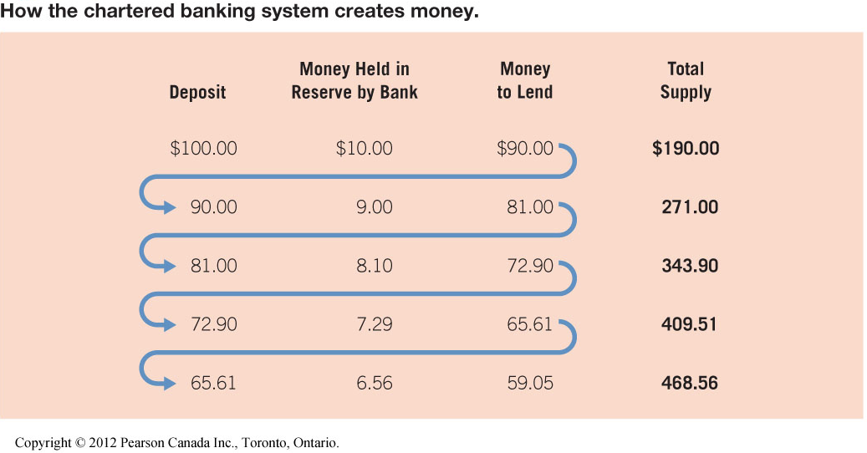

Changes in Banking
- Deregulation
  - Banks and trust companies combining together
  - Provide other services (insurance, stocks)
- Changes in consumer demands
  - Banks that will plan and pay for funeral
- Competition from foreign banks

Bank of Canda – Bank for banks
- Canada’s central bank
- Manages economy and regulates aspects of chartered bank operations (sets the reserve, determines interest rates)
- Manages money supply
- Changes market by open market operations and bank rate
- Simulate: buy government securities, lower the bank rate (more people will borrow money)
- Slow down: sell government securities, raise the bank rate

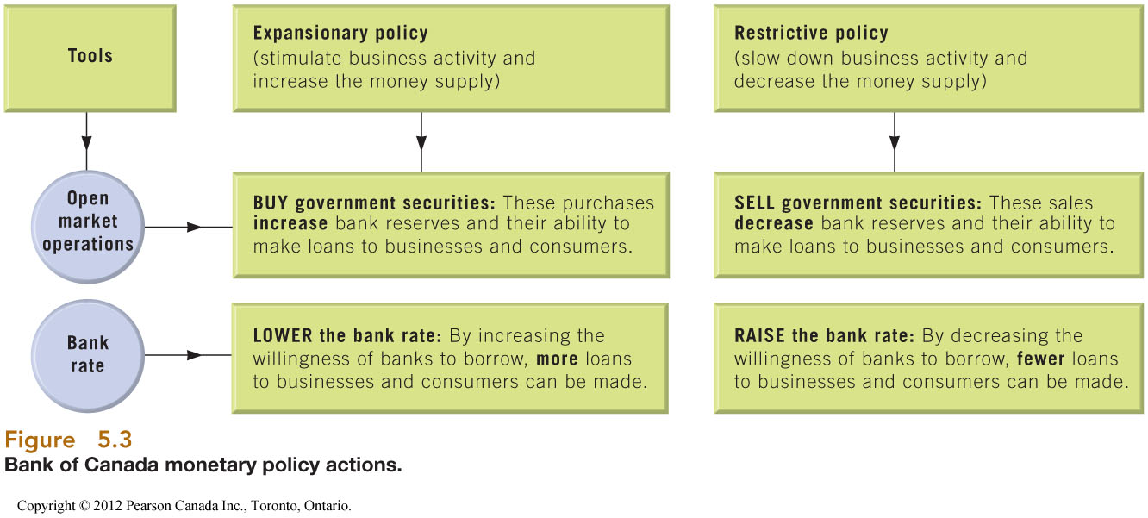

Pillars #2 and #3
- Pillar #2 – alternate banks
  - Trust companies and credit unions
- Pillar #3 – specialized lending/saving intermediaries
  - Insurance co., venture capital firms, pension funds
  - **Equity financing – Dragons Den

Pillar #4 – Investment Dealers (Stocks and Bonds)
- Facilitate trade of stock, bonds and other products in securities markets
- Give advice on how much to sell stock, what features it should have
- Bonds – lending someone money
- Primary markets – where the stock goes when it leaves the corporation (first person to buy it)
  - Investment bankers/dealers
  - Advise, underwrite, distribute (buy the bond then sell it on behalf of the company)
- Secondary markets – when that first person sells it to another company
  - TSX and other exchanges

International Banking and Finance
- Governments and corporations frequently borrow in foreign markets
- International Bank Structure
  - Aims for stability
  - World Bank produces limited services, funds national improvement
  - International Monetary Fund (can only encourage, doesn’t always happen)
    - Promotes stability of exchange trades
    - Provides short term loans to members
    - Encourages member cooperation
    - Promotes system for international payments

Securities Markets
- Part of pillar #4
- Where stocks, bonds and other securities are sold
- Primary market – investments are created
  - Investment bankers
- Secondary markets – investments are traded
  - TSX and other exchanges

Type of Investments: BONDS
- Represents debt for issuing corporation or government (business: you are borrowing money from investor, investor: you are lending money to a business)
- You will pay back that investment with interest
- Characteristics
  - Legal, binding agreement (stock: company does not owe anything to you, we own piece of the company. Bond: no say in company, but we can demand our money back)
  - Fixed rate of return (often paid semi-annually) – company has to 4% per year (coupon rate)
  - Fixed term – principle repaid at maturity – on this date in the future I will pay you back what I owe you
  - Priority over stockholders – if company goes bankrupt, the bondholders get their money back first
- Lower risks for bondholders compared to stocks
- Types
  - Secured vs. unsecured (collateral, no collateral) (debentures – no collateral)
  - Registered vs. bearer
    - Bearer – name of owner is not listed, who ever has it can cash it, works like cash
    - Registered – company that borrowed money they know who you are, registered as debt holder
- Features
  - Callable
    - Corporation has the right to recall that bond should it decide it wants to
    - Companies do this when interest rates drop and they can reissue the bond at a lower interest rate
    - Good for companies, not for investors
    - Paying it off before maturity date
  - Serial
    - Mature in staggered dates
    - Makes the bond less risky
  - Convertible
    - Bond can be converted from debt to equity
    - Gives investors flexibility

Determinants of Bond Value
- What impacts the coupon rate at bond issue?
  - Prevailing interest rates – bare minimum, on top of that is the adjustment for risk, more risker the company is the more risker the bond is
  - Credit rating of issuer
- What impacts bond price when traded?
  - Coupon rate (given) and prevailing rates of interest (relationship) – prevailing interest rate affect the bond price
  - Changes in credit rating – less attractive, means drop
  - Economic/market risk
  - Inflation – affects prevailing interest rates
Concept of Yield
- Percentage return on any investment
- Helps us to compare investments

- For a bond:
  - Interest = coupon rate (semi annually) x face value
  - Capital gain (what you paid for something minus the price you got for it) = face value – purchase price
  - ALWAYS USE FACE VALUE OF $1,000 FOR BONDS
Approximate Yield to Maturity
- If we buy the bond today and hold onto it until it matures, what returns will the bond give me every year?

- Only change from previous is “annual capital gain”

Notes:
- Assume you will hold the bond until maturity
- Need to calculate “what you made” on annual basis

Example: Approximate Yield to Maturity
- Example” You buy a 6% bond for $850 with 10 years to maturity. Calculate the approximate yield to maturity on this bond
- Step 1: Identify key information
  - Coupon rate: 6%
  - What you bought it at: $850
  - Face value: $1000
  - Years to maturity: 10 years
- Step 2: Calculate components
  - 6% x 1000 + (1000 – 850/10 yrs) / $850
  - = 8.8%
- Yield is higher than the coupon rate… (why?)
  - Because were making 6% on the coupon and earning a capital gain the totally yield is higher then 6%

Why do bond prices fluctuate?
- Same risk, same return – all investments that offer you the same level of risk should offer you the same level of return (low risk, low return)
- Yield – interest rate in economy (given by bank of Canada) + risk premium (decided by us)
- Coupon rate, face value, time to maturity – cant change
- Price paid – only thing that can change
- Price changes after the bond is issued if the interest rate or risk premium changes

Bond Pricing
- Three scenariors
  - You pay less than face value (<$1000) for the bond
    - Priced “at a discount”
  - You pay more then face value (>$1000) for the bond
    - Priced “at a premium”
  - You pay face value (=$1000) for the bond
    - Priced “at par”

Scenario 1: Pay at a “discount”
- This scenario happens when the coupon rate is less than the expected yield.
- Example: You are buying a 2008 bond with a 3% coupon and today’s expected bond yields are 5%
- Is this a bond you would be willing to pay face value for?
- Not willing paying $1000 for it, so will negotiate for a lower face value price
  - Negotiate down to get the yield that you would get at 5%
- Notice: With a Yield expectation that is greater than the coupon rate, you would need a capital gain to attain the Yield, which means you pay less than face value for the bond.

Scenario 2: Pay at “a premium”
- This scenario happens when the coupin rate is more than the expected yield
- Example: You are buying a 2004 bond with a 7% coupon and today’s expected bond yields are 5%
- Capital gain is negative
- Notice: With a Yield expectation that is less than the coupon rate, you would be willing to pay more than face value (a premium) for the bond; in other words you would take a capital loss.

Secarnio 3: Pay “at par”
- This scenario happens when the coupon rate is equal to the expected yield.
- Example: You are buying a 2006 bond with a 5% coupon and today’s expected bond yields are 5%
- Notice: Since your Yield expectation is met by the coupon rate, you would have no capital gain, which means you pay face value for the bond.
- There is no capital gain
- **EXAM: explain why do bond price go up when interest rates go down and vice versa

Types of Investments: STOCKS
- Represents equity/capital for issuing company
- You only get money if the company does well
- Characteristics
  - Voting rights – entitled to an opinion
  - No fixed term – no maturity date
  - Variable return – bond you are guaranteed coupon rates every year
  - Discretionary payment (dividends) – portion of the profits
  - Risk

Types of Stocks
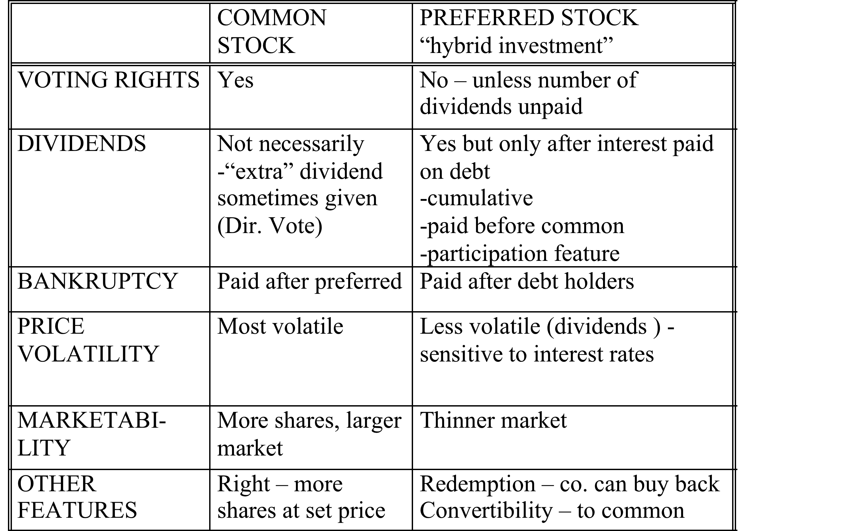

How Dividend Features work
- Revenue – expenses (bond interest 1st) = net income (reinvest in company or share with owners – pay dividends)
- Preferred dividends 2nd = in arrears + present year
- Common dividends 3rd – up yo participation
- Common and preferred share in remaining earnings
- ABC company earns a net income of 5 million. Its BOD decides to declaire a dvidence of 60% of earnigns. There are 100 000 sharees of 5% cumulative participating preferreds outstanding with a 50$ par value, dividencs are 1uear in arrears and participation commences hen common dividends hit $5 per share. There are 200 000 shares of common stock outstanding
- Revenue $11 000 000 – expenses 6 000 000 (including bond interest) = Net income of 5 mill
- Dividences (60%) are 3 mill - Preferred dividend are $500 000 (100 000 shares X.05 X50 X 2 years) = Remaining for commons 2.5 mill
- Before participation = 1 mill (5 x 200 000 shares)
- Available for participation = 1.5 mill / 300 000 shares total = 5 each

What impacts stock price?
- Demand and supply of stock due to negative or positive perceptions/facts
- Primary factors
  - Earnings – above or below expectations, rumours
  - General market conditions – bull (things are going up, lots of interest, motivated to buy, more demand than supply, effects all stocks) vs. bear markets, economy, interest (especially preferred)
  - Speculation – bough or sold on belief price will soon move
- PRICE OF A SECURITY SI A COLLECTIVE EXPRESSION OF ALL OPINIONS OF THOSE WHO ARE BUYING AND SELLING
- Undervalued issue – offers higher return than stocks of similar risk

Reading Stock Quotations

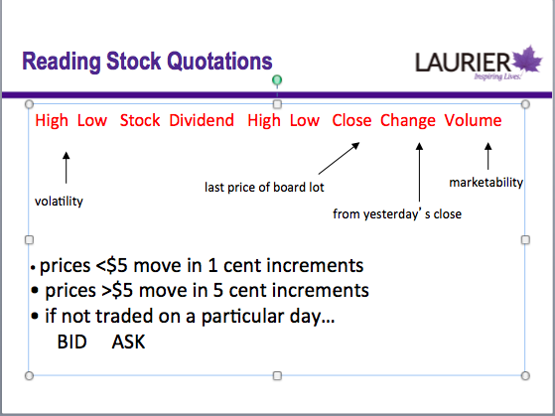

- 2nd high and low is the highest and lowest prices for that day
- Volume – how much it was traded hands that day

Other investment Vehicles
- Blue chip stocks - high quality investments, establishe organizations
- Small cap stocks – capitalization, small capitalization, their stocks aren’t worth a lot and there aren’t a lot outstanding
- Penny stocks – trade for under a dollar
- Canada Savings Bonds – CSBs, government of Canada bonds
- Guarenteed Investment Certificates – GICS, locked in savings accounts for a few years, higher interest rates
- Treasuring Bills – T-Bills, these have 90 day maturities, buy them below face value
- Mutual Funds – investment in a diversified portfolio that someone else has created

Leverage
- Engaging in a transactions whose value is greater than the actually dollars you have available
- On the same dollars you have to invest you can invest more
- Creates potential to make a larger return or loss than indicated by the investment you have made
- Examples
  - Selling short – deposit 50% of value of transaction
  - Buying on margin – invest part of the value of transaction (margin requirements), borrow the rest

Buying on Margin
- Put up only part of purchase price
- Broker lends remainder (with interest)
- Min. requirements set and enforced by Securities Commission – crash of ’29 – 10%

Comparison of long and margin buy
- SEE SLIDES
- Assum 2% commission

Margin Buying Rules
- Must qualify for margin account
- Must sign ‘hypothecation’ agreement (margin account agreement form) – pledging of securities as collateral for a loan
- Must pay interest on load
- The investors % equity (margin) in the margined stock must always be greater or equal to the minimum margin requirement
- Only thinfg you can control is the loan
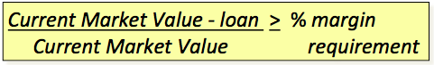

Example: Margin Call
- 1 month into the transaction the price os XYZ drops to $40 CMV = $40 x 200 shares = $8,000
- 8000-27000/8000 = 66.25%
- Therefore receive a “margin call” from brother for amount ‘x’ that will bring % equipy back up to minimum requirpment (increase equity by reducing loan)

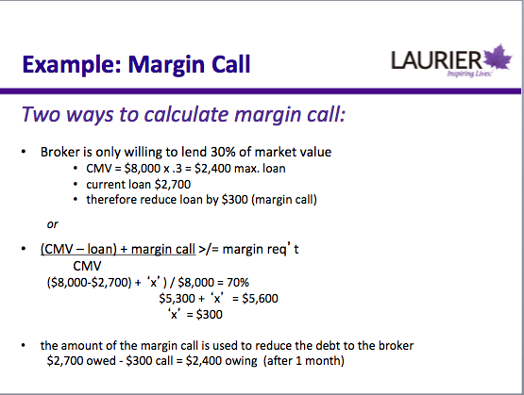

Impact on interest
- Margin call 1 month into transaction
- Sell stocks after total of 3 months
- Interest = 2700 X 10% x 1/12 = 22.50
- + 2400 x10% x 2/12 = 40.00
- = 62.50

Selling Short – sell it before you buy it - hoping that the price will decrease
- Buy low, sell high = sell high, buy low
- Sell shares you don’t own – borrow from broker
- RULES
  - Short deposit must be 150% CMV (current market value) at all times
  - Agreement may be terminated by either part at any time – forced to cover / “buy-in”
  - Short sale price government by ‘last sale’ rule – you cant sell lower than the last sale so you cant push the price down
  - Dividends declared are the responsibility of the seller
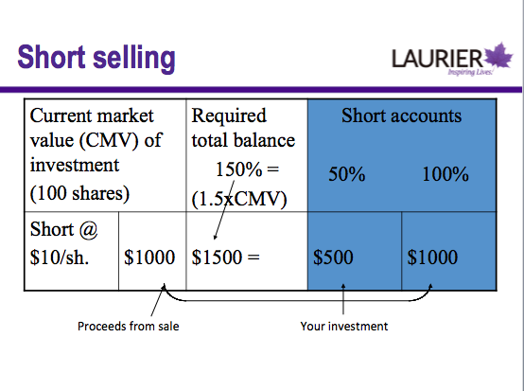

Short Selling Example
- ABC selling at $70/share; expect drop in price, short 100 shares
- Broker lends you 100 shares
- Sell @ $70 x 100 (left as collateral) = 7000
- Deposit 50% of CMV as collateral 3500
- Total short deposit – 10500
- Buy 100 shares of ABC @55 (cover short_ = 5500
- Shares go back to broker – investor gets back additional collateral (and interest – depends on the short account, less common nowadays)
- Proceeds from sale 7000
- Cost of covering 5500
- Gross profit – 1500
- Less: 2% (sale) – 140
- 2% (purchase) – 110
- Capital gain – 1250
- During the transaction (prior to the price falling and covering your short) the price of XYZ rises to 80
  - CMV = 80 x 100 shares = 8000
- Total in short account must away be 150 CMV of stock
- 8000 x 150% = 12000 vs 10500 currently on account
- Therefore receive a short call from broker for difference = 1500 that will bring short account up to 150% CMV

Revisit Yield – after call…
- Yield after call = 1250/3500+1500 = 25%
- Purpose of the short deposit is so that the broker can be sure that there is enough money in the account to cover your short position if you don’t meet your short call

Short Selling Summary
- What is the maximum profit you can make?
  - Price of the short
- What is maximum loss?
  - Anything goes; price can rise infinitely
  - Max profit on margin buy – unlimited
  - Max loss on margin = the lowest the stock price can go
- Risk
  - Unlimited losses
  - Forced to cover short as disadvantageous price
  - Dividends may be declared that you must cover
  - Short calls
- Notice similarities and difference between margin buying and short selling **exam

Time Value of Money
- Is $1 one year from today worth the same as $1 today?
- NO! It’s worth less because of:
  - Risk
  - Real Interest
  - Inflation
- Concept important to leases, mortgages, bonds, retirement contributions, stock valuation, project selection

Single amount – FV single period
- What will you have in one year if your deposit $100 into an account today that earns 4% interest compounded annually?
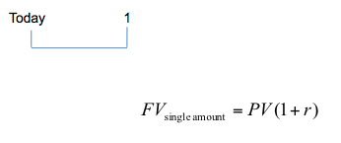

Single amount = FV multiple peroids
- What will you have in three years if you deposit a 100 gift into an account today that earns 4% interest compounded annually?

Social Factors
PEST Social Factors
- Customs, values attitudes and demographic characteristics
- Influences customers preferences
- Influences worker attitudes and behaviors
- Influences standards of business conduct
  - Ethics, social reasonability, stakeholder management
- Affects how we live, work, consume produce
- Society in which you operate dictates how you work

Business – Stakeholder Connection
- Stakeholders provide business with the capacity to operate
  - Owners and creditors – capital
    - Allow business to start with money
  - Customers – purchases
    - QTTA – why is it important to pay attention to your stakeholders and link it to the critical success factors
  - Employees – human resources
  - Natural environment – natural resources
  - Society – human, physical and financial resources
- Stakeholders have expectations of the business…
  - Owners and creditors: ROI, responsible management
  - Customers – quality, choice, communication, safety, respect
  - Employees – fair pay, meaningful work, safety, fair treatment, training
    - Expect that they are contributing to something valuable
  - Natural environment – responsible stewardship
  - Society –community concern, social value

Areas of Social Responsibility
- Responsibility towards natural environment
- Responsibility towards society
- Responsibility towards customers
- Responsibility towards employees
- Responsibility towards investors
  - **BE able to discuss why it is important to pay attention to them and what actions must you take in order to engage in CSR for each one? **EXAM

Responsibility towards the Natural Environment
- Areas: Air, water and land pollution
  - We share the cost of pollution as a society
- WHY?
  - Paradigm shift in management thinking
    - Was all about profits
    - Triple bottom line – people, planet, profit
    - How managers actions effect people and the planet
    - Diamond E – managers had a shift in their heads on what was important
  - Quantification of economic impact
    - Are able to put numbers to the damage we create
    - Out of PEST – comes from the economic environment
    - We are harming ourselves when we pollute – reduces GDP
  - Change in societal attitudes
    - More sensitive to the idea of pollution and we have a responsibility to future generations
    - PEST – comes from social factors
    - Dominant paradigm was take, make, waste
    - Starting holding business’s accountable
    - Action – increase corporate “greening

Responsibility to Society
- Areas – human development, poverty eradication
  - You want a stable environment – DIAMOND E
- Why? – diffuse the issues of social decay, political chaos, terrorism and further environment degradation
- Analyzing economic growth – does everyone benefit?
  - Looking beyond aggregate figures and considering income inequality
  - Growth is not always good
  - Sometimes it only benefits some people (rich get richer, poor stay the same)
- Human Development Index and Poverty Eradication
  - The more education your workforce the more you will benefit
- Action
  - Innovative business models and leveraging business skills can contribute to social development (eg. SOS)
  - Bigger business and community partnerships
    - You gain employee commitment with this

Responsbility to Customers
- Why? – provide businessness with revenue and in return they expect/want action in
- Consumerism
  - Right to safety
  - Right to be informed
  - Right to be heard
  - Right to choose
  - Right to courtesy
  - Right to education
- Fair pricing
- Ethics in advertising
Responsibility to Employees
- Why – they provide businesses with talent, skills, labour
- Actions
  - Responsibly hiring and promotion – not bias
  - Safety
  - Opportunities for advancement
  - Respect – benefits you give to your employees
    - Going beyond the minimum
  - Protection of whistleblowers

Responsibility to Investors – Corporate Governance
- Why – provide businesses with capital
- Agency problem
  - Shareholders allocate decision making authority to managers via Board of Directors
    - Not qualified to manage company
    - Don’t have time or incentive
  - But can lead to conflict of interest and shirking
    - Managers may be tempted to act in their own best interest rather than shareholder’s
- New Regulations for boards and new expectations from investors due to repeated irresponsibility
- Result
  - More independence
  - New practices
  - New disclosure rules
  - Different legal attitude – directors and investors
- Canadian Coalition for Good Governance
- Actions
  - Return on investment (ROI)
  - xResponsible management

Why Manage Stakeholders? – relate to D-E, CSF, and P5
- LINK TO OTHER COURSE MODELS
- Improve ability to predict/control/cope with environmental uncertainty
  - Environment is hard to predict, more uncertain it is the more time it takes for us and more challenges it presents
  - LINK: makes environment more manageable, Diamond E model
- Avoid adverse actions by stakeholders
  - May turn against you
  - Easier to do now because of internet and social media
  - Sue you, boycott your products if you treat them wrongly
  - LINK: makes environment more manageable, Diamond E model
- Promote more favorable legislation/regulation
  - Do not like regulation – prefer to have choices because they have more flexibility
  - Laws out there to make sure you are respecting your customers
  - Ensures less regulation
  - Restricts how you’re going to comply to regulations
  - LINK: makes environment more manageable, Diamond E model
- Align company values with societal values
  - As a society we want companies to act in a socially acceptable way
  - LINK: Principal logic of the Diamond E
    - Alignment with strategy
- Promote higher entry barriers
  - When you are socially responsible you stand apart from those organizations that do not
  - You also limit how many other organizations can have your reputation
  - You create higher barriers to entry
  - LINK: Improve environment by making it less competitive and allows you to keep your distinct competitive advantage
- Potentially improve profitability
  - LINK: Achieving financial performance from CSF
- Promote higher levels of trust and loyalty with customers/employees
  - They know the company respects them and wont rip them off
  - LINK: Gaining employee commitment and meeting customer needs
  - Example: giving employees a fair pay
    - EXAM: Explain how this action of a company promotes higher levels of trust and therefore allows you to gain employee commitment
- Improving the percentage of successful new product/service introductions
  - LINK: Encouraging innovation and creativity
  - What actions can you take to help improve this?
- Promote higher levels of operating efficiency and organization flexibility
  - LINK: Building quality products and services and achieving financial performance
  - THINK OF EXAMPLES

When/which stakeholders should you manage?
- Importance of stakeholder varies by issue
- When stakeholders affect uncertainty faced by firm they are either
  - Threatening = increase it
    - Determined by relative power and capacity and willingness to act
    - Its not enough that they can threaten you but are they going to be willing to act on this?
      - EX: sweatshops, although we care about the issue many of us don’t look into where our clothing is produced
    - LINK: Porter’s 5 Forces
  - Cooperative = decrease it
    - Determined by dependence on organization and capacity to expand interdependence
      - Force you to need stakeholders more then they need you
    - By being your cheerleaders or at least by staying out of the mix and not creating problems for you

How to strategically manage stakeholders
- Identify key organizational stakeholders
  - Who is going to care about what I am doing here
- Diagnose them along two critical dimensions of potential for threat and potential for cooperation – categorize them
  - Look at if they are going to threaten you
- Formulate appropriate strategies both to enhance or change current relationships with those key stakeholders and to improve the organizations overall situation
- Effectively implement these strategies

Strategic Stakeholder categories
- Each stakeholder to relevant to an action or decision is going to fall into one of these categories
- Where do my employees, investors, customers fall on this chart etc

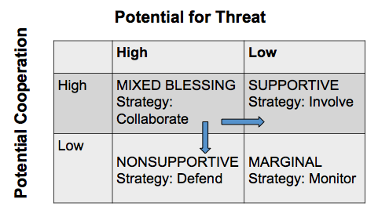

- Supportive – ex parents with university education
  - Not going to take actions of harm you in your objective, more likely to help you
  - Strategy: involving them in the decision or action, asking for help, soliciting their input, they feel they have a voice
- Marginal – potential for threat is low, potential for support is low
  - They don’t care enough about the issue or they don’t have the resources
  - They wont do much
  - Strategy: monitor them, keep them informed, etc, don’t pay a lot of attention
- Non supportive – high potential for threat, low potential for cooperation
  - Might try to work with them on an issue, they wont want to talk to you, will only work with you once you stop doing what they don’t like
  - Example: Greenpeace and Apple’s production techniques
  - Strategy – reduce your dependence on them, use media to tell your side of the story
  - Bring in the supportive stakeholders to help defend you
- Mixed Blessing – high potential to cooperate but also a high threat
  - Might be supportive or might be non-supportive
  - Customers and society fall into this box on a given issue and how you deal with that issue will determine what box they fall into
  - Strategy: collaborate – don’t want advice, I want to work with you to help us, lets look at this issue together

Stakeholder management strategies
- Low strategic importance
  - Buffering – satisfy needs and or demands
  - Don’t need to pay to much attentions
- High strategic importance
  - Customers and suppliers – involve in product design
  - Competitors – joint R&D, joint market development
  - Government – invite involvement in setting safety/technical standards, appoint to board of directors
  - Community – involve in urban renewable projects
  - Activist groups – appoint to board of directions, seek input, consult
  - Unions – invite involvement in joint committees, appoint to board of directors, profit-sharing

Warning
- Stakeholders will watch out for other stakeholders
  - Does the environment watch out for itself?
- Stakeholders can move from supportive or marginal to non-supportive on behalf of/in defense of other stakeholders
  - We defend the weak i.e. stakeholders that don’t have the capacity to act/threaten
- We demand on behalf of people that cannot speak that they deserve to be treated fairly

Impact of Demographics
- Based on David Foot’s work
  - Came up with a model to understand what those populations mean
- What is demography?
  - Study of human populations
- Why is it important to business?
  - Powerful predictor of human behavior/trends
  - Certainty and simplicity of age data – easy to predict
  - Change in relative proportions and participation rates of age groups have significant impact on business environment
    - Same in relative size and proportion
    - Sometime there will be bulge in a particular age group (ex. Baby boomers)

Understanding Demographics
- Key factors in predicting behavior
  - Size of cohort = # of people in each age group (age group=cohort)
  - “Activity participation rate” – what is the frequency of engaging in this particular acitivty
  - EX:
- Factors affecting size of cohorts
  - Fertility rate – avg. # children per women
  - Birth rate – total # of births/size of population

Cohorts – David Foot
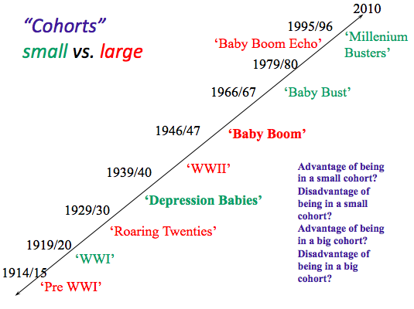
- Baby boomers – retirement homes, increase in demand

Canadian Demographic Trends
- Aging baby boomers most influential demographic force shaping marketplace
- Shrinking youth group
- Population proportionately older due to rise in life expectancy
  - People are living longer because of health care etc
- No longer reflects traditional pyramids
- Implications
  - Increased paid and unpaid elder care
  - Increase number of vulnerable seniors

Boom and Echo
- Echo generation – children of boomers – relatively large group
  - They have money to spend on nicer cars, nicer trips, technology etc
  - Even if they are not spending they’re own money, they have influence on what there parents are spending
- More disposable income because parents provide essentials
- Increasingly influence family purchases
- Implications
  - Government policy and business opportunities to address the needs of boomers
  - Market impact of echo
    - What should you change to fit this demographic
      - Market to them

Changing Households
- One person household hrowing faster then one family households
  - Divorce rates, as they get older a spouse passes away
  - Choosing to stay single longer/forever
  - Highest among seniors
- Implications: lost economics of scale in living (share rent, internet, utilities), shopping (not going to be buying in bulk), threat for bulk stores (they deal with that threat by packaging products differently (dividing cereal into smaller boxes); Aging seniors living alone and smaller younger cohort (can take care of them)= will have smaller support network
- Majority households without children
- Lone parent families increasing; two earner families face time constraints (both parents are working, not enough time to do everything)
  - Implications – increased demand for time savers
    - Ready prep healthy meal
    - Ordering groceries online
    - Day care centers

Changing Ethnic Composition
- Immigration increasing over past decades
- Immigrants are younger and more likely to live in city than average Canadian
- Interaction with marketplace difficult
  - Getting a cellphone in Canada if you’re from a foreign company
- Implication – increased demand for multilingual consumer support/services/goods
  - Hiring sales people that are multilingual
  - Adjusting plans that are offered to cater to foreigners
  - Transition service for Canada

Geographic Distribution
- Increasing urban concentration – four areas: Golden Horseshoe, Montreal, BC lower mainland and Vancouver, Calgary – Edmonton
- Donut effect
  - Happening in the outskirts of the city rather than in the core
- Rural living predominates in Atlantic Canada, Saskatchewan, territories
- Net exodus of youth from rural areas
  - Young people are increasing are moving away from rural to the city
- Implication: affects median age in rural areas and access to goods and services

Demographic Trends: International Context
- Changing demographics in emerging economies present new opportunities and partnerships for Internation business

Political Factors
How Government influences business – Link to P5F – how do these factors influence the rest of the PEST factors
- Customer – buyers products and services
  - Opportunity – large scale customer, stable
  - Threat – bargaining power because they are so large
  - P5F – buyers, good thing because they
- Competitor – Canada Post, CBC
  - Threat – for Purolator, UPS, FedEx Etc.
  - Can change the rules so they have an advantage
  - Influence competitor
  - Cheaper for the customers – generally not looking to make a profit, you’re competitor a not for profit in many cases
  - Rivalry among existing firms
- Regulator/law maker
  - Regulates business activity; influences technology standards – CRTC
    - Technology factors
  - Purpose
    - Promotes competition – Competition Act, small business support
    - Promotes innovation – intellectual property rights
    - Protects consumers – i.e. Hazardous products act
    - Achieve social goals – i.e. universal health care, education
    - Protect the environment – Canada Water Act, Fisheries Act
  - Educated work force – providing corporations with a trained work force
- Taxation agent
  - Collected by all three levels of government
  - Types – business (much lower then personal) and personal
    - Lower taxes on business to help promote jobs, new businesses and trade
  - Approaches – progressive (ex: income tax system in Canada, as your income goes up, the more taxes you pay), regressive (independent of your income, ex: sales tax), restrictive (deter someone from buying an item, ex: tobacco, alcohol, gas)
  - Raises money for government programs
- Provider of incentives and financial assistance
  - Subsidies, tax breaks (setting up in a particular area), support services for small and large businesses (encourage them to set up in Canada), research funding (encouraging innovation)
  - Bail out – if they were not bailed out all of the jobs they provide would be gone
  - Ex: pollution – rebates for installing a high efficiency furnace
- Provider of essential services
  - Highways, armed forces, police and fire dept., hospitals, education
  - Competitor – 407 vs. 401, cars vs. public transportation

Links to Porter’s
- Customer – government
- Competitor – Canada Post, highways, CBC
- Provider of incentives and assistance – suppliers, influence potential entrants
- Regulator (laws) – rivalry
- Taxation agent – barrier to entry, can lower or raise barriers

Intellectual Property Rights
- What: legal rights that result from intellectual activity in the industrial, scientific, literary and artistic fields, Grants exclusive rights to the creator
  - Most common types are patents, copyright and trademarks
- Why?
  - Creates incentive to innovate and be unique by allowing you to benefit from your innovation/creation
  - Allows you to keep your competitive advantage

Trademarks
- A word (ord words), a design, or a combination of these used to identify the goods or services of one person or organization
- Protection for 15 years; renewable
- Legislation = Trade-marks Act
- Can be a symbol/shape and/or words
- Vary from country to country
- Why?
  - Establishes an protects reputation/brand
    - Can be one of your most valuable assets
  - Facilitates licensing your trademark
  - Creates a distinct competitive advantage

Copyright
- Any original literary, dramatic, musical or artistic owkr
- Subject to copyright from the moment it is created (no registration necessary)
- Owner is creater of the work
  - Created while at work = owned by employer
  - Who ever hired them to do it is considered the owner of the work
- Duration – life of owner + 50 years
  - Becomes public domain
- Caution: Doesn’t cover ideas, only the form in which they are expressed, i.e. music, play, art
- Why?
  - Receive credit for your work
  - Receive royalties for your work

Patents
- Government grants that five inventors exclusive rights to their inventions
- Must be new (first in the world), useful (functional and operative), and show ingenuity (i.e. is not obvious to someone skilled in that area)
- Can be a product, composition, apparatus, process or improvement on any of these
- Protection = 20 years
- Just because you have patent protection but doesn’t mean you have a competitive advantage
- Why?
  - Provides protection for the owner
  - Can license/receive royalties
  - Provides valuable information and inspiration for further research and innovation
  - Details disclosed to the public after 18 months

Links to Critical Success Factors - **EXAM
- LOOK AT CHART, YOU DO IT
- Link political aspect to EST
- Achieving financial performance – increasing restrictive taxes on tobacco, decrease sales for tobacco companies, will negatively effect their financial performance, which is a positive because smoking is bad

How Business influences government
- Lobbyists
  - Hired to represent company’s/group’s interest
  - Lobbying Act – must register and follow rules
  - Trade associations – small business/individuals join and lobby as an industry lobby group
  - Persuade them to take government action that will favor the company
- Collaboration with government/decision input
  - CRTC consults with industry members
- Advertising
  - Corporations influence voters

Forms of Ownership – compare and contrast how they are similar/different, better/worse; under what conditions is each firm going to choose each type
- Traditional forms of ownership
  - Sole proprietorship
  - Partnership
  - Corporation
- Public vs Private Corporations
- Other forms
  - Co-operatives
- Forms of ownership will likely change over life of business

Sole Proprietorship
**EXAM, EXPLAIN THE DIFFERENCES AND SIMILARTIES BETWEEN THE DIFFERENT TYPES AND WHEN YOU WOULD SWITCH TO ONE OR THE OTHER**
- Owned and operated by one person
- Business and owner = one legal entity
Advantages | Disadvantages
Ease of formation – government makes it easy, only $30 | Taxed as personal income (advantage if business has losses – deduct losses if you are working at another job)
Fewer regulations – in comparison to corporations, they are small businesses and cant do much, over regulation will discourage people to do so | Unlimited liability – views owner and business and one, if business messes up, owner is responsible
Complete control over profits and decisions | Lack of continuity
Government support (advice) | Limited managerial and financial resources – whatever the owner brings to the table
 | Difficult to obtain outside financing - just the owner, just one person

Partnership
- Two or more owner
- Business and owners = one legal entity
Advantages | Disadvantages
Ease of formation – partnership agreement | Taxed as personal income (advantage if business has losses) – similar to sole proprietorship, difference is that it is shared amongst partners
Few regulations | Unlimited liability *
More managerial and financial resources | Lack of continuity, difficult to transfer ownership – if someone decides to leave, that partnership does not exist and have to refile for a new partnership - unlike SP, only one business owner
Government support (advice) | Difficult to obtain outside financing – similar to SP
Easier to borrow money | Shared profits and decisions – conflicts – in SP you get to keep everything

Types of Partnerships
- General partner
  - All partners have joint and several liability – involved in decision making of the business
    - Joint liability – together share liability
    - Several liability – 1 ma be liable for all
- Limited partner
  - Limited partners liability – investment – limited in input, you aren’t responsible for decisions because you didn’t make them
  - Limited partners cannot be active in management
  - At least one general partner

Corporations
- Separate entity from owners (shareholders)
- Types
  - Public – starts with IPO (initial public offering) – stocks are publically available, no restriction on who can buy stocks
  - Private – similar to public in that you have shareholders, but shares are traded privately
  - Crown – run by the government
- Interests represented by board of directors – have to have BOD for corporations – protect the interests of the company
  - Inside directors – CEO, VP etc
  - Outside directors – not employed by the company but do get paid to sit on the BOD

Private Corporation
- Shares not sold to public, less than 50 shareholders
- Owners and business – separate entities in theory
Advantages | Disadvantages
Relatively flat taxes, lower than public corporation and individual rates | Double taxation? – you get paid in dividends, those dollars have been taxed through the corporation and now you have to declare them as individual as well
Limited liability? – most the owners can lose is the investment | Complexity of formation? – more complicated to form a corporation
Continuity, easy of transferring ownership – since they are separate, if ownership changes (new shareholders) doesn’t change the business itself | Regulation?
Ease of raising money? – bank would be more likely to give you a loan | Lack of secrecy? – only have to share info with shareholders
Can attract/afford experts? – because you are bigger

Public Corporation
- Many (thousands) owners, shares public available
- Business and owners = separate entities
Advantages | Disadvantages
Flat tax rate (may be lower than individual rates) – higher then private, lower then personal | Double taxation - you get paid in dividends, those dollars have been taxed through the corporation and now you have to declare them as individual as well
Limited liability – only have your investment to lose | Cost and complexity of formation – you first have to incorporate, have to hire an investment dealer to trade your shares publically
Continuity, easy of transferring ownership – easiest to transfer ownership | Regulation – most highly regulated, gov’t wants to protect us as investors
Ease of raising money, unlimited – easiest to raise money, because they are big, shares are traded publicly, no limitations on how many shareholders | Lack of secrecy – have to make financial statement publically available
Can attract/afford experts - since it is easiest to raise money they can afford the experts

- SP to partnerships – don’t have resources to do it on your own, organization of diamond-e– don’t have the skills or capabilities, management preferences – like working with other people, don’t like taking risks
- SP to private corporations – when you get larger and have more financial resources, don’t want it to be taxed as personal since its lower for corporations, trying to protect yourself from liability
- Private to public – raise more money and you have enough money to hire an investment banker to do that IPO

International Business
- Globalization – single interdependent system
- Forces:
  - Greater awareness of benefits – looking at outsourcing
  - Technology makes it easier, faster, cheaper – includes transportation
  - Competitive pressure

Major Marketplaces
- Country categorization by income – determines how suitable that environment is going to be to sell your product
  - High income
  - Middle income
    - Upper middle-income
    - Low middle –income
  - Low income
- Geographic Clusters
  - North America
  - Europe
  - Pacific Asia

Forms of Competitive Advantage
- Absolute advantage – cheaper/better than other countries
  - You are better then any other country at producing something
- Comparative advantage – better than other goods; lower OC
- National competitive advantage – from 4 conditions:
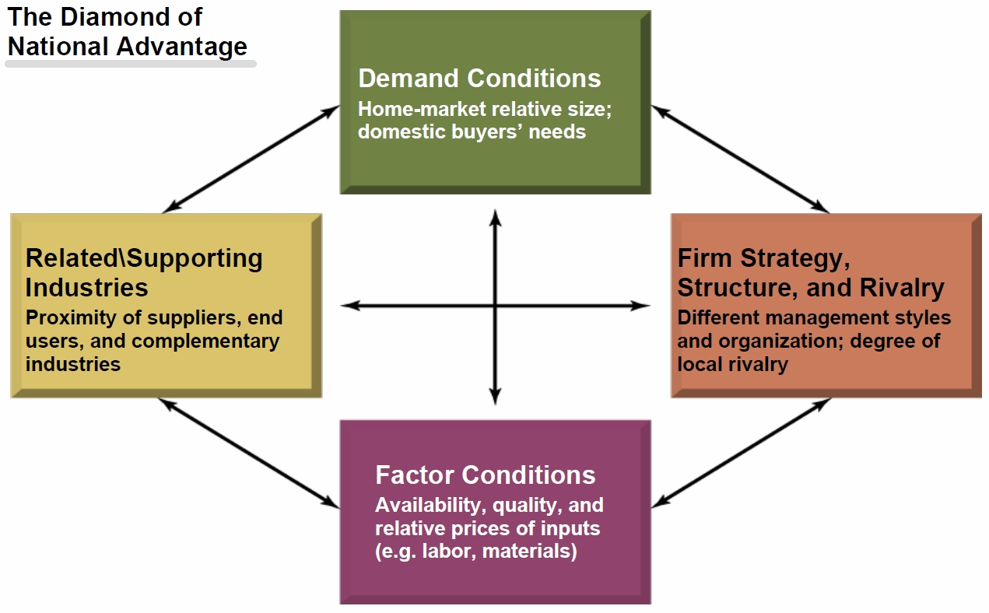

Going International
Considerations
- Is there international demand for the firm’s product?
- Can the project be modified to fit a foreign market?
- Is the foreign business climate suited to imports?
- Does the firm have or can it get the necessary skills and knowledge to do business?
- If yes, go international, if “no”, stay domestic!

Barriers to International Trade - PEST
- Social and cultural differences
  - Adapting to customer needs
- Economic differences
  - Exchange rates
  - Income levels – luxury goods
- Legal and political differences
  - Quotas, tariffs, subsidies
  - Protectionism
  - Local content laws
  - Business practice laws – cartels and dumping

Overcoming Trade Barriers
- Government support through free trade treaties
  - GATT – General Agreement on Tarrif and Trade
  - WTO – World Trade Organization
  - EU - 28 members
  - NAFTA – 3 members
- Employing firm strategies for new market entry

Firms strategies for entering foreign markets
- Aliances with local firms – overcome social, economic but will the partnership work?
- Establishment of foreign subsidiaries (buy or build)
  - Overcome E and P (if allowed); do you know s? Risky
- Brand offices – low risk; marketing control/ overcome S? doesn’t help with P or E
- Local agents – marketing knowhow (overcome S) and low risk but doesn’t help with E and may or may not with P
- Licensing – overcome S E P but lower marketing control

**EXAM - How does international business affect each of the critical success factors? What changes might you have to make to meet each one?

