Chapter 52

What is ecology?
- The scientific study of:
    - Interactions between organisms & environment
  - OR
    - Distribution & abundance of organisms
  - NOT
    - Environmental activism

2 great environmental issues of our time?
- Climate change
- Biodiversity

What is the current population of humans on earth?
- 7.2 billion

How many humans on earth 20 years ago ?
- 5.4 million

% of changes in last 20 years
- World population increased by 31%
- Canadian population increased by 23%
- Atmospheric CO₂ increased by 9.8%
- Fossil fuel consumption increased by 58%
- People with HIV increased by 313%

2 approaches to ecology/science?
- Reductionism – seeks answers at lower levels of hierarchy
  - Reducing complex systems to simpler components
- “traditional” science

Holism
- Holism seeks answers at the same or higher levels of analysis by examining
- Emergent properties
- Novel properties that emerge at each level
  - invisible to reductionist
  - become apparent to holist

Emergent properties: examples
- Individuals
- Age, size, clutch size, lifespan, personality
- Populations
- Density, dispersion, growth rate
- Communities
- S, species diversity, successional stage, species interactions
- Ecosystems
- Efficiency of nutrient cycling, energy flow, transfer efficiency

The environment has 2 components
- Abiotic
- Biotic

Why do we care about climate?
- Predicts the distribution of terrestrial species &terrestrial biomes on earth (major ecosystems)
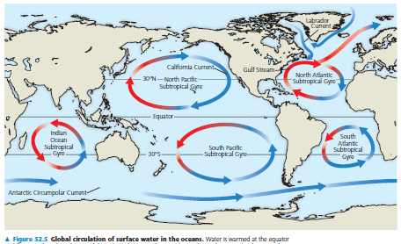

4 abiotic components of climate
- Temperature
- precipitation
- Sunlight
- Wind

Why do we have seasons?
- Earth is tilted toward the sun during summer and away during winter

Global Climate Patterns: I. Latitude
- Latitude predicts almost everything in ecology
- The latitude matters because of the angle of incidence of the sun
  - Because the closer to 90 degrees the angle of incidence then the higher the concentration of sunlight higher concentration on energy

Global Patterns of Climate: II. Seasons
- Tilt of the earth 23.5 degrees
- Where is the sun overhead on:
  - June 21 23.5°N
  - December 21 23.5°S
  - March 21 equator March Equinox
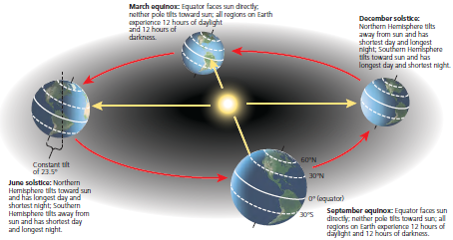
  - September 21 equator September Equinox

Global Climate Patterns: III. Wind & Precipitation
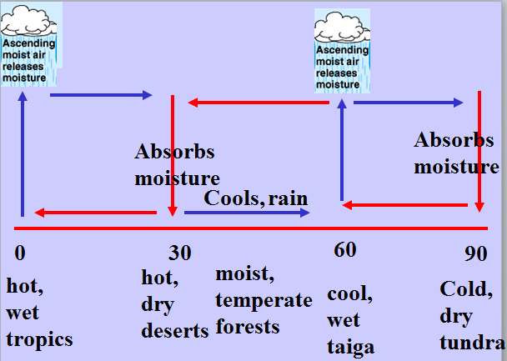
- The main principles:
  - Cold air is denser than warm air
  - Air cools as it rises
  - Warm air holds more moisture than cold air
  - Earth rotates

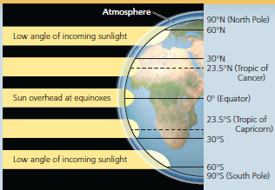

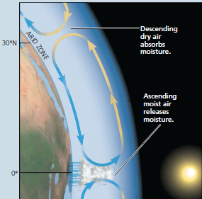
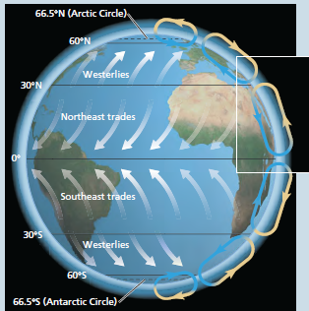
- All the desserts on earth are just shy of 30 degrees
- Sun is over the equator on average
- When it’s low pressure snow and rain
- When it’s high pressure hot
- On average Tropics are warm and wet

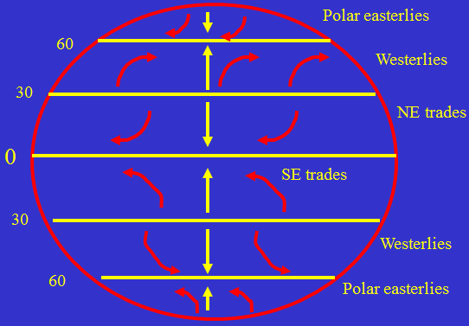
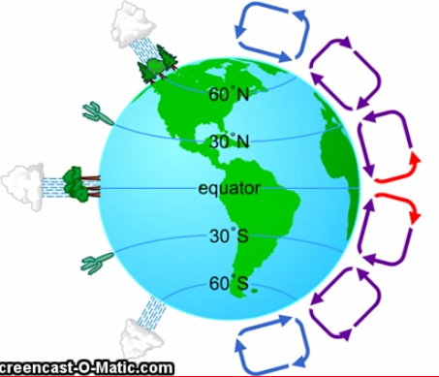
- Wind always moves away from the poles on average
- Wind always flows towards the equator on average
- At the equator the sun is very close so the air is always rising due to heat. (ex. Evaporation)
  - So the air rising up has to be replaced
    - This air gets replaced from the 30 point of the globe where the air is cooler
      - This is why air flows towards the equator
- Since the air is coming from -30 and +30 this will make the winds rotate
- We live in the westerly flow that’s
- Tropical regions are always easterly
- Temperate regions are always westerly flow
- Polar regions are always easterly flow

- Differential heating on earth is the cause major wind patterns of the earth.

Global Climate Patterns: III. Wind & Precipitation
- Wet at equator, dry at 23.5 N & S
- Onshore winds: moist
- Offshore winds: dry

Local Climate Patterns: I Proximity to water
- The lake or ocean effect
- Moderating influence of water
- Water reflects more radiation than land
- Water higher specific heat than air/land
- Water heats up more slowly than air/land
- Cools more slowly than land
- Daily wind patterns
  - During the Day: the breeze blows on to the land from the lake
  - During the Night: the breeze blows off the land to the lake
Air always moves form cooler to warmer to replace the warm air that is rising causing wind
    - This is only if the land gets cooler than the water at night
&
    - The water gets cooler than the land during the day

Tropical rainforest
- Equatorial & subequatorial regions
- Constant rain fall (tropical rain forest)
- Rain is seasonal (tropical dry forest)
- T° 25-29° C, little seasonal variation
- Vertically layered
- Intense competition for light
- Home of millions of species

Chaparral
- Mediterranean
- Really hot dry summers
- Best place to want to live
- Prone to fires
- Don’t get big trees because :
  - Seasonally very dry
  - Seasonally very wet

Boreal Forest
- One of the biggest terrestrial forest on earth

Dessert
- At 30° north and south latitude
- Precipitation low & really variable (-30cm/year)
- Hot deserts: 50° + / Cold deserts: -30° -
- Widely scattered plants
- Cacti, euphorbs, shrubs & herbs
- Heat & desiccation tolerance, water storage & reduced leaf surface area
- Defenses: spines, toxins / many are C4 or CAM plants
- Snakes, lizards, scorpions, ants, beetles, birds, rodent (most nocturnal)

Northern coniferous forest
- Taiga

Tundra
- Primary producers lots of mosses

Savanna
- Equatorial & subequatorial regions
- Seasonal rainfall (30-50 cm/year)
- Dry season up to 9 months
- Warm 24-29° C / more seasonal variation than tropical forest
- Scattered, thorny & small leaves tress
- Common fires in dry season (dominant plants are fire-adapted & tolerant to drought
- Forbs (grasses, small non-woody plants), grow fast after rain
- Animals zebras, lions, dominant herbivore insects (termites)
- Fires by man helps maintain this biome
- Cattle ranching & overhunting declines in large-mammal

Temperate deciduous forest
- Our forest

Temperate grassland
- Plaines & prairies, pampas, puszta, steppes
- Precipitation are seasonal (30-100cm)/ Dry W & wet S
- Drought is common
- W cold down -10°C / S hot approaching 30°C
- Mostly grasses & forbs / Have Adaptation to drought & fire
- Grasses sprout quickly after fires/ Large animal grazing prevent woody shrubs & trees
- Large grazers (bison & wild horses), burrowing mammals
- Grassland become farmland/ can be turned into deserts (by cattle)
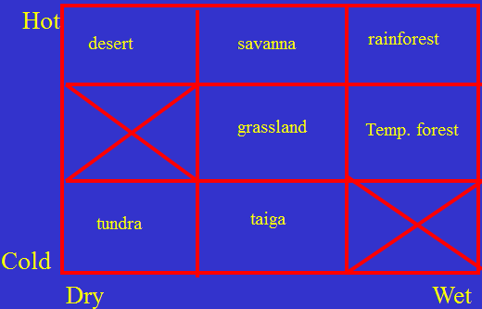

Desserts are found near + or -25 degrees from the equator because?
- Air descends at these latitudes
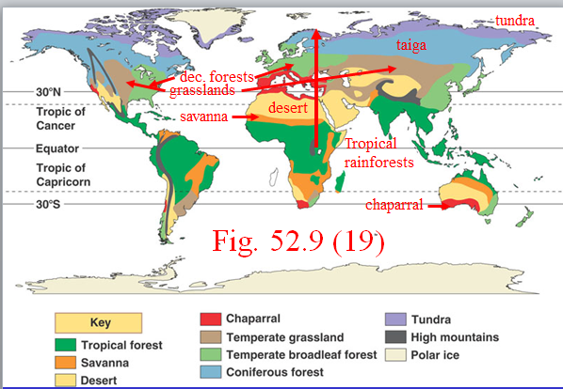
Equinox: means equal days over the equator

                - Grasslands are stuck in the middle
                - Deciduous are more on the coasts

Climate vs. Terrestrial Biomes – North America?

Aquatic Biomes
- Marine
- Freshwater

Marine organisms
- Salt uptake
- Water loss

Freshwater organisms
- Water uptake
- Salt loss
Few organisms can handle both

Intermediate biomes
- Land & water?
  - Wetland
- Why valuable?
  - Filtering
  - water regulation
- Fresh-salt?
  - Estuary
- Why productive?
  - Mixing, nutrients from land
- land-salt water
  - Inter-tidal
  - Vertical zonation?
  - Duration of drying

2 types of fresh water biomes
- Standing water lakes
  - Vertical zonation
- Running waterstreams
  - Longitudinal zonation
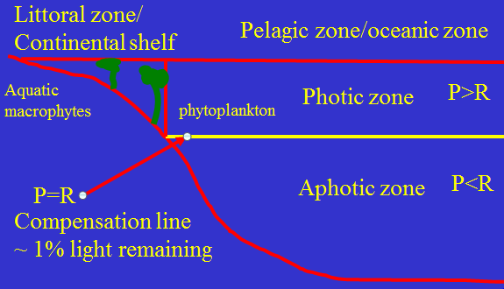
Photic zone : photosynthesis rate exceeds that of the respiration rate
Aphotic zone: respiration rate exceeds that of the photosynthesis rate
Compensation line: just where it all balances
What is the most productive area of the lake?
  - Littoral zone
No latitudinal effect except for coral reefs
Coral reefs need to be in warm water

