CHAPTER 54 COMMUNITY ECOLOGY

What is a community?
- Assemblage of species living in an area that can potentially interact
- New emergent properties
- Population interactions
- Species richness, species diversity
- Succession
- Patterns in biodiversity

What is community ecology?
- Study of interactions between populations
- How interactions affect community composition
- “biodiversity crisis” is question of community ecology
- Species go extinct, but spp are embedded within communities

Population Interactions?
- Defined mechanistically: based on interactions between individuals of each pop’n
- Defined by effects: one population on the density or growth rate of another population

Interspecific interactions:
the big 3
- +/+ mutualism
- -/- competition
- +/- Predation/parasitism

Elk/Wolf:
- This is an -/+ interaction

Lion/hyena:
- This an -/- interaction because they compete for the same prey

Honeybee/flower:
+/+ interaction because they benefit from one another

Monarchs/viceroys:
- -/+
- Viceroys are palatable but monarchs are not
- Since monarchs are not palatable, animals won’t want to eat any animals that look like them
- Since viceroys are palatable, animals will want to eat any animals that look like them
- Batesian mimicry: a palatable or harmless species mimics an unpalatable or harmful one

Cuckoo bee/yellow
- +/+
- Mullerian mimicry: two or more unpalatable species, such as the cuckoo bee and yellow jacket resemble each other

Humans/wolves:
- Beforeg we thought: -/-
- Today: 0/-

Humans/cows:
- +/+

Review Q: In exponential growth, a graph of r vs. N is:
- A horizontal line

Competition: -/-
- Use of a resource by one population that reduces its availability to other populations
- Mechanistic definition
- Resource: important for the fitness of individuals &/or viability of populations & is depletable
  - Ex: light is a resource to plants
  - Ex: primary producers are a resource to us

Gause’s Competitive exclusion principle
- No 2 species can coexist on the same limiting resource
Or
- No 2 species can coexist in the same ecological niche

Ecological niche
- How a species use the biotic and abiotic resources and conditions in the environment
- “role” in the community
Weakest evidence of competition: resource partitioning
- Or: different fundamental niche?
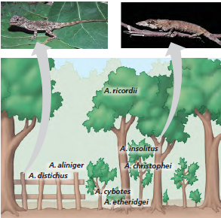
- Or: ghost of competition past?

Stronger evidence: character displacement
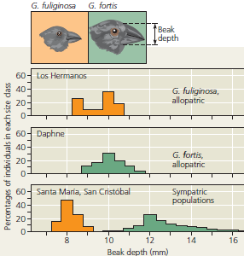
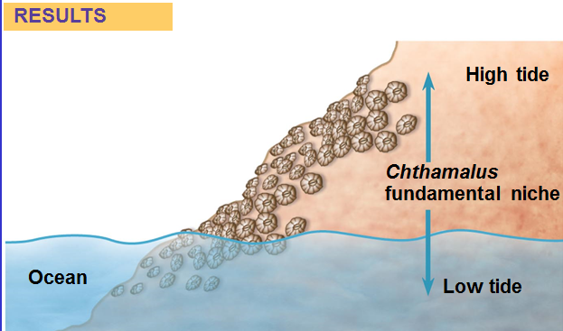
- If you remove balanus chthamalus takes over the whole tidal zone ( balanus habitat)
- Balamus doesn’t care about chthamalus
- Symmetrical competition
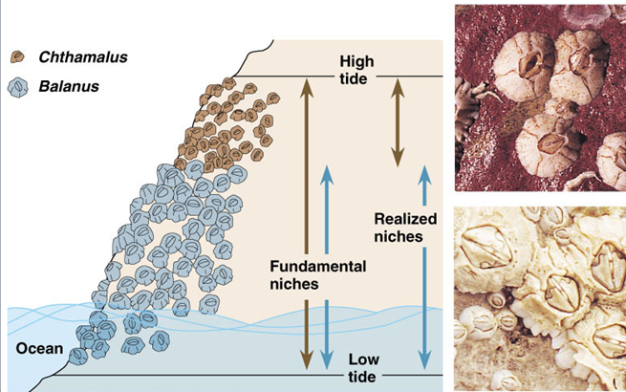

Invasive species as evidence of competition
invasive species which are organisms that become established outside their native range

Review Q: Which of the following is an example of Müllerian mimicry?
two species of unpalatable butterfly that have the same color pattern

Predation/parasitism: +/-
- Predator?
  - Consumes & removes an individual prey
- Parasite?
  - Consumes, but doesn’t kill prey

Herbivores?
- Eat plants or parts of plants
- Predators of plants Seed eaters
- Parasites of plants Browsers & Grazers

Do predators decrease the density of prey populations?
- Sometimes
- Exotic predators often have devastating effects on prey
  - Biological control
- Exotics with few predators

Should we cull predators to increase prey populations?
- Cod population is low and seal populations are high so should we cull seal to let cod pop. to rise?
- Fact: seals eat some cod
- Will a cull of seals increase cod?
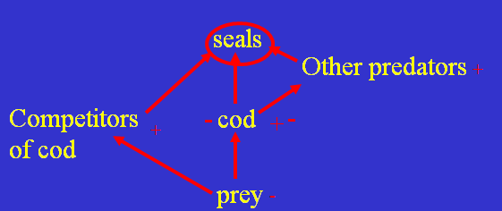
- Build a food web model Conduct an experiment
- SO THE ANSWER TO THIS PROBLEM: there’s no evidence unless you actually do the real life experiment

Mutualism: +/+
- Symbiosis vs. mutualism?
- Symbiosis: is 1/1 living together
- Mutualism: is when both organisms benefit from one another
- Mutualism is a type of symbiosis
- Variety of interactions

Examples of mutualism?
- Lichens
- N₂ fixation in legumes by Rhizobium
- Digestion of cellulose by gut microbes
- Dispersal of seeds
- Pollination
- Mycorrhizae
- Eukaryotic cells

Species diversity – Fig. 54.10 (9): 2 components
- Species richness = S
- 1=2
- Relative abundance (evenness)
- 1>2
- Species diversity
- 1>2

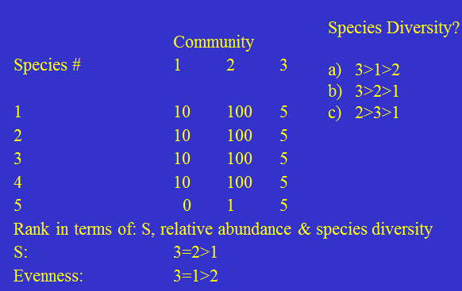
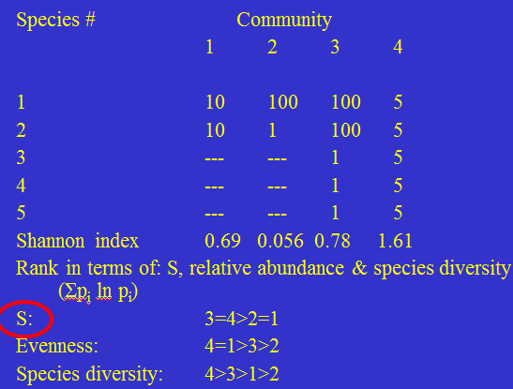

- Community structure is determined by feeding relationships:

Problems with food chain concept?
- Trophic position of a species is not fixed
- Species feed at more than one trophic level
  - Ex: omnivores feed at different trophic levels
- Since the food chain concept has problems we result to Food web concept

Trophic levels Food web
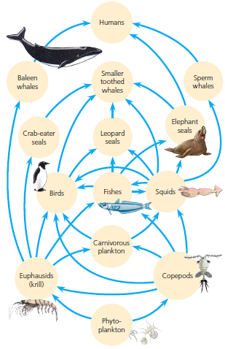

Community structure in time
- Communities are always changing in time
- Succession
  - changes in times
  - Directional & continuous patterns of colonization & extinction at a site
- Changes in resources and microclimate
- Changes in life history of species (r- vs. K-selected)
  - R selected employs species for fast growth
  - K selected are species that can grow well when species are abundant (logistic)
- Pioneer (r) vs. climax (K)
  - Pioneer species do well in open new environment
  - Climax species do well in environments where resources are hard to come by

Old-field succession (compete for light & nutrients):
Changes in light and nutrients makes species outcompete others over time
(ex: from empty field to hardwood forest in 100 years)
As time goes on:
- Annual plants (already there)
- Perennial plants (outcompete annuals)
- Shrubs (outcompete perennials)
- Softwood trees (outcompete shrubs, create conditions for their own demise)
- Harwood trees
- Climax community is formed which is forest

Balance of nature vs. flux of nature?
- Balance of nature: if disturbance is infrequent then you will get a community more or less at equilibrium
- Flux of nature: if disturbance is frequent then you will get changes all the time

Infrequent disturbance: a uniform climax community

Mosaic of patches

diversity peaks at intermediate levels of disturbance
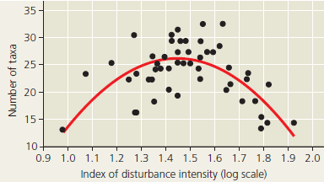
Mosaic of successional stages
Climax com.

Patterns in Species Richness: I.
- Is affected by Latitude

Latitudinal gradient in S?
- Tropics are older than temperate zones
- Evapotranspiration
  - In terrestrial communities, the two main climatic factors correlated with diversity are:
    - solar energy input
    - water availability
  - These factors can be considered together by measuring a community’s rate of evapotranspiration:
    - the evaporation of water from soil plus the transpiration of water from plants.

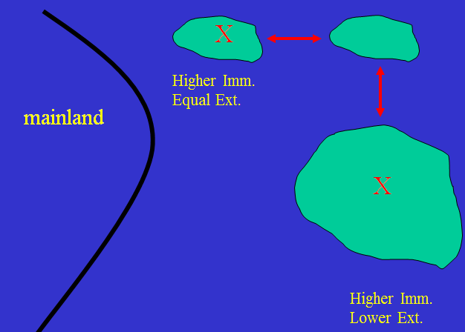
- MARKARTHUR and Wilson law:
- Wilson observed:
  - Small island close to mainland higher immigration rate + equal extinction rate
  - Small island further from mainland lower immigration + equal extinction rate
  - Big island higher immigration rate + lower extinction rate

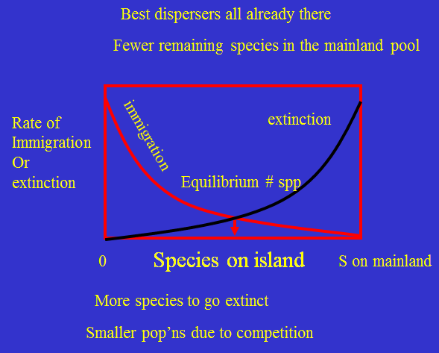

- As you get more species on land the chances of getting more species on land lowers

II. Area: Island biogeography theory
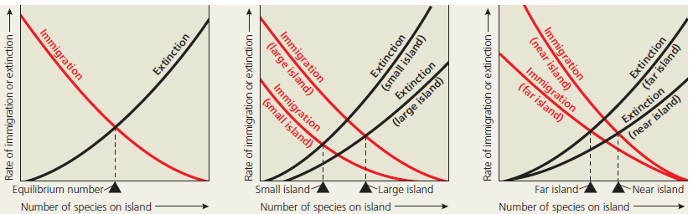

II. Area effect
- Bigger islands have more species major thing
- Area effect: also on mainland & also on ecological islands
- 10:50 rule of park conservation:
10% of area can protect 50% of S
this relationship is a declining exponential curve

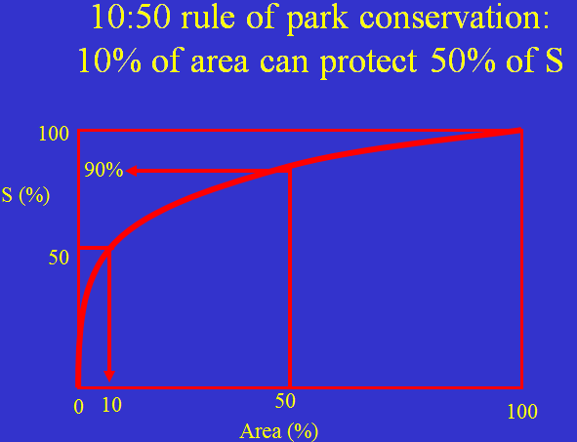

CHAPTER 54. HIGHLIGHTS
- Communities are structured by interactions
- +/-, -/-, +/+
- Competitive exclusion principle
- Ecological niche
- Predators kill & remove prey
- Parasites don’t normally kill prey
- Ch. 54. Highlights (cont’d)
- Succession: community structure in time
- Patterns of S: latitude, energy & area
- Predictions of island biogeography theory
- Implications for park design

