Chapter 55: Ecosystem & Restoration

What is an ecosystem?
- Biological community + its interactions with the abiotic environment
- Emergent properties= ENERGY FLOW & NUTRIENT CYCLE
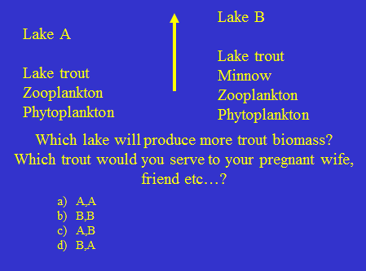
          - Answer: A, A
          - Why? : A) because there are less trophic level there will be more energy from the trout \
A) Because less trophic level= less concentration (extra trophic level= magnify anything that you don’t want ex: mercury)

Ecosystem dynamics
- Energy flows
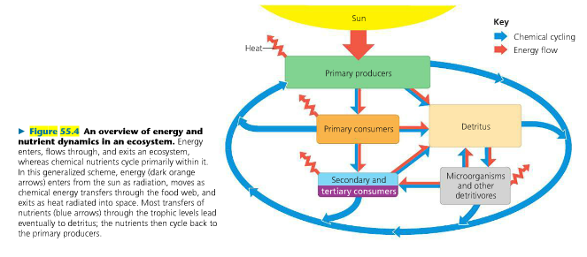
- All the energy is fixed by primer producers
- All the energy ends up as heat or gets stored as coal
- Nutrients don’t go away; they are blew, they get passed up,
they die and they come back
- Fate of all energy= nutrient cycle

All trophic levels are linked to decomposers
- Everything is dying giving off heat, dying and recycling

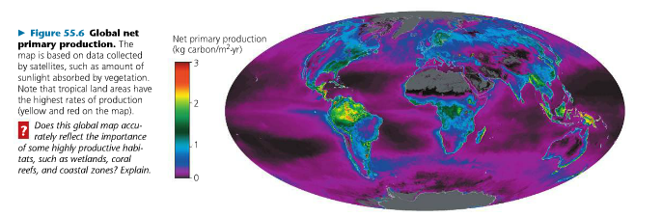
Primary Production
- The source of all energy
for ecosystems: most photosynthesis/ also but rare: chemoheterotrophy
- GPP (gross primary production) = light energy that is converted to chemical energy by photosynthesis (fixed energy)
- Energy flows & dissipates because of metabolisms
- NPP (net primary production) = GPP – Respiration of PP
- Biomass available to consumers
- Most & least productive ecosystems on earth?
- Most: Tropical Rain Forests
- Least: Desert, Arctic tundra

What limits NPP on land?
- Intensity of sunlight
- Water
- Nutrients
- Best nutrients
- Best predictor= latitude

What limits NPP in oceans?
- Nutrients
- Iron

P: limiting nutrient in fresh water
- The phosphorous availability limits cyanobacteria growth (limits primary production)

What limits NPP in water?
- Light
- Nutrients

2nd law of thermodynamics
- Entropy is always increasing
- Form of entropy? = Heat
- Moves from warmer to colder areas
- Usable energy is always decreasing in every ecological “reaction”
- Energy is “lost” as heat – i.e. biologically unavailable
- ENERGY FLOWS AND DISSIPATES

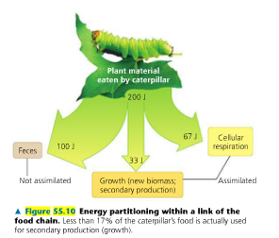
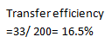
Trophic Efficiency
- T.E.= energy produced by trophic level
n/energy produced by trophic level n-1
=% of production that is transferred from one
Trophic level to the next
- T.E.= E_{n} / E_{n-1} * 100
- T.E: 10% rule of thumb (you get about 10% out of it/
It is an estimate not a rule)
- 90% is lost at each transfer!!
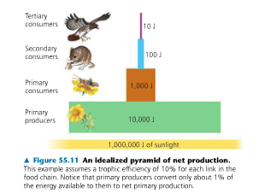

Pyramids of energy or net production
- A law of physics
- We got 0% efficiency unless you give birth,
since you will give milk to your baby

Consequences of 2nd law?
- Carnivores are rare for 2 reasons:
- They are big animals
- They are carnivores (on top of the pyramids= gets less energy than herbivores)
That is why carnivores have lowest densities & are more in danger (ex. big cats)

- Ecological vegetarianism 7:00 min It is also a consequence of the second law (10%)/ they want to reduce the agriculture
- Reduce your ecological footprint by:
- Eating lower on the food chain
- Leave more space for nature or
Ecosystems others than farm
(So we need less land for agriculture)
- Fate of all energy in an ecosystem= Heat

Pyramid of biomass
- Not a law of physics they can sometimes be a verse pyramids/ the consumers produce more biomass
- Example: a small standing crop of primary producers supports a larger primary consumers..why?:
- The consumers are maybe mixotrophs
- The producers have short turnover time (time required to replace a standing crop of a population), the producers replace their biomass at such a rapid rate, they can support a biomass of a bigger consumer than their own biomass
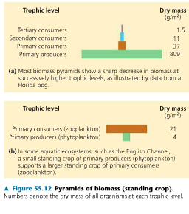

Pyramid of numbers: not a law of physics
- Not a law of physics since it also may look like an inverse pyramid
- Counting for example the trees, the insects…

Law of conservation of matter/ mass
- The mass of a closed system remains constant
Atoms/molecules are not destroyed, but are rearranged and recycled
- NUTRIENTS CYCLE
- ENERGY FLOWS, BUT NUTRIENTS CYCLE
(nutrients don’t go away as energy)

Consequences of nutrient cycling?
- Anything we create doesn’t go away
- Most of our pollution problems are linked to ‘’nutrients’’ cycling
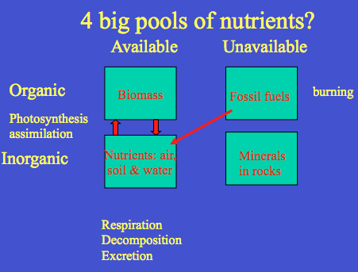
- We do not really care about the unenviable, except for what humans do on Earth
- InorganicOrganic by:
- Photosynthesis assimilation
- Organic Inorganic by:
- Respiration
- Decomposition
- Excretion
- Fossil fuels Nutrients:
- Burning
- Is so slow it doesn’t change much
- This is the standard lifecycle for a nutrient

Nutrient cycles
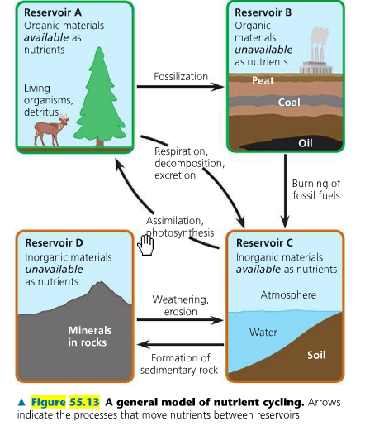
- This is a detailed lifecycle of the nutrient

The limiting resource for the 21th century?
- It is water
- Canadians think they have more water than what they really do

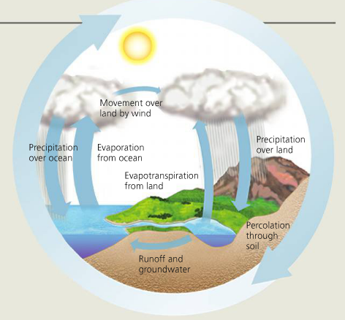
Hydrological cycle
- We do not need to know the water cycle!!
- Powered by: the Sun
- Solar energy creates the water cycle
- Link between terrestrial & aquatic: by that one-way flow
- 1-way flow of nutrients: Water flows down the hill carrying the nutrients
- Anything we do on land affects aquatic ecosystems: fertilizers
- Samuel de Champlain: More molecules in a glass of water than glasses of water in
the ocean (analogy to make you think about global effect)
So, every time you drink a glass of water,
the odds are good that something in that glass has
passed through the bladder of Samuel de Champlain (Lewis Wolpert)

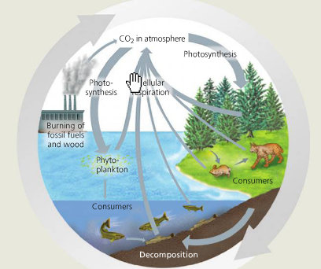
Carbon cycle
- Photosynthesis vs. Respiration
- P: Converts Carbon into Oxygen
- R: Converts Oxygen into Carbon
- Carbon problem: Burning of fossils fuels & wood
- Link to greenhouse effect
Cause: 300 million year burning old coal forests (more coal
that can be burned than oil)
- Acid rain is tied to the carbon cycle:
How linked to C cycle:
- Oxides of N and S (because of the nutrients they
are release oxidize and then make acids )
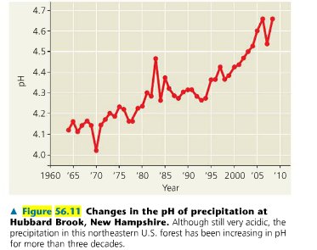
- Ocean acidification
CO2 dissolves in water (decrease of pH)

Some good news
- Recovery of pH from the acids rain

Acid rain and Sudbury
- Lakes were devastated in terms of pH, but are not recovering,
because of the technology that takes Sulphate out

Nitrogen cycle
- Most of the Nitrogen is found in the atmosphere
- Inorganic phase: atmospheric
- Unavailable: we can’t do anything with it because it is a really stable molecule
- The only way available is through the nitrogen fixing bacteria in the roots
- N₂ fixation: bacteria
- So all the nitrogen fixation is done by bacteria therefore it is limited in oceans
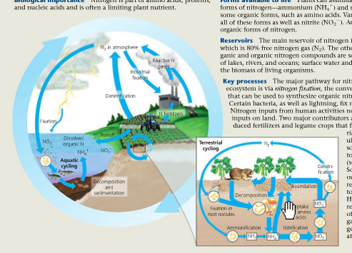
- We can fix Nitrogen with energy and lots of oil
- Add fertilizers to plants for growth
- Human nitrogen production is now equal to
100% of that fixed by bacteria
- Doubled the supply of fixed N on earth by using the fertilizers
to get this response from agriculture
- Good for global food production (we can feed the world)
- Bad for aquatic ecosystems
- Efficient cycling within soil
- Add fertilizers: eutrophication (overproduction in fresh water),
But now we are transferring the problem to oceans!!

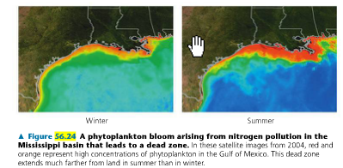
- Phytoplankton bloom ‘’dead zone’’
- Because of use of fertilizers in agriculture,
Lakes are contaminated, and they bring
their contamination to oceans
- Phytoplankton uses all the O₂ from the lake
Then the fish die.

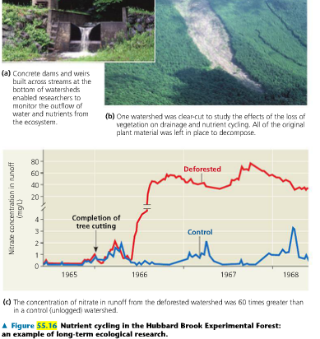
Hubbard Brook Experiment
- Little experiment in New Hampshire
- They measured the nitrate and phosphate from
deforestation
- Found that the concentration of nitrate was 60 times
greater than in a control area
- Agriculture= deforestation + adding fertilizers!!
So there are much more nitrate concentration!

Effect of deforestation: decoupled nutrients
- Less biomass
- Less transpiration (40% of rain)
Because no more trees to do this
- Less absorption of nutrients
- More runoff (40%)
- More export of nutrients (4-60x increase)
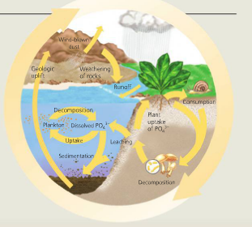
- Eutrophication of receiving waters
Loss of forest fertility

Phosphorous
- There is no atmosphere phase: local effects
so you can take easily action
- Fertilizers (we make our own phosphate), agriculture & sewage = human impact
- Eutrophication of receiving water (people don’t like to swim in them)
- Sewage treatment has worked in the Great Lakes (They had a big phosphorous problem)

The return of an indicator species
- The mayflies are indicator of oxygen in water and of low pollution in lakes

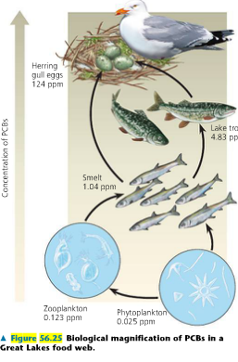
Biomodification (Figure 56.25)
- Synthesis of nutrients cycling & energy flow
- Food webs passes energy on, but also chemicals
26X
that will magnify
- Whenever ingestion> excretion
- Chemicals increase in your body
5000X increase of PCBs
- Typically: fat-soluble compounds
5X
- Banning DDT in 1978

8X

5X

