Economic Factors: Canadian Financial Systems
Goals of Economic System | Economic elements that influence business
Economic Growth (measures: aggregate output, GDP) | - Balance of Trade  - Exchange Rates  - National Debt
Stability | - Inflation/deflation  - Interest rates
Employment | Employment rates and measures
Goals of the Financial System:
These elements affect Costs, Sales, and Financial uncertainty.

In This Section:
- Canadian Financial Sysytem
  - Purpose
  - Structure and Organization
  - Changes in Banking
- International Banking & Finance

Canadian Financial System

Purpose:
- Facilitate flow of money
- There are four legal “Pillars”
  - Chartered banks
  - Alternate banks
  - Life insurance companies
  - Investment dealers
- Pillars have been blurred due to deregulation

Pillars:
  - Chartered Banks:
- Privately Owned
- Publicly traded
- Profit seeking
- Concentrated and highly regulated industry
  - 5 of the largest chartered banks account for 90% of total bank assets
  - Bank Act: Limits foreign- controlled banks to <8% of total domestic bank assets
- Open to serve individuals, businesses and others
- They are the main source for short term loans for business
  - Secured vs Unsecured
Chartered Banks expand their money supply through deposit expansion:
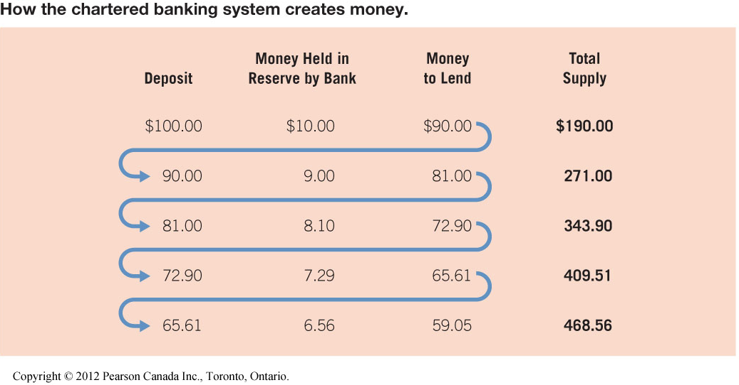
Banking is always changing and some of these changes are:
- Deregulation: The act or process of removing or reducing state regulations
- Consumer Demands: They are always changing what they want, and what they feel is appropriate.
- Competition from foreign banks: Although foreign banks are limited by The Bank Act they still can be competition for other banks.
Example of a chartered bank: TD, Scotia Bank, RBC
Bank of Canada
- The central bank of Canada
- It serves the purpose of managing the economy and regulating chartered bank operations
- Manages the supply of money going into chartered banks throughout Canada
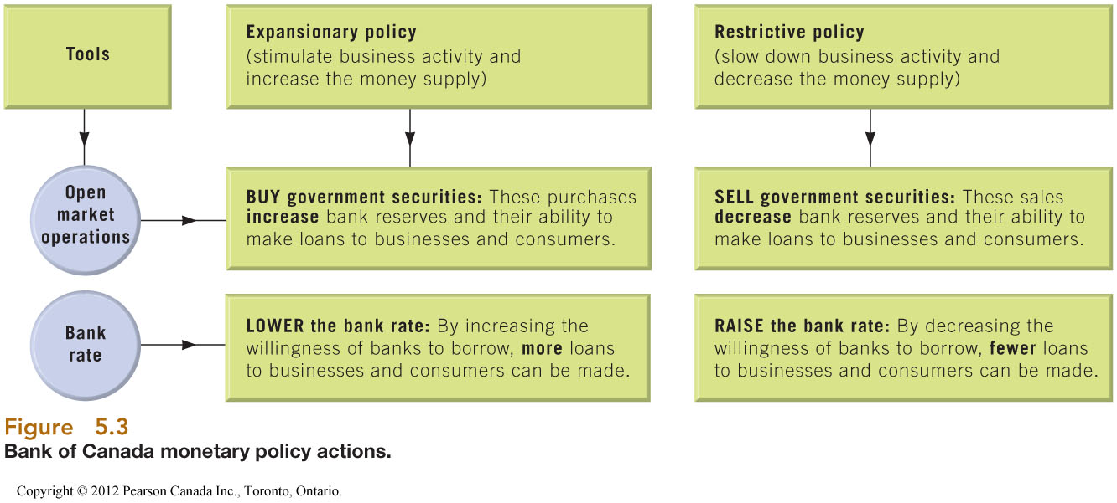
  - Alternate Banks:
(Descriptions not so important, use for understanding and grasp of type of bank)
Trust Companies: organized to perform the fiduciary of trusts and agencies. It is normally owned by one of three types of structures: an independent partnership, a bank, or a law firm, each of which specializes in being a trustee of various kinds of trusts and in managing estates.
Credit Unions: a member-owned financial cooperative, democratically controlled by its members, and operated for the purpose of promoting thrift, providing credit at competitive rates, and providing other financial services to its members.

  - Specialized lending/ saving intermediaries:
- Insurance Co., Venture Capital Firms, Pension funds
  - Investment Dealers:
- Organize and oversee the trading of stocks, bonds and other products in Securities Markets.
- Primary markets
  - Investment bankers/dealers
  - Primary Markets serve the purpose to Advise, underwrite, distribute
- Secondary Markets
  - Toronto Stock Exchange and other exchanges

International Banking & Finance
Governments and Corporations frequently borrow in foreign markets, this means there need to be a central way of dealing with this.
  - International Bank Structure:
- Aims to keep the international market stable.
- World Bank
  - Limited services are provided and is in place to fund national improvement
- International Monetary Fund: Works to foster global growth and economic stability
  - Aims to
    - Promote stability of exchange rates
    - Provides short term loans to members
    - Encourages member cooperation
    - Promotes system for international payments

Economic Factors: Investment Instruments

Types of Investments:

  - Bonds:
Represents debt for issuing corporation or government
Characteristics:
- Legally binding agreement
- Fixed rate of return: Profit of an investment over a period of time.
- Fixed Term: Principal is repaid at maturity
- Priority over stockholders
Types of Bonds:
- Unsecured(Debentures) vs Secured
- Registered vs bearer
Features:
- Callable
- Serial
- Convertible
Determinants of Bond Value
- Impacts on the cupon rate at bond issue
  - Prevailing interest rates
  - Credit rating of issuer
  - Features
- Impacts on Bond price when traded
  - Coupon Rate & prevailing rates of interest
  - Changes in credit rating
  - Economic/market risk
  - Inflation

Yield:
- Percentage of return on any investment
- Used to compare investments
Yield = Cupon rate X Face Value + (Face Value – price paid/ time to maturity)
Price Paid
Face Value is always = $1000
Bond Pricing
- You pay less than face value (<$1000) for the bond
  - Priced “At a discount”

Notice: With a Yield expectation that is greater than the coupon rate, you would need a capital gain to attain the Yield, which means you pay less than face value for the bond.
- You Pay more than face value(>$1000) for the bond
  - Priced “At premium”

Notice: With a Yield expectation that is less than the coupon rate, you would be willing to pay more than face value (a premium) for the bond; in other words you would take a capital loss

- You pay face value (=$1000) for the bond
  - Priced “At par”

Notice: Since your Yield expectation is met by the coupon rate, you would have no capital gain, which means you pay face value for the bond.
Summary:
Bond prices vary inversely with interest rates
Reading Bond Quotations: refer to slide 18/40 in Economic Factors investment instruments
  - Stocks:
Represents equity/capital for issuing company
Characteristics
- Voting rights
- No fixed term
- Variable return
- Discretionary payment(Dividends)
- Risk
Types of Stocks
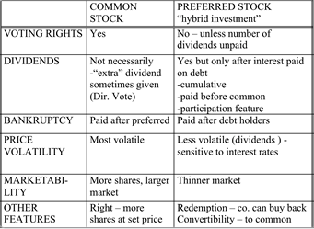

Impacts on stock price:
- Demand and supply of stock due to negative or positive perceptions/facts
- Primary factors
  - Earnings – above or below expectations, rumours
  - General market conditions – bull vs bear markets, economy, interest
  - Speculations – bought or sold on belief price will soon move
- Price of a security is a collective expression of all the opinions and thoughts of those who are buying/ selling
- Undervalued issue – offers higher return than stocks of similar risk
  - Other investment Vehicles:
- Blue chip stocks
- Small-cap stocks
- Canada Savings Bonds -CSB
- Guaranteed Investment Certificates - GIC
- Treasury Bills - T-BILLS
- Mutual Funds
  - Leverage:
- Engaging in a transaction that’s value is greater than the value you have .
- Has large risk and return possibilities
- Examples:
  - Selling short
  - Buying on margin

Social Factors

PEST – Social Factors
  - Elements:
- Customs, values, attitudes, and demographic characteristics
Influences customer preferencse
Influences worker attitudes and behaviours
Influences standards of business conduct
- Ethics, social responsibility, stakeholder management
Affects how we live, work, consume and produce
  - Ethics & its importance:
Ethics
“individual standards/beliefs regarding what is right and wrong or good and bad”
Business or Managerial Ethics
“standards of behaviour that guide individual managers in their work”
Corporate Social Responsibility

  - Corporate Social Responsibility:
What does the organization do to, and for stake holders?
How does a business define ethical conduct at organizational level – “Colective code”
Way in which way a business tries to balance its commitments to its organizational stakholders
Two opposing views
- Profits focus(investor)
- Actively consider other stakeholders
  - Approaches to ethical dilemmas:
Four approaches to individual decision making:
Rights Approach:
- Don’t’ violate basic/legal rights
Utilitarian Approach:
- Most good for most people
Fairness/Justice Approach:
- Equitable distribution of burdens and rewards
Caring Approach:
- Consistent with peoples responsibilities to each other
  - Approaches to Corporate social Responsibility:
Four levels:
- Obstructional Stance – do as little as possible
- Defensive Stance – legally required only
- Accomodative Stance – goes further in some areas
- Proactive Stance – looks for opportunities
  - Managerial preferences influenced by:
- Hiring criteria
- Managerial role modeling
- Mission statement/ care value statement
- Code of conduct/ethics
- Ethics booklets & training
- Goals and evaluation criteria
- Rewards systems
- Employee protection mechanisms
  - Stakeholders – Who are they?
- Groups, individuals, and other organizations who are affected by organizations activities
- Their importance is dependant on the situation
- Challenge: stakeholders opinions are varying and conflicting
Stakeholder connection to the business:
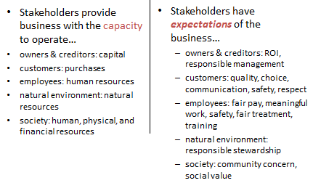
Stakeholders have a social responsibility to:
- Natural environment
  - Air, water, and land pollution
  - Paradigm shift in management thinking
    - E.g 1987: Bruntland defines sustainable development: “meets the needs of the present without compromising the ability of future generations to meet their own needs”
  - Quantification of impact
    - E.g 2012: “Climate Vulnerability Monitor: A Guide to the Cold Calculus of a Hot Planet” states that climate change is costing $1.2 trillion (U.S) per year and reducing global GDP by 1.6 per cent
  - Change in social attitude
    - Dominant paradigm was take, make, waste
    - 99% of US produced goods in waste stream in 6 mos.
    - Must learn to live differently
  - Action: increased “corporate increase”
- Society
  - Diffuse the issues of social decay, political chaos, terrorism, environmental degradation
  - Human Development, poverty eradication
  - Analyzing economic growth
    - Looking beyond aggregate figures & considering income inequality
    - Growth is not always good
  - Action: innovative business models and leveraging business skills can contribute to social development
    - Social entrepreneurship e.g SOS
- Customers
  - They provide business with Revenue; in return they expect/ want action in:
    - Consumerism:
      - Right to safety
      - Right to be informed
      - Right to be heard
      - Right to choose
      - Right to courtesy
      - Right to education
    - Fair pricing
    - Ethics in advertising
- Employees
  - They provide business with Talent, Skills, Labour
  - Actions
    - Responsible hiring and promotion
    - Safety
    - Opportunities for advancement
    - Respect
    - Protection of whistleblowers
- Investors
  - They provide businesses with Capital
  - Agency Problem:
    - Shareholders allocate decision making authority to managers via board of directors
      - Not qualified to manage company
      - Don’t have time or incentive
    - This can lead to a conflict of interest and shirking
      - Managers may be tempted to act their own best interest rather than shareholders
    - New regulations for boards and new expectations from investors due to repeated irresponsibility
    - Result:
      - More independence
      - New practices
      - New disclosure rules
      - Different legal attitude
    - Canadian Coalition for Good Governance
  - Actions
    - Return on investment
    - Responsible management
  - Manage Stakeholders:
Make environment more manageable:
- Improve ability to predict/ control/ cope with environmental uncertainty
- Avoid adverse actions by stakeholders
- Promote more favourable legislation regulations

Why Manage Stakeholders?
Diamond-E:
- Align company values with societal values
Promote higher entry barriers:
- Increase environment and distinctive competitive advantage
Potentially improve profitability:
- improving financial performance
Promote higher levels of trust and loyalty with customers/employees:
- Meeting customer needs
- Gaining employee commitment
Improve the % of successful new products/service introductions:
- Encourage innovation and creativity
Promote higher levels of operating efficiency and organizational flexibility:
- Building quality products & services; financial performace
  - When and which stakeholders to manage and do it strategically:
Stakeholders are important dependent on situation and are either
- Threatening = increase it
  - Determined by relative power, capacity and willingness to act
- Cooperative = decrease it
  - Determined by the dependence on the organization and capacity to expand interdependence.
Strategic:
- Identify key organizational stakeholders
- Diagnose them along two critical dimensions of potential for threat and potential for cooperation – categorize them
- Formulate appropriate strategies both to enhance or change current realtionships with those key stakeholder and to improve the organizations overall situation
- Effectively implement these strategies

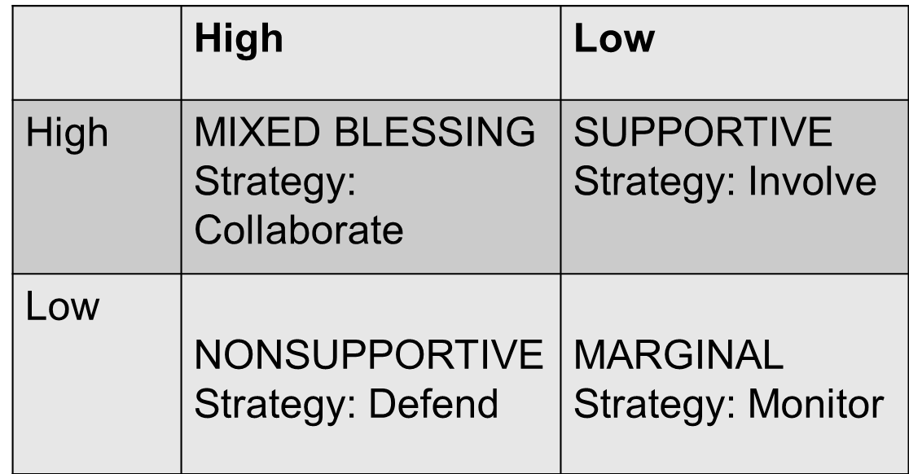
Potential Cooperation
Potential for Threat

Stakeholders with low strategic importance:
Buffering – satisfy needs and/ or demands of stakeholders.
STAKEHOLDERS WITH HIGH STRATEGIC IMPORTANCE:
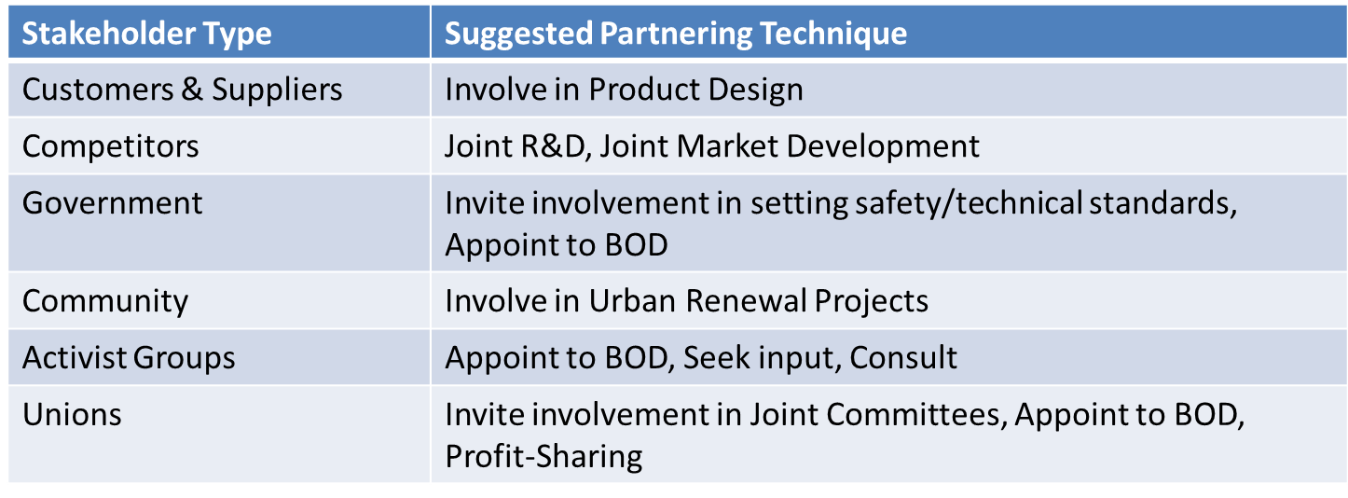

Stakeholders watch out for other stakeholders
- Environment does not watch out for itself
Stakeholders can move from supportive or marginal to non-supportive on behalf of/in defense of other stakeholders
- Defend the weak

Impact of demographics
Demography: Study of human populations
Importance:
- Powerful predictor of human behaviour/trends
- Certainty and simplicity of age data
- Change in relative proportions of age groups have significant impact on business environment
Understand demographics:
- Used to predict behavior
  - Size of cohort = # people in each age group
  - “Activity participation rate”
- Effect on size of cohort
  - Fertility rate – avg #children/women
  - Birth rate total # births/size of population
Canadian trends:
- Aging baby boomers most influential demographics force shaping marketplace
- Shrinking youth group
- Population proportionately older due to rise in life expectancy
Implications:
- Increased paid/ unpaid elder care
- Increased number of vulnerable seniors
  - Boom and echo
- Echo generation = children of boomers = relatively large group
- More disposable income because parents provide essentials
- Increasingly influence family purchases
Implications:
- Government policy and business opportunities to address the needs of boomers
- Market impact of echo
Changing households:
- One person houses growing faster than ever
  - Implications:
    - Lost economies of scale living, shoping, aging seniors living alone + smaller younger cohort.
- Majority no children in homes
- Single parent families increasing
Changing ethnic comp:
- Immigration increasing over past decade
- Immagrants are younger and more likely to live in city than average Candian
- Interacting with marketplace difficult
Implication: increase demand for multilingual support/services/goods
Geographic Distribution:
- Increasing urban concentrations: montreal, BC lower mainland + Vancouver, Calgary Edmonton
- Donut Efect
- Rural living in predominates ion Atlantoc Canada. Sas, Territories

Political Factors:
Elements:
- Laws, regulations
- Taxes
- Trade agreements or conditions
- Political system
- Political stability
Government can create incentives, constraints, or support/bail out when needed
Affects uncertainty, risk and constraints/costs faced by firm

Government influence on businesses
- Customers – buy products & services
- Competitor – Canada Post, CBC
- Regulator/law maker
  - Regulates business activity; influences tech standards
  - Purpose
    - Promotes competition – competition act(small business support)
    - Promotes innovation – IP rights
    - Promotes consumers
    - Achieve social goals
    - Protect environment
- Taxation agent
  - Collected by all three levels of government
  - Types – business, personal
  - Aproaches- progressive, regressive, restrictive
- Provider of incentives & finance assistance
  - Subsides, tax breaks, support services for all kinds of businesses
  - Bail outs
- Provider of essential services
  - Highways, armed forces, police & fire dept. hospitals, education

Intellectual property rights:
Legal rights that result from intellectual activity in the industrial, scientific, literary and artistic fields. Grants exclusivity to owner
Types:
- Patents
- Copyrights
- Trademarks

Why: Creates incentives to innovate and be unique by allowing you to benefit from your innovation/creation
  - Trademarks:
- A word, design, or combination of them. Used to identify goods, services of one person or organization
- Protection for 15 years; renewable
- Legislation = trade-marks Act
- Can be a symbol/shape and/ or words
  - Copyright
- Any original literary, dramatice musical or artistic work
- Copyright is from the moment it is created
- Owner is the creator
- Created while at work = owned by employer
  - Duration – life of owner =+ 50 years
- *does not cover ideas only the form in which they are expressed
- Done to receive credit for work and royalities
  - Patents
- Government grants that give inventors exclusive rights to their inventions
- Must be new, useful, and dhow igenuitty
- Can be a product, composition, aperatus, process, or improvement
- Protection = 20
- Provides protection, royalties, and allows others to benefit on your discovery
  - Details disclosed after 18 months

Know the way gov’t effects critical success factors

How businesses influence govt:
  - Lobbyists:
- Hired to represent company’s/group’s interest
- Lobbying Act – must register and follow rules
- Trade associations – small businesses/ individuals join and lobby as an industry lobby group
  - Collaboration with government/decision input
- CRTC consult with industry members
  - Advertising
- Corporations influence voters

  - Forms of ownership
- Traditional forms f ownership
  - Sole proprietorship
    - Owned and operated by one person
    - Business and owner = one legal entity
Advantages | Disadvantages
Ease of formation | Taxed as personal income (advantage if business has losses)
Fewer regulations | Unlimited liability
Complete control over profits and decisions | Lack of continuity
Government support (advice) | Limited managerial and financial resources
 | Difficult to obtain outside financing

  - Partnership
    - Two or more owners
Advantages | Disadvantages
Ease of formation – partnership agreement | Taxed as personal income (advantage if business has losses)
Few regulations | Unlimited liability *
More managerial and financial resources | Lack of continuity, difficult to transfer ownership
Government support (advice) | Difficult to obtain outside financing
Easier to borrow money | Shared profits and decisions - conflicts
    - Business & owner = one legal entity
    - General Partnership:
      - All partners have joint and several liability
        - Joint liability: together share liability
        - Several liability: 1 may be liable for all
    - Limited partnership:
      - Limited partners liability = investment
      - Limited partners cannot be active in management
  - Corporation
    - Separate entity from owners
    - Types
      - Public
      - Private
      - Crown
    - Interests represented by board of drirectors
      - Inside directors
      - Outside directors

- Private Corporations
  - Shares are not sold to public < 50 shareholders
  - Owner & business = separate entities in theory
Advantages | Disadvantages
Relatively flat tax rates, lower than public corp. & individual rates | Double taxation?
Limited liability? | Complexity of formation?
Continuity, ease of transferring ownership | Regulation?
Ease of raising money? | Lack of secrecy?
Can attract/afford experts?

- Public Corporations
  - Several Owners, shares publicly available
  - Business & owner = separate entities
Advantages | Disadvantages
Flat tax rates (may be lower than individual rates) | Double taxation
Limited liability | Cost and complexity of formation
Continuity, ease of transferring ownership | Regulation
Ease of raising money, unlimited shareholders | Lack of secrecy
Can attract/afford experts

- Other forms
  - Co operatives
*forms of ownership will change/mutate

International business
- Globalization – single interdependent system
- Forces
  - Greater awerness of benefits
  - Tech makes it easier, faster cheaper
  - Competitive pressure

Major marketplaces:
- Country categorization by income
  - High-income
  - Middle income
    - Upper middle income
    - Low income
  - Low income
- Geographic Clusters:
  - North America
  - Europe
  - Pacific Asia

Forms of competitive advantage
- Absolute advantage: cheaper/better than other countries
- Comparative advantage: better than other goods; lower opportunity cost
- National Competitive advantage – from 4 condtions:
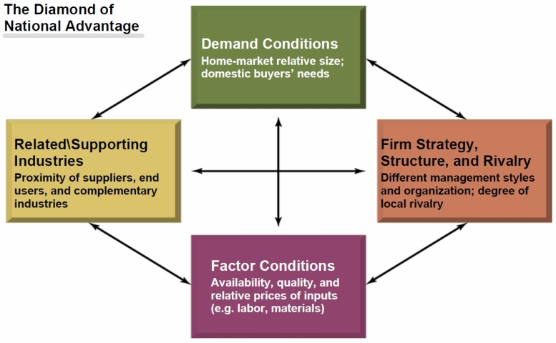

If “Yes” go international if “no” stay domestic

Barriers to international trade
- Social and cultural differences
  - Adapting to customer needs
- Economic differences
  - Exchange rates
- Legal and political differences
  - Quota, Tarrifs, Subsidies
  - Protectionism
  - Local content laws
  - Business practice laws – cartel and dumping
Over come trade barriers
- Gov’t support through free trade trearties:
  - GATT
  - WTO
  - EU-28 mems
  - NAFTA-3 mems
- Employing firm strategies for new market entry

Firm Strategies for entering foreign markets
Alliances with local firms withing a foreign country – overcomes social and economical but will the partnership work?
Establish a subsidiary within a foreign market
- Overcome Economic and political but is social known
Branch Offices: low risk
- Overcomes social but doesn’t help with political and economical
Local agents: overcomes Social with marketing know-how & low risk doesn’t help with economic or political
Liscensing: overcome social, economic, political but lwoe market control
- Connect everything to Critical success factors

Know how to connect new information to Critical Success Factors/ Diamond E/ Porters Five Forces.

Critical Success Factors:
- Achieving financial performance
- Quality products and services
- Customer needs
- Innovation / creativity
- Employee commitment
- Distinctive competitive advantage
Diamond E:
MORSE
- Managers
- Reasources
- Strategy -> enviroment
- Organization
Porters Five:
- Substitutes
- Entrants
- Suppliers
- Buyers
- Rivalry

