COMM 226– BUSINESS TECHNOLOGY MANAGEMENT

Ch. 1 Information Systems & You (E-MIS)

INFORMATION SYSTEMS
Information System: a group of components that interact to produce information.
- All information systems comprise a five-component framework of:
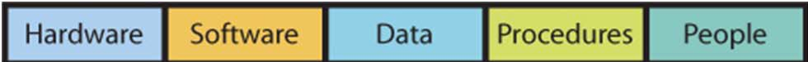
- Computer Hardware: the electrical components and associated gadgetry that constitute a computer system.
- Software: programs/applications that run or operate on computer systems.
- Data: the basic building blocks of information, i.e. facts & observations.
- Procedures: instructions or processes that one follows to achieve objectives.
- People: actors who want to achieve a particular outcome by interacting with the system.

MANAGEMENT INFORMATION SYSTEMS
Management Information Systems (MIS): comprises the development and use of information systems that help organizations achieve their goals and objectives.

- One must take an active role in order to ensure that system will meet their needs.
- Understand how they are constructed.
- Consider the user’s needs during development.
- Learn how to employ the system.
- Take into account other important functions like security, backup, & recovery.
- Information systems are used to help organizational actors achieve their goals and must be developed for the right reasons. Always ask: What is the purpose? How does this help us achieve our goals?

I.T. VS. I.S.
Information Technology (IT): represents raw technology components of I.S. and it only concerns hardware, software, and data components.
- I.T. refers to methods, inventions, standards, and products.
- I.T. can help an organization only when it is embedded into an I.S.
- I.T. must be combined with people and procedure components.

IMPORTANCE OF INFORMATION SYSTEMS IN THE ECONOMY
- The Information & Communications Technology sector includes companies involved in software & computer services, cable & other program distributors, telecommunication services, ICT manufacturing, and ICT wholesaling.

- Some of the basic IS are:
- E-Mail
- Web Pages
- Word Processors, Spreadsheets & PowerPoint
- Using Cell Phones
- Instant-Messaging & location-based services on their smart phones.
- To be effective in today’s economy, you need more than the basics. Business professionals need to expand their knowledge to include the following:
- Use of mobile devices and applications.
- Use of project-management software – Microsoft Project, OpenProject.
- Business graphics – MS Visio, SmartDraw.
- Collaborative systems such as Google Docs.

SHAPE OF THINGS TO COME
- Moore’s Law noted that the density of circuits on an integrated chip was doubling approximately every two years or so.
- This prediction has been generally accurate for more than 40 years.
- Moore’s Law is one of the few predictions in area of IT that has really stood the test of time.
- The cost of computers has declined over the past 55 years or, the same amount of money can buy increased computer capacity.

- David Ticoll suggested that within the next decade:
- Unlimited storage will be almost free.
- Analytical software will reveal hidden treasures.
- The real and virtual world will collide as wide-area networks become cheap, reliable, and widely available.
- These technology trends will enable deep, powerful, performance-enhancing innovations that will be felt in almost every industry.
________________________________________
Ch. 4 Hardware & Software (E-MIS)
HISTORY OF I.T.
- The first digital computing devices were invented in the 1940s.
- The first commercial computers were available in the 1950s and the first PCs in the 1980s.
Early Computers: 1939–1952
- Electronic Numerical Integrator And Computer
- It was very large, complex and expensive.
- Only a single user could operate and only one program run at a time.

Mainframes: 1952–Present
- First digital computers - large, room-sized devices.
- Mainly used by business and government.
- 1st generation: vacuum tube technology.
- 2nd generation: transistors.
- 3rd generation: operating systems & multiprocessing.

Microcomputers: 1975–Present
- Integrated circuits.
- Small microprocessors
- These microcomputers had monitors, keyboards, portable floppy disks and software.

Networking Personal Computers: 1985– Present
- Local Area Networks (LANs).
- Linking many personal computers together.
- Shared access to data, printers, and other peripheral devices.
- Wide Area Networks (WANs)– the Internet, email & web browsing.

Mobile & Tablet Computing: 1990s– Present

EVOLUTION OF TECH: WHAT’S IMPORTANT
- Price & Performance Advances
- Small is powerful: the 3 main components of the computer– the processor, the memory, & the storage, have all been getting smaller and costing less.
- Network is “The Thing”: the value of I.T. is also measured in the power of the network that can be accessed through the machine.

HARDWARE
Hardware: consists of electronic components and related gadgetry that input, process, output, and store data according to instructions encoded in computer programs or software.
- Basic hardware categories:
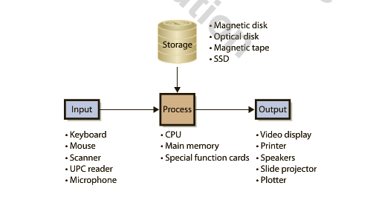
Input: keyboard, touchscreen, barcode scanner, microphones, & cameras.
Processing: CPU, which works with the RAM.
Output: display/monitor, printers, and speakers.
Storage: hard drive, optical disks, flash or solid-state device memory (SSD) i.e. USB, special function cards i.e. graphics or video cards.

COMPUTER DATA
Binary Digits (bits): used to represent data.
- Represented as either 0 or 1.
Sizing Computer Data: Computer data are represented in bits.
- Bits grouped in 8-bit chunks.
K Kilobyte 1,024 Bytes
MB Megabyte 1,024 K
GB Gigabyte 1,024 MB
TB Terabyte 1,024 TB

HOW A COMPUTER WORKS
CPU (Central Processing Unit): Transfers program or data from disk to main memory.
- Moves instruction from main memory via data channel or bus.
- Has small amount of very fast memory called cache.
- Keeps frequently used instructions.
- Large cache makes computer fast, but is expensive.

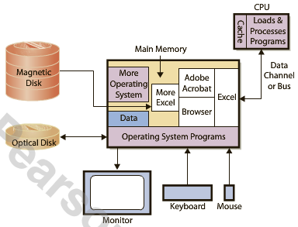

Memory Swapping: Main memory is too small to hold all data so the CPU loads programs into memory in chunks, places new program into unused memory and if none available, the operating system will remove the chunk being used and replace it with requested data.

- Cache & main memory are volatile. Magnetic & optical disks are not!

CLIENT VS. SERVER
- Client computers used for word processing, spreadsheets, & database access.
- Connect to servers for Web, e-mail, & database.
- Servers provide service and are faster, larger, & more powerful than client computers.
Cloud Computing: Similar to the concept of servers that supply applications and data, i.e. Google Docs.
Computer Software– two types:
1. Operating System (OS): program that controls computer’s resources.
2. Application Programs: perform specific user tasks.
- Constraints: a particular version of an operating system is written for a particular type of hardware. Application programs are written to use a particular operating system.

FOUR MAJOR OPERATING SYSTEMS
Windows
- Used by 85% of the world’s desktops  95% of business users.
- Current version is Windows Vista
Mac OS
- Apple Computer, Inc. developed for Macintosh computers.
- Easy-to-use interfaces. Used primarily by graphic artists and art community.
- Current version is Mac OS X
Unix
- Developed by Bell Labs.
- Workhorse of scientific and engineering community.
- Sun Microsystems is a major vendor of computers employing this operating system.
Linux
- A version of Unix.
- Developed by open-source community.
- This community is a loosely coupled group of programmers.
- Volunteers - contribute code to develop and maintain Linux.
- IBM is a primary proponent.

APPLICATION SOFTWARE
- Application Software consists of programs that perform a business function.
- Some are general purpose, i.e. Excel or Word.
- Some are specific, i.e. QuickBook– an application program that provides general ledger and other accounting functions.
- Types:
Horizontal-Market Application Software: Provides capabilities common across all organizations and industries, i.e. Word, Excel, PowerPoint, Acrobat, Photoshop, Paint Shop Pro.
Vertical-Market Application Software: Serves the need of a specific industry and usually altered or customized, i.e. appointment scheduling software, tracking system for mechanics.
One-Of-A-Kind Application Software: Designed for a specific, unique need, i.e. IRS software.
Other (Dual-Category) Application Software: CRM software

FIRMWARE & UTILITY SOFTWARE
Firmware: Computer software installed into devices, i.e. printers, print servers, and other communication devices.
- Coded like other software but installed into read-only memory.
- It becomes part of device’s memory and can be changed or upgraded.
Basic Input/Output System (BIOS): Used when a computer is initially booted up.
- Required because all volatile memory is lost when the computer is shut down.

THIN & THICK CLIENT
- The terms thin and thick refer to the amount of code that must run on the client computer.
- An application that requires nothing more than a browser on the client is called a thin client.
- An application such as Microsoft Outlook that requires programs other than a browser on the user’s computer is called a thick client.
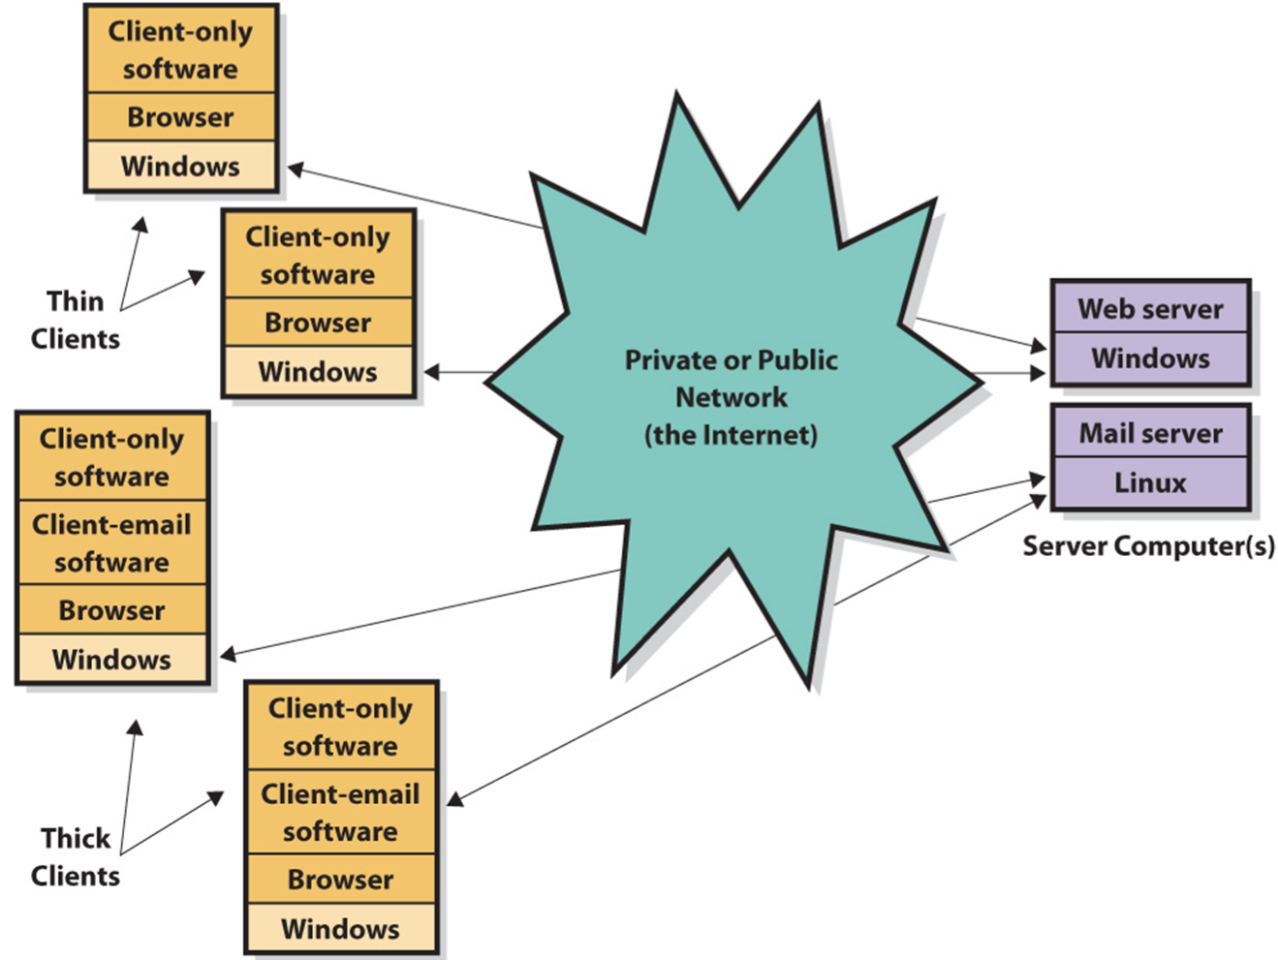

MANAGEMENT’S CONSIDERATIONS
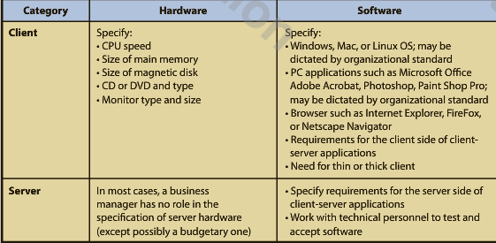
VIRUSES, WORMS & ZOMBIES
Virus: Computer program that replicates itself, consuming computer resources.
- Payload is a program code that causes unwanted activity. It can delete programs or data.
Macro Viruses: Attached themselves to various types of documents and when the document is opened, the virus is placed in startup files of the application. Thereafter, the virus infects every file the application creates or processes.
Worm: A virus that propagates using Internet or network.
- It spreads faster than other viruses.
- Specifically programmed to spread.
Zombies: Subsequent computers infected with worm or virus.
Botnet is a compromised machine; a set of computers and applications that are coordinated through a network and used to perform malicious tasks undetected.
________________________________________
Ch. 3 Productivity, Innovation, & Strategy (E-MIS)
IMPORTANCE OF PRODUCTIVITY & INNOVATION
Productivity/Labor Productivity: the ratio of the Canadian gross domestic product (GDP) over the total paid hours worked by Canadians.
- It measures the value that Canadian workers generate per hour.
- The Conference Board of Canada has suggested that labor productivity is the primary indicator of our per capita income.

- Increasing productivity in tour current global environment is about working smarter.
- Most experts agree that to enhance productivity, Canada must foster a culture of innovation, open its industries to more competition, and increase the amount of machinery & equipment (particularly in the ICT Sector) in the economy.

How does IT add to productivity– how can it be used to create business value?
- Productivity – IT allows a company to make either more output from the same inputs, and/or to make better output and/or to make the output faster than before the technology.
- Structure of competition – IT can alter the way corporations compete.
- Benefits to the End customer – IT helps make processes more efficient and changes the nature of the competition. Consumer may see cheaper and better goods and services.

BUSINESS TECHNOLOGY MANAGEMENT
- The ICT industry sector is an important industry for productivity and innovation because it includes technologies that can enhance individual and organizational productivity.
- The need for students with combined technology and business skills has increased the need for educational programs combine tech and business training.
- The Canadian Coalition for Tomorrow’s ICT Skills (CCICT) was founded by Bell for this purpose.
- BTM programs include a variety of course topics, such as:

- Business and technical training
- Financial accounting
- System analysis and design
- Project management
- IT infrastructure
- Marketing
- International business management
- Writing and business communication
- Organizational behavior
- Teamwork skills.

- BTM programs are designed for students who are inspired to use technology to change the way the world does business.

HOW I.T. HELPS IMPROVE PRODUCTIVITY
- Increasing efficiency means that business processes can be accomplished either more quickly or with fewer resources and facilities (or both).
- “Doing things right.”
- Increased effectiveness means that the company considers offering either new or improved goods or services that the customer values.
- “Doing the right things.”

BUSINESS PROCESSES & VALUE CHAINS
Value Chain: a network of activities that improve the effectiveness (or value) of a good/service.
- It is therefore made up of many business processes.
- There are two types of activities that support value chains:
1. Primary Activities: activities where value is added directly to the product, i.e. shipping the raw materials for a product.
2. Support Activities: activities that do not necessarily add value directly to the product but are instrumental in helping the primary activities along, i.e. scheduling for shipment of raw materials.

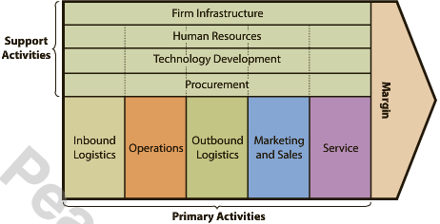
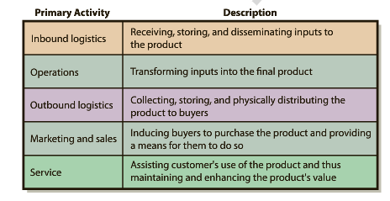

- Value chains help to understand how information systems increase productivity and enable the development of more efficient or more effective supporting activities.
- Information systems increase productivity by offering new and improved services.
ORGANIZATIONAL STRATEGY & INDUSTRY STRUCTURE
- Organizational Strategy reflects an organization’s goals and objectives.
- The strategy is influenced by the competitive structure of the company’s industry.
- It establishes the structure, features, and functions of information systems.
- There are five forces that determine industry structure:
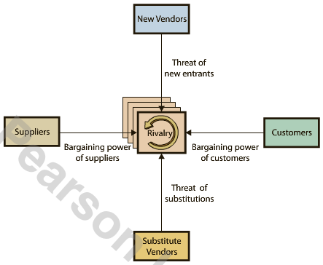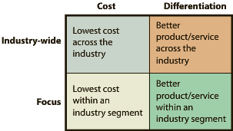
Porter’s Model of Industry Structure Porter’s Four Competitive Strategies

- The intensity of each of the five forces determines the characteristics of the industry, how profitable it is, and how sustainable that profitability will be.
- An organization responds to the structure of its industry by choosing a competitive strategy.

- Porter identified four competitive strategies:
1. Cost leadership across industry
2. Cost leadership focused on particular industry segment
3. Differentiation across industry
4. Differentiation focused on particular industry segment
- Porter says goals, objectives, culture, and activities must be consistent with strategy.

INNOVATION & INFORMATION TECHNOLOGY
- Changes to industry structure often occur through innovation.
- Bower and Christensen suggested two general types of technology innovations:
Sustaining Technologies: changes in technology that maintain the rate of improvement in customer value.
Disruptive Technologies: introduce a very new package of attributes to the accepted mainstream products.
- When a company gains a competitive advantage using a disruptive technology, the potential to alter the structure of an industry is created.
- Some times, the competitive advantage is so large it leads to a new industry altogether.
- One must also think about how quickly the innovation “catches on” in society or diffused through it.
- The theory of the diffusion of technology:
- Everett Rogers defined this theory.
- The process by which an innovation is communicated through certain channels over time among the members of a social system.
- Stages of diffusion of an innovation are: 1) Knowledge, 2) Persuasion, 3) Decision, 4) Implementation, & 5) Confirmation.

INFORMATION SYSTEMS & COMPETITIVE ADVANTAGE
Competitive Advantage Via Products:
Competitive Advantage Via Products:
- Organizations can gain a competitive advantage by implementing business systems.
- Locking in customers: high switching costs.
- Locking in suppliers: making it easy to connect to and work with organization.
- Create entry barriers: making it expensive for new competition to enter market.
- Establish alliances.
- Reducing costs.

Is competitive advantage through I.T. sustainable?
- It is almost impossible to keep competitors from developing competing technology.
- However, long-term competitive advantage lies not with the technology but rather in how a company and its people adopt the technology.
- Information Systems are the key to sustainable competitive advantage.
________________________________________
Ch. 5 Using I.S. to Improve Processes (PS&I, p. 130-155)

FUNDAMENTAL TYPES OF PROCESSES IN AN ORGANIZATION
Business Process: a sequence of activities for accomplishing a function.
Activity: tasks within a business process.
Resources: items necessary to accomplish an activity.
Actors: resources that are either human or computers.
Role: subset of activities in a business process performed by a particular actor.
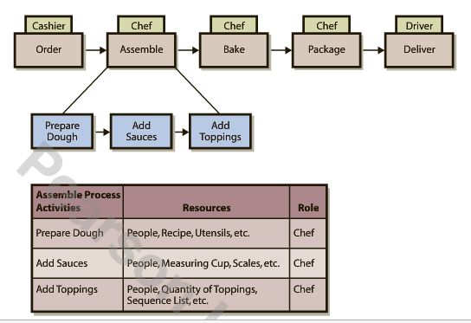
Scope of Processes
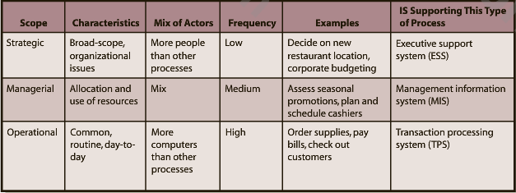

Objectives of Processes
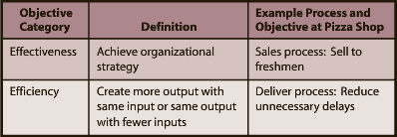

Processes Within a Value Chain
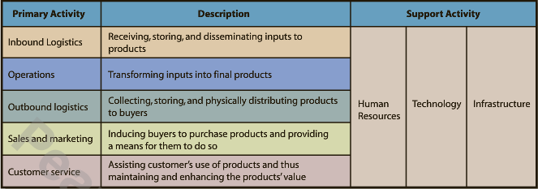

- A value chain is composed of five primary activities and several supporting activities.

Inbound Logistics Processes
- Processes include procurement, manage inventory, and evaluate potential suppliers.
- Procurement is an operational process that acquires goods and services.
Operations Processes
- Schedule the equipment, people, and facilities necessary to build/assemble a product/service.
Outbound Logistics Processes
- Collect, store, and distribute products to buyers.
Sales & Marketing Processes
- Find prospects and transform them into customers by selling them something.
Service Processes
- Providing after-sales support to enhance or maintain the value of a product.

Human Resource Processes
- Assess the motivations & skills of employees; create job positions; investigate employee complaints; and staff, train, & evaluate personnel.
Technology Development Processes
- Designing, testing, and developing technology in support of the primary activities.

Value Chain Activities and Processes
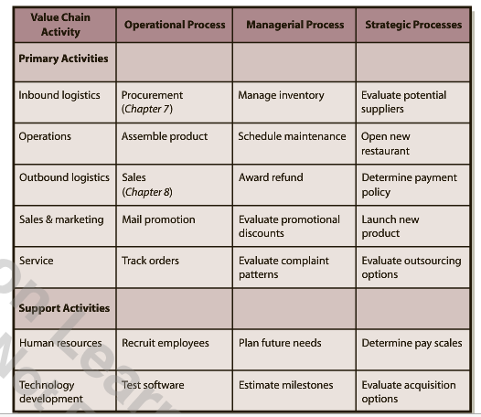

IMPROVING PROCESSES
- There are three fundamental steps in a process for improving processes:
- Objectives: specify & improve.
- Measures: specify & improve.
- IS: implement I.S. improvements.

Process Objectives
- Each process has one or more objectives, classified as either efficient or effective.
- Objectives must be explicitly stated and classified.
Process Measures
- Measures a.k.a. metrics are quantities assigned to attributes, i.e. elapsed time is a measure for the delivery process.
- Measures must be reasonable, accurate, & consistent.
I.S. Process Improvements
- Improve efficiency or effectiveness or activities, i.e. GPS improves delivery process.
- Provide linkages (impact of one activity on another) across activities, i.e. order display improves offsite delivery process.
- Improve control of the process.
Non-I.S. Process Improvements
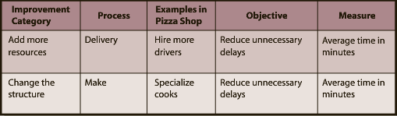

Six-Sigma
- The most common approach to process improvement.
- Seeks to improve process outputs by removing causes of defects & minimizing variability in the process.
- Gets its name from its goal that 99.99966% of process outputs will be free from defects.

Participants & Diagrams in Process Improvement
- Typically, the process includes the users who are the actors in the process, managers, and business analysts.
- Managers help by coordinating the changes, acquiring the necessary resources, and motivating participants.
- Business analysts contribute by understanding the fundamentals of process change and by creating diagrams of processes.
- Diagrams of the current process are called as-is diagrams.
- Diagrams of suggested improvements are called out-to-be diagrams.

I.S. & HINDERING PROCESSES
- An I.S. can also reduce process efficiency & effectiveness and limit its improvement.
- Storing data in multiple locations can hinder a process and make it difficult to improve.
- The key disadvantage is that the data become difficult to share.
Information Silos: a condition that exists when data are isolated in separated information systems or when data are duplicated in various files & databases.
- Because they operate in isolation from one another, they create islands of automation or information silos that can diminish the efficiency & effectiveness of a process & limit the opportunities to improve it.

S.O.A. & IMPROVING PROCESSES
- Service-Oriented Architecture helps solve the information silos problem.
- It is a new I.S. approach designed to make it easier to share data among process activities.
- S.O.A. enables the development of middleware– software that sits between two computer programs and facilitates inter-program communication & data sharing.
- S.O.A. is not a piece of hardware or software; it is a design philosophy.
- It is a design in which every activity is modeled as an encapsulated service and exchanges among those services are governed by standards.

Service– Repeatable task that a business needs to perform
Encapsulation– Hides data within containers so that services can communicate
Standards– Standardized formats for data exchange
________________________________________

Ch. 6 Supporting Processes with ERP Systems (PS&I, p.156-183)
SAP– a German multination software corporation that makes enterprise software to manage business operations and customer relations– realized that fiber optic cables & advances in database storage allowed them to create large, centralized, well-connected databases that spanned entire companies.

- The KEY to ERP systems is that data are consolidated in one central database.
- ERP systems help solve the information silo problem.
- Another solution is called Enterprise Application Interface (EAI).

ENTERPRISE APPLICATION INTERFACE (EAI)
- It provides layers of software that connect information systems together.
- It allows silos to communicate and share data with each other.
- It provides integrated data.
- Leverages existing systems, leaving departmental information systems as is, but providing an integration layer over the top.
- Converting to an EAI is not nearly as disruptive as converting to ERP and it can be less expensive, while providing many of the same benefits of an ERP.
- EAI is often a stepping-stone to an ERP.
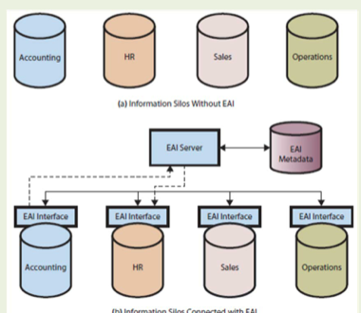

ENTERPRISE RESOURCE PLANNING (ERP)
- A suite of software, a database, procedures and a set of processes for supporting business operations with a single, consistent, information system.
- It integrates data and supports processes across departmental areas into a SINGLE database.
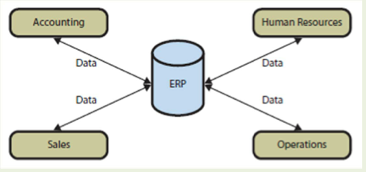

ELEMENTS OF AN ERP SYSTEM
- Current ERP systems are particularly strong in the areas in which they were first developed, such as manufacturing and supply processes.
- In the 1970s, businesses began to buy their own mainframe computers and manufacturing companies began to use software called:
Material Requirements Planning (MRP) to efficiently manage inventory, production, and labor.
Manufacturing Resource Planning (MRPII) was then developed adding financial-tracking capabilities as well as the opportunity to schedule equipment and facilities.

- Today, ERP systems include applications that integrate the processes in the following business functions:
- Supply Chain Management (SCM; procurement, sales order processing, inventory management, supplier management)
- Manufacturing (scheduling, capacity planning, quality control, bill of materials)
- Customer Relationship Management (CRM; sales prospecting, customer management, marketing, customer support)
- Human Resources (payroll, time & attendance, HR management, commission calculations, benefits administration)
- Accounting (general ledger, accounts receivable, accounts payable, cash management, fixed-asset accounting)

Five Components of an ERP System

– Software
– Hardware
– Databases
– Procedures
– People

Software
- Accomplishes interprocess data integration.
- It can be customized to meet customer requirements without changing program code– customization.

Databases
- ERP systems have extensive databases with over 25,000 tables.

Procedures
- IS procedures are instructions & methods for users to interact with the application.
- ERP vendors have developed training curricula to enable users to learn the system.
- Train the Trainer: vendors train the organization’s users to become in‐house trainers

Hardware
- Each ERP implementation requires a wide variety of hardware, i.e. disk storage, servers, clients, printers, scanners, network devices, and cables.
- ERP hardware dilemma: Should the firms allow individuals to user their private smartphones with installed company apps to interact with the ERP products or should they purchase company smartphones for its employees?

People
- There are 3 roles for the people involved with ERP systems:
- Users– employees of the firm implementing the system.
- Analysts– employees with specialized training that enables them to support, maintain, and adapt the system after it has been implemented.
- Consultants– helps budget, plain, train, configure, and implement the system.

Inherent Business Processes in ERP
- ERP systems also specify processes for the implementing organization called inherent processes (sometimes called process blueprints).

BENEFITS OF AN ERP SYSTEM
- An I.S. can improve a process by improving:
- Activities
- Links among activities
- Control of the process
- An ERP system also provides benefits to the organization as a whole, such as:
- Implements processes that are industry’s best practices.
- Data sharing occurs in real time.
- Management can be more insightful and provide better oversight.
- The information silo problem is solved.
CHALLENGES OF IMPLEMENTING AN ERP SYSTEM
- The process of converting an organization into an ERP-supported one is daunting & expensive.
- There are a lot of details involved in implementation decisions that an organization will have to face with an ERP system.
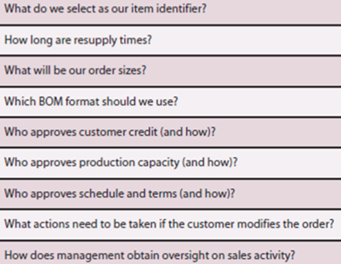
- In addition to the challenge of sorting through all these decisions, the actions & attitudes of the people in the implementing organization can make the situation even more challenging.
- People tend to resist change even when the benefits are well known.

TYPES OF ORGANIZATIONS & ERP
- Two important factors that influence whether an organization uses ERP systems are:

- Industry
- Size

ERP by Industry Type
- The first major companies were large manufacturers in the aerospace, automotive, industrial equipment, & other industries.
- Distribution, mining, materials extraction, medical care, government & public service, utilities, retail & education are among other examples.

ERP by Organization Size
- ERP solutions differ for companies depending on their size and subsequent needs.

International ERP
- One way the needs of large organizations do differ in character from those of small organizations is international presence.
- Most billion-dollar companies operate in many countries, and the ERP application programs must be available in many languages & currencies.

MAJOR ERP VENDORS

ERP Vendor Market Share
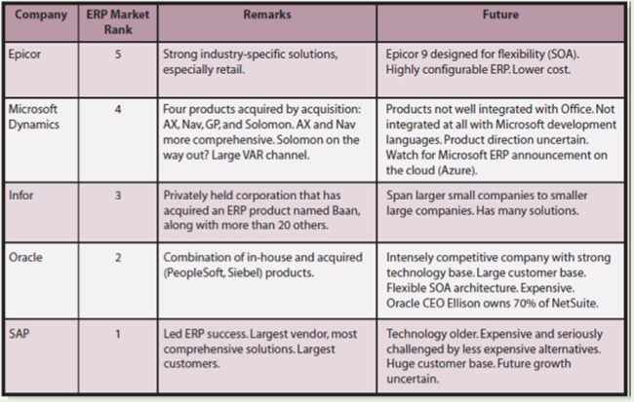

ERP Products

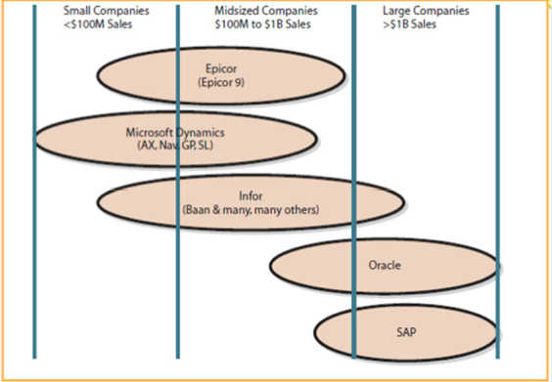

SAP VS. OTHER ERP PRODUCTS
- Systems, Applications, Products is a product of SAP AG, a German firm.
- It is the gold standard of ERP products.
- It is the third largest software company in the world.
- Over 80% of Fortune 500 companies use SAP.
- To speed up the configuration process, SAP produces & sells industry-specific platforms.
- A common way to view SAP is as a collection of interconnected & interdependent modules.
Module: a distinct & logical grouping of processes.
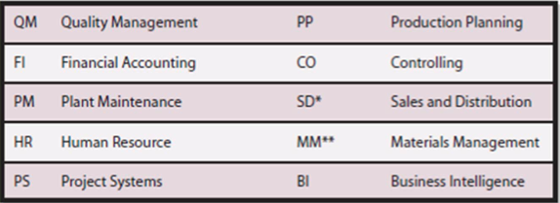

- Different roles in the organization give people access to different screens & different data.
- SAP software was the first ERP software designed to work at different companies.
- One of the more well-known versions of SAP is called R/3– the first truly integrated system that was able to support most of an organization’s major operational processes.
- R/3 has been rebranded as the SAP Business Suite, which runs on a program called an application platform.
- The SAP application platform is NetWeaver (like an OS)– it connects SAP to hardware.
________________________________________
Ch. 7 Supporting the Procurement Process with SAP (PS&I, p.184-211)
FUNDAMENTALS OF A PROCUREMENT PROCESS
Procurement: the process of obtaining foods & services, i.e. raw materials, spare parts, & cafeteria services.
- The 3 main procurement activities are:

- Order
- Receive
- Pay

- We consider the portion of procurement that supports the inbound logistics process in the value chain, where procurement obtains the raw material needed for subsequent assembly in the production process of the operations activity in the value chain.
*Note: Other value chain activities also develop & execute procurement processes to obtain things other than raw materials. i.e. legal services, machine parts, & transportation services.
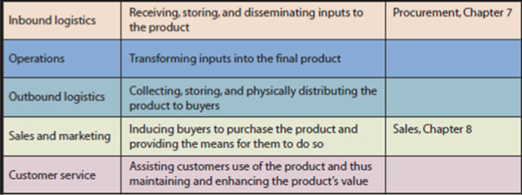

Example of the Procurement Process at CBI
- Six Roles: Two roles performed by people.
• Warehouse Manager and Accountant
– Four roles performed by separate computer applications with separate databases (DB)
• Sales DB, Purchase Order DB, Warehouse DB, & Accounting DB
- These resulted in information silos in addition to other inefficiencies.

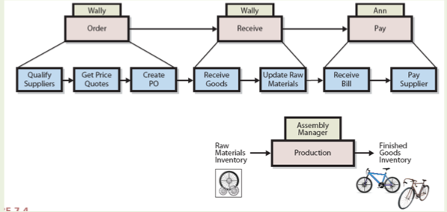

*Note: Before Accountants pay the bill, they make sure that data on the invoice matches the data in the purchase order & the goods receipt (three-way match).

PROBLEMS WITH PROCUREMENT PROCESS BEFORE SAP
Warehouse Problems
- Growth in finished goods inventory reduces warehouse space for raw material inventory.
- Warehouse manager does not have data on sales price discounts.

Accounting Problems
- Three-way match discrepancies take time to correct.
- Accounting data are not real time.

Purchasing Problems
- Purchasing agents not centralized, low training experience, and motivation difference.
- Weak internal controls lead to limited scrutiny of purchases.
Internal Control: limit the actions and behaviors of employees, processes, & systems within the organization to safeguard assets and to achieve objectives.

CBI IMPLEMENTATION OF SAP
- CBI had to reexamine & refocus their strategy.
- The strategy examination process has three activities:
- Determine industry structure.
- Commit to specific competitive strategy.
- Develop objectives & measures for processes to support the competitive strategy.

________________________________________

Appendix 7– SAP Procurement Tutorial (PS&I, p.212-227)

