Chapter 10: Externalities
Negative externality: any negative spillover cost stemming from a production activity that is imposed on a party other than the decision maker.
Decision maker does not face the external cost.
Example: a crack house operating next to a day care centre or a pulp and paper mill upstream from a fishery.
Positivity externality: any positive spillover benefit stemming from a production activity that is imposed on a party other than the decision marker,
The decision marker does not reap the external benefit.
Example: OC transpo and stores near the transit way.

Both positive and negative externalities cause market failure in the form of an inefficient level of output.
- Efficiency means that total surplus is maximized at the level of production.
- Equivalently, the marginal benefit, which is the consumers’ willingness to pay for the last unit, equals the supplies valuation of the last unit which is the cost of production.
- The implication is that in the presence of an externality, that efficient level of output is not attained.

Polution
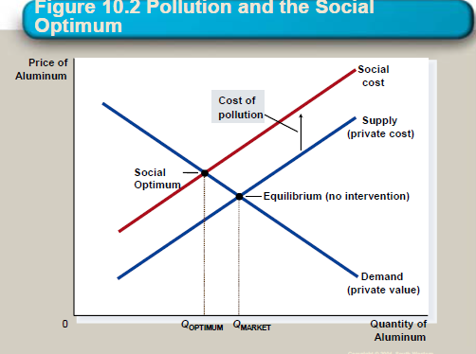
What is the optimal level of output for a polluting firm?
Typical the polluting firm produces something that is valued by consumers, so some output, and therefore some pollution as a by-product, should be produced.
The polluting firm doesn’t care the costs that t is imposing on others as these costs are external to its decision process. It makes its choices based on its own marginal benefit and the costs that is faces.
The costs that is imposes on others are included in the social cost (SC) of production.
SC = private cost (PC) + damages imposed on others
Because SC > PC (private cost) at the free market rate of output, the polluting firm is over producing from a social point of view.
The intersection of the demand curve and the social cost curve determines the optimal level. The socially optimal output level is lower than the market equilibrium quantity. From the point of view of society, we are over producing at the market level of output.
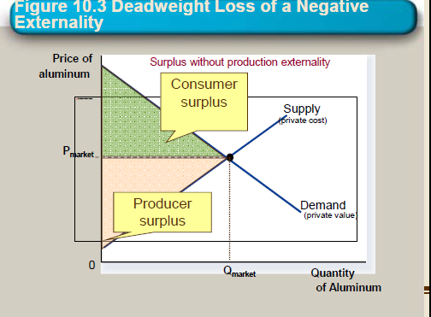
Calculation of deadweight loss
Deadweight loss is loss in total surplus stemming from the pollution.
It arises because we are producing at the market equilibrium rather than at the socially optimal equilibrium.

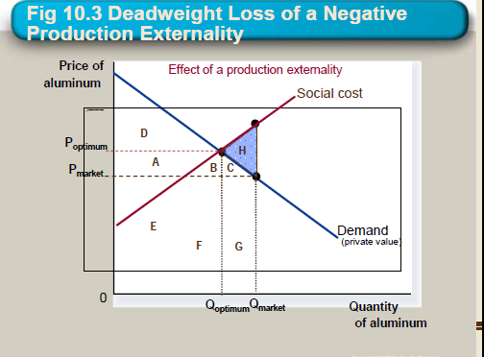
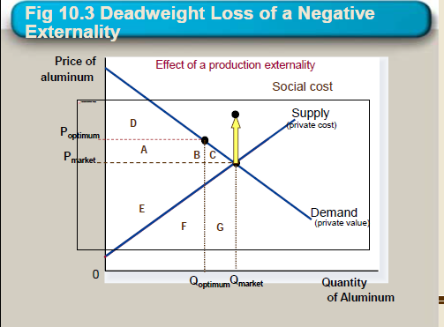
How to achieve the socially Optimal Output
- Decree by law that the level of output cannot exceed Q optimum
- The government can internalize an externality by imposing a tax on the producer to reduce the equilibrium quantity to the socially desirable quantity.
  - The polluters will take them into account when setting its output and how much it pollute
Pigovian Tax
A special tax that is often levied on companies that pollute the environment or create excess social costs, called negative externalities, through business practices.

Positive externalities
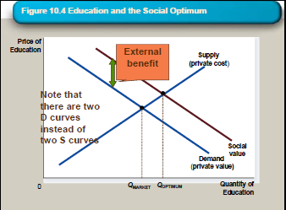
Whenever the production by one party benefits others a side effect; the social value of producing the good exceeds the private value.
Examples: technological spillover, subsiding higher education, subsiding arts.
The intersection of the supply curve and the social value curve determines the optimal output level.
The optimal output level is more than the equilibrium quantity.
The market produces a smaller quantity than is socially desirable because the producer does not reap the social benefits- only the private benefits.

Rectifying a positive externality
The opposite of a Pigovian tax is a Pigovian subsidy. It subsidizes the producer by the amount of the social benefit. As such, the externality will be internalized as the producer will consider the full benefits of production. The subsidy can be difficult to evaluate, as it is a subjective quantity.
Most subsidies granted in the real world are justified in part by a positive externality argument.
Industrial policy is government intervention in the economy that aims to promote technology-enhancing industries. (Widespread with political lobbying).
Private solution to externalities
- Merger of the enterprises (put the fishery could take over the pulp)
- Contracting between two enterprises (the fishery could bribe the pulp and paper mil into not polluting as much)
Public policies toward externalities
Command and control policies, or direct regulation, impose quotas on the production level of polluting firms.
Pigovian taxes and subsidies are essentially a tax on the right to pollute.
Tradable pollution permits. The government sets a rigid maximum amount of pollution that can be emitted. It then auctions these permits to pollute among firms.

