PSYCH 1X03
Prof: Joe Kim
Preferred To Be Addressed As: Dr. Kim
Office: PC 106
Office Hours: See website
Lectures: See schedule ; Web lectures
Tutorials: See schedule
TA:Micayla at micaylajean@gmail.com
Website: Avenue To Learn
Assessment: See course syllabus
Lecture Schedule: See course syllabus/website

Levels Of Analysis

Introducing Psychology
- The brain
- Sensation and perception
- Memory
- Language
- Animal behaviour
- Friendship and attraction
- Stress and health
- Child development
Common Goal: Understanding human thought and behaviour.
Psych teaches us how we think, feel, develop, learn, interact, and grow.
Psyche: soul
Logos: study of
Psychology’s Parents
- Philosophy’s Influence
  - Descartes proposed that the mind controlled the movements of the mechanical body and the mind in turn received info about the outside world through sense organs
- Physiology’s Influence
  - Muller studied the messages that nerves transmit and concluded it was coded as electrical impulses that travelled along different channels
  - Particular parts of the body are connected to specific areas of the brain to serve different functions
  - Experimentally supported by Flourens who used a technique to systematically destroy different regions of an animal’s brain to study its function
  - Learned which brain regions control heart rate, breathing, and processing of visual and auditory reflexes
  - Helmholtz measured the speed of the nerve impulse and found it to be 90 feet/second (much slower than electrical current flowing along a metal conductor)
Psychology As An Independent Field
Wilhelm Wundt
- 1879: Opened the first lab devoted to the study of psychology
- Believed that conscious experience could be studied using the same experimental tools that chemists/physicists use to study their research questions
- 1881: Launched first scientific journal devoted to publishing psychological research
- 1883: Hall (student) opened the first psychology lab in North America at John Hopkins University
- 1887: Established the first psychology journal in America
- 1892: Founded the American Psychological Association – world’s largest psychological organization with 150k+ members
- Lead to the development of other organizations such as the Association For Psychological Science
Looking Ahead
- Early focus of psychology was on the mind, with little attention paid to the brain
- Today we draw links between the brain and behaviour
- Modern approach draws on expertise from fields including physical, biological, chemical, social, mathematical, and computer sciences
Multiple Levels Of Analysis
- All psychology can be reduced to one question: What would an alien scientist observing human beings conclude about us?
- [1] Neuroscience
  - Reductionism: All human behaviour can be reduced to the biology of the brain
  - Our understanding of the brain is incomplete
  - Radio analogy: Understanding how the music comes out of a radio by taking the speaker apart and looking at the circuits
    - Understand how the speaker can generate sound
    - Where does the sound come from?
  - Francis Crick studied this
  - Early pioneers drilled through the skull to expose the brain
  - Modern techniques allow us to use less evasive procedures to look at the brain
    - X-rays/CT scans
    - Neuroimaging: Noninvasive method used to examine a subject’s brain while the subject is fully awake
      - Structural neuroimaging shows the physical makeup of the brain
        - Ex. Do men have a larger brain than women?
      - Functional neuroimaging shows what the brain is actually doing
        - Ex. Do men and women use the same areas of the brain to perform a particular task?
- [2] Learning
  - Pavlov’s bell/dog experiment
  - Cues and behaviour
  - Structuralism – to understand the structure of consciousness in its basic elements and how they’re related
  - Individuals were trained to observe their own experiences and report through a method called introspection
  - Functionalism – sought to understand the function of consciousness which needed to be studied as a stream
  - Argued that Structuralists were using unscientific methods and were missing the point by dissecting consciousness into individual elements
  - Behaviourism emerged
  - Watson (father of) is credited with formalizing the methodology of learning research
  - Overt behaviour is the only valid means of measure in psychology
  - Scientists should consider the mind to be an off limits “black box” that takes input and makes output
  - What happens in the “black box” is outside the domain of science
  - Focused on designing controlled experiments to understand the influence of environment on behaviour
  - Firmly believed in the role of the environment on determining behaviour
  - Favoured the influence of nurture over nature in determining human behaviour
  - BF Skinner believed one could learn everything about an organism by studying its behaviour
  - An organism will repeat a behaviour if it leads to something pleasant and vice versa
  - Formed the core of a therapy called behaviour modification
- [3] Cognition
  - Proper scientific methods can be used to study internal mental processes and is necessary to fully understand outputted behaviour
  - Studies the internal processes of the mind which includes thought, attention, memory, language, and problem-solving
  - The mind is an abstract concept that refers to all the conscious and unconscious processing that generates thought and behaviour
  - Uses models to construct representations of how the mind functions
  - Ex. Single Memory Model (single unlimited storage area where all memories are kept) – finding that would dispute this argument: it’s easy for someone to forget what they just learned as opposed to something they’ve known for years
  - Ex. More complex model: temporary short term memory processing permanent long term memory
  - Ex. Conduct experiments to test the model
  - Models provide a framework to describe data and generate testable questions
  - No “true” model of the mind, merely the best and most useful model at the given time
- [4] Social psychology
  - Study of how individuals are influenced by other people
  - [1] The influence of an individual on a group
  - [2] The influence of a group on an individual
  - [3] The influence of one group on another
  - Ex. How crowds react in an emergency situation
    - Artificial social situation in which there’s a perceived emergency
    - Manipulates variables such as the severity of the emergency and size of group
  - Ethical considerations: Distress and deception
    - May have to deceive people to create artificial social situations
    - Experiments must pass the standards of the McMaster Research Ethics Board (ethics committees)
    - Ex. Milgram Experiment in 1963 would not pass
- [5] Evolution
  - Evolutionary psychology: How behaviours develop over many generations
  - How genetic and environmental factors contribute to changes in behaviour across the history of a species
    - Ex. How are reproductive behaviours in men and women differently influenced by selective pressures?
- [6] Development
  - Developmental psychology: How behaviours develop over the lifespan
  - How genetic and environmental factors contribute to changes in behaviour across a lifespan
    - Ex. What factors determine the different rates of alcoholism in individuals and populations?
    - Ex. At what age can an infant tell people apart?
      - Habituation: Present pictures of one person repeatedly until the infant becomes bored and spends less time looking at the picture
      - Then present a new picture
      - If the infant shows renewed interest in the new picture, it suggests that the infant recognizes the image as a new image and vice versa
Methodological Case Study: Depression
- Depression is categorized by depressed mood and social withdrawal
- May lead to problems with thoughts and sleep
- [1] A Neuroscience Approach
  - Interested in the neural mechanisms of behaviour
  - May ask, “How do changes in the brain lead to depression?”
  - Involves understanding the physical and chemical changes in the brain
  - Identifying a potential drug treatment to reverse changes
  - Structural brain changes that occur in depressed people: hippocampal region of the brain is smaller in depressed patients compared to control subjects
  - Antidepressants target specific brain systems to reverse the brain chemistry abnormalities
- [2] A Learning Approach
  - Learned helplessness (inspired by animal research): subjects have learned through repeated trials that they’re unable to escape an unpleasant stimulus; the subject essentially learns that it’s “helpless” and doesn’t try to escape from similar situations in the future, even when there’s a clear course of action to avoid the unpleasant stimulus
  - People who are depressed may have learned in the past that their actions are ineffective for escaping their negative circumstances
- [3] A Cognitive Approach
  - Generates models of negative thought processes
  - Considers that depression is caused and maintained by maladaptive thought processes called negative schemas
  - Ex. Negative schema model of depression suggests that depressed individuals are inclined to interpret new info about the world more negatively than others
  - May ask, “What negative thoughts are driving depression and how can they be changed?”
  - Aaron Beck’s Cognitive Triad Theory: Depression is maintained by negative views of one’s self; the world; and the future (may lead to below)
  - Personalization: A process in which a person may believe that every bad thing that happens is somehow their fault
- [4] A Social Psychological Approach
  - Considers the role that other people in a person’s life play in the development, maintenance, and treatment of depression
  - May ask, “How does a person’s relationship affect their depression?”
  - Ex. Someone being alienated from the group
- [5, 6] An Evolutionary/Developmental Approach
  - Interested in the development of depression across generations/across the lifespan
  - May ask, “How did a genetic predisposition for depression arise in an evolutionary context?”
  - May ask, “What genetic or environmental factors lead to depression?”
  - Marcello Spinella suggested that in a social species, depression increased peer support benefit an individual’s survival
  - Developmental psychologists argue that depression has a strong genetic component
    - If you have a parent who is depressed, you have a higher chance of being depressed
  - If identical twins were raised in different environments, one could become depressed while the other does not
    - Suggests that both genetic and environmental factors contribute to the development of depression

Research Methods 1

The Scientific Method
- Construct a theory
  - General set of ideas about the way the world works
- Generate a hypothesis
  - Testable statement guided by theories that make specific predictions about the relationship between variables
- Choose a research method
  - The way in which the hypothesis will be tested
- Collect data
  - Taking measurements of the outcomes of the test
- Analyze data
  - Understand the data and discover trends or relationships between the variables
- Report the findings
  - Publish articles in scholarly journals
- Revise existing theories
  - To include new info into our understanding of the world
Paradigm Shift: A dramatic change in our way of thinking (ex. 1543 – Copernicus challenged the existing dogma that the Earth was at the centre of the universe).
MegaStudy Drink
Theory: Test performance can be affected by external factors that occur while studying for the test.
Hypothesis: Students taking energy drink should show improved test performance when compared with students not drinking energy drinks
Anecdotal Evidence: Evidence gathered from others or self-experience.
Problems With A Makeshift Experiment:
- Single experience might not be representative
- Personal experience might not represent others
- Cannot be sure that result is due to energy drinks alone
Experiment: Scientific tool used to measure the effect of one variable on another.
Independent Variable: Variable manipulated by the scientist (ex. Energy drink).
Dependent Variable: Variable being observed by the scientist (ex. Test scores).
Control Groups: Used to measure the effect the independent variable has on its subjects. They are not given the experimental manipulation.
Potential Biases:
Within-Subjects Design: Manipulating the independent variable within each participant to minimize the effect of external variables on the dependent measure (ex. Eric becomes his own control group).
Practice Effect: Improved performance over the course of an experiment due to becoming more experienced (ex. The subject’s performance could improve over the course of an experiment, thus it becomes difficult to distinguish between a person’s natural improvement and the independent variable).
Between-Subjects Design: One group of participants receive experimental manipulation while another group acts as the control group.
Confounding Variable: A variable other than the independent variable that has an effect on the results.
Sampling: Results from very specific groups of participants cannot be generalized to other groups.
Population: The general group of people we are trying to learn about (ex. Undergrads @ Mac).
Sample: The selected members of the population that we actually collect data from (ex. 40 individuals).
Random Sampling: Best way to choose participants because this way we reduce the chance that our selections might be biased towards a specific group.
Random Assortment: Assigning participants to either the experimental or control group at random to avoid any biases that may cause differences between the groups of participants.
Placebo Effect: Occurs when an individual exhibits a response to a treatment that has no related therapeutic effect (ex. Patients showing recovery from illness when given drugs that were presented as “miracle cures” even when these drugs were known to have no effect).
Participant Bias: The above is a form of this, which can influence the results of the experiment.
Blinding: When participants don’t know which group they belong in.
Experimenter Bias: Actions made by the experimenter to promote the result they hope to achieve.
Double-Blinding: Neither the experimenter or participants know which group each participant belongs in.
Research Method: Using the between-subjects design and double-blinding.
Collecting Data: Having both groups write the test.

Research Methods 2

Descriptive Stats: Statistics allow us to summarize, interpret, and present the data we’ve collected.
Types Of Descriptive Stats
- [1] Measures Of Central Tendency
- Summary stats: mean, median, mode
- Histograms, bar graphs, pie charts, Venn diagrams
- Histogram: Type of graph used to report the number of times groups of values appear in a data set. The x-axis is divided into groups of values called bins. The y-axis measures the number of times that a value in the data set falls into a given bin, known as the frequency.
Frequency Distribution: Type of graph illustrating the distribution of how frequent values appear in the data set. A histogram is often used as a base to create this.
Normal Distribution: A distribution with a characteristic smooth, bell, and symmetrical shaped curve around a single peak.
Measure Of Central Tendency (Mean/Average): Tells us where a data set is centred. It cannot tell us how the other values fall around that point.
Outliers: Extreme points distant from others in a data set. The mean is very susceptible to influence by outliers.
Median: The centre value in a data set when the set is arranged numerically. It cannot be pulled in one direction by an outlier.
Mode: The value that appears most frequent in the set. It tells us the most typical response when looking at a data set, and is the only one of the stats that can be used for non-numerical data sets (ex. Most popular ice cream flavour).
- [2] Measures Of Variability
- Smaller spread = smaller standard deviation
- Larger spread = larger standard deviation
- The standard deviation of a set is the measure of the average distance of each data point from the mean
Measure Of Variability: Review the spread and distribution of a data set.
Inferential Statistics
How big must the observed difference be between the groups to be considered an important finding?
Inferential Stats: Allow us to use results from samples to make inferences about overall, underlying populations.
T-Test: A basic inferential stats technique used to compare the difference between the data from the control and experimental group. It is a statistical test that considers each data point from both groups to calc the probability of getting the results by chance if there is in fact only one distribution underlying both groups in the experiment.
P-Value: A value expressing the probability calculated by the t-test.
Statistically Significant: If the resulting p-value is less than 0.05. There is less than 5% probability to obtain the data by chance. In other words, we are 95% confident that a difference between the two groups exists.
Statistical Significance: When the difference between the two groups is due to a true difference between the properties of the two groups and not due to a random variation.
Analyzing Data: Eric gets a p-value of 0.44, which is too high for him to conclude that his hypothesis was correct.
Observational Research
Observational Studies: Scientists observe the effect of variables they’re interested in without performing any manipulation (ex. When scientists cannot perform an experiment due to ethical concerns).
Correlation: A measure of the strength of the relationship between two variables (ex. When a scientist conducting an observational study finds that two variables are related to each other, we say that these variables are correlated).
Perfect Positive Correlation: r=1
Perfect Negative Correlation: r=-1
Correlation Coefficient: Measures the degree with which two variables are correlated and is symbolized by the letter r. If r is close to 0, then it indicates that there is no relationship existing between the two variables.
- Correlation =/= causation

Classical Conditioning 1

Types Of Learning
- Classification by the learning processes in general (the forming of contingencies)
- The learning that is happening within the brain is not a process that is consciously chosen to be experienced
- Behaviour is changed/shaped by the learning processes

- Conscious
- Unconscious
  - Classical conditioning (Pavlovian conditioning)
    - Allows us to associated two related events
    - Involves involuntary/subconsciously driven behaviour (ex. Vomiting, fear)
    - Type of behaviour that learning is applied towards: involuntary, subconscious
  - Instrumental conditioning
    - Allows us to associate actions and consequences
    - Involves voluntary/consciously controlled behaviour (ex. Choosing to be polite, dogs learning tricks)
    - Type of behaviour that learning is applied towards: voluntary, conscious
Ivan Pavlov
- Created the foundation for classical conditioning
- Experiment: Metronome sound would signal food for the dog
  - Interested in the stages of digestion
  - Dogs would salivate before the delivery of food in their mouth
  - Early step in process of digestion was triggered before food stimulus arrived
  - Prior to training, the sound had no effect on the dog
  - After training, the dog would salivate in response to the sound alone
  - This behaviour is called a conditional reflex
- Contingent Relationship: The presentation of one stimulus reliably leads to the presentation of another.
  - An organism can respond to the signal before the event occurs
  - Can promote survival (ex. Salivating before the food arrives makes digestion more efficient)
- A contingency has been formed between the two stimuli when an organism learns the association between a signal (metronome sound) and an event (food)
Classical Conditioning: The learning of contingency between a particular signal and a later event that are paired in time and/or space (ex. Imagining a juicy lemon will make humans salivate for two purposes: to neutralize the citric acid and prepare the body for digestion because we have learned a contingency between the sight of a lemon and the act of citric acid meeting in your mouth from past experiences).
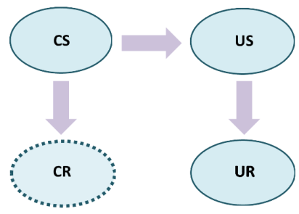
Unconditioned Stimulus (US): Any stimulus or event that occurs naturally prior to learning, which triggers a response.
Unconditioned Response (UR): Response that occurs after the US and occurs naturally prior to learning (ex. Often a biologically programmed reflex or natural response).
Conditioned Stimulus (CS): Paired with the US to produce a learned contingency.
- It’s a previously neutral stimulus, that after becoming associated with a US, eventually comes to trigger a response on its own
- CS typically appears before the US and may take several trials of training in which the CS and US are paired before the CS alone triggers a response
Conditioned Response (CR):Response that occurs once the contingency between the CS and US has been learned.
- Often similar to the UR
- Ex. When CR differs from UR
- CS is the airplane food
- US is the rotten food
- CR is avoiding the airplane food
- UR is vomiting

Example 1
- CS is the sound of the metronome
- US is the food in the dog’s mouth
- CR is salivation
- UR is salivation
Example 2
- CS is repeated images of a lemon
- US is past experience with citrus foods
- CR is salivation
- UR is salivation

Acquisition (In CC): Process by which a contingency between a CS and an US is learned.
- A negatively accelerated increasing function with CR on the y-axis and trial #s on the x-axis
- Most of the learning occurs in the earliest trials
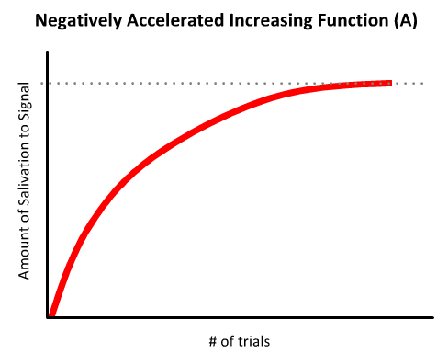
Rats
- Acquisition takes one trial
- Developed special learning mechs for food selection to help survival:
- [1] Dietary neophobia: avoid unfamiliar foods
- [2] Consume small quantities
- Can pinpoint a specific food with illness
- Learns contingency between food and sickness in one trial
- CS is taste
- US is sickness
- CR is aversion
- UR is aversion
- The rat will show a strong aversion response before the sickness ever occurs due to this contingency
Extinction (In CC): The loss of CR when the CS no longer predicts the US (ex. Presenting the dog with a metronome and no food).
Case 1: Previously learned contingency is unlearned
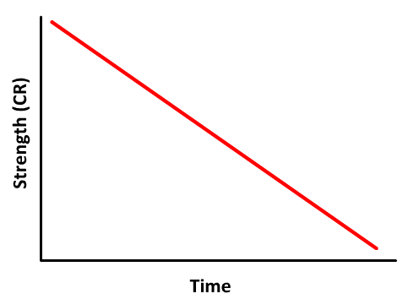
- Strength (CR) is steadily decreasing over time
- Following extinction, retraining between the CS and US would lead to acquisition of the CR at the same rate as the original training
Case 2: Old learned contingency remains, which competes with a new inhibitory response that is learned to the CS
- Following extinction, learning of an inhibitory response to the CS suggests that there exists two learned processes
- [1] Original learned response to the CS
- [2] New inhibitory learned response to the CS
- Retraining between the CS and US would occur at a faster rate compared to original training
Spontaneous Recovery
- Suggests that extinction involves a new inhibitory learned response
- The CR gradually fades following an extinction procedure
- Following a rest period, the CS is presented again, and it once again elicits a CR
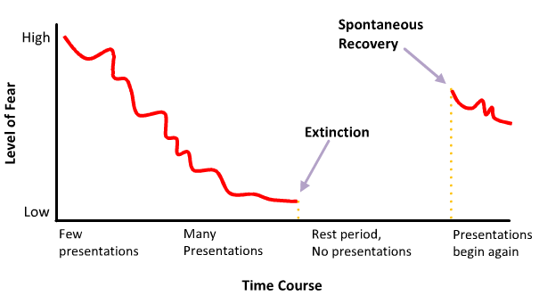

Classical Conditioning 2

Stimulus Generalization: A process in classical conditioning of learned responses to a variety of different stimuli (ex. Stimuli similar to the CS will often produce a CR).
- Ex. Pairing a 500 Hz tone with an electrical shock
- Once the contingency has been established, we can test for stimulus generalization by presenting various tones and measuring the fear CR
- A normal distribution is observed
- Strongest CR is elicited by the original 500 Hz
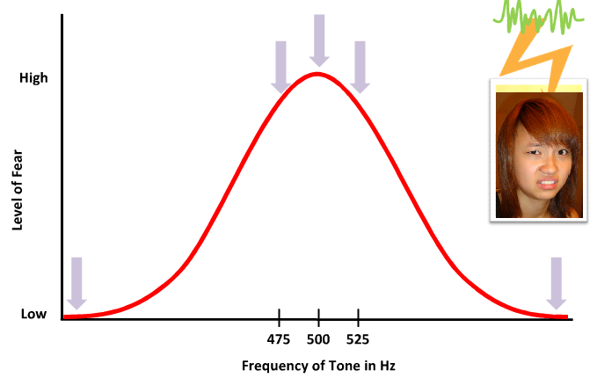
Stimulus Discrimination (In CC): Narrows the range of CS that can elicit a CR.
- Ex. Continually presenting Amanda with the 500 Hz tone and no shock
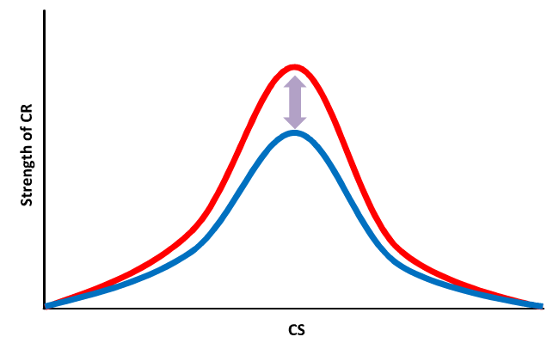
- Ex. Presenting Amanda with tone frequencies at the far ends of the graph with no shock
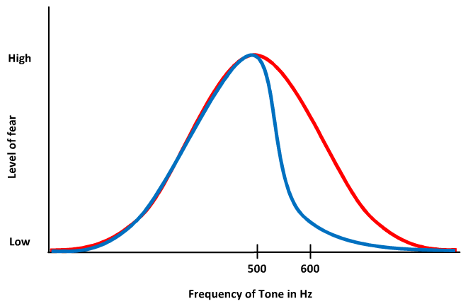
- Ex. Eliminating Amanda’s fear of 600 Hz tones while maintaining her fear of 500 Hz tones by repeatedly presenting a 600 Hz tone in the absence of the electrical shock
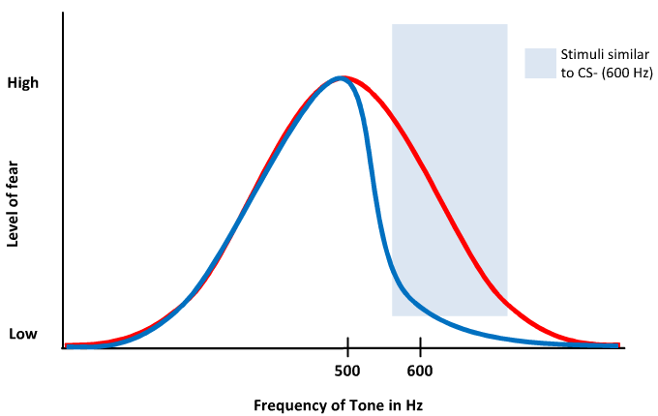
- CS- predicts the absence of shock
- CS+ predicts the presence of shock
- Presenting the 600 Hz tone in the absence of shock with alternating trials of presenting the 500 Hz tone in the presence of shock will achieve a precise discrimination in which the fear response is pinpointed to the 500 Hz tone
Learning About Absences/Presences
- Ex. Presenting a CS+ of 500 Hz with a CS- of 600 Hz will cause Amanda to show an intermediate fear response (somewhere between the two cues)
- Explain how classical conditioning help:
  - [1] Antelopes forage on a grassy savannah plain
  - [2] Commuters dodge traffic on a busy street
build complex responses that allow adaptive interactions with the environment
Phobia Treatment
Phobia: Exaggerated, intense, and persistent fear of certain situations, activities, things, or people (ex. Claustrophobia).
Implosive Therapy: CS is presented in the absence of the associated US and the individual is encouraged to confront the fear CS (ex. An individual with a particular phobia is encouraged to confront the fear CS that evokes their anxiety).
- Ex. Someone with a germ phobia will be asked to sit with their hands covered in dirt for as long as possible
- Could be a traumatic experience for the individual
Systematic Desensitization:A gradual exposure to the feared CS by starting with extinguishing a CS at the ends of the generalization gradient.
- Ex. From the previous example, the individual will be asked to sit with their hands covered in confetti instead
- More acceptable to patients
Other Conditioning Therapies
- Ex. An alcoholic may be given a drug treatment in which Antabuse is placed in their drinks
- This gives them extreme nausea in hopes that they will associate this sickness with drinking and cease to drink in the future
Homeostasis: A process in which the body is actively regulating its core temperature, glucose and ion levels, and numerous other processes within strict parameters.
- Made more efficient through classical conditioning
Compensatory Response: A process which counteracts a challenge to homeostasis (ex. Release of insulin).
- Ex. You drink a sugary beverage
- Shortly after, blood glucose levels rise and insulin is released into the bloodstream to take up excess glucose to be stored
- This process regulates blood glucose levels and maintains homeostasis
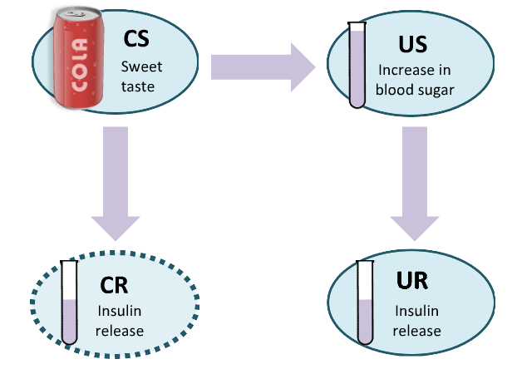
Addictions
- Ex. Morphine is used to decrease pain and respiration
- After many drug-taking trials, a contingency will form between the CS of the environment and the US of the drug effects
- A presentation of the environmental cues will trigger the CR
- Therefore, a morphine addict with an empty syringe will experience nausea and pain (opposite normal drug effect)
Drug Tolerance:A drug’s effect will decrease over repeated drug exposure.
- Drug tolerance is a reflection of the UR and the CR that counteract the drug effects
- Each drug-taking trial increases the strength of the CR
- Drugs taken in a novel environment means that the drug effects are only countered by the natural UR, which could lead to an overdose
- Withdrawal is expressed as an unopposed CR
- Relapse may occur when the individual is exposed to previous environmental cues

Instrumental Conditioning 1

Instrumental Conditioning: The learning of a contingency between behaviour and consequence (ex. Touching a hot stove will burn).
- Proceeds best when the consequence immediately follows the response
Edward Thorndike
- Studied cats in a puzzle box
- Measured the time it took the cat to learn to open the door by pulling the string
- Put the focus on overt behaviour rather than on mental elements
- Puzzle box was a small chamber with a door that could be opened by performing a specific behaviour (ex. Pulling a rope)
- Outside the box was a dish of food used as motivation for the cat to escape
- Predicted that the cat would first engage in random behaviour as they tried to escape
- Trials following the discovery of the correct solution would lead to a dramatic step down in time to escape
- Discovered that the frequency of random behaviours gradually decreased over time
- Suggested that animals followed a simple stimulus-response type process (long trial-and-error process of discovery) unlike humans
- Stamping In/Out: A process which determines whether a behaviour was maintained or eliminated (ex. Pulling the rope was stamped in because it was followed by the favourable consequence of access to food).
Law Of Effect:Behaviours with positive consequences are stamped in and those with negative consequences are stamped out.
Four Consequences
- To define the satisfying/annoying states, which determine the frequency of a behaviour
- Reinforcer: Any stimulus, which, when presented after a response, leads to a change in the rate of that response.
- [1] Presenting a positive reinforcer
- [2] Removing a positive reinforcer
- [3] Presenting a negative reinforcer
- [4] Removing a negative reinforcer
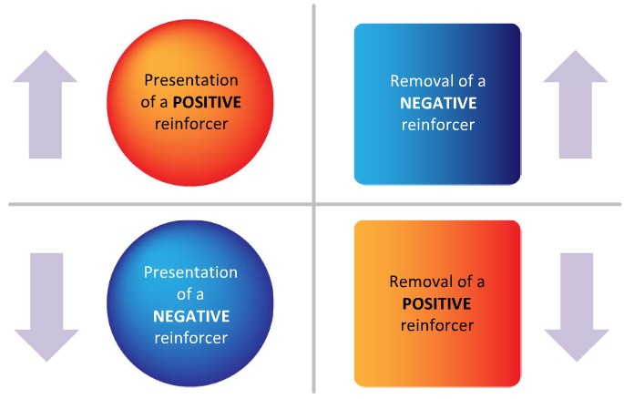
Stamped Out
Stamped In
Stamped In
Stamped Out
Reward Training: Presentation of a positive reinforcer following a response (ex. Give Amanda 30k NX every time she does her math homework <3).
- Behaviour is likely to increase
Punishment Training: Presentation of a negative reinforcer following a response (ex. KSing someone in MS leads to auto mesos loss).
- Behaviour is likely to decrease
- Controversial issue and must consider ethics of experiencing pain/fear
- Skinner believed that when using punishments, a contingency may be formed between the authority figure and pain (thus damaging a parent-child relationship)
Omission Training: Removal of a positive reinforcer following a response, which leads to a decrease in the behaviourbeing reinforced (ex. Amanda loves playing MS and teasing Sumit so every time she teases him, her mother turns the game off for half an hour).
- Situation that wants to be avoided
- The game (MS) is a positive reinforcer and removing it will likely cause Amanda to stop picking on Sumit
Escape Training: Removal of a negative reinforcer following a response.
- A constant negative reinforcer that the learner is motivated to have removed
- By performing a specific response, the negative reinforcer can be removed, which leads to an increase in the target behaviour
- Ex. Amanda is a grumpy landlord with very sensitive hearing and lives below a tenant, Sumit, playing music in her apartment. She hits the ceiling with a broom and the music stops. Amanda has learned that she can avoid the loud music (negative reinforcer) by hitting the ceiling (specific response).
Conclusion
- Ex. Using punishment to train Sumit to stop using his right hand
- He receives a shock every time he uses his right hand
- Task would be made difficult if there was a long period between the response of using his right hand and the consequence of receiving a shock
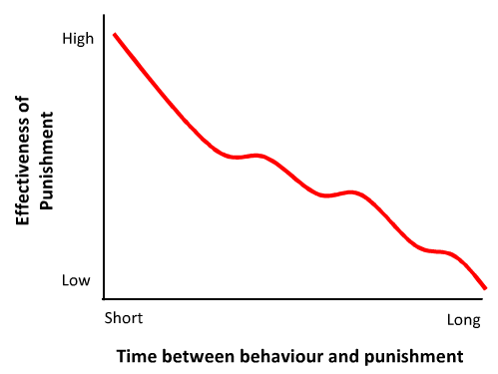
Acquisition (In IC):Learning the contingency between a response and its consequences.
- Psychologists are often interested in measuring the rate of responding of the new behaviour
Graphing Responses
- Ex. Result of reward training
- Flat horizontal line indicates when the subject isn’t responding
- Upward slope indicates a response has been made
- Pattern of responding depends on the complexity of the behaviour, type of reinforcement used, and the subject
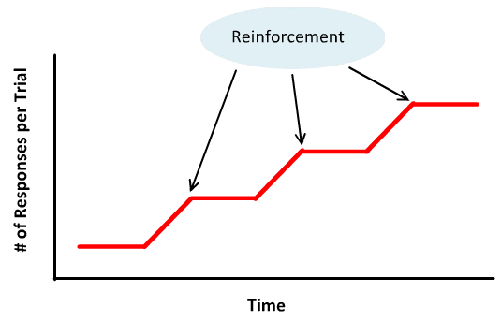
Autoshaping: A contingency formed between a behaviour and a consequence without explicit training guided by a researcher (ex. A pigeon will learn to peck at a keyhole for grains of seed on its own).
Shaping By Successive Approximation: A technique that organizes complex behaviour into smaller steps and gradually builds up to the full response we hope to condition (ex. If a squirrel can waterski across a pool, he’ll receive a food pellet).
- Each step can be reinforced through reward training
- Used extensively by animal trainers
Skinner And Pigeons
- Taught pigeons to play ping pong
- Broke down the complex response into successive components
- [1] Peck at the ping pong table to receive food
- [2] Peck a stationary ball
- [3] Peck a moving ball
- [4] Peck ball across table

Instrumental Conditioning 2

Discriminative Stimulus: Signals when a contingency between a particular response and reinforcement is valid/invalid.
- Ex. Pigeon learns to peck a keyhole to receive food and above the keyhole is a light
- A green light means that the contingent relationship is valid
- A red light means that the contingent relationship is invalid
- SD green light
- S-delta (Sδ) red light
- SD = response = reinforcement
- S-delta (Sδ) = response =/= reinforcement
SD Generalization Gradient: A graph of the range of responses to the SD.
- Ex. Amanda has learned a contingency between polite behaviour and reward
- SD is the presence of the parents
- If Amanda behaves politely around her parents, she’ll be praised and given att’n
- Generalization can occur with her displaying politeness to other adults and authority figures, but less politeness to her peers
Extinction (In IC)
- Ex. Jeff’s polite behaviours have always been rewarded by his parents with praise and att’n
- One time, however, his parents were busy and his politeness (and charisma, hehe) went unnoticed
- This creates an extinction process that may lead Jeff to stop responding with his polite behaviour
Discrimination (In IC)
- Ex. One summer, Jeff visits his grandparents who are not accustomed to children and take his politeness for granted
- This may lead Jeff to restrict his polite behaviour responses to the presence of the original SD, being his parents
CS Versus SD
- In CC, the CS is paired with the US and the response is involuntary and automatic
    - CS automatically elicits a response
- In IC, the SD is paired with the response-reinforcer outcome and the response is voluntary
  - The SD sets the condition for a response by signaling when the response-reinforcer outcome relationship is valid/invalid
    - SD sets the occasion for a response
Continuous Reinforcement: A schedule of reinforcement in which a response leads to a reinforcer on every single trial.
Partial Reinforcement: A schedule of reinforcement in which a response leads to a reinforcer on selective trials (ex. Some good deeds aren’t rewarded).
- More realistic
- Reinforcement delivery determined by total work or time
- Ratio Schedule Of Reinforcement: Based on the # of responses made by a subject, which determines when reinforcement is given.
  - Fixed schedule
    - Ex. Pigeon on FR-1 schedule is rewarded with food for 1 pecking response and a pigeon on FR-10 schedule is rewarded with food for 10 pecking responses
    - Display a characteristic type of cumulative record called a pause and run pattern
    - Limit to how “stingy” the schedule can be as it’ll lead to ratio strain, which causes the subject to stop responding
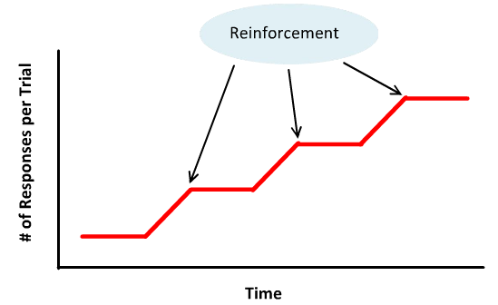
  - Variable schedule
    - Ex. Pigeon on VR-10 schedule must peck an average of 10 times to get food reward, but this changes across trials
    - First trial: 12 pecks for food
    - Second trial: 8 pecks for food
    - Third trial: 6 pecks for food
    - Fourth trial: 14 pecks for food
    - Display a characteristic type of cumulative record of a diagonal line with no pauses
    - Slope of a variable ratio schedule’s cumulative record reflects the set average # of responses required before reinforcement is delivered
    - VR schedules that deliver more frequent reinforcement will support higher response rates and have steeper slopes
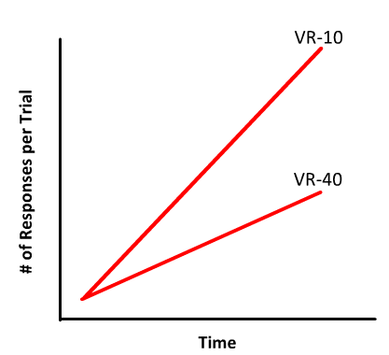
- Interval Schedule Of Reinforcement: Based on the time since the last response that was reinforced.
  - Fixed schedule
    - Ex. Pigeon on FI-1 schedule is rewarded with food for the first pecking response after a 1 minute period and a pigeon on FI-10 schedule is rewarded with food for the first pecking response after a 10 minute period
    - Display a characteristic type of cumulative record of a scallop pattern
    - Following reinforcement, there’s a lull period in which responding drops and then slowly picks up and peaks just before the reinforcement is scheduled to be delivered
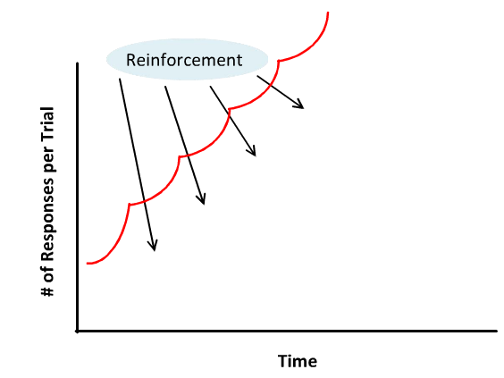
  - Variable schedule
    - Ex. Pigeon on VI-10 schedule must have an average of 10 minutes passing before food reward, but this changes across trials
    - First trial: 5 minutes for food
    - Second trial: 15 minutes for food
    - Third trial: 10 minutes for food
    - Display a characteristic type of cumulative record of a diagonal line with no pause
    - Reinforcement can be received anytime
    - Subject tends to respond at a steady rate
    - Schedule that delivers more frequent reinforcements has a steeper slope
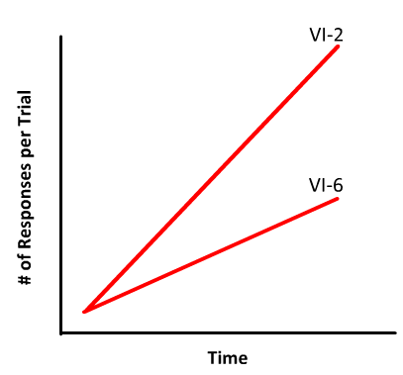
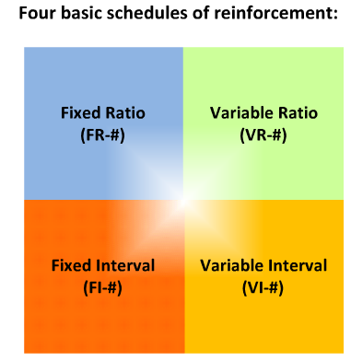
Extinction And Schedules
- PRF learned behaviours are more resistant to extinction than CRF
- On a CRF-schedule, once reinforcement stops, the subject will immediately be aware of this abrupt change and may decrease responding
- On a PRF-schedule, once reinforcement stops, it’s not immediately obvious that an abrupt change has happened

Problem Solving And Intelligence

Intelligence: The cognitive ability of an individual to learn from experience, reason well, remember important information, and cope with the demands of daily living.
- Edwin Boring defined intelligence as being whatever intelligence tests measured
- Psychologists assume intelligence involves the ability to perform cognitive tasks and the capacity to learn from experience and adapt
- Sternberg combined the two viewpoints and formed the definition
Problem Solving
- [1] Deductive Reasoning
  - Idea Conclusion
  - Coming to a concrete conclusion based on a general idea
  - Ex. Jeff tells Amanda it’s going to rain
  - Amanda uses deductive reasoning to determine that the ground will soon be wet
- [2] Inductive Reasoning
  - Fact Idea
  - Generating a general idea given some concrete information
  - Ex. Amanda wakes up in the morning and notices a box of chocolates by her bed
  - Amanda uses inductive reasoning to determine that Jeff must have put it there
Arch Of Knowledge
- Generating a testable hypothesis with deductive reasoning and interpreting collected data with inductive reasoning
- May lead to revised theories
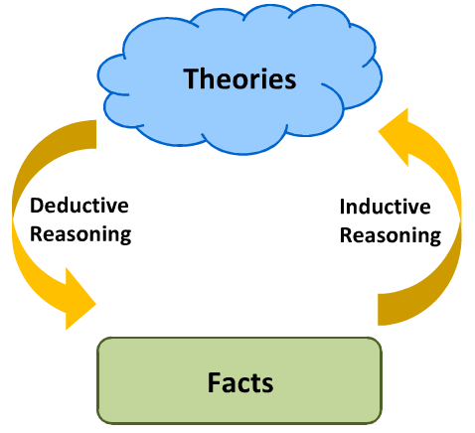
Insight Problem
- Ex. Given a box of thumbtacks, some candles, and a bulletin board, how do you attach the candles to the bulletin board and light them without setting the board on fire?
- Pin the box to the board with the candles inside
- Functional Fixedness: Difficulty seeing alternative uses for common objects.
Qualities Of A Test
- [1] Reliability
  - A reliable test produces the same results if one person takes it multiple times
  - Reliability of a test measures the extent to which repeated testing produces consistent results
  - Ex. Periodic Avenue quizzes can be said to be reliable if a student taking repeat versions of the quiz scores a consistently similar result
  - Reliability of testing is esp. important for intelligent tests because psychologists assume that intelligence is a static, internal quality
- [2] Validity
  - A valid test only measures the trait it’s supposed to be measuring
  - Validity of a test measures the extent to which a test is actually measuring what the researchers claim to be measuring
  - Ex. SATs, MCATs, LSATs
Francis Galton
- Started the modern study of intelligence
- Goal was to formally quantify intelligence in an unbiased manner
- Recorded how quickly subjects could respond to sensory motor tasks by their reaction time
- Equated faster reaction times with higher intelligence
- Reliable and unbiased measure
- Validity is questionable
Stanford-Binet Intelligence Test
- Intelligence scale to help identify public school children who needed special education
- Included 30 short tasks related to everyday life
Charles Spearman
- Firm believer in the idea of a single type of intelligence
- Observed that most people who performed well on classical intelligence tasks also performed well on all kinds of tasks
- Reasoned this was the case because there’s one generalized intelligence, which he named “G”
- Made excessive claims, such as voting and reproduction should be limited to people with a minimum level of “G” intelligence
Howard Gardner
- 1980s: Proposed a multiple intelligence theory and intelligence test
- Argued that there were eight different types of independent intelligence
- [1] Linguistic (Verbal)
- [2] Mathematical (Logical)
- [3] Rhythmic (Musical)
- [4] Spatial (Visual)
- [5] Kinesthetic (Bodily)
- [6] Interpersonal
- [7] Intrapersonal
- [8] Naturalistic
Wechsler Scales
- Intelligence tests today are patterned from a scale developed by David Wechsler in the 1930s
- Two commonly used tests are Wechsler Adult Intelligence Scale (WAIS) and Wechsler Intelligence Scale For Children (WISC)
- Tests are standardized to produce an intelligence quotient for each individual
- IQ scoring is based on the results of large samples of individuals who have taken the test
- Someone who achieves the mean score will be assigned an IQ of 100
- IQ scores surrounding the mean are assigned around a perfect normal distribution with a standard deviation of 15
- Specific IQ is relative to the performance of the rest of the population
Genetic And Environmental Contributions
- Do the individual differences in human IQ result more from genetic or environmental differences?
- Researchers use correlational studies to answer this question
- Researchers compare identical twins, which have 100% of their genes in common to fraternal twins, which have 50% of their genes in common
- Correlation between IQs of twins:
  - Identical: +0.80 (strong positive correlation)
  - Fraternal: +0.60
- Suggests a role for genes in the development of intelligence as well as the environment because 0.60 is a high number
- Researchers compared identical twins in different environments and the correlation was 0.73
- Suggests a strong role of genetics in intelligence development
- Limitations to correlational studies
  - Researcher cannot possibly consider all the environmental similarities/differences between the different homes the twins were raised in
- Ultimately, both genes and environment contribute to IQ
The Flynn Effect:Raw IQ scores have been on the rise since 1932.
- Mean score for intelligence testing in the population has been steadily increasing since it was first measured in 1932
- Finding has been documented through the years by James Flynn
- Due to increased quality of schooling, access to information/ideas, quality of nutrition and health
Jean Piaget
- Psychologist who developed one of the most influential theories of intellectual development
- Fundamental idea that children are active learners by manipulating and exploring their environments
- Schema: A mental framework for interpreting the world around us.
  - Ex. Jeff frowns at Amanda
  - Amanda uses her schemas to interpret that he must not be happy and can act accordingly
  - Schemas of young children may not be fully developed, thus ignoring the frown
- Assimilation: Incorporation new information into existing schemas.
- Accommodation: Modifying existing schemas to fit incompatible information.
Four Stages Of Cognitive Development
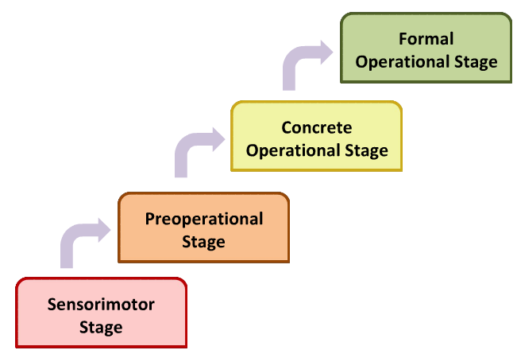
- Piaget proposed that cognitive development proceeds in four basic stages
- Each stage is characterized by specific abilities and limitations
- Transition from one stage to the next is marked by some changes in the child’s schema
- Children can progress through the stages at different rates
- Every child must pass through the stages in the same sequential order
- [1] Sensorimotor Stage
- 0 – 2 years
- Object Permanence: Realization that objects continue to exist when they’re no longer visible.
- Child begins to recognize that he can affect change on his environment
- Child begins to engage with the world and act with intention (ex. Rattle a toy to hear a sound)
- Milestone at the end of this stage is learning object permanence
- [2] Preoperational Stage
- 2 – 7 years
- Limitations:
  - Egocentrism
    - Difficulty understanding the world from another person’s perspective
    - Demonstrated in Piaget’s Three Mountains task
    - Child sees three mountains and is asked to choose from a series of pictures what the display would look like from the perspective of someone across the table
  - Seriation: Ability to logically order a series of objects.
    - Ex. Cannot rearrange different length cylinders according to height
  - Reversible relationships
    - Ex. Ron and Ginny are siblings
    - Ask Ron if he has a sister response: yes
    - Ask Ron if Ginny has a brother response: no
  - Conservation
    - Ex. Fluid conservation
    - Ron sees two glasses of milk and understands they contain the same amount
    - If you pour the milk from one glass into another taller, narrower glass, the child will want the taller glass
    - Ron doesn’t realize that it’s only at a higher level because the glass is narrower
- [3] Concrete Operational Stage
- 7 – 11 years
- Child’s schemas are concrete and based on personal experiences with the world
- Child’s unable to think in abstract terms or reason based on hypotheses
- [4] Formal Operational Stage
- 11+ years
- Able to do everything that make up the range of adult cognitive abilities
- Ex. Children begin to develop an interest in video games
Criticisms
- Phenomenon OfDecalage: Finding that children sometimes develop some skills out of order in the strictest sense of Piaget’s theories.
- Tasks that Piaget used to formulate his hypotheses relied heavily on the child’s language abilities
Bias And Heuristics
Confirmation Bias: Our tendency to seek out information that supports our hypothesis.
- Often feels like the ideal strategy because it helps to amass a wealth of confirming data
- If there is evidence against your hypothesis you must discard/revise it
- Ex. Physician making a diagnosis listens to the patient’s description of the symptoms and makes an initial diagnosis
- Physician continues to ask the patient questions
- In this process, the physician is collecting more information that might support her initial diagnostic hypothesis and is focusing on evidence that would confirm her initial diagnosis
- However, the physician is failing to consider disconfirming evidence, thus falling victim to the confirmation bias
Availability Heuristic: Our tendency to base our decisions on the first thing that comes to mind.
- Making a judgment about something based on the information most available to you (ex. Through media sources)
- Ex. Thinking that people are more likely to die from a plane crash than a cold because you hear about that more on the news
- Reliance on heuristics to make decisions causes errors in judgment
- A heuristic is a mental “shortcut” used to solve a problem quickly
- Ex. Thinking that a person with a British sounding accent necessarily comes from the UK
Representativeness Heuristic: Our tendency to assume what we see is representative of a larger category.
- Ex. Assuming every English professor looks like the English professor in your head
- Can be thought of as a stereotype
- You have a representation for a category and judge things to be in that category if they match the representation
- Ex. Brown people smell like curry and everyone who smells like curry must be brown

Language

- Most complex form of communication is language
- Words, dog growling, and parrot mimicking humans are examples of communication
- Most psychologists consider only human communication to be language
Natural Language
- Three criteria outline a “true” language
- [1] Regular
- Means that language is governed by rules and grammar
- A sentence can be reorganized and still retain its meaning because the system of rules detail how each word fits with the ones around it
- [2] Arbitrary
- The specific sound assigned to represent a concept is completely arbitrary
- Lack of resemblance between words and their meaning
- Ex. A cat is called a “mao” in Mandarin
- [3] Productive
- Limitless ways to combine words to describe objects, situations, and actions
- Evident in native language development in infants as they experiment with new words and sound combinations without being taught
Whorf-Sapir Hypothesis: Language influences our thoughts and the way we perceive and experience the world.
- Ex. The 1337 tribe’s language only contains three counting words corresponding to one, two, and many
- According to this hypothesis, they should have trouble with numerical concepts such as three, four, etc.
- Ex. The un-1337 tribe’s language lack specific words to differentiate relatives as they use a single word to describe any senior male relative
- Arguing against this hypothesis, the tribe was able to clearly understand the differences between these individuals, and are able to understand precisely how they’re related to each one
Morphemes: The smallest unit of sound that contains information.
- In sign language, morphemes are identified in units of signs rather than sound
- A single word can be made up of more than one morpheme
- Morphemes themselves can form complete words
- Ex. Tablecloth = two morphemes, tables = two morphemes, table = one morpheme
Phonemes: When morphemes are broken apart into its constituent sounds.
- Ex. Dog has three phonemes: /d/, /o/, /g/
Syntax (Grammar):The rules that govern how sentences are put together.
- Differences in syntactic rules among languages are as varied as the cultures they originate from
- Ex. In French, there is gender assigned to objects
Semantics: Refers to the meaning of each individual word.
- A sentence can have perfect syntactical structure and no semantic meaning
- Ex. The colourless green ideas sleep furiously
Language Development
Milestones Of A Baby
12 Weeks | Makes cooing sounds
16 Weeks | Turns head toward voices
6 Months | Imitate sounds
1 Year | Babbles
2 Years | Uses 50 – 250 words; uses 2 word phrases
2.5 Years | Vocabulary >850 words
- Babbling is characterized by drawn-out sounds made up of a variety of combinations of vowels/consonants
- May sound like a real sentence/question because of the use of inflection and rhythm in the production of the babble
- Combination progress to become real words
Language Explosion
- 1.5 – 6 years
- Vocabulary increases rapidly and major aspects of language are mastered
- Complexity of syntax continues to improve throughout childhood
Production Versus Comprehension
- Ex. While an infant progresses to gain language comprehension, language production can be limited by factors such as vocal anatomy
- The infant is unable to express his/her comprehension
- Researchers must consider this extinction
- Method is to test by analyzing infants’ behavioural responses to verbal stimuli
Segmentation Problem: Difficulty segmenting the speech stream of an unfamiliar language into word units.
- Problem translates into your perception that a person speaking in an unfamiliar language often sounds as though they’re speaking very quickly
- Similar to the disorienting effects of reading a sentence no natural breaks
- Ex. Does an infant’s proficiency at speech segmentation predict language ability?
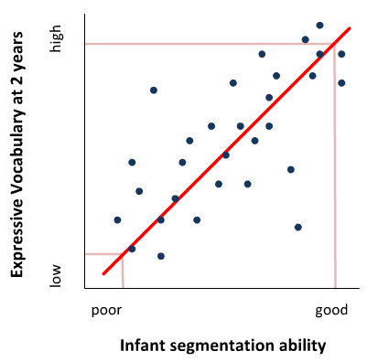
- Researchers began familiarizing infants with a target word and later read stories to them to see if they could detect the target word
- Early speech segmentation skills showed a strong positive correlation with expressive vocabulary
Infant-Directed Speech: Tendency for mothers to use higher pitch and exaggerated changes in pitch when speaking to infants.
- May help infants learn to segment speech
Universal Phoneme Sensitivity: Ability of infants to discriminate between any sounds they’re tested on, including sounds from non-native languages.
- Ex. A native English speaker would have no difficulty discriminating between the /ra/ and /la/ phonemes, while a native Korean speaker would have no difficulty discriminating between the /ja/ and /jja/ phonemes
- Adults cannot do so, which suggests there may be some developmental basis for phoneme discrimination influenced early in life
- Tested infants are pre-verbal
- Janet Werker used the head-turn procedure to indirectly measure the perception of phonemes
- Infant turns head toward speakers when a new sound is heard
- Ability is nearly lost by ten to twelve months old
Accents
- Canadian Raising: The phonetic phenomena that characterizes a typical Canadian accent.
- Shaped by the location and dominant speech patterns in the environment in which an individual is raised
- Brain injuries (ex. Stroke) can cause accents to develop
- Foreign Accent Syndrome: Following severe brain injuries, the individual will sound as though they’re speaking their native language with a novel, acquired foreign accent.
  - Sound as though they alternate between a variety of accents, rather than a single one
  - Results because the patient is adopting various rhythms that facilitates speech and happen to resemble a family of accents
- Injury to Broca’s Area suggest that part of the problem may be in speech production
- Injury to the cerebellum affects motor coordination, which can affect the individual’s ability to pronounce the phonemes specific to his native language
Social Learning Theory: Children learn language through a combination of imitation and operant conditioning.
- Ex. Baby is babbling and accidentally stumbles upon “mama”
- Mother will respond with praise, smiles, and attention, therefore providing reinforcement for the desired behaviour
- [1] Evidence For Social Learning Theory
- Promotes “nurture”
- Case of Genie
- Throughout Genie’s childhood, she was locked in a small room and had no interaction with other people
- After she was rescued from an abusive situation at age thirteen, she had no language skills
- Indicates that without exposure to adequate sources of language, children will fail to develop language skills
- [2] Evidence Against Social Learning Theory
- Promotes “nature”
- Argues that children’s language development is too complex to be driven by imitation and reinforcement alone
- Once children have learned to produce words, they combine them in novel ways that have never been modeled before
- Children make language errors that would never be heard in adults:
  - Overextensions
    - Occurs when children apply a rule too broadly
    - Can occur at the level of meaning or syntax
    - Ex. Family pet (dog) named Doggie
    - Child begins to call all four-legged animals Doggie
    - Ex. Adding the suffix –ed to all words
    - Child says she “runned” instead of ran
  - Underextensions
    - Occurs when children apply a rule to a specific object only
    - Ex. Child only calls her pet Dog and doesn’t recognize the other dogs as dogs
- Noam Chomsky argues that language develops rapidly due to an innate mechanism
- Language Acquisition Device (Innate Mechanism Theory): Innate mechanism present only in humans, which helps language develop rapidly according to universal rules.
- Ex. Deaf children from around the world were found to share the same sign language gestures without ever being taught
- Spontaneous signing did not necessarily match the grammar rules of their parents’ native language
- Neurological data show that very young infants show neurophysiological responses to the first language they’re exposed with
- Indicates that infants’ brains are pre-wired to adapt to the sounds and their associated meanings that are present in their environment
- Very young infants also prefer listening to speech rather than non-speech sounds
- Indicates an innate predisposition to expose themselves to language
Animal Communication
- Ex. The waggle dance by honey bees
  - Performed to communicate the location of food to the other bees
- Ex. Birds singing complex songs
  - Done for mate attraction and competition
- Differences between animal and human communication are best understood in experiments where researchers try to teach non-human animals to use human language
  - Ex. (Using CC) Washoe, a chimp raised by scientists and taught how to communicate using American Sign Language
    - Washoe learned to use signs to communicate simple requests and could combine them to communicate more complex requests
    - Washoe couldn’t communicate using any systematic grammar
  - Ex. (Using CC) Sarah, a chimp raised in a lab setting and taught to use plastic symbols to communicate demands
    - Sarah learned to use many different symbols, showing evidence of a large vocabulary
    - Sarah couldn’t combine them in novel combinations
  - Ex. Kanzi, a bonobo taught to communicate using a set of geometric figures known as lexigrams arranged on a keyboard
    - Instead of using CC, scientists utilized complete immersion in the language, hoping that Kanzi would learn the language by observation

Categories And Concepts

Introduction
- Two cognitive mechanisms: attention and memory
- Attention helps you to focus finite mental resources on key parts of the active scene
- Memory helps you recall specific behaviours, which are appropriate to your current needs
Categorization
- Without the cognitive ability to categorize, every sensory experience would be completely unique, thus making you unable to draw connections with the past and being forced to make unique decisions on even the most routine actions
- Ex. Sumit wakes up with a headache and categorizes the situation in “hangovers”
- With previous experience, he concludes that his current condition is best treated with lots of water and quietness
Functions Of Categorization
- [1] Classification
- Allows you to treat objects that appear differently as belonging together
- Ex. Green, red, and yellow apples appear different on a colour dimension, but by classifying them as apples, you can treat them similarly and assume they’re safe to eat
- [2] Understanding
- [3] Predicting
- Categorizing the current event experience and comparing it to similar experiences in memory
- [4] Communication
- Many words in our language refer to some type of category or concept and using the category name allows for efficient communication
Illusion Of The Expert: Feeling that something must be simple because you’re so good at it.
- Susceptible to this when dealing with simple categories
Rules
- When asked to define rules, you may find it difficult to properly exclude and include items for category membership
- When given a test stimulus, you can easily decide membership
- Suggests that humans have an internal representation of categories that’s independent of the rule we try to define
Prototype: An internal representation of the category.
- Ex. A prototype of cars would be one single representation of a car
- Thought the be the average or best member of a category
- Formed through experience and can be very personal
- All the objects you’ve previously encountered are averaged together
- Experiment: evidence supporting this theory from a classic study of robins and penguins
  - Subjects were asked to verify if the statement was true or not
  - Subjects responded significantly slower when they were asked if the penguin was a bird or not
- Suggests that more typical category members, which are likely closer to the prototype, are categorized more quickly/easily
Prototype Theory: Suggests that we categorize objects by comparing them to a prototype.
Exemplar: A stored memory representation.
- Ex. In the category of cars, there is one exemplar for every car you see
- There are multiply representations for each category
Exemplar Theory: Suggests that we store our entire lifetime worth of experiences.
- Quickly search through your library of exemplars to compare to the current object
- Identifies current object as a member of the same category if there’s sufficient similarity in the exemplar and object
- Provides a more compelling account of human categorization abilities
Children And Categories
- Children as young as three are able to understand general categories
- Ex. Teach Sumit a new fact about his pet dog, he can generalize that new fact to different dogs
- Children are able to understand innate properties of a given category (ex. Child understands that you can change the nature of a machine, but not the nature of an animal)
Conclusion
- We don’t fully understand how adult/child categorization proceeds
- We know what children can and cannot do at particular ages
- This information helps us understand how categorization functions throughout the lifespan
Animal Categorization
- Scientists have taught baboons to categorize objects as being food or non-food
- Baboons could also identify whether or not two objects were the same or different

Attention

- Allows you to navigate through a crowded world brimming with information/distraction
- Ex. Crossing a busy street requires the ability to focus attention on more than just crossing a busy street intersection
- Without the ability to focus limited processing resources, it wouldn’t be possible to enjoy a piece of music, understand a joke, or learn new things
- Phenomenon Model Hypothesis
  - Psychologists need to operationally define the problem to build cognitive models and design experiments with testable hypotheses
- William James
  - Defined attention as, “It is the taking possession by the mind in clear and vivid form, of one out of what seem several simultaneously possible objects or trains of thought… It implies withdrawal from some things in order to deal effectively with others, and is a condition which has a real opposite in the confused, dazed, and scatterbrained state.”
Concept Of Selection
- Attending to something causes the object of attention to be selected apart from the rest of the unattended objects
  - Ex. Noting the softness of the shirt’s fabric in the morning
  - No longer aware of the sensation later on during the day
  - Sensations fade into the background noise of stimuli competing for attention
- Some stimuli automatically trigger your attention
  - Ex. Light flashing in your peripheral vision
- The conscious ability to attend to the information that is relevant to our goals
  - Ex. Trying to find a particular person you are stalking in a large crowd
  - Actively selecting where to focus the attention
- Irrelevant information in the environment can act as noise and make it difficult to identify and attend to important information
  - Ex. Looking for your stalking victim in a crowd versus walking leisurely by the beach
  - Ex. Driving through busy traffic becomes more difficult as you engage in an important call on your cell phone
Processes That Influence Attention
- Automatic Processes
  - Triggered involuntarily by external events
  - Triggers the “capture” of attention
  - Operate in a fast, efficient, and obligatory manner
  - Ex. The notion of salience
  - A salient piece of information appears to naturally pop out at you
  - Certain cues are more noticeable and lead to stronger/quicker association when paired with events
  - Ex. It’s hard to miss the loud sounds and flashing lights of a police car chasing Sumit
  - The information automatically captures your attention whether intentional or not
  - Ex. Practicing a task will eventually lead to doing it with little to no effort
  - Driving a car is a learned motor skill involving many steps (pedals, signaling, steering)
- Controlled Processes
  - Guides attention voluntarily and consciously to objects of interest
  - Requires cognitive effort
  - Operate in a slow manner
  - Ex. Driving a car using flexible controlled processes involved in conscious attention as you choose when to make lane changes, speed up/down, change the radio station, etc.
  - Ex. Turning down the radio when looking for an address
  - Demonstrates that it’s difficult to consciously attend to many aspects of the task-environment at the same time because the resources for controlled processes are limited
  - Performance in all tasks will suffer if adjustments are not made to the demand for attention
The Spotlight Model
- On stage, the spotlight illuminates a key part of the visual scene
- Similarly, according to Michael Posner, the attention spotlight focuses on only one part of the environment at a time
- Attention can be consciously directed across the visual scene (ex. Looking for a friend at a crowded after-party)
- Attention can be hijacked by unconscious processes that quickly grab attention (ex. Avoid oncoming speeding cars when stepping off the sidewalk)
- Objects within the spotlight are processed preferentially as they yield a faster reaction time and higher accuracy
Measuring Changes In Attention: Spatial Cueing Paradigm
- Fix attention to the middle box of three boxes
- At some point, a target will appear in either the left or right box
- Indicate the correct target location ASAP
- Before the target appears, a potential box briefly flashes
- Flashing box serves as cue for attention
- Target can follow in either the cued or the not cued location
Influence Of Flashing Cue On Target Detection Time
- [1] Automatic Processing
- Ex. The target appears randomly on either the left or right target box and is equally often cued or not cued
- The cue provides no predictive information about where the target will appear
- More likely to have a faster reaction time with an unreliable cue if the target appears in the same box
- Consider all the trials in which the target appears in the left box
- Target detection is quicker when it’s correctly cued
- Experiment suggests difference in target detection is governed by automatic control of attention
- The relatively short time interval between cue and target presentation in this experiment favours automatic processes
- Cue automatically attracts the attention spotlight to the cued location
- Attention will amplify the perceptual processing of the target in the cued location
- If a target appears in a non-cued location, it’ll be detected slower because the attention spotlight will have been directed away from the actual target location
- [2] Controlled Processing
- Ex. The attention cue provides accurate predictive information about where the target is likely occur
- Consciously controlled shifts of attention can lead to faster response to targets that appear in the location indicated by the cue
Auditory Attention: Filter Models
- Ex. Sumit attends a fancy cocktail party and is surrounded by many different sounds competing for his attention
- Despite the noise, he is still able to single out the specific voice of his conversation partner
- Colin Cherry conducted experiments on the cocktail party effect in which subjects were asked to listen to two different messages played from a single loudspeaker at the same time
- Subjects tried to separate the messages
- Proved the ability to separate target sounds from background noise is based on physical characteristics (ex. Speaker’s gender, pitch, speed)
Filters And Attention
- Ex. A cognitive model comparing attention processes to a filter, which sifts away distractions and only allows important information through
- Information Filter Further Processing
- Ex. Examining a particular brown guy in a crowd of white men
- Filter and spotlight models propose different mechanisms for attention
- Spotlight model suggests that attention would enhance the processing of the single brown guy relative to the white men
- Spotlight = Focus on brown guy
- Filter model suggests that attention helps us ignore the white men and allows the brown guy to continue on for further processing
- Filter = Ignore white men
Broadbent’s Single Filter Model
- In 1958, Donald Broadbent proposed the first filter model of attention
- Used data from behavioural experiments to infer the functional stages of cognitive processing
- Filter selects important information on the basis of physical characteristics and allows that information to continue on for further processing
- Information that doesn’t pass through the early physical filter was assumed to be completely eliminated and unavailable for deeper analysis for meaning and semantic importance
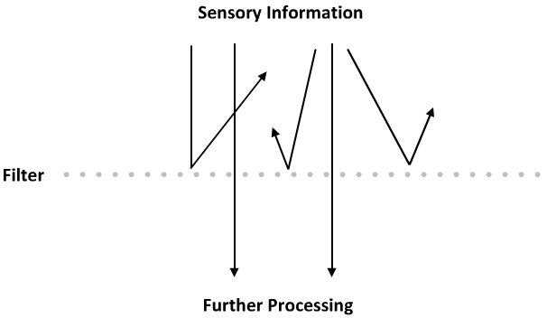
- Ex. Dichotic listening paradigm
- Sumit puts on headphones and listens to a different message directed into each ear
- He is to shadow the message in the attended ear by repeating back the message
- If he is asked questions concerning the content of the attended message, he should have no problem
- If he is asked questions concerning the content of the unattended message, he should have processed almost no information
- Limitation: model assumes that there’s absolutely no additional processing of unattended signals
- Experiment by Von Wright et al. suggests that in fact some information is processed in the unattended ear
- [1] Classical conditioning paradigm is used to associate a particular word with an electrical shock
  - Sumit is electrically shocked whenever he hears “Leafre”
- [2] Dichotic listening experiment sometimes play words with similar sound or meaning to the conditioned word
  - When similar words are presented in the attended ear, they reacted with a conditional response
  - When similar words are presented in the unattended ear, they also reacted with a conditional response
Triesman’s Dual Filter Model
- Breakthrough: When participants are able to remember important information in the unattended stream.
  - Common when the unattended information is highly relevant
  - Ex. Sumit is having a conversation with Amanda at a MI meet-up
  - Many distracting sounds that must be filtered out in order to focus on the conversation
  - If someone happens to say Sumit’s name aloud in the crowd, this information is likely to break through and capture his attention
- Proposed two filters
- [1] Physical
  - Information is first passed through
  - Information is evaluated based on physical cues
  - Physical filter weighs the importance of incoming stimuli based on these physical cues and passes along all the information to the semantic filter
- [2] Semantic
- Information is evaluated for meaning
- Takes into account the weights assigned by the physical filter
- Considers the deeper meaning and relevance of the stimuli
- Chooses which information to attend and discard
- Can override the physical filter by considering the meaning of particular information
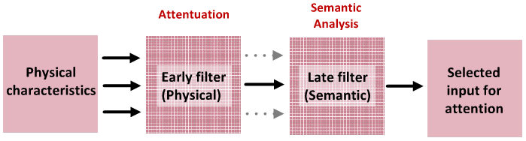
The Stroop Task: Popular task in attention research first described in 1935.
- Paradigm designed to test the limits of the attention filter
- Participants are presented with a colour-word and asked to name its ink-colour
- Congruent Items: Contain matching word and colour dimensions (ex. The word “red” written in red).
- Incongruent Items: Contain mismatching word and colour dimensions (ex. The word “red” written in green).
- Researchers measure how long it takes participants to correctly identify the ink-colour while trying to ignore the word dimension
- Performance is faster for congruent items
The Stroop Effect: Occurs when performance is faster in a list of congruent colour-words when given a list of congruent colour-words and a list of incongruent colour-words.
- Requires you to attend to information on the task-relevant dimension and to ignore information on the task-irrelevant dimension
- Difference in performance between incongruent and congruent trials can serve as an empirical measure of processes involved in selective attention
Controlling TheStroop Effect
- Proportion Congruent Manipulation: Used when measuring conscious control over Stroop interference, which changes the ratio of congruent to incongruent trials.
- [1] Increased Stroop Effect
- High proportion congruent block of trials
- 75% congruent, 25% incongruent
- More “easy” trials
- Take advantage of the word dimension matching the ink-colour dimension and employ a conscious strategy to attend to the word dimension
- Strategy increases performance on congruent trials
- Strategy decreases performance on incongruent trials
- [2] Decreased Stroop Effect
- Low proportion congruent block of trials
- 75% incongruent, 25% congruent
- More “difficult” trials
- Actively try to ignore the word dimensions entirely because the word hardly ever provides the correct response
The Stroop Task: Automatic And Controlled
- Measures the influence of both automatic and controlled processes
- [1] Automatic
- Evidence: Word reading influences performance even when the word is to be ignored
- [2] Controlled
- Evidence: People can adopt consciously controlled word reading strategies that modulate The Stroop Effect
Visual Search Task: Subjects look for a target in an array of distractions.
- Designed to test how everyday attention is used
- Analogous to tasks performed everyday (ex. Looking for lost keys)
- Ex. 8x8 array of the letter “I” with one “T”
- Increase difficulty by increasing the number of items to search through (ex. 15x15 array)
- Set Size: The number of items to search through.
- Set Size Effect: Increase in difficulty as set size increases.
Feature And Conjunction Search
- [1] Feature Search Tasks
- Ex. Finding the letter “T” in an array of the letter “I”
- Single feature search task
- Look for one particular feature to identify the target (ex. The horizontal line that distinguishes a “T” from the “I”)
- Pop-out Effect: Visual search task that proceeds rapidly regardless of set size and is easily induced by colour.
- Ex. 15x15 array of the letter “I” in red with one “T” in green
- Colour is an easy feature to search for
- [2] Conjunction Search Tasks
- Identifying a target that is defined by two or more features
- Ex. 15x15 array of the letter “I” in red and green and the letter “T” in red with only one “T” in green
Contextual Cueing
- The context of the search task serves as a cue to make searching more efficient
- Ex. Sumit cannot find his Nexon game cards, but knows he usually keeps it in his left drawers
- Sumit begins the search in his left drawers
- As a result, he finds them quicker
Importance Of Attention
- Attention errors lead to everyday inconveniences
- Ex. Forgetting to put the milk in the fridge
- Chronic attention errors play a role in psychological problems
- Ex. ADHD, anxiety insomnia, OCD

Memory

Common Memory Metaphors
- Memory acts like a video camera, which accurately preserves image and audio to be played back at a later date
- Memory acts like a filing cabinet, which stores memory files in an organized folder system and can be accessed to recall something
- Memory acts like a computer, which has specialized components responsible for handling different memories at different times
Frederic Bartlett
- Metaphors are useful, but misleading
- Metaphors are assuming memory can store experiences in their original, undistorted form
- Metaphors are assuming memory retrieval is as simple as accessing a previously stored item that has been kept in a specific place
- [1] Data
- Stored data is identical to inputted information
- Retrieved data is identical to inputted information
- [2] Memory
- Stored memory includes personal details and interpretations
- Retrieved memory may be altered or lost
Testable Hypotheses About Memory
- Questions about memory acquisition
  - What’ll be stored in memory?
- Questions about memory storage
  - Where’ll it be stored?
- Questions about memory retrieval
  - How can memories be returned to consciousness?
Importance Of Cues
- One memory triggers another, shaping the flow of the conversation
- Ex. Sumit tells a funny anecdote about KSingnoobs and Amanda is reminded of when she KS’d someone as well
- Early researchers of memory were heavily influenced by the behaviourists
- Early focus of memory research concerned how cues interact with encoding and retrieval mechanisms of memory
Testing Hypotheses
- Psychologists rely on cognitive models to understand a complex cognitive function like memory
- Models describe and organize data
- Models make specific, testable predictions that can be studied in controlled experiments in the lab
Basic Memory Task
- [1] Encoding Phase
- Subject learns a list of items, words, or pictures
- Ex. Researcher presents the same list of items to two different groups
- Experimental group is asked to learn the presented items
- Control group is distracted
- [2] Retrieval Phase
- Subjects are tested for their memory of the items presented in the encoding phase
Recall Test: Subject is asked to freely generate as many items as she can remember.
Recognition Test: Subject is shown several items and asked to judge whether each item is new, meaning it was not presented during the encoding phase, or old, meaning it was presented during the encoding phase.
Hermann Ebbinghaus
- Operationally defined memory as a serial learning task
- He memorized word lists and suggested each word in the list served as a cue that triggered the memory of the following word
- Used the basic encoding and retrieval design to learn about cueing and forgetting of memories
- Ex. He memorized nonsense words during the encoding phase and later tested his recall ability during the retrieval phase
- Used nonsense words to minimize the influence of his prior experience on his test results
- Discovered his ability to recall words was highest immediately following learning and that over time he remembered fewer words
- Forgetting Curve: Constructed by Ebbinghaus and describes the increasing rate of memory failure over time.
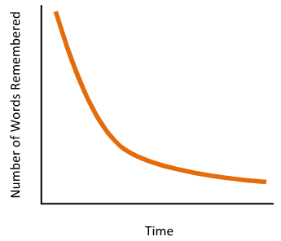
The Multi-Store Model
- In 1968, proposed by Atkinson and Shiffrin
- Assumes that memory is composed of both short and long-term storage systems
- Short-term memory buffer operates similar to RAM on a computer
- Long-term memory operates similar to saving files onto the hard drive of a computer
- [1]Incoming perceptual information is first stored in a short-term memory buffer
- Information in short-term memory is available for online tasks but isn’t stored permanently
- [2]Important information encoded in short-term memory can be transferred to the long-term memory storage system for more permanent, long-term storage
- Ex. Items in short-term memory are rehearsed and then transferred into the long-term memory storage system
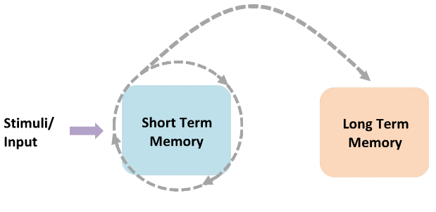
Rehearsal
Short-Term Memory Capacity
- Demonstrated by George Miller to usually be 7 (+/- 2) items
- Demand on short-term memory becomes strained when asked to memorize 7+ items
- If rehearsal stops, the short-term memory can fade
- Chunking: Re-organize information into meaningful packets, which allows more information to be held in short-term memory.
- Ex. List II is easier to memorize
- List I: JGTLXYKAOGHQCVPT
- List II: CBCFBICIARSVPIBM
- Both lists contain sixteen letters, but the letters in the second list can be chunked into five bits of information forming similar letter groupings
- Letter grouping can pack a lot of information
- Ex. Remembering seven random letters of the alphabet versus seven animal names
Serial Position Curve
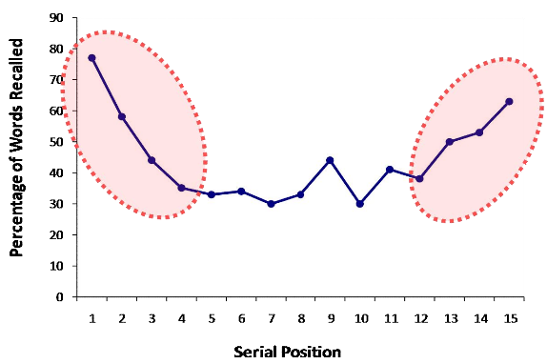
- Typical results from a recall test during the retrieval phase
- Memory performance is best for items early or later in the list
- Primacy Effect: Memory performance is good for items encoded early in the list.
- Driven by rehearsing items into the LTM
- According to the multi-store model, items at the beginning of the list will be first to enter STM, thus have the most opportunity to be rehearsed
- Ex. Memorize the list, “butter, tiger, hat, jump”
- Memorize by repeating in sequential order
- Stimuli/input goes into STM, and goes into a process of rehearsal
- First item will be the most rehearsed and has the best chance of being transferred into LTM for permanent storage
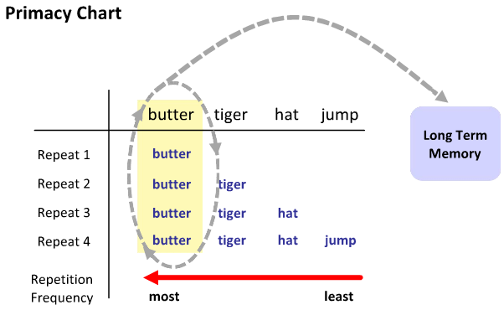
- Items in the middle have less opportunity for rehearsal and a lower chance of being transferred into LTM
- Recency Effect:Memory performance is good for items encoded later in the list.
- Driven by items remaining active in the STM buffer
- According to the multi-store model, all encoded information is first sent to the STM buffer that is limited to hold ~7 items
- Newest items replace the oldest items in the STM buffer
- At the end of a list, the last seven items are not replaced and will remain in STM
Improving Primacy
- Primacy effect is influenced by manipulating a subject’s ability to rehearse items
- Ex. Manipulating the presentation time of each to-be-remembered item
- More time to encode each item would allow more time for rehearsing those items into LTM
- Primacy effect is enhanced for a list of items given with a long interval of presentation relative to a list of items given with a short interval of presentation
- Increasing time between item presentation increases:
  - Amount of times each item can be repeated
  - Probability of item being stored in LTM
  - Performance recalling first couple of items
Diminishing Recency
- Recency effect is influenced by manipulating the contents of the STM store
- Ex. Manipulation that causes the most recent contents of the STM to be replaced or disrupted
- Subject is asked to perform a distracting task immediately following the encoding phase
- Performing the distracting task requires STM resources
- Ex. Three groups of subjects are asked to memorize a list
- Group I: Recall after performing different task for 30s
  - Recency effect diminished
- Group II: Recall after silent interval for 30s
  - Recency effect present
- Group III: Recall immediately
  - Recency effect present
Levels Of Processing
- Memory performance depends on the level at which items are encoded
- [1] Shallow Level
- Encode physical characteristics
- Encoding requires little effort
- Poor memory performance
- [2] Deeper Level
- Encode semantic characteristics
- Encoding requires significant effort
- Better memory performance
CraikAnd Lockhart
- Tested the levels of processing model by directly manipulating the level at which a subject encoded a list of words
- Ex. Subjects were presented with words that could be judged on different properties
- Shallow encoding condition made physical judgments
- Moderate encoding condition made acoustic judgments
- Deep encoding condition made semantic judgments
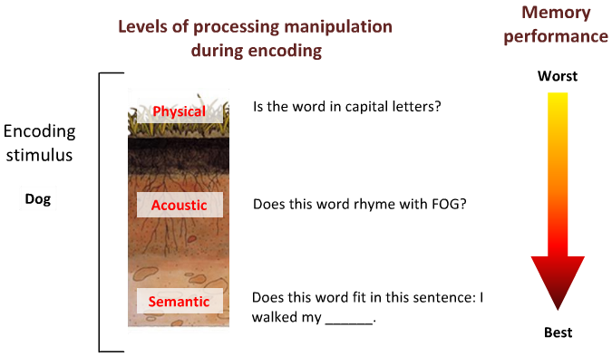
Levels Of Processing Principle: The more you actively organize and understand material to be learned, the better you will be able to remember it and paying attention to only surface details leads to poorer recall.
- Shallow levels of processing: Passively skimming through a reading, taking verbatim notes
- Deep levels of processing: Actively reading, note-taking by making connections with existing knowledge base
Encoding Specificity
- In a lab, researchers purposely use simplified memory tasks, which allow variables to be controlled and manipulated
- In the real world, memories are not restricted to learning lists of items, but are rich, detailed, and experienced in the context of the world around you
- Environmental cues are incorporated into your memories along with learned items
- Principle Of Encoding Specificity: Memory encodes all aspects of specific experiences.
  - Ex. When encoding a word in a memory experiment, all of the specific aspects of that experience including properties of the room you’re in, the chair you’re sitting on, the font type you’re looking at, etc.
  - All of these specific aspects of the experience can influence memory performance in the future by acting as specific cues for the event/item being recalled
Godden AndBaddelley
- Tested the environmental influence on memory performance
- Ex. Scuba divers encoded a list of words on land or under water
- Follow-up recall test was done in the same or different encoding context
- Subjects were better able to remember items from the list when they were in the same context during the memory test
- Concludes that memory performance depends on how items are encoded and the encoding context
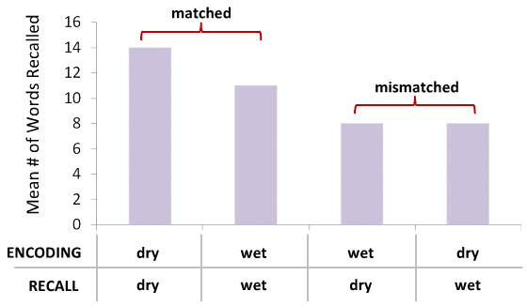
Eich et al.
- Tested the influence on memory ability by the internal state of a subject
- Ex. Subjects under the influence of drugs while attempting to encode a list of items
- One group of subjects blazed while encoding
- Another group of subjects received a placebo while encoding
- Follow-up recall test was done in the same or different internal state
- Concludes that memory performance depends on the match in subjects internal states between encoding and recall test
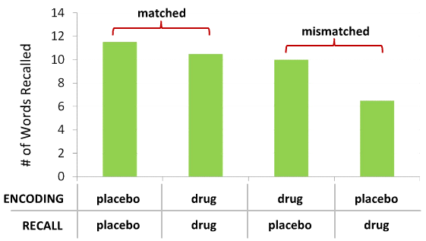
Elizabeth Loftus
- Researches the extent to which false memories can be implanted by suggestion
- Ex. Asked subjects to remember a list of childhood experiences that were obtained from their parents
- ¾ experiences were real, ¼ experience was fake
- Subjects were asked to recall and describe these four experiences over a period of three days
- By the third day, 20% of people believed a fake experience happened in their past
- False memories demonstrate that memory is high constructive
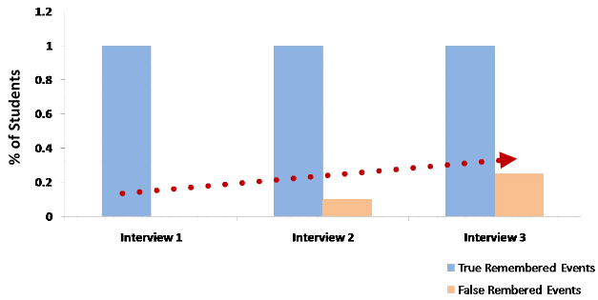
False Memory Implantation
- [1] Plausible Memories
- Ex. Getting lost in a mall
- [2] Bizarre Memories
- Ex. Being raised by penguins
- Seamon et al. demonstrated that repeatedly imagining an event can lead to the formation of false memories, even for bizarre situations
- Ex. Subjects visited various locations on a university campus
- At each stop a familiar or bizarre action was either performed or imagined
  - Subject stopped at a pop machine was told to look for change
  - Subject stopped at a pop machine was told to imagine praying
- Follow-up recall test two weeks later showed subjects believed to have performed the bizarre action
Memory
- False Memories
  - Provide support for the idea that memory is a reconstructive process
  - Recalling a memory is open to interpretation and suggestion
- Fluency-based Memory Illusions
  - Fluency: The ease with which an experience is processed, some easier (more fluent) than others.
  - Ex. Sense of familiarity when looking at a stranger
  - Familiar experiences are generally processed more fluently than are novel experiences
- Attributional View
  - Attribution: Judgment trying together causes with effects.
  - To make an attribution on the basis of processing fluency, we’re making a judgment that identifies a cause/source to the feeling of the processing fluency
  - Ex. Make many different kinds of attribution when having a feeling of processing fluency about a stranger
  - Maybe I know him from work?
  - Maybe his unconventional glasses caught my attention?
Experiment: Become Famous Overnight
- Memory illusions can be created by manipulating how people interpret their feelings of fluency
- Ex. Subjects are asked to read a list of names in phase I
- Group A had a 24-hr delay before phase II
- Group B had no delay before phase II
- Subjects were given a fame rating task in phase II
- List included famous celebrities, not-so-famous celebrities, and non-famous fictional names
  - Some non-famous fictional names were novel and some were from phase I
- Group A:
- Appropriately rated the famous celebrities and not-so-famous celebrities
- Rated the non-famous fictional names from phase I as being more famous than the novel non-famous fictional names
- False Fame Effect: Illusion produced in which a name is believed to be famous because it was previously seen.
- Subjects experienced a feeling of processing fluency in phase II when non-famous fictional names from phase I were encountered
- Group A produced a false fame effect because the feelings of fluency for the non-famous fictional names from phase I were improperly attributed to fame
- Mistakenly attributed fluent processing of the name to the person’s fame and not to the fact that this name was read a day earlier
- Group B:
- Appropriately rated the famous celebrities, not-so-famous celebrities, and non-famous fictional names
- Subjects experienced a feeling of processing fluency in phase II when non-famous fictional names from phase I were encountered
- Group B didn’t produce a false fame effect because the feelings of fluency for the non-famous fictional names from phase I were properly attributed to the fact that they just read those names moments ago
Bartlett
- Proposed that memories are constructed when required to remember something
- Implied that memories don’t exist until the present situation requires that we construct a memory
- The memory system is a pile of basic building blocks using the raw materials of perception and experience
- Idea of “true objective” memories is inexact because memory is often subject to interpretation/reconstruction

Personality 1And Personality 2

- Ex. Shy, considerate, talkative, practical, traditional
- Personality has no physical existence
- Personality is an idea, an abstract concept used to express or capture something important about our experiences
- Abstract concepts referred to as “hypothetical constructs” help organize/understand experiences
  - Ex. Personality, memory, gravity, energy
Approaches To Personality
- [1] Type Approach
- Assumes there are a small number of distinct personality types
- Dominant in Western thinking until the 16th and 17th centuries
- Proposed by Hippocrates
- Believed the human body was made of four “humours”
  - Blood
  - Phlegm
  - Yellow bile
  - Black bile
- Believed personality was determined by the balance of these four “humours”
- Ex. Someone with a melancholic personality type is often sad and wistful
  - Melan: black
  - Cholic: bile
- [2] Psychodynamic Approach
- Personality is generated by internal psychic structures or processes
- Many of these structures are unconscious, thus people are unaware of many important aspects to their personality
- Pioneered by Sigmund Freud
- Freud’s Tripartite Model Of Personality
- Ex. Sumit’s friends are all gaming at a LAN party and he wants to join, but he has a group assignment to do
- Three personality structures:
  - [1] Id (Libido)
    - Source of one’s basic instincts and motivational energy
    - Pleasure Principle: Seek pleasure and avoid pain (ex. Seek out water, food, air, sex).
    - Selfish, impatient
    - Ex. He can feel the arrow-key spamming at his fingertips
    - Motivated to seek out the pleasure associated with gaming instead of doing work
  - [2] Ego
    - Serves as a mediator between the id and the superego
    - Aware of the outside reality
    - Ex. Working on the group assignment and then meeting his friends at the LAN party
  - [3] Superego
    - Source of one’s moral principles
    - Obeying rules and respecting values
    - Occurs around age five or six and is established through parental control and self-control
    - Ex. Getting the group assignment done
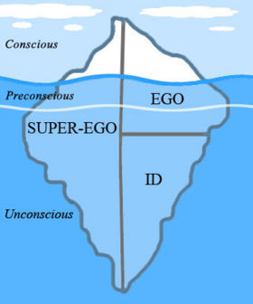
- Defense Mechanisms
- Id impulse is immoral Conscious ego feels moral anxiety
- Id impulse is dangerous Conscious ego feels neurotic anxiety
- Conscious ego is protected against anxiety by defense mechanisms created by the unconscious ego
- Repression: Unconscious ego blocks id impulses from ever reaching consciousness.
  - Simplest defense mechanism
  - Repressed impulses continue to press for entry into consciousness
  - Keeping them out takes a lot of the ego’s available energy
  - Information can sometimes slip through defense into consciousness
- Freudian Slips: Repressed impulses that sneak into consciousness as slips of the tongue or symbolically disguised as dream images.
- Denial: Conscious ego engaged in an activity, but the unconscious ego prevents any memory of the event.
  - Conscious ego feels no anxiety despite having done something dangerous or immoral because there is no memory of the behaviour
  - Anxiety-producing behaviour begins in the conscious ego after a behaviour has already occurred
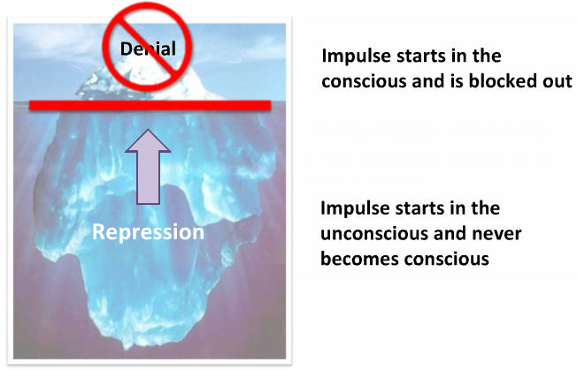
- Rationalization: Unconscious ego justifies some conscious action.
  - Sometimes used if an impulse cannot be repressed or denied
  - Conscious ego has done something dangerous or immoral
  - Unconscious ego floods consciousness with plausible, non-threatening reasons for the behaviour
  - No anxiety is experienced because the conscious ego believes that it has engaged in the behaviour for harmless reasons
  - Ex. Sumit is involved in a traffic accident and an argument turns into a brawl, but he justifies himself with the excuse of self-defense
  - Aggression generated from id conflicts with belief that violence is wrong from superego
- Projection: Anxiety-producing thoughts are attributed to someone else.
  - Ex. Sumit doesn’t like Amanda, but he’s not sure why and feels guilty
  - Sumit projects his feelings on Amanda and convinces himself that it’s really her who doesn’t like him
- Reaction Formation: Conscious ego is filled with opposite ideas and feelings.
  - Ideas and feelings are opposite to actual impulses
  - Ex. Sumit has a strong attraction to Amanda, which causes him anxiety because the feeling isn’t mutual
  - Sumit deals with this consciously by outwardly feeling dislike and disapproval for her
- Displacement: Unconscious ego redirects forbidden impulses away from its original target to consciously acceptable targets.
  - Ex. Sumit doesn’t like his supervisor at work and feels aggressive towards him
  - However, it’d be inappropriate to act on this aggression, thus he ends up arguing with Amanda
  - Sublimation:A special type of displacement in which sexual/aggressive impulses are displaced to objects/activities that are socially acceptable.
    - Freud believed so-called “higher” activities are due to sublimated id, such as sports, painting, sculpting, literature, and science
    - Rational and emotion-free enterprise is ultimately derived from sexual/aggressive impulses
- Freud’s Personality Development: Psychosexual Stages
- Covers birth to puberty, where the fundamental features of personality have been shaped and remain the same throughout adulthood
- Psychosexual stages are defined by the dominant erogenous zone from which the child gets the most sexual/aggressive gratification
- During each stage, the child’s pleasure is obtained from primarily a single erogenous zone
- [1] Oral Stage (Birth 1year)
- First erogenous zone is the mouth
- Child discovers the pleasures of sucking and swallowing, and later of biting and chewing
- First objects associated with oral pleasure are the bottle, the mother’s breast, and one’s own thumb
- Pleasure from oral activities continues throughout a lifetime
- [2] Anal Stage (1 year 3 years)
- Second erogenous zone is the anal area
- Child discovers the pleasures of excreting feces through bowel movements, and later of retaining feces when potty training is introduced
- [3] Phallic Stage (3 years 6 years)
- Most important stage
- Third erogenous zone is the phallic area
- Child discovers the pleasures of stimulating the phallic area
- Oedipus and Electra Complexes generate intense anxiety
- Most memories of the child’s sexual/aggressive impulses toward mom and dad are blocked from consciousness through repression
- Boys go through the Oedipus Complex
  - Ego invests sexual id to his mother and wants to possess her for himself
  - Boy wants to get rid of his dad because he’s an obstacle to his exclusive possession of mom
  - Boy observes that girls don’t have penises and becomes convinced that his dad will retaliate against him by castrating him
- Boys resolve their dilemma by identifying with their fathers
- Identification: The process of becoming psychologically like the father and superego is formed from the father’s beliefs and values.
- Girls go through the Electra Complex
  - Ego invests sexual id to her mother and wants to possess her for herself
  - Girl observes that some people don’t have penises, including herself
  - Girl blames her mother for the perceived loss and experience a strong desire to regain a penis
  - Penis envy leads her to direct her sexual desires towards her dad
  - Girl wants to get rid of her dad because she’s a “penis thief” and obstacle to her exclusive possession of dad
- Girls resolve their dilemma by identifying with their mothers
- [4] Latency Stage (6 years Puberty)
- Child enters a period of relative sexual quiescence
- Id is channeled into behaviours that aren’t yet overtly sexual
- [5] Genital Stage (Puberty +)
- Child experiences a surge of hormones, which produces a new wave of id
- Specific direction of sexual interests/urges depend on where the id was directed as it was passed through the stages of childhood sexuality and what was done with the id that was withdrawn from mom and dad
- Phenomena Of Fixation
  - Fixation: Libido is attached to a specific erogenous zone at each stage and some excess libido can be left behind at a specific stage.
  - Ex. Fixation at the oral stage
  - Excess libido might be directed toward eating, smoking, or nail-biting
  - Ex. Fixation at the anal stage
  - [1] Anal Expulsive
  - Children who have fixated on pleasure from excreting feces
  - As adults, they may become messy and disorganized, and experience pleasure from giving things to others
  - [2] Anal Retentive
  - Children who have fixated on pleasure from retaining feces
  - As adults, they may have become overly neat and orderly, but stingy, stubborn, and rigid
- Anna Freud
  - Freud’s youngest daughter expanded on his work by developing the role of the ego
  - Partially developed the defense mechanisms
  - Developed a system of diagnosis that allowed therapists to distinguish between less serious childhood problems and more serious disturbances
- Erik Erikson
  - Expanded on the research of the ego
  - Emphasized the ego’s positive and adaptive effects on development
  - Stressed social aspects of development
  - Stressed ego strengths, which are strengths gained by the ego when each stage of development is resolved
  - Re-termed psychosexual stages to psychosocial stages
  - Stages span throughout a lifetime
  - Trust/mistrust stage was equivalent to Freud’s oral stage
    - Emphasized the conflict children face when they’re highly dependent, but have limited communication capacities
    - Ego strength that emerges from the resolution of this conflict is hope
- Carl Jung
- Freud’s student who disagreed with him
- Believed motivation to be provided by the libido
- Drives in libido are for more than sex and aggression
- Libido is not sexual energy, but a general life-enhancing energy that can be directed toward meeting different needs at different times throughout a lifetime
- Proposed a different psychic structure for the mind
  - Ego is central to our conscious mind
  - Unconscious psyche is divided into a personal unconscious and a collective unconscious
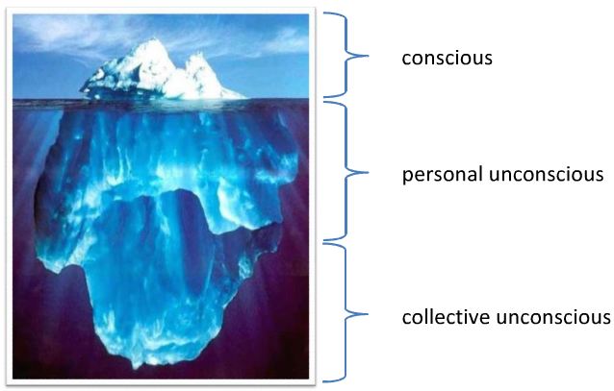
- Collective Unconscious: An ancient part of the human mind that forms the biological basis of human nature.
  - Same in everyone
  - Contents cannot enter consciousness
  - Archetypes: Libido contained in the collective unconscious in the form of basic human instincts.
  - Archetypes in the collective unconscious guide society’s perceptions/beliefs
  - Jungian Archetypes: Assumed that these common themes, characters, and ideas about life and the world among dozens of cultures reflected the projection of universal archetypes.
    - Birth
    - Separation
    - The Hero
    - The Wise Old Man
    - Disaster
- Personal Unconscious:Repository of thoughts, memories, and emotions that were once conscious, but have been repressed into unconsciousness.
  - Different in everyone
  - Contents can be brought back into consciousness and into the ego by recalling events in the past
  - Complexes: Collections of images, memories, and feelings connected by a common theme.
  - The themes of these complexes are underlying archetypes
  - Uses up libido thinking about complexes
  - Ex. Jung had a mother complex
  - He spent a lot of psychological energy on ideas, feelings, and behaviours related to his mother
  - Collection of complexes that an individual holds help to make up their personality
  - Special Complexes: Some complexes reflect archetypes and are possessed by everyone.
    - Persona
      - Related to Freud’s superego since it represents social values
    - Archetype
    - Instinct for social conformity
    - Need to be with others and to please them
    - Complex
    - Public self
    - Feelings, thoughts, and impulses that are presented to others because they’re believed to be approved
    - Animus And Anima
    - Archetype (Animus)
    - Every woman’s instinctive image of maleness
    - Archetype (Anima)
    - Every male’s instinctive image of femaleness
    - Complex (Animus)
    - Feelings and thoughts rejected from consciousness because they’re masculine
    - Complex (Anima)
    - Feelings and thoughts rejected from consciousness because they’re feminine
    - The Shadow
    - Archetype
    - Instinct for sexuality and aggression, also can be a source of energy, vitality, creativity, and intuition
    - Complex
    - The things about ourselves (ex. Emotions, impulses) that we totally reject
    - The Self
    - Archetype
    - Instinctive desire for unity, balance, integration, and wholeness
    - Projected through our affinity for circles and symmetrical shapes
    - Role
    - Integrate conflicting complexes
    - Ex. Reconcile the shadow with the persona
- Self-actualization: When all rejected complexes are discovered and allowed to function with the other complexes.
  - Highest goal in personality development
  - Doesn’t typically begin until middle age
  - Rarely occurs
- Ego: The conscious mind.
  - Selects perceptions, thoughts, and feelings from the personal unconscious and lets them enter consciousness
  - Helps to establish a sense of stability in our perceptions of ourselves and of the world
- [3] Humanistic Approach
- Considered most optimistic
- Focuses on human interests, values, strengths, and virtues
- There is an ideal developmental goal
- Advancements and set-backs are experienced
- Not limited by one’s past (Ex. Having the potential to fully develop ideal personality characteristics despite experiencing a hardship during childhood)
- Pyramid Of Abraham Maslow’s Hierarchy Of Needs
- Proposed a hierarchy of steps that must be satisfied in order to develop a healthy, ideal personality
  - Physiological
    - Bottom rung of the hierarchy
    - Focuses on the most basic and essential needs
    - Ex. Food, water, air
  - Safety
    - Focuses on a safe place to live with some stability and security
    - Having some form of income
    - Neurotic/insecure adults are stuck at this level
  - Love And Belongingness
    - Focuses on the need to bond and relate with others
    - Ex. Forming close friendships and romantic relationships
    - Individuals who don’t fulfill this need are emotionally maladjusted
  - Esteem
    - Focuses on two forms of esteem:
    - Self-esteem, which is feelings of self-worth and respect for oneself
    - Esteem of others expressed via social status and recognition
  - Self-actualization
    - Top rung of the hierarchy
    - Focuses on maximizing personal abilities and strengths
    - Being able to identify one’s strengths and weaknesses
    - Rarely occurs
- [4] Trait Approach
- Focuses on a set of characteristics that define an individual’s personality
- Established by the work of Gordon Allport and Raymond Cattell
- Everyone possesses various personality traits
- Personality Traits: Predispositions to behave and react in similar ways in response to a variety of stimuli.
  - Can be expressed at different levels by different people
  - Considered to be on a continuum and can be thought of as a % (ex. On a given personality trait, some people may be at 100%, while others are below 50%)
- Ex. Someone who refuses to donate money to charities, doesn’t leave tips for servers, and avoids buying gifts for others is said to be cheap
- These characteristics define one specific personality trait
- Factor Analysis: A statistical method used by Cattell that creates broad personality factors, which are groupings of numerous related characteristics.
  - Reduced personality characteristics to sixteen general personality factors
    - Warmth, reasoning, emotional stability, dominance, liveliness, rule-consciousness, social boldness, sensitivity, vigilance, abstractedness, privateness, apprehension, openness to change, self-reliance, perfectionism, tension
  - Criticized for having too many factors
- Hans Eysenck
  - Proposed a three factor model using similar factor analysis methods
    - Extraversion, neuroticism, psychoticism
  - Criticized for having too little factors
- Robert McCrae And Paul Costa
  - Proposed a five factor model
  - The Big Five: Most commonly accepted groupings of personality traits.
    - Openness, conscientiousness, extraversion, agreeableness, neuroticism
  - Factors have been replicated in many different samples, cultures, and languages
  - Openness [to experience]
  - Reflects a desire for new, exciting, and adventurous experiences instead of constantly repeating the same experiences
  - People high in openness tend to be intellectually curious, inquisitive, imaginative,unconventional and enjoy/appreciate reading, art, and nature
  - Conscientiousness
  - Associated with a well-ordered life
  - People high in conscientiousness tend to be neat, organized, and highly moral/ethical
  - Ex. Always early for appointments
  - Extraversion
  - Associated with a desire and ease to engage in social interactions especially in large groups of people
  - People high in extraversion tend to be energetic, highly social, and strong leaders
  - Agreeableness
  - Reflects a preference for cooperation and trust
  - People high in agreeableness tend to be warm, caring, and polite
  - Ex. Role of caregiver
  - Neuroticism
  - Reflects a trait that is not socially desirable
  - People high in neuroticism tend to be distressed, dependent on others, and overly sensitive
  - Ex. Someone who requires a lot of emotional support and is very self-conscious
- [5] Behaviourist Approach
- Treats the mind as black box
- All that’s known about someone is through their overt behaviour
- Behaviour = personality
- Not interested in psychic structures of the mind
- Not interested in finding particular traits
- [6] Cognitive Approach
- Thoughts are the important determiner of personality
- Way of thinking, interpretations of the world, and understanding of yourself affect how you feel/behave
- Thought patterns are central to personality and are the cause of overt behaviours

Psychopathology 1

Abnormality
- Varies between people, culture, time periods
- Clinicians use a fixed set of criteria:
- [1] Deviance
- Refers to having thoughts, emotions, and behaviours that fall far outside of the standards of what others are doing
- Includes those who fall below and above the standard of the group
- Doesn’t include cultural practices of minority populations
- [2] Distress
- Refers to experiences of intense negative feelings
- Includes bipolar patients in the manic phase who often feel extremely elated
- Includes antisocial personality disorder patients who feel no remorse when causing harm to others
- [3] Dysfunction
- Refers to the inability to function properly in everyday life
- Behaviours are often described as maladaptive because they prevent an individual adapting well to their environment
- Doesn’t include someone on a hunger strike
- [4] Danger
- Refers to danger to oneself or another
- Ex. Person who engages in violence toward others
- Doesn’t include athletes who participate in extreme sports
Classifying Disorders
- The Diagnostic And Statistical Manual (DSM): Book that clinicians refer to for guidelines.
  - Provides standardized criteria to aid in the diagnosis of psychological disorders
    - [1] Categorizes and describes mental disorders so clinicians will have a common set of criteria for applying a diagnostic label to the symptoms of their patients
    - [2] Allows researchers to talk to each other about mental disorders using a common language
  - Outlines two general criteria that must be met before a clinician can make any diagnosis regarding mental health, regardless of the specific disorder in question
    - [1] Disordered behaviour must originate from within the person, rather than being a reaction to something in the environment
    - [2] Disordered behaviour must be involuntary and the symptoms being experienced are uncontrollable
  - Attempts to group together disorders that have similar sets of symptoms with the assumption that similarities suggest a common cause and that they can be similarly treated
  - Doesn’t offer an explanation for the disorder or suggest treatment methods
Models Of Psychopathology
- Attempt to explain the causes of disorders and to help decide how to treat them
- [1] Biological
- Assumes that a psychological disorder result from malfunction in the brain
- Brain may malfunction because it’s physically damaged or because there’s abnormal chemical activity (ex. Genetics, nutrition, disease, stress)
- Treatment often relies on drug therapy (ex. Antidepressants that change the balance of neurotransmitters in the brain)
- Treatment for extreme cases include electroconvulsive shock or brain surgery
- [2] Psychodynamic
- Brain may malfunction due to mental conflict in the mind (ex. Unresolved childhood issues)
- Treatment must focus on therapy to cope with underlying stressors (ex. Psychoanalysis)
- [3] Behavioural
- Assumes psychological disorders are external, overt behaviour rather than an internal malfunction
- Disordered behaviours are established through classical and instrumental conditioning
- Contingencies, rewards, and punishments received for our actions influence our behaviours
- Treatment focuses on seeking out positive situations and actions
- Treatment uses principles from conditioning
- Not all disorders can be explained by reinforcement
- Treatment is only effective in the therapist’s office
- Criticized for treating people as simple reflexive beings that just react to their environment, rather than having the ability to plan, remember, and predict things in their world
- [4] Cognitive
- Assumes that a psychological disorder result from maladaptive or inappropriate ways of selecting/interpreting information from the environment
- Anxious not because of what’s happening around us, but because of the way we interpret those events
- Experience and learning play an important role in shaping maladaptive thinking
- Treatment focuses on positive interpretations of situations
- Aaron Beck
- Depressogenic Schemata: Maladaptive thinking processes.
  - Under stress, people with these tendencies develop unrealistically negative interpretations of events, which lead to negative views of themselves, the world, and their futures
Cognitive-Behavioural Therapy:Treats psychological disorders by focusing on both disordered thoughts and behaviours.
Mood Disorders
- Characterized by disturbances in emotion
- Two main types of depressed mood disorders:
- [1] Unipolar (Major) Depression
- Ex. Sumit lost his job as a MapleStory GM four months ago
- Instead of searching for a new job, he spends his time sleeping
- He has little interest in doing anything and finds it hard to get out of bed
- He’s normally very active, but lately he has little appetite and feels chronic headaches
- When he tries to do something, he moves slowly and has difficulties concentrating on the task at hand
- His mind is filled with negative thoughts
- Depression can present itself in a less severe form and not every symptom needs to be present for a clinician to make a diagnosis
- Episodes of major depression are recurrent
- Person usually returns to normal in between episodes
- Should be treated due to suicide/harmful risks
- [2] Bipolar Depression
- Individuals alternate between severe depression and mania
- During mania, a person experiences heightened self-esteem, activity, energy, and sleep little
- Ex. Sumit feels that his thoughts are racing ahead of his ability to deal with them
- May do things that are potentially risky (ex. Sexual promiscuity, unrestrained buying sprees)
- May become very angry at anyone who serves as an obstacle to goals
Dysthymia: Chronic variant of depression in which individuals exhibit persistent, moderate levels of depression.
- Rarely return to normal levels of functioning in between bouts of depression
Anxiety Disorders
- Characterized by persistent feelings of anxiety that interfere with daily activity
- Viewed as displaced tension between the ego and the id by the psychoanalytic model
  - Id: Immediate impulse gratification
  - Ego: Blocks inappropriate ego impulses
  - Creates anxiety and how this anxiety is displaced can lead to symptoms of anxiety disorders
- [1] Generalized Anxiety Disorder
- Causes continuous anxiety throughout various, trivial situations
- Ex. Anxious about getting to work
- Experience extreme feelings of anxiety for at least six months
- Can cause pervasive physical symptoms
- Ex. Dizziness, sleep problems, fatigue, nausea, headaches, difficulty concentrating
- [2] Obsessive-Compulsive Disorder
- Recurring obsessions or compulsions that disturb the person or interfere with daily living
- Obsession is an idea, impulse, or image that the mind cannot rid
- Compulsion is a behavioural ritual that a person feels compelled to perform over and over again
- Person knows the ritual is unreasonable, but still feels anxious if the ritual isn’t completed
- Ex. Hand-washing is a common compulsion (done 40x/day)
- [3] Post-Traumatic Stress Disorder
- Occurs following a highly traumatic incident
- Feelings of persistent anxiety and intrusive thoughts about the event occur
- Ex. Survivors of sexual abuse
- May have flashbacks to the traumatic event
- Re-living the memory where a person actually thinks and feels like the event is happening again
- Feel the need to avoid certain situations, objects, or people that remind them of the traumatic event
- May suffer from nightmares and intrusive thoughts, and feel depressed, irritable, easily startled
- Helpful for trauma survivors to discuss the event in detail
Somatoform Disorders:Psychologically caused disorders with physical symptoms that cannot be explained by physiology.
- [1] Conversion Disorder
- Specific sensory/motor symptom (ex. Pain) without any physiological cause
- Ex. Sudden loss of vision
- Usually develop during a stressful situation and symptoms appear suddenly
- Believed to be caused by traumatic hidden memories by Freud
- [2] Hypochondriasis
- Most common
- Persistent fears of having a serious illness, despite medical evaluations and reassurances to the contrary
- May report a pattern of symptoms consistent with feared illness
- May be generated partially by misinterpretations of bodily signals
- Ex. Overreact to a common cold
- Therapy involves educating the patient to reinterpreting the bodily signals more accurately
Psychophysiological Disorders
- Partially caused by psychological problems
- Ex. Being anxious may lead to headaches
- Physical disease that can be treated physically
- Ex. Tylenol would alleviate the pain from the headache
- Can be explained by physiology

Psychopathology 2

d

