Social context of business – Final exam

Lecture 7 – Ethics of Business;

How do we define “business ethics”;
- “…The study of business situations, activities, and decisions where issues of right and wrong are addressed.
- “…Rules, standards, codes or principles which provide guidelines for morally right behaviour and truthfulness in specific situations.”

Business Ethics:
- “The application to business activity of ethics, the study of morals or principles of what is right or wrong in human behaviour”
- “…Concerned with the beliefs that determine what is acceptable (and what is not) in business”
- “Applies a group’s standards of right and wrong to the decision and actions of business organization, managers, and employees’;

Common Themes Emerging From Definitions Of Business Ethics;
- Right and wrong;
- Moral Standards;
- The means by which individuals judge their actions and the actions of others based upon accepted behaviour in society;
- Value Judgements;
- Subjective evaluations of what is considered important, based on how managers intuitively feels about the goodness or rightness of various goals;

Influences on Ethical Behaviours;
- Individual morals;
- National and ethnic cultures;
- Government legislation and regulation;
- The legal system;
- Religion;
- Colleagues or peers;
- Education;
- Media;
- Corporate mission, vision, and values statements;
- Union contracts;
- Competitive behaviour;
- Activist or advocacy groups;
- Business or industry organizations;
- Professional associations;

Business ethics; Two Key Branches of Ethics;
- Descriptive ethics involves describing, characterizing and studying morality;
  - “What is”;
- Normative ethics involves supplying and justifying moral systems;
  - “What should be”;

Making Ethical Judgments
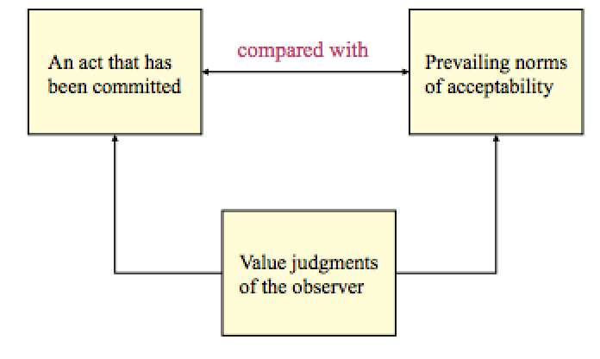

Deciding what is ethical:
- Ethical dilemmas:
  - Situations where a decision must be made between two equally valid but mutually exclusive courses of action;
- What approaches exist to help make defensible ethical decision;
  - Otto Bremer: Four Questions;
    - What is (descriptive ethics)?
      - What is actually going on in an ethical sense (what is the real situation)
    - What ought to be (normative ethics)?
      - What managers should do;
    - How do we get from What IS to What Ought to Be?
      - How is the gap closed? May actually not be able to fully close the gap!
    - What is our motivation
      - What is the motive for being ethical;
  - Josephson: Bell, Book, Candle method;
    - Three tests:
      - “Listen for the bells warning you of an ethical decision (the “bell”);
      - Check to see if there are any laws, regulations or rules which restrict your choices (the “book”);
      - How will your decision look in the light – could a reasonable, fair-minded person conclude you acted improperly? (The “candle”);
  - Nash;
    - Have you defined the problem accurately?
    - How would you define the problem if you stood on the other side of the fence?
    - How did this situation occur in the first place;
    - To whom and to what do you give your loyalty as a person and as a member of the corporation?
    - What is your intention in making this decision?
    - How does this intention compare with the probable results?
    - Whom could your decision or action injure?
    - Can you discuss the problem with the affected parties before your make your decision?
    - Are you confident that your position will be as valid over a long period of time as it seems now?
    - Could you disclose without qualm you decision or action to your boss, your CEO, the Board of Directors, your family, society as a whole?
    - What is the symbolic potential of your action if understood? If misunderstood?
    - Under what conditions would you allow exceptions to your stand?
  - Pagano;
    - Is it legal?
    - The benefit cost test (the greatest good for the greatest number?)
    - The categorical imperative (Do you want this action to be a universal standard?);
    - The light of day test (What is your actions appeared on TV?);
    - Do unto other (Do you want the same to happen to you?);
    - The ventilation test (Get a second opinion from someone with no investment in the outcome);
  - Integrated ethical decision model;
    - What exactly is the decision?
      - Does the decision involve doing what is right, just, and fair?
    - Is the decision a matter of ethics?
      - Does the decision cause the decision-maker to reflect on personal morals, vales, duties, goals, norms, and beliefs;
    - If the answer of both questions are yes, then this decision is a matter of ethics;
      - Precisely articulate the decision(s) to be made.
    - Decisions and “decisions outcomes”:
      - Decision X, Y, Z
        - Is it legal?
    - Who are the key stakeholders impacted by this decision?
    - Do you believe the decision is right, just and fair for the majority of key stakeholders?
    - Deontological test:
      - Is the decision consistent with my ideals for behaviour, the behaviour other have a right to expect of me, and my sense of duty?
    - Teleological test:
      - Does the decision produce the best outcome for the greatest number, or the worse outcome for the fewest number?

Importance of business ethics
- Business ethics helps business understand how to deal with:
  - The uneasiness of many public stakeholders with the growing power and influence of business in society;
  - Providing significant contributions to society;
  - Mitigate business malpractices with the potential to inflict harm on individuals, communities, and the environment;
  - Increasingly complex demands to be ethical;
  - Formalizing business ethics, given that few business people receive formal ethics training or education;
  - Ethical violations that continue to occur in business across countries;
  - How to asses the benefits and problems associated with different ways of managing ethics in organizations;
  - Issues that transcend the traditional framework of business studies and confront some of the most important questions faced by society;

Ethical perspectives and challenges;
- Ethical decisions make good business sense but can be complicated by:
  - Globalization – managers from diverse cultures and backgrounds doing business in different geographic locations governed by different laws and customs;
  - Accountabilities – In 2008, Greece’s GDP was about the same as Wal-Mart’s revenues (US$4 billion): but the stakeholders affected by Wal-Mart decisions have comparatively little on the company compared to shareholders;
  - Technology – Internet technology for sales, research, distribution, promotion: what type of information is being collected and for what purposes?

Lecture 8 ~ Business’s Influence on Government

Public-Private-Partnership (3Ps)
- Ex: Paramedics;
- Both sides come out a winner

Business-Government Relations
- The prevailing view that business and government rarely agree and that each is of the view the other “doesn’t get it”;
- Understanding one another:
  - Does business understand government?
  - Does government understand business?
  - Recall: unique characteristics of government:
    - Multiplicity of goals, difficulty in measuring performance, need to address difficult problems, multiple accountabilities, public visibility, many stakeholders, complexity;

- How can this difference be explained?
  - Some models:
    - Jane Jacob’s “Two-Syndromses”;
      - The “guardian value syndrome” vs. the “commercial value syndrome”;
      - Government as the “guardian”;
        - Collectivist;
        - Public interest;
        - Risk averse;
          - How to avoid the most losses;
      - Business as the “commercial”
        - Individualist;
        - Private interest;
        - Risk tolerant (may lead to reward)
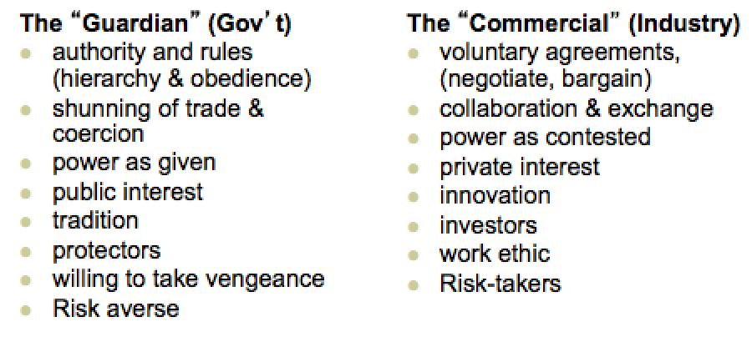
    - W. T. Stanbury
      - What makes government/business act like they do;
      - Slightly oversimplified model;
      - Factors affecting business and its success
        - Nature of relations between business and its primary stakeholders (government could be one);
        - Extent of government intervention in the sector;
        - The degree to which government actions determine success or failure;
        - Characteristics of members in the business interest group;
        - The perceptions of the public;
      - Factors affecting government;
        - Size of government’s majority;
        - Regional distribution of seats in the legislature;
        - Actions of other governments;
        - Prevailing extent of government intervention instruments;
        - Behaviour in the media;
        - Legal and constitutional allocation of powers between different levels of government;
        - Action of opposition parties;
        - Public opinions, attitudes and perceptions;
      - Framework:
        - Two Worlds ~ Business and government;
          - Consistent with Jacobs;
        - Different variables/ processes/ factors;
          - Policy evolves along different trajectories;
            - Exogenous and endogenous factors;
        - They clash in the “Policy area”;
          - Business “lobbying” government;
          - Government “regulating business;
        - Portrait of business facing off against government, strategizing within environmental constraints to shape outcomes according to their preferences and priorities;
        - Each sector always attempting to protect and further its own interests – confrontational model;

- Business-government relations – The result;
  - Business is different from government;
  - Business and government are influenced by different factors;
  - Public policy results from a series of processes and influences;
  - Expecting each segment to fully understand the other is perhaps ambitious (but reasonable to expect each segment to better understand each other);
  - Notwithstanding business-government “differences” today, senior managers of major corporations generally believe the worse possible strategy is to take positions that would be perceived by the public as unresponsive to social interests;
  - Social interests, of course, are represented by government;
  - Senior executives spend considerable time in four external areas:
    - Meetings with elected officials;
    - Dialoguing with regulatory personnel;
    - Maintaining relations with the corporations various constituents (stakeholders);
    - Overseeing communications with the public.

Functions of a Government relation department
- Legislative monitoring and analysis;
- Regulatory agency liaison and response;
- International legislative monitoring and analysis;
- Domestic and international market development assistance;
- Trade association liaison;
- Political analysis and response;
- Government information services;
- Relations with think tanks and public interest groups;

Fundamental errors
- Dealing only with the politicians;
- Approaching the government at the wrong time;
- Providing tome-like reports to politicians;
- Wading n on an issue too late;
- Assuming influence is directly proportional to company size;
- Using an unprepared disorganized and uncoordinated approach;
- Reacting to government on an issue-by-issue basis;
- Hot topic stock options;

Lobbying
- An activity directed at decision makers, carried out on behalf of special interests to influence public policy outcomes;
- A communication with public officials to influence their decisions in a manner harmonious with the interests of the individual or group communicating;
- “Ask”;
  - Procurement
    - $13 billion per year on goods and services
  - Freebies;
    - Grants and contributions;
  - Policy
    - Most common and complicated;
Policy Rule | Context | Key Challenge
Good rules | The rule is acceptable but the interpretation is not | Getting the government to interpret the rule differently
Bad Rules | The existing rule is not acceptable | Getting the government to drop the rule
New Rules | You are propsing a new rule | Getting the government to adopt the new rule
Sad Rules | The current rule is obsolete and must be changes | Getting the government to change the rule
    - Policy concerns the “rules” that frame and influence the business environment;
    - Joe Jordon – 4 types of rules:

Complication of “Policy”
 | No. Of Words
Pythagorean Theorem | 24
Gettysburg Address | 286
Declaration of Independence | 1,300
Charter of Rights & Freedoms | 2,609
Regulations on the Sale of Cabbage | 26,911
The Lobbying Act
- On December 12. 2006 the Federal Accountability Act received Royal Assent.
- Among the changes that this act makes to Federal statues are several relating to the Lobbyists Registration Act (LRA), which is currently in force;

“Lobbying” defined in the Act
- The Act now states that lobbying will consist of “any oral or written communication made to a public office holder”;

Types of Lobbyists
- Consultant lobbyists:
  - Consultants who are paid to lobby on behalf of clients;
  - They may be
    - Consultants in public relations, or in marketing;
    - Lawyers, notaries, engineers or accountants whose functions include lobbying;
- In-house lobbyists (corporations and organization);
  - These are salaried employees of either corporations or non-profit organizations who lobby on behalf of their employer;
- There are approximately 7, 483 registered lobbyists in Canada of which 5, 322 are active;

Types of Issues: Strategic vs. Operational
- Proactive (one step ahead) vs. reactive (react after the law has been passed);
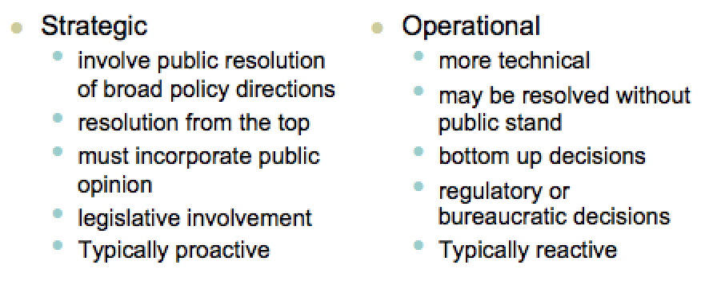
What do lobbyists do?
- Be informed of emerging legislation that could affect their clients or organization;
- Be knowledgeable of the position of key players on the issue;
- Be credible with good contacts;
- Understand the issue from several perspectives;
- Understand the public policy process;
- Prepare the client to lobby – not lobby for the client;
Direct lobbying occurs through
- Formal an informal meetings;
- Submission of briefs and policy papers;
- Appearances before parliamentary committees;
- Telephone calls;
- Written mail;
- E-mail, petitions, alliance and coalition building;
- Organization of protests;
- Litigation;

Indirect lobbying occurs through
- Advocacy advertising;
  - A special type of lobbying effort;
  - Any kind of paid public communication or message, from an identified source and in a conventional medium of public advertising, which represents information or a point of view bearing on a publicly recognized controversial issue;
    - Designed to sell ideas, not products or services;
    - Aimed directly at policy makers or at some segment of public opinion;
    - Ultimate objective is to influence public opinion and public policy on an item that is of importance to the advertiser;
  - Five Key targets:
    - Key stakeholders;
    - Politicians and public servant advisors;
    - Media influencers;
    - Influential intellectual leaders;
    - Politically aware persons with influence;
- Funding think tanks;
  - An indirect lobbying technique;
  - An organization or group of experts researching and advising on issues of society, science, technology, industry or business;
    - Academic;
    - Contract;
    - Advocacy;
  - Approximately 46 Canadian think tanks;
  - Usually the message is given in the title of the think tank;
    - Usually adds a lot of credibility if the name appeals to the heart;
    - Message is usually slanted to begin with;
  - Importance is increasing;
    - Policy issues are increasingly complex and require a full knowledge contribution from all stakeholders;
    - Present networking opportunities for business and government;
Type of think tank | Funding paradigm | How agenda is set | Nature of research
Academic | Endowments, grants, organizations, private individuals | Researchers play a large role | Idea-driven; long-term, future oriented. Disinterested. Distribute social science research findings to serve all humanity
Contract | Primarily government contracts | Government needs | Driven by government contractor needs; long-term future-oriented but findings distributed primarily to contract authority
Advocacy | Constituents play a significant role | Driven by ideology | Short-term focus; ideologically driven research with findings distributed to constituents

The lobbying strategy
- Frame the issue (strategic, operational, or both?);
- Position the issue in the sector (important only to your firm or other firms in your sector?);
- Whom to lobby? (Politicians, bureaucrats, or both?);
- Which lobbying approach? (Direct, indirect?);
- How long? (Timing is key – how long will your lobbying effort last?);
- Resources? (People, organizations/collaborators, money);
- Contingency plan (What is plan B in the event of a sudden change in policy direction, Minister, Bureaucrats?);

Business’s influence on civil society;
- Funding;
- Encouraging employee participations;
- Knowledge transfer;
- Network opportunities;

Lecture 9 ~ Government’s influence

Government’s influence on business
- Regulation
  - The imposition of constraints, backed by the authority of government, that are intended to modify economic behaviour in the private sector significantly;
  - According to the Cabinet Directive of Streamlining Regulation, 2007, p. 1, in regulating, the federal government seeks to;
    - Protect and advance the public interest;
    - Promote a fair and competitive market economy;
    - Make decisions based on hard evidence and the bet available knowledge;
    - Create regulation that is accessible, understandable and responsive;
    - Advance the efficiency and effectiveness of regulation;
    - Require timeliness, policy coherence, and minimal duplication;
  - Types of regulations;
    - Market failures;
    - Social regulation;
      - Focuses on firm’s impacts on people as employees, consumers, and citizens;
      - Addressing business practices in all industries;
      - Examples – Employment equity regulations, occupation health and safety regulation;
    - Political reasons;
      - For votes but also;
        - To appear as a leader in a matter of public policy (Kyoto);
        - In response to pressure from interest groups;
        - In response to pressure from the media;
- Non-regulatory forms of influence;
  - Government ownership
    - Crown corporations typically provide a service or product that the private sector would be unwilling or unable to provide;
      - Export develop corporation;
      - Canada post;
      - Canadian Wheat Board;

Other Corporate Interests | Description | Number
Mixed Enterprises | Corporate entities with share ownership split between the Government of Canada and private sector | 0
Joint Enterprises | Corporate entities with share ownership split between the Government of Canada and another level of government  e.g., The Lower Churchill Development Corporation Limited | 2
International Organizations | Corporate entities created pursuant to international agreements in which the Government of Canada either owns shares or has the right to appoint members to the governing body  e.g., International Monetary Fund | 18
Shared Governance Corporations | Corporate entities without share capital in which the Government of Canada has the right to appoint members to the governing body  e.g., The Canadian Wheat Board | 149
Corporations under the terms of the Bankruptcy and Insolvency Act | These corporations are partially own by the Government of Canada following receipt by a bankruptcy trustee | 45

- Government subsidies;
  - Either the direct transfer of cash to a recipient or the indirect transfer of benefits;
  - Either increase the supply of a product or the demand for a product or service – the resulting market prices affect competition;
  - $19 billion in subsidies to business in 2004 (Fraser Institute);
- Tax Policy;
  - Encourage investment in some activities, but not others;
  - Deductibility of business operating expenses;
  - Capital cost allowance policy;
  - Tax-credit policy;
- Government procurement
  - Government is a major purchaser of goods and services;
  - $13 billion annually;
  - Changes in procurement policy can significantly affect business;
- International trade
  - Negotiation of international tariff laws;
  - Non-tariff barrier elimination;
  - Strong proponent for Canadian business abroad;

- Industrial policy/strategy;
  - Any attempt by government to apply a coherent and consistent set of policies that are designed to improve the performance of the economy;
    - Framework policies;
    - Concentration-based strategies;
    - Intervention

Theories of regulation
- Market failure: responding to natural monopoly conditions
  - Monopoly a market controlled by one supplier;
  - Considered “natural” when the economies associated with large scale production make It inefficient for more than one firm to operate;
    - Per=unit production costs decrease as the firm’s size increases;
  - If unregulated, production can be restricted and prices increase;
- Market failure: Use of natural resources:
  - A “common resource” needs to be used sensibly;
  - Where many producers draw from a common pool – the fisheries for example – no single produce will have an economic incentive to conserve;
- Market failure: Externalities;
  - Spill-over effects – costs imposed on other people;
    - Ex: pollution;
  - In the absence of regulation compelling the polluter to minimize pill-over effects, they would have little incentive to do this on their own;
- Market failure: Inadequate information
  - Insufficient information with which to make informed decisions in the marketplace;
  - Free availability of product safety information – companies have little incentive to do this on their own;
- Market failure: Public Goods;
  - Public Goods goods that generate social benefit that everyone can enjoy and that no one can be deprive of;
    - Ex: clean air, national defense;
  - Government provides these services to all Canadians (funded through tax dollars);
- Market Failure: Moral Hazard
  - A party insulated from risk may behave differently than if exposed to the full risk;
  - In the context of economic regulation…

Spectrum of government influence

Self-regulation
Voluntary Action/ Self-imposed standards
Procurement and contracting
Taxation and Subsidies
Government Regulation
Government Ownership

Government’s influence of civil society
- Direct funding;
- Tax policy;
- Contracts;
- Knowledge transfer;
- Alternative service delivery mechanisms;

Lecture 10 – Civil Society’s Influence

Civil society’s three main objectives
- To inspire;
- To inform;
- To persuade;

Drivers of the Importance of Civil Society
- Increasingly culturally diverse Canadian population introducing new demands that fall outside the purview of government or business (to improve);
- Information Communications Technology enables civil society to being instantaneous attention to its causes and issues (to inspire; to inform);
- Stakeholders expect business and government to engage with civil society (to improve)
- Complexity of civil society issues (to improve; to inspire; to inform);

Changes in the relationships between business and the not-for-profit segment
Cause response
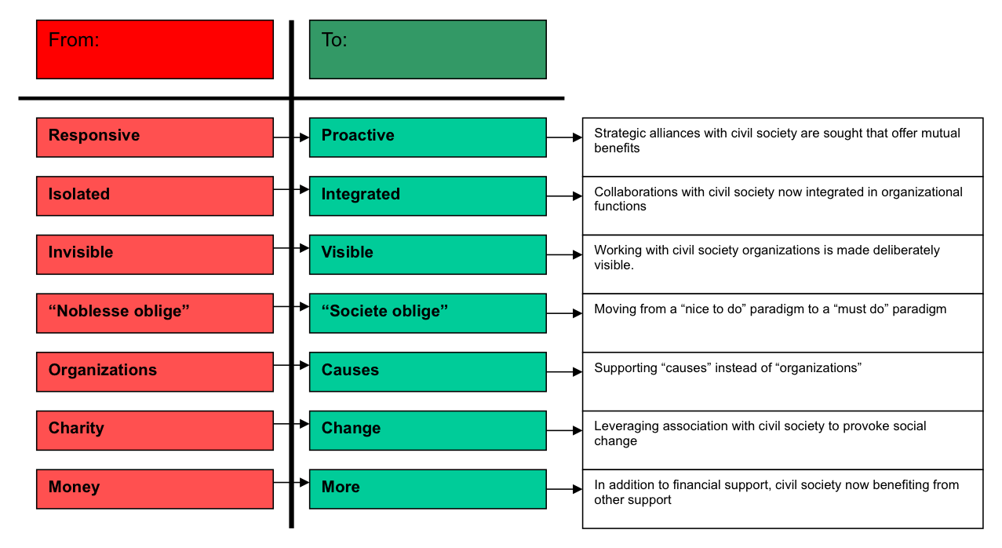

Civil Society’s “Tool Chest” of Influence on Business and Government;
- Publishing
  - Print, on-line;
- Social network participation;
- Lobbying
  - Direct; indirect advocacy;
- Media campaigns;
- Demonstrations and protests;

Civil Society’s Supportive influence
- Neutral broker between government and business;
- Supplier of knowledge and skills (knowledge transfer);
- Source of workers;
- Intimate knowledge of community (closer to stakeholders);
- Citizen engagement venue;
- Social capital provider;
- Building image and buffering media;
- Alternative service delivery methods and new models of community engagement;
- Cause-related marketing venue;
- Awareness building;
- Public policy test environment;
- Distributor of information;
- Point of entry for citizens to engage in policy debates;

