Persuasion

Attitude = cognitive + affect + behavior

Persuasion – purposely changing someone’s existing attitudes or beliefs to fit a desired state

Persuasive Communication:
- Communication supporting a particular side of an issue – what you want them to believe
- Education – message could be good or right (i.e. Canadian government endorsing ‘going green’)
- Propaganda – message could be bad or wrong (i.e. Nazi government convinced people that Jews were inferior)

WHO Persuader - the one conveying the message
- Perceived expertise
- Perceived trustworthiness
- Attractiveness
- Speech – rapid or slow

WHAT Message content
- Reason vs. emotion
- Fear
- Discrepancy
- 1-sided vs. 2-sided argument

WHOM Target audience – ones receiving the message
- Intelligence and education
- Self-esteem
- Age

HOW Method of delivery
- Active vs. passive
- Personal vs. media
- Type of media

Elaboration Likelihood Model: focus on what is happening within the individual
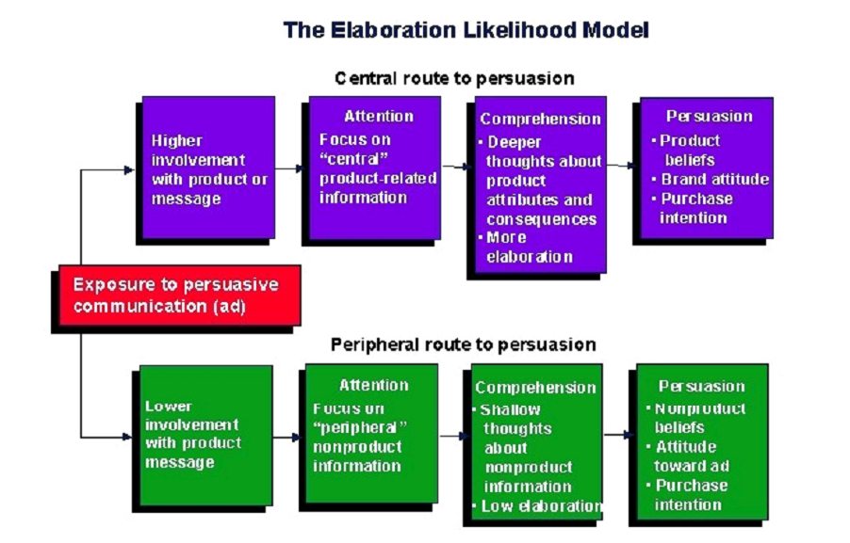

2 Ways to Persuasion:
- Central route
- Elaboration - thinking carefully about issue-relevant arguments contained in a persuasive message
- Message is specific and provides all relevant information
- Strong, long-term attitude change
- Peripheral route
- Accept or reject a message - without active thinking about the attributes of the issue of object of consideration
- Quick, cue-based decisions (i.e. financial, sexy, authority)
- Weak, short-term attitude change

Central vs. Peripheral:
- Central route processes the arguments of communication – requires motivation and attention
- Peripheral route is swayed by surface characteristics of communication – occurs with distracted audience

Is it easier to resist or accept a persuasive communication? Accept
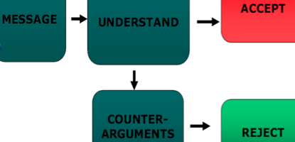

Resistance to Attitude Change:

How can we increase resistance to persuasive communication?
- Attitude inoculation, McGuire
  - Initial attitude weak opponent strong opponent
  - What are we doing to understand the argument? Information in a thoughtful or cognitive manner
  - Why does it work? Bring to mind pros and cons of existing attitude
  - Better prepared to defend against stronger persuasive communication
- Fear and attitude change
  - Can fear used to manipulate someone into changing their attitude? Yes and no
    - High fear – “a picture is worth 1,000 words” (i.e. picture of a lung decayed by cigarette smoke vs. one that has not been)
    - Moderate fear (i.e. the same formaldehyde that preserves dead frogs is found in cigarettes)
    - Low fear (i.e. Don’t smoke, it’s bad for you)
  - Moderate fear is most effective – increases attention to the message and is more relatable/realistic
  - Presenting information about how to reduce the fear increases effectiveness (i.e. how to quit smoking or avoid skin cancer)
  - Too much fear = denial; if there is no reasonable way to avoid the fear message, it can be overwhelming

Interpersonal Communication
Interpersonal communication – exchange of message across a communication channel from one person to another

3 Main Problems Areas: where things can go wrong and interfere with accurate communication of the message
- Intended message vs. message sent
Solutions:
- Thinking about what you want to communicate – often we don’t say what we mean because we are not sure what we want to say
- Practice what you want to communicate – changing tone of voice, altering first line or thinking of topics to discuss in advance
- Learn better communication skills – courses in public speaking, writing and interpersonal communication to better communicate effectively

- Message sent vs. message received
Factors:
- Actual words used – particular words may mean one thing to one person and something different to another; vague words or phrases give us a chance to “test the waters”
- Communication channels – orally, nonverbally, through a second party, written medium
  - Interpreted in different ways based on the channel used
  - Using an inappropriate channel may interfere with the message’s meaning or accurate interpretation
- Noise – any variable affecting the channel that interferes with the proper reception of a message (i.e. passing train, appropriateness of the channel, reputation of the person delivering the message, other information being received at the same time)
- Nonverbal cues:
- Body language – use of appropriate nonverbal communication is highly correlated with interview scores
- Paralanguage – the way we say things (i.e. tone, tempo, volume, number and duration of pauses, rate of speech)
- Use of space – status figures are given more space, take space from others and increase space to establish differences between themselves and the people they are dealing with
- Use of time – tardiness is more accepted from a higher-status person
- Artifacts
  - Open desk arrangement – desk against a wall so a visitor can sit next to the person who sits behind the desk; perceived as more comfortable and their occupants as friendlier, trustworthy, open, interested and extraverted
  - Closed desk arrangement – desk is placed so visitor must sit across from the person behind the desk
- Amount of information:
  - Leveled – describing a message where it’s unimportant details have been removed before the message is passed on
  - Sharpened – describing a message where interested and unusual information has been kept when it is passed on
  - Assimilated – description of a message where the information has been modified to fit the existing beliefs and knowledge of the person sending the message before it is passed on

Gender Differences in Communication, Tannen 2001
Men | Women
- Talk about major global events  - Tell the main point  - More direct  - Use “uh-huh” to agree  - Comfortable with silence  - Concentrate on words spoken  - Sidetrack unpleasant topics | - Talk about daily life  - Provide details  - More indirect  - Use “uh-huh” to listen  - Less comfortable with silence  - Concentrate on meta-messages  - Focus on unpleasant topics

Superiority in body language = interrupting others, leaning back in a chair, moving closer to someone or sitting while others stand

Body language when people lie - more likely to purse their lips, raise their chin, fidget and show nervousness.

Paralanguage when people lie – talk less, provide fewer details, repeat words and phrases, more uncertainty and vocal tension, and speak in a higher pitch

McElroy, Morrow and Ackerman, 1983 – personality of faculty members who had open desk arrangements were more extraverted, “people oriented”, had lower external locus of control and scored high on the Least-Perferred Coworker Scale

Zweigenhaft, 1976 – older, higher-status faculty members used closed desk arrangements and were evaluated less favorably in the classroom

Reactions to Communication Overload: adapting or adjusting to reduce the stress
- Omission – conscious decision not to process certain types of information; only works if overload if temporary
- Error – a response to communication overload by processing all information but unintentionally processing some of it incorrectly
  - Probability of error can be reduced by: making the message redundant (i.e. writing a memo to summarize the major points) and to have the recipient verify the message (i.e. repeat or acknowledging that they have read and understood it)
- Queuing – a method to cope with communication overload by organization work into an order that it can be handled; based on the message’s importance, timeliness or sender; only effective if overload is temporary
- Escape – a response to communication overload where employee leaves the organization due to stress (i.e. absenteeism, resignation, dropping out of a course)
- Using a gatekeeper – person who screens potential communication for someone else and allows only most important information to pass through (i.e. receptionists, secretaries)
- Using multiple channels – coping strategy of communication overload where an organization reduces the amount of communication to one person by directing some of it at another person (i.e. hiring a bookkeeper and assistant manager)
*Omission, error and escape can result in negative consequences for the organization.

- Message received vs. message interpreted
Factors:
- Listening skills
  - Most important communication skill a supervisor should master
  - 70% of a white-collar workday is spend communicating
  - Listening is a skill
  - Listening effectiveness is poor – immediately after a meeting, we only retail 50% of the material and 48 hours later, only 25%
- Listening style
  - Attitudinal Listening Profile, Geier & Downey 1980 – measure employee’s listening style based on 6 main styles
Leisure listening – “good-time” people who only listen for goods that indicate pleasure
Inclusive listening – listens for main ideas behind any communication; advantage when cutting through lots of details but disadvantage if those details are important
Stylistic listening – listens to the way the communication is presented
Technical listening – hears and retains large amounts of detail but does not hear the meaning of those details
Empathic listening – tunes into feelings of the speaker and is most likely to pay attention to nonverbal cues
Nonconforming listening – cares only about information that is consistent with their way of thinking
  - Becoming aware of your own style allows you to understand the filter you use when listening to others
  - 6 styles can lead to better communication with others
- Emotional state – interpretation of a message can be affected by the receiver’s emotional state
- Cognitive ability – a person can receive a message exactly as it was sent but not be bright enough to understand it
- Personal biases – we process every piece of information that is consistent with our opinion

Improving Employee Communication Skills
Interpersonal Communication Skills:
- Training workshop conducted by an outside consultant – only bring ST improvement in skills
- Freston & Lease, 1987 – believed organization’s managers were not properly trained in communication
  - Designed training program that included seminars on awareness, nonverbal communication, assertiveness and listening
  - Used role play and group discussion

Written Communication Skills:
- Improving writer’s skills
  - Some consulting firms specialize in the improvement of employee writing by teaching employees most important concepts of writing
  - Broadbent, 1997 – writing can be improve when writers value what they write, set personal standards and goals, and spend time doing their own editing or getting others to
  - Employees need to analyze their audience (i.e. written communication is meant for a busy executive, message must be short)
- Making material easier to read
  - Smith & Christensen, 2007 – found a wide range of readability levels in written materials given to employees ranging from the 4th grade (memo to cooks) to 9th grade to 15th grade (sexual harassment policy)
  - “Plain talk” policy – documents must be written at a level that can be understood by the general public
  - Readability indices – an index to ensure employees will be able to understand written material; analyze written material and compares readability level with typical education of employees who will read the document (i.e. Fry Readability Graph, Flesch Index, FOG Index, Dale-Chall Index - all show reasonable reliability and correlate highly with each other)

Focus on Ethics: Ethical Communication
- Transparent communication – open and honest communication between employees and management regarding work-life issues
- Management may feel it is more ethical not to communicate possible layoffs to employees until they are absolutely sure
  - Management is not sure if layoffs would be necessary
  - May cause panic with employees
  - Employees may look for and take positions in other organizations
  - “Protects” employees from unnecessary stress
- Could cause problems for employees
  - If they are about to make some kind of financial decision (i.e. buying a house, car or vacation)
  - May have been offered another job and are deciding whether to stay or quit
  - 2008 Ethics and Workplace Survey – 84% of employees surveyed say that transparent communication leads to a more ethical workplace
- Employees’ responsibility to communication certain information to supervisors (i.e. searching for another job)

Chapter 12: Leadership

Introduction to Leadership
- Understanding theories and research behind leadership is important because the theory that company executives believe will determine how an organization selects or develops its managers
- i.e. believing people are “born leaders” because of their personality traits, needs or orientation led to selecting managers based on their scores on certain tests, theoretically should be able to train any employee to become an outstanding leader
- i.e. believing good leadership is the result of any interaction between types of behaviors and aspects of the situation, may teach leaders how to adapt behavior to meet the situation

Personal Characteristics Associated with Leadership
Leader emergence – people who become leaders possess traits or characteristics different from people who do not become leaders
- People are “born” with a desire to lead or not – genetic basis of 17-30%
- No “leadership gene” that influences leader emergence
- We inherit traits and abilities that influence our decision to seek leadership
- Meta-analyses of leader emergence and performance:
  - People high in openness, conscientiousness and extraversion and low in neuroticism are more likely to emerge as leaders
  - High self-monitors emerge as leaders
  - More intelligence people are more likely to emerge as leaders
  - Looking at patterns of abilities and personality traits is more useful than looking at single abilities and traits
- Lack of agreement on a list of traits consistently related to leader emergence due to complexity of motivation:
3 Aspects/Factors of Motivation, Chan and Drasgow 2001
  - Affective identity – motivation to lead as a result of a desire to be in charge and lead others; tend to have the most leadership experience and are rated by others as having high leadership potential
  - Non-calculative motivation – seek leadership positions when they perceive that it will result in personal gain (i.e. increase in status or pay)
  - Social-normative motivation – desire to lead out of a sense of duty or responsibility
- Individuals with high leadership motivation tend to obtain experience and have confidence in skills
- Bruce, 1997 – best way to select a CEO is to look for leadership qualities (i.e. risk taking, innovation, vision) and success early in a person’s career
- Meta-analyses of gender
  - Men and women emerge as leaders equally often in leaderless group discussions
  - Men emerge as leaders in ST groups and groups carrying out tasks with low social interaction
  - Women emerge as leaders in groups involving high social interaction
  - Historically, women are excluded from highest levels of leadership and power in politics and business

Leader performance – leaders who perform well possess certain characteristics that poorly performing leaders do not

Relationship between personal characteristics and leader performance:
- Traits
- Extraversion, openness, agreeableness and conscientiousness were positively related to leader performance
- Youngjohn & Woehr, 2001 – management, decision-making and oral-communication skills were highly correlated with leadership effectiveness
- Self-monitoring – focuses on what leaders do, not what they are (i.e. high self-monitor leader who is shy may adapt outward behavior to appear outgoing and confident)
- Certain traits are necessary requirements for leadership excellence but do not guarantee it
  - Leadership excellence is a function of the right people in the right place at the right time

- Needs
- Argus & Zajack, 2008 – significant relationship between need for achievement and leader performance
- High-performance managers have a leadership motive pattern – high need for power and low need for affiliation
  - Not personal power but organizational power
  - Important because it implies that an effective leader should be concerned more with results than with being liked
  - Leaders with high affiliation needs may want to be more liked than successful, causing conflict with organizational decisions
  - Explains why internal promotions do not work
- Thematic Apperception Test (TAT) – projective personality test designed to measure various need levels; subject is shown a series of pictures and asked to tell a story about what is happening in each
- Job Choice Exercise (JCE), Stahl & Harrell 1982 – read descriptions of jobs that involve various degrees of power, achievement and affiliation needs and rate how desirable each sounds

- Orientation – differences in leader performance can be attributed to differences in the extent to which leaders are task vs. person oriented
3 Major Schools of Thought
- Ohio State Studies
- Theory X
- Managerial Grid

Cognitive ability:
- Significant corrected correlation between cognitive ability and leadership performance
- Most important when the leader is not distracted by stressful situations and uses a more directive leadership style
- Sternberg, 2007 – key to effective leadership is the synthesis of 3 variables: wisdom, intelligence (academic and practical) and creativity
Gender:
- Men and women do not differ in leadership effectiveness – but women are more likely to engage in behaviors associated with high-quality leadership
- Men are more effective leaders in traditionally-defined masculine situations and where majority of subordinates were men
- Women are more effective leaders in situations traditionally-defined as less masculine

Leadership Models:
- Authoritarian – leader users strong, directive, controlling actions to enforce the rules, regulations, activities and relationships in the work environment
- Sets goals individually
- Engages primarily in 1-way, downward communication
- Controls discussions of followers
- Sets policy and procedures unilaterally
- Dominates interaction
- Personally directs completion of tasks
- Provides infrequent positive feedback
- Rewards obedience and punishes mistakes
- Exhibits poor listening skills
- Uses conflict for personal gain

Democratic – leader takes collaborative, responsive, interactive actions with followers concerning the work and the work environment
- Involves followers in setting goals
- Engages in 2-way, open communication
- Facilitates discussion with followers
- Solicits input regarding determination of policy and procedures
- Focuses interaction
- Provides suggestions and alternatives for the completion of tasks
- Provides frequent positive feedback
- Rewards good work and uses punishment only as a last resort
- Exhibits effective listening skills
- Mediates conflict for group gain

Laissez-faire – leader fails to accept the responsibilities of the position
- Allows followers free rein to set own goals
- Engages in non-committal, superficial communication
- Avoids discussion with followers to set policy and procedures
- Avoids interaction
- Provides suggestions and alternatives for the completion of tasks only when asked to do so by followers
- Provides infrequent feedback of any kind
- Avoids offering rewards/punishments
- Poor or effective listening skills
- Avoids conflict

- Task vs. Interpersonal:
Task orientation
- Circulates information
- Ignores positions, ideas and feelings of others
- Rigid, stylized communication
- Interrupts others
- Makes demands
- Focus on facts, data and information as they relate to tasks
- Emphasis on productivity through acquisition of technical skills
- Communicates in writing – most of the time
- Maintains a “closed door” policy

Interpersonal orientation
- Solicits opinions
- Recognizes the positions, ideas and feelings of others
- Flexible, open communication
- Listens carefully to others
- Makes requests
- Focus on feelings, emotions and attitudes as they relate to personal needs
- Emphasis on productivity through acquisition of personal skills
- Communicates orally most often
- Maintains an “open door” policy

Generations:
- Veterans 1922-1943 52 million born
- Gain their trust
- Respect their experience

- Baby boomers 1944-1960 73 million
- Show appreciation of work
- Involve in decision-making
- Offer opportunities to serve as mentors

- Generation Xers 1961-1980 70 million
- Be honest
- Respect sense of work-life balance
- Respect their experiences

- Generation Nexters 1981-today 70 million
- Provide structure and leadership
- Clarify long-term goals
- Offer mentoring programs

Audit Your Organization Cultures:
“Organizations don’t have one culture. They have as many as they have supervisors or managers. Hold every manager accountable for the culture that he or she builds.”

Why is it important to find opportunities in the disruptions rather than just to lament the change? Provides opportunity for dialogue, positive action, finding solutions

Why is it good to have good communication if you want to build good human capital in an organization? Co-constructive to sharing knowledge, foster sense of belonging and community, effective commitment, becoming a team
Results in: increased morale, lower turnover and absenteeism

Studies that Identified Communication Patterns of Leaders:
- Michigan Leadership Studies
- Conducted shortly after WWII
- 1-dimensional
- 2 basic leadership styles: production oriented and employee oriented
- Building block for new leadership studies

- Ohio State Leadership Studies
- After WWII
- Measured specific leader behaviors
- Identified 2 dimensions: consideration and initiating structure
- A leader could possess varying amounts of both dimensions

- McGregor’s Theory X and Theory Y - MIT professor identified 2 approaches to supervision

- Blake & McCanse’s Leadership/Managerial Grid
- Person-oriented leaders
  - i.e. country club leaders, Theory Y leaders
  - High in consideration - act warm and supportive
  - Show concern for subordinates
  - Believe employees are intrinsically motivated, seek responsibility, self-controlled and do not dislike work
  - Consult subordinates before making decisions, praise their work, ask about their families, do not look over their shoulder and use a “hands-off” approach
  - Under pressure, are socially withdrawn
  - Tend to appreciate humor
- Task-oriented leaders (i.e. task-centered, Theory X)
  - High in initiating structure – define and structure their own roles and their subordinates to attain the group’s formal goals
  - Believe employees are lazy, extrinsically motivated, wanting security, undisciplined and avoiding responsibility
  - Manage by giving directions, setting goals and making decisions without consulting subordinates
  - Under pressure, they are anxious, defensive and dominant
  - Tend to produce humor
- Best leader = task and person oriented (team); satisfied and productive employees
- Worst leader = neither task or person oriented (impoverished); unhappy and unproductive employees
- Moderate amounts of both orientations (middle-of-the-road)
- Meta-analysis, Judge, Piccolo and Ilies 2004
  - High scores on consideration or initiating structure is associated with positive leadership criteria (i.e. follower satisfaction, group performance)
  - Bigger relationship between person orientation (consideration) and follower satisfaction, follower motivation and ratings of leadership effectiveness
- Leadership Opinion Questionnaire (LOQ) – filled out by supervisors who want to know their own behavioral style
- Leader Behavior Description Questionnaire (LBDQ) – completed by subordinates on how they perceive their leader’s behavior
- Eagly & Johnson, 1990 - women were more likely to have a person-orientation and less likely to have task-orientation; women were more likely to use participative approach and men to use autocratic
- Person-oriented leaders should have satisfied employees
- Task-oriented leaders should have productive employees
- Leader experience/knowledge and external variables (i.e. time pressures, work importance) moderate the relationship between:
  - Person-orientation scores and satisfaction
  - Task-orientation scores and performance
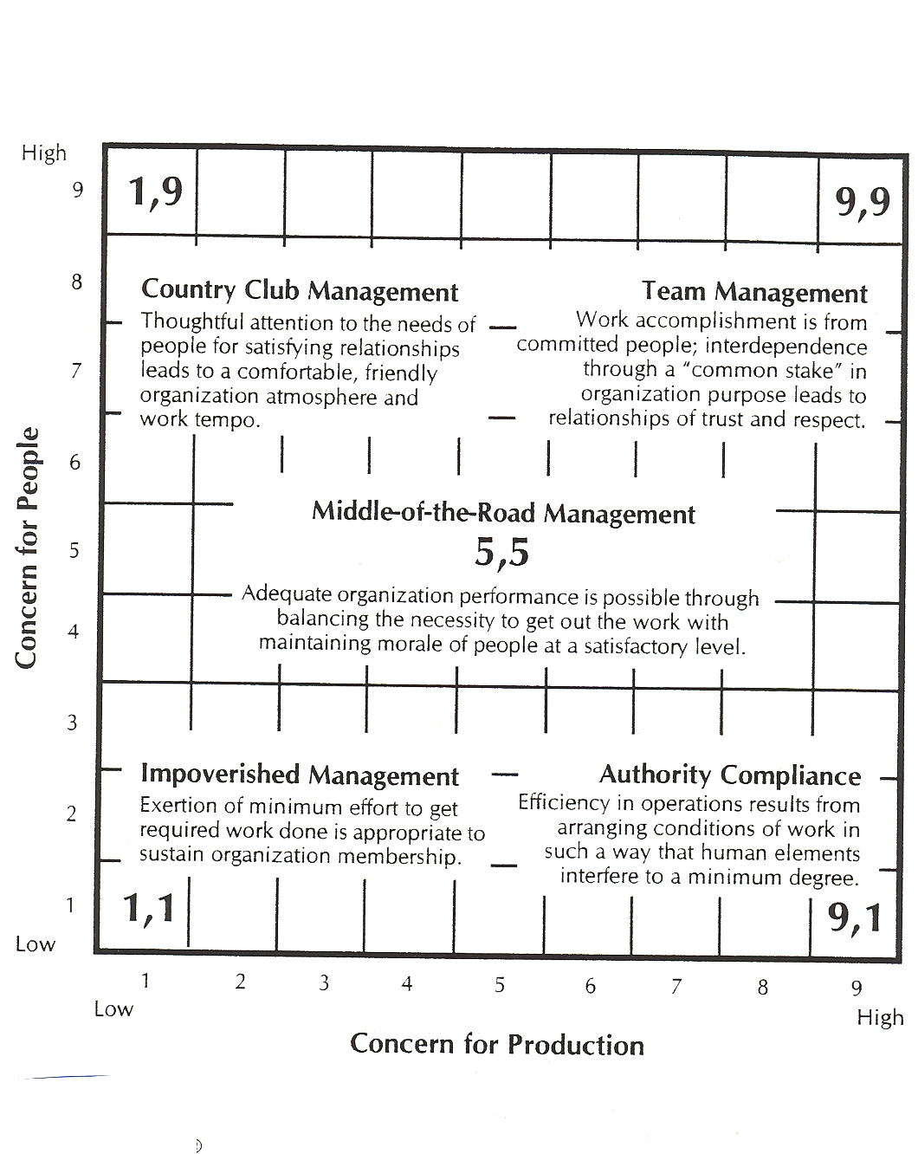

Unsuccessful Leaders:
3 Major Causes, Hogan, Raskin & Fazzini 1990
- Lack of training – most norm for organizations is to promote a current employee or hire a new employee and if training is provided, it us after the promotion and well after supervisor as begun supervising

- Cognitive deficiencies – poor leaders are unable to learn from experiences or think strategically; make the same mistakes; do not plan ahead

- Personality – unsuccessful leaders are insecure and adopt 1 of 3 personality types
  - Paranoid/passive-aggressive
- Feel betrayed
- Deeply-rooted and perhaps unconscious, resentment and anger
- Charming, quiet and usually compliment their subordinates
- Resent success of others and act against subordinates in passive-aggressive manner
  - High-likability floater
- Goes along with the group, friendly to everyone and never challenges anyone’s ideas
- Many friends and no enemies
- Will be promoted but never fired even though they make no great performance advances
- High morale but low performance
  - Narcissist
- Overcome their insecurity by their overconfidence
- Like to be the centre of attention
- Promote own accomplishments
- Take most or all of the credit for success of the group but avoid blame for failure

Beliefs of an Old Leadership Paradigm:
- Leaders are born, not made
- Efficient management = successful organizations
- Failure must be avoided at all costs
- People in positions of authority must have all the answers to be true leaders
- Must control people to accomplish goals
- An effective manager’s job is to watch, measure and define what is best for other workers

Kelley’s Characteristics of Followership:
- Alienated followers
- Conformists
- Pragmatists
- Passive followers
- Exemplary followers

4 Requirements of Partnership:
- Exchange of purpose – joint sense of purpose
- Right to say no – not a command and control environment
- Joint accountability
- Absolute honesty

DePree’s Suggestions on Leadership:
- Could create negative environment preventing followers from growing
- Give good training and access to all relevant information
- Make followers feel needed
- Successfully managing change is essential for survival
- Listen and help, especially when they don’t like what they hear
- Fair in providing resources and in evaluation of followers

