- Chapter 5 – Stress

- 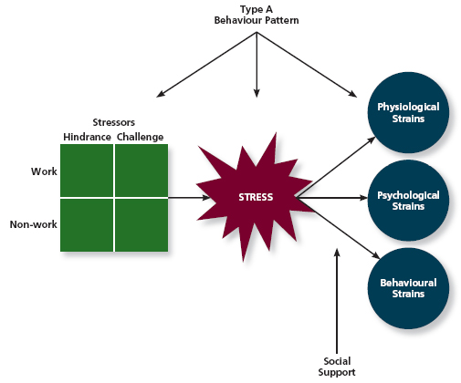

- Stress refers to the psychological response to demands when there is something at stake for the individual and coping with these demands would tax or exceed the individual's capacity or resources. Stressors are the demands that cause the stress response, and strains are the negative consequences of the stress response.

- stress The psychological response to demands when there is something at stake for the individual, and when coping with these demands would tax or exceed the individual's capacity or resources

- Stressors come in two general forms: challenge stressors, which are perceived as opportunities for growth and achievement, and hindrance stressors, which are perceived as hurdles to goal achievement. These two stressors can be found in both work and non-work domains.

- stressors Demands that cause the stress response

hindrance stressors Stressors that tend to be appraised as thwarting progress toward growth and achievement
- WORK INCLUDES
- role conflict Others' having differing expectations of what an individual needs to do in a role
- role ambiguity A lack of direction and information about what needs to be done in a role
- role overload An excess of demands on an employee preventing him or her from working effectively
- daily hassles Minor day-to-day demands that interfere with work accomplishment

- NON WORK INCLUDES
- work–family conflict A form of role conflict in which the demands of a work role hinder the fulfillment of the demands in a family role (or vice versa)
- negative life events Events such as a divorce or death of a family member that tend to be appraised as a hindrance
- financial uncertainty Uncertainties with regard to the potential for loss of livelihood, savings, or the ability to pay expenses

- challenge stressors Stressors that tend to be appraised as opportunities for growth and achievement
- WORK INCLUDES
- time pressure The sense that the amount of time allotted to do a job is not quite enough
- work complexity The degree to which job requirements tax or just exceed employee capabilities
- work responsibility The number and importance of the obligations that an employee has to others

- NON WORK INCLUDES
- family time demands The amount of time committed to fulfilling family responsibilities
- personal development Participation in activities outside of work that foster growth and learning
- positive life events Events such as marriage or the birth of a child that tend to be appraised as a challenge

- 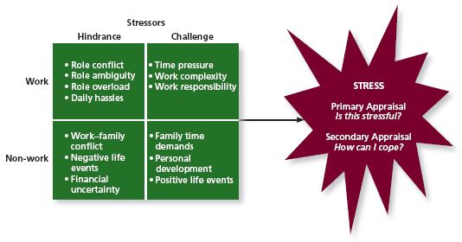strains Negative consequences of the stress response

- transactional theory of stress A theory that explains how stressful demands are perceived and appraised, as well as how people respond to the perceptions of appraisals
- primary appraisal Evaluation of whether a demand is stressful and, if it is, the implications of the stressor in terms of personal goals and well-being
- secondary appraisal When people determine how to cope with the various stressors they face
- benign job demands Job demands that are not appraised as being stressful

- Coping with stress involves thoughts and behaviours that address one of two goals: addressing the stressful demand or decreasing the emotional discomfort associated with the demand.
- coping Behaviours and thoughts used to manage stressful demands and the emotions associated with the stressful demands
- behavioural coping Physical activities used to deal with a stressful situation
- cognitive coping Thoughts used to deal with a stressful situation
- problem-focused coping Behaviours and cognitions of an individual intended to manage the stressful situation itself
- emotion-focused coping Behaviours and cognitions of an individual intended to help manage emotional reactions to the stressful demands

- 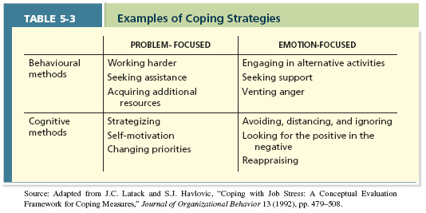
- Individual differences in the Type A Behaviour Pattern affect how people experience stress in three ways. Type A people tend to experience more stressors, appraise more demands as stressful, and be prone to experiencing more strains. Another individual factor is the degree of social support that is experienced.

- 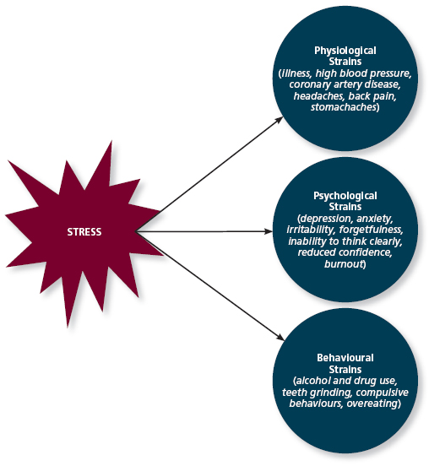
- physiological strains Reactions from stressors that harm the human body
- psychological strains Negative psychological reactions from stressors such as depression, anxiety, and anger
- burnout The emotional, mental, and physical exhaustion from coping with stressful demands on a continuing basis
- behavioural strains Patterns of negative behaviours that are associated with other strains

- Type A Behaviour Pattern People who tend to experience more stressors, to appraise more demands as stressful, and to be prone to experiencing more strains

- The way people handle stress is influenced by
- social support The help people receive from others when they are confronted with stressful demands
- Breaks into
- instrumental support The help people receive from others that can be used to address a stressful demand directly

emotional support The empathy and understanding people receive from others that can be used to alleviate emotional distress from stressful demands

- The effects of stress depend on the type of stressor. Hindrance stressors have a weak negative relationship with job performance and a strong negative relationship with organizational commitment. In contrast, challenge stressors have a weak positive relationship with job performance and a moderate positive relationship with organizational commitment.

- 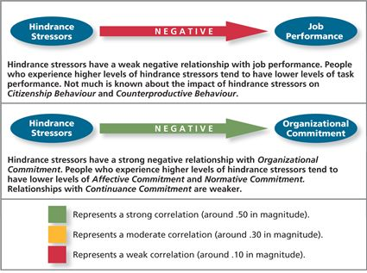
- 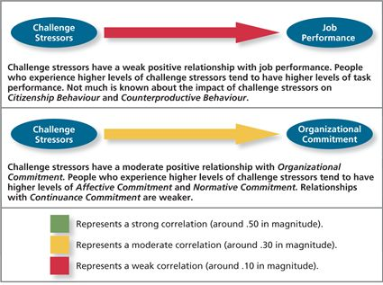
- Because of the high costs associated with employee stress, organizations assess and manage stress using a number of different practices. In general, these practices focus on reducing or eliminating stressors, providing resources that employees can use to cope with stressors, or trying to reduce the strains.
- Managers first do a
- stress audit An assessment of the sources of stress in the workplace
- if managers find stress they can use:
- job sharing When two people share the responsibilities of a single job
- employee sabbaticals. A sabbatical gives employees the opportunity to take time off from work to engage in an alternative activity.
- For challenge stressors,
- or for hinderance stressors they can use
- training interventions Practices that increase employees' competencies and skills
- and/or
- supportive practices Ways in which organizations help employees manage and balance their demands
- 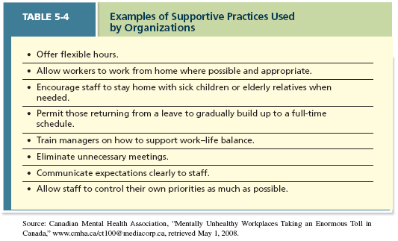

- Managers can also target strains rather than stressors and use
- relaxation techniques, such as progressive muscle relaxation, meditation, and miscellaneous calming activities like taking walks, writing in a journal, and deep breathing
- cognitive–behavioural techniques Various practices that help workers cope with life's stressors in a rational manner
- health and wellness programs Employee assistance programs that help workers with personal problems such as alcoholism and other addictions

- Chapter 6 – Motivation
- 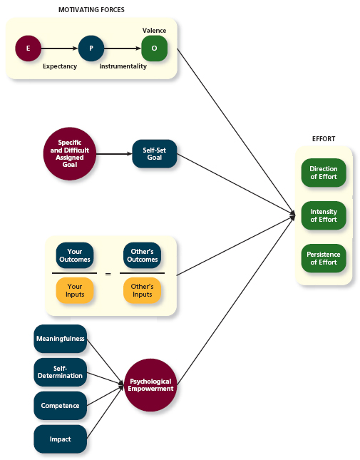

- Motivation is defined as a set of energetic forces that originates both within and outside an employee, initiates work-related effort, and determines its direction, intensity, and persistence.

- motivation A set of energetic forces that determine the direction, intensity, and persistence of an employee's work effort
- 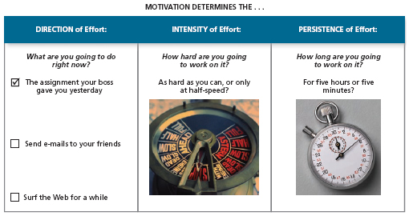
- High levels of Intensity and Persisance lead to engagement A widely used term in contemporary workplaces that has different meanings depending on the context; most often refers to motivation, but it can refer to affective commitment

- According to expectancy theory, effort is directed toward behaviours when effort is believed to result in performance (expectancy), performance is believed to result in outcomes (instrumentality), and those outcomes are anticipated to be valuable (valence).

- expectancy theory A theory that describes the cognitive process employees go through to make choices among different voluntary responses.
- The theory suggests that our choices depend on
- expectancy The belief that exerting a high level of effort will result in successful performance on some task
  - shaped by self-efficacy The belief that a person has the capabilities needed to perform the behaviours required on some task
- instrumentality The belief that successful performance will result in some outcome or outcomes
- valence The anticipated value of the outcomes(s) associated with successful performance
  - The degree of desire in an outcome is based on needs Groupings or clusters of outcomes viewed as having critical psychological or physiological consequences
  - 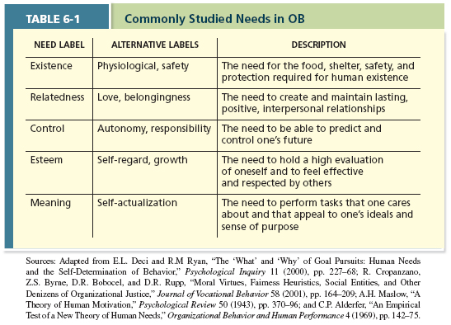

- meaning of money—the degree to which they view money as having symbolic, not just economic, value.⁴⁰ The symbolic value of money can be summarized in at least three dimensions: achievement (i.e., money symbolizes success), respect (i.e., money brings respect in one's community), and freedom (i.e., money provides opportunity).⁴¹

- According to goal setting theory, goals become strong drivers of motivation and performance when they are difficult and specific. Specific and difficult assigned goals affect performance by increasing self-set goals and task strategies. Those effects occur more frequently when employees are given feedback, tasks are not too complex, and goal commitment is high.
- 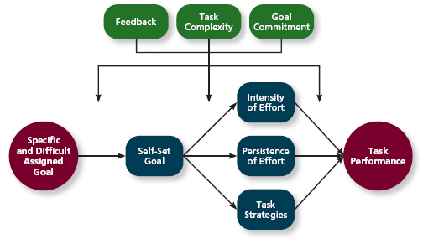
- goal setting theory A theory that views goals as the primary drivers of the intensity and persistence of effort
- specific and difficult goals Goals that stretch an employee to perform at his or her maximum level while still staying within the boundaries of his or her ability
- self-set goals The internalized goals that people use to monitor their own progress
- Moderators:
- feedback In goal setting theory, it refers to progress updates on work goals
- task complexity The degree to which the information and actions needed to complete a task are complicated
- goal commitment The degree to which a person is determined to reach the goal
- 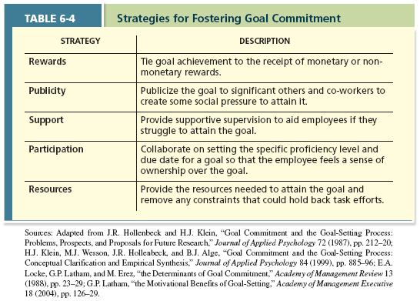
- S.M.A.R.T. goals Acronym that stands for Specific, Measurable,Achievable, Results-based, Time-sensitive goals

- According to equity theory, rewards are equitable when a person's ratio of outcomes to inputs matches those of some relevant comparison other. A sense of inequity triggers equity distress. Underreward inequity typically results in lower levels of motivation or higher levels of counterproductive behaviour. Overreward inequity typically results in cognitive distortion, in which inputs are reevaluated in a more positive light.

- equity theory A theory that suggests that employees create a mental ledger of the outcomes they receive for their job inputs, relative to some comparison other
- comparison other Another person who provides a frame of reference for judging equity
- 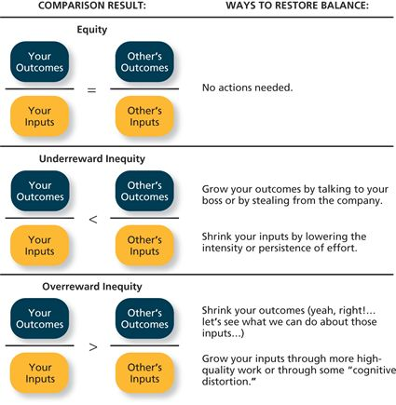
- ^^equity distress An internal tension that results from being overrewarded or underrewarded relative to some comparison other.
- Can be mentally solved by
- cognitive distortion A reevaluation of the inputs an employee brings to a job, often occurring in response to equity distress
- or changing your comparison other to either
- internal comparisons Comparing oneself to someone in your same company
- or
- external comparisons Comparing oneself to someone in a different company

- Psychological empowerment reflects an energy rooted in the belief that tasks are contributing to some larger purpose. Psychological empowerment is fostered when work goals appeal to employees' passions (meaningfulness), employees have a sense of choice regarding work tasks (self-determination), employees feel capable of performing successfully (competence), and employees feel they are making progress toward fulfilling their purpose (impact).
- psychological empowerment An energy rooted in the belief that tasks are contributing to some larger purpose

- meaningfulness A psychological state reflecting one's feelings about work tasks, goals, and purposes, and the degree to which they contribute to society and fulfill one's ideals and passions
- self-determination A sense of choice in the initiation and continuation of work tasks
- competence The capability to perform work tasks successfully
- impact The sense that a person's actions “make a difference”—that progress is being made toward fulfilling some important purpose

- Motivation has a strong positive relationship with job performance and a moderate positive relationship with organizational commitment. Of all the energetic forces subsumed by motivation, self-efficacy/competence has the strongest relationship with performance.
- 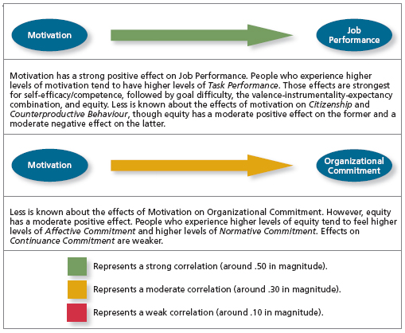

- Organizations use compensation practices to increase motivation. Those practices may include individual-focused elements (piece rate, merit pay, lump-sum bonuses, recognition awards), unit-focused elements (gain sharing), or organization-focused elements (profit sharing).
- 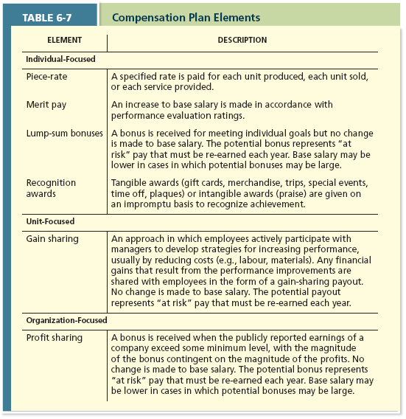

- Chapter 7 – Trust, Justice, and Ethics
- 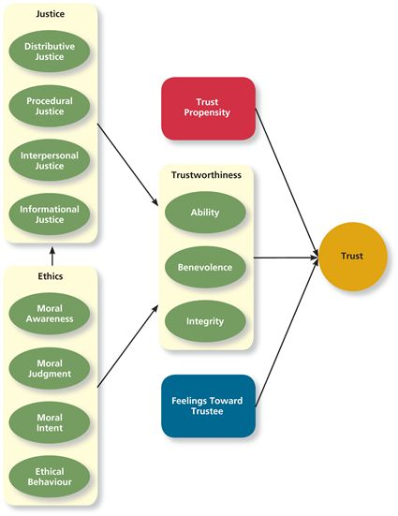

- Trust is the willingness to be vulnerable to an authority based on positive expectations about the authority's actions and intentions. Justice reflects the perceived fairness of an authority's decision making and can be used to explain why employees judge some authorities as more trustworthy than others. Ethics reflects the degree to which the behaviours of an authority are in accordance with generally accepted moral norms and can be used to explain why authorities choose to act in a trustworthy manner.

- trust The willingness to be vulnerable to an authority based on positive expectations about the authority's actions and intentions
- justice The perceived fairness of an authority's decision making
- ethics The degree to which the behaviours of an authority are in accordance with generally accepted moral norms

- Trust can be disposition-based, meaning that one's personality includes a general propensity to trust others. Trust can also be cognition-based, meaning that it's rooted in a rational assessment of the authority's trustworthiness. Finally, trust can be affect-based, meaning that it's rooted in feelings toward the authority that go beyond any rational assessment of trustworthiness.

- disposition-based trust Trust that is rooted in one's own personality, as opposed to a careful assessment of the trustee's trustworthiness
  - dependent on an individuals trust propensity A general expectation that the words, promises, and statements of individuals can be relied upon

- The trustworthiness of an authority (e.g., manager) is judged along three dimensions. Ability reflects the skills, competencies, and areas of expertise that an authority possesses. Benevolence is the degree to which an authority wants to do good for the trustor, apart from any selfish or profit-centred motives. Integrity is the degree to which an authority adheres to a set of values and principles that the trustor finds acceptable.
- cognition-based trust Trust that is rooted in a rational assessment of the authority's trustworthiness
  - Once we get to know an authority we can gauge its trustworthiness Characteristics or attributes of a person that inspire trust, including competence, character, and benevolence
  - Breaks into
  - benevolence The belief that an authority wants to do good for a trustor, apart from any selfish or profit-centred motives
  - integrity The perception that an authority adheres to a set of values and principles that the trustor finds acceptable
  - ability The skills, competencies, and areas of expertise that enable an authority to be successful in some specific area

- affect-based trust Trust that depends on feelings toward the authority that go beyond any rational assessment of trustworthiness
- 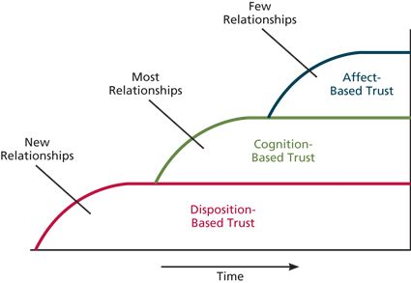

- The fairness of an authority's decision making can be judged along four dimensions. Distributive justice reflects the perceived fairness of decision-making outcomes. Procedural justice reflects the perceived fairness of decision-making processes. Interpersonal justice reflects the perceived fairness of the treatment received by employees from authorities. Informational justice reflects the perceived fairness of the communications provided to employees from authorities.
- 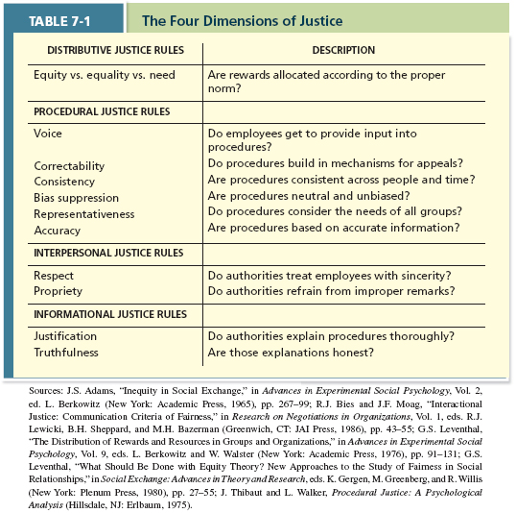
- distributive justice The perceived fairness of decision-making outcomes

- procedural justice The perceived fairness of decision-making processes

- interpersonal justice The perceived fairness of the interpersonal treatment received by employees from authorities

- informational justice The perceived fairness of the communications provided to employees from authorities

- The four-component model of ethical decision making argues that ethical behaviour depends on three concepts. Moral awareness reflects whether an authority recognizes that a moral issue exists in a situation. Moral judgment reflects whether the authority can accurately identify the “right” course of action. Moral intent reflects an authority's degree of commitment to the moral course of action.
- whistle-blowing Employees' exposing illegal or immoral actions by their employer

- 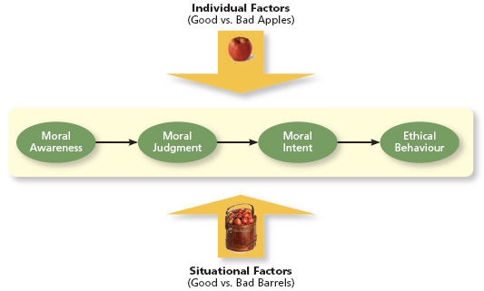

- ^^four-component model A model that argues that ethical behaviours result from the multistage sequence of moral awareness, moral judgment, moral intent, and ethical behavior

- moral awareness Recognition by an authority that a moral issue exists in a situation
  - moral intensity The degree to which an issue has ethical urgency
  - moral attentiveness The degree to which people chronically perceive and consider issues of morality during their experiences
- moral judgment When an authority can accurately identify the “right” course of action
  - cognitive moral development As people age and mature, they move through several states of moral development, each more mature and sophisticated than the prior one
  - moral principles Prescriptive guides for making moral judgments
- moral intent An authority's degree of commitment to the moral course of action
  - moral identity The degree to which a person views himself or herself as a moral person

- Trust has a moderate positive relationship with job performance and a strong positive relationship with organizational commitment.
- 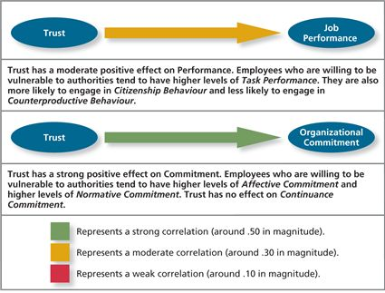
- *Also influences citizenship behaviour and counterproductive behaviour. Why? One reason is that the willingness to accept vulnerability changes the nature of the employee–employer relationship.
- We don’t simply want
- economic exchange Work relationships that resemble a contractual agreement by which employees fulfill job duties in exchange for financial compensation
- But rather
- social exchange Work relationships that are characterized by mutual investment, with employees willing to engage in “extra mile” sorts of behaviours because they trust that their efforts will eventually be rewarded.

- Organizations can become more trustworthy by emphasizing corporate social responsibility, a perspective that acknowledges that the responsibilities of a business encompass the economic, legal, ethical, and citizenship expectations of society.

- corporate social responsibility A perspective that acknowledges that the responsibility of a business encompasses the economic, legal, ethical, and citizenship expectations of society

- 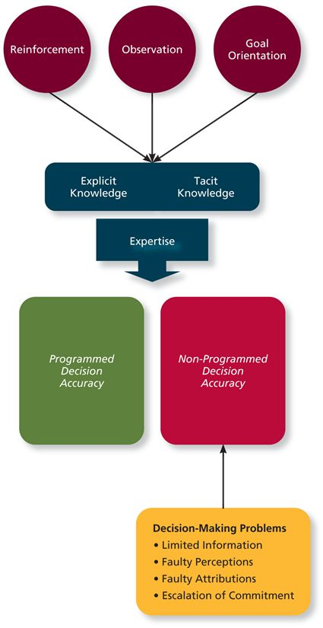 Learning is a relatively permanent change in an employee's knowledge or skill that results from experience. Decision making refers to the process of generating and choosing from a set of alternatives to solve a problem. Learning allows employees to make better decisions by making those decisions more quickly and by being able to generate a better set of alternatives.
- learning A relatively permanent change in an employee's knowledge or skill that results from experience
- decision making The process of generating and choosing from a set of alternatives to solve a problem

- Employees gain both explicit and tacit knowledge as they build expertise. Explicit knowledge is easily communicated and available to everyone. Tacit knowledge, however, is something employees can only learn through experience.
- tacit knowledge Knowledge that employees can only learn through experience
- explicit knowledge Knowledge that is easily communicated and available to everyone
- 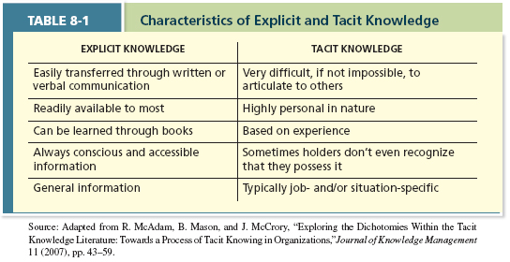

- Employees learn new knowledge through reinforcement and observation of others. That learning also depends on whether the employees are learning-oriented or performance-oriented.

- Reinforcement:
- 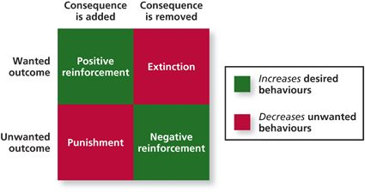
- contingencies of reinforcement Four specific consequences used by organizations to modify employee behaviour

- positive reinforcement A reinforcement contingency in which a positive outcome follows a desired behaviour
- negative reinforcement A reinforcement contingency in which an unwanted outcome is removed following a desired behaviour
- punishment An unwanted outcome that follows an unwanted behaviour
- extinction The removal of a positive outcome following an unwanted behaviour

- 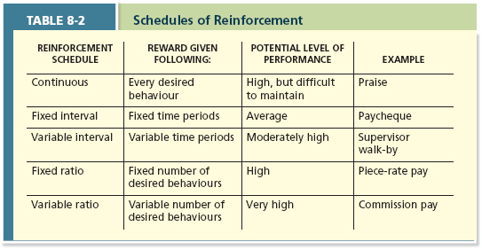
- schedules of reinforcement The timing of when contingencies are applied or removed

- continuous reinforcement A schedule of reinforcement in which a specific consequence follows each and every occurrence of a certain behaviour
- fixed-interval schedule A schedule whereby reinforcement occurs at fixed time periods
- variable-interval schedule A schedule whereby reinforcement occurs at random periods of time
- fixed-ratio schedule A schedule whereby reinforcement occurs following a fixed number of desired behaviours
- variable-ratio schedule A schedule whereby behaviours are reinforced after a varying number of them have been exhibited

- Observation:
- social learning theory Theory that argues that people in organizations learn by observing others
- behavioural modelling When employees observe the actions of others, learn from what they observe, and then repeat the observed behaviour
- 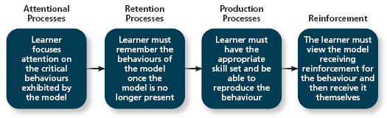

- Observation and reinforcement depend on if the employee has a
- learning orientation A predisposition or attitude according to which building competence is deemed more important by an employee than demonstrating competence
- Or
- performance–prove orientation A predisposition or attitude by which employees focus on demonstrating their competence so that others think favourably of them
- performance–avoid orientation A predisposition or attitude by which employees focus on demonstrating their competence so that others will not think poorly of them

Programmed decisions are decisions that become somewhat automatic because a person's knowledge allows him or her to recognize and identify a situation and the course of action that needs to be taken. Many task-related decisions made by experts are programmed decisions. Non-programmed decisions are made when a problem is new, complex, or not recognized. Ideally, such decisions are made by following the steps in the rational decision-making model.
- 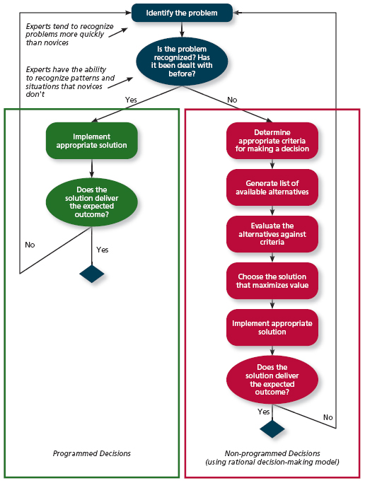
- programmed decisions Decisions that are somewhat automatic because the decision maker's knowledge allows him or her to recognize the situation and the course of action to be taken
  - intuition An emotional judgment based on quick, unconscious gut feelings
  - crisis situation A change—sudden or evolving—that results in an urgent problem that must be addressed immediately
  - five steps for communicating intent when using intuition:
- 1. | - Here's what I think we face (How does the manager perceive the situation?).
2. | - Here's what I think we should do (a task-focused statement of what the manager wants to happen).
- 3. | - Here's why (the reasoning behind the decision).
- 4. | - Here's what we should keep our eye on (What things should the staff look for to ensure the intuition is correct or that the situation hasn't changed?).
- 5. | - Now, talk to me (confirm that everyone understands their roles and that there is no other information to consider).³⁰

- non-programmed decisions Decisions made by employees when a problem is new, complex, or not recognized
  - rational decision-making model A step-by-step approach to making decisions that is designed to maximize outcomes by examining all available alternatives

- Employees are less able to translate their learning into accurate decisions when they struggle with limited information, faulty perceptions, faulty attributions, and escalation of commitment.

- LIMITED INFORMATION
- bounded rationality The notion that people do not have the ability or resources to process all available information and alternatives when making a decision
- 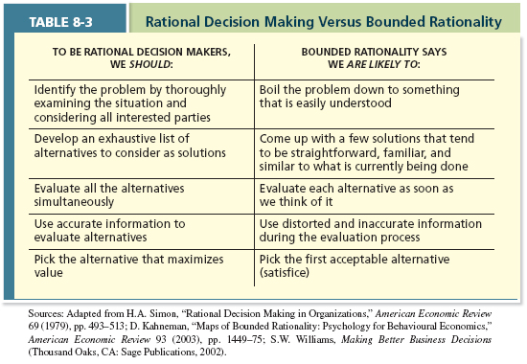

- As a result employees often settle for satisficing What a decision maker is doing who chooses the first acceptable alternative considered

- FAULTY PERCEPTIONS
- selective perception The tendency for people to see their environment only as it affects them and as it is consistent with their expectations
- projection bias The faulty perception by decision makers that others think, feel, and act as they do
- social identity theory A theory that people identify themselves according to the various groups to which they belong and judge others according to the groups they associate with
- stereotype Assumptions made about others based on their social group membership
- heuristics Simple and efficient rules of thumb that allow one to make decisions more easily
- availability bias The tendency for people to base their judgments on information that is easier to recall
- 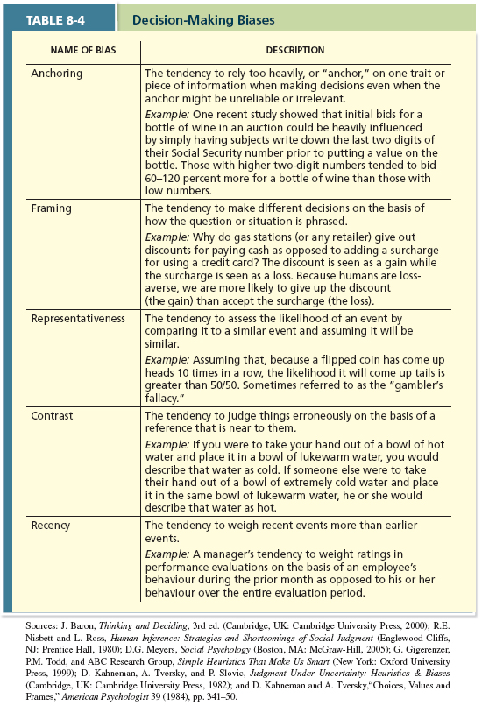

- FAULTY ATTRIBUTIONS.
- fundamental attribution error The tendency for people to judge others' behaviours as being due to internal factors such as ability, motivation, or attitudes
- self-serving bias When one attributes one's own failures to external factors and success to internal factors
FIGURE 8-5 | Consensus, Distinctiveness, and Consistency
- 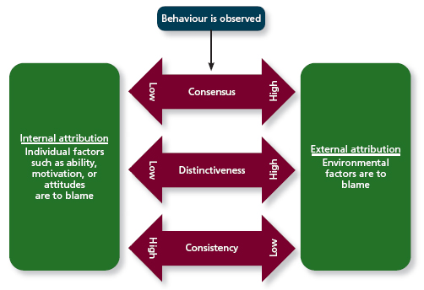
- Consensus: Did others act the same way under similar situations? In other words, did others arrive late on the same day?
- consensus Used by decision makers to attribute cause; whether other individuals behave the same way under similar circumstances
- Distinctiveness: Does this person tend to act differently in other circumstances? In other words, is Joe responsible when it comes to personal appointments, not just work appointments?
- distinctiveness Used by decision makers to attribute cause; whether the person being judged acts in a similar fashion under different circumstances
- Consistency: Does this person always do this when performing this task? In other words, has Joe arrived late for work before?
- consistency Used by decision makers to attribute cause; whether this individual has behaved this way before under similar circumstances

- ESCALATION OF COMMITMENT.
- escalation of commitment A common decision-making error, in which the decision maker continues to follow a failing course of action

- Learning has a moderate positive relationship with job performance and a weak positive relationship with organizational commitment.
- 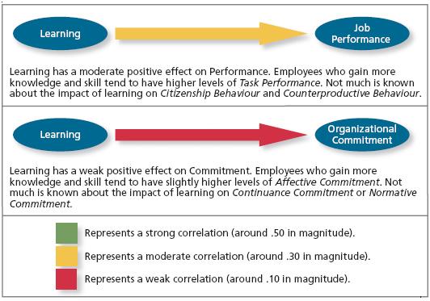
- Through various forms of training, companies can give employees more knowledge and a wider array of experiences that they can use to make decisions.

- training A systematic effort by organizations to facilitate the learning of job-related knowledge and behaviour
  - behaviour modelling training When employees observe the actions of others, learn from what they observe, and then repeat the observed behavior
  - communities of practice Groups of employees who learn from one another through collaboration over an extended period of time
  - transfer of training Occurs when employees retain and demonstrate the knowledge, skills, and behaviours required for their job after training ends
  - climate for transfer An organizational environment that supports the use of new skills

