Chapter 14: Psychological Disorders

Abnormal Behaviour: Myths, Realities, and Controversies
- Medical Model: proposes that it is useful to think of abnormal behaviour as a disease
- Diagnosis: involves distinguishing one illness form another
- Etiology: refers to the apparent causation and developmental history of an illness
- Prognosis: a forecast about the probable course of an illness
- Three Stereotypes About Psychological Disorders That are Largely Inaccurate
  - Psychological disorders are incurable
  - People with psychological disorders are often violent and dangerous
  - People with psychological disorders behave in bizarre ways and are very different from normal people

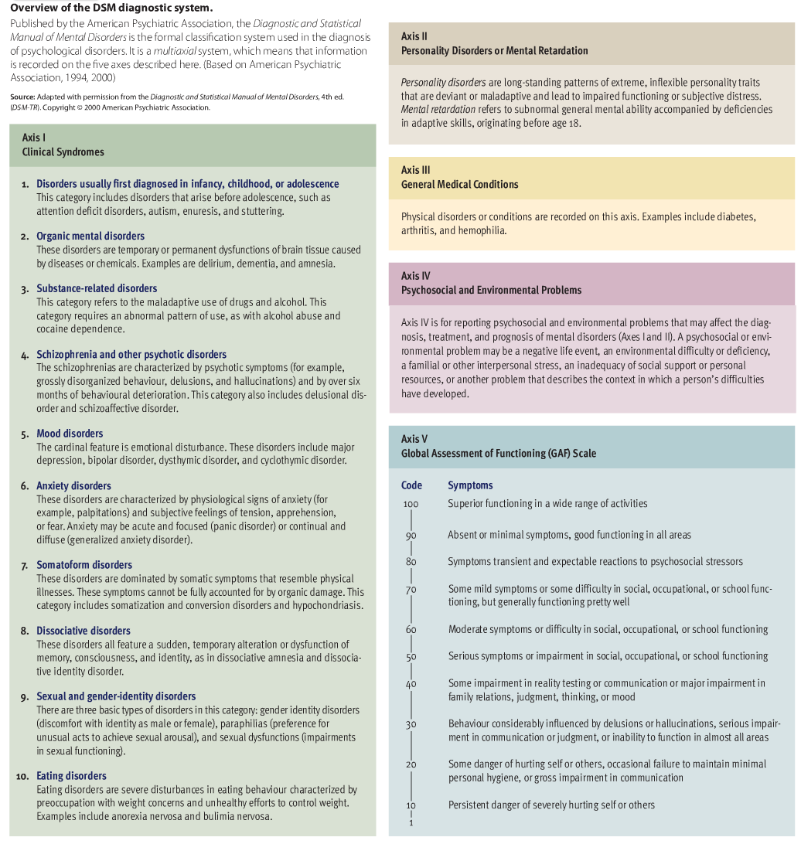

- Comorbidity: the coexistence of two or more disorders
- Epidemiology: the study of the distribution of mental or physical disorders in a population
- Prevalence: refers to the percentage of a population that exhibits a disorder during a specified time period

Review of Key Points
- The medical model assumes that it is useful to view abnormal behaviour as a disease. This view has been criticized on the grounds that it turns questions about deviance into medical questions. Nonetheless, the medical model has proven useful, although one should remember that is it only an analogy
- Three criteria are used in deciding whether people suffer from psychological disorders: deviance, personal distress, and maladaptive behaviour. Often it is difficult to clearly draw a line between normality and abnormality. Contrary to popular stereotypes, people with psychological disorders are not particularly bizarre or dangerous, and even the most severe disorders are treatable
- Research by David Rosenhan showed that pseudopatients were routinely admitted to mental hospitals, which were unable to detect the patients’ normalcy. His study showed that the distinction between normality and abnormality is not clear-cut.
- DSM is the official psychodiagnostic classification system. This system asks for information about patients on five axes, or dimensions. The current version is DSM – IV. Work is underway on DSM – 5, which may supplement the current categorical approach with a dimensional approach. It is difficult to obtain good data on the prevalence of psychological disorders. Nonetheless, it is clear that they are more common than widely believed.

Anxiety Disorders
- Anxiety Disorders: a class of disorders marked by feelings of excessive apprehension and anxiety
- Generalized Anxiety Disorder: marked by a chronic, high level of anxiety that is not tied to any specific threat
- Phobic Disorder: marked by a persistent and irrational fear of an object or situation that present no realistic danger
- Panic Disorder: characterized by recurrent attacks of overwhelming anxiety that usually occur suddenly and unexpectedly
- Agoraphobia: a fear of going out to public places
- Obsessive Compulsive Disorder (OCD): marked by persistent, uncontrollable intrusions of unwanted thoughts (obsessions) and urges to engage in senseless rituals (compulsions)
- Concordance Rate: indicates the percentage of twin pairs or other pairs of relatives who exhibit the same disorder

Review of Key Points
- The anxiety disorders include generalized anxiety disorder, phobic disorder, panic disorder, obsessive-compulsive disorder, and post-traumatic stress disorder. Many people who develop one anxiety disorder also suffer from another
- Twin studies suggest that there is a weak genetic predisposition to anxiety disorders. These disorders may be more likely in people who are especially sensitive to the physiological symptoms of anxiety. Abnormalities in neurotransmitter activity at GABA synapses or serotonin synapses may also play a role in anxiety disorders.
- Many anxiety responses, especially phobias, may be caused by classical conditioning and maintained by operant conditioning. Parents who model anxiety may promote these disorders through observational learning
- Cognitive theorists maintain that certain styles of thinking – especially a tendency to over-interpret harmless situations as threatening – make some people more vulnerable to anxiety disorders. Stress may also predispose people to anxiety disorders

Dissociative Disorders
- Dissociative Disorders: a class of disorders in which people lose contact with portions of their consciousness or memory, resulting in disruptions in their sense of identity
- Dissociative Amnesia: a sudden loss of memory for important personal information that is too extensive to be due to normal forgetting
- Dissociative Fugue: people lose their memory for their entire lives along with their sense of personal identity
- Dissociative Identity Disorder (DID): involves the coexistence in one person of two or more largely complete, and usually very different, personalities (multiple personality disorder)

Review of Key Points
- Since the 1970s, there has been a dramatic and controversial increase in the diagnosis of dissociative identity disorder
- Some theorists believe that people with DID are engaging in intentional role playing to use an exotic mental illness as a face-saving excuse for their personal failings. These disorders may be rooted in emotional trauma that occurred during childhood.

Mood Disorders
- Mood Disorders: a class of disorders marked by emotional disturbances of varied kinds that may spill over to disrupt physical, perceptual, social, and thought processes
- Major Depressive Disorder: people show persistent feelings of sadness and despair and a loss of interest in previous sources of pleasure
- Anhedonia: a diminished ability to experience pleasure
- Dysthymic Disorder: consists of chronic depression that is insufficient in severity to justify diagnosis of a major depressive episode
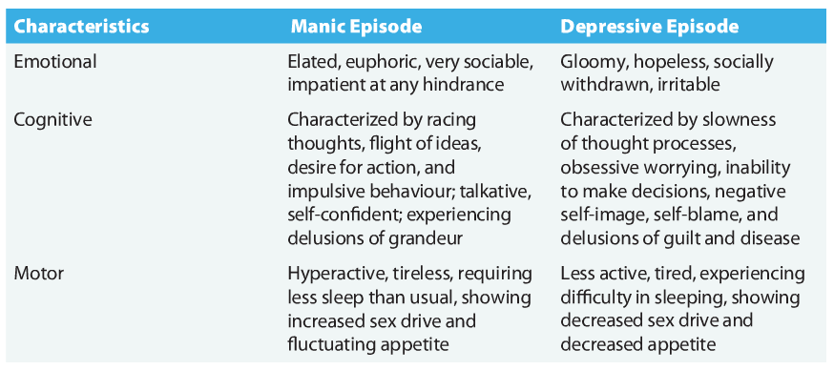

- Bipolar Disorder: formerly known as manic depressive disorder; is characterized by the experience of one or more manic episodes as well as periods of depression
- Cyclothymic Disorder: when they exhibit chronic but relatively mild symptoms of bipolar disturbance
- Seasonal Affective Disorder (SAD): a type of depression that follows a seasonal pattern
- Postpartum Depression: a type of depression that sometimes occurs after childbirth
- Etiology of Mood Disorders
  - Genetic Vulnerability
  - Biological and Neurochemical Factors
  - Hormonal Factors
  - Dispositional Factors
  - Cognitive Factors
  - Interpersonal Roots
  - Sports Concussions and Depression

Review of Key Points
- The principal mood disorders are depressive disorder, dysthymic disorder, bipolar disorder, and cyclothymic disorder. Mood disorders are episodic.
- Major depressive disorder is marked by profound sadness, slowed thought processes, low self-esteem, and a loss of interest in previous sources of pleasure. Unipolar depression is more common than bipolar depression disorder, and it appears to be increasing in prevalence.
- Bipolar disorder is marked by the experience of both depressed and manic episodes. Manic episodes are characterized by inflated self-esteem, high energy, grandiose plans, and racing thoughts
- Evidence indicates that people vary in their genetic vulnerability to mood disorders. These disorders are accompanied by changes in neurochemical activity in the brain. Abnormalities at norepinephrine and serotonin synapses appear particularly critical
- Reduced hippocampal volume and suppressed neurogenesis are also associated with depression. Hormonal changes resulting from over activity along the HPA axis may contribute to depression
- Cognitive models posit that negative thinking contributes to depression. A pessimistic explanatory style has been implicated, as has a tendency to ruminate about one’s problems.
- Interpersonal inadequacies may contribute to depressive disorders. Poor social skills may lead to a paucity of life’s reinforcers and frequent rejection. The development of mood disorders is affected by personal stress and also has been associated with head trauma

Schizophrenic Disorders
- Schizophrenic Disorders: a class of disorders marked by delusions, hallucinations, disorganized speech, and deterioration
- Delusions: false beliefs that are maintained even though they clearly are out of touch with reality
- Hallucinations: sensory perceptions that occur in the absence of a real, external stimulus or are gross distortions of perceptual input
- Paranoid Schizophrenia: dominated by delusions of persecution, along with delusions of grandeur
- Catatonic Schizophrenia: marked by striking motor disturbances, ranging from muscular rigidity to random motor activity
- Disorganized Schizophrenia: a particularly severe deterioration of adaptive behaviour is seen
- Undifferentiated Schizophrenia: marked by idiosyncratic mixtures of schizophrenic symptoms
- Negative Symptoms: involves behavioural deficits, such as flattened emotions, social withdrawal, apathy, impaired attention, and poverty of speech
- Positive Symptoms: involves behavioural excesses or peculiarities, such as hallucinations, delusions, bizarre behaviour, and wild flights of ideas
- Expressed Emotion (EE): the degree to which a relative of a schizophrenic patient displays highly critical or emotionally overinvolved attitudes toward the patient

Review of Key Points
- Schizophrenic disorders are characterized by deterioration of adaptive behaviour, irrational thought, delusions, hallucinations, and disturbed mood
- Schizophrenic disorders are classified as paranoid, catatonic, disorganized, or undifferentiated. A new classification scheme based on the predominance of positive versus negative symptoms is under study. Schizophrenic disorders usually emerge during adolescence or young adulthood
- Research has linked schizophrenia to a genetic vulnerability and changes in neurotransmitter activity at dopamine synapses. Structural abnormalities in the brain, such as enlarged ventricles, are associated with schizophrenia, but their significance is unclear
- The neurodevelopmental hypothesis of schizophrenia asserts that schizophrenia is attributable to disruptions in the normal maturation processes of the brain before or at birth that are caused by prenatal viral infections, obstetrical complications, and other insults to the brain. Patients who come from homes high in expressed emotion have elevated relapse rates. This suggests that unhealthy family dynamics play a role in schizophrenia. High stress may also contribute to the onset of schizophrenia

Personality Disorders
- Personality Disorders: a class of disorders marked by extreme, inflexible personality traits that cause subjective distress or impaired social and occupational functioning
- Antisocial Personality Disorder: marked by impulsive, callous, manipulative, aggressive, and irresponsible behaviour that reflects a failure to accept social norms

Review of Key Points
- Personality disorders are marked by extreme personality traits that cause distress and impaired functioning. There are ten personality disorders allocated to Axis II is DSM – IV
- Personality disorders can be grouped into three clusters: anxious-fearful, odd-eccentric, and dramatic-impulsive. Specific personality disorders are poorly defined and there is excessive overlap among them, creating diagnostic problems. Some theorists believe that these problems could be reduced by replacing the current categorical approach with a dimensional approach
- The antisocial personality disorder involves manipulative, impulsive, exploitive, aggressive behaviour. Research on the etiology of this disorder has implicated genetic vulnerability, autonomic reactivity, inadequate socialization, and observational learning

Disorders of Childhood
- Autism: refers to a developmental disorder characterized by social and emotional deficits, along with repetitive and stereotypic behaviours, interests, and activities
- Culture Bound Disorders: abnormal syndromes found only in a few cultural groups

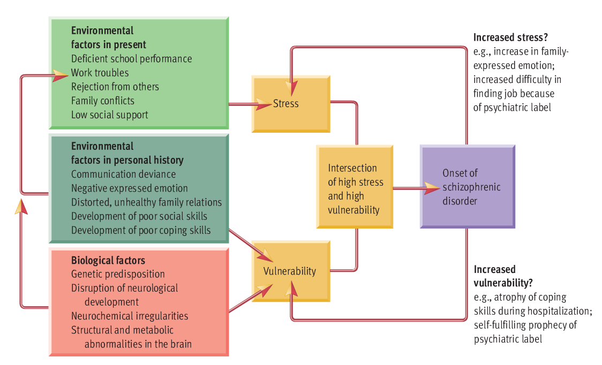

Review of Key Points
- Some psychological disorders are specific to childhood, such as autism, which is a pervasive developmental disorder. Children suffering from autism exhibit social and emotional deficits along with repetitive, ritualistic actions, and interests
- Insanity is a legal concept applied to people who cannot be held responsible for their actions because of mental illness. While the term insanity is used in some other countries, in Canada, the correct terminology is not criminally responsible on account of mental disorder. The insanity defense is used less frequently and less successfully than widely believed
- The principal categories of psychological disturbance are identifiable in all cultures. But milder disorders may go unrecognized in some societies, and culture-bound disorders further illustrate the diversity of abnormal behaviour around the world. The symptoms associated with specific disorders are largely the same across different cultures, but cultural variations are seen in the details of how these symptoms are expressed.

Chapter 15: Treatment of Psychological Disorders

The Elements of the Treatment Process
- Treatments: How Many Types Are There?
  - 1. Insight therapies
    - “Talk therapy” in the tradition of Freud’s psychoanalysis
    - Clients engage in complex verbal interactions with their therapists
  - 2. Behaviour therapies
    - Based on the principles of learning
    - Make direct efforts to alter problematic responses (i.e. phobias) and maladaptive habits (i.e. drug use)
  - 3. Bio-medial therapies
    - Involve interventions into a person’s biological functioning
- Clients: Who Seeks Therapy?
  - In the therapeutic triad (therapists, treatments, clients), the greatest diversity of all is seen among the clients.
  - Full range of problems: anxiety, depression, unsatisfactory interpersonal relationships, troublesome habits, poor self-control, low self-esteem, martial conflicts, self-doubt, a sense of emptiness, and feelings of personal stagnation.
- Therapists: Who Provides Professional Treatment?
  - Therapists can come from a variety of professional backgrounds
  - Psychotherapy refers to professional treatment by someone with special training
  - Psychology and psychiatry are the principal professions involved in the provision of psychotherapy.
  - Two types of psychologists:
    - Clinical Psychologists: emphasizes the treatment of full-fledged disorders
    - Counseling Psychologists: slanted toward the treatment of everyday adjustment problems
  - Psychiatrists: physicians who specialize in the diagnosis and treatment of psychological disorders
  - Other mental health professionals include: clinical social workers, psychiatric nurses, and a variety of counselors

Review of Key Points
- Clients being a wide variety of problems to therapy and do not necessarily have a disorder. People vary their willingness to seek treatment, and many people who need therapy do not receive
- Each of these professions shows different preferences for approaches to treatment. Psychologists typically practice insight or behaviour therapy. Psychiatrists rely more heavily on drug therapies.

Insight Therapies
- Insight Therapies: Involve verbal interactions intended to enhance clients’ self-knowledge and thus promote healthful changes in personality and behaviour
- Psychoanalysis: an insight therapy that emphasizes the recovery of conscious conflicts, motives, and defenses through techniques such as free association and transference
- Free Association: Clients spontaneously express their thoughts and feelings exactly as they occur, with a little censorship as possible
- Dream Analysis: The therapist interprets the symbolic meaning of the client’s dreams
- Interpretation: Refers to the therapist’s attempts to explain the inner significance of the client’s thoughts, feelings, memories, and behaviours
- Resistance: Refers to largely unconscious defensive maneuvers intended to hinder the progress of therapy
  - When an analyst’s probing hits sensitive areas, resistance can be expected.
- Transference: Occurs when clients unconsciously start relating to their therapist in ways that mimic critical relationships in their lives
  - The transference relationship may be used to overcome resistance so that the client can handle interpretations that lead to insight.
- Client-Centered Therapy: An insight therapy that emphasizes providing a supportive emotional climate for clients, who play a major role in determining the pace and direction of their therapy
  - Roger’s client-centered therapy assumes that neurotic anxieties are derived from incongruence between a person’s self-concept and reality. Accordingly, the client-centered therapist trues to provide a supportive climate in which clients can restructure their self-concept. The process of client-centered therapy emphasizes clarification of the client’s feelings and self-acceptance.
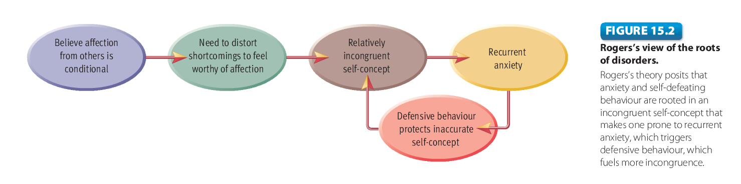

Therapeutic Alliance: The Importance of Therapy Climate
- The importance of therapeutic alliance, more broadly considered as the nature of the bond between therapist and client, is central to most other contemporary therapeutic orientations
- To create an atmosphere of emotional support, client-centered therapists must provide three conditions:
  - 1. Genuiness: The therapist must be genuine with the client, communicating honestly and spontaneously. The therapist should not be phony or defensive
  - 2. Unconditional positive regard: The therapist must also show complete, nonjudgmental acceptance of the client as a person. The therapist should provide warmth and caring foe the client, with no strings attached
  - 3. Empathy: The therapist must provide accurate empathy for the client. This means that the therapist must understand the client’s world from the client’s point of view.
Group Therapy
- Group Therapy: the simultaneous treatment of several clients in a group
  - In group therapy, participants essentially function as therapist for one another
  - The therapist’s responsibilities include selecting participants, setting goals for the group, initiating and maintaining the therapeutic process, and protecting clients from harm

Couples and Family Therapy
- Couples/Marital Therapy: Involves the treatment of both partners in a committed, intimate relationship, in which the main focus is one relationship issues
- Family Therapy: Involves the treatment of a family unit as a whole, in which the main focus is on family dynamics and communication
- Spontaneous Remission: A recovery from a disorder that occurs without formal treatment

Review of Key Points
- Freudian approaches to therapy assume that neuroses originate from unresolved conflicts lurking in the unconscious. Therefore, free association and dream analysis are used in psychoanalysis to explore the unconscious.
- Classical psychoanalysis is not widely practiced anymore, but Freud’s legacy lives on in a rich diversity of modern psychodynamic therapies
- The growth of the positive psychology movement has begun to inspire new approaches to insight therapy, such as well-being therapy. Positive psychotherapy attempts to get clients to recognize their strengths, appreciate their blessings, savour positive experiences, and find meaning in their lives.
- Most theoretical approaches to insight therapy have been adapted for use with groups. Participants in group therapy essentially act as therapists for one another, exchanging insights and emotional support. Group therapy has unique advantages in comparison to individual therapy
- Evaluating the effectiveness of any approach to therapy is complex and difficult. Nonetheless, the weight of modern evidence suggests that insight therapies are superior to no treatment or to placebo treatment. Studies generally find the greatest improvement early in treatment
Behaviour Therapies
- Behaviour Therapies: Involve the application of learning principles to direct efforts to change clients’ maladaptive behaviours
  - Behaviour therapies are based on certain assumptions
    - First, it is assumed that behaviour is a product of learning
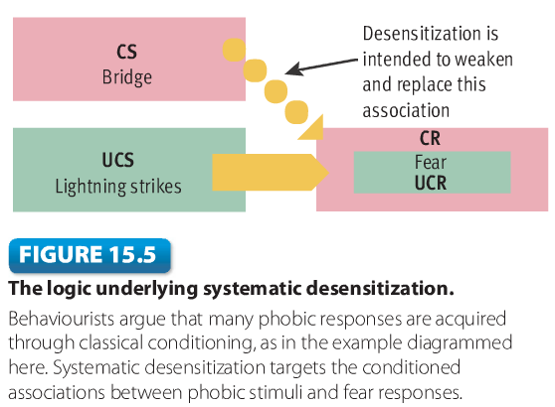
    - Second, it is assumed that what has been learned can be unlearned.

- Systematic Desensitization: A behaviour therapy used to reduce phobic clients’ anxiety responses through counterconditioning
  - First, the therapist helps the client build an anxiety hierarchy. The hierarchy is a list of anxiety-arousing stimuli related to the specific source of anxiety, such as flying, academic tests, or snakes
  - The second step involves training the client deep muscle relaxation. May begin during early sessions while the therapist and client are still constructing the anxiety hierarchy.
  - In the third step, the client tries to work through the hierarchy, learning to remain relaxed while imagining each stimulus. Starting with the least anxiety-arousing stimulus, the client imagines the situation as vividly as possible while relaxing. If the client experiences strong anxiety, he or she drops the imaginary scene and concentrates on relaxation
- Exposure Therapies: Clients are confronted with situations that they fear so that they learn that these situations are really harmless.
- Aversion Therapy: A behaviour therapy in which as aversive stimulus is paired with a stimulus that elicits an undesirable response
- Social Skills Training: A behaviour therapy designed to improve interpersonal skills that emphasizes modeling, behavioural rehearsal, and shaping
- Cognitive-Behavioural Treatments: Use varied combined combinations of verbal interventions and behavioural modification techniques to help clients change maladaptive patterns of thinking
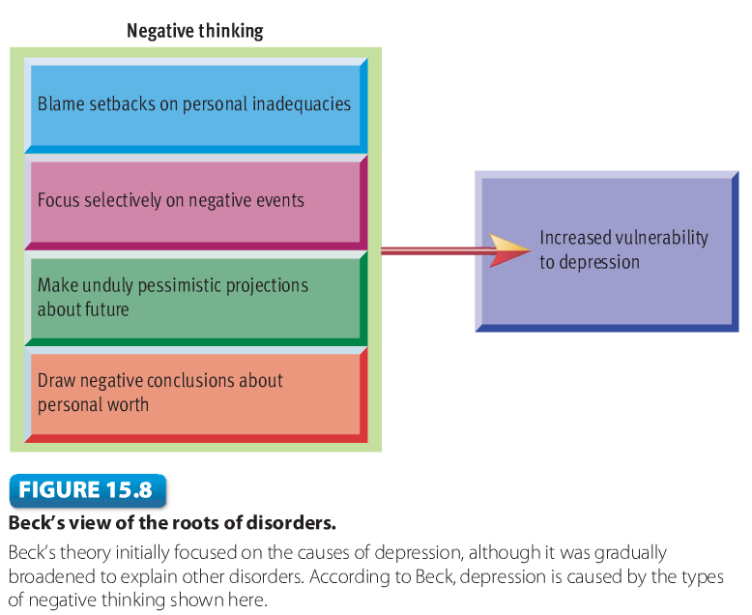
- Cognitive Therapy: Uses specific strategies to correct habitual thinking errors that underlie various types of disorders

Review of Key Points
- Behavioural therapies use the principles of learning in direct efforts to change specific aspects of behaviour. Wolpe’s systematic desensitization, a treatment for phobias, involves the construction of an anxiety hierarchy, relaxation training, and step-by-step movement through the hierarchy, pairing relaxation with each phobic stimulus.
- In aversion therapy, a stimulus associated with an unwanted response is paired with an unpleasant stimulus in an effort to eliminate the maladaptive response. Social skills training can improve clients’ interpersonal skills through shaping, modeling, and behavioural rehearsal
- Cognitive-behavioural treatments concentrate on changing the way clients think about events in their lives. Cognitive therapists re-educate clients to detect and challenge automatic negative thoughts that cause depression and anxiety. Cognitive therapy also depends on modeling, behavioural rehearsal, and homework assignments. Recent developments in cognitive therapy include mindfulness-based cognitive therapy, which integrates cognitive approaches to therapy with mindfulness meditation
- Behaviour therapists have historically placed more emphasis on the importance of measuring therapeutic outcomes than insight therapists have. There is ample evidence that behaviour therapies are effective in the treatment of a wide variety of disorders

Bio-Medial Therapies
- Bio-medical Therapies: Physiological interventions intended to reduce symptoms associated with psychological disorders
- Psychopharmacotherapy: The treatment of mental disorders with medication
- Antianxiety Drugs: Relieve tension, apprehension, and nervousness
- Antipsychotic Drugs: Used to gradually reduce psychotic symptoms, including hyperactivity, metnal confusion, hallucinations, and delusions
- Tardive Dyskinesia: A neurological disorder marked by involuntary writhing and tic-like movements of the mouth, tongue, face, hands, or feet
- Antidepressant Drugs: Gradually elevate mood and help bring people out of depression
- Mood-Stabilizers: Drugs used to control mood swings in patients with bipolar mood disorders
- Electroconvulsive Therapy (ECT): A bio-medical treatment in which electric shock is used to produce a cortical seizure accompanied by convulsions
- Trans-cranial Magnetic Stimulation (TMS): A new technique that permits scientists to temporarily enhance or depress activity in a specific area of the brain
  - It may have value in the treatment of depression. In deep brain stimulation, a thin electrode is surgically implanted so that electrical currents can be delivered to selected areas of the brain. It may have value in the treatment of depression or obsessive-compulsive disorder
- Deep Brain Stimulation (DBS): A thin electrode is surgically implanted in the brain and connected to an implanted pulse generator so that various electrical currents can be delivered to brain tissue adjacent to the electrode

Review of Key Points
- Antianxiety drugs exert their effects quickly and are fairly effective in reducing feelings of anxiety, but their impact is short-lived. They produce some nuisance side effects, and there can be complications involving abuse, dependence, and overdose. Antipsychotic drugs are used primarily in the treatment of schizophrenia. They reduce psychotic symptoms in about 70 percent of patients. Traditional antipsychotics can have a variety of serious side effects, which have been reduced in the newer, atypical antipsychotics
- Antidepressants are used to bring people out of episodes of depression. SSRI’s are the dominant type used today. Side effects tend to be manageable, although there are concerns that antidepressants may increase suicide risk slightly. Mood stabilizers, such as lithium and valproate, are mostly used to prevent the recurrence of episodes of disturbance in people with bipolar mood disorders
- Drug therapies can be quite effective, but they have their drawbacks. All of the drugs produce side effects, some of which can be very troublesome. Some critics maintain that drugs’ curative effects are superficial and that some drugs are overprescribed. Disturbing questions have been raised about the scientific impartiality of contemporary research on therapeutic drugs
- Electroconvulsive therapy (ECT) is used to trigger a cortical seizure that is believed to have therapeutic value for mood disorders, especially depression. Evidence about the effectiveness of ECT is contradictory but seems sufficient to justify conservative use of the procedure. Cognitive deficits are the principal risk, with much debate about how severe and enduring these deficits tend to be.

Current Trends and Issues in Treatment
- Eclecticism: The practice of therapy involves drawing ideas from two or more systems of therapy instead of committing to just one system
- A variety of barriers appear to contribute to the problem of minority groups within North America underutilizing therapeutic services
  - 1. Cultural barriers: Some cultural groups are reluctant to turn to formal, professional sources of assistance. They prefer to rely on informal assistance from family members, the clergy, respected elders, herbalists, acupuncturists, and do on, who share their cultural heritage.
  - 2. Language barriers: Most hospitals and mental health agencies are not adequately staffed with therapists who speak the languages used by minority groups in their service areas. This makes it awkward and difficult for many minority group members to explain their problems and to obtain the type of help that they need
  - 3. Institutional barriers: The vast majority of therapists have been trained almost exclusively in the treatment of white, middle-class clients and are not familiar with the cultural backgrounds and unique characteristics of various ethnic groups. This cultural gap often leads to misunderstanding, ill-advised treatment strategies, and reduced rapport.

Review of Key Points
- Combinations of insight, behavioural, and bio-medical therapies are often used fruitfully in the treatment of psychological disorder. Many modern therapists are eclectic, using specific ideas, techniques, and strategies gleaned from a number of theoretical approaches
- The highly culture-bound origins of Western therapies have raised doubts about their applicability to other cultures and even to ethnic groups in Western society. Because of cultural, language and access barriers, therapeutic services are underutilized by ethnic minorities in Canada
- More culturally responsive approaches to treatment will require more minority therapists, specialty training for therapists, and additional investigation of how traditional therapies can be tailored to be more compatible with specific ethnic groups’ cultural heritage

Institutional Treatment in Transition
- Mental Hospital: A medical institution specializing in providing impatient care for psychological disorders
- Deinstitutionalization: Refers to transferring the treatment of mental illness from inpatient institutions to community-based facilities that emphasize outpatient care.

Review of Key Points
- Disenchantment with the negative effects of psychiatric hospitals led to the advent of more localized community mental health centres and a policy of deinstitutionalization. Long-term hospitalization for mental disorders is largely a thing of the past
- Unfortunately, deinstitutionalization has left some unanticipated problems in its wake. Including the revolving door problem and increased homelessness, although some theorists argue that homelessness is primarily an economic problem
- Our discussion of psychotherapy highlighted the value of theoretical diversity. Conflicting theoretical orientations have generated varied approaches to treatment. Our coverage of therapy also showed once again that cultural factors shape psychological processes.


