Chapter 3: The Biological Bases of Behaviour

Nervous Tissue: The Basic Hardware
- Neurons: individual cells in the nervous system that receive, integrate, and transmit information
- Soma (Cell Body): Contains the cell nucleus and much of the chemical machinery common to most cells
- Dendrites: the parts of a neuron that are specialized to receive information
- Axon: a long, thin fibre that transmits signals away from the soma to other neurons or to muscles or glands
- Myelin Sheath: insulating material, derived from glial cells, that encase some axons
- Terminal Buttons: small knobs that secrete chemicals called neurotransmitters
- Synapse: a junction where information is transmitted from neuron to another
- Glia: cells found throughout the nervous system that provide various types of support for neurons

The Neural Impulse: Using Energy to Send Information
- Resting Potential of a Neuron: its stable, negative charge when the cell is inactive
- Action Potential: a very brief shift in a neuron’s electrical charge that travels along an axon
- Absolute Refractory Period: the minimum length of time after an action potential during which another action potential cannot begin

The Synapse: Where Neurons Meet
- Synaptic Cleft: a microscopic gap between the terminal button of ne neuron and the cell membrane of another neuron
- Neurotransmitters: chemicals that transmit information from one neuron to another
- Postsynaptic Potential (PSP): a voltage change at a receptor site on a postsynaptic cell membrane
- Excitatory PSP: a positive voltage shift that increases the likelihood that the postsynaptic neuron will fire action potentials
- Inhibitory PSP: a negative voltage shift that decrease the likelihood hat the postsynaptic neuron will fire action potentials
- Reuptake: a process in which neurotransmitters are sponged up from the synaptic cleft by the presynaptic membrane

Neurotransmitters and Behaviour
- Agonist: a chemical that mimics the action of a neurotransmitter
- Antagonist: a chemical that opposes the action of a neurotransmitter
- Endorphins: internally produced chemicals that resemble opiates in structure and effect

Review of Key Points
- Behaviour depends on complex information processing in the nervous system. Cells in the nervous system receive, integrate, and transmit information
- Neurons are the basic communication links. They normally transmit a neural impulse along an axon to a synapse with another neuron. The neural impulse is a brief change in a neuron’s electrical charge that moves along an axon. An action potential is an all-or-none event. Neurons convey information about the strength of a stimulus by variations in their rate of firing
- Action potentials trigger the release of chemicals called neurotransmitters that diffuse across a synapse to communicate with other neurons. Transmitters bind with receptors in the postsynaptic cell membrane, causing excitatory or inhibitory PSPs.
- Whether the postsynaptic neuron fires a neural impulse depends on the balance of excitatory and inhibitory PSPs. Our thoughts and actions depends on patterns of activity in neural circuits and networks
- The transmitter Ach plays a key role in muscular movement. Serotonin circuits may contribute to the regulation of sleep, eating, and aggression. Depression is associated with reduced activation at norepinephrine and serotonin synapses
- Schizophrenia has been inked to over-activity at dopamine synapses. Cocaine and amphetamines appear to exert their main effects by altering activity at DA and NE synapses
- GABA is an important amino acid transmitter whose inhibitory effects appear to regulate anxiety and sleep. Glutamate is another amino acid transmitter, which is best known for its role in memory. Endorphins, which resemble opiates, contribute to pain relief and may modulate eating and stress reactions

The Peripheral Nervous System
- Peripheral Nervous System: made up of all those nerves that lie outside the brain and spinal cord
- Nerves: bundles of neuron fibres (axons) that are routed together in the peripheral nervous system
- Somatic Nervous System: made up of nerves that connect voluntary skeletal muscles and to sensory receptors
- Afferent Nerve Fibres: axons that carry information inward to the central nervous system, from the periphery of the body
- Efferent Nerve Fibres: axons that carry information outward from the central nervous system to the periphery of the body
- Autonomic Nervous System (ANS): made up of nerves that connect to the heart, blood vessels, smooth muscles, and glands
- Sympathetic Division: the branch of the autonomic nervous system that mobilizes the body’s resources for emergencies
- Parasympathetic Division: the branch of the autonomic nervous system that generally conserves bodily resources

The Central Nervous System
- Central Nervous System (CNS): consists of the brain and the spinal cord
- Cerebrospinal Fluid (CSF): nourishes the brain and provides a protective cushion for it

Review of Key Points
- The nervous system can be divided into two main subdivisions: the central nervous system and the peripheral nervous system. The central nervous system consists of the brain and spinal cord
- The peripheral nervous system consists of the nerves that lie outside the brain and spinal cord. It can be subdivided into the somatic nervous system, which connects to muscles and sensory receptors, and the autonomic nervous system, which connects to blood vessels, smooth muscles, and glands
- The autonomic nervous system mediates the largely automatic arousal that accompanies emotion and the fight-or-flight response to stress. The ANS is divided into the sympathetic division, which mobilizes bodily resources, and the parasympathetic division, which conserves bodily resources

Looking Inside the Brain: Research Methods
- Electroencephalograph (EEG): a device that monitors the electrical activity of the brain over time by means of recording electrodes attached to the surface of the scalp
- Lesioning: involves destroying a piece of the brain
- Electrical Simulation of the Brain (ESB): involves sending a weak electric current into a brain structure to stimulate (activate) it
- Transcranial Magnetic Stimulation (TMS): a new technique that permits scientists to temporarily enhance or depress activity in a specific area of the brain

Review of Key Points
- Neuroscientists use a variety of methods to investigate brain-behaviour relationships. The EEG can record broad patterns of electrical activity in the brain. Different EEG brain waves are associated with different states of consciousness
- Lesioning involves destroying a piece of the brain. Another technique is electrical stimulation of areas in the brain in order to activate them. Both techniques depend on the use of stereotaxic instruments that permit researchers to implant electrodes at precise locations in animals’ brains
- In recent years, new brain-imaging procedures have been developed, including CT scans, PET scans, MRI scans, and fMRI scans. These techniques have enormous potential for exploring brain-behaviour relationships. However, brain scans are not as precise and ambiguous as they appear to be. And increased metabolic activity in an area does not prove that it is crucial to a particular psychological function

The Brain and Behaviour
- Hindbrain: includes the cerebellum and two structures found in the lower part of the brainstem - the medulla and the pons.
- Midbrain: the segment of the brainstem that lies between the hindbrain and the forebrain
- Forebrain: the largest and most complex region of the brain, encompassing a variety of structures, including the thalamus, hypothalamus, limbic system, and cerebrum
- Thalamus: a structure is the forebrain through which all sensory information (except smell) must pass to get to the cerebral cortex
- Hypothalamus: a structure found near the base of the forebrain that is involved in the regulation of basic biological needs
- Limbic System: a loosely connected network of structures located roughly along the border between the cerebral cortex and deeper subcortical area
- Cerebral Cortex: the convoluted outer layer of the cerebrum
- Cerebral Hemispheres: the right and left halves of the cerebrum
- Corpus Callosum: the structure that connects the two cerebral hemispheres

The Plasticity of the Brain
- Neurogenesis: the formation of new neurons

Review of Key Points
- The brain has three major regions: the hindbrain, midbrain, and the forebrain. Structures in the hindbrain include the medulla, pons, and cerebellum. These structures handle essential functions such as breathing, circulation, coordination of movement, and the rhythm of sleep and arousal
- The midbrain contributes to the coordination of sensory processes. Deterioration of an area in the midbrain has been implicated as a factor in Parkinson’s disease
- The forebrain includes many structures that handle higher functions. The thalamus is primarily a relay station. The hypothalamus is involved in the regulation of basic biological drives such as hunger and sex
- The limbic system is a network of loosely connected structures along the border between the cortex and deeper subcortical areas. It includes the hippocampus, which appears to play a role in memory; the amygdala, which is involved in the regulation of emotion, and areas rich of self-stimulation sites
- The cerebrum is the brain area implicated in most complex mental activities. The cortex is the cerebrum’s convoluted outer layer, which is subdivided into four lobes
- These lobes and their primary functions are the occipital lobe (vision), the parietal lobe (touch), the temporal lobe (hearing), and the frontal lobe (movement of the body). The prefrontal cortex may contribute to working memory and relational reasoning. The structure and function of the brain appears to be more plastic than widely appreciated

Right Brain/Left Brain: Cerebral Laterality
- Split-Brain Surgery: the bundle of fibres that connects the cerebral hemispheres (the corpus callosum) is cut to reduce the severity of epileptic seizures
- Perceptual Asymmetries: left-right imbalances between cerebral hemispheres in the speed of visual or auditory processing

Review of Key Points
- The cerebrum is divided into right and left hemispheres connected by the corpus callosum. Evidence that the left cerebral hemisphere usually processes language led scientists to view it as the dominant hemisphere
- However, studies of split-brain patients revealed that the right and left halves of the brain each have unique talents, with the right hemisphere being specialized to handle visual-spatial functions
- Studies of perceptual asymmetries in normal subjects also showed that the left hemisphere is better equipped to handle verbal processing, whereas the right hemisphere is more adept at nonverbal processing

The Endocrine System: Another Way to Communicate
- Endocrine System: consists of glands that release hormones into the bloodstream; hormones help to control bodily functioning
- Pituitary Gland: releases a great variety of hormones that fan out around the body, stimulating actions in the other endocrine glands
- Oxytocin: a hormone released by the pituitary gland, which regulates reproductive behaviours

Review of Key Points
- The endocrine system consists of glands that secrete hormones, which are chemicals involved in the regulation of basic bodily processes. Hormone release tends to be pulsatile. The control centres for the endocrine system are the hypothalamus and the pituitary gland
- Hormones regulate many aspects of behaviour, such as the fight-or-flight response, which occurs in repose to stress, Hormones also regulate many aspects of physiological development, such as sexual differentiation
- Recent research suggests additional effects of hormones. For example, oxytocin, a hormone regulating reproductive behaviours that is produced in the pituitary gland, has been found to have effects on complex social behaviour such as adult-adult pair bonding

Heredity and Behaviour: Is It All in the Genes?
- Behavioural Genetics: an interdisciplinary field that studies the influence of genetic factors on behavioural traits
- Chromosomes: strands of DNA (deoxyribonucleic acid) molecules that carry genetic information
- Zygote: a single cell formed by the union of a sperm and an egg
- Genes: DNA segments the serve as the key functional units in hereditary transmission
- Homozygous Condition: the two genes in a specific pair are the same
- Heterozygous Condition: the two genes in a specific pair are different
- Dominant Gene: one that is expressed when paired genes are different
- Recessive Gene: one that is masked when paired genes are different
- Genotype: refers to a person’s genetic makeup
- Phenotype: refers to the ways in which a person’s genotype is manifested in observable characteristics
- Polygenic Traits: characteristics that are influenced by more than one pair of genes
- Family Studies: researchers assess hereditary influence by examining blood relatives to see how much they resemble one another on a specific trait
- Twin Studies: researchers assess hereditary influence by comparing the resemblance of identical twins and fraternal twins with respect to a trait
- Identical (monozygotic): twins emerge from one zygote that splits for unknown reasons
- Fraternal (dizygotic): twins result when two eggs are fertilized simultaneously by different sperm cells, forming two separate zygotes
- Adoption Studies: asses hereditary influence by examining the resemblance between adopted children and both their biological and their adoptive parents
- Genetic Mapping: the process of determining the location and chemical sequence of specific genes on specific chromosomes
- Epigenetics: the study of heritable changes in gene expression that do not involve modifications to the DNA sequence

Review of Key Points
- The basic units of genetic transmission are genes housed on chromosomes. Genes operate in pairs and, when heterozygous, one may be dominant and one recessive. Genotypes are translated into phenotypes in many ways. Most behavioural qualities appear to involve polygenic inheritance
- Researchers assess hereditary influence through a variety of methods. Family studies cannot provide conclusive evidence that a trait in influenced by heredity. Twin studies can provide much better evidence
- Research indicates that most behavioural qualities are influenced jointly by heredity and environment, which play off of each other in complex interactions

The Evolutionary Bases of Behaviour
- Fitness: refers to the reproductive success (number of descendants) of an individual organism relative to the average reproductive success in the population
- Natural Selection: posits that heritable characteristics that provide a survival or reproductive advantage are more likely than alternative characteristics to be passed on to subsequent generations and thus come to be “selected” over time
- Mutation: a spontaneous, heritable change in a piece of SNA that occurs in an individual organism
- Adaptation: an inherited characteristic that increased in population (through natural selection) because it helped solve a problem of survival or reproduction during the time it emerged
- Inclusive Fitness: the sum of an individual’s own reproductive success plus the effects on the organism has on the reproductive success of related others

Review of Key Points
- Darwin argued that if a heritable trait contributes to an organism’s survual or reproductive success, organisms with that trait should produce more offspring than those without the trait should gradually increase over generations – thanks to natural selection
- Because of the gradual, incremental nature f evolution, adaptations sometimes linger in a population even though they no longer provide a survival or reproductive advantage. Hamilton proposed the theory of inclusive fitness to explain the paradox of self-sacrifice
- Theorists have focused primarily on the evolution of physical characteristics in the animal kingdom, but from the very beginning, Darwin recognized that natural selection was applicable to behavioural traits as well
- Firstly, we saw how heredity interacts with experience to govern behaviour. Second, the discussions of biological factors underlying schizophrenia highlighted the multifactorial causation of behaviour. Third, we saw how innovations in research methods often lead to advances in knowledge, underscoring the empirical nature of psychology

Chapter 5: Variations in Consciousness

The Nature of Consciousness
- Mind Wandering: Refers to people’s experience of task-unrelated thoughts
- Electroencephalograph (EEG): A device that monitors the electrical activity of the brain over time by means of recording electrodes attached to the surface of the scalp

Biology Rhythms and Sleep
- Biological Rhythms: Periodic fluctuations in physiological functioning
- Circadian Rhythms: The 24-hour biological cycles found in humans and many other species
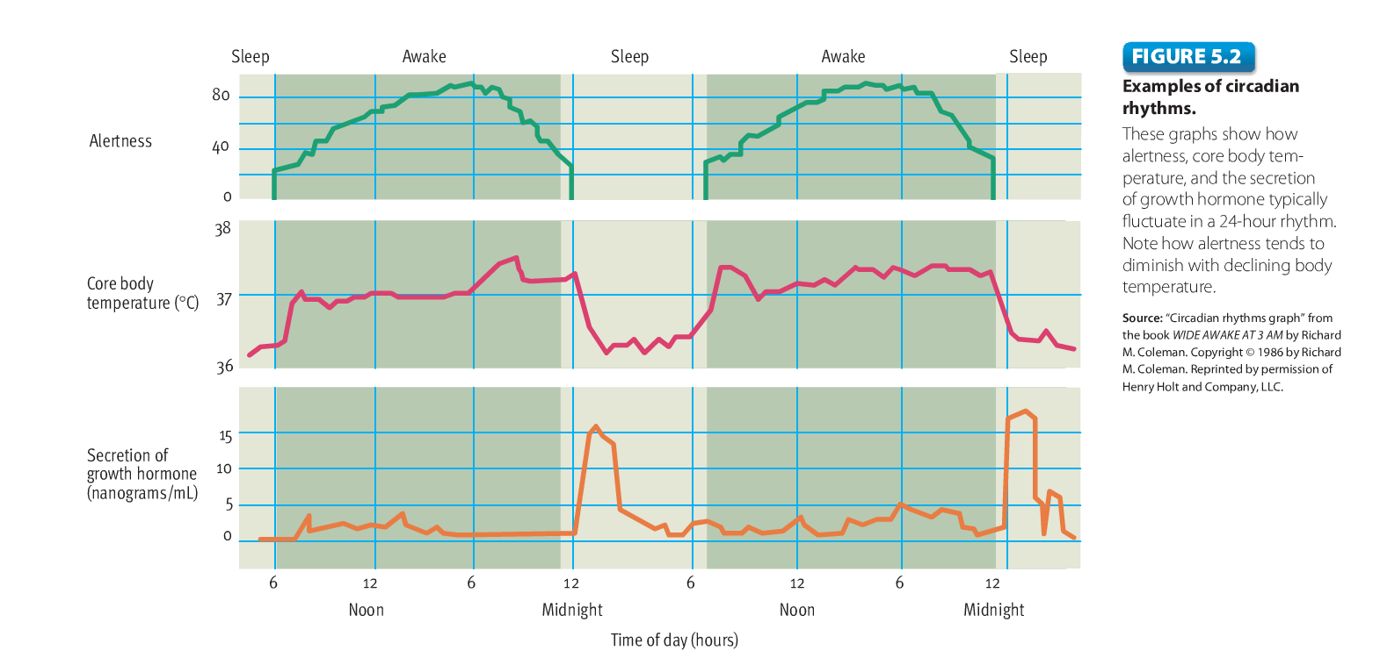

Review of Key Points
- Biological rhythms are periodic fluctuations in physiological functioning, which indicate that most organisms have internal biological clocks. The cycle of sleep and wakefulness is influenced considerably by circadian rhythms, even when people are cut off from the cycle of light and darkness. Exposure to light resets biological clocks by affecting the activity of the suprachiasmatic nucleus and the pineal gland, which secretes the hormone melatonin.
- Ignoring your biological clock by going to sleep at an unusual time may have a negative effect on your sleep. Being out of sync with circadian rhythms is one reason for jet lag and for the unpleasant nature of rotating shift work. Melatonin may have value in efforts to alleviate the effects of jet lag. Bright-light administration and circadian-friendly rotation schedules can sometimes reduce the negative effects of rotating shift work.

Cycling Through the Stages of Sleep
- Slow-Wave Sleep (SWS): Consists of sleep stages 3 and 4, during which high-amplitude, low frequency delta waves become prominent in EEG recordings
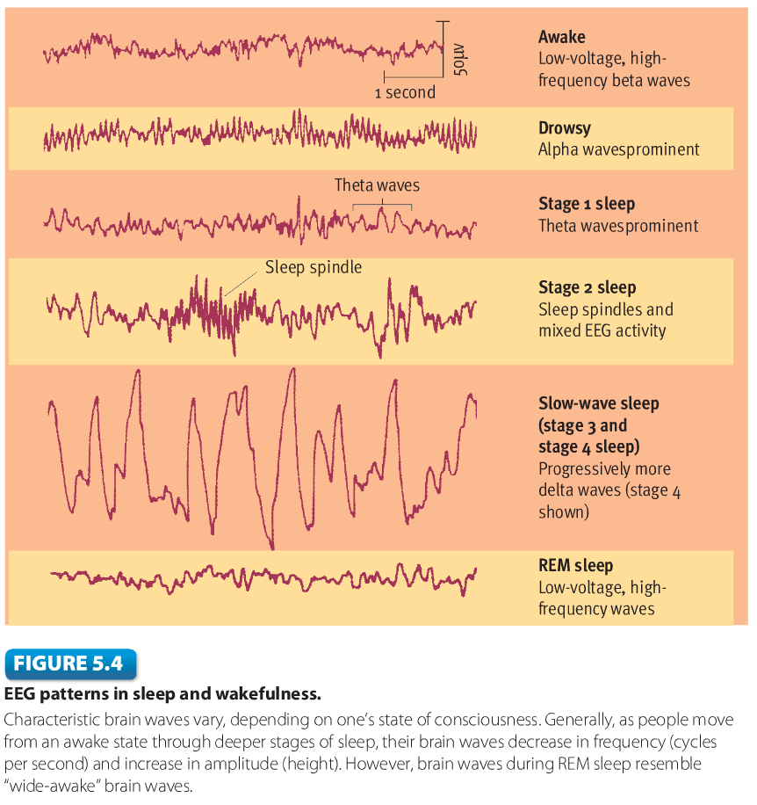

- REM Sleep: A relatively deep stage of sleep marked by rapid eye movements; high-frequency, low amplitude brain waves; and vivid dreaming
- Non-REM (NREM) Sleeps: Consists of sleep stages 1 through 4, which are marked by an absence of rapid eye movements, relatively little dreaming, and varied EEG activity
- Ascending Reticular Activating System (ARAS): Consists of the afferent fibres running through the reticular formation that influence physiological arousal

Review of Key Points
- Research on sleep is typically done in laboratories, where volunteers come to spend the night. Participants are hooked up to an EEG, EOG, EMG, and instruments that monitor heart rate, respiration, pulse rate, and body temperature
- When people fall asleep, they evolve through a series of stages in cycles of approximately 90 minutes. Slow-wave sleep consists of stages 3 and 4, during which delta waves are prominent. During the REM stage, sleepers experience rapid eye movements, brain waves that are characteristic of waking though, and vivid dreaming. The sleep cycle tends to be repeated about four times a night, as REM sleep gradually becomes more predominant and NREM sleep dwindles.
- The REM portion of sleep declines during childhood, leveling off at around 20 percent. During adulthood, slow-wave sleep declines. Total sleep time decreases for most elderly people, although it increases for some. Culture appears to have little impact on the physiological experience of sleep, but it does influence napping patterns and sleeping arrangements, such as co-sleeping.
- The neural bases of sleep are complex. Arousal depends on activity in the ascending reticular activating system, but a constellation of brain structures and neurotransmitters contribute to regulation of the sleep and waking cycle.

Insomnia
- Insomnia: Refers to chronic problems in getting adequate sleep
  - Prevalence: Vary considerably because surveys have to depend on respondents’ highly subjective judgments of whether their sleep is adequate. Also, nearly everyone suffers occasional sleep difficulties because of stress, disruption of biological rhythms, or other temporary circumstances.
  - Causes: Excessive anxiety and tension prevent relaxation and keep people awake. Insomnia is frequently a side effect of emotional problems, such as depression, or of significant stress, such as pressures at work. Health problems such as back pain, ulcers, and asthma can lead to insomnia as well as the use of certain drugs, like stimulants (cocaine and amphetamines).
  - Treatment: Usually people suffering from insomnia do not seek out professional treatment; these people rely on over the counter sleep aids, which have questionable value. The most common approach in the medical treatment is the prescription of two classes of drugs: benzodiazepine sedatives and nonbenzodiazepine sedatives

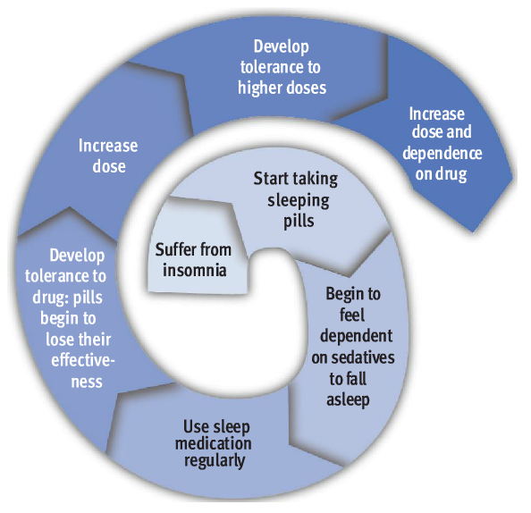

Other Sleep Problems
- Narcolepsy: A disease marked by sudden and irresistible onsets of sleep during normal waking periods
- Sleep Apnea: Involves frequent, reflexive gasping for air that awakens a person and disrupts sleep
- Nightmares: Anxiety-arousing dreams that lead to awakening, usually from REM sleep
- Night Terrors (Sleep Terrors): Abrupt awakenings from NREM sleep, accompanied by intense autonomic arousal and feelings of panic
- Somnambulism (Sleepwalking): Occurs when a person arises and wanders about while remaining asleep
- REM Sleep Behaviour Disorder (RBD): Marked by potentially troublesome dream enactments during REM periods
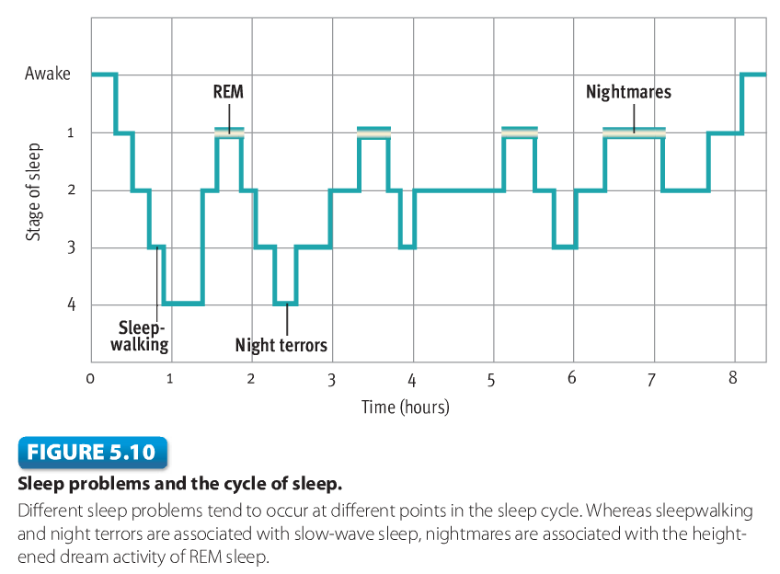

Review of Key Points
- The effects of sleep deprivation depend on a variety of factors. Increased sleepiness can be a significant problem that appears to contribute to many transportation accidents and mishaps at work.
- Research on selective sleep deprivation suggests that people need REM sleep and slow-wave sleep. These stages of sleep may contribute to memory consolidation. Short sleep duration is associated with a variety of health problems. People who sleep seven to eight hours per day have lower mortality rates than individuals who are long or shorts sleepers. Many people are troubled by sleep disorders. Insomnia has a variety of causes. Sleeping pills generally are a poor solution. The optimal treatment for insomnia depends on identification of its apparent cause

The World of Dreams
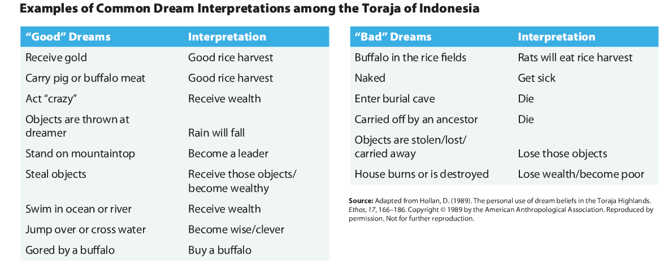

Review of Key Points
- The conventional view is that dreams are mental experiences during REM sleep that have a story-like quality, include vivid imagery, are often bizarre, and are regarded as real by the dreamer, but theorists have begun to question many aspects of this view
- Researchers have found modest differences between men and women in dream content that seem to reflect conventional gender roles. The content of one’s dreams may be affected by what is going on in one’s life and by external stimuli that are experienced during the dream
- In many non-Western cultures, dreams are viewed as important sources of information. Cultures vary in beliefs about the nature of dreams, dream recall, dream content, and dream interpretation
- Freud argued that the principal purpose of dreams is wish fulfillment. Cartwright has articulated a problem-solving view, whereas Hobson and McCarley asserts that dreams are side effects of the neural activation seen during REM sleep. Ultimately, theories of dreaming remain largely untested.

Hypnosis
- Hypnosis: A systematic procedure that typically produces a heightened stage of suggestibility
  - Interesting Effects Produced Through Hypnosis
    - Anesthesia
    - Sensory distortions and hallucinations
    - Disinhibition
    - Posthypnotic suggestions and amnesia
- Dissociation: A splitting off of mental processes into two separate, simultaneous streams of awareness

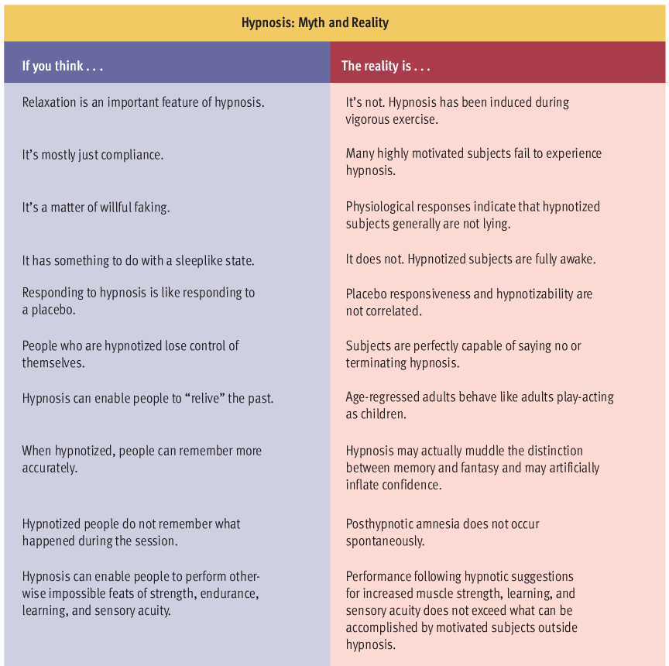

Meditation
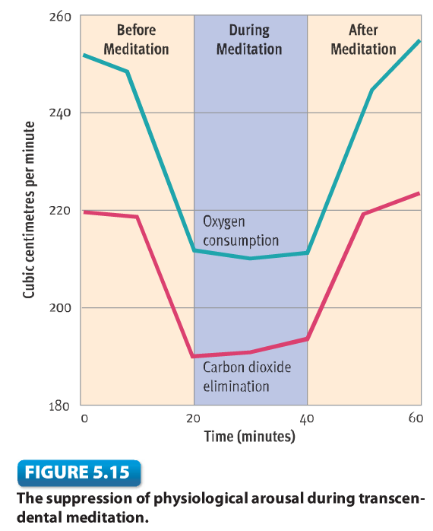
- Mediation: Refers to a family of practices that train attention to heighten awareness and bring mental processes under greater voluntary control

Review of Key Points
- Hypnosis has had a long and curious history since the era of mesmerism in the 18th century. Hypnotic susceptibility is a stable trait. It is only weakly correlated with personality, but highly hypnotizable people tend to score somewhat higher than others in absorption and imaginativeness.
- One approach to hypnosis, the social cognitive approach, views it as a normal state of consciousness in which subjects assume a hypnotic role. Another approach asserts that hypnosis leads to an altered state in which consciousness is split into two streams of awareness
- Evidence suggests that mediation leads to a potentially beneficial physiological state characterized by suppression of bodily arousal. However, some experts suggest that the benefits of mediation are not unique to mediation and are a product of any effective relaxation procedure.

Altering Consciousness with Drugs
- Psychoactive Drugs: Chemical substances that modify mental, emotional, or behavioural functioning
- Narcotics (Opiates): Drugs derived from opium that are capable of relieving pain
- Sedatives: Sleep-inducing drugs that tend to decrease central nervous system (CNS) activation and behavioural activity
- Stimulants: Drugs that tend to increase central nervous system activation and behavioural activity
- Hallucinogens: Diverse group of drugs that have powerful effects on mental and emotional functioning, marked most prominently by distortions in sensory and perceptual experience
- Cannabis: The hemp plant from which marijuana, hashish, and THC are derived
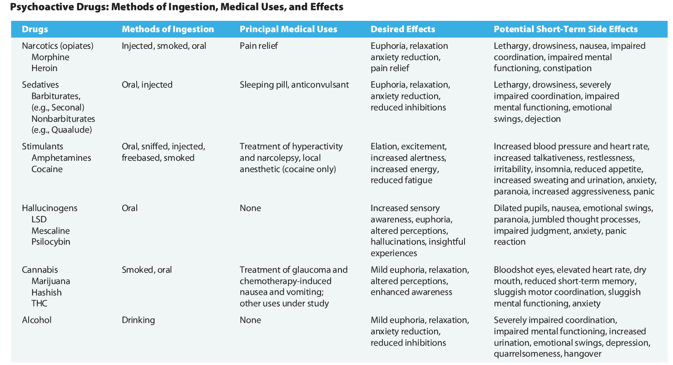
- Alcohol: Encompasses a variety of beverages containing ethyl alcohol

- MDMA (Ecstasy): A compound drug related to both amphetamines and hallucinogens, especially mescaline
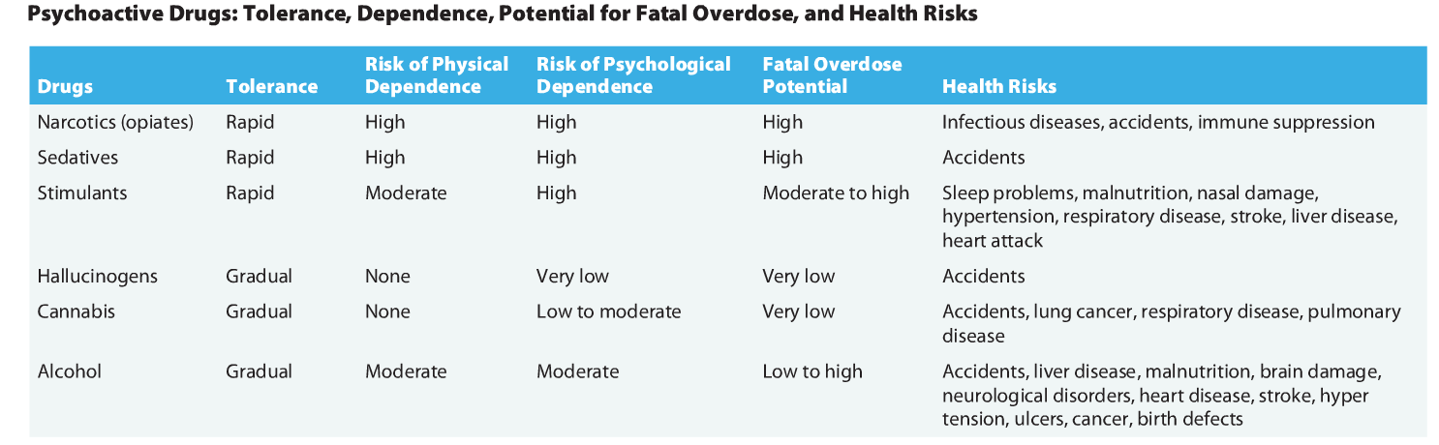
- Tolerance: Refers to progressive decrease in a person’s responsiveness to a drug

- Physical Dependence: Exists when a person must continue to take a drug to avoid withdrawal illness
- Psychological Dependence: Exists when a person must continue to take a drug to satisfy instance mental and emotional craving for the drug

Review of Key Points
- Although it’s possible to describe the typical effects of various drugs, the actual effect on any individual depends on a host of factors, including subjective expectations and tolerance to the drug
- Psychoactive drugs exert their main effects in the brain, where they alter neurotransmitter activity at synaptic sites in a variety of ways. For example, amphetamines increase the release of DA and NE, and like cocaine, they slow reuptake at DA and NE synapses. The mesolimbic dopamine pathway may mediate the reinforcing effects of most abused drugs
- Recreational drug use can prove harmful to health by producing an overdose, by causing tissue damage, or by increasing health-impairing behaviour. The chances of accidentally consuming a lethal overdose are greatest for the CNS depressants and cocaine. Direct tissue damage occurs most frequently with alcohol and cocaine. The health risks of marijuana have generated debate. Preliminary evidence suggests that MDMA may be more dangerous than widely assumed

Chapter 12: Personality – Theory, Research, and Assessment

The Nature of Personality
- Personality: Refers to an individual’s unique constellation of consistent behavioural traits
- Personality Trait: A durable disposition to behave in a particular way in a variety of situations
- Factor Analysis: Correlations among many variables are analyzed to identify closely related clusters of variables
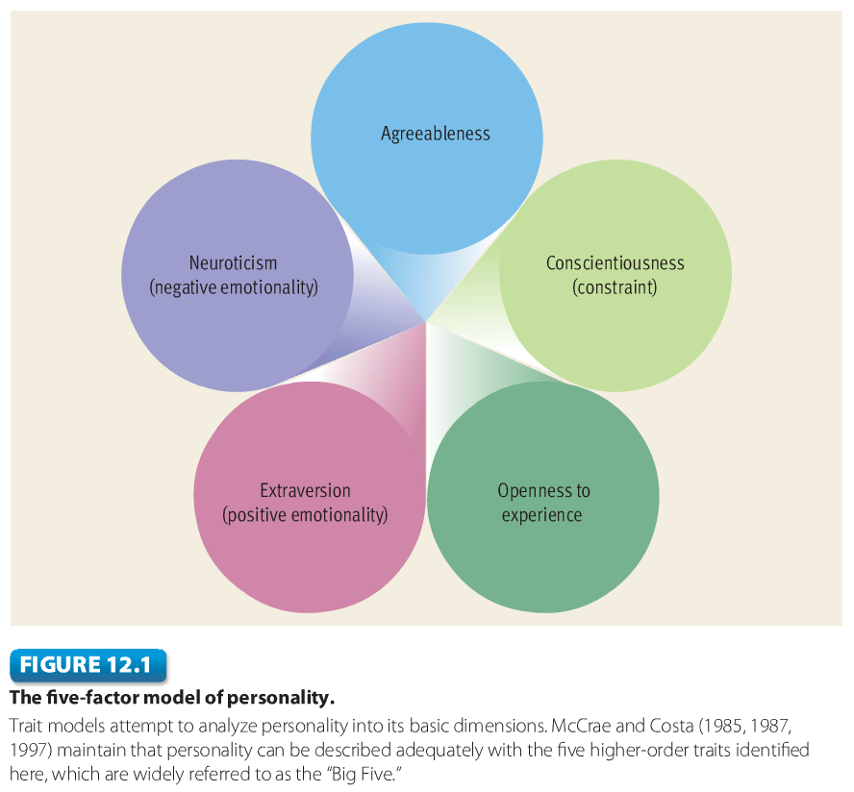

- Extraversion (positive personality)
- Characterized as outgoing, sociable, upbeat, friendly, assertive, and gregarious
- Tend to be happier than others
- More positive outlook on life and are motivated to pursue social contact, intimacy, and interdependence
- Neuroticism (negative personality)
- Tend to be anxious, hostile, self-conscious, insecure, and vulnerable
- Tend to overreact, more in response to stress than others
- Exhibit more impulsiveness and emotional instability
- Openness to Experience
- Associated with curiosity, flexibility, vivid fantasy, imaginativeness, artistic sensitivity, and unconventional attitudes
- Tend to be tolerant of ambiguity and have less need for closure on issues than others
- Key determinant of people’s political attitudes and ideology because they exhibit less prejudice against minorities than others

- Agreeableness
- Tend to be sympathetic, trusting, cooperative, modest, and straightforward.
- Associated with constructive approaches to conflict resolution, making agreeable quarrelsome than others
- Correlated with empathy and helping behaviour
- Opposite is suspicious, antagonistic, and aggressive
- Conscientiousness
- Tend to be diligent, disciplined, well organized, punctual, and dependable.
- Referred to as a constraint in some models; associated with strong self discipline and the ability to regulate one-self effectively
- Fosters diligences and dependability in the workplace and that it is related to impression management

Review of Key Points
- The concept of personality explains the consistency in people’s behaviour over time and across situations while also explaining their distinctiveness. Factor analysis can be used to identify higher-order traits from which specific traits are derived. There is considerable debate as to how many trait dimensions are necessary to account for the variation in personality
- Nonetheless, the five-factor model has become the dominant conception of personality structure. Recent research suggests that the Big Five traits are predictive of important life outcomes, such as grades, career success, and divorce. Neuroticism is associated with poorer health and elevated mortality, whereas the opposite relationships are seen for the trait of conscientiousness

Psychodynamic Perspectives
- Psychodynamic Theories: Include all of the diverse theories descended from the work of Sigmund Freud, which focus on unconscious mental forces
- Structure of Personality
  - Id: The primitive, instinctive component of personality that operates according to the pleasure principle
    - Pleasure Principle: Demands immediate gratification of its urges
  - Ego: The decision-making component of personality that operates according to the reality principle
    - Reality Principle: Seeks to delay gratification of the id’s urges until appropriate outlets and situations can be found
  - Superego: The moral component of personality that incorporates social standards about what represents right and wrong
- Conscious: Consists of whatever one is aware at a particular point in time
- Preconscious: Contains material just beneath the surface of awareness that can easily be retrieved
- Unconscious: Contains thoughts, memories, and desires that are well below the surface of conscious awareness but that nonetheless exert great influence on behvaiour

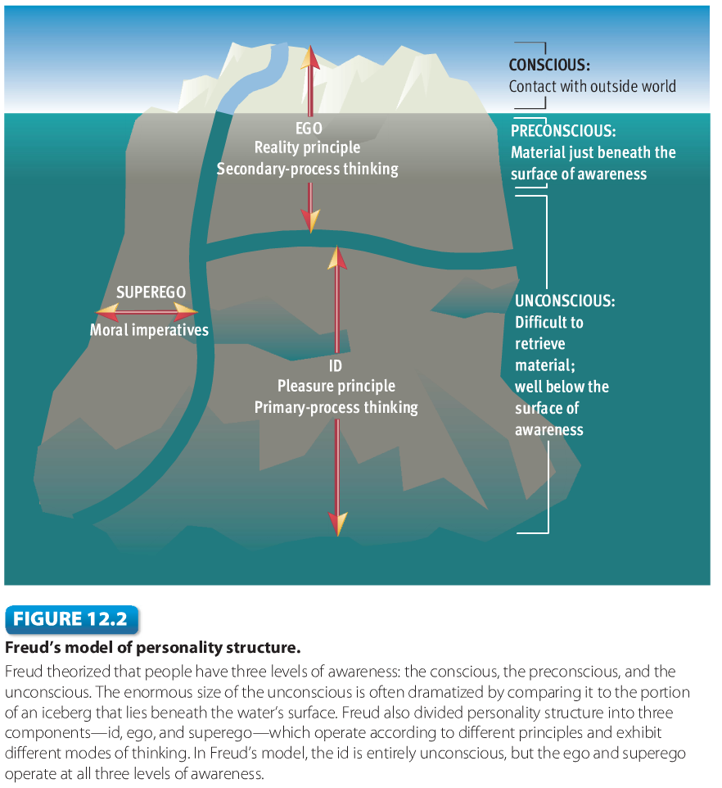

- Defence Mechanisms: Largely unconscious reactions that protect a person from unpleasant emotions such as anxiety and guilt
  - Rationalization: Creating false but plausible excuses to justify unacceptable behaviour
    - Ex: A student watches TV instead of studying, saying that “additional study wouldn’t do any good anyway”
  - Repression: Keeping distressing thoughts and feelings buried in the unconscious
    - Ex: A traumatized soldier has no recollection of the details of a close brush with death
  - Projection: Attributing one’s own thoughts, feelings, or motives to another
    - Ex: A woman who dislikes her boss thinks she likes her boss but feels that the boss doesn’t like her
  - Displacement: Diverting emotional feelings (usually anger) from their original source to a substitute target
    - Ex: After parental scolding, a young girl takes her anger out on her little brother
  - Reaction Formation: Behaving in a way that’s exactly the opposite of one’s true feelings
    - Ex: A parent who unconsciously resents a child spoils the child with outlandish gifts
  - Regression: A reversion to immature patterns of behaviour
    - Ex: An adult has a temper tantrum when he doesn’t get his way
  - Identification: Bolstering self-esteem by forming an imaginary or real alliance with some person or group
    - Ex: An insecure young man joins a fraternity to boost his self-esteem
  - Sublimation: Occurs when the unconscious, unacceptable impulses are channeled to socially acceptable, perhaps even admirable, behaviours
    - Ex: A young man’s longing for intimacy is channeled into his creative artwork
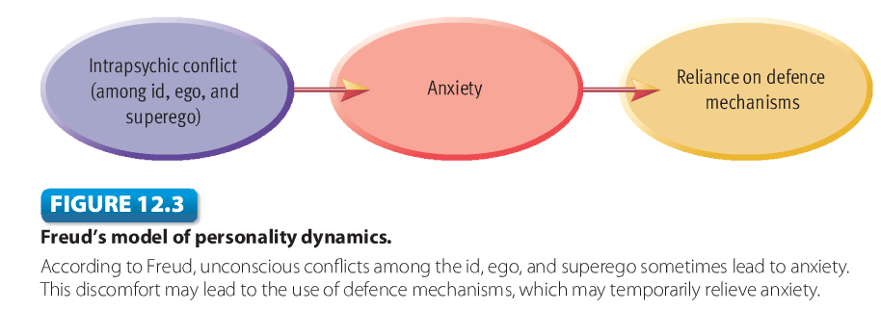

- Psychosexual Stages: Developmental periods with a characteristic sexual focus that leave their mark on adult personality
- Fixation: Failure to move forward form one stage to another as expected
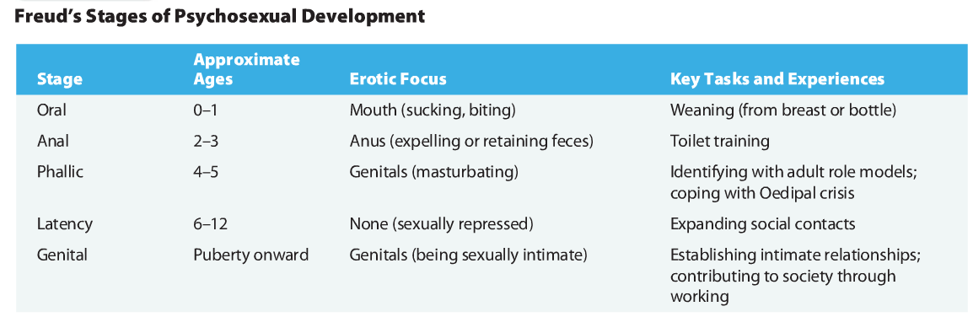

- Oedipal Complex: Children manifest erotically tinged desires for their opposite sex parent, accompanied by feelings of hostility toward their sam sex parent

Jung’s Analytical Psychology
- Personal Unconscious: Houses material that is not within one’s conscious awareness because it has been repressed or forgotten
- Collective Unconscious: A storehouse of latent memory traces inherited from people’s ancestral past
- Archetypes: Emotionally charged images and thought forms that have universal meaning
- Introverts: Tend to be preoccupied with the internal world of their own thoughts, feelings, and experiences
- Extraverts: Tend to be interested in the external world of people and things
Adler’s Individual Psychology
- Striving for Superiority: A universal drive to adapt, improve oneself, and master life’s challenges
- Compensation: Involves efforts to overcome imagined or real inferiorities by developing one’s abilities

Review of Key Points
- Psychodynamic approaches include all of the theories derived from Freud’s insights. Freud described personality structure in terms of three components – the id, the ego, and the superego – which are routinely involved in an ongoing series of conflicts
- Freud described three levels of awareness: the conscious, the preconscious, and the unconscious. His theory emphasized the importance of unconscious processes. Freud theorized that conflicts centering on sex and aggression are especially likely to lead to significant anxiety. According to Freud, anxiety and other unpleasant emotions such as guilt are often warded off with defence mechanisms.
- Freud believed that the first five years of life are extremely influential in shaping adult personality. He described a series of five psychosexual stages of development: oral, anal, phallic, latency, and genital. Certain experiences during these stages can have lasting effects on adult personality. Resolution of the Oedipal complex is though to be particularly critical to healthy development
- Adler’s individual psychology emphasizes how people strive for superiority to compensate for their feelings of inferiority. He explained personality disturbances in terms of overcompensation and inferiority complexes.
- Overall, psychodynamic theories have produced many groundbreaking insights about the unconscious, the role of internal conflict, and the importance of early childhood experience in personality development. However, psychodynamic theories have been criticized for their poor testability, their inadequate base of empirical evidence, their male-centered views, and the unrepresentativeness of their samples.
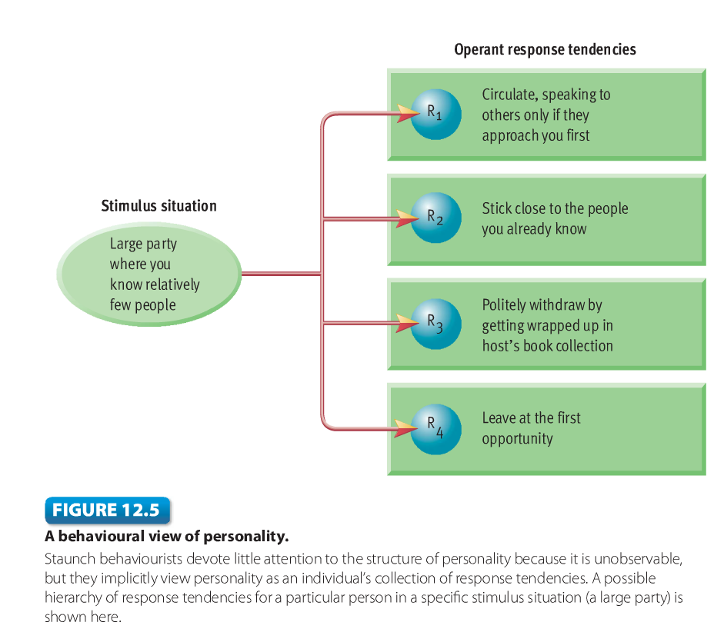
Behavioural Perspectives
- Behaviourism: A theoretical
orientation based on the premise
that scientific psychology should
study only observable
behaviour

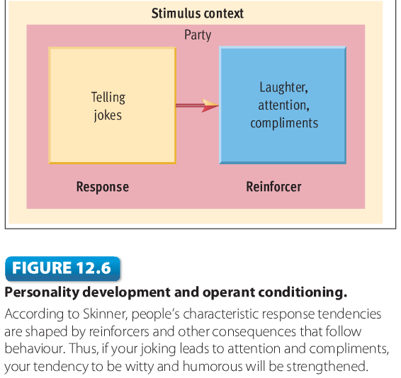
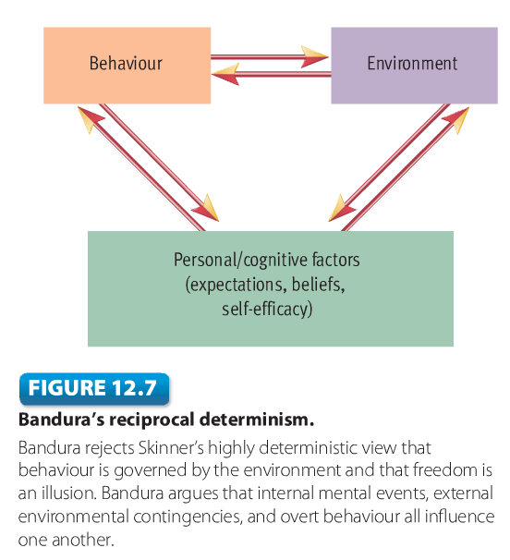

- Reciprocal Determinism: The idea that internal mental events, external environmental events, and overt behaviour all influence one another
- Observational Learning: Occurs when an organism’s responding is influenced by the observation of others, who are called models
- Model: A person whose behaviour is observed by another
- Self-Efficacy: Refers to one’s belief about one’s ability to perform behaviours that should lead to expected outcomes

Review of Key Points
- Behavioural theories explain how personality is shaped through learning. Skinner had little interest in unobservable cognitive processes and embraced a strong determinism
- Skinner’s followers view personality as a collection of response tendencies to specific stimulus situations. They assume that personality development is a lifelong process in which response tendencies are shaped and reshaped by learning, especially operant conditioning
- Social cognitive theory focuses on how cognitive factors such as expectancies regulate learned behaviour. Bandura’s concept of observational learning accounts for the acquisition of responses from models. High self-efficacy has been related to successful health regimens, academic success, and athletic performance, among other things
- Mischel has questioned the degree to which people display cross0situational consistency in behaviour. Mischel’s arguments have increased psychologists’ awareness of the situational determinants of behaviour. According to Fleeson, situational factors dominate small chunks of behaviour, whereas personality traits shape larger chunks of behaviour
- Behavioural approaches to personality are based on rigorous research. They have provided ample insights into how environmental factors and learning mould personalities. Radical behaviourism’s dehumanizing view of human nature has been criticized, but more contemporary social cognitive theories have been knocked for diluting the behavioural approach

Humanistic Perspectives
- Humanism: A theoretical orientation that emphasizes the unique qualities of humans, especially their freedom and their potential for personal growth
- Phenomenologaical Approach: Assumes that one ahs to appreciate individual’s personal, subjective experiences to truly understand their behaviour
- Self-Concept: A collection of beliefs about one’s own nature, unique qualities and typical behaviour
- Incongruence: The degree of disparity between one’s self-concept and one’s actual experience
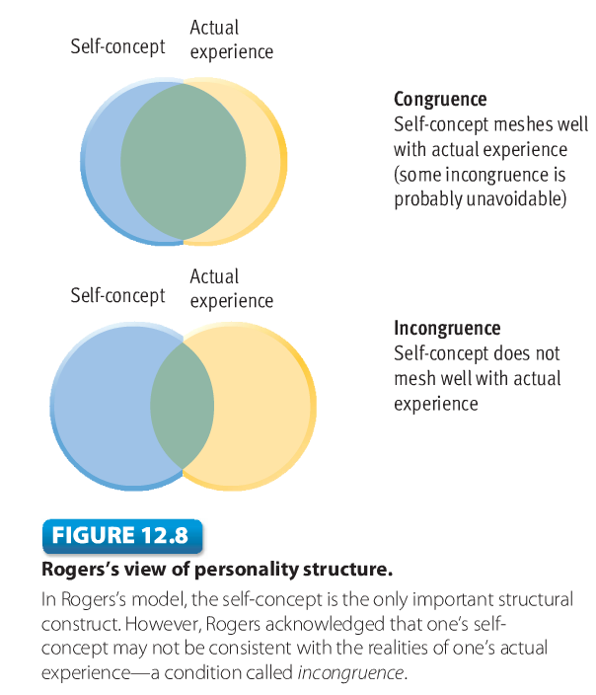

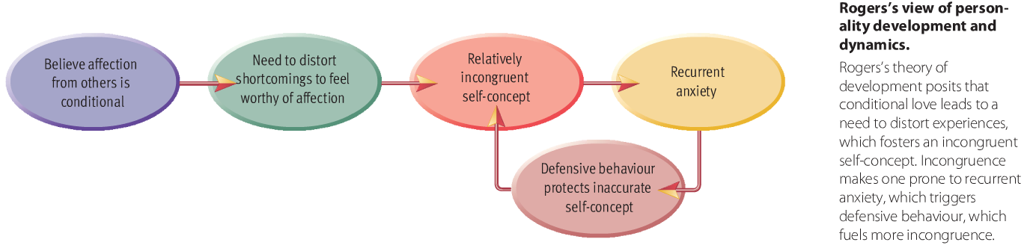

- Hierarchy of Needs: A systematic arrangement of needs, according to priority, in which basic needs must be met before less basic needs are aroused
- The Need For Self-Actualization: The need to fulfill one’s potential; it is the highest need in Maslow’s motivational hierarchy

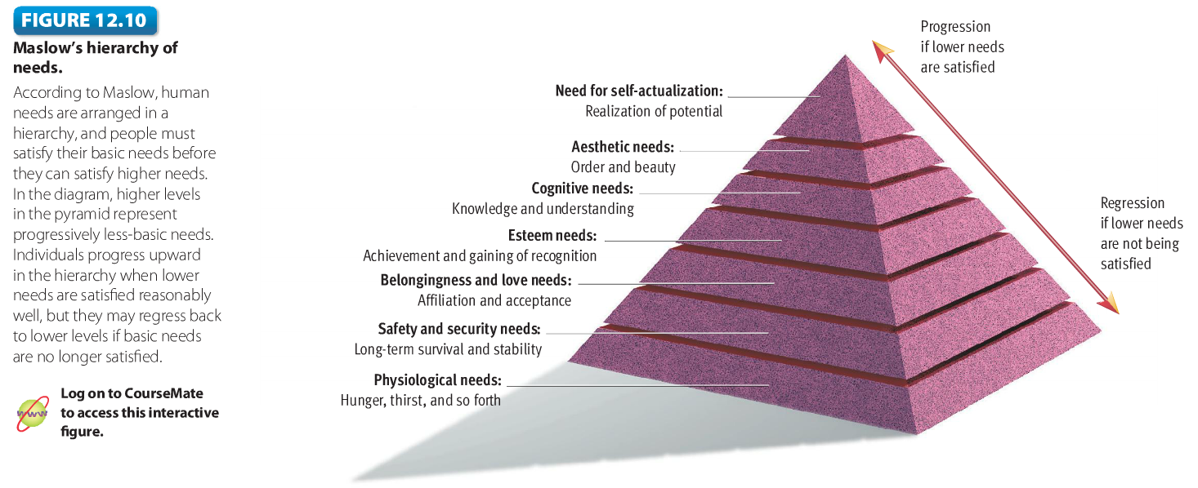

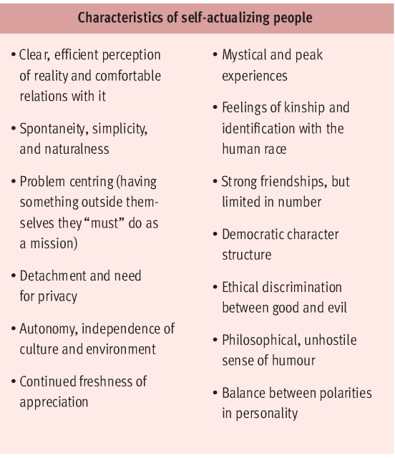
- Self-Actualizing Persons: People with exceptionally healthy personalities, marked by continued personal growth
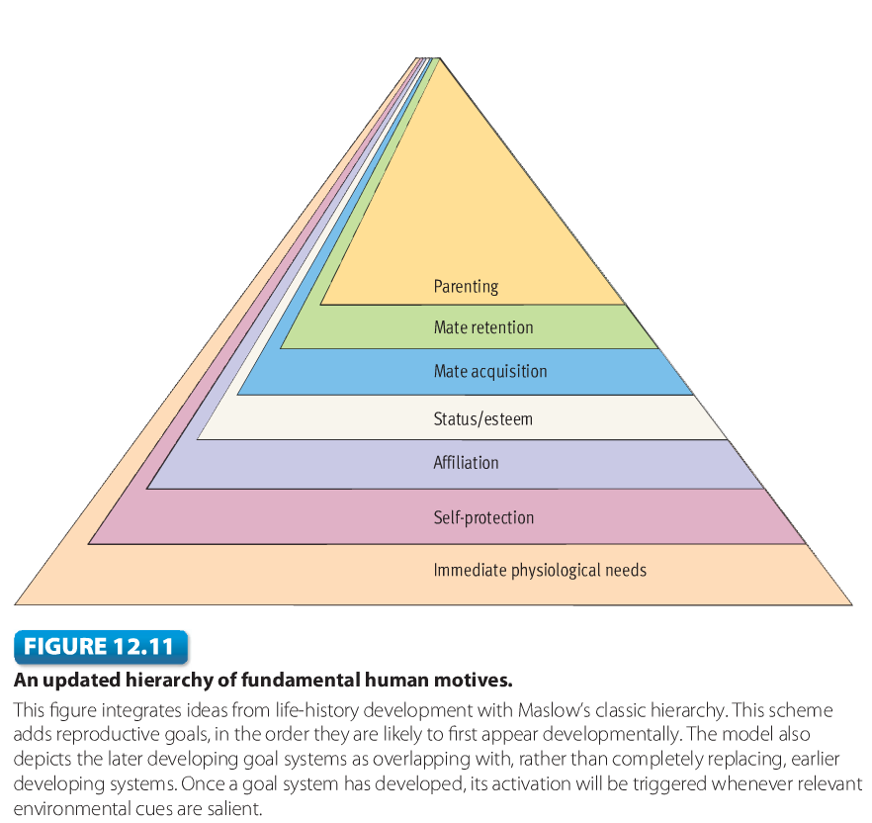

Weaknesses in the Humanistic Approach
- Poor testability
- Unrealistic view of human nature
- Inadequate evidence

Review of Key Points
- Humanistic theories are phenomenological and take an optimistic view of people’s conscious, rational ability to chart their own courses of action. Rogers focused on the self-concept as the critical aspect of personality. Incongruence is the degree of disparity between one’s self-concept and actual experience
- Rogers maintained that unconditional love fosters congruence, whereas conditional love fosters incongruence. Incongruence makes on vulnerable to recurrent anxiety, which tends to trigger defensive behaviour that protects one’s inaccurate self-concept
- Maslow theorized that needs are organized hierarchically and that psychological health depends on fulfilling one’s need for self-actualization which is the need to realize one’s human potential. His work led to the description of self-actualizing persons as idealized examples of psychological health. Recently, theorists have proposed a major revision of Maslow’s pyramid of needs in which the higher growth needs are replaced by motives related to reproductive fitness

- Humanistic theories deserve credit for highlighting the importance of subjective views of oneself and for confronting the question of what makes for a healthy personality. Humanistic theories lack a firm base of research, are difficult to put to an empirical test, and may be overly optimistic about human nature
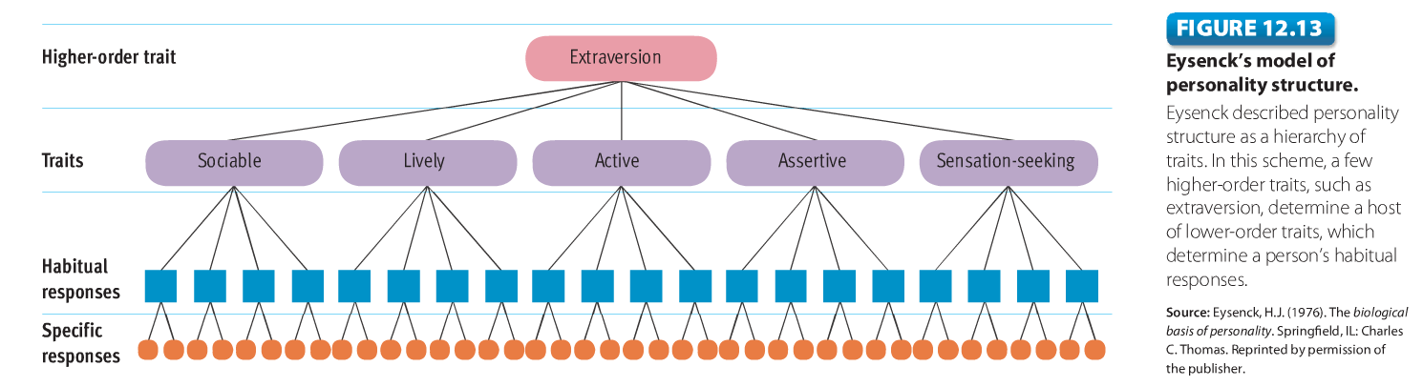

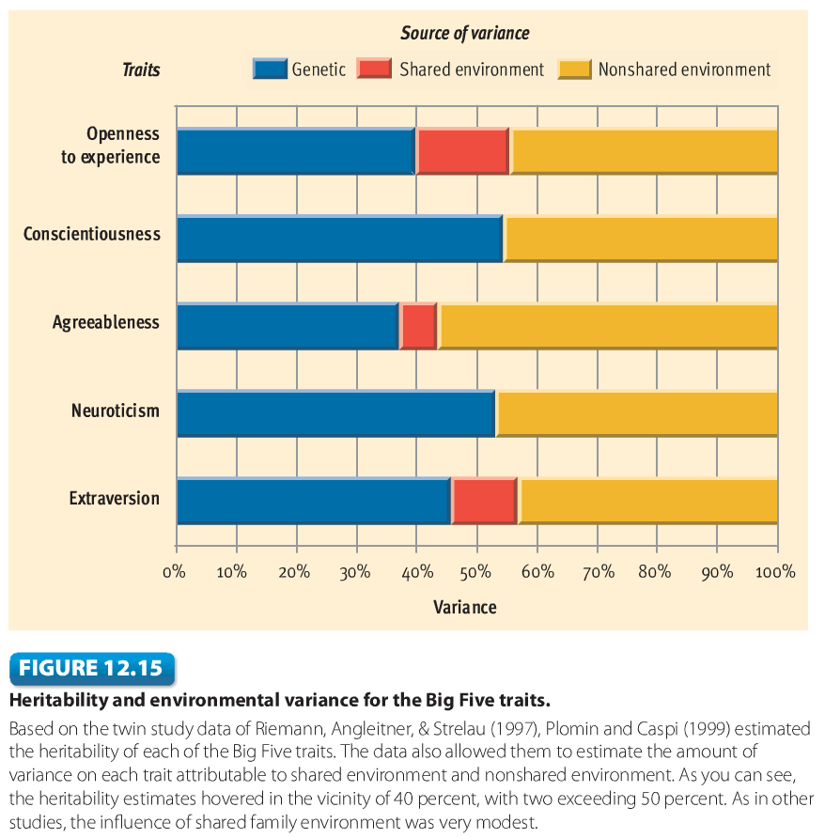
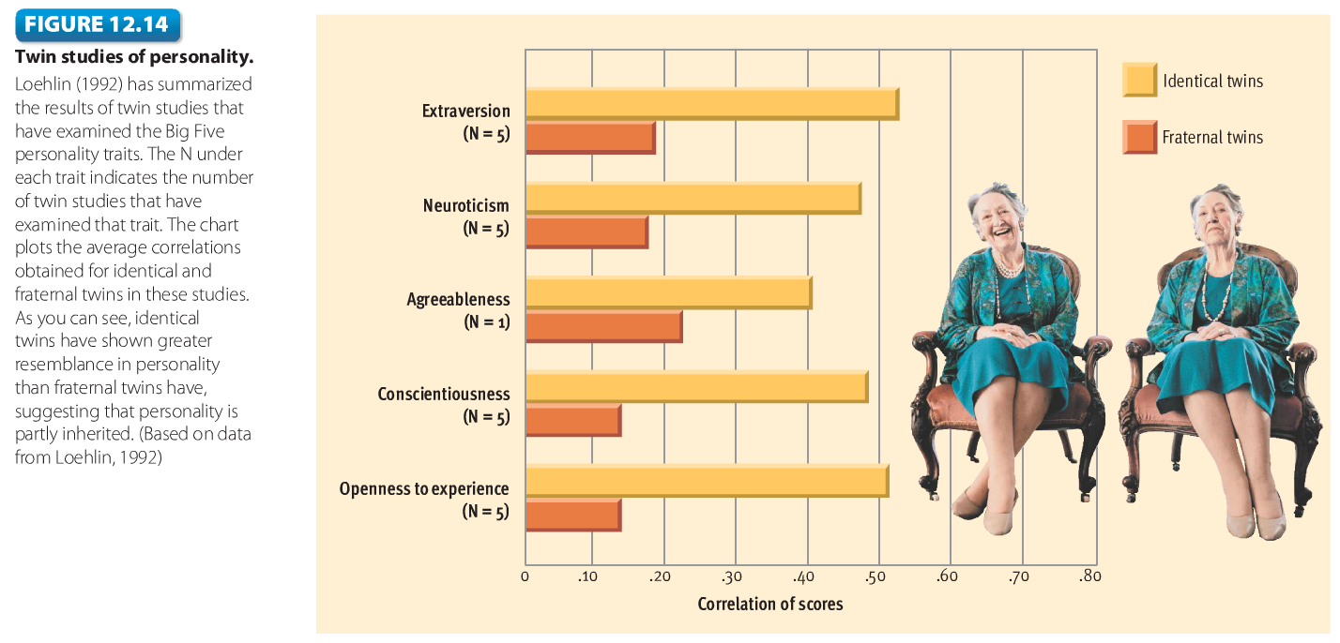

Review of Key Points
- Contemporary biological theories stress the genetic origins of personality. Eysenck views personality structure as hierarchy of traits. He believes that heredity influences individual differences in physiological functioning that affect how easily people acquire conditioned inhibitions
- Twin studies of the Big Five personality traits find that identical twins are more similar in personality than fraternal twins, thus suggesting that personality is partly inherited. Estimates for the heritability of personality hover in the vicinity of 50 percent. Recent research in behavioural genetics has suggested that shared family environment has surprisingly little impact on personality, although a variety of theorist have been critical of this conclusion
- Neuroscientists have found some interesting correlations between Big Five traits and the size of certain brain regions
- According to Buss, the ability to recognize and judge others’ status on the Big Five traits may have contributed to reproductive fitness. Nettle argues that Big Five traits themselves (rather than the ability to recognize then) are products of evolution that were adaptive in ancestral times
- Researchers have complied convincing evidence that genetic factors exert considerable influence over personality. However, the biological approach has been criticized because of methodological problems with heritability ratios and because the effort to carve personality into genetic and environmental components is ultimately artificial

Contemporary Empirical Approaches to Personality
- Narcissism: A personality trait marked by an inflated sense of importance, a need for attention and admiration, a sense of entitlement, and a tendency to exploit others
- Terror Management Theory: Concerns the psychological consequences of the “juxtaposition of a biologically rooted desire for like with awareness of the inevitability of death”
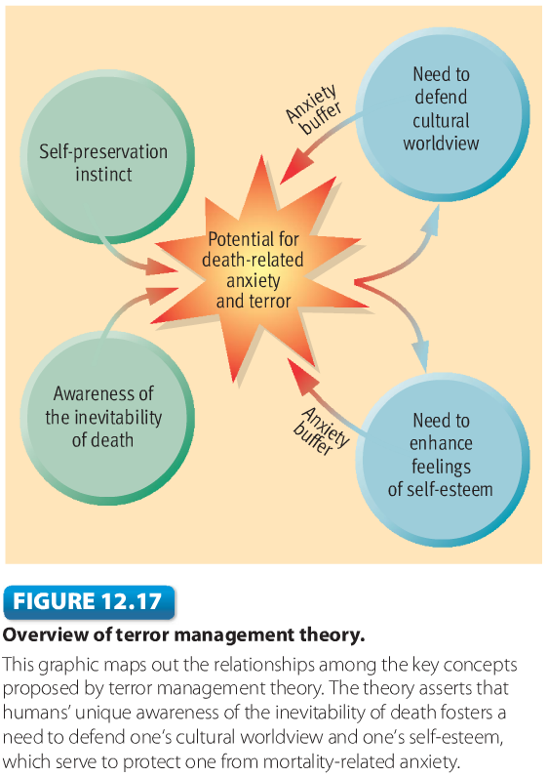
- Mortality Salience: The degree to which subjects’ mortality is prominent in their minds

Culture and Personality
- Individualism: Involves putting personal goals ahead of group goals and defining one’s identity in terms of personal attributes rather than group memberships
- Collectivism: Involves putting group goals ahead of personal goals and defining one’s identity in terms of the groups one belongs to (such as one’s family, tribe, work group, social class, caste, and so on)
- Self-Enhancement: Involes focusing on positive feedback from others, exaggerating one’s strengths, and seeing oneself as above average

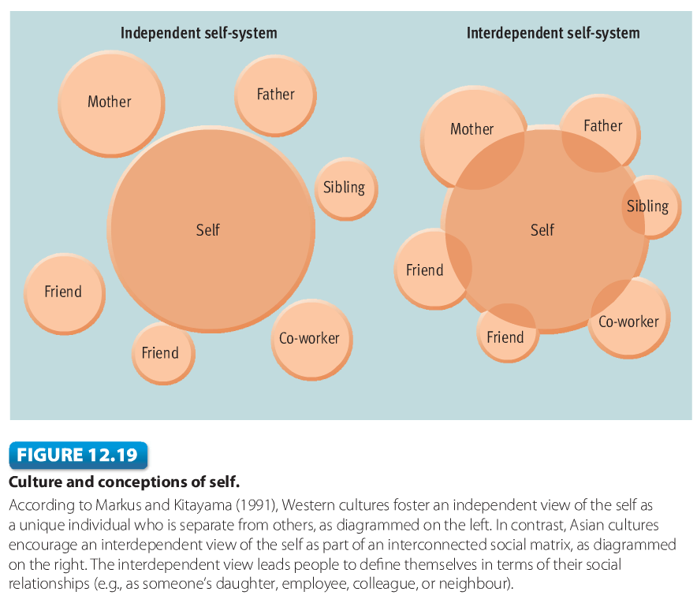

Review of Key Points
- People who score high in narcissism work overtime trying to impress others with self-aggrandizing tales of their accomplishments, all to protect their fragile self-esteem. They often are well-liked at first, but eventually seen as arrogant and self centered. Research suggests that levels of narcissism have been increasing in recent generations
- Terror management theory proposes that self-esteem and faith in a cultural worldview shield people from the profound anxiety associated with their mortality. Manipulations of mortality salience lead to harsh treatment for moral transgressions, elevated respect for cultural icons, and increased prejudice
- Some studies suggest that the basic trait structure of personality may be much the same across culture. However, some critics have voiced doubts about this conclusion
- Markus and Kitayama assert that Western culture fosters an independent conception of self, whereas Asian cultures foster an interdependent view of the self. These different views of the self lead to cultural disparities in the tendency to engage in self-enhancement
- The study personality illustrates how psychology is characterized by great theoretical diversity. The study of personality also demonstrates how ideas in psychology are shaped by sociohisorical forces and how cultural factors influence psychological processes

