Zach Lynch 7473931
Brady Stewart 7489014
26/11/13
ADM1370

ACCESS Assignment – Part 1

Company: Oracle

Introduction
Big data is a term that has started emerging frequently in recent years. This term refers to the collection of data sets that are too large and/or complex to properly and efficiently process them using traditional data processing tools and applications. Big data offers newly mined information to companies that was not previously available or easily accessible. As Oracle states, “For decades, companies have been making business decisions based on transactional data stored in relational databases. Beyond that critical data, however, is a potential treasure trove of non-traditional, less structured data”. The number one source for this unstructured data is social media profiles including Facebook, Twitter, Tumblr, etc. Tapping these social network profiles provide valuable business related information such as likes and interests. In order to decode true value from big data, one requires the proper applications and tools to discover and sort the colossal amounts of data. Many companies now develop and offer products that enable the ability to work with big data as it is becoming a prominent market. Many business professionals claim that in the next years to come, big data will become a key basis of competition. In McKinsey Global institute’s 2011 executive summary they state that approximately 30 billion pieces of content are shared on Facebook every month. They also claim that the projected growth of global data generated per year will increase by 40% every year for the next 8 years. Additionally, they project that a 60% increase in retailers’ potential operating margins is possible with big data. This being said, it is clear that big data is becoming an essential and effective part of our current and future business world.

Figure 1. Amount of Facebook users 2009 – 2011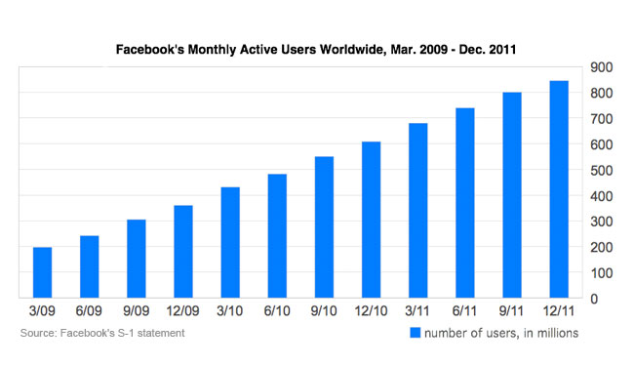
Source: http://go.bloomberg.com/facebook-unleashed/2012-02-01/facebooks-secret-accurate-data/

Solutions
Over the last few years, several technologies have been released in order to be used as databases for acquiring and storing big data. These systems have been divided into NoSQL and SQL solutions. SQL’s development began in the 1970s and was essentially created in order to have well structured and well organized data. NoSQL’s on the other hand, were created in the 2000s in order to cope with the limitations of SQL databases. These NoSQL databases are created to capture absolutely every piece of data, however do not process and organize it in the same manner as an SQL model. NoSQL databases provide rapid performance seeing as data is stored without being interpreted, as it would be in an SQL model. It is difficult for users to extract actual valuable information out of the data collected, and thus companies such as Oracle, IBM, etc. have created solutions that combine SQL and NoSQL models into a single infrastructure.

Figure 2. Spectrum of Divided Solutions
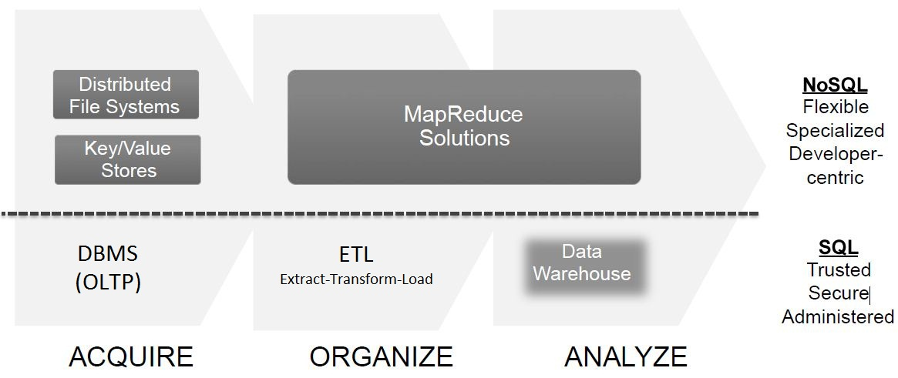
Source: http://www.oracle.com/us/products/database/big-data-for-enterprise-519135.pdf?ssSourceSiteId=ocomcaen

Oracle
According to their website, Oracle is the first to offer a complete solution addressing the entire spectrum of enterprise big data requirements.⁶
Figure 3. Oracle’s Solutions to Big Data
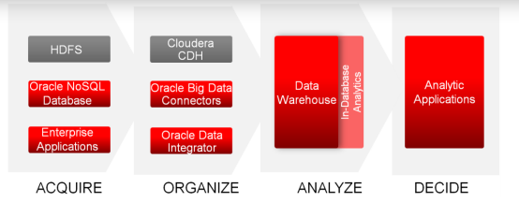
Source: http://www.oracle.com/us/products/database/big-data-for-enterprise-519135.pdf?ssSourceSiteId=ocomcaen
NoSQL Database
Oracle’s complete solution is referred to as Oracle’s Big Data Application. This application is made up of several components including Oracle NoSQL Database and Oracle Big Data Connectors. This application paired with Oracle Exadata gives enterprises a the capacity to acquire, organize and analyze all data in order to make informed executive decisions.⁶ Oracle’s big data appliance has the capacity to store 648 Terabytes of data. The NoSQL Database is a database based on the Oracle Berkeley Database, which is a software library that provides high-performance embedded database for value data. In addition to the abilities of Berkeley DB, Oracle’s NoSQL Database has an added intelligent driver that shards the data and can place it with the lowest possible latency, which essentially avoids delays in data.
Oracle Big Data Connectors
Oracle Big Data Connectors are made up of four essential components: Oracle Loader for Hadoop, Oracle SQL Connector for Hadoop Distributed File System, Oracle Data Integrator Application Adapter for Hadoop, and Oracle R Connector for Hadoop. “Hadoop is an open source software that enables the distributed processing of large data sets across clusters or commodity servers”. Oracle Big Data Connectors enable the ability to analyze all data together with extreme performance.⁶
Oracle Analytics
Oracle’s new solutions provide users with very simplistic tools that enable advanced in-database analytics. A significant tool that is used is the ability to mine data as well as text (known as In-Database Data/Text Mining). Data mining is defined as the practice of examining large pre-existing databases in order to generate new information. Oracle explains that their system enables “the ability to create complex models and deploy these on very large data volumes to drive predictive analytics”⁶. They use the example that a model could be used to predict a customers age based on purchasing behaviour as well as demographic data.
Text mining is quite different from data mining. Text mining is the ability to mine text from online sources and social media (Ie: Twitter, Facebook, etc). Through text mining, users can find information through unstructured data that would normally be nearly impossible to analyze. Other analytic abilities that Oracles solutions carry are Graph Analysis, Spatial, and MapReduce.

Works Cited
Brust, A. (2012, July). Top 10 categories for Big Data sources and mining technologies. Retrieved November 2013, from ZDnet: http://www.zdnet.com/top-10-categories-for-big-data-sources-and-mining-technologies-7000000926/
Dijcks, J.-P. (2013, June). Oracle: Big Data for the Enterprise. (Oracle) Retrieved November 2013, from Oracle.com: http://www.oracle.com/technetwork/server-storage/engineered-systems/bigdata-appliance/overview/wp-bigdatawithoracle-1453236.pdf?ssourceSited=ocomcaen
IBM. (n.d.). What is Hadoop. Retrieved November 2013, from IBM.com: http://www-01.ibm.com/software/data/infosphere/hadoop/
James Manyika, M. C. (2011, May). Big data: The next frontier for innovation, competition, and productivity. Retrieved November 2013, from McKinsey & Company: http://www.mckinsey.com/insights/business_technology/big_data_the_next_frontier_for_innovation
N/A. (2013). NoSQL Databases Explained. Retrieved November 2013, from MongoDB: http://www.mongodb.com/learn/nosql

http://www.oracle.com/technetwork/server-storage/engineered-systems/bigdata-appliance/overview/wp-bigdatawithoracle-453236.pdf?ssourceSited=ocomcaen
^{(Brust, 2012)}
http://www.mckinsey.com/insights/business_technology/big_data_the_next_frontier_for_innovation
http://www.mckinsey.com/~/media/McKinsey/dotcom/Insights%20and%20pubs/MGI/Research/Technology%20 and%20Innovation/Big%20Data/MGI_big_data_exec_summary.ashx
http://www.mongodb.com/learn/nosql
http://www.oracle.com/us/products/database/big-data-for-enterprise-519135.pdf?ssSourceSiteId=ocomcaen
http://www.oracle.com/technetwork/products/berkeleydb/overview/index.html
http://www-01.ibm.com/software/data/infosphere/hadoop/

