Business Mid-Term Study Notes

Critical Success Factors & Environmental Analysis Models

Critical Success Factors
- Achieving financial performance
- Meeting costumer needs
- Building quality products and services
- Encouraging innovation and creativity
- Gaining employee commitment
- Creating a distinctive competitive advantage

Diamond E- Framework
Identifies key variables to be considered in strategic analysis

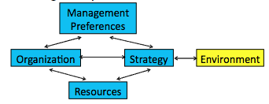

Importance of Strategy

Strategy: What opportunities the business is pursuing.
-Determines needed resources, organizational capabilities and management preferences.

Critical linking variable
-Any variable can either drive or constrain strategy
-Each variable related to the rest

First task- deal with the strategy-environment linkage.
-Assess forces at work and their implications

Diamond E- Principal Logic

- Principal Logic= consistency or alignment
- Internal consistency leads to performance
- External consistency ensures strategy is right for the given environment
- Challenge: Environment is always changing
-Is strategy in alignment with environment?
-Is strategy in alignment with internal variables?

- Important of consistency between variables
- EXAMPLES:
-P&G Strategy in 2000 (inconsistency)
-Ikea Strategy (consistency)
- Note: Absolute alignment is not realistic

Strategy- Environment Linkage

- First task: Deal with strategy-environment linkage.
- Assess forces at work and their implications.
- EXAMPLES: Digital camera market: Canon vs. Kodak

EXTERNAL ANALYSIS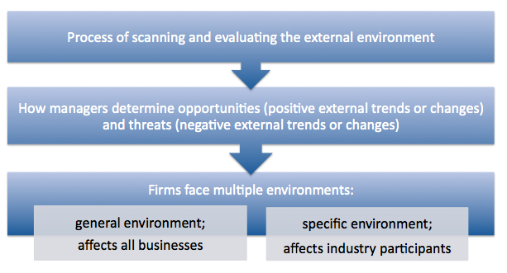
How to do an external analysis

General Environment
- PEST model- considers political, economic, social/demographic, and technological factors.
- Identifies general trends and changes.

Specific Environment
- Porter’s Five Forces- analyzes five important sources of competitive pressure and intensity; predicts profitability of industry.
- Look for data, statistics, trends, forecasts, expert opinions, etc.

Benefits of External Analysis
- Makes managers proactive
- Provides information used in planning
- Helps organization get needed resources
- Helps organization cope with uncertainty
- Improves consistency and performance

Challenges of External Analysis
- Forecasts and trend analyses imperfect
- Rapidly changing environment is hard to keep up with
- Time consuming

PEST FACTORS

Political- Legal:

Elements:
- Laws, regulations
- Taxes
- Trade agreements
- Political system
- Political stability
- Government can create incentives, constraints, or support/ bail out when needed.
- Affects uncertainty, risk, and costs faced by firms.

Economic:

Elements:
- Economic growth- GDP and standard of living
- Economic stability- inflation, unemployment
- Trade balance- importing vs. exporting
- National debt- government borrowing
- Interest rates
- Exchange rates
- Influences costs, potential sales, and financial uncertainty.

Social:

Elements:
- Customs, values, attitudes, and demograpic characteristics
- Influences customer preferences
- Influences worker attitudes and behaviours
- Influences standards of business conduct
- Ethics, social responsibility, stake holder management.
- Affects how we live, work, consume and produce.

Technological

Elements:
- Internet affects buying, selling, communication
- Information technologies affect information access, inter-firm cooperation, cycle times.
- Computer technologies have changed our products and how we design and build.
- Not limited to computers and information.
- Affects what we produce/what it can do, affects how we produce and how we sell
- Demands constant learning and scanning

Three most important issues facing Canadian businesses
- Value of Canadian dollar
- Skilled labor shortage
- Natural/physical environment

Questions to answer from PEST

- Do the economic conditions support my business?
- What legal protection do I have or laws do I have to consider?
- What demographic and social trends affect my business and how?
- What technological forces affect me now and in the future? How do they assist or constrain?
- What opportunities or threats does the environment possess?

PORTERS FIVE FORCES
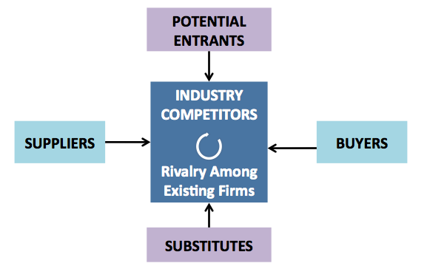

Suppliers:
- Fewer suppliers, high switching costs, low attractiveness of substitute suppliers, high threat of forward integration means= increased bargaining power for other suppliers.
- Bargaining power increases cost of inputs.
- Solution: use strategic alliance or internal supply

Potential Entrants:
- Can cause big changes
- Ease of entry=more intense competition
- Solutions: create or use barriers
-Capital Intensity
-Technology
-Know how
-Regulatory approval
-Brand loyalty
-Access to distribution

Substitutes
- Many substitutes = increased competition
- Puts ceiling on price that can be charged
- Pressure increases as price of substitutes and switching costs decline
- Solution: Make buyers believe you are unique & lock them in.

Buyers
- Few or concentrated buyers, standardized products, low switching costs, discretionary purchases = increased bargaining power for buyer.
- Reduces price that you can demand
- Solution: create alliances with other firms, build strong marketing.

Rivalry among existing firms
- Results in price competition and increased costs
- Most powerful of five forces
- Causes:
-Many competitors of equal size/capability
-Growth rate of industry
-Consumers’ switching costs
-Products are commodities or are perishable

Questions to answer with Five Forces Analysis
- Is the industry a realistic place for a new venture to enter?
- Can we do a better job than incumbents at avoiding or diminishing factors that suppress industry profitability?
- Is there a unique position we can pursue?
- Is there a superior business model that incumbents would find hard to duplicate?

Entrepreneurship

Entrepreneurship: identifying to opportunity and accessing resources to capitalize on it.

Entrepreneurial process
- Influenced by PEST
- Successful only when entrepreneur, opportunity, and resources match
- Begins with entrepreneur identifying an opportunity then accessing resources

Opportunity Recognition

Idea generation
- Often paradigm shifts
- Originate in events relating to work or daily life, hobbies, chance happening

Screening
- Weeding out bad ideas
- Saves time, money
- Ensures you have a viable idea with a competitive advantage

3 Step Screening Process

- Idea creates or adds value for customer
-Solves a problem
-Customer willing to pay for it

- Idea provides a competitive advantage that can be sustained
-Product unique in a valuable way/better than others
-How is it different and better from existing products and substitutes?
-Are differences valuable to costumers?
-Is it something that existing firms can easily do or may want to imitate?
-Can the idea be protected legally?
3) The idea is marketable and financially viable
-Are there enough costumers who are willing to buy it?
-What is the market demand likely to be?
-Who are the key competitors?

Safety point: Does the idea have low exit costs?
- Longer time to profitability or greater up-front investment needed = riskier venture.

High vs. Low potential ventures

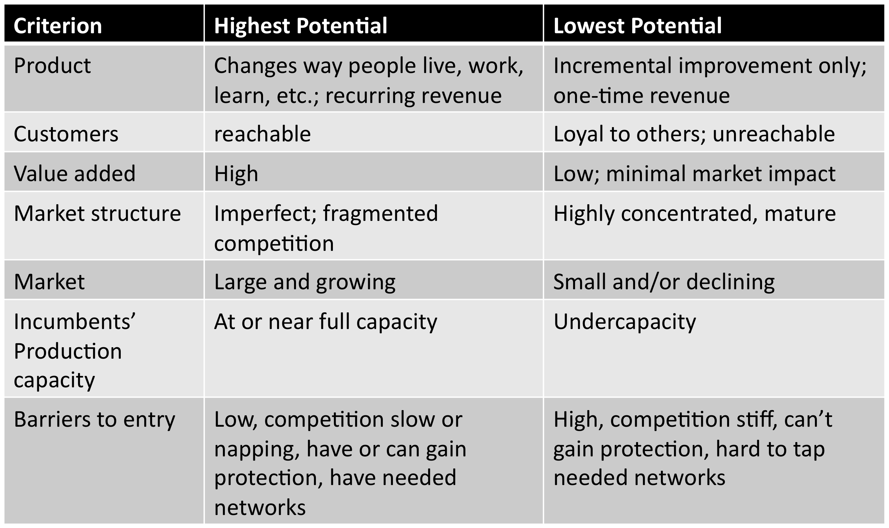

Accessing Resources

Bootstrapping- doing more with less
-Make do with as few resources as possible
-Use other people’s resources where possible
-Find/use free stuff

Financial resources- Debt vs. equity financing
- Debt = interest and control
- Sources- financial institutions, suppliers
- Equity= no interest, less control
- Sources- savings, love money, private investors, venture capitalists

Social Entrepreneurship- Society’s change agents: creators of innovations that disrupt the status quo and transform our world for the better.

Key facets of social entrepreneurs

- Help overcome market inequities/failures
-How? Entrepreneurs seek innovative solutions to the world’s toughest problems
-Often in areas of education, health, environment
- Social value as the primary objective
-Economic value is a by product
-Key difference
- Results in companies with social missions
- Form of business can vary
-Importance of attaining social value proposition through the legal business form (not for profit, charity)
- Accountability to community stakeholders
-Rather than only private investors
- Important of bootstrapping and self-sustainability- charity vs. social business
- Examples:
-Prof. Muhammad Yunus (founder of the Grameen Bank & nobel prize winner)
-Provided loans to women in impoverished areas of rural Bangladesh
-Greg Overholt (Students offering support)
-Volunteers run help sessions and student fees fund projects in Latin America

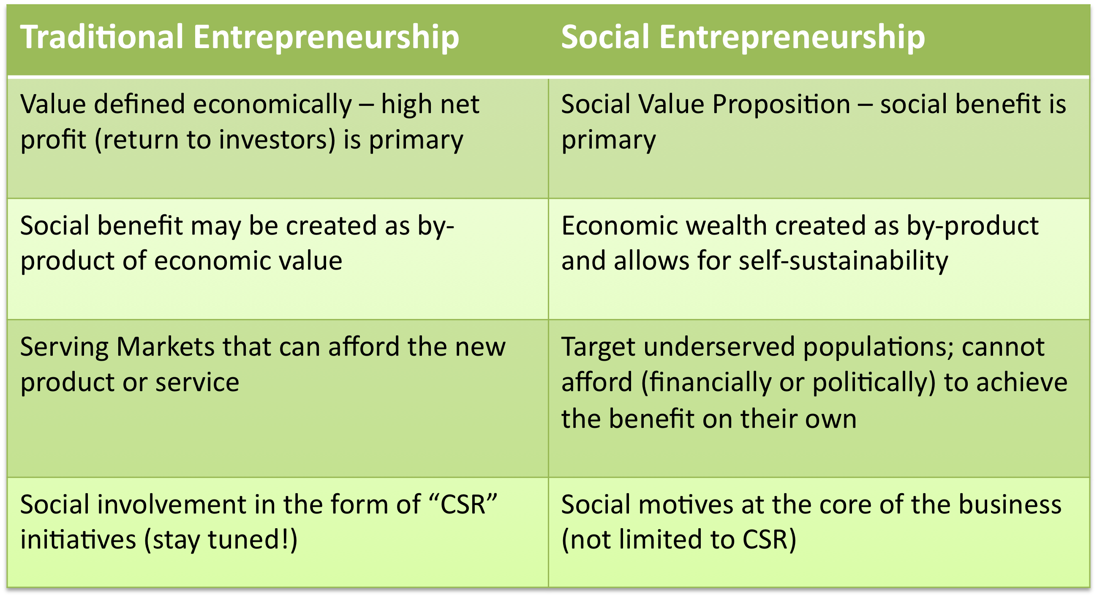

Technological Factors

What is technology?
- Advancements in equipment and it’s uses
-Often substitutes for/magnifies human efforts
-Includes human knowledge, work methods, equipment, processing systems
- Includes information technology
-The various devices for creating, storing, exchanging, and using information
-Consumers use it daily, ex: ATM, shopping
-Companies use it to gather and share info and execute activities
Opportunities/ Threats of Technology

Opportunities:

- Products: innovation, uniqueness, value
- Management and organizational processes
-Instant access to information
-Better service through coordination
-Leaner organization
-Improved operations efficiency
-Greater independence of company and work place
- Competiveness
-Creates barriers to entry; cooperation with other firms, reduced times
- Communication and collaboration
-Within firm with customers
- Customization

Threats:

- Imitation
-Information costly to develop but cheap to share
- New technologies in unfamiliar areas
-Disruptive technologies challenge the value of organizational capabilities and resources
- Unpredictable evolution
-VHS vs. BetaMax
-Blu-ray vs DVDS
- Need for constant learning and scanning
- Information overload
- Greater independence of company and workplace

Technology Standards

Standard wars
- Battles between incompatible technologies
- Can determine survival of companies involved
- Not limited to information technology

Important technology concepts

- Installed base- # of users
-Bigger = greater influence
- Lock-in= size of investment
-Larger= greater resistance to switch
- Switching costs- cost of moving
-Entry barrier; makes lock-in worse
- Complementary goods – needed for value, creates vicious or virtuous cycle
- Network effects- value depends on users

Key assets and Strategies

Control over installed base of users
- First mover advantages – preemption
- Expectations management
- Offer customers a migration path

Intellectual property rights
- Slows imitation or requires cooperation

Ability to innovate
- Stay on your guard

Strength in complements
- Use alliances

Lower customer switching costs
- Make your product cheap or easy (Firefox)
- Build in an adapter (Apple)

- Offer a leap in performance for price (sporting goods)

- Make your product compatible with the dominant standard

Sustaining technology

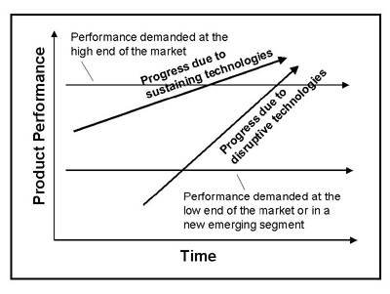
• Presents improvements to existing products in expected ways

• Provides mainstream, high- margin customers with enhancements in product functionality

• Existing firms normally win

Disruptive Technology

• Presents a different package of performance attributes that aren’t initially valued by mainstream customers (starts in peripheral markets)

• Gains foothold in lower performance segment, improves technology rapidly until they meet mainstream performance needs, then enter these markets

• New, disrupting firms normally win

How different types of innovation impact existing firms

- Challenge value of existing capabilities and/or structure



