Chapter 15 Monday week 23

- Critically evaluate what is considered (ab)normal using the three Cs.
- Discuss the Rosenhan (1973) study of mental hospitals and what we can learn from it.
- Evaluate the risks and benefits of labeling psychological disorders.

Definition of psychological disorders: persistent/harmful/thoughts/ feelings interfere with daily functioning
1.
- Statistical rarity  - Evaluate the content  - E.g., Shout out on the bus to no one in particular | Societal disapproval  - Evaluate the context  - E.g., wearing a Viking hat everyday | - Personal suffering  - Evaluate the consequences  - E.g., Pulling out one’s own hair in fistfuls

2. The study concluded, "It is clear that we cannot distinguish the sane from the insane in psychiatric hospitals" and also illustrated the dangers of dehumanization and labeling in psychiatric institutions. It suggested that the use of community mental health facilities which concentrated on specific problems and behaviors rather than psychiatric labels might be a solution and recommended education to make psychiatric workers more aware of the social psychology of their facilities.
3.
Costs/Risks | Benefits/Uses
- Misdiagnosis  - Stigma job applications, friendship…  - Misdiagnosis not solving the real problem and/or worsening and/or triggering new problem  - Legal implications  - Lens to interpret all behaviour  - Confirmation bias from others  - Giving up in the face of the label | - Help understand why you might be feeling what you do  - Legal implications  - Educational resources  - Appropriate treatment  - Researchers to consider what symptoms belong together/apart  - Help eliminate misdiagnosis through research  - Definitions spur research

Wednesday week 23
- Summarize the features and purpose of the DSM.
- Describe some of the biopsychosocial contributions to understanding disorders in general and anxiety disorders in particular.
- Explain similarities and differences among phobias, GAD, and panic disorder.

1.
- Biopsychosocial approach
- Classification only
- 17 categories (list in text)
- Rule out physical cause first (e.g., thyroid)
- High inter-rater reliability
- Cultural influence
- Focus: Is it problematic for daily functioning?
2.

- Phobias  - trigger is consistent  - Intense and automatic in response to that particular trigger  - Irrational fear  - Leads to some kind of impairment | - Generalized Anxiety Disorder  - anxiety throughout the day  - High level constantly  - Future-focused | - Panic Disorder  - Physical symptoms (heart rate, feeling hot or cold, negative thoughts)  - think of it afterward and afraid of it happening again
Panic Disorder
  - Physical symptoms (heart rate, feeling hot or cold, negative thoughts)
  - think of it afterward and afraid of it happening again
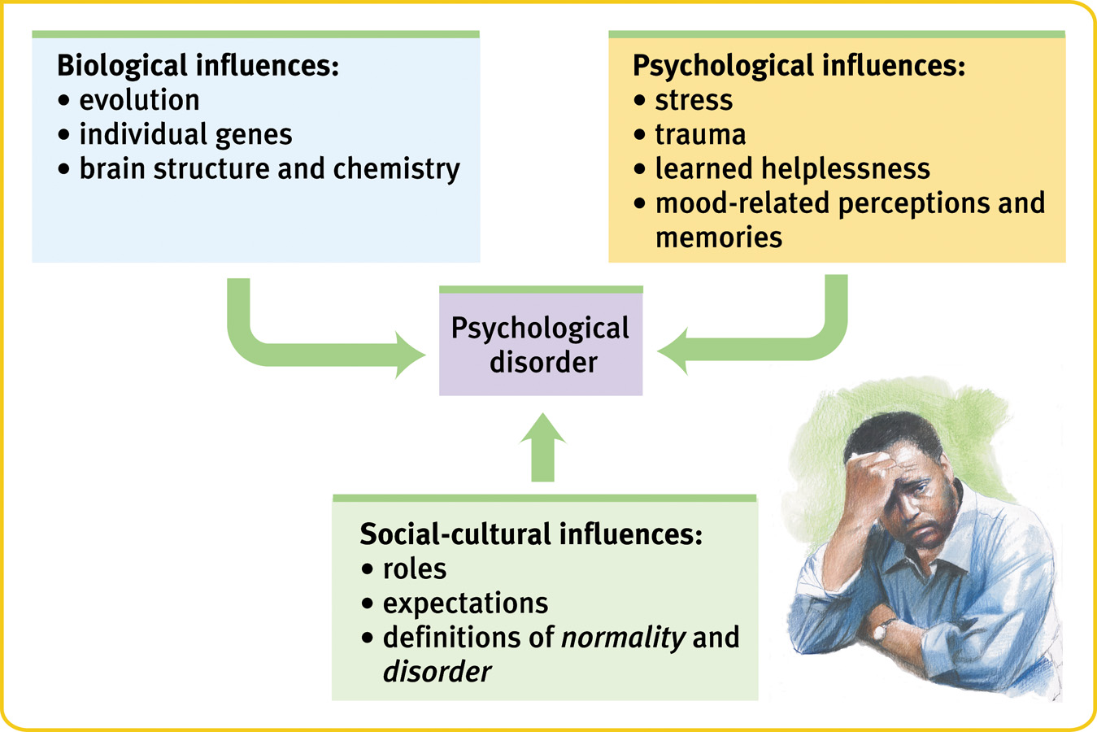
3

Friday week 23
- Identify examples of phobias, GAD, and panic disorder. (pg 652)
- Apply principles of conditioning to explain phobias.
- Describe some of the biopsychosocial contributions to understanding disorders in general, as well as mood disorders in particular.
- Compare and contrast the features and experiences of major depressive disorder versus bipolar disorder.
- Distinguish schizophrenia from dissociative identity disorder.

Intense, persistent worries that impair everyday functioning
Some Types
  - Generalized Anxiety Disorder : (perpetual worries)
  - Panic Disorder (terrors that come out of the blue)
  - Phobias (irrational fears)
  - Obsessive-Compulsive Disorder
  - Post-Traumatic Stress Disorder
Development has biopsychosocial components
  - Genetic preparedness
  - Conditioning
  - Observational learning
2. Classical conditioning develop
Operant conditioning maintain

3.
- Biological component  - Genetics  - Brain activation  - Volume in parts of brain  - Neurotransmitters | - Social Component  - Triggered & worsened by traumatic events  - Worsened by ostracism | - Psychological Component (Depression)  - Loss of reinforcement  - Learned helplessness  - Rumination  - Negative explanatory style

4. mood disorder
Bipolar Disorder: Alternate between depressive episode and mania  - Characteristics of Manic Episodes  - Fast forward!  - Dramatically elevated mood  - Decreased need for sleep  - Increased energy  - Inflated self-esteem  - Increased talkativeness  - Irresponsible behavior (e.g., $$$$) | Depression:  - Two or more weeks of…  - Depressed mood  - Low interest in pleasurable activities  - Unable to experience pleasure  - Feel worthless  - Not caused by drugs or medication  - Severe impairment  - Episode often lasts 6-12 months  - Typically 5-6 episodes in lifetime  - Worldwide  - In NA, women twice as likely to be diagnosed as men  - Most likely people in 30s, but any age

5. Distinguish schizophrenia from dissociative identity disorder.
- Schizophrenia is not characterized by split personalities.
- Schizophrenia is characterized by split from reality.
- Controversial diagnosis: DID
  - Dissociative Identity Disorder
  - Supposed development of multiple coexisting personalities
- Dissociation, broadly defined
  - DSM-IV-TR: “a disruption in the usually integrated functions of consciousness, memory, identity, or perception of the environment”
  - Note: Common to sometimes feel disconnected from self, reality

Monday week 24
- Distinguish two models of DID and summarize key research findings about this controversial diagnosis.
- Describe the 3 hallmark characteristics of schizophrenia.
- Differentiate the subtypes of schizophrenia.
- Describe the current understanding of what causes schizophrenia.
- Analyze two serial killers for evidence of Anti-Social Personality Disorder versus Psychopathy. Compare and contrast the disorders.
- Identify important symptoms for diagnosing four psychological disorders.
1.
Common Assumption: Posttraumatic Model  - Coping with intense stressors (e.g., child abuse)  - Cognitive deficits interfere with processing emotional info  - Forget painful memories | Alternative (2012): Sociocognitive Model  - Consequence of social learning, expectancies  - Unintentional cues from therapists  - Media & sociocultural expectations  - Explains extremely unstable behaviours of BorderlinePD  - Similar to model of hypnosis

2.
- Disorganized thinkingj | - Disturbed perceptions | - Inappropriate emotions and actions
- Delusions (persecution)  - Disorganized speech | - Hallucinations  E.g., hear voices | - E.g., laugh at a funeral  - No emotion or movement

3.
- Catatonic Schizophrenia (can harm themselves and other)
  - Waxy flexibility
  - Echolalia
- Paranoid Schizophrenia(hallucination)
  - Delusions of persecution
  - A Beautiful Mind
    - http://www.youtube.com/watch?v=qgi_EaO0iXk
- Disorganized Schizophrenia (mr. bean)
  - Illogical, incoherent thoughts and speech
4.
Genetics  - Predisposition, but not whole story  - Fetal environmental conditions  - 2nd trimester: viruses, starvation  - Birth trauma (O₂ deprivation) | Increased risks:  - Brain abnormalities  - E.g., overactive dopamine  - Enlarged ventricles  - Acute stressors  - E.g., poor social interactions, trauma, chronic family problems  - “diathesis-stress model”

5.
Antisocial Personality Disorder:  - Impairments in personality (self and interpersonal) functioning and presence of pathological personality traits.  - Significant impairments in personality functioning  - Identity or self-direction  - Empathy or intimacy | Pathological personality traits  - Antagonism (manipulative, deceitful, callous, hostile)  - Disinhibition (irresponsible, impulsive, risk taking)

6. Anxiety disorders
  - Panic Disorder, GAD, Phobias, OCD
- Mood disorders
  - Bipolar disorder, Major Depressive Disorder
- Schizophrenia
  - Catatonic, paranoid, disorganized, (vs. DID)
- Personality Disorders
  - Antisocial personality disorder (vs. psychopathy)

Wednesday week 24
Learning Objectives for the film…
By the end of this lesson you should be able to…
- Identify the symptoms and ways depression affects peoples’ lives.
- Describe the variety of treatment options available for depression, and the order and/or combination in which they are pursued. -> Psychotherapy, Antidepressant drugs, then ECT
- Summarize research findings on depression and the brain (e.g., hippocampus). -> Too many cells in the hippocampus

Friday week 24
- Describe two major approaches to therapy.
- Discuss an example of a family therapy.
- Describe the goal, assumptions, and examples of drug therapy.
- Describe the goal, assumptions, overall method, and examples of cognitive therapy.
- Identify an example of a cognitive therapy style approach.

1.
Psychotherapies  - Insight therapies  - Psychoanalysis  - Humanistic-Existential therapies  - Group & Family Therapies  - Behavioural Approaches  - Behaviour therapyy  - Cognitive therapy | Biomedical Therapies  - Drug therapies  - Brain stimulation  - (Psychosurgery)

2.
- “Structural Family Therapy”  - Therapist deeply involves self in family activity  - Changes organization of interactions among family members | - Overall, more effective than no treatment  - at least as effective as individual therapy

3.
- Goal
  - To alleviate symptoms of psychological disorders by altering body functions
- Assumptions
  - Altering brain chemicals can affect behaviour (thoughts, actions, feelings)
- Examplesh d
  - Antipsychotic drugs
  - Antidepressants
  - Antianxiety drugs
4. Goal
  - Teach people new, more adaptive ways of thinking, acting
- Assumptions
  - Thoughts = key to (un)healthy functioning
  - Irrational beliefs can be replaced by rational, adaptive thoughts
  - In terms of Ellis’ Rational Emotive Behaviour Therapy…
Emotional and behavioural Consequences to Activating Events in our lives are influenced by our Beliefs
- Method
  - Examples…
    - Therapist: Question client to help discover irrationalities
    - kClient: Prioritize, set goals for most important problems
  - In terms of Ellis’ Rational Emotive Behaviour Therapy…
    - Teach people to actively Dispute irrational beliefs and adopt more Effective and rational beliefs
- Examples of effective use
  - Depression
  - Anxiety, panic disorder
  - Bulimia
  - u
Monday week 25
- Discuss the efficacy of cognitive therapy, specifically when compared with drug therapy.
- Describe the process of systematic desensitization, including how virtual reality is used in that process.
- Explain how processes of classical and operant conditioning can be used to treat some psychological problems (e.g., phobias).
1.
- Key strength: solid scientific support
  - E.g., for depression, bulimia, anxietyj
  - Relative to insight therapies…
  - Can be more effective
  - Relative to drug therapies (e.g., antidepressants)
  - CT effective in short-term and better relapse prevention
2. Behavior Therapy
- Goal
  - Change specific maladaptive behaviour using principles of learning
- Assumptions
  - Overt symptoms are the problem
  - Behaviour change from basic principles of learning
- Methods
  - Classical Conditioning
    - Systematic desensitization
    - Aversive conditioning
  - Operant Conditioning (rewards)
- Systematic desensitization
  - Type of exposure therapy
  - Patients taught to relax as gradually exposed to what they fear
Examples of psychological disorders that respond well to behavioural approaches
  - Phobias
  - Panic disorder
  - Bulimia
  - OCD
  - Depression
Wednesday week 25

- Contrast two insight therapies.
- Compare three approaches to treating depression.

1. Goals differ depending on type
  - Psychoanalysis: expand awareness, insight into unconscious processes
  - Humanistic-existential: realize fullest potential by understanding self
- Assumptions
  - Psychoanalysis: insight into unconscious conflicts reduces symptoms
  - Humanistic-existential: self-actualization is a process
- Methods
  - Psychoanalysis: Dream analysis, free association, interpretation…
  - int
- Efficacy
  - Better than no treatment
  - Overall less effective than CT/CBT/BT
  - Not effective for psychotic disorders
  - Therapeutic relationship = key
- 2. Cognitive therapy
- Behaviour therapy
- Drug therapy

Wednesday week 26

- Describe the overall effect of psychotherapy on mental health.
- Discuss an example of a therapy that is more likely to cause harm than good.
- Explain ways different kinds of therapists differ.

- 80% of the untreated people have poorer outcomes than the average treated people
- Pseudotreatments : Scared straight
3.
- CBT
  - Depression, bulimia, anxiety disorders, obesity, marital problems, alcoholism, PTSD…
- Behaviour therapy
  - ADHD
- Interpersonal therapy (insight approach)
  - Depression, bulimia
- Family therapy
  - Adolescent anorexia & bulimia
  - Child & adolescent bipolar disorder

