- explain the role of biology in the discipline of psychology.
- describe how biological psychology helps us understand phenomena like love.
- identify the parts of a neuron.
- describe the process of neuronal communication.
- compare and contrast “graded potentials” versus “all or none responses.”
_____________________________________________________________________
- Image sensed by your eye, triggered neurons
- Neurons fired to visual cortex to perceive shapes
  - to association cortex to figure out what shapes are
- Neurons fired to amygdala feel fear
- Neurons fired to hypothalamus autonomic NS response increased heart rate…
- Neurons fired in prefrontal cortex controlled thoughts: Wait a second, it’s only an image, calm down…
__________________________________________________________________________________________
- Brain regions especially active
  - In romantic partner condition only!
  - Reward processing regions
    - Amygdala (limbic system), parts of prefrontal cortex
- Conclusion
  - When viewing image of romantic partner while in pain, activation of neural reward systems and lower self-reported pain

If we want to understand people, we have to understand their biology, too.

- Excitatory
  - Transmitter substance excites post-synaptic neurons
  - More likely to fire
- Inhibitory
  - Transmitter substance inhibits post-synaptic neuron
  - Less likely to fire
- Activation of the cell body must meet a threshold to fire
  - Once threshold is reached, fires down whole axon (All or none)
________________________________________________________________________________________________

- List and describe key points about major neurotransmitters
- List and describe the key functions of the major brain parts, including what would happen if they were damaged
- Describe the effects of severing the corpus callosum

- Resting potential = -70 mv
- AP: electrical impulses that travles down the axons and allow neurons to communicates
- Neurotransmitter: chemical messengers specialized for communication and released after synapse.
- Absolute refractory period: ap is impossible
Category/ Type | NT’s Name | Key facts to remember
Monoamines | Norepinephrine | Low levels in mood disorders;  Increases attention to environment
Monoamines | Dopamine | Involved in movement, attention, learning, reinforcement...  Low levels Parkinson’s Very high levels related to schizophrenia (e.g., hallucinations) play a role in moving and reward
Monoamines | Serotonin | Low levels in mood disorders;  Regulation: mood, eating, sleep, arousal, pain

How do drugs affect synaptic transmission?
Three Rs: Release, receptors, reuptake
- Stimulate or inhibit release of neurotransmitters
  - E.g., heroin stimulates dopamine release (reinforcing)
  - Stimulate or block postsynaptic receptors
  - E.g., alcohol partially deactivates glutamate receptors
  - Inhibit reuptake
  - E.g., meth & cocaine on dopaminergic neurons
The _sympathetic___ nervous system is to excitement as the _parasympathetic___ nervous system is to relaxation.

- Glia/Glial cells: support cells that form myelin and blood brain barrier, respond to injuries and remove debris.
- Blood Brain barrier: glial cells forming a fatty coating that prevent certain substance form entering the brain.
- Endorphin reduces pain

1. Primary motor cortex -> action
- Primary sensory cortex -> sensing the inside and outside world
2. Primary somatosensory cortex
3. Primary visual cortex
4. Primary auditory cortex
5. Association cortex -> between sensation and action
- List and describe the key functions of the major brain parts
- Describe the effects of severing the corpus callosum
- Summarize current research-based thinking on hemispheric lateralization
- Discuss how brain damage can teach us about brain function.
Motor association cortex: planning body movement.
Primary motor cortex: plan and execute movements
Primary somatosensory cortex: receive data about sensation
Somatosensory association cortex: integrates sensory information from the primary somatosensory cortex (temperature, pressure, etc.) to construct an understanding of the object being felt. 5senses
Auditory association cortex: analyze data about sound so we can recognize the words or melodies
Visual association cortex: Analyze visual data to form images.
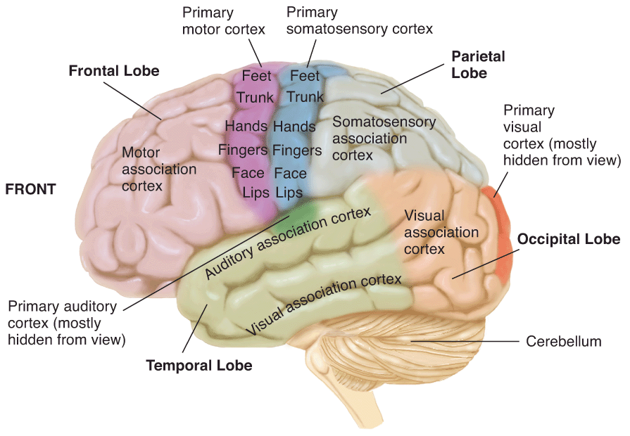
- Differentiate Broca’s aphasia and Wernike’s aphasia in terms of brain regions involved and key symptoms.
- Corpus Callosum: bundle of fibers that connects the cerebrum’s two hemisphere
- Basil ganglia: generate motor programs/control movement -> Parkinson’s disease
- Prefrontal cortex: responsible for thinking planning and language
- Broca’s area: language area in the prefrontal cortex that helps to control speech production
- Broca’s aphasia: speech deficit
- Motor cortex: part of frontal lobe responsible for body movement
- Sensory cortex: 5 senses
- Associative cortex: simple to complex functions
- Frontal lobe: responsible for motor function, language and memory
- Parietal lobe: specialize for touch and perception
- Temporal lobe: hearing, understand language and memory
- Occipital cortex: specialized for vision
- Thalamus: part of the brain that processes sensory information and serves as a gateway to cerebral cortex
- Forebrain: front part of the brain that allows advance intellectual abilities; =cerebrum
- Midbrain: control head and neck reflexes and modulate motor activities
- Hindbrain: cerebellum (balance) ,pons and medulla
- Pons connects cerebral cortex with cerebellum
- Medulla helps with major functions such as heart beat and breathing

Many functions are contralateral. In general, this means…
- right side of brain controls left side of body (and left right).

Split Brain Syndrome
- Severed corpus callosum
- Most functions are contralateral
- CC coordinates input from two sides
- Remember while watching the clip…
  - Left hemisphere tends to specialize in language & speech
  - Right hemisphere tends to specialize in images, patterns

Lateralization
- Some functions: dominant hemisphere
- Cooperate but specialize to some extent
- Media oversimplifies
  - E.g., draws invalid conclusions about personality

Damage to PFC
- Personality change
  - Slowing of thoughts, behaviour
  - Loss of spontaneity
  - Can’t change strategies when isn’t working
  - Lose self-awareness
  - Change in emotional reaction
  - Deficient in foresight, ability to plan actions
- Keep intelligence, memories…

Brain Damage can Teach us about Brain Function
- Damage to primary visual cortex
  - Contralateral blindness
Damage to primary auditory cortex
  - Contralateral hearing loss
Damage to primary motor cortex
  - Contralateral paralysis

Damage to Association Areas
- Much more complex results
- Examples
  - PFC personality
  - visual association cortex Perception
  - auditory association cortex Language

 | Broca’s Area | Wernike’s Area
Key Deficit | Language production | Language comprehension
Hallmark Aphasia Characteristics | Very laboured but retains meaning | Word salad
Newer Developments in understanding aphasias | - More extensive damage  - Agrammatism means it’s a comprehension problem too | Two problems:  - Recognizing spoken words  - Comprehension of word meaning

production of speech sounds -> Motor association cortex
language comprehension problems -> Auditory association cortex

The Limbic System
- Deeper brain structures
- Communicate with cortex
Emotions, learning, reward, judging

- Memory
- Lesions = can’t learn anything new! -> anterograde

Structures of the Limbic System: Amygdala
- two almond-shaped neural clusters
- fear and anger
- Physiology of fight & flee
- Active in risky decisions
  - Works with PFC to judge riskiness

Structures of the Limbic System: Hypothalamus
- The Regulator
- Controls endocrine system
- directs maintenance activities
  - Eating
  - Drinking
  - Body temp
  - Emotion control
  - Sleep
Hippocampus: part of the brain that plays a role in spatial memory or mind map

Somatic nervous system: part of peripheral nervous system carrying messages from CNS through the body to control movement
Automatic nervous system: controls involuntary actions
-sympathetic: engage during a crisis or after actions. Fight or flight (excitement)
-parasympathetic: control rest and digestion (relaxation)

Heredity  - All of traits, tendencies you inherited from your biological ancestors  - Passed from parent to offspring  - whether it shows up or not for you depends on interactions between genes and environment | Heritability  - How much of the diversity in a trait in a given population is due to genetics?  - A statistical calculation  - Ranging from 0 (no genetic contribution) to 1 (all genetic contribution)  - E.g., earlobes are highly heritable in the population

Sensation & Perception
- Sensation
  - Sensory receptors & nervous system
  - Detecting properties of stimuli
- Perception
  - Organizing and interpreting sensory input
  - Enables recognition of meaningful objects, events
  - We make meaning!
  - Sometimes sensation & perception mismatch…

