CMN1148
What is communication?
The process of acting upon information
(Someone/Something says or does something and others respond with words or actions.)
Human Communication
The process of making sense out of the world and sharing it with others
Interpersonal Communication
The process of engaging in simultaneous and mutually influential interaction with others
Foundation of organizational communication
Organizational Communication
The process of making sense out of the world and sharing that sense with others in order to achieve mutual goals in organizational contexts
Why we communicate?
- Physical needs – request for coffee and muffin at Pivik
- Identity needs – joining one of the cultural student organizations on campus
- Social needs – calling friend to ask if (s)he plans to attend company barbeque
- Practical needs – purchase of books
Why Models?
- Explain communication processes
- Visually depict relationships
- Pinpoint reasons for breakdowns
Some early models: Classics in the field
- Aristotle
- Lasswell
- Shannon and Weaver
- Berlo
- Schramm
- Dance
- Barnlund
Aristotle
A simple communication model with a sender transferring a message containing information to a receiver.
- Speaker, speech, audience
- One way and linear

Three kinds of appeals that a speaker
could use:
Ethos – Source credibility
Pathos – Emotional appeals
Logos – Logical appeals

Lasswell
Communicator (Who?)
Message (Says What?)
Channel (In what channel?
Receiver (To Whom?)
Effect (With what effect?)
Added concept of effects
Often applied in political contexts

Shannon Weaver: Mathematical Model 1949
- Extended Aristotelian model
- Added concept of noise

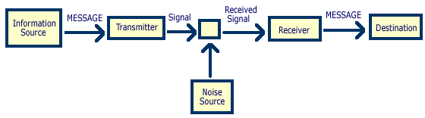
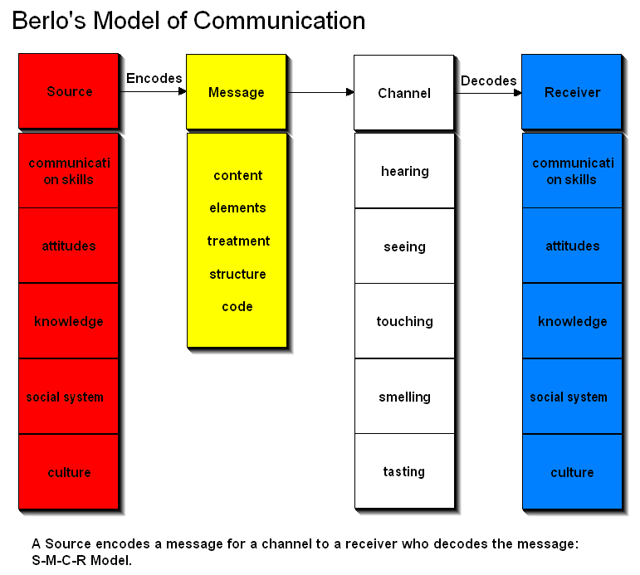

dSchramm
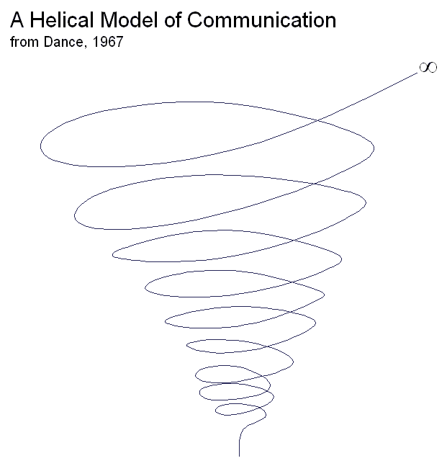
Transactional Model: Barlund
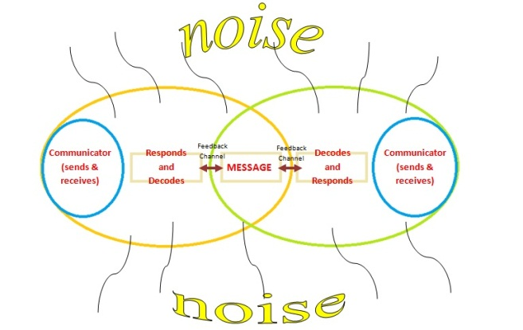

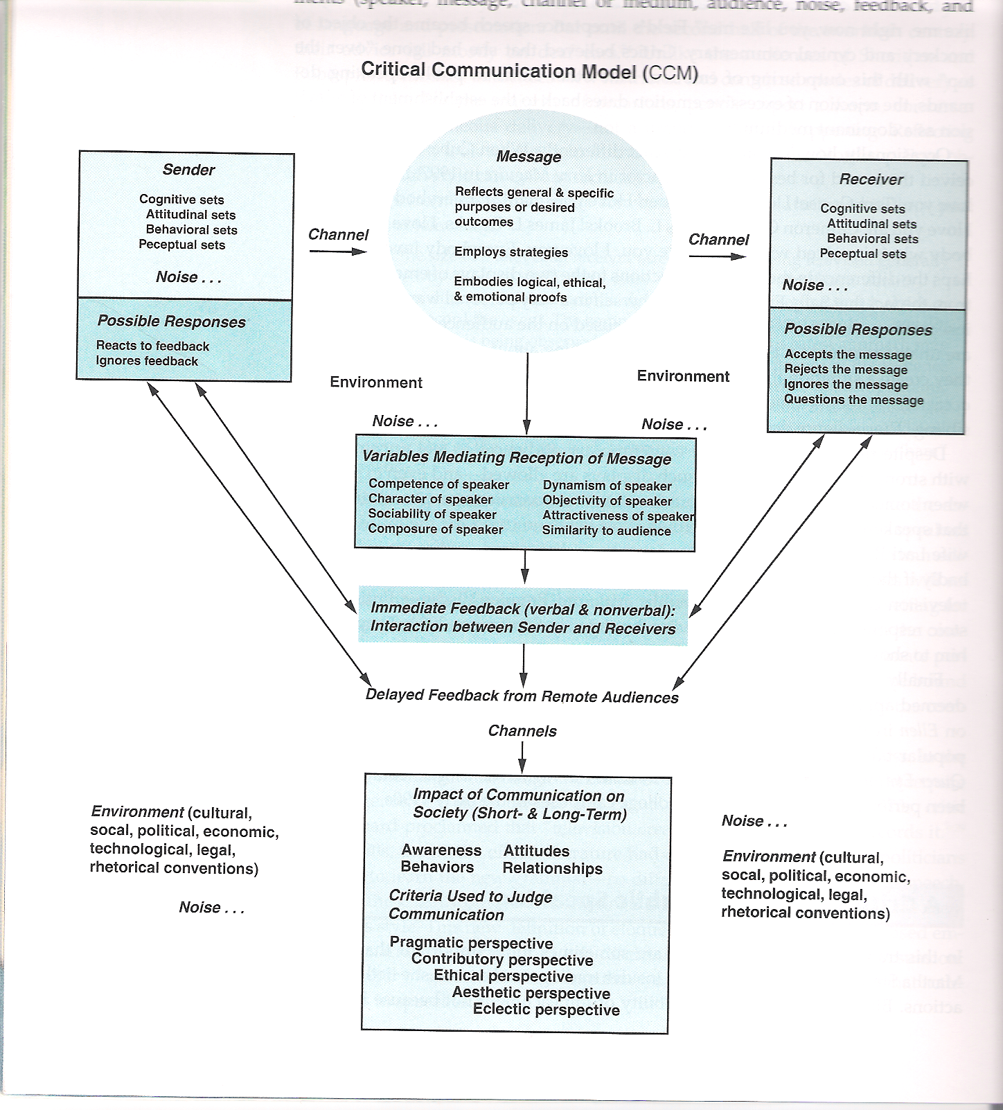
Model in Interplay, Adler, Rosenfeld, Proctor, and Winder
What can we learn from these models?
- Communication can be intentional or unintentional.
- Communication has a relational, as well as a content, dimension.
- Communication is irreversible.
- Communication is unrepeatable.
- Communication is a dynamic, ongoing process.
- Sending and receiving is usually simultaneous.
- Talking is not the same as communicating; communication requires an effect and shared meaning.
- Communication has verbal and nonverbal elements.
- Environment and noise affect communication.
- Channels make a difference.
- Communication is value-driven and culturally defined.
- Communication has ethical implications.
Transformation of information exercise: what happened
- Speed affects our ability to respond.
- If we wait until person finishes and listen carefully, we will receive message better.
- If we miss a link, we may tune out.
- Personality affects our ability to respond.
- Nervousness and frustration decrease our ability to respond
- The more frequently we interact, the higher the likelihood we will develop common vocabulary.
- Usually (but not always) nonverbal communication is helpful.
- Feedback is important.
- More communication is not necessarily better.
- Repetition helps to convey meaning so long as we don’t overdo it.
- Letting the other person finish before we interpret their meaning or ask questions is important.
- Effective communication is not a natural ability

CMN1148 Chapter 1 Week 1

Why we communicate?
- Physical needs: communication is so important that its presence or absence affects physical health
- Identity needs: it is the major way in which we learn who we are
- Social needs: communication is the principal way relationships are created
- Practical needs: lets us communicate and express our practical needs
The communication Process
A Model of communication
- Communication models have become increasingly sophisticated in an attempt to represent all the factors that affect human interaction
Insights from the Communication Model
- Sending and receiving are usually simultaneous
- Meanings exist in and among people
- Environments affect communication
- Noise affects communication
- Channels make a difference
Communication Principles
- Communication is transactional (a dynamic process created by the participants through their interaction with one another)
- Communication can be intentional or unintentional
- Communication has a content and a relational dimension (which involves the information being explicitly discussed)
- Communication is irreversible
- Communication is unrepeatable
Communication Misconception
- Not all communication seeks understanding
- More communication is not always better
- Communication will not solve all problems
- Effective communication is not a natural ability

Interpersonal Communication Defined
Quantitative and Qualitative Definitions
- Interpersonal communication has been defined in two ways
- Most definitions take a quantitative approach that defines interpersonal communication as any interaction between two people
- Social scientists call two persons who are interacting a dyad
- From a qualitative point of view, interpersonal communication occurs when people treat one another as unique individuals, regardless of the context in which the interaction occurs or the number of people involved
- Uniqueness, irreplaceability, interdependence, disclosure, and intrinsic rewards distinguish qualitatively interpersonal communication from less personal exchanges

Personal and Impersonal Communication: A Matter of Balance
- Most relationships are neither personal nor impersonal
- Interpersonal communication: when we’re tired, distracted, bust, or just not interested
Interpersonal Communication and Technology
- Computer mediated communication provides another way to interact
- Text messaging, email, instant messaging, social networking, and blogging are ways of communicating through technology
- Recent immigrants to Canada are more likely to use internet every day to communicate with family
- Internet provides the ability to maintain relationships over long distances

Interpersonal Communication and Cultural Diversity
Culture: the language, values, beliefs, traditions, and customs people share and learn
In groups: for groups with which we identify
Out groups: for those that we view as different
Intercultural Communication: the process by which members of two or more culture exchange messages in a manner that is influenced by their different cultural perceptions and symbol systems
Interpersonal and Intercultural Communication

Communication of Canadian and US culture
Attitudes towards violence
Tolerance to diversity
Relative Status of Men and Women

Communication Competence
- Is both effective and appropriate
- Effective communication would get the results you want
- Appropriate communication would do so in a way that, in most cases, enhances the relationship in which it occurs
Motivation and Open-Mindedness is Key
Ethnocentrism: is the belief that one’s own culture is superior to other, an ethnocentric person think that anyone who does not belong to his or her in-group is somehow strange, wrong, or even inferior
Prejudice: ethnocentrism leads to prejudice- an unfairly biased and intolerant attitude toward others who belong to an out-group. Stereotyping is an important element of prejudice.
There is no single ideal or effective way to communicate
Competence is situational
Competence requires mindfulness
Competence can be learned
Characteristics of competent communication
- A large repertoire of skills
- Adaptability
- Ability to perform skillfully
- Involvement
- Empathy and perspective taking
- Cognitive complexity
- Self-monitoring: the process of paying close attention one’s own behavior using these observations to shape the way one behaves
Lecture #2: Week 2
Practice exam questions
- the earliest models of communication were
one-way and linear
2. the so-called mathematical model of communication is associated with
Shannon and weaver
3. the helical model is associated with
Dance
4. Transactional models assume that communication is
Mutual and simultaneous
5. Meanings exist in people, not in words
True
6. The term used to refer to interactions involving two people is
Dyad
7. Ethnocentrism refers to the belief that our culture is superior to another culture
8. Cognitive complexity refers to
The ability to construct a variety of frameworks
9. Which of the below factors does not contribute to communication competency?
Ethnocentrism
10. The term co-culture refers to subcultures within a society
True

Self Concept
- Self-concept is relatively stable set of perceptions you hold of yourself
- Self-concept begins to emerge when children recognize themselves as separate from others- 6 or 7 months- continually evolves
Four faces of self-concept
- Self image- how we see ourselves
- Looking glass or reflected appraisal- how we think others see us
- Idea self- how we would like to be
- Real self- how we actually are
How do define yourself
- Social of familial relationships (son, parent, sister, friend)
- Cultural or linguistic (Canadian, French, Russian, etc.)
- Occupation (student, employee)
- Natural abilities (artist, writer, athlete)
- Belief systems (religious, political, pacifist)
- Physical qualities (height, weight, build)
- Intellectual attributes (intelligent, slow)
- Attitudinal or behavioral attributes (hard-working, independent, shy)

Culture
- It is said we cant know our culture until we leave it to compare it to others
- It is also said that as Canadians, we often define ourselves as what we are not- and what we are not is usually American
- So how do we see ourselves as different from- or similar – to American culture?
Consider the following list of American values (how Americans see themselves)
- Patriotic
- Competitive
- Dominant
- Egalitarian
- Responsible
- Achievement-oriented
- Caring
- Cultured
- Materialistic
- Moral
How do Canadians see Americans?
Highest ratings
- Highly patriotic
- Materialistic
- Competitive
- Dominant
- Achievement-oriented
Lowest ratings
- Peaceful
- Cultural
- Moral
- Responsible
- Caring
- Egalitarian
Association for Canadian studies: recognition of similarities
- Despite perceived differences, Canadians see themselves to be more like Americans than like people in other countries
- 55% believe our values are similar to Americans
How culture shapes our Identities: Studies by Geert Hofstedte
- administered psychological inventories to 1160,000 employees working in multinational corporation with offices in 40 countries
- Took six years to complete original (1980) study; repeated in 2001
- Found in original study that employees varied on four cultural dimensions
- Power distance – extent to which we believe those in power should look and act powerful (French among highest scoring on this dimension)
- Uncertainty avoidance – how much we accept and need rules, bureaucracy, clear delineation of responsibilities (Germans among highest)
- Individualism-collectivism – extent to which we see individuals as primary resource for decision making and problem solving (US among highest scoring on individualism)
- Masculinity-feminism or achievement-nurturance– extent to which we value stereotypically masculine traits (e.g., assertiveness, independence, & achievement) vs. stereotypically feminine traits (nurturance and sympathy) – US among highest scoring)
How did Canadians score?
- Hofstede’s studies (1980 and 2001) show Canada and U.S. to be close on cultural dimensions such as individualism, uncertainty avoidance, power distance, and achievement orientation (stereotypical masculine).
- Other countries, similar in orientations, are Britain and Australia
What are Canadian values?
Communication Canada Survey – 2002 (% indicates how many chose value)
- Family (79%)
- Respect (66%)
- Peace (65%)
- Freedom (64%)
- Helping others (63%)
- Integrity (58%)
- Safety and security (57%)
- Fairness (56%)
- Cooperation (54%)
- Appreciation of heritage & history (54%)
- Openness and tolerance (54%)
- Democracy (51%)
- Sharing (51%)
- Caring (51%)
- Community (48%)
- Friendliness (48%)
- Politeness (40%)
- Being inclusive (30%)
- Humility (26%)
- Individual autonomy (26%)
How Interactions with others influence our self-concept
- Reflected appraisal – idea that judgments of others influence our self-concept
- Social comparison – tendency to compare ourselves to others, looking either downward or upward
- Significant others – family, teachers, peers, employers
How judgment of ourselves influence self-concept
- Reference groups – those groups with which we compare ourselves
Demographic and psychographic groups to which people belong or aspire.

The media as a source of social comparisons
- Many people turn to the media for the role models with whom to compare themselves
- These comparisons are often unfavorable for the average person since the media perpetuates a myth of perfection
- When we choose unrealistic groups for social comparison, our self-esteem suffers and we feel inadequate
- In the present
Alien Cultural Values transmitted in the media
- Media is also relevant to influence of reference groups.
- Reference groups, found in the media, convey beliefs, attitudes, and values.
- When these beliefs, attitudes, and values come into conflict with our value configurations, we must accommodate or reject them.
Rokeach’s belief structure
- Type A beliefs – basic truths about physical reality (“This is a tree”)
- Type B beliefs – ego-centred beliefs that require zero consensus (“I am intelligent” or “I am unintelligent”
- Type C beliefs – authority beliefs
- Type D beliefs – derived from authority figures
- Type E beliefs – involve arbitrary and inconsequential matters of taste
What Happens to Self-Identity in Event of Threat to Central Beliefs?
- Classic study by Rokeach identified way in which credible threats to belief system can destroy self-identity.
- Study demonstrated that some beliefs are more important than others to us.
- The most important beliefs are located at the center of our value system.
How do expectations of others influence our self-concept
- Self-fulfilling prophecy refers to way in which expectations of others can influence expectations of ourselves.
- We tend to live up to—or down to—these expectations.

Identity Management
- Presenting image or self – how we want to appear to others (as opposed to perceived self – how we actually see ourselves)
- Facework – verbal and nonverbal ways in which we act to maintain our presenting image and the image of others (e.g., politeness strategies)
- Identity management – process of trying to control how we present ourselves
Analyzing your Self-Concept:
Questions for Consideration
- Is your definition of self up-to-date?
- Have any changes occurred in recent years to make you reevaluate your self-concept? Positively? Negatively?
- Have you ever had a relationship with a significant other who has upgraded or degraded your sense of self worth?

Identity: Lecture 3: January 22
Who I am
How we think of ourselves
Our perceived and private selves
Our views of self are influenced by:
- Social comparison (upward or downward)
- Reflected appraisal (how we think others see us), including friends, family, work colleagues, reference groups appearing in the media, and others
Who are you?
Your identity
- Our public or presenting self
- Characteristics that allow others to recognize us
- Multiple identities related to the roles we play: university student, daughter, son, hockey player, friend, employee, human rights activist, etc.
Identity Markers
- Physical – e.g., appearance and athletic abilities
- Social – e.g., competence in relationships
- Academic – e.g., intellectual capabilities
- Emotional – e.g., how we feel
Experimenting with our Identities
- May colour our hair or change our style of dress (physical identity)
- Assume a new name on Twitter (social identity)
- Enter a new field of studies (academic identity)
- Practice being more controlled and less emotional (emotional identity)
- 50% of Internet users have pretended to be someone else on some occasion.
- Most likely to use Internet to experiment with identities in adolescent years
- One study of 1158 Dutch adolescents (10-17) found lonely adolescents experiment more
- Create alternate identities on blogs, Second Life, Facebook, My Space, instant messenger, Skype, Twitter, YouTube, Craig’s List
- Women tend to lie about weight, men about height
- Most deceptive when it comes to photos
What is the impact of this experimentation?
- Online constructions lead to manifestation of same personalities in offline lives
- Tend to internalize behaviours
- “Perhaps it’s impossible to wear an identity without becoming what you pretend to be.” Orson Scott Card
Deception: Good or bad
- Sometimes we represent our ideal selves – who we would like to be in future (thinner or non-smoker)
- Sometimes we represent our historical selves – person to whom we would like to return (e.g., athletic abilities)
- Sometimes we exaggerate claims
Concealable Stigmatized Identities
- Sometimes people have “concealable stigmatized identities”
- Mental illness, HIV-positive, rape or incest victim, eating disorders, history of imprisonment
- Person perceives possibility of rejection if condition is revealed
Difficulties with deception
- Lies and exaggerations destroy trust.
- Lies and exaggerations destroy credibility.
- We depend on others to validate our identities, but they are validating a pseudo version of us if we are not authentic (e.g., Marilyn Monroe)
Checking for verification
- Self-verification theory says we want others to see us as we see ourselves
- So we seek to present ourselves in ways that will create good impressions.
- In other words, we seek to manage impressions.
How do we manage impressions?
- Mostly unconscious in nature, normal part of everyday interactions
- Occur in varied contexts (friendships, family, romantic, and professional)
- Tailor our interactions to the situation and occasion
- Monitor how others react - may be high or low self-monitors
- Among these strategies are “facework” or politeness strategies
High self monitors
- Are very aware of opinions of others:
- Alter behaviours to different situations
- Likely to be who you want them to be
- Harder to predict because they assume different roles
- Can influence people to follow their lead
- Make good managers
Low-self monitors
- Do not pay attention to how others perceive them:
- Rely on own values to guide behaviour
- Expect you to take them as they are
- Don’t try to manage perceptions
- Behave in same way across different contexts (family, work, recreational)
- Make good researchers & project members
Managing impressions
- Self-promotion
- Ingratiation
- Intimidation
- Exemplification
- Supplication
Self-promoting strategies
- Self-enhancement strategies
- Emphasizing competencies, abilities, or accomplishments o
- Desired to be respected, admired, and seen as likeable and knowledgeable
Possible Communication Behavior
- Talk proudly about experience or education
- Make people aware of talents or qualifications
- Talk about value to organization
- Make people aware of accomplishments
Immigration Strategies
- Concern with being liked by others
- Might compliment, use flattery, or behave in ways to get favourable responses from others
- Sometimes extreme efforts to be liked by others
Possible Communication Behavior
- Compliments colleagues so they will see you as likeable
- Displays interest in personal lives of colleagues to show friendliness
- Praises colleagues for accomplishments
- Does personal favours for colleagues to ingratiate yourself
Exemplification Strategies
- Focus on moral worthiness
- Attempts to earn respect by showing sincerity, devotion, and responsibility
- Run the risk of being perceived as hypocrites by those they are trying to impress
Possible communication behavior
- Stays late at work in order to be seen as hard-working
- Tries to appear busy, even at times when things are slower
- Arrives at work early to look dedicated
- Goes to the office at night or on weekends to show dedication
Supplication Strategies
- Attempt to get sympathy and attention by presenting oneself as in need of help
- Might emphasize newness to job or organization or other reason for doing badly at some task
- Could be attempt to evade work by playing dumb or appearing incompetent

Possible Communication behavior
- Pretends to know less in order to get people to help out
- Tries to gain assistance or sympathy by appearing needy in some areas
- Pretends not to understand something in order to get someone’s help
Intimidation Strategies
- Attempts to provoke fear in others
- No concern with being liked
- Desire to establish control
- Can make the strategist less liked but sometimes necessary in responding to aggressive personalities
Possible communication behavior
- Makes others aware of power to make things difficult if necessary
- Deals forcefully with colleagues when they hamper ability to complete work
- Reacts strongly or aggressively when co-workers interfere with activities
- Uses intimidation to get colleagues to behave differently
Managing Impression in Online Environments
- Many options – Facebook, Twitter, dating sites, computer conferencing, instant messaging, email, blogs, etc.
- Verbal (texting) or nonverbal (photos)
- Synchronous (same time/different place) or asynchronous communication (different time/different place)
- Risks for hiring and workplace
Self Disclosure
- Two models offer insights into role of information-sharing in building relationships:
- Social Penetration Theory
- Johari’s Window
Social Penetration Theory
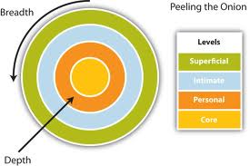
Breath of relationship
- No. of conversational topics that allow you to reveal aspects of yourself
- Hobbies, career, health, sports played
- Exploration of more & more topics as your relationship progresses

Depth of relationship
- As you go deeper into a relationship, you share more info
- Outermost layer involves more superficial sharing (e.g., participation in hockey)
- Outermost layer is easy to uncover or observe (e.g., preference in foods, favorite movies, etc.)
- As you move to inner layers of onion, you share increasingly personal or intimate info
- Inner layers are not so observable or known to others (e.g., personal fears and secrets)
- Strong relationships involve moving beyond superficial outer layers and disclosing personal info about yourself
- When we disclose, we put ourselves at risk
- Potential good and bad consequences come from disclosure
What do studies tell us about self-disclosure?
- Our brains register more pleasure when we talk about ourselves
- Thinking about, writing, and expressing personal, private, & troubling thoughts can be therapeutic
- Phenomenon of laundering
- PostSecret.com
Why do people self-disclose?
- To find a non-judgmental listener
- To work through issues by talking about them out loud
- To obtain empathetic responses to expression of problems
- Expect reciprocity – phenomenon of voyeurism accelerated by social media

Perceiving: Lecture 4: January 29th

What is perception?
- Perception is the process by which we make sense of the world.
- Touch, taste, hearing, smell, sight
Steps in perceiving
1.Selecting information
- Choosing information to which we will attend
2.Organizing information into patterns
- Arranging info in a meaningful way, imposing a structure and filling in the gaps
3.Interpreting information
- Assigning meaning to the information
4.Negotiating information
- Attempting to influence perceptions of others
- Trying to reach a consensus when communicating with someone else to have a shared meaning
Step 1: Selecting Information
- Our attention is drawn to:
- repetitious occurrences,
- the novel
- the unusual,
- intense stimuli
- contrast and change
- things that motivate us.
Step 2: Organizing Information into Patterns
- Characteristics of perception that influence organizational patterns:
- Perception is learned and backward-looking.
Examples of Learned Nature Perception
- Sight – experiments with seeing
- Touch – experiments with touch
- Smell – experiments with smell
- Sound – experiments with sound
- Taste – experiments with taste
Step 3: Interpreting Information
- Characteristics of perception that influence our interpretations:
- Perception is relative.
- Perception is culture-bound and value- laden.
Standpoint theory – a person’s position in society (race, ethnicity, gender,
sexual orientation, or socio-economic class)influences his/her view of society and others.

In other words
Inluences on perception may be
- Physiological in nature (ex. Sensory inputs, either external or internal)
- Psychological (ex. Our tendency to look for closure and fill in missing info- stereotyping or our views of ourselves)
- Social (ex. How we perceive the roles of men and women)
- Cultural (ex. attributes toward silence)
Step 4: Negotiation
- Negotiation – process by which people use communication to influence perceptions of others and arrive at mutual understanding
One way of negotiating information is to check our perceptions against those of the other person.
Perception Checking
Three Steps in Perception Checking:
- Describe the behaviour you noticed.
- Give two possible interpretations of the behaviour.
- Request clarification on how to interpret the behaviour.
Note: Perception checking works best in low context cultures, where people are explicit in their verbal patterns.
Empathy
- Empathy – the ability to recreate another’s perspective, to experience the world from the other’s point of view
- Involves suspending judgment
- Involves experiencing the feelings of the other person (emotional contagion)
- Involves having a sincere interest the well-being of the other person
- That is, we must understand the person intellectually and emotionally. In turn, the person gains in self-esteem, feels comforted, and acquires trust for the empathizer.
Skills and Attitudes Required for Development of Empathy
- Open-mindedness – putting aside your own beliefs long enough to consider the perspective of the other person (you do not have to accept their beliefs, only understand them)
- Imagination – being able to picture another person’s background and thoughts
- Commitment – sincere desire to understand the other person
Other terms to know
- Androgynous – possessing both masculine and feminine traits
- Attribution – assigning meaning to the behaviour of another person
- Punctuation – the process of determining causal relationships among events
Examples of Punctuation
- We perpetuate arguments by organizing or “punctuating” the arguments in different ways.
- “I nag you because you never talk to me.”
- “I never talk to you because you nag me.”
Common Problems in perceiving others
- We cling to first impressions.
- Primacy effect –pay more attention and remember what we see first
Did you make a first impression error?
- First impressions can form lasting impressions.
- In the business world how individuals present themselves can influence the way their peers and superiors relate to them personally and professionally.
- First impression errors occur when people form lasting opinions about an individual based on initial perceptions.
- Powerful in nature, these errors can have a negative impact on an employee’s credibility.
- We assume others are like us.
- We favour negative impressions of those who are different from us.
- We judge ourselves more charitably than we judge others, blaming our faults on external factors and the faults of others on internal (personality) factors.
- We allow our moods to influence our communication.
- We stereotype and over-generalize.
- Categorizing others on the basis of easily recognized but not necessarily important traits or ascribing a set of characteristics to all members of a group
Extending our Generalization
- Halo Effect
- When we consider a person good in
- one context, we think everything they
- do is good. They can do no wrong.
- “You’re an angel!”
- Horn Effect -When we consider a person bad in one context, we think everything they do is bad. They can do no right.“You’re a devil!”
Stereotypes
- When we organize information into categories about people, we have to simplify.
- We base our categories and generalize based on limited number of people and experiences
- E.G. Assume all mathematicians are nerds, all Italians like pizza, all men are good at handy work

Lecture 5: Feb 5th
Theory of Multiple intelligences by Howard Gardner
Linguistic intelligence (word smart)- learn best through works-learning through lectures, taking notes, writing essays
Logical mathematical intelligence- number/reasoning smart-learn best through numbers or logics, exercise in augmentation and reasoning, participation in debate, math theories)
Visual spatial intelligence (picture smart)- learn best through pictures and visuals- photographs in texts and movies,
Bodily kinesthetic intelligence- body smart- learn through best through a physical experience- nonverbal group exercise, observing behavior of others
Musical intelligence- music smart- learn best through music- asked to illustrate an idea by choosing appropriate music to reflect the mood of the idea
Naturalistic intelligence- nature smart- learn best through an experience in the natural world- anthropology
Existence intelligence-sensitivity to and tackle deep questions about human existence
Interpersonal intelligence- people smart- learn best through social experience
Intrapersonal intelligence (self smart)- capacity to be self-ware and in tune with inner feelings, vales, beliefs and thinking processes; learn best through self reflection
Five Major Points concerned Presentation by Goleman
- Self awareness
- Empathy
- Motivation
- Managing emotions
- Social skills
Contexts in which emotional intelligence manifests
- In our personal lives
- In our social lives
- In our workplaces
Types of emotions
- First order emotions- triggered by environmental threats (fear evoked by threat of attack or humiliation)
- Second-order emotions- triggered by emotional scripts (guilt or shame that we feel because of cultural scripts)
- Primary emotions- limited number such as happiness, fear, disgust, anger, surprise, sadness, and contempt
- Mixed emotions – jealousy can be mix of anger, fear, anxiety, and sadness
Influences on Emotional Expression
- Personality
- Culture
- Fear of self-disclosure

How do emotions manifest themselves?
- Physiological changes
- Non-verbal reactions
- Cognitive interpretations
- Verbal expression
- Social roles
- Social conventions
- Emotional contagion
- Biological sex and gender
Guidelines for expressing emotions
- Recognize your feelings
- Choose the best language
- Share multiple feelings
- Recognize the difference between feeling and acting
- Accept responsibility fir your feelings
- Choose the best time and place to express your feelings
Managing Difficult Emotions
- Facilitative and debilitative emotions
- Thoughts as a cause of feelings
-Activating event-consequence
-Activating event – thought/belief- consequence
-Event-thought-feeling
- Irrational thinking and debilitative emotions
-The fallacy of perfection
-The fallacy of approval
-The fallacy of should
-The fallacy of overgeneralization
-The fallacy of causation
-The fallacy of causation
-The fallacy of helplessness
-The fallacy of catastrophic expectations
- Minimizing debilitative emotions
-Monitor your emotions
-Note the activating event
-Record your self-talk
-Dispute your irrational beliefs

February 26th 2013: Listening
Why is listening so important?
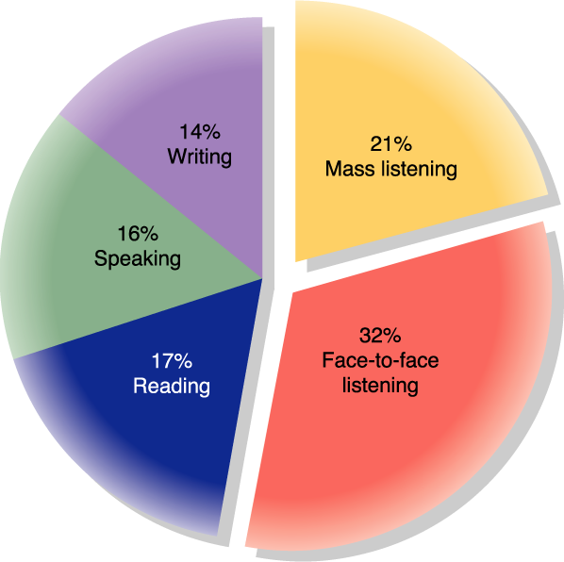

March 5th 2013: Verbal and Non-verbal Communication
Problems with multitasking
- Study asked students to listen to audiotape of someone reading sentences aloud while comparing two rotating objects.
- Task engaged two different parts of the brain—one that processed spoken info and one that processed visual info.
- When trying to listen and compare rotating objects, brain activation dropped by 53% with spoken and by 29% with visual.

1)Language is symbolic
2)Words are arbitrary
- Note the dotted line between the referent and its symbol.
- Words do not necessarily have a logical connection with their referent.
- Language is alive -- it continually evolves.
Influence on women on the evolution of language
- Sali Tagliamonte (U of T) is studying the ways that language in Toronto changes from generation to generation. http://individual.utoronto.ca/tagliamonte/
- Her research shows that historically women have had a strong influence on the evolution of language
- Upper-class females drove the shift from medieval to modern English (e.g. “Ye” to “You”)
Influence on Teens on Language
- According to Tagliamonte and other linguists, middle class teenage girls are the greatest disseminators of new slang and language forms today.
- For example, Tagliamonte traced origins of “Valleyspeak” to teenage girls.
Origins of Valleyspeak
- Valleyspeak originated with teens in San Fernando Valley, near Los Angeles.
- It drew also from the California surfer crowd.
- The song and movie Valley Girl (1970) introduced a whole lexicon that is still in use, now by the general population.
Examples of valleyspeak
- Like (placed anywhere in the sentence)
- Whatever (placed anywhere in sentence)
- “I’m like so totally not into that.”
- “He was like freaking me out.”
- “He goes, like bag your face!”
- “I’m sure!”
- “Oh wow, I’m like ready to veg.”
Language is bound by words
- Although language is symbolic and meanings are in people, we have developed conventions to help us understand each other.
- Phonological rules:
How sounds combine to form words (e.g. same word in different languages sounds different: champagne, double, occasion).
- Syntactic rules:
The way symbols we arrange symbols – the rules of structure
(“Where are you?” rather than “Where you are?” or “Throw Mum down the stairs her keys”)
- Semantic Rules:
The meanings carried by words; need shared meanings to communicate (e.g. football has different meaning in Scotland than in the U.S.)
- Pragmatic Rules
Consider context or culture, the relationship, etc. (“You’ll have to come for dinner sometime” could be request, demand, or meaningless phrase—American vs. British interpretation) or another example (“I need to speak with you.” – different meaning when said to child, spouse, or subordinate
Language is subjective
- Words are culture-bound (some words exist in only one culture).
Iktsuarpok (Inuit) - to keep going outside to check if anyone is coming while you are waiting
Tartle (Scottish) - the experience of hesitating when you are introducing someone whose name you can’t remember
Drachenfutter (German)—“dragon fodder,” a type of gift German husbands bestow on their wives when they’ve stayed out late or have otherwise engaged in inappropriate behavior
Gumusservi (Turkish) - the light of the moon as it shines upon the water
Vybafnout (Czech) - to jump out and say boo
- Words are context-bound.
- The meaning depends on what is happening, who is involved, and where and when the words are spoken.
- To understand a word, we have to take the context into consideration (E.G. “I want to see you”).
Language has a donative and connotative meaning
- Denotative or dictionary meaning
E.G. Dog: A domesticated carnivorous mammal (Canis familiaris) related to the foxes and wolves and raised in a wide variety of breeds.
- Connotative or personal/
subjective/emotional meaning
E.G. The dog you see in your
head, which reflects good or
bad experiences (fear, love, etc.)

Language influences reality
Until we have a label (or name) for something, we cannot talk about it or address it.

E.G. ADD, OCD, narcolepsy, post-partrum depression, and PTSD unaddressed for years because they had no name

Naming and Identity
Your name is more than just a label for you.
Names can influence how we see ourselves and how others see us.

People associate many characteristics, such as athleticism, masculinity/femininity, intelligence, creativity, and popularity with names.

Problematic Language
- Ambiguous language
- Imprecise language
- Abstract language
- Inflated language
- Euphemisms
- Doublespeak
- Relative language
- Static evaluation
- Deferential language

Ambigiuous language
- When the same word means different things to different people.
- E.G.:“Joe was in court fighting a ticket for parking his car in a restricted area. The judge asked him if he had anything to say in his defense. "They should not put up such misleading notices", said Joe. "It said, FINE FOR PARKING HERE."
Imprecise or incorrect language
Using words incorrectly.
Malapropism (one word that sounds
like another)
E.G. “I got my subscription for the pill.”
Using a word that doesn’t exist
E.G., “Moo point”, “irregardless”
Using words in the wrong context
E.G.: “I’m anxious to receive my prize.”

Abstract language
Language can be abstract or concrete
Concrete:
You can experience the referents for concrete words with your five senses.
Abstract
You cannot touch, see, taste, hear, or feel the referents for abstract words.

Whats wrong with abstract language
- Good writers use concrete descriptions—words that paint a picture (Obama film).
- Abstractions are usually boring.
- Abstract words rely on listener interpretations, but listeners are all different; so the meanings vary from person to person.
Abstract vs concrete language
Description using abstract term: The Huns were barbaric.
Highly concrete and vivid language: “The Huns ate raw meat, drank fermented mare’s milk, and murdered captives by allowing their children to club them to death.”
Inflated language
- Wordiness and unnecessarily big words are not good communication.
- Saying: To be sure of achieving optimal outcomes, it is essential that employees be given the tools that are necessary for the completion of their tasks.
- Instead of: To get the best results, you must give your employees the tools they need to get the job done.
Euphemism-Taking the edge off uncomfortable Concepts
- A euphemism is an expression intended by the speaker to be less offensive, disturbing, or troubling to the listener than the word or phrase it replaces.
- What are some examples?
Euphemism for organizational firiings and layoffs
- Downsizing Reengineering
- Rightsizing Restructuring
- Streamlining Repositioning
- Outsourcing Transitioning
- Personnel enhancement
Doublespeak - Language that Aims to Disguise, as in War
- Doublespeak is more dangerous than euphemisms:
- Elimination of unreliable elements – people imprisoned, shot, or sent out of the country
- Non-operative personnel - dead soldiers
- Enhanced interrogation – use of waterboarding, stress positions, and hypothermia to extract information from prisoners of war
- Collateral damage - unintentional injury or killing of innocent people such as civilians and children
- Servicing the targets - killing the enemy
Relative language
- Relative language gains meaning by comparison. In the below example, the meaning depends on the class to which the comparison refers:
- “That job is easy, good, hard, boring….”.
- What are some more examples?
Static evaluation
- We attach labels that assume people do not change over time or in different situations. These labels“freeze frame” our views and influence our language.
- What are some examples?
Deferential or Powerless Language – Used More Often by Women than Men
- Tag questions such as “It’s hot in here, isn’t it?” imply that you are uncertain and that you seek approval from the listener.
- Disclaimers such as “This may be a bad idea, but. . . . .” or “This is just my opinion” announce that you are unsure about your viewpoint even before you state it.
- Rising pitch at the end of sentences such as “I was thinking we might go to the movie?” imply doubt.
- Hesitations (“well,” “um”) and hedges (“I guess,” “sort of”) are fillers that we associate with a lack of certainty and lack of confidence.
- Self-doubt also finds expression in an excess of words such as “I think,” “I’m not too sure about this,” or “I’m not an expert in this but. . .”
What is non-verbal communication
- Non-verbal communication is defined as “messages expressed by non-linguistic means” (or means that are not related to language).
Types of non-verbal communication
- Face and eyes
- Kinesics (body movements, posture, gestures)
- Voice
- Proxemics and territoriality (use of space)
- Physical attractiveness
- Clothing
- Physical environment
Reasons to study non-verbal communication
- It is the primary way we communicate feelings (emotions) and attitudes toward others.
- We believe actions more than words.
- Mehrabian (1972) argued that we convey 93% of the emotional impact of a message through non-verbal means and only 7% through verbal. Birdwhistell (1970) argued it was 65/35 non-verbal/verbal.
Characteristics of non-verbal communication
- Non-verbal communication is primarily relational (serves many social functions).
- Non-verbal communication is ambiguous (open to many possible interpretations).
- Culture influences non-verbal communication (some signals are shared across cultures (e.g. smiles); others are culture specific (e.g., proximity, greetings).
Functions of non-verbal communication
- Repeating (added to a word)
- Saying “over there” while pointing
- Saying “yes” while nodding.
- Man in photo would have
- to be talking also for this
- gesture to count as
- example of repeating.
Substituting
- Nonverbal cues that replace the verbal with nonverbal message.
- Nonverbal cues with specific and generally understood meanings in a given culture.
- These nonverbal cues are called emblems (e.g., nodding head, applauding)
Emblems are culture and context bound!
Complementing and Accenting (illustrator)
Nonverbal cues can complement or add emphasis to verbal messages (smiling warmly when saying “I love you” or slapping your hand on the table as you say “No!”). Illustrators have no meaning on their own; they get their meaning from the context.
E.G. Different from substituting function because they accompany words
E.G., Different from repeating function because they do not duplicate the words. Smiling is not the same as “I love you”; slapping your fist on the table is not the same as saying “no”.
Regulating
- Nonverbal cues that
- control and manage the
- flow of communication between people.
- E.G. Raising hand to say
- "wait til I finish.”
- E.G. Raising finger to say
- “I want to speak.”
Contradicting
Sometimes our nonverbal communication contradicts our words.
“I’m not upset” in an angry tone with red face.
“I’m so happy for you” when the face says otherwise.
Adaptors
Gestures designed to satisfy some need.
E.G. Scratching an itch, adjusting clothes
When they occur in private, they are usually done in their entirety; when in public, they often involve an abbreviated form—a tug on tie.
We also use non-verbal communication to hide and detect deception
When lying, people often leak cues:
  - Greater lag time in response to questions
  - Reduced eye contact
  - Increased shifts in posture
  - Unfilled pauses
  - Less smiling
  - Slower speech
  - Higher pitch
  - More careful speech
However…
- Good liars know that they must control these cues; so they might sustain more eye contact, smile more, etc.
- Research by Paul Seager finds that facial expressions are less accurate indicators because they are easier to control.
- Leaks often come from hands and feet.
- The more complex the lie the more liars will leak clues.
- The extra effort needed to remember what they've said and to keep stories consistent may cause liars to restrain movements and use more pauses.
- These indicators come from studies of mainstream cultural groups in countries such as U.S. and Canada—different for different cultures, even within countries
Two truths and a lie
- Think of two things about yourself that are true and one that is false.
- Please turn to your neighbor and say these three things about yourself.
- Your neighbor will guess which of the statements is a lie.
- Try to determine which cues you used to detect your partner’s lie.
March 26th
Initiating stage: meet at the garment factory.
Experimenting stage: small talk, leave work, trying to get to know the other person
Intensifying stage: the relationship-becomes close friends. After he hasn’t seen them for a while and after he sees them- their relationship becomes more informal. Using “we” “lets”
Integrating stage: women never refer to them as Donna or gale but as a couple, they move in together (bonding stage)
Dressing alike- others begin to see the pair as a package
Differentiating stage: going out with the boys, taking the rides, donna refuses to go with gale when she wants to go home
Communication: fighting and conflict
Process of uncoupling:

