COMM 308
TEST #2 – PRACTICE QUESTIONS
Correct answers are marked in white. Select al (ctrl+A)l and change font color to black to reveal them

- You are considering the following two mutually exclusive projects. The required rate of return is 14.6 percent for project A and 13.8 percent for project B. Which project should you accept and why?

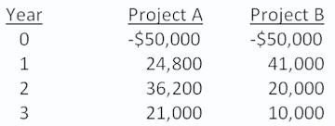

 project A; because it has the higher required rate of return

 project A; because its NPV is about $4,900 more than the NPV of project B X project B; because it has the largest total cash inflow
project B; because it has the largest cash inflow in year one

project B; because it has the lower required return

- A project has average net income of $5,900 a year over its 6-year life. The initial cost of the project is $98,000 which will be depreciated using
straight-line depreciation to a book value of zero over the life of the project. The firm wants to earn a minimum average accounting return of 11.5 percent. The firm should the project because the AAR is percent.

accept; 5.71

accept; 9.90

accept; 12.04 X

reject; 5.71

reject; 12.04
- A project has average net income of $5,900 a year over its 6-year life. The initial cost of the project is $98,000 which will be depreciated using 3.
Bleakly Enterprises has a capital structure of 40 percent common stock, 10 percent preferred stock, and 50 percent debt. The flotation costs are 4.5 percent for debt, 7 percent for preferred stock, and 9.5 percent for common stock. The corporate tax rate is 34 percent. What is the weighted average flotation cost?

5.8 percent

6.2 percent

6.4 percent

6.6 percent

6.8 percent X

- What is the profitability index for an investment with the following cash flows given a 14.5 percent required return?

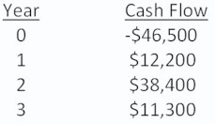

0.94

0.98

1.02 X

1.06

1.11
- You just sold 600 shares of Wesley, Inc. stock at a price of $32.04 a share. Last year, you paid $30.92 a share to buy this stock. Over the course of
the year, you received dividends totaling $1.20 per share. What is your total capital gain on this investment?

-$618 -672 $672 X $618 $720
- Chelsea Fashions is expected to pay an annual dividend of $0.80 a share next year. The market price of the stock is $19.60 and the growth rate is 5
percent. What is the firm's cost of equity?

7.58 percent

7.91 percent

8.24 percent

9.08 percent X

10.00 percent
- J&J Enterprises is considering an investment that will cost $318,000. The investment produces no cash flows for the first year. In the second year,
the cash inflow is $47,000. This inflow will increase to $198,000 and then $226,000 for the following two years, respectively, before ceasing permanently. The firm requires a 15.5 percent rate of return and has a required discounted payback period of three years. Should the project be
accepted? Why or why not?

accept; The discounted payback period is 2.18 years. accept; The discounted payback period is 2.32 years. accept; The discounted payback period is 2.98 years. reject; The discounted payback period is 2.18 years.
reject; The project never pays back on a discounted basis. X

- A project has an initial cost of $6,500. The cash inflows are $900, $2,200, $3,600, and $4,100 over the next four years, respectively. What is the payback period?

1.73 years

2.51 years

2.94 years X

3.51 years

3.94 years
- Phillips Equipment has 80,000 bonds outstanding that are selling at par. Bonds with similar characteristics are yielding 7.5 percent. The company
also has 750,000 shares of 7 percent preferred stock and 2.5 million shares of common stock outstanding. The preferred stock sells for $65 a share. The common stock has a beta of 1.34 and sells for $42 a share. The U.S. Treasury bill is yielding 2.8 percent and the return on the market is 11.2 percent. The corporate tax rate is 38 percent. What is the firm's weighted average cost of capital?

10.15 percent X

10.64 percent

11.18 percent

11.30 percent

11.56 percent
- You recently purchased a stock that is expected to earn 30 percent in a booming economy, 9 percent in a normal economy, and lose 33 percent
in a recessionary economy. There is a 5 percent probability of a boom and a 75 percent chance of a normal economy. What is your expected rate of return on this stock?

-3.40 percent

-2.25 percent

1.65 percent X

2.60 percent
3.50 percent $8,900
- What is the variance of the returns on a portfolio that is invested 60 percent in stock S and 40 percent in stock T?

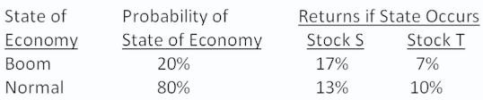

.000017

.000023 X

.000118

.000136

.000161

- Four months ago, you purchased 1,500 shares of Lakeside Bank stock for $11.20 a share. You have received dividend payments equal to $0.25 a share. Today, you sold all of your shares for $8.60 a share. What is your total dollar return on this investment?

-$3,900 -$3,525 X -$3,150 -$2,950 -$2,875
- Jerilu Markets has a beta of 1.09. The risk-free rate of return is 2.75 percent and the market rate of return is 9.80 percent. What is the risk
premium on this stock?

6.47 percent

7.03 percent

7.68 percent X

8.99 percent

9.80 percent
- The rate of return on the common stock of Lancaster Woolens is expected to be 21 percent in a boom economy, 11 percent in a normal economy,
and only 3 percent in a recessionary economy. The probabilities of these economic states are 10 percent for a boom, 70 percent for a normal economy, and 20 percent for a recession. What is the variance of the returns on this common stock?

0.002150

0.002606

0.002244 X

0.002359

0.002421
- Panelli's is analyzing a project with an initial cost of $110,000 and cash inflows of $65,000 in year one and $74,000 in year two. This project is
an extension of the firm's current operations and thus is equally as risky as the current firm. The firm uses only debt and common stock to finance its operations and maintains a debt-equity ratio of 0.45. The aftertax cost of debt is 4.8 percent, the cost of equity is 12.7 percent, and the tax rate is 35 percent. What is the projected net present value of this project?

$7,411 $7,809 $8,333 $8,938
$9,840 X

- The Daily Brew has a debt-equity ratio of 0.64. The firm is analyzing a new project which requires an initial cash outlay of $420,000 for equipment. The flotation cost is 9.6 percent for equity and 5.4 percent for debt. What is the initial cost of the project including the flotation costs?

$302,400 $368,924 $456,328 X $456,700 $583,333
- What is the beta of the following portfolio?

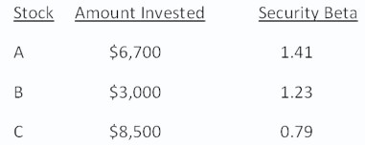

.95

1.01

1.05

1.09 X

1.23
- You've observed the following returns on Crash-n-Burn Computer's stock over the past five years: 3 percent, -10 percent, 24 percent, 22 percent,
and 12 percent. Suppose the average inflation rate over this time period was 3.6 percent and the average T-bill rate was 4.8 percent. Based on this information, what was the average nominal risk premium?

5.15 percent

5.40 percent X

6.01 percent

6.37 percent

6.60 percent

- 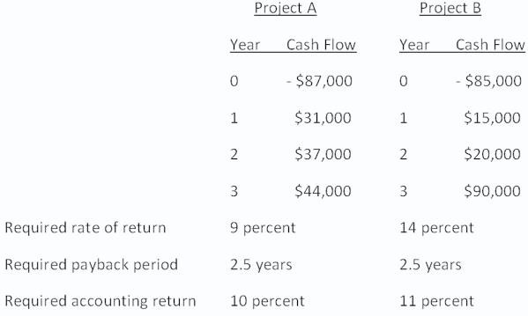You are considering the following two mutually exclusive projects. Both projects will be depreciated using straight-line depreciation to a zero book value over the life of the project. Neither project has any salvage value.

Should you accept or reject these projects based on net present value analysis? accept Project A and reject Project B X

reject Project A and accept Project B accept both Projects A and B
reject both Projects A and B

You cannot make this decision based on net present value analysis.
- The expected return on JK stock is 15.78 percent while the expected return on the market is 11.34 percent. The stock's beta is 1.51. What is the
risk-free rate of return?

2.22 percent

2.31 percent

2.42 percent

2.50 percent

2.63 percent X

