MCS 1000 Exam Review – 70 MC questions
April 2nd 2013

The 5 Steps of Marketing Process –
Positioning –

Needs: State of deprivation
Wants: Form that needs take as they are shaped by culture and individual personality
Demands: Wants backed by buying power
Market segmentation refers to dividing the markets into segments of customers
Target marketing refers to which segments to go after

The Marketing Mix
Price
Place
Promotion
Product

The marketing environment includes the actors and forces outside marketing that affect marketing management’s ability to build and maintain successful relationships with customers
  - Microenvironment (company, suppliers, intermediaries, competitors, publics and customers)
  - Macroenvironment (DEPEST – demographic, environment, political, economic, social and technology)

MISSION STATEMENT –

COMPANY WIDE STRATEGIC PLANNING
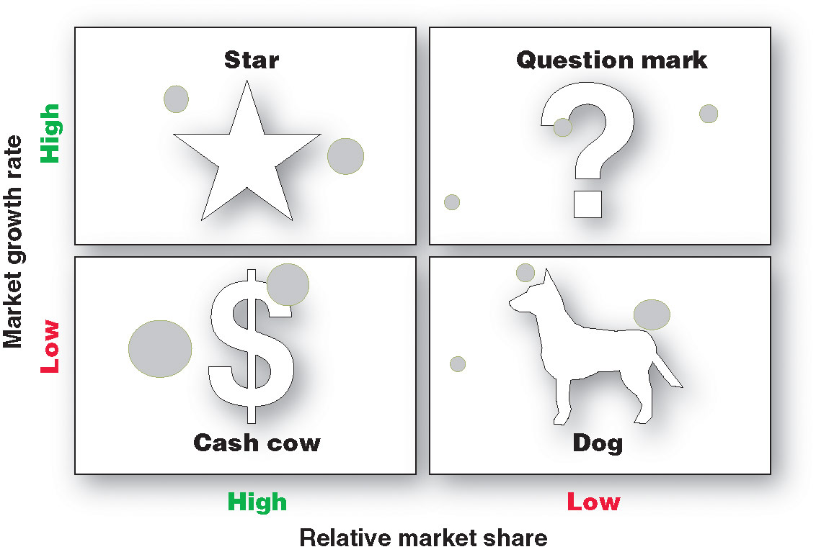
Stars are high-growth, high-share businesses or products requiring heavy investment to finance rapid growth. They will eventually turn into cash cows.
Cash cows are low-growth, high-share businesses or products that are established and successful SBUs requiring less investment to maintain market share.
Question marks are low-share business units in high-growth markets requiring a lot of cash to hold their share.
Dogs are low-growth, low-share businesses and products that may generate enough cash to maintain themselves but do not promise to be large sources of cash.

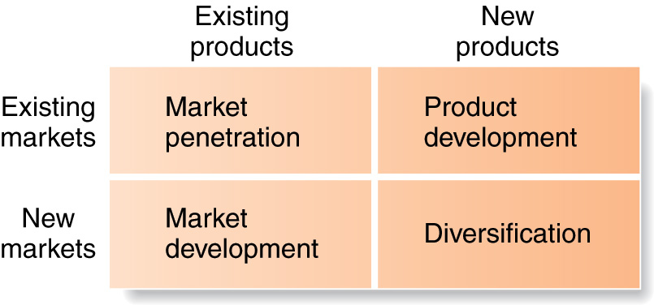

Marketing Information System (MIS) –
Resources of marketing information – internal, marketing intelligence
4 Steps of Market Research Process
Source of data – secondary, primary, ethnographic and experimenting

Marketing Research Process
Key ways to contact – telephone, personal, mail, online

Consumer vs. Business buying behaviours
Cultural, Social, Personal, Psychological (Consumer)
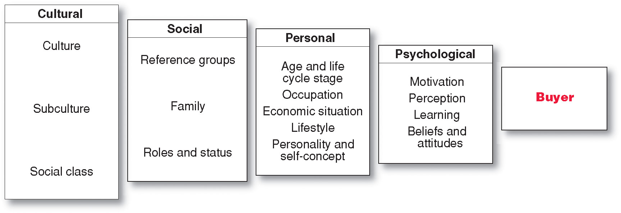

Need Recognition – Information Search – Evaluation of Alternatives – Purchase Decision – Post purchase Behaviour

Adoption process is the mental process an individual goes through from first
learning about an innovation to final regular use.
Awareness – Interest – Evaluation – Trial – Adoption

Business buyer behaviour refers to the buying behaviour of the organizations that
buy goods and services for use in production of other products and services that are sold, rented, or supplied to others
BUSINESS BUYING PROCESS
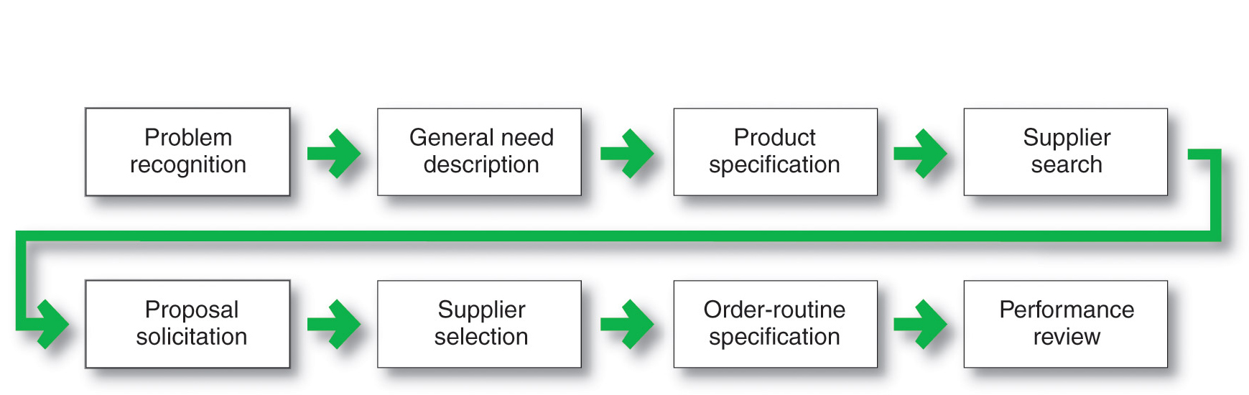

Market segmentation involves dividing the market into smaller groups with
distinct needs, characteristics, or behaviours that might require separate marketing strategies or mixes
Multiple segmentation is used to identify smaller, better-defined target groups
Measurable: The size, purchasing power, and profiles of segments can be measured
Accessible: The market segments can be effectively reached and served
Substantial: The market seems large or profitable enough to serve
Differentiable: The segments are conceptually distinguishable and respond
differently to different marketing mix elements and programs
Actionable: Effective programs can be designed for attracting and serving the
segments
Market targeting (targeting) is the process of evaluating each market segments
attractiveness and selecting one or more segments to enter
Five factors influence on choosing a target market
    - Company resources
    - Product variability
    - Product life-cycle stage
    - Market variability
    - Competitor’s marketing strategies
Product position is the way the product is defined by consumers on important
attributes—the place the product occupies in consumers’ minds relative to competing products
Levels of Products and Services – core benefits, actual product, augmented product

Nature and Characteristics of a Service-
Intangibility
Inseparability
Variability
Perishability

Product Development
Idea generation, idea screening, concept development, marketing strategy, business analysis, product development, test marketing, commercialization

LEVELS OF PRODUCTS AND SERVICES
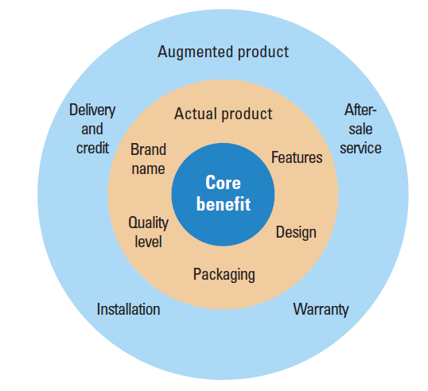
Types of Product
Convenience, Shopping Products (shoes), Specialty Products(cars), Unsought Products(does not know about), Industrial Products (further processing)
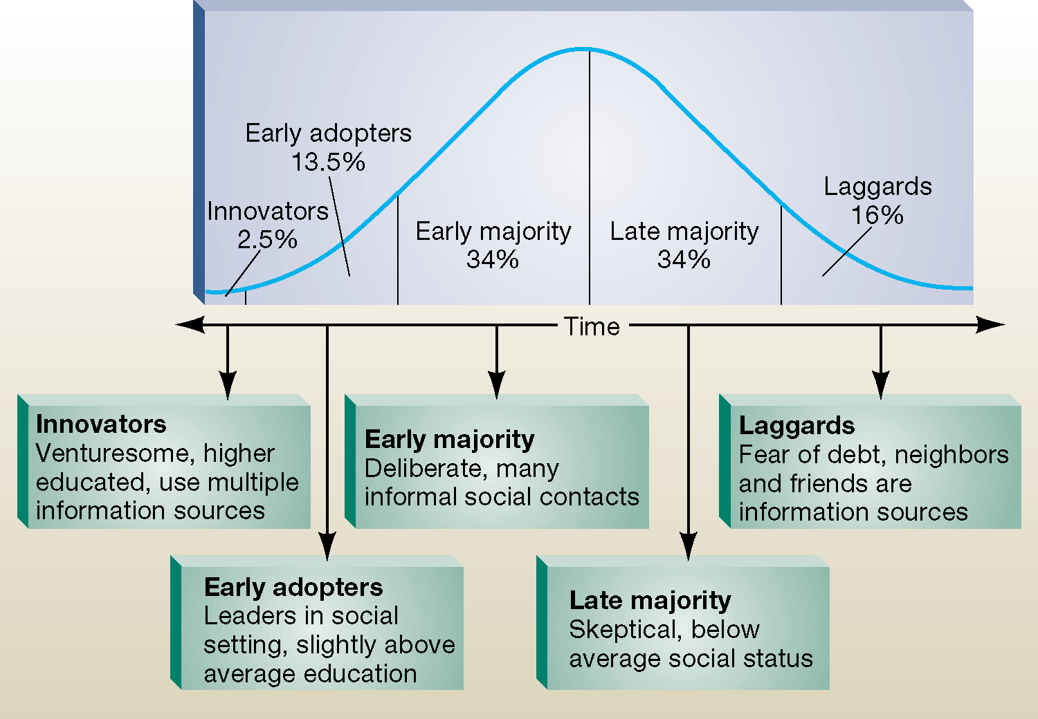

Brand equity is the value a brand adds to a product.

Value-Based Pricing –
Target Profit Pricing – is the price at which the firm will break even or make the
profit it’s seeking
Break-even Pricing - is the price at which total costs are equal to total revenue and
there is no profit
Cost-Based Pricing –

Market Skimming -
Market Penetration – price sensitive market, low prices must keep away
Competition

Informative advertising is used when introducing a new product category; the
objective is to build primary demand
Comparative advertising directly or indirectly compares the brand with one or
more other brands
Persuasive advertising is important with increased competition to build selective
Demand, using emotions
Reminder advertising is important with mature products to help maintain
customer relationships and keep customers thinking about the product

Personal Selling

Public relations involves building good relations with the company’s various
publics by obtaining favorable publicity, building up a good corporate image, and handling or heading off unfavorable rumors, stories, and events. (NEWS, SPEECHES, SPECIAL EVENTS, INTERNET, WRITTEN MATERIALS)

Sales Promotion – samples, coupons, refunds, games, contests, premiums, etc

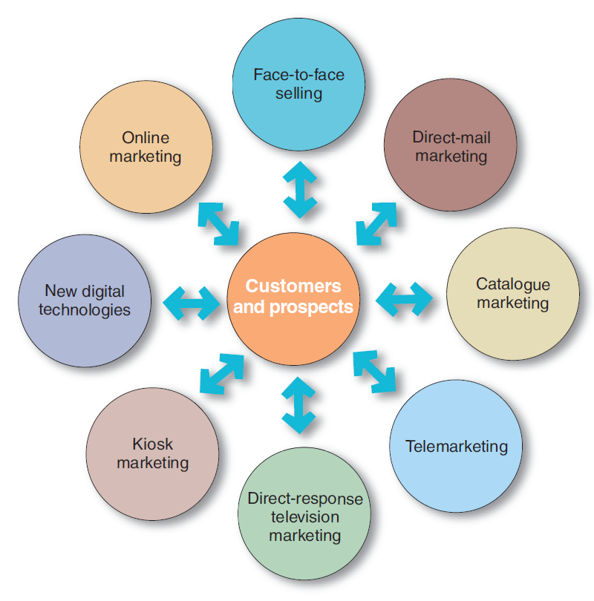

Online marketing will remain an important approach in the marketing mix to:
Build customer relationships
Improve sales
Communicate company and product information
Deliver products and services more effectively and efficiently

How Channel Members Add Value – information, promotion, contact, matching,
negotiation

Market Considerations: Type of market, geographic concentration, potential
customers, order size.
Product Considerations: Consider unit value, perishability, and technical nature of
product.
Intermediaries Considerations: Services offered, availability, attitude, dominance.
Company Considerations: Desire for channel control, management, money and
services seller can provide to support sales.

