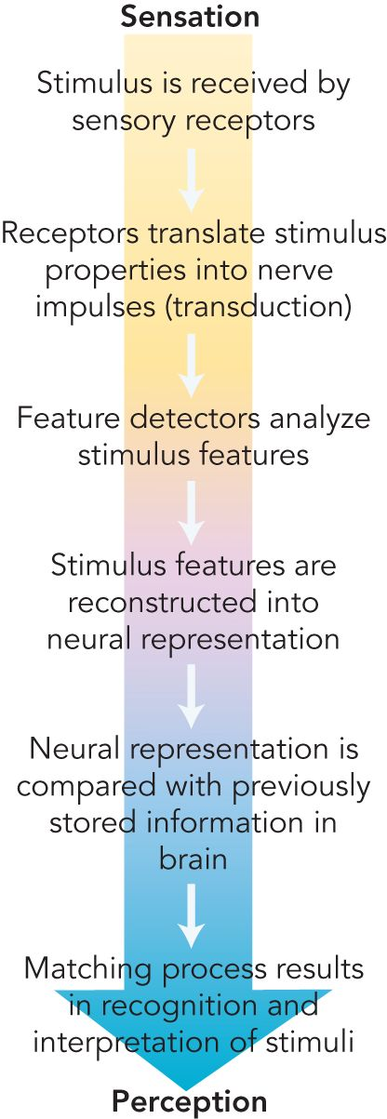
Sensation & Perception

Synesthesia
- Mixing of senses
- May experience sounds as colours or tastes as touch sensations that have different shapes
- Women are more likely to be synaesthetes than men
- Cross-wiring
- One activity in one part of the brain evokes responses in another part of the brain dedicated to another sensory modality
- Word-colour linkages – hearing certain words is associated with neural activity in parts of the visual cortex – doesn’t occur
- Theory
  - One
    - Pruning of neural connections that occurs in infancy has not occurred
    - Brain regions retain connections that are absent in most people
  - Two
    - Deficit in neural inhibitory processes in the brain that ordinarily keep input from one sensory modality from “overflowing” into other sensory areas and stimulating them

Introduction to the Process
- Transduction
  - Sensory receptors must translate this information into the language of nerve impulses
- Feature Detectors
  - Specialized neurons called feature detectors break down and analyze the specific features of the stimuli
- Numerous stimulus “pieces” are reconstructed into a neural representation that is then compared with previously stored information, such as our knowledge of what particular objects look, smell, or feel like
- This matching of a new stimulus with our internal storehouse of knowledge allows us to recognize the stimulus and give it meaning. We then consciously experience a perception

Sensation vs. Perception
- Sensation
  - Stimulus-detection process by which our sense organs respond to and translate environmental stimuli into nerve impulses that are sent to the brain
- Perception
  - Making “sense” of what our senses tell us—is the active process of organizing this stimulus input and giving it meaning – decision making

Sensory Processes
- Contact with outer world only possible through neurons that are specialized sensory receptors – transform energy forms into language of nerve impulses
  - Energy Forms – Senses

    - Taste – gustation
    - Sight – vision
    - Hearing – audition
    - Touch - pain, pressure, temperature
    - Smell – olfaction
    - Sense magnetic field
    - Electric currents
    - Infrared radiation
    - Balance and body position
    - Chemical composition of blood
    - Immune system– detection of foreign invaders

- Stimuli to which different animals are sensitive vary
- Sensory equipment adaptation to the environment
- Transduction
  - Process whereby the characteristics of a stimulus are converted into nerve impulses
  - Range of stimuli and the manner in which sense organs carry out
- Sensory systems designed to extract information form the environment to survive
- Psychophysics
  - Studies relations between the physical characteristics of stimuli and sensory capabilities
  - Concerned with two kinds of sensitivity
    - Absolute limits of sensitivity
      - Weakest salt solution
      - Softest sound
    - Differences between stimuli
      - Smallest difference in brightness
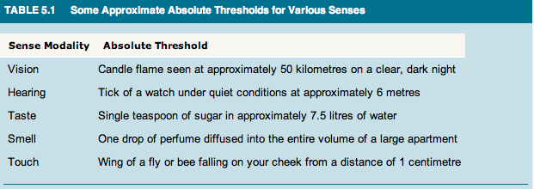
      - Weight differences

Stimulus Detection: The Absolute Threshold
- Absolute Threshold
  - Lowest intensity at which a stimulus can be detected correctly 50 percent of the time
  - Lower absolute threshold, the greater the sensitivity

Signal Detection Theory
- Individuals apparent sensitivity can fluctuate
- Concept of fixed absolute threshold is inaccurate – no single point on the intensity scale that separates nondetection from detection
- Range of uncertainty – people set their own decision criterion
  - Standard of how certain they must be that a stimulus is present before they will say they detect it
  - Change from time to time – depends on fatigue, expectation and potential significance of stimuli
- Signal Detection Theory
  - Concerned with the factors that influence sensory judgments
  - Experiment example
    - Participants are told that after a warning light appears, a barely perceptible tone may or may not be heard
    - Tell the experimenter whether they heard the tone
    - Four possible outcomes
      - Tone - “Yes” (a hit) or “No” (a miss)
      - No tone - “Yes” (a false alarm) or “No” (a correct rejection)
- At low stimulus intensities, both the participant's and the situation's characteristics influence the decision criterion
- Can be influenced to become bolder or more conservative by manipulating the rewards and costs for giving correct or incorrect responses.
- Increasing the rewards for hits or the costs for misses results in lower detection thresholds
  - Ex.
    - Navy radar operator more likely to notice a faint blip during wartime than during peacetime (disastrous consequence for miss)
    - Doctors who will not perform a risky medical procedure without strong evidence to support their diagnosis – patients careful about “Yes” responses as costs are higher - higher detection thresholds

Difference Threshold
- Subtle differences important
- Difference Threshold (jnd – just noticeable difference)
  - Smallest difference between stimuli that can be perceived 50% of the time
- Weber’s Law
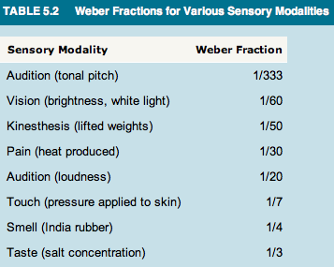
  - Difference threshold is directly proportional to the magnitude of the stimulus with which the comparison is being made, and can be expressed as a Weber fraction
  - Breaks down at incredibly high and low intensities
  - Smaller the fraction – greater sensitivity to differences
  - Ex.
    - jnd value for weights is a Weber fraction of approximately 1/50
    - If you lift a weight of 50 grams, a comparison weight must weigh at least 51 grams in order for you to be able to judge it as heavier
    - If the weight were 500 grams, a second weight would have to weigh at least 510 grams (i.e., 1/50 = 10 grams/500 grams) for you to discriminate between them

Sensory Adaptation
- Sensory systems are finely attuned to changes in stimulation
- Sensory Adaptation
  - Sensory neurons are engineered to respond to a constant stimulus by decreasing their activity and diminishing sensitivity to unchanging stimulus
  - Part of everyday experience
  - Reduce overall sensitivity – frees senses from constant and mundane informative changes in environment

Sensory Systems

Vision
- Normal stimulus: electromagnetic energy, or light waves
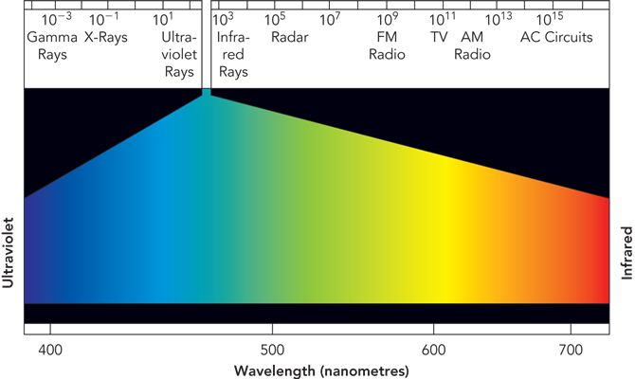
- Measured in nanometres (or one billionth of a metre)
- Electromagnetic Spectrum
  - X-rays
  - TV & Radio signals
  - Infrared
  - Ultraviolet
  - Visual spectrum
    - Wavelengths from 700 (red) to 400 (blue-violet) nanometers

Human Eye
- Cornea
  - Light waves enter the eye through
  - Transparent protective structure at the front of the eye
- Pupil
  - Behind cornea
  - Adjustable opening that can dilate or constrict to control the amount of light that enters the eye
  - Size is controlled by muscles in the coloured iris that surrounds the pupil
  - Low levels of illumination cause the pupil to dilate, letting more light into the eye to improve optical clarity
  - Bright light triggers constriction of the pupil
- Lens
  - Elastic structure that becomes thinner to focus on distant objects and thicker to focus on nearby objects
  - Lens of the eye focuses on the visual image on the light-sensitive retina
- Retina
  - Multi-layered tissue at the rear of the fluid-filled eyeball
  - Lens reverses the image from right to left and top to bottom when projected on the retina
  - Brain reconstructs the visual input into the image that we perceive
  - Ability to see clearly depends on the len’s ability to focus the image directly onto the retina
- Myopia
  - Good vision for nearby objects but difficultly seeing faraway objects (nearsightedness)
  - Lens focuses the visual image in front of the retina (too near the lens), resulting in a blurred image for faraway objects
  - Eyeball is longer (front to back) than normal
- Hyperopia
  - Excellent distance vision but have difficulty seeing close-up objects clearly
  - Farsightedness
  - Lens does not thicken enough and the image is therefore focused on a point behind the retina (too far from the lens)
  - Eyeball becomes shorter overtime
  - Middle-aged people acquire reading glasses
- Astigmatism
  - Refractive errors due to a curvature of the cornea

Photoreceptors: Rods & Cones
- Retina
  - Multi-layered screen that lines the back surface of the eyeball and contains specialized sensory neurons – an extension of the brain
  - Contains two types of light-sensitive receptor cells, called rods and cones because of their shapes
  - 120 million rods, 6 million cones in human eye
- Rods
  - Function best in dim light
  - Primarily black-and-white brightness receptors
  - 500 times more sensitive to light than are the cones – no not give rise to colour sensations
  - Retinas of night creatures – contain only rods
  - Humans – rods are found throughout retina except in the fovea (small area in the centre of the retina)
  - Periphery of the retina contains mainly rods
  - Evenly distibuted
- Cones
  - Colour receptors
  - Function best in bright illumination
  - Active during the day – pigeon and chipmunk
  - Humans – decrease in concentration as one moves away from the centre of the retina
  - Not evenly distributed
  - Fovea is large group of cones in specific spot where there is the most cones (only cones)
- Send messages to the brain via two additional layers of cells
- Bipolar Cells
  - Synaptic connections with the rods and cones
  - Synapse with a layer of about one million ganglion cells, whose axons are collected into a bundle to form the optic nerve
- Process
  - Input from more than 126 million rods and cones is eventually funneled into only one million traffic lanes leading out of the retina toward higher visual centres
  - Rods and cones not only form the rear layer of the retina – light-sensitive end actually point away from the direction of the entering light so that they receive only a fraction of the light energy entering
  - Many rods are connected to the same bipolar cell
    - Combine or “funnel” their individual electrical messages to the bipolar cell – additive effect of many signals may be enough to fire it
    - We can more easily detect a faint stimulus
    - Ex. Dim star - If we look slightly to one side so that its image falls not on the fovea but on the peripheral portion of the retina – rods are packed most densely
  - Cones that lie in the periphery of the retina
    - Share bipolar cells
    - In fovea, the densely packed cones each have their own private lane to a single bipolar cell
    - Visual acuity (fine detail) is greatest when the visual image projects directly onto fovea
    - Focusing results in the firing of large number of cones and their private-line bipolar cells
  - Optic Nerve
    - Formed by the axons of the ganglion cells
    - Exits through the back of the eye not far from the fovea – producing a blind spot (no photoreceptors)
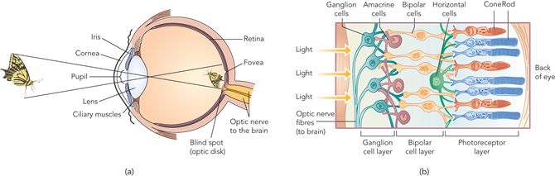
    - Unaware of blind spot because our perceptual system “fills in” missing part of field

Visual Transduction: From Light to Nerve Impulses
- Transduction
  - Process whereby the characteristics of a stimulus are converted into nerve impulses
- Photopigments
  - Rods and cones translate light waves into nerve impulses through the action of protein molecules
  - Absorption of light by molecules produces a chemical reaction – changes the rate of neurotransmitter release at the receptor’s synapse with the bipolar cells
  - Greater the change in transmitter release – stronger the signal passed to bipolar cells and in turn to the ganglion cells whose axon forms the optic nerve
- Nerve Responses
  - Triggered at three levels
    - Rod or cone
    - Bipolar cell
    - Ganglion cell
  - Message is instantaneously on its way to the visual relay station in the thalamus – then onto visual cortex of brain

Brightness Vision & Dark Adaptation
- Rods are far more sensitive than cones under conditions of low illumination
- Brightness sensitivity of both the rods and the cones depends in part on the wavelength of the light
- Rods have much greater brightness sensitivity than cones throughout the colour spectrum except at the red end, where rods are relatively insensitive
- Cones are most sensitive to low illumination in the greenish-yellow range of the spectrum
- Dark adaptation is the progressive improvement in brightness sensitivity that occurs over time under conditions of low illumination
- After absorbing light, a photoreceptor is depleted of its pigment molecules for a period of time
- If the eye has been exposed to conditions of high illumination, such as bright sunlight, a substantial amount of photopigment will be depleted
- During the process of dark adaptation, the photopigment molecules are regenerated, and the receptor's sensitivity increases greatly
- Cones gradually become sensitive to fainter lights as time passes, but after about 5 to 10 minutes in the dark, their sensitivity has reached its maximum
- Rods - whose photopigments regenerate more slowly, do not reach their maximum sensitivity for about half an hour

Colour Vision
- Two theories of colour vision

Trichromatic Theory
- Additive Colour Mixture
  - Three types of colour receptors in the retina
  - A beam of light of a specific wavelength directed onto a white surface is perceived as the colour that corresponds to that wavelength on the visible spectrum
  - Beams of light that fall at certain points within the red, green, or blue colour range are directed together onto the surface in the correct proportions
  - Combined or additive mixture of wavelengths will result and any colour in the visible spectrum can be produced
  - White at the point where all three colours intersect
  - Assumes that colour perception results from the additive mixture of impulses from cones that are sensitive to red, blue, and green
  - Problems
    - Theory: yellow is produced by activity of red and green receptors
      - People with red-green colour blindness are able to experience yellow
    - Colour Afterimage
      - An image in a different colour appears after a colour stimulus has been viewed steadily and then withdrawn
- Subtractive Colour Mixture
  - Mixing pigments or paints produces new colours by subtraction—that is, by removing (i.e., absorbing) other wavelengths
  - Paints absorb (subtract) colours different from themselves while reflecting their own colour
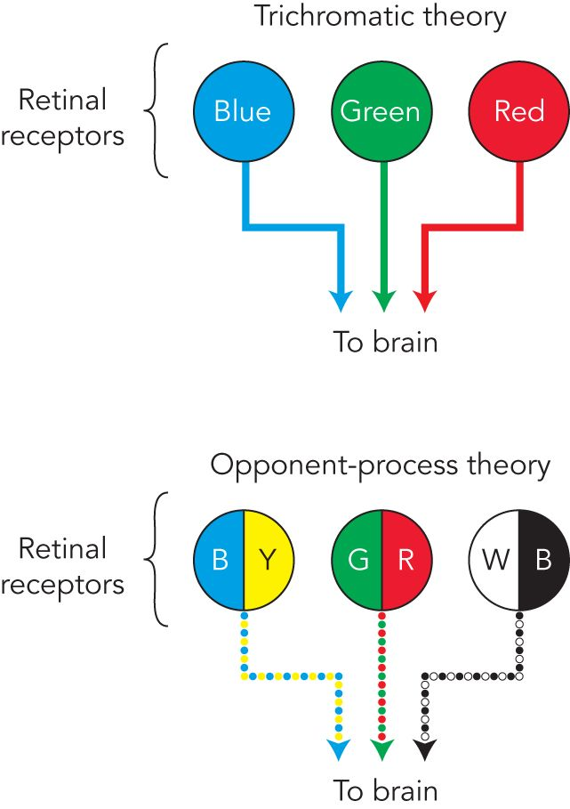
  - Ex. blue paint mainly absorbs wavelengths that correspond to nonblue hues. Mixing blue paint with yellow paint (which absorbs wavelengths other than yellow) will produce a subtractive mixture that emits wavelengths between yellow and blue (i.e., green).
  - Theoretically, certain wavelengths of the three primary colours of red, yellow (not green, as in additive mixture), and blue can produce the whole spectrum of colours by subtractive mixture

Opponent-Process Theory
- Assumed that there are three types of cones
- Proposed that each of the three cone types responds to two different wavelengths
- One type responds to red or green, another to blue or yellow, and a third to black or white
- For example, a red-green cone responds with one chemical reaction to a green stimulus and with its other chemical reaction (opponent process) to a red stimulus
- Ex. Staring at a coloured-image
  - Stared at the black and green colours, the neural processes that register these colours became fatigued
  - Cast gaze on the white surface, which reflects all wavelengths, a “rebound” opponent reaction occurred
  - Each receptor responded with its opposing white or red reactions

Dual Process – Colour Transduction
- Combines the theories to account for the colour transduction process
- Trichromatic theorists were right that cones do indeed contain one of three different protein photopigments that are most sensitive to wavelengths roughly corresponding to the colours blue, red, and green
- Different ratios of activity in the red-, blue-, and green-sensitive cones can produce a pattern of neural activity that corresponds to any hue in the spectrum
- Opponent processes do not occur at the level of the cones, as he maintained
- Certain ganglion cells in the retina, as well as some neurons in visual relay stations and the visual cortex, respond in an opponent-process fashion by altering their rate of firing

Colour-Deficient Vision
- Trichromats
  - Normal colour vision
  - Sensitive to all three systems
    - Red-green
    - Yellow-blue
    - Black-white
  - Dichromat
    - Person who is colour-blind in only one systems (red-green or blue-yellow)
  - Monochromat
    - Sensitive to only black-white system

Analysis & Reconstruction of Visual Scenes
- Once the transformation of light energy to nerve impulses occurs, the process of combining the messages received from the photoreceptors into the perception of a visual scene begins

Feature Detectors
- From the retina, the optic nerve sends nerve impulses to a visual relay station in the thalamus, the brain's sensory switchboard
- Input is then routed to various parts of the cortex, particularly the primary visual cortex in the occipital lobe
- Point-to-point correspondence between tiny regions of the retina and groups of neurons in the visual cortex
- Fovea
  - One-to-one synapses of cones with bipolar cells produces high visual acuity, is represented by a disproportionately large area of the visual cortex
  - More than one cortical “map” of the retina; there are at least 10 duplicate mappings
- Groups of neurons within the primary visual cortex are organized to receive and integrate sensory nerve impulses originating in specific regions of the retina
- Feature Detectors
  - Fire selectively in response to stimuli that have specific characteristics
  - Certain neurons fired most frequently when lines of certain orientations were presented
  - One neuron might fire most frequently when a horizontal line was presented; another neuron would fire most frequently to a line of a slightly different orientation
  - Some cells respond to bars, slits, edges in certain positions
  - Respond to colour, movement, depth
- Parallel processing
  - Subdivide a visual picture into components and process them at the same time
  - Construct a unified image of its properties
- Visual Association Cortex
  - Final stages in the process occur
  - Information is analyzed and recombined by the primary visual cortex and is routed to the VAC
  - Complex features of visual image are combined and interpreted in light of memories and knowledge

Audition
- Stimuli for sense of hearing – sound waves – mechanical energy
- Sound
  - Pressure waves in air, water or conducting medium
  - Vibrations of sound caused by successive waves of compression and expansion among the air molecules surround source
  - Two Characteristics
    - Frequency
      - Number of sound waves, or cycles per second
      - Hertz (Hz) - technical measure of cycles per second
      - Related to the pitch (higher pitch: higher frequency)
      - Human Range: 20 Hz – 20,000 Hz
    - Amplitude
      - Vertical size of sound waves
      - Amount of compression and expansion of molecules in conducting medium
      - Primary determinant of the perceived “loudness”
      - Differences expressed as decibels (db) – measure of physical pressures that occur at eardrum
      - Increase tenfold – decibel

Auditory Transduction: From Pressure Waves to Nerve Impulses
- Transduction System
  - Made up of tiny bones, membranes, and liquid-filled tubes designed to translate pressure waves into nerve impulses
  - Sound waves travel into an auditory canal leading to the eardrum – movable membrane that vibrates in response to waves (1,200 km/h)
- Middle Ear
  - Beyond eardrum
  - Cavity housing three smallest bones
    - Hammer (malleus)
      - Attached to eardrum
    - Anvil (incus)
    - Stirrup (stapes)
      - Attached to the oval window (membrane) – boundary between middle and inner ear
  - Amplifies sound waves 30x
- Inner Ear
  - Contains cochlea
    - Coiled, snail-shaped tube
    - Filled with fluid
    - Contains basilar membrane
  - Basilar Membrane
    - Sheet of tissue
    - Runs its length
  - Origin of Corti
    - Resting on basilar membrane
    - Contains 16,000 tiny hair cells (sound receptors)
  - Hair Cells
    - Tips are attached to tectorial membrane that overhands the basilar membrane along the entire length of cochlea
    - Synapse with neurons of the auditory nerve – sends impulses via an auditory relay station in thalamus to auditory cortex – temporal lobe
- Process
  - Sound waves strike eardrum
  - Pressure created at the oval window by hammer, anvil and stirrup
  - Sets fluid inside cochlea into motion
  - Fluid waves vibrate the basilar membrane and the membrane above it
  - Bending of hair cells
  - Triggers a release of neurotransmitter substance into synaptic space between hair cells and neurons of auditory nerve
  - Nerve impulses result and sent to brain
  - Auditory cortex – feature detector neurons that respond to specific kinds of input

Coding of Pitch & Loudness
- Transforms sensory qualities of loudness and pitch into nerve impulses
- Loudness
  - High-amplitude sound waves cause hair cells to bend more
  - Release more neurotransmitter substance
  - Resulting in a higher rate of firing within auditory nerve
  - Certain receptor neurons have higher thresholds – only fire when considerable bending occurs
  - Coded in terms of both rate of firing in axons of auditory nerve and which specific hair cells are sending messages
- Pitch
  - Involves two processes
    - Frequencies < 1,000 Hz
    - Frequencies > 1,000 Hz
  - Frequency Theory of Pitch Perception
    - Nerve impulses sent to brain match frequency of sound waves
      - 30 Hz – 30 volleys of nerve impulses per second to brain
      - Cannot match sound wave frequencies of 1,000 Hz + - limited in firing rate
  - Place Theory of Pitch Perception
    - Specific point in cochlea where fluid wave peaks and most strongly bends the hair cells – serves as a frequency coding cue
    - Tonal frequency “map” corresponds to specific areas of cochlea
    - By analyzing the specific location of the cochlea from which auditory nerve impulses are being received – brain can code higher frequency pitches

Sound Localization
- Two ears play a crucial role
- Nervous system uses information concerning the time and intensity differences of sounds arriving at the two ears to locate the source of sounds in space
- Sounds arrive first and loudest at the ear closest to the sound
  - Source directly in front of us - sound wave reaches both ears at same time and at same intensity - perceived as being straight ahead

Hearing Loss
- Two Major Types
  - Conduction Deafness
    - Caused by problems involving the mechanical system that transmits sound waves to the cochlea
    - Punctured eardrum or a loss of function in the tiny bones of the middle ear can reduce the ear's capacity to transmit vibrations
    - Hearing aid helps – amplifies sound
  - Nerve deafness
    - Caused by damaged receptors within the inner ear or damage to the auditory nerve
    - Cannot be helped by a hearing aid
    - Aging and disease can produce it
    - Exposure to loud sounds is a leading cause

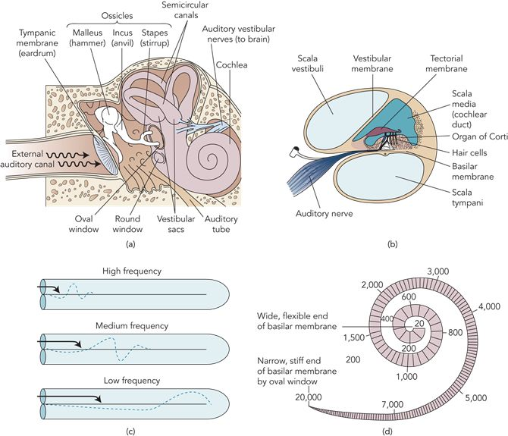

Taste & Smell: Chemical Senses
- Chemical senses because their receptors are sensitive to chemical molecules (not energy)
- Common Chemical Sense
  - Senses are intertwined

Gustation: Sense of Taste
- Responds to only four qualities: sweet, sour, salty, and bitter
- Taste Buds
  - Chemical receptors concentrated along the edges and back surface of the tongue
  - Most responsive to one or two of the basic taste qualities – responds weakly to others
  - Umani
    - Additional taste sensation
    - Increases the sensitivity of other taste qualities
    - Activated by certain proteins and monosodium glutamate – flavour enhancer
  - Humans – 9,000 taste buds
  - Consist of several receptor cells arranged like slices of oranges
  - Small number of receptors found in the roof and back of mouth
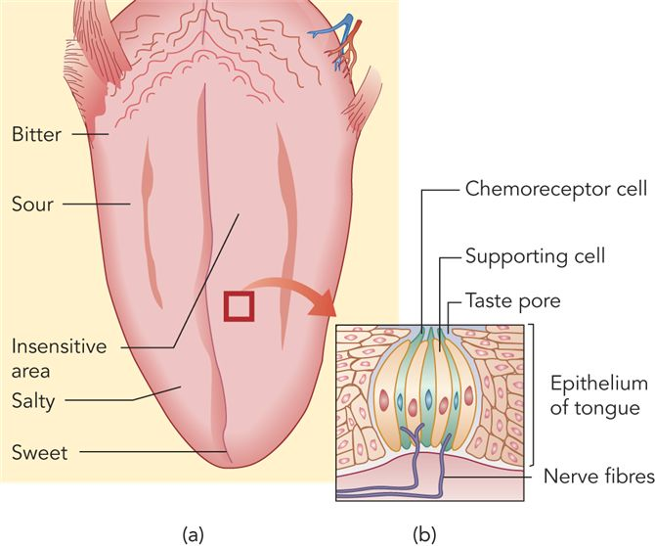
  - Hairlike structures project from the top of each cell into the taste pore, an opening to the outside surface of the tongue
  - Process
    - Substance is taken into the mouth
    - Interacts with saliva to form a chemical solution
    - Solution flows into the taste pore
    - Stimulates the receptor cells.
    - “Taste” results from complex patterns of neural activity produced by the four types of taste receptors

Olfaction: Sense of Smell
- Receptors
  - Long cells
  - Project through the lining of the upper part of the nasal cavity and into the mucous membrane
  - Have receptor structures that resemble neurotransmitter binding sites on neurons
  - Odour molecules lock into sites that are tailored to fit them – coded in terms of the specific area of the olfactory bulb that is excited
  - Receptors fire send their input to the olfactory bulb
    - Forebrain structure immediately above nasal cavity
  - Humans: 40 million olfactory receptors
- Theory
  - Olfactory receptors recognize diverse odours individually rather than by mixing the activity of a smaller number of basic receptors, as occurs in taste
- Pheromones
  - Chemical signals found in natural body scents – may affect human behaviour in subtle ways
- Menstrual Synchrony – may have to do with odour
  - Women who live together to become more similar in their menstrual cycle

Skin & Body Senses

Tactile Senses
- Lack of tactile contact retards physical, social, and emotional development
- Humans sensitive to four tactile sensations
  - Pressure (touch)
  - Pain
  - Warmth
  - Cold
- Sensations form the basis of all other common skin sensations (ex. itch)
- Skin
  - Multi-layered elastic structure
  - Covers 90 cm²
  - Weighs between 2.7 and 4.5 kg
  - Largest organ in body
  - Contains variety of receptor structures
  - Role is less clear than other senses
- Sensations
  - Depend on specific patters of activity in the various receptors
  - Primary receptors for pain and temperature
    - Free Nerve Endings
      - Simple nerve cells beneath skin surface
      - Resemble the bare branches of trees
  - Primary receptors for touch and light pressure
    - Nerve fibres situated at the base of hair follicles
- Brain can locate sensations – skin receptors send messages to the point in the somatosensory cortex that corresponds to the area of the body where receptor is located
  - Amount of cortex devoted to each area of the body is related to that part's sensitivity
- Phantom Limb Phenomenon
  - Brain “locates” sensations that cannot possibly be present
  - Amputees experience vivid sensations coming from the missing limb
  - Irritation of the nerves that used to originate in the limb fools the brain into interpreting the resulting nerve impulses as real sensations

Pain
- Receptors are found in all body tissues with the exception of the brain, bones, hair, nails, and nonliving parts of the teeth
- Process
  - Free nerve endings in the skin and internal organs respond to intense mechanical, thermal, or chemical stimulation
  - Send nerve impulses into the spinal cord
  - Sensory tracts carry pain information to the brain
  - Sensory information (once in brain) about pain intensity and location is relayed by the thalamus to the somatosensory and frontal areas of the cerebral cortex
  - Faster than any other tactile stimuli
  - Other tracts from the thalamus direct nerve impulses to the limbic system, which is involved in motivation and emotion
  - Control the emotional component of pain
- Has both a sensory and an emotional component
- Suffering
  - Occurs when both painful sensations and a negative emotional response are present

Spinal & Brain Mechanisms
- Gate Control Theory
  - Proposes that the experience of pain results from the opening and closing of gating mechanisms in the nervous system
  - Events in the spinal cord can open a system of spinal cord “gates” and allow the nerve impulses to travel toward the brain
  - Other sensory inputs can partially or completely close the gates and blunt our experience of pain
  - Acupuncture achieves its pain-relieving effects because the acupuncture needles stimulate mostly tactile receptors that close the pain gates
  - Allows thoughts, emotions, and beliefs to influence the experience of pain
  - Viewed pain as solely reflecting the action of neurons
- Immune System & Pain
  - Glial cells
    - Structurally support and service neurons within the spinal cord
    - Involved in the creation and maintenance of pathological pain
    - Become activated by
      - Immune challenges (viral or bacterial infection)
      - Substances released by neurons within the pain pathway
    - Can amplify pain
      - Releasing cytokines (messenger molecules) that promote inflammation (ache when ill)

Endorphins
- Opiates
  - Opium, morphine, and heroin
  - Used to relieve pain
  - Strongly affect the brain's pain and pleasure systems
  - Produce their effects by locking into specific receptor sites in brain regions associated with pain perception
- Endorphins
  - Analgesics (painkillers) – opiatelike properties
  - Exert some of their painkilling effects by inhibiting the release of neurotransmitters involved in the synaptic transmission of pain impulses from the spinal cord to the brain
  - Acupuncture releases endorphins

The Body Senses
- Kinesthesis
  - Provides feedback about our muscles’ and joints’ positions and movements
  - Receptors are nerve endings in muscles, tendons and joints
  - Basis for making coordinated movements
- Vestibular Sense
  - Cooperates with kinesthesis
  - Sense of body orientation or equilibrium
  - Receptors are located in vestibular apparatus of inner ear
  - Three Semicircular Canals
    - Contain receptors of head movement
    - Each lies in a different plane
    - Filled with fluid and lined with hairlike cells that function as receptors
    - When the head moves, the fluid in the appropriate canal shifts
    - Stimulating the hair cells and sending messages to the brain
    - Respond only to acceleration and deceleration
    - Located at the base
      - Vestibular sacs also contain hair cells that respond to the position of the body and tell us whether we are upright or tilted at an angle

Perception: Creation Of Experience
- Sensory systems
  - Provide the raw materials from which experiences are formed
  - Organs do not select what we will be aware of or how we experience it
  - Transmit as much information as they can through our nervous system
- Perception
  - People experience same sensory information in different ways
  - Active, creative process in which raw sensory data are organized and given meaning
  - Processing Functions
    - Bottom-Up Processing
      - System takes in individual elements of the stimulus and then combines them into unified perception
      - Ex. as you read
      - Feature detectors analyze the elements in each letter of every word, and then recombine them into your visual perception of letters and words
    - Top-Down Processing
      - Sensory information is interpreted in the light of existing knowledge, concepts, ideas, and expectations
      - Ex. as you interpret the words and sentences constructed by the bottom-up process
      - Here you make use of “higher-order” knowledge, including what you have learned about the meaning of words and sentence construction
      - Changes based on personal experience
      - Accounts for many psychological influences on perception, such as the roles played by our motives, expectations, previous experiences, and cultural learning

Perception is Selective: Role of Attention
- Attention, involves two processes of selection:
  - (1) Focusing on certain stimuli
  - (2) Filtering out other incoming information
- Shadowing
  - We cannot attend completely to more than one thing at a time
  - Shift our attention rapidly back and forth between the two messages drawing on our general knowledge to fill in the gaps

Inattentional Blindness
- Electrical recording and brain-imaging studies have shown that unattended stimuli register in the nervous system but do not enter into immediate experience
- Refer to the failure of unattended stimuli to register in consciousness
- Alcohol increases inattentional blindness

Environmental & Personal Factors in Attention
- Attention is strongly affected by the nature of the stimulus and personal factors
- Stimulus characteristics that attract our attention include intensity, novelty, movement, contrast, and repetition
- Internal factors, such as our motives and interests, act as powerful filters and influence which stimuli in our environment we will notice
- People are especially attentive to stimuli that have relevance to their well-being
- Humans have developed a special visual system that unconsciously triggers protective responses to stimuli that are interpreted as threatening

Perceptions Have Organization & Structure
- Perceptions of different and distinct objects must be a product of an organization imposed by our nervous system (
- Top-down process of perceptual organization occurs so automatically that we take it for granted

Gestalts Principles of Perceptual Organization
- Top-down processing
  - Wholes we perceive are often more than (and frequently different from) the sum of their parts
  - Interested in how separate stimuli come to be perceived as parts of larger wholes
- Emphasized the importance of figure-ground relations
  - Tend to organize stimuli into a central or foreground figure and a background
  - Central figure is usually in front of or on top of background
  - Perceive borders or contours wherever there is a distinct change in the colour or brightness of a visual scene, but we interpret these contours as part of the figure rather than background
- Gestalts Laws
  - People group and interpret stimuli in accordance with laws
  - Law of Similarity
    - When parts of a configuration are perceived as similar, they will be perceived as belonging together
  - Law of Proximity
    - Elements that are near one another are likely to be perceived as part of the same configuration
  - Law of Closure
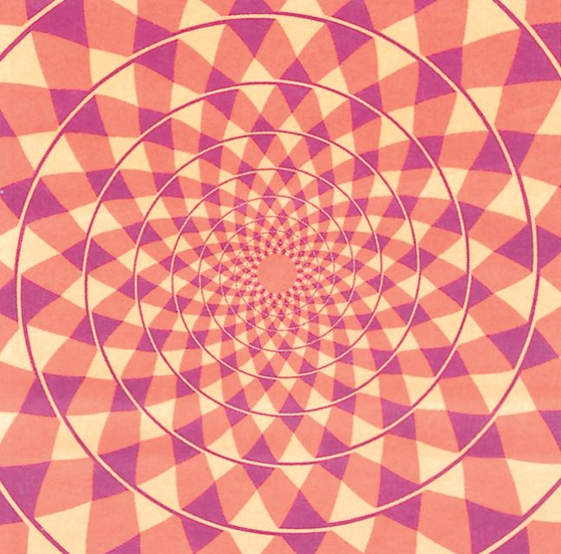
    - People tend to close the open edges of a figure or fill in gaps in an incomplete figure, so that their identification of the form
  - Law of Continuity
    - People link individual elements together so that they form a continuous line or pattern that makes sense
- Ignoring inconsistent elements
- Imposing order

Perception Involves Hypothesis Testing
- Perceptual Schema
  - “Recognizing” a stimulus implies we have this
  - Mental representation or image to compare it with
  - Schemas contain critical features of objects, events and other phenomena
  - Allow classification and identification of sensory input – top-down fashion
- Perception
  - Attempt to make sense of stimulus input
  - Search for the “best” interpretation of sensory information we can arrive at, based on knowledge and experience
  - Hypothesis about nature of object – meaning of sensory information
- Sensory information fits two different internal representations, and there can be not enough information to permanently rule out one of them in favour of the other

Perception – Influenced by Expectations: Perceptual Sets
- Perceptual Set
  - Readiness to perceive stimuli in certain ways, based on our expectations, assumptions, motivations, and current emotional state.
  - Sometimes believing is seeing
  - Influence our social perceptions
- Ex. Guest Lecturer
  - Half of the students in the class were given a set of introductory notes that described the guest as “industrious, critical, practical, determined and a rather cold person”
  - Other half were given notes that described the visitor as “industrious, critical, practical, determined and a rather warm person.”
  - Students rated the guest lecturer and his presentation
  - Received the cold description
    - Interacted very little with him and later rated the guest lecturer as unhappy and irritable during the lecture
  - Received the warm description
    - Rated him as happy and good-natured during the lecture, and they took part actively

Stimuli – Recognizable Under Changing Conditions: Perceptual Constancies
- Perceptual Constancies
  - Allow us to recognize familiar stimuli under varying conditions
    - Ex. closed door swinging open – different image on retina – perceived still as a door
    - Ex. recognize a tune even if it is played in different octave
- Shape Constancy
  - Recognize people and objects from many different angles
- Brightness Constancy
  - Relative brightness of objects remain the same under different conditions of illumination
  - Occurs because the ratio of light intensity between an object and its surroundings usually is constant
- Size Constancy
  - Perception that the size of objects remains relatively constant even though images on our retina change in size with variations in distance

Perception of Depth, Distance & Movement

Depth & Distance Perception
- Retina receives information in only two dimensions (length and width)
- Brain translates these cues into three-dimensional perceptions
  - Using
    - Monocular cues (which require only one eye)
    - Binocular cues (which require both eyes)

Monocular Depth Cues
- Patterns of light and shadow
- Linear perspective
  - Refers to the perception that parallel lines converge or angle toward each other as they recede into the distance
- Interposition
  - Which objects closer to us may cut off part of our view of more distant objects, provides another cue for distance and depth
- Height
  - In the horizontal plane provides another source of information
- Texture
  - Texture or grain of an object appears finer as distance increases
- Clarity
  - Can be an important cue for judging distance
- Relative Size
  - Another basis for distance judgments
- Motion Parallax
  - Which tells us that if we are moving, nearby objects appear to move faster in the opposite direction than do faraway ones

Binocular Disparity
- Most dramatic perceptions of depth arise
- Ex. 3-D movies
- Binocular Disparity
  - In which the eye sees a slightly different image
- Within the brain, the visual input from the two eyes is analyzed by feature detectors that are attuned to depth
- Some of the feature detectors respond only to stimuli that are either in front of or behind the point we are fixing our gaze upon
- The responses of these depth-sensitive neurons are integrated to produce our perception of depth
- Convergence (cue)
  - Produced by feedback from the muscles that turn your eyes inward to view a near object

Perception of Movement
- Complex process that requires the brain to integrate information from several different senses
- Primary cue: movement of stimulus across retina
- Optimal conditions: retinal image need move only about one-fifth the diameter of a single cone to detect movement
- Movement Cue
  - Relative movement of an object against structured background
- Illusion of smooth motion can be produced if we arrange for the sequential appearance of two or more stimuli
- Stroboscopic Movement
  - Illusory movement produced when a light is briefly flashed in darkness and then, a few milliseconds later, another light is flashed nearby
  - If the timing is just right, the first light seems to move from one place to the other in a manner indistinguishable from real movement
  - Ex. Moving pictures & films

Illusions: False Perceptional Hypotheses
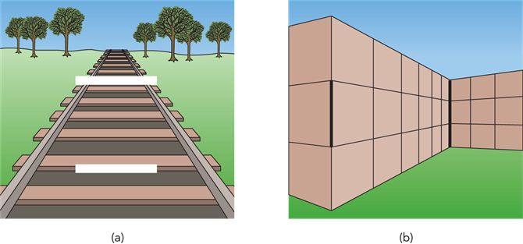
- Illusions
  - Compelling but incorrect perceptions
  - Understood as erroneous perceptual hypotheses about the nature of a stimulus
  - Attributed to perceptual constancies
- Distance cues can be manipulated to create other size illusions
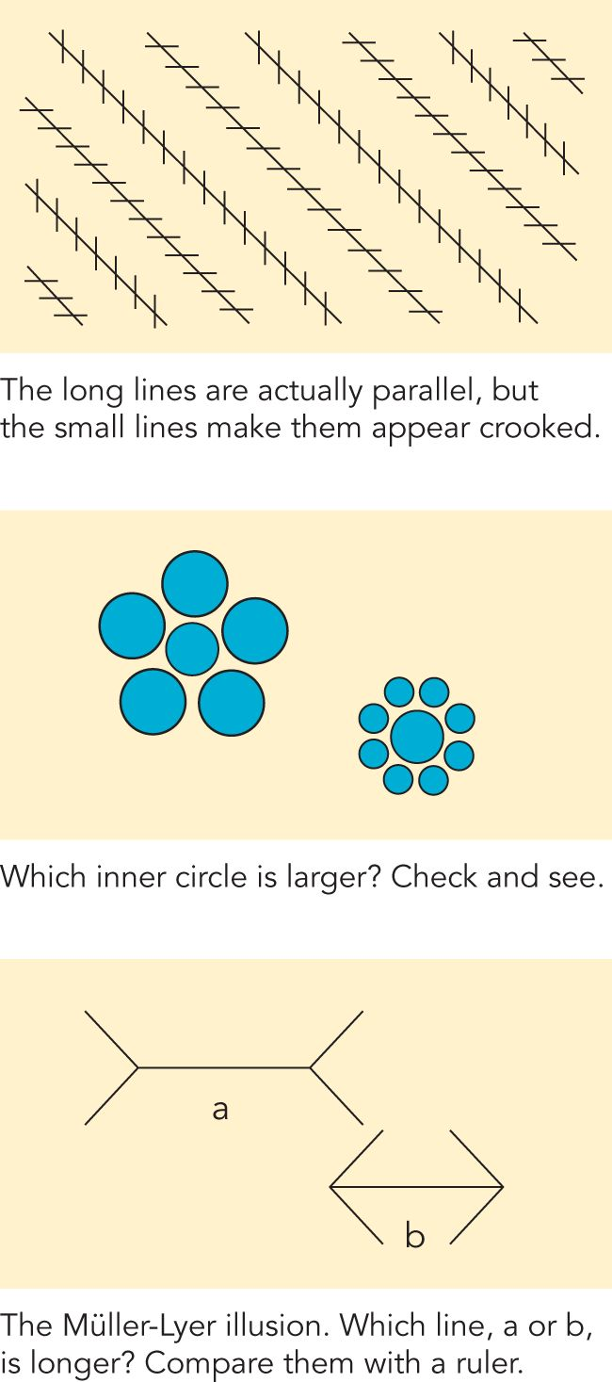
- Study of perceptual constancies shows that perceptual hypotheses are strongly influenced by context, or surroundings, in which a stimulus occurs
- Perceptual distortions are produced when monocular depth cues are manipulated to produce an image whose individual parts make sense and overall organization is “impossible”
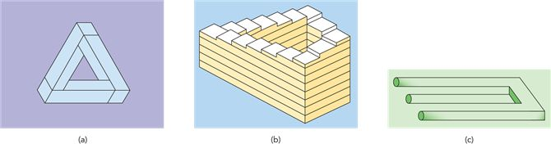

Experience, Critical Periods & Perception Development
- Development of sensory and perceptual systems results from the interplay of biological and experiential factors
- Genes program biological development, but this development is also influenced by environmental experiences
- Ex. Blinded and Learned Braille
  - Area of the somatosensory cortex that is devoted to the fingertips would enlarge over time as it “borrowed” other neurons to increase its sensitivity
  - Kenge's misperception, buffalos as insects, occurred as a failure in size constancy - lived without open spaces, had no experience in judging size of objects at great distances
- Ex. inverted glasses – right-side up on retina instead of upside down
  - Initial nausea and confusion – brain adapted

Cross-Cultural Research on Perception
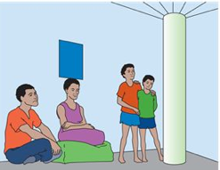
- Culture one grows up in helps to determine the kinds of perceptual learning experiences people have
- Consider the perception of a picture, which depends on both the nature of the picture and the characteristics of the perceiver
- Ex.
  - Most North Americans and Europeans reply instantly, “window” and see the family sitting inside a dwelling
  - Most East Africans reply, “basket or box” and family is outside, sitting under a tree
- Perception of illusions also affected by cultural experience
  - Western – more likely to believe illusions
  - Other Cultures – more likely to see the image as real
- Perceptions of tastes, odours, and textures are strongly influenced by our cultural experiences

Restored Sensory Capacity
- Visual deprivation studies, manipulation of visual input, and studies of restored vision have shown that the normal biological development of the perceptual system depends on certain sensory experiences at early periods of development
- Ex.
  - Born with cataracts grow up in a visual world without form
    - Clouded lenses of their eyes permit them to perceive light, but not patterns or shapes
    - Undergo surgery to remove thick cataracts
    - Result:
      - Light, there was colour, all mixed up, meaningless, a blur
      - Retina and optic nerve were active, transmitting impulses, but brain could make no sense of them
      - Had to touch objects to identify them
      - Had to be led through his house and quickly would become disoriented if he deviated from his path

