COMM 223 - Chapter 2/ Strategic Planning

Strategic planning: the process of developing and maintaining a fit between the company’s goals and capabilities and its changing marketing opportunities.

Step 1) Defining a Market-Oriented Mission

Definition - The mission statement is what the company wants to accomplish in the larger environment.
- Defines the business in terms of satisfying basic customer needs.
- Acts as an “invisible hand” that guides employees in the company.

Step 2) Setting Company Objectives and Goals

- Build profitable customer relationships
- Invest in research
- Improve profits.
- Increase market share
- Create local partnerships
- Increase promotion

Step 3) Designing the Business Portfolio

business portfolio is the collection of businesses and products that make up the company.

Portfolio analysis is the activity management does to evaluates the products and businesses that make up the company.

*The best business portfolio is the one that best fits the company’s strengths and weaknesses to opportunities in the environment.

Analyzing the Current Business Portfolio

- Strategic business unit (SBU) is a unit of the company that has a separate mission and objectives that can be planned separately from other company businesses.
  - Company division
  - Product line within a division
  - Single product or brand
- Identify key businesses that make up the company.
- Decide how much support each SBU deserves.

Problems with Matrix Approaches

- Difficulty defining SBUs and measuring market share and growth
- Time consuming
- Expensive
- Focus on current businesses, not future planning

Developing Strategies for Growth and Downsizing /Market Expansion Grid Strategies

- Product/market expansion grid is a tool for identifying company growth opportunities through market penetration, market development, product development, or diversification.
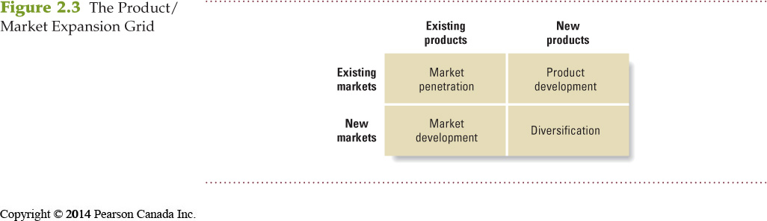
- Market penetration is a growth strategy, increasing sales to current market segments without changing the product.
- Market development is a growth strategy that identifies and develops new market segments for current products.
- Product development is a growth strategy that offers new or modified products to existing market segments.
- Diversification is a growth strategy through starting up or acquiring businesses outside the company’s current products and markets.
- Downsizing is the reduction of the business portfolio by eliminating products or business units that are not profitable or that no longer fit the company’s overall strategy.

Planning Marketing

Partnering to Build Customer Relationships

- Value chain is a series of departments that carry out value-creating activities to design, produce, market, deliver, and support a firm’s products.
- Value delivery network is made up of the company, suppliers, distributors, and ultimately customers who partner with each other to improve performance of the entire system.

Marketing Strategy and the Marketing Mix
Mission Statement and Marketing Strategy
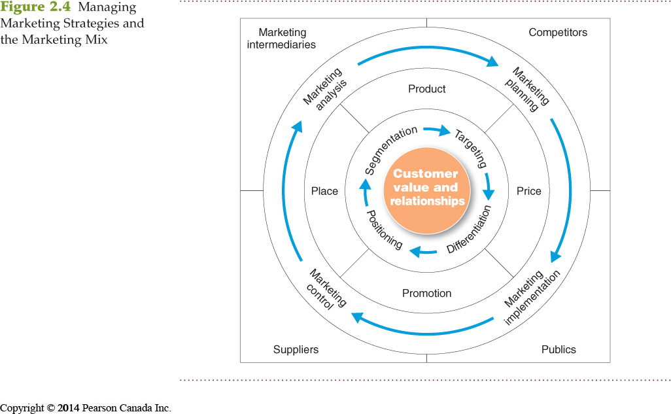

- Market segmentation is the division of a market into distinct groups of buyers who have distinct needs, characteristics, or behaviour and who might require separate products or marketing mixes.
- Market segment is a group of consumers who respond in a similar way to a given set of marketing efforts.
- Market targeting is the process of evaluating each market segment’s attractiveness and selecting one or more segments to enter.
- Market positioning is the arranging for a product to occupy a clear, distinctive, and desirable place relative to competing products in the minds of the target consumer.
- Marketing mix is the set of controllable tactical marketing tools—product, price, place, and promotion—that the firm blends to produce the response it wants in the target market.
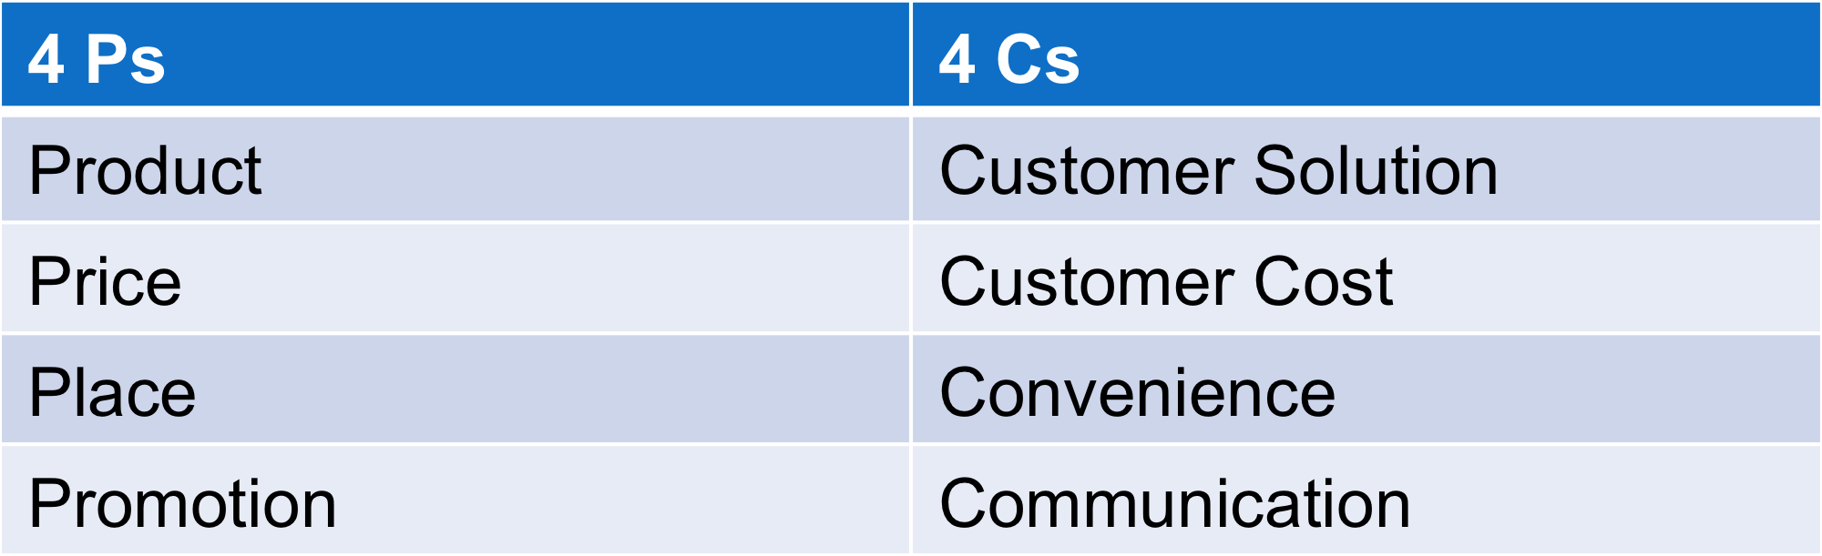

Seeing the 4 Ps from the customer’s perspective (example: promotion in terms of communication) can help us understand how we create value for our customers.

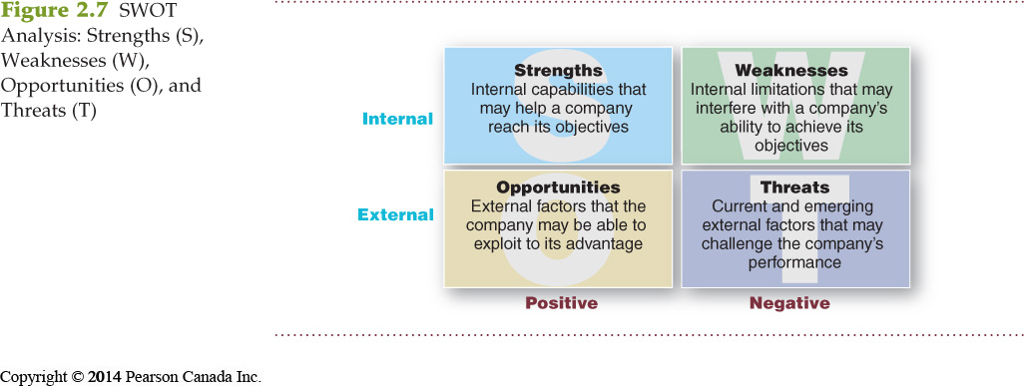
- Analysis (SWOT)
- Planning
- Implementation

Implementing is the process that turns marketing plans into marketing actions to accomplish strategic marketing objectives.
  - Successful implementation depends on how well the company blends its people, organizational structure, decision and reward system, and company culture into a cohesive action plan that supports its strategies.

- Control

Controlling is the measurement and evaluation of results and the taking of corrective action as needed.

Operating control
involves checking ongoing performance against an annual plan and taking corrective action as needed.

Strategic control
involves looking at whether the company’s basic strategies are well matched to its opportunities.

- Return on marketing investment (Marketing ROI) is the net return from a marketing investment divided by the costs of the marketing investment. Marketing ROI provides a measurement of the profits generated by investments in marketing activities.

Chapter 3/ Analyzing the Marketing Environment

The marketing environment consists of the actors and forces outside marketing that affect marketing management’s ability to build and maintain successful relationships with target customers.

- Microenvironment consists of the actors close to the company that affect its ability to serve its customers, the company, suppliers, marketing intermediaries, customer markets, competitors, and publics.

Actors in the Microenvironment

- The Company

- Suppliers
  - Provide the resources to produce goods and services
  - Treated as partners to provide customer value
- Marketing intermediaries
  - Help the company to promote, sell, and distribute its products to final buyers
  - These are: Resellers, physical distribution firms, marketing agencies and financial intermediaries.
- Competitors
  - Firms must gain strategic advantage by positioning their offerings against competitors’ offerings.
- Publics
  - Any group that has an actual or potential interest in or impact on an organization’s ability to achieve its objectives.
The Company’s Macroenvironment

- Demographic Environment
  - Demographic environment is important because it involves people, and people make up markets. Include age, family structure, geographic population shifts, educational characteristics, and population diversity.
  - Generational marketing is important in segmenting people by lifestyle or life state rather than by age.
- Natural Environment
  - Natural environment involves the natural resources that are needed as inputs by marketers or that are affected by marketing activities.
    - Trends:
    - Shortages of raw materials
    - Increased pollution
    - Increased government intervention
    - Environmentally sustainable strategies
- Technological environment is perhaps the most dramatic force now shaping our destiny. Technology has released such wonders as antibiotics, robotic surgery, miniaturized electronics, smartphones, and the Internet.

- The political environment consists of laws, government agencies, and pressure groups that influence or limit various organizations and individuals in a given society.

The social environment refers to social codes and rules of professional ethics beyond written laws and regulations.
  - Socially responsible behaviour.
  - Cause related marketing

- Economic environment consists of factors that affect consumer purchasing power and spending patterns:
  - Industrial economies are richer markets.
  - Subsistence economies consume most of their own agriculture and industrial output.
  - Ernst Engel—Engel’s Law
- As income rises, the percentage spent on food declines. The percentage spent on housing remains constant. The percentage spent on savings increases.

- Cultural environment consists of institutions and other forces that affect a society’s basic values, perceptions, and behaviors.

  - Core beliefs and values are persistent and are passed on from parents to children and are reinforced by schools, churches, businesses, and government.
  - Secondary beliefs and values are more open to change and include people’s views of themselves, others, organization, society, nature, and the universe.

HOW TO REMEMBER MACROENVIROMENT.
Political
Demographic
Social/Cultural
Technological
Environment (Natural)
Economic
P
E
S
T
D
E

Chapter 5/ Managing Marketing Information to Gain Customer Insights

Customer Insights

- Fresh and deep insights into customers needs and wants
- Difficult to obtain
  - Not obvious
  - Customer’s unsure of their behaviour
- Not derived from more information but better information and more effective use of existing information

Marketing Information Systems (MIS)

- Marketing information system (MIS) consists of people and procedures for the following:
  - Assessing the information needs
  - Developing needed information
  - Helping decision makers use the information for customers
- MIS provides information to the company’s marketing and other managers and to external partners, such as suppliers, resellers, and marketing service agencies.

Characteristics of a Good MIS

- Balancing the information users would like to have against what they need and what is feasible to offer

Marketers obtain information from the following:

Internal Data
- Internal databases are electronic collections of consumer and market information obtained from data sources within the company network.
- Information collected from different sources within the company, and stored within the organization’s information system:
  - Accounting system
  - Operations/production
  - Sales reporting system
  - Past research studies
- Internal data is cheap, quick, and easy.
  - May not be in a usable form for the decision to be made
  - May be incomplete or inappropriate to a particular situation

Marketing Intelligence
- Marketing intelligence is the systematic collection and analysis of publicly available information about consumers, competitors, and developments in the marketplace.

Marketing Research

Marketing research is the systematic design, collection,
analysis, and reporting of data relevant to a specific marketing
situation facing an organization.

Marketing Research Process
- These objectives guide the entire process.

- Defining the Problem and Research Objectives
  - Defining the problem and the research objectives is often the hardest step in the research process.
- Developing the Research Plan
  - Outlines sources of existing data
  - Spells out the specific research approaches, contact methods, sampling plans, and instruments to gather data
  - Secondary data consists of information that already exists somewhere, having been collected for another purpose.
  - Primary data consists of information gathered for the special research plan.
  - Observational research involves gathering primary data by observing relevant people, actions, and situations.
  - Ethnographic research involves sending trained observers to watch and interact with consumers in their natural environment.
  - Survey research is the most widely used method and is best for descriptive information—knowledge, attitudes, preferences, and buying behaviour.
  - Characteristics of survey research are as follows:
  - It is flexible.
  - People may be unable or unwilling to answer.
  - People may give misleading or pleasing answers.
  - There may be privacy concerns.
  - Experimental research is best for gathering causal information—cause-and-effect relationships.

Marketing Research /Contact Methods

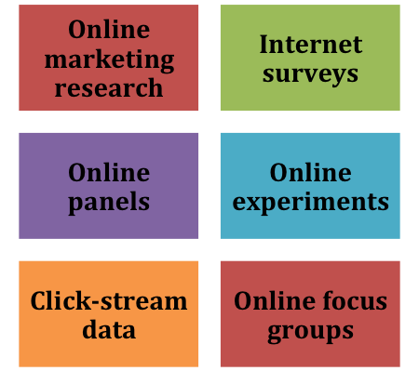

- Sample is a segment of the population selected for marketing research to represent the population as a whole.
  - Who is to be surveyed?
  - How many people should be surveyed?
  - How should the people be chosen?

Implementing the Research Plan

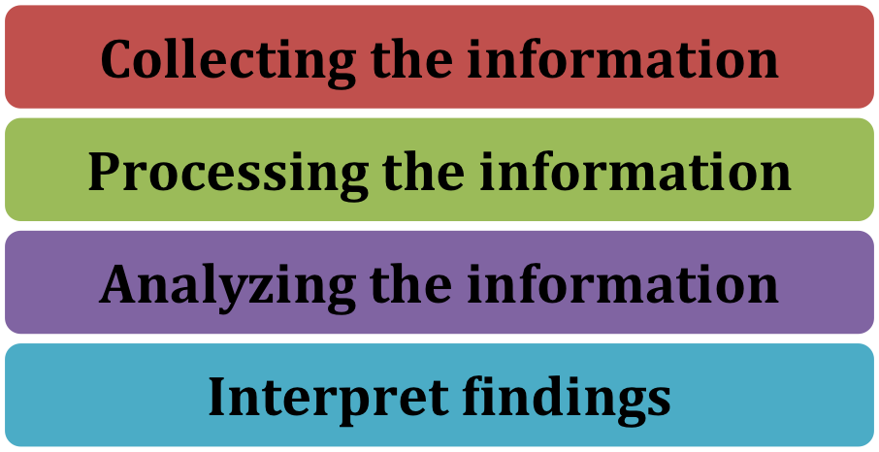
- draw a conclusion then report to management.

Analyzing and Using Marketing Information

Customer Relationship Management (CRM)

- CRM consists of sophisticated software and analytical tools that integrate customer information from all sources, analyze it in depth, and apply the results to build stronger customer relationships.

Distributing and Using Marketing Information

- Information distribution involves entering information into databases and making it available in a time-useable manner.
  - Intranet provides information to employees and other stakeholders.
  - Extranet provides information to key customers and suppliers.

Chapter Consumer Markets and Consumer Buyer Behaviour

Model of Consumer Behaviour

- Consumer buyer behaviour refers to the buying behaviour of final consumers—individuals and households who buy goods and services for personal consumption.
- Consumer market refers to all of the personal consumption of final consumers.

Factors Influencing Consumer Behaviour

1) Culture

- Culture is the set of basic values, perceptions, wants, and behaviors learned from family and other important institutions.
- Subcultures are groups of people within a culture with shared value systems based on common life experiences and situations.
- Social classes are society’s relatively permanent and ordered divisions whose members share similar values, interests, and behaviours.
  - Measured by a combination of occupation, income, education, wealth, and other variables

2) Groups and Social Networks

- Online social networks are online communities where people socialize or exchange information and opinions.
- Online social networks include blogs, social networking sites (Facebook), and virtual worlds (Second Life).

3) Personal Factors

- Occupation affects the goods and services bought by consumers.
- Economic situation includes trends in the following:
  - Personal income
  - Savings
  - Interest rates

- Lifestyle is a person’s pattern of living as expressed in his or her psychographics.
  - Measures a consumer’s AIOs (activities, interests, opinions) to capture information about a person’s pattern of acting and interacting in the environment

- Personality and self-concept
  - Personality refers to the unique psychological characteristics that lead to consistent and lasting responses to the consumer’s environment.
- Brands also have personalities; consumers are likely to choose brands with personalities that match their own.

Psychological Factors
- A motive is a need that is sufficiently pressing to direct the person to seek satisfaction.
- Motivation research refers to qualitative research designed to probe consumers’ hidden, subconscious motivations.
- Perception is the process by which people select, organize, and interpret information to form a meaningful picture of the world from three perceptual processes:
  - Selective attention
  - Selective distortion
  - Selective retention
- Selective attention is the tendency for people to screen out most of the information to which they are exposed.
- Selective distortion is the tendency for people to interpret information in a way that will support what they already believe.
- Selective retention is the tendency to remember good points made about a brand they favour and forget good points about competing brands.
- Learning is the change in an individual’s behaviour arising from experience and occurs through interplay of the following:

Belief is a descriptive thought that a person has about something based on the following:
- Knowledge
- Opinion
- Faith

Attitudes describe a person’s relatively consistent evaluations, feelings, and tendencies toward an object or idea.

Types of Buying Decision Behaviour

Four Types of Buying Behaviour

1) Need Recognition
- Occurs when the buyer recognizes a problem or need triggered by the following:
  - Internal stimuli
  - External stimuli

