Bricks can be used in many different ways. Some of which include walls of buildings, chimney stacks, sidewalks, and flowerbeds.


Bricks are used in a wide range of construction projects. The most popular use for bricks is for exterior walls of low-rise buildings such as schools and homes. The reason that bricks are used as exterior walls is because the high porosity of the blocks help to increase thermal mass of the building, which helps to keep the building cool in the summer and warm in the winter. The brick layer helps to insulate the building throughout the year which saves money on heating and cooling. Bricks also help to keep out unwanted noises such as traffic and airplanes. Another reason that bricks are popular to use as exterior walls is because they do not need to be painted or stained which helps to decrease the yearly maintenance of the outside of the building.
Another way the bricks are used often is in fire places and chimney stacks. The reason that bricks are used in this way is because they are highly fire resistant, and have a high melting point. This means that the heat of the fire in the fireplace will not melt or catch the bricks on fire.
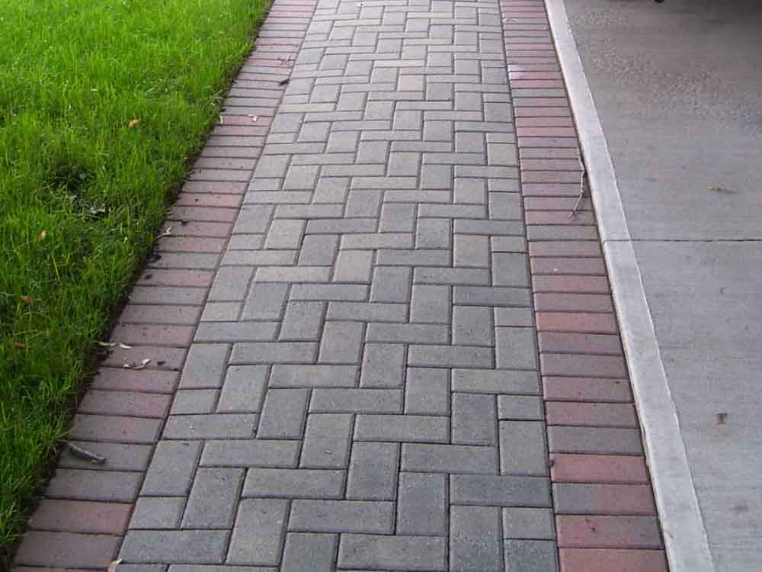
Bricks were previously used to pave roads, however they are not capable of holding up to heavy traffic flow, so the use of bricks on roads has now been limited to pedestrian walkways, and decorative surfaces.
Crushed up and recycled bricks are used in landscaping in place of wood chips around flowers because they are long lasting and low maintenance. Brick chips are useful in flower beds because they are heavy enough to withstand leaf blowing and are not a good environment for insects to live in.
The reason that bricks can be used in so many different applications is because they are relatively lightweight naturally coloured, and have many air cavities which help to insulate and sound proof buildings. They are also heat resistant and have a high melting point so they will not catch fire easily.

http://www.boral.com.au/bricks/bricks-advantages.asp
http://www.architonic.com/ntsht/bricking-it-innovative-applications-of-mans-most-trusted-material/7000623
http://www.siouxcitybrick.com/products/brick-chips

