Functions
- Transport:
  - Transports oxygen, nutrients, hormones (produced by endocrine glands), waste products, drugs that have been injested
  - Waste is removed by the cells, an example is the carbon dioxide which blood takes back to the lungs
- Temperature regulation:
  - vasoconstrict or vasodilate vessels to adjust flow of blood according to body’s requirements
  - blood vessels contrict and dilate. When the body needs to lose heat, the blood vessels dilate causing the increase of blood flow to the surface of the skin and heat is released. When heat needs to be conserved the blood vessels constrict and the blood is shunned to only the core of the body to maintain heat.
- Maintain interstitial fluid composition:
  - There is a constant change of fluid between plasma and intersititial fluid
  - Maintains quantity and quality of what is in body fluid. Maintains environment in which cells live/survive important in composition and volume of what is in the blood

The Heart
- Location:
  - The heart is located in an area of the thorax called mediastinum
  - There is a superior and inferior component, and heart sits in the middle
- Heart Layers:
  - Pericardial Sac: Heart is covered in double layered serous membrane called pericardium:
    - Parietal Pericardium: which within itself has an outer fibrous layer (tough connective tissue to protect heart), and an inner serous layer which is a thin delicate membrane that is in the inside surface of the fibrous component of the parietal pericardium.
    - Visceral pericardium: (remember visceral means organ so right outside the organ, which is the heart in this case). Another name for visceral pericardium is epicardium. It is also a serous membrane layer.
    - Space between visceral and parietal pericardium is called the pericardial cavity.
    - Serous membranes are able to produce a little bit of fluid. Parietal serous membrane and visceral serous membrane rub when heart moves, and because they are lubricated there is a reduction in the friction generated when heart beats.
  - Myocardium is the actual heart muscle
  - Endocardium is the epithelial layer that lines the inside of the four chambers of the heart as well as veins and arteries

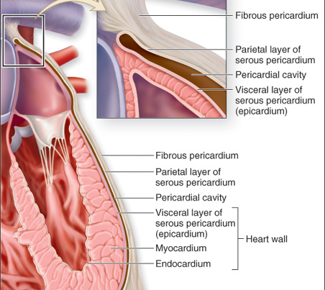

Blood Circulation of The heart
- Blood comes from superior and inferior vena cava, to the right atrium to the right ventricle, through the pulmonary artery to the lungs where gas exchange takes place. Comes back through the pulmonary veins to the left atrium to the left ventricle through the aorta and distributes to the body.
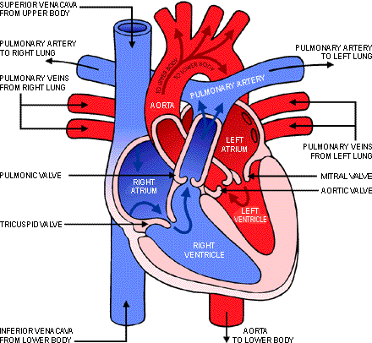

Heart Chambers
- Right Atrium
  - Superior vena cava: the large vein that is the final vein in a system that beings venous blood from areas above the heart and the upper extremity back to the right atrium
  - Inferior vena cava: the large vein that is the final vein in a system that brings most of the venous blood from areas below the heart to right atrium
  - Atrial Septum: this wall separates the right and left atria
  - Fossa Ovale: a depression in the septum separating the atria which is a remnant of fetal circulation. The fetus does not breath so blood goes through placenta into the heart from right to left atrium directly, as pressure increases the hole is filled in
  - Coronary Sinus Opening: the opening where the blood of the coronary sinus empties into the right atrium.
- Right Ventricle
  - Right Atrioventricular [AV] (tricuspid) valve: has three flaps (cusps), superior portion of cusps attach at opening between ventricle and atrium. Inferior portion of cusps attach to chordae tendineae (collagen fibres) which attach to muscle coming from inner wall of ventricle called papillary muscle (poke out from ventricle wall like cone). When right ventricle contracts, the pressure of blood going out increases and the blood causes flaps to come back up and seal off opening to prevent blood from going back into atrium. In order to keep valves closed, papillary muscle contracts putting tension on chordae tendineae. This keeps valves closed.
  - Interventricular septum is the wall that divides the left and right ventricles.
- Pulmonary artery
  - Pulmonary semilunar valve: the cusps are half moon shaped. This is the opening between right ventricle and pulmonary artery. The flaps fit around the circumference of the pulmonary artery. When blood goes from ventricle to pulmonary artery the pressure causes valves to push in and let blood through. When pressure of ventricle is not active anymore, then blood rushes back in, but pockets fill in blocking passage of blood back in.
- Left atrium
  - Receives oxygenated blood
- Left Ventricle
  - Left Atrioventricular [AV] (bicuspid) valve: same as tricuspid valve but with two cusps (flaps)
- Aorta
  - Aortic Semilunar valve: is at the base of aorta. This function is the same as the pulmonary semilunar valve, but it has 3 pockets. The pockets have the entrance to the left and right coronary arteries. When the ventricles relax, instead of blood flowing back into the ventricle, the aortic semilunar valves fill with blood closing the opening. When pockets fill with blood, the blood also goes through the opening and into the coronary arteries.

Cardiac Blood Supply
- The heart itself has its own little circulatory system. Coming off aorta are right and left coronary arteries. They supply heart muscle itself with oxygenated blood.
- Coronary veins bring venous blood back to the heart through a collecting vein located at the posterior of heart called the coronary sinus, which empties out into the right atrium through an opening.

Heart Surface Markings
- Base:
  - Base of the heart is the superior boarder, it is across the top and shaped like a triangle
- Apex
  - The apex of heart is the bottom pointed area (somewhere between clavicle line on left side. Apex of heart is around 5th rib
- Coronary sulcus
- External grove around the heart that marks the division between two ventricles and two atria. Between atrium and ventricle, this grove is all the way around the heart. The coronary sinus is located here
- Between right/left ventricle there is a groove called the anterior ventricular sulcus, continuation of the back is the posterior ventricular suluc

