Lecture 23
- Demonstrating Competition
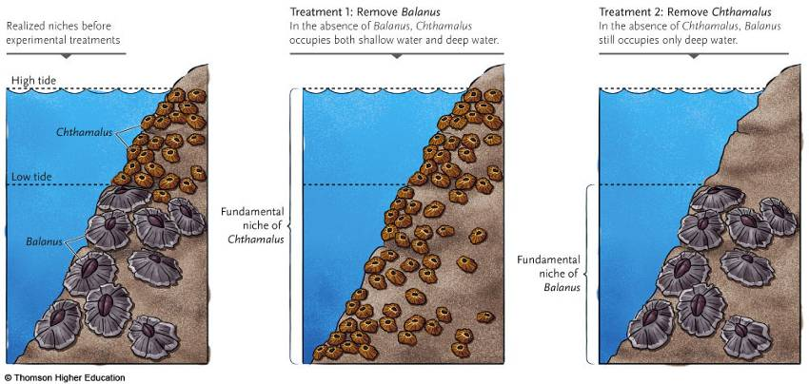
  - Competition drives diversity
- Species diversity: species richness and evenness
- Trophic Levels
  - At the base of the food web, there are primary producers (usually plants), followed by primary consumers (usually herbivores), then secondary consumers (first carnivores), then tertiary consumers (eat the first carnivores), and additional trophic levels in a system, although most don’t have a large number of trophic levels.
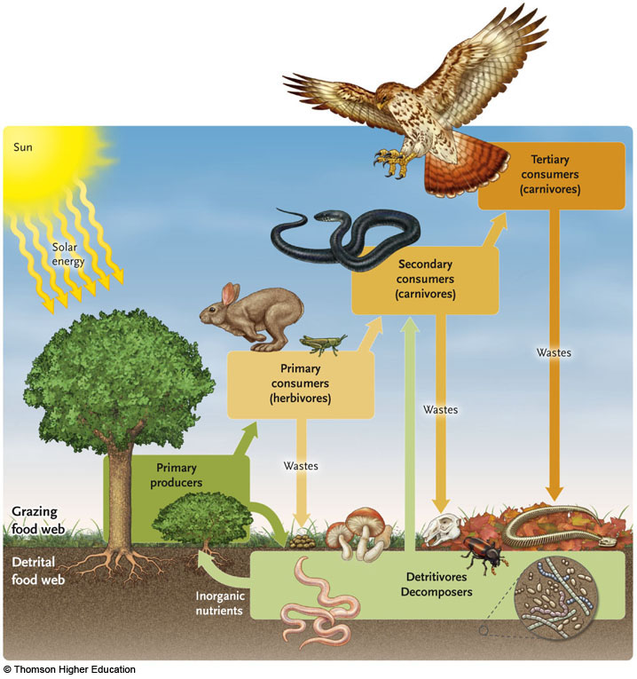
  - Energy flows up through the trophic levels, however the majority of the energy fixed by plants does not make it all the way up, a lot of it goes to waste
  - Ecological complexity also takes into account how many trophic levels there are
  - Why is it important how complex a community is?
    - Sometimes, they are more stable
- Diversity and keystone species
  - Some ecological communities have a particular species contained in them called a keystone species
    - Have disproportionate effects on a species i.e. the sea otters control the amount of urchins. They are keystone predators (typical for keystone species)
    - The presence of a keystone predator tends to enhance or increase the number of species in a community , increase species richness
- General trends in species diversity:
  - Latitudinal trends in species diversity: (species richness is the number of species in an area, species diversity is the number of species in an area and their distributions)
    - The lower you are in latitude, the more species you’ll find. Communities are more species rich in the tropics than they are closer to the North or South Pole
  - Island equilibrium theory
    - These patterns can be explained by island biogeography
      - The number of species on an island will reflect a balance between the rates at which new species colonize the island and the rate at which the species go extinct on the island.
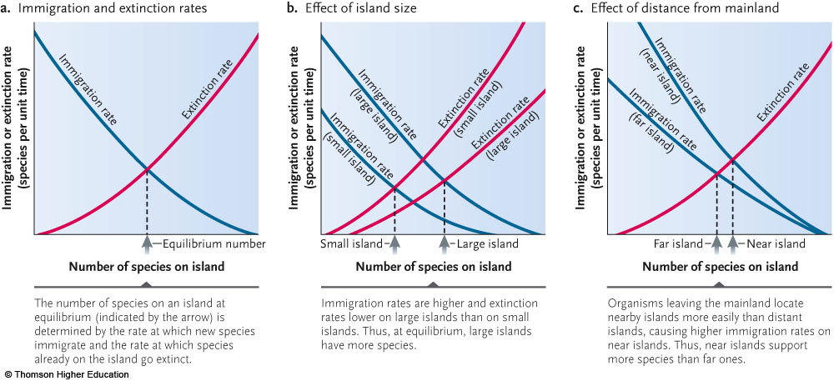
      - The more species there are on the island, the less likely there is that the new species immigrating will be species that aren’t already there
  - More species usually on big islands than little islands?
    - Immigration rate is higher on big islands because it’s a bigger target; also the extinction rate tends to be lower on big islands because it can probably support more ecological niches than smaller islands. Therefore, they have more species than little islands
    - Islands that are far away from the main land have less species than islands that are close to the mainland. This is because it is easier to colonize islands that are close the main lands.
- This theory can also be applied to habitat islands :
  - When designing a nature reserve, a large reserved area of space is better than multiple small ones according to island biogeography theory
- Ecological succession—if no ecological disturbance
  - A change in the species make-up of the community
    - New species comes and colonizes
    - Primary succession, the first living things come to colonize an area
    - Secondary succession- when the community is disturbed and the colonization begins again
  - r-selected organisms are generally the first to colonize the area, K-strategists come later
  - climax community- when its reached , it stops changing and stays until the community is disturbed
  - Equilibrium communities (disclimax communities) - depend on periodic disturbance in order to persist.
  - As the plants change, the community of animals also changes
- Ecological disturbances:
  - Removes a significant amount of biomass from a community (typically plant community)
  - If herbivory is significantly extreme, it can result in ecological disturbance
  - Fires and floods can also remove a lot of plant mass
  - Intermediate disturbance hypothesis:
    - Some optimal level of ecological disturbance at which we should expect to find the maximum species diversity
    - If a particular community undergoes sever disturbance events, only r-selected species can live there, species richness is fairly low
    - If a particular community has too infrequent disturbance, then, the only species that are able to live there are the extreme K-strategists
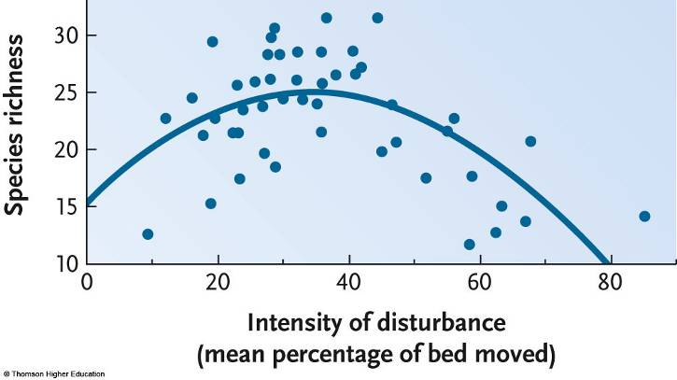

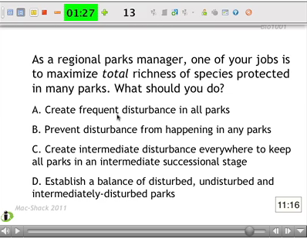
- D) is the right answer because despite the fact that there is a higher total number of species richness in intermediately disturbed habitats, communities that have low rates of disturbance may not contain as many total species but they tend to be species that aren’t found anywhere else.

