BIO2137 – Midterm questions
Plant Evolution
- In brief discuss principles of micro- and macroevolution.
Microevolution is defined as evolution within a species, gradual change occurring below species level. Involves small changes that do not create new species whereas macroevolution creates new species. Microevolution is changes in the gene pool that do not create new genes. Microevolution creates new alleles, evolution occurring on a grand scale of time and geography. Macroevolution changes in the gene pool that creates new genes. Since new organs and structures require new genes, any evolutionary transition that involves a new structure or organ is an example of macroevolution.
- Hardy-Weinberg law and equation of population gene pool
Law says that allele and genotype frequencies in a population will remain constant from generation to generation in the absence of other evolutionary influences. These influences include non-random mating, mutation, selection, genetic drift, gene flow and meiotic drive. The equilibrium is where the population’s gene pool remains constant.
p² +2pq+q²=1 where p2 is the frequency of homozygous dominant, q2 is homozygous recessive and 2pq is frequency of heterozygous individuals
- List and explain 5 factors which can cause population to evolve
Mutations
Migration (in or out population)
Small population size: accumulation of certain genes
Non-random mating
Natural selection

- Charles Darwin theory of natural selection: 5 factors driving microevolution
Focuses on microevolution. Natural selection leads to survival of best adapted (fittest). Surviving individuals pass on characters leading to gradual population changes over long periods of time. Mutation, migration, genetic drift, and natural selection are all processes that can directly affect gene frequencies in a population.
- Describe mechanisms and driving forces of speciation (allopatric, peripatric )
Allopatric: isolation of populations from each other. Classic island speciation proposed. Individuals of a species migrate to an island and become isolated from their parest population. Natural selection then acts to modify the founder population.
Peripatric: no island. One mountain to another. Much like allopatric but it isn’t as extreme, can be an isolated mountain
Parapatric: if a species expands its range and enters a new or slightly different habitat, natural selection will favour local adaptation to meet the demands of this new environment.
Sympatric: within the same population. Darwin’s local adaptations to different environments within a species range;. If new variants arise which are better suited to a particular niche they will be favoured by natural selection.

- Define biological and phylogenetic species concept. Main complication in biological species concept.
Biological species concept: species are populations of individuals, which can be, interbred with each other but cannot or do not interbreed with other groups. Species are genetically isolated. Some of the complications include: plants can form fertile hybrids (little potential to breed in nature) and geographically isolated species cannot breed due to different locations and not due to genetic isolation.

Phylogenetic species concept: population that has evolved long enough to have traits that are statistically different. This implies genetic isolation. There is a statistical difference and multiple traits difference.

- List and define main plant evolutionary processes (processes of note in plant evolution)
Allopatric isolation: geographic isolation and adaptive radiation. Adaptive radiation is when organisms diversify rapidly into a multitude of new forms. Due to lack of competition they adapted to widely different habitats on different islands
Sympatric isolation: hybrids and apomixes, polyploidy, co-evolution
- Explain causes and driving forces of allopatric speciation. Provide examples.
Geographic isolation: Pangaea, A mountain range prevents two types of goat from mating, causing the gene pool to become less varied.
Adaptive radiation: change in the environment makes new resources available and opens new environmental niches. Example: silverswords in Hawaii, more than 28 species evolved from single-family ancestor.

- List and briefly define driving forces of sympatric speciation. Provide examples.
Hybrids and apomixes: often sterile but may spread widely if asexual reproduction is possible. Can sometimes develop into new species. Plant species in the same genus often form hybrids. Apomixis: special situation where hyrbids can form seeds that are genetically identical to female parent. Avoidance of meiosis and fertilization
Polyploidy explained in next question
Co-evolution: would be the evolution of one species in response to the change in another species. For example, as honeybees became dependent on flowers, flowers became dependent upon bees for their survival. It could also be antagonistic.... like if humans develop resistance to a virus, the virus could evolve to become resistant to the newly evolved human resistance.

- What is polyploidy? The role of polyploidy in plant speciation.
Polyploidy: increase in chromosomes beyond usual diploids (2n) to tetraploids (4n) and hexaploids (6n). The polyploids become reproductively isolated from diploids and form new species. his can happen by a mutation that simply makes two copies. It can also happen when the chromosomes from two different species are mixed. One obvious consequence is that the resulting creature has no one it can breed with. However, this is not necessarily a problem. For example, many plants are both male and female, so they can simply fertilize themselves. Some earthworms can do this too.
- Types of polyploidy. Briefly explain each type of polyploidy.
Autopolyploidy: non-disjunction of chromosomes during meiosis
Allopolyploidy: Cross between two different species and genome duplication, diploid gametes and cross between two different species, double cross between two different species (along with genome duplication.
- Plant hybrids as driving force in speciation. What are the limitations and mechanisms for avoiding these limitations?
Limitations include sterile but with asexual it will spread, or apomixes.

- Describe co-evolution as driving force in evolution of insects and flowering plants: principles and examples
The flowering plant and insects (pollinators and herbivores have co-evolved. Each group affects the evolution of the other in turn (reciprocal). Co-evolution is thought to be a driving force for insect and plant diversification.

- Explain principles of macroevolution theory and punctuated equilibrium.
The extinction events may be more common than we realized and there is no possible adaptation for these therefore change can play a role as to which major groups dominate.

Theory of punctuated equilibria: evolution may occur by rapid bursts followed by periods of tranquility. Modern example: lead tolerant grasses that have evolved to colonize mine tailings in less than 100 years. Species seem to be slowly but constantly changing. Unfortunately, gaps in the fossil record make it impossible to support this view with direct fossil evidence.

- List and define main factors leading to 6th extinction event

-Fragmentation and habitat loss (area): agriculture, forestry, manufacturing, and urbanization. It is the loss and subdivision of a habitat and the corresponding increase in other habitats in the landscape.

-Invasive species: threat fall into six categories:
Habitat alteration: change in natural conditions
Predation: introduction of a predator not previously exposed to
Competition: exotic species can often outcompete native species for food and habitat acquisition because no local controls to keep population in check.
Hybridization: geograpahic barriers help to maintain genetically difiverse populations. Resulted in interbreeding of native and non native species. Consequent decline of native species.
Disease and parasites: pest species accidentally introduced , most dramatic example of damage.
Homogenization of ecosystems: all the above impacts combine to decrease the number of native species in a habitat and replace them with weedy, widespread species, and thus homogenization of ecosystems.

-pollution: addition of materials usually not present or in very different amounts. Sewage, algal blooms.

-global warming: plants and animals are sensitive to fluctuation in temperature and climate. Evidence from fossils have indicated that these periods of rapid climate change have been associated with mass extinction events.
Some scientists sat ut ciykd wipe as much as 90% of species living.

Plant Taxonomy

- Compare taxonomy and phylogeny - main differences.
Taxonomy: older) identicfication, naming and classification of species on the basis of shared characteristics.
Phylogeny: the evolutionary history and relationships of species or groups. How it is different relative to common ancestor.
- Describe principles of binominal nomenclature of species and list advantages (compared to common names)
Principles of binomial nomenclature: each name is composed of two parts, both of which use latin grammatical forms. We use it for care for research purposes. You have to know where it belongs, scientific name. Common names for species are words in the language of layperson. Can be misleading. Disadvantages: they are not useful to people with different language or dialect. Some species have several common names and some species share the same common name. Some species (like algal) may not have a common name. Each name composed of two parts; genus and then species
- List 3 Domains of life (by most recent classification) and briefly describe their characteristics
Eukaryota: plant, animal fungi, eukaryotic organisms
Bacteria: cyanobacteria, all prokaryotic organisms without membrane bound nucleus
Archaea: halophiles, thermophiles, prokaryotic organisms

- List and briefly describe characteristics of 6 kingdoms of life.
Archaea Domain
•Archaebacteria Kingdom

Bacteria Domain
•Eubacteria Kingdom: microscopic, unicellular prokaryotic cells. Some are autotrophs, some heterotrophs.

Eukarya Domain
•Protista Kingdom: mostly unicellular organisms that do not fit into the other kingdoms
•Fungi Kingdom: heterotrophic, sexual and asexual, eukaryotic ( more closely related to animals than plants, can be multicellcular or unicellular. Have chitinous cell wall.
•Plantae Kingdom
•Animalia Kingdom

- List and briefly describe major evolutionary events in land plants, which are currently used for plant taxonomy.
Embryo: protected from desiccation
Vascular tissue: specialized for the transport of water and solutes throughout the body of a plant. Better for plants to grow on land and much higher.
Seeds: contains an embryo and stored organic nutrients within a protective coat.
Flower: reproductive structure, protected structure for initiation of growth and food formation.

- List 4 main higher level classification units of land plants and describe their main characteristics.
Kingdom:
Subingdom:
Superdivision:
Division:
- Compare (in brief) three life cycles: zygotic, gametic and sporic meiosis.
- List main characteristics of Bryophytes
Do not have specific and specialized tissues for transporting water or other organic nutrients. No real roots, leaves or stems because they are non-vascular by definition. They require wet environment. Have a dominant gametophyte stage on which the adult sporophyte is dependent on the gametophyte for nutrition.

- List main characteristics of Ferns and club mosses
Seedless (produce spores) vascular plants grew to enormous sizes during the carboniferous period when the climate was warm and wet many of these plants became extinct when the climate became colder and drier. They all require moist and often warm environments. The sporophyte is dominant and the gametophyte is usually separate and independent. Look more like plants.

- List main characteristics of Gymnosperms
First (naked) seed plants developed during evolution. Have a sporophyte dominant life cycle, vascular plant. Conifers, evergreen, well differientiated sporophyte consisting of root, stem and leaves. Plants have well developed root system.

- List main characteristics of Angiosperms

Flowering plants are much more diverse. The flowers are the reproductive organ and aid to a wider range of adaptability and broadening the ecological niches. Staments with two pairs of pollen sacs. Better adapted to specialized pollination. Reduced male parts, three cells. The smaller pollen decreases the time from pollination to the pollen grain reaching the female plant fertilization. Closed carpel enclosing the ovules (carpel or carpels and accessory parts may become the fruit. Reduced female gametophytes, seven cells with eight nuclei-adaptations allowing for more rapid seed production. Endosperm: a highly nutritive tissue that can provide food for the developing embryo.

- Describe principles of molecular taxonomy. List and briefly explain main methods discussed in class.

- What is AFLP? Describe principles of this method for identification of species relationships.
It is the amplified fragment length polymorphism. The DNA is cut with restriction enzymes into fragment primers are used to amplify selected fragments by PCR reaction. The fragments are separated on gel to provide unique banding patterns for species. The banding pattern is coded to undertake a numerical analysis of similarly between tested populations and predict phylogenetic tree.

- What is ITS? How ITS sequence analysis helps to identify relationships between organisms.
Internal transcribed spaced. Not coded, spaces between genes. Much more mutation. Used to detect small changes. The Ribosomal DNA is very conserved and will result in a huge differene. It is the non-functional RNA situated between structural ribosomal RNAs. The length polymorphism – more distant species. The minor differences in nucleotide sequence-closely related species.

- What is the node on phylogeny tree?
They represent ancestors.

- What does the branch length of phylogeny tree tell us about species evolution and relationship to sister species?
The longer the branch- the more differences between two species or between particular species and its ancestors.

Prokaryotes
- List main characteristics of Bacteria
Cell forms: bacilli, cocci, spirilla, vibrio. Cell wall is made out of peptidoglycan and the capsule (lipopolysaccharide may be present). Nucleoid is a single molecule of circular genomic DNA. Rpeoduction by simple division- fission (no mitosis). Horizontal gene transfer by conjugation. 70 s ribosomes (different from eukarotes). Plasma membrane is site of respuiration and bacterial photosynthesis. Do not mate but have certain ways for protein transfer.

- Describe structure of bacterial cell – list main cell components
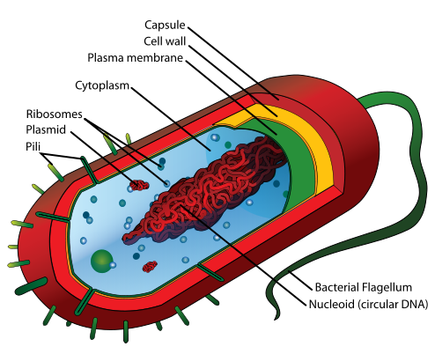

- Describe principles of bacterial cell division
- What is cell conjugation and how it benefits for bacterial genetic information exchange
Cell conjugation is the transfer of genetic information. The genetic information transferred is often beneficial to the recipient: antibiotic resistance, xenobiotic tolerance, ability to use new metabolites.

- What are three main methods for genetic information exchange in bacteria?
1) Conjugation-transfer of plasmids by formation of conjugation bridges by sex pili. transfer of genetic material (plasmid) between bacterial cells by direct cell-to-cell contact or by a bridge-like connection between two cells
2) Transduction-with the help of bacteriophages, DNA transfer by viruses
3) Transformation-getting genetic material from dead relatives in surrounding medium, take up of naked DNA

- List types of bacterial metabolism and main principles of each type (in terms of carbon and energy acquisition).
Heterotrophs: consume organic molecules. (saprophytes: obtain carbon from dead organisms, decomposers. Parasites cobtain carbon from living organisms and are harmful. Symbionts: obtain organic carbon from living organisms in exchange to other compounds and non harmful)

Autotrophs: make own organic molecules from redox reactions.
(chemoautotrophs use inorganic compounds to obtain energy for biosynthesis. Photoautrotrophs make own organic molecules from photosynthesis using light energy)

- Briefly describe principles and mechanisms of plant infection by Agrobacterium tumefaciens

- How Agrobacterium tumefaciens is used for plant biotechnology? Briefly explain modifications done in order to make this bacteria suitable for plant biotechnology.
- Provide examples of bacterial enzymes used in molecular biology and biotechnology. Briefly explain their applications.
Tool for plant transformation – agrobacterium,
gene cloning and amplification – ecoli. Producers of restriction enzymes, DNA modifying enzymes, DNA polymerases. Producers of various chemicals such as organic acids and biopropanol, biobutanol. Food fermentation and processing: acidophilus, lactobacillus: dairy products, vinegar, food supplements.

- What is Rhizobium?
A nitrogen-fixing bacterium (genus Rhizobium) that is common in the soil, esp. in the root nodules of leguminous plants. Rhizobia require a plant host; they cannot independently fix nitrogen. In general, they are Gram-negative, motile, non-sporulating rods.

- Briefly describe principles of Rhizobium infection of plant roots.
- Describe benefits of Rhizobium / plant symbiosis for each symbiosis partner.
- What is leghemoglobin? Its role in plant/ Rhizobium symbiosis? Which organism produces leghemoglobin and why?
It is an oxygen carrier protein found in the nitrogen fixing root nodules of a leguminous plant. It is produced by legumes in response to the roots being infected by nitrogen fixing bacteria as part of the symbiotic interaction between plant and bacterium: roots uninfected with rhizobium do not synthesise leghemoglobim. Close structure to hemoglobin, red in colour.

- Compare bacterial photosynthesis with cyanobacterial and plant.
- What is the major evolutionary advance in cyanobacterial photosynthesis?
- In brief: principles of “Z scheme” electron transport in cyanobacteria.
- Structure of filamentous cyanobacteria: 3 types of cells and their function.
- What is heterocyst of cyanobacteria? Its function and adaptation to perform this function.
- Ecological importance of cyanobacteria.

- Main characteristics of Archeobacteria
Only recently recognized as separate group of bacteria. Cell wall lack NAM (N-acetyl muramic acid) r-RNA sequences different. Lipids in membranes different (resistant to salt, high temperature. The photosynthesis is rhodopsin based. More similar to gran positive bacteria.

- Ecological niches of Archeobacteria.
Methanogens: anaerobic-produce methane in bogs, ruminants (cows), ocean depths (brine pools) which support unique marine ecosystem.
Halophiles in saline lakes and thermophiles in hot springs up to 70-105 C
Fungi
- Fungal protists: main characteristics of Oomycota (water molds)
Decomposers and parasites growing by hyphae without cross walls ( non septate). Cellulose in cell wall as opposed to chitin ( not controlled by fungicides), centrioles (like animals. Characterized by large thick walled oospores (zygote 2n) in sexual cycle and zoospore (n) in asexual cycle.
- Indicate diploid and haploid stages in the life cycle of Oomycota (water molds).
The egg and sperm are the products of meiosis and are the only haploid stage in the life cycle. Zoosporangium, zoospores, cyst and mycelium are in diploid stage.

- Fungal protists: main characteristics of Myxomycota (plasmodial slime molds)
No cell wall- forms big multinucleae oeganism. Reproduce by spores. Decomposition of dead vegetation and feeding on microorganisms. Up to few centimeters but some may reach op to several metres squared. When the food is abundant, single celled organisms. When food is short then congregate and start moving as a single body.

- Which stage (diploid or haploid) is dominating in Myxomycota (plasmodial slime molds) life cycle – briefly describe life cycle.
Main stage is haploid. Only zygote is in diploid stage. Vegetative stage can function as gametes

- Fungal protists: main characteristics of Dictiosteliomycota (cellular slime molds)
50 species of amoeba like organisms. Cellulose cell wall ( no chitin). Centrioles like animals. Cells remain uninuclear, they are just clustered together. Individual cellular slime molds (slugs) crawl along the subsrates at 1 mm per hour and leave a trail of chemicals which draws other slugs towards it. Slugs aggregrate and become pseudoplasmodium. When cells come together about a third of the cells come together to produce a stalk like fruiting body. Other cells are then transformed into spores. They reproduce same way as plasmodial slime molds but most of their life cycle they are in diploid stage.

- The main similarities and differences between plasmodial and cellular slime mold life cycle (Myxomycota vs Dictiosteliomycota).
Similarities between all 3: no photosynthetic pigments, all use glycogen for food reserve, and all can be found terrestrially.
Differences: Both dictyosteliomycota and oomycota have cellulose cell walls, while myxomycota has none on plasmodium. Both oomycota and myxomycota can have 2 flagella, but myxomycota is only in reproductive gametes,and oomycota is in male gametes and zoospores. Dictyosteliomycota has no flagella.

- List characteristics of true fungi.
Heterotrophic absorbers, primary terrestrial, unicellular of filamentous (hyphae form mycelium), chitin in cell wall (like in some animals), glycogen reserve (storage bodies), have vacuole (like plants), reproduction by spores (sexual and asexual), unique mitosis and meiosis (lack of centrioles. Nuclear envelope does not disintegrate and spindle forms within nucleus), probably diverged from colonial protists.

- Why true fungi often can have multiple nuclei in single cell? Explain.

- Composition and structure of fungal cell wall.
- Compare unicellular vs multicellular fungal body structures. Provide examples.

- The role and importance of hyphal growing tip.
Plays an important role in apical growth and secretion. Very different from the rest of the hypha; its cytoplasm is more dense; without major organelles and accumulation of membrane bound vesicles.
- List 4 divisions (Phyla) of true fungi and their main characteristics (hyphal structure, sexual and asexual spore type)
Chytrids-Chitridiomycota: hyphae aseptated, asexual motile zoospores, no sexual spores.
Bread molds-Zygomycota: hyphae aseptated, asexual non motile spores (sporangiospores), sexual zygospores.
Cup fungi:-Ascomycota: Hyphase septated, asexual-budding or conidia ( nonmotile) sexual ascospores
Mushroom and rusts-basidiomycota: hyphae septated, asexual- budding or conidia ( non motile), sexual basidiospores)

- What is the type of life cycle in Chitridiomycota (Chytrids)? Briefly describe.
- Chitrids (Chytridiomycota) as plant pathogens – provide 2 examples.
- Body structure of Zygomycota.
Most have profuse, rapidly growing hyphae, but some are unicellular and yeast-like. Most species of zygomycetes live in soil, or on decaying plant and animal matter. Saprophytes and terretstrial.

- Describe sexual reproduction and fertilization of Zygomycota.
Zygomycetes carry out asexual reproduction by means of spores produced in sporangia that are borne on the hyphae. They also produce thick-walled sexual structures called zygosporangia (singular zygosporangium), which can remain dormant for long periods.

- Why cup fungi (Ascomycota) are important in human’s life and biotechnology? Provide examples
- Life cycle of filamentous Ascomycota (cup fungi): with focus on 3 stages in life cycle.
- Yeasts - unicellular Ascomycota (cup fungi): In brief describe life cycle (including mating types) and cell division types.

- Principles of mating type switch in yeast.
It is a model in molecular genetics to study gene conversion, recombination and gene silencing.

- Biodiversity of Basidiomycota: 3 classes and their importance in human’s life and agriculture.
Three classes: basiodiomycetes, teliomycetes, ustomycetes. Edible mushrooms, toxic mushrooms ( mushrooms absorb heavy metals and radioactivity, even edible mushrooms can become toxic), psychoactive mushrooms: macig mushrooms. Medicinal properties: some mushroom materials, including polysaccharides, glycoproteins, proteoglycans modulate immune system responses and inhibit tumor growth.

- Puccinia graminis (Teliomycetes) – wheat stem rust: describe life cycle and alternation of hosts.
- Basidiomycetes: life cycle in brief (main body parts, stages, ploidy and spore types).
- Fruiting body of Basidiomycetes: type of cells and ploidy (nuclear) stage in fruiting body.

- Fungal/plant mycorrhizal symbiosis: benefits to plant and fungal partners.
Plant to fungus: mainly carbohydrates (products of photosynthesis)
Fungus to plant: water and mineral nutrition. There is increased absorption area, heigher capacity to uptake water, high number of ion transporters to fungal cells, increased uptake of phosphorus, particularly in basic pH soil. Higher amount of nitrogen.

- Main differences between two types of mycorrhiza. Briefly explain each type and specific fungal hyphae structures involved.

- Lichens: name symbiotic partners and benefits to each organism involved in symbiosis.
- Three growth forms of lichens and their morphological characteristics.
- Structure of lichen: use as example foliose lichen type and describe specific layers of cells.
- What is haustorium? Its function in lichens – fungal /algal symbiosis.
- How do lichens reproduce (sexual vs asexual)?
- Application of yeast (conventional and non-conventional) in industry and biotechnology. Provide few examples.
- Application of filamentous fungi in industry and biotechnology. Provide few examples.
- Fungal hydrolytic enzymes, their activities for specific substrates and their applications in biotechnology.
- What is bioremediation and why fungi are useful tool in bioremediation?

Alga (algal protists and green alga)
- Algae and plant specific cell organelles (3 organelles (specific cell parts) and their functions)
Chloroplast: an organelle containing chlorophyll-a, which traps sun energy for photosynthesis.
Amyloplast - an organelle in some plant cells that stores starch. Amyloplasts are found in starchy plants like tubers and fruits
Cell wall: an additional and rigid outer membrane which aids in protection and intercellular interaction.

- Evolution of chloroplasts - endosymbiosis theory: principles and evidences.
-Chloroplasts contain their own circular piece of DNA characteristic of prokaryotes. They have a double membrane indicating phagocytosis. Chloroplasts are the same size as prokaryotes. They reproduce by binary fission, which is characteristic of bacteria not eukaryotes.

- Primary endosymbiosis: three groups of algae evolved through primary symbiosis and the main characteristic of their chloroplasts.
Red algae:
Green Algae:
Glaucophytes:

- Secondary endosymbiosis: the ancestors of secondary symbiosis and three main types of chloroplasts evolved during secondary symbiosis.
Euglenoids: ancestor is green algae
Haptophytes:
Cryptophytes:

- What is nucleomorph?
A nucleomorph is the remains of a cell that was ingested and retained for its photosynthetic capabilities (only occurs in secondary endosymbiosis).

- The origin of four genomes in some algal species (containing nucleomorph).
Cryptophytes at some point in time engulfed a red algal cell, which had within it mitochondrion, and a photosynthetic cyanobacterium (chloroplast), and incorporated the red algal cell into itself. Now the cryptophyte contains the two circular genomes of the cyanobacteria and the prokaryotic mitochondria, and the linear genomes of the red algal cell and its original genome.

- Primary and secondary endosymbiosis: in brief describe diversity and origin of plastids derived from these endosymbiotic events
A phagotrophic eukaryotic cell engulfed a cyanobacterium (photosynthetic bacteria) which became its plastid (chloroplast).

- Describe principles and main differences of three types of life cycle (type of meiosis) in algae.
Gametic meiosis: (ex. Diatom) in gametic meiosis, the organism produces male and female gametangia, through meiosis, which are haploid. The sperm and egg fuse to form a zygote which grows into another organism through mitosis. Only the gametes are haploid.
-Sporic meiosis: (ex. Kelp) in sporic meiosis there is an alternation of generations meaning there are sporophytes (diploid), and gametophytes (haploid). The adult sporophyte produces male and female spores which grow into the gametophyte. The male gametophyte releases motile sperm which fertilize the female gametophyte. The fertilized zygote grows into a mature sporophyte and the cycle restarts.

- Euglenoids (Euglenophyta): characteristics and special features.
-their chloroplasts came from green algae
-they have no cell wall and are motile with flagella
-they are unicellular
-Pellicule – made up from proteins, arranged in strips spiraling around the cell. The action of these pellicle strips sliding over one another gives Euglena its exceptional flexibility and contractility
-Stigma – eye spot with light sensing system
-Contractile vacuole – collects access of water accumulating due to osmosis in fresh water.

- Ecological niches of Euglenoids (Euglenophyta)
-Fresh waters which are rich in organic materials, because they rely on particle feeding.

- Chryptomonads (Chryptophyta): Ancestor of Chryptomonads chloroplasts. Pigment composition and cell characteristics.
-the ancestor of chloroplasts is red algae, the pigments contained are: chlorophyll a, and c, and carotenoids, some contain phycobilin.
-unicellular, with two unequal flagella

- Dinoflagellates (Dinophyta) life cycle: sexual and asexual cycles. Why sexual reproduction is important?
: sexual and asexual cycles. Why sexual reproduction is important?
Asexual: longitudinal cell division
Sexual: non-motile cysts which float on the bottom of a body of water in anticipation for favorable conditions. When conditions are favorable the cysts germinate and revive the swimming population of cells.

- The nature of red tides. Ecological importance and why we cannot predict red tide appearance (relate to life cycle of dinoflagellates and ecological conditions).
Red tides occur when pollution causes dinoflagellates to produce dormant cysts which rest at the bottom of the ocean until nutrient content increases and they bloom.

- Dinoflagellate endosynbionts and their ecological importance in corals and other sea invertebrates.
Dinoflagellates, specifically zooxanthellae, are symbiotic with many species including corals. Zooxanthellae produce carbohydrates which are useful to coral and keep them alive.

- Bioluminescence in sea and ocean: where does it come from? Basic principles of bioluminescence mechanisms.
Cells produce luciferin and luciferase enzyme.
In the process of being oxidized, luciferin briefly exists in an excited state, after which it decays to the ground state- releasing energy in the form of light.

- Life cycle of diatoms. Why sexual reproduction is important?
If the asexual reproductive cycle continued then the daughter cells would become smaller and smaller until the cells died.

- Briefly describe principles of asexual and sexual reproduction of diatoms.
Asexual: simple cell division in which each of the daughter cells have half of the parent shell.
Sexual: once the diatom reaches a size (small) it is fertile, it releases eggs and sperm which fuse to form an auxospore. The auxospore divides and divides until it is fertile once more.

- What is diatomite? Economic uses of diatomite.
Diatomite is a material that forms at the bottom of a body of water when many diatoms die and their shells coalesce. Used in: insulating brick, absorbents, filtration (clarification of beer, wine, vegetable oil, syrup, pharmaceuticals, etc.) and fillers.

- What is coccoliths (in Haptophyta)?
Coccoliths - individual plates of calcium carbonate arranged around algal cell

- Why do Haptophytes (Haptophyta) and some other alga accumulate calcium carbonate in their “shells”?
-Reutilization of CO2 for photosynthesis
-Protection from predator and pathogens
-Regulation of floating
-Diffraction of sun light into the cell center (for photosynthesis in deep-sea water)

- List 3 major taxonomic groups which include multicellular alga.
Brown algae, red algae, green algae

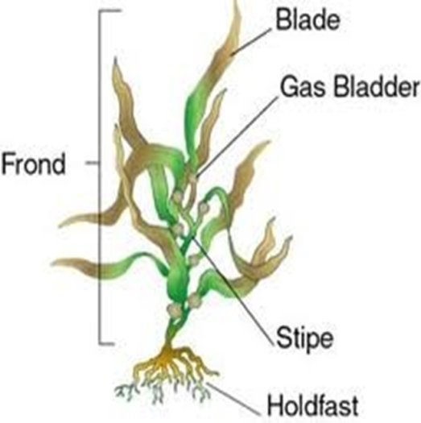
- Body structure of brown alga. Function of each body part.

Blade - leaf-like photosynthetic organ.
Stipe resembles stems with sieve tubes and ‘phloem’ for conducting sugar to deep holdfast.
Holdfast maintains attachment and doesn’t allow tide to wash the plants. Unlike plants – doesn’t supply water and nutrients.
Gas Bladders filled with air at the base of each blade that keeps the plant up toward the surface as it gathers light for photosynthesis.

- Two main orders of brown alga (Phaeophyta) and their ecology (growth habitats)
-Fucales – rockweeds - dominate rocky shores
-Laminariales – kelps – form beds offshore

- Briefly describe life cycle (including meiosis type) of Laminaria.
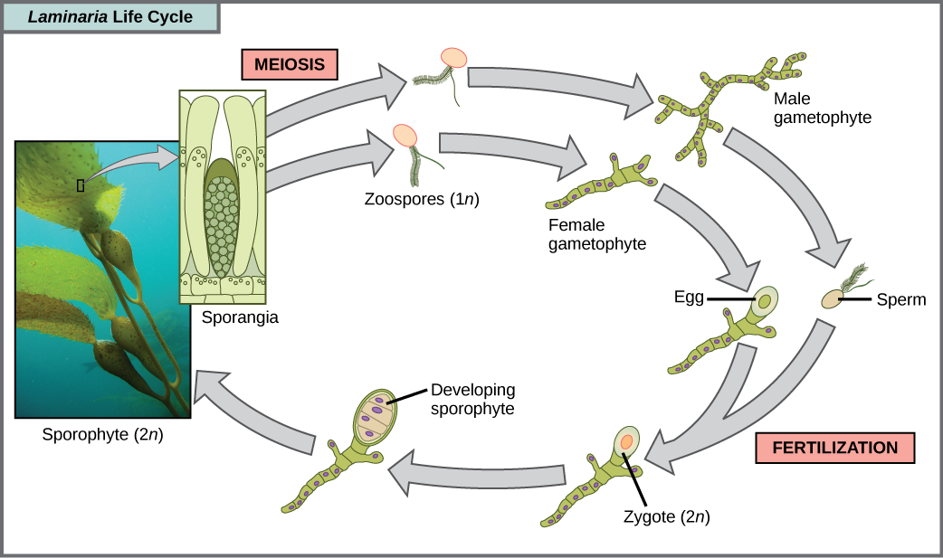
Male
Female

- Briefly describe life cycle (including meiosis type) of Fucus.
- Describe main uses of brown algae (Phaeophyta) in human life, provide examples.
- List main characteristics of red algae (Rhodophyta)
- Characteristics of photosynthetic pigments in red algae (Rhodophyta)
- Ecology and economic use of red algae (Rhodophyta)
- Biodiversity of green algae (Chlorophyta). Body forms and examples.
- Four types of cytokinesis in green alga. Describe principles and special structures for each.
- Chlorophyceae: describe structure and life cycle of unicellular green algae using Chlamydomonas as example
- Chlorophyceae: describe structure of colonial green alga. Why they are considered colonial but not multicellular?
- Chlorophyceae: evolutionary stream from small to bigger colonies coupled with diversity and evolution of fertilization type (related to form of female and male gametes).
- Chlorophyceae: describe asexual life cycle of Volvox carteri
- Chlorophyceae: describe sexual life cycle of Volvox carteri
- List and briefly explain potential applications of green alga in biotechnology and green biofuels.
- Describe body structure of filamentous green algae – provide few examples.
- The body structure of Fritschiella. Why it is considered the most advanced (evolutionary) Chlorophyceace.
- Biodiversity of Ulvophycease. Provide examples and their ecological niches.
- Life cycle of Ulva. Type of meiosis (life cycle).
- Structure of siphonous marine green alga.
- Life cycle of Caulerpa. Type of meiosis (life cycle).
- Importance of Caulerpa species in humans’ life and ecology.
- Charophyceae: provide few biodiversity examples and briefly describe their body forms.
- Charophyceae: What is sexual reproduction type of Spyrogyra? Briefly describe.
- Charophyceae: characteristics of multicellular green alga order Charales and Coleochaetales.
- Charales: body structure and reproduction type.
- Which groups/species of green alga is most likely ancestor of land plants? Why?
Bryophytes (Bryophyta)
- List three major groups of Bryophytes
- Liverworts (Hepatophyta)
- Hornworts (Anthocerophyta)
- Mosses (Bryophyta)

- Main characteristics of Bryophytes.
- The most primitive of terrestrial plants
- Small leafy or flat plants lacking true vascular tissue and true plant organs (roots, leaves)
- A gametophyte (n) dominant life cycle (dependent sporophyte)
- Grow in moist environment (generally)

- Explain Bryophytes sporophyte dependence from gametophyte and gametophyte dominance.
- Sporophytes are nutritionally and structurally dependent on gametophytes (at least for the early embryo development stage)
- Gametophyte dominate life cycle, are larger, completely free-living, and contain photosynthetic chloroplasts (autotrophic)

- General structure of Bryophytes – main body parts and their functions.
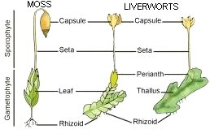
Moss
Liverworts
Sporophyte
Gametophyte
Capsule
Capsule
Seta
Seta
Perianth
“Leaf”
Thallus
Rhizoid
Rhizoid

Rhizoid - multicellular linear row of cell to attach to substrate – not for water transport.
Perianth in liverworts is the sterile tubelike tissue that surrounds the female reproductive structure
Thallus – undifferentiated body
- Gametophyte (green in colour): rhizoid (not real roots, for attachment not nutrient uptake), leaf or thallus (for photosynthesis)
- Sporophyte (for sexual reproduction): foot (attachment to gametophyte), capsule (contains spores) and seta (stem structure)
- Perianth – in liverworts’ female reproductive structure

- Liverworts (Hepatophyta): main characteristics and body structure
- Primitive leaf-like structure in gametophyte stage: “thallus”
- Separate male/female plants: dioecious
- Primitive pores (Lack stomata - mosses and hornworts have stomata) and rhizoids
- Common in wet forests, on rocks, tree trunks

- Liverworts (Hepatophyta): life cycle – indicate haploid (gametophyte) and diploid (sporophyte) stages.
- Liverworts have alternation of heteromorphic generations with gametophyte dominance
- Gametophyte gen. Initiated with meiosis – haploid spores form – rise of +/- sporophytes.
- Sporophyte gen. Initiated with fertilization – diploid zygote form ie spores (water needed for sperm to reach egg) – zygote develops into embryo inside archegonium structure – mature sporophytes form, spores released and rhizoid develop, restarting gametophyte gen.

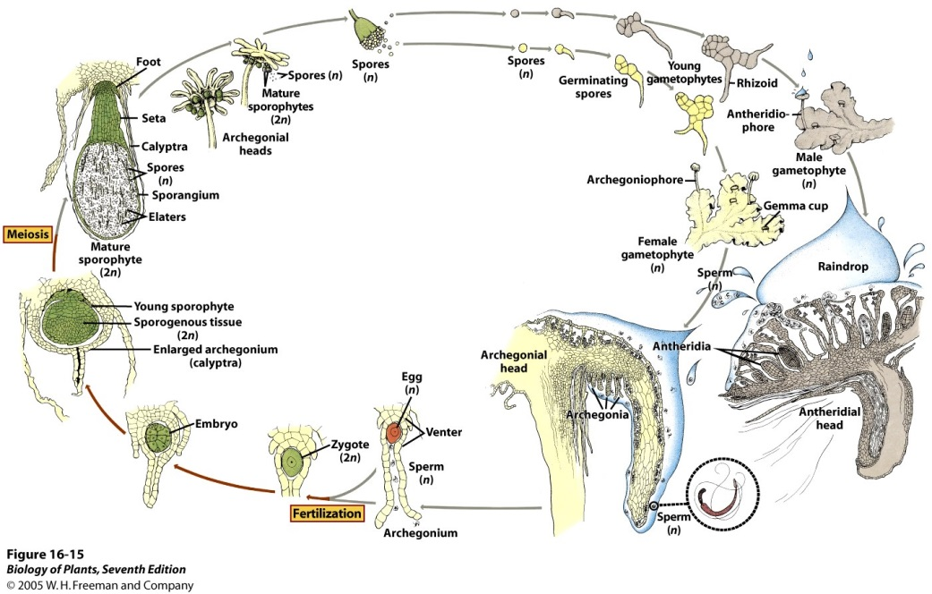

- What is asexual (vegetative) reproduction structure of liverworts (Hepatophyta)?
Gemmae: multicellular vegetative bodies (haploid). Form in Gemmae cup. After release, grow into new gametophytes

- Hornworts (Anthocerophyta): characteristics and body structure (gametophyte and sporophyte).
- Similar to thallose liverworts
- Most have a single large chloroplast with pyrenoid
- Gametophyte: rosette-like, 1-2cm across, unicellular rhizoids
- Sporophyte: photosynthetic, contains stomata, contains foot and long, cylindrical sporangium

- Evolutionary advantage and development of sporophyte in hornworts compared to liverworts.
- Liverworts are mainly gametophytes - is the entire organism with tiny sporophytes (non photosynthetic) attached on top
- Hornworts: still dependent on gametophytes, but can now photosynthesize. Advantage of sporophytes which are a little more independent and bigger

- Mosses: main characteristics and body structure (gametophyte and sporophyte)
- Upright gametophyte carries sporophyte
- Gametophytes are separate male and female plants
- Primitive vascular tissues present: hydroids and leptoids
- Widely distributed in many wet habitats

- List three major classes of mosses (Bryophyta)
- Sphagnidae (peat mosses)
- Andreaeidae (granite mosses)
- Bryidae (true mosses)

- Main genus of peat mosses (class Sphagnidae): body structure and growth habitats.
-Sphagnum grows in peat bogs (wetland areas) and DNA analysis indicate they diverged early from the main line of moss evolution
-Pseudopodium (stalk), part of the gametophyte, with capsule (for spores). Capsules are distinctive looking red or blackish-brown spheres with a lidlike operculum.

- The mechanism of spore dispersion in peat moss.
As the capsule dries and matures, its epidermal cells collapse laterally, causing the capsule to change shape from spherical to cylindrical. The internal air pressure of the capsule increases until the operculum is eventually blown off and the spores are released with explosive force

- Principles of formation of turf in peat bogs.
- Peat (ie. turf) is formed from the accumulation and compression of the mosses (sphagnum) and the sedges, reeds, grasses, and other plants that grow in peat bogs
- Plant growth is slow but decay is even slower. The dead parts accumulate, thus becoming a carbon sink (source of organic C)
- Decay is also slowed by anaerobic environ and also other microbe particle releases
- (From BIO219) flooded (non-running) water slows flow of oxygen from the atmosphere. Decomposition slows as a result

- Ecological and economic importance of peat moss (class Sphagnidae).
- Dead matters accumulate and become carbon source.
- Peat bogs create unique environmental systems for other species
- Economically: fuel (source of C) or improvement of soil
- Conservation of the dead bodies of other organisms → Interesting fossils.

- Granite moss growth habitats and special features for spore dispersion.
- Two genera: Andreaea and Andreaeobryum
- Andreaea can be found in mountain and arctic regions and are dark/blackish green or dark reddish-brown in colour. Often grow on granite rocks
- Andreaeobryum is restricted to northwestern Canada and adjacent Alaska and grow on calcareous rocks
- Capsules are marked by four vertical lines of weaker cells along which the capsule splits and spores are released when the sporangium dries (ie. In the summer)

- Main characteristics of true mosses.
- The majority of Bryophyta species are true mosses
- Multicellular rhizoids but single cell layer leaves
- Distinguish from algae by their slanted cell walls
- Stems with central strand
- Primative vascular tissue, hadrom (for water, similar to xylem) and leptom (for food, similar to phloem)
- Hydroids lack lignin (secondary cell wall)

- Pre-vascular tissues for fluid conduction in true mosses: commonalities and differences with vascular plants.
- Primative vascular tissue, hadrom (for water, similar to xylem) and leptom (for food, similar to phloem). When mature, they both are elongated cells with small pores and living protoplasts with degenerate nuclei
- Hydroids lack lignin (secondary cell wall) and vascular tissues are also comparatively less structured

- Ecological importance of true mosses.
- Contribute to soil erosion and formation,
- water balance in temperate and tropical forests
- in tropical forests, moss retains and purifies rainfall and release it to lower level forests
- lowers soil pH (increase acidity), increasing mineral availability

- Life cycle of true mosses. Indicate gametophyte and sporophyte stages (indicate dominant stage).
- Two growth patterns: “cushiony” or “feathery”
- Cushiony: erect gametophyes and little branched bearing terminal sporophytes
- Feathery: highly branched gametophytes, plants are “creeping” and sporophytes are borne laterally
- Lifecycle: spores released from a capsule (operculum is lost in the process), haploid spore germinates, forming a branched, filamentous protonema from which a leafy gametophyte develops (cushiony or feathery; male or female). Sperm released from anthreridium and chemically attracted to egg in archegonium, fertilization produces diploid zygote. Zygote divides mitotically, forming sporophyte, which grows from a seta from the female gametophyte

- Compare sporophytes of liverworts, hornworts and true mosses.
-All are small and nutritionally dependent on gametophyte life stage, are unbranched
-Liverworts: smallest, mostly just sporangium, some species have foot, short septa as well, lack stomata (pore only)
-Hornworts: foot and long, cylindrical sporangium with a meristem in between. Cuticle and stomata present. No specialized vascular tissue
-True Mosses: foot, long seta, and sporangium. Phenolic materials in epidermal cell walls. Stomata present. Primative vascular tissue (hadrom and leptom). Hydroids without lignin

