Organizations
- Organizations. Social inventions for accomplishing common goals through group effort
Social Inventions
- Essential characteristic is the coordinated presence of people, not necessarily things
- Some organizations may have lots of capital and resources, while other service organizations have little physical capital
- It is the people who present both opportunities and challenges
Organizational Behaviour is about understanding people and managing them to work effectively
Goal Accomplishment
- Individuals are assembled into organizations for a reason
- Certain behaviours are necessary for survival and adaptation
- People have to be motivated to join and remain in the organization
- People have to carry out their basic work reliably, in terms of productivity, quality and service
- People have to be willing to continuously learn and upgrade their knowledge and skills
- People have to be flexible and innovative
- Innovation and flexibility provide for adaptation and change which are essential for contemporary organizations to survive
Organizational Behaviour is concerned with how organizations can survive and adapt to change
Group Effort
- Organizations depend on interaction and coordination among people to accomplish their goals
- Much of the intellectual and physical work done in organizations is performed by permanent work teams or shortterm project teams
- Informal grouping also occurs in all organizations as people develop friendships and informal alliances to accomplish work
Organizational Behaviour is concerned with how to get people to practise effective teamwork.
Organizational Behavior
- Organizational Behaviour. The attitudes and behaviours of individuals & groups in organizations
- Studies how organizations can be structured more effectively and how events in external environments affect organizations
- What is an organizational culture and what role does it play in an organization’s success?
- How do employees learn and what is the role of training and career planning?
- How can organizations motivate employees and how important is compensation?
- How should managers communicate to employees?
Organizational Behaviour Makes a Difference
- The main factor that differentiates organizations is their human capital
- The most successful organizations are those that effectively manage their employees
- Sustained competitive advantage and organizational effectiveness are increasingly related to the management of human capital and organizational behavior
Goals of Organizational Behaviour
Predicting Organizational Behaviour
- There is considerable interest in predicting when people will make ethical decisions, create innovative products or engage in sexual harassment
- Through systematic study, OB provides a scientific foundation that helps improve predictions of organizational events
Explaining Organizational Behaviour
- Prediction and explanation are not synonymous as you can predict an event without understanding why it happened
- Explaining events is more difficult than predicting them
- A particular behaviour could have multiple causes each of which requires a specific solution
- Explanation is further complicated by the fact that the underlying causes of some event or behaviour can change over time (economic climate, high/low unemployment in the field)
Managing Organizational Behaviour
- Management. The art of getting things accomplished in organizations through others
- Managers acquire, allocate and utilize physical and human resources to accomplish goals
- A variety of management styles might be effective depending on the situation at hand
- If behaviour can be predicted and explained, it can often be controlled or managed effectively
Management Approach
Classical View and Bureaucracy
- Based on experience in military settings, mining operations and factories in early 1900s
- Classical Viewpoint. An early prescription on management that advocated high specialization of labour, intensive coordination and centralized decision making
- Each department was to tend to its own affairs with centralized decision making from upper management to provide coordination
- To maintain control, managers would have fairly few workers except for low level jobs
- Frederick Taylor contributed to the classical school with his development of scientific management - using research to determine the optimum degree of specialization and standardization of work tasks
- Rather than informal rules for job design, Taylor’s Scientific management advocated the use of careful research to determine the optimum degree of specialization and standardization
- Encouraged development of written instructions to clearly define work procedures and encouraged supervisors to standardize workers movements and breaks to maximize efficiency
- Max Weber further contributed with the term bureaucracy by advocating it as a means of rationally managing complex organizations
  - A strict chain of command in which each member reports to only a single superior
  - A set of detailed rules, regulations and procedures ensuring the job gets done regardless of who the specific worker is
  - The use strict specialization to match duties with technical competence
  - The centralization of power at the top of organization
  - Criteria for selection and promotion based on impersonal technical skills and competence rather than nepotism and favoritism
- Bureaucracy was seen as the ideal type or theoretical mode that would standardize behaviour in organizations and provide employees with security and a sense of purpose
- Mary Parker Follett noted the classical view of management seemed to take for granted an essential conflict of interest between managers and employees
Human Relations Movement and Critique of Bureaucracy
- Began with the Hawthorne Studies in the 1920s and 1930s
- Originally conducted to examine the impact of fatigue, rest pauses and lighting on productivity
- During the studies, researchers began to notice the effects of psychological and social process on productivity and work adjustment
- This impact suggested that there could be dysfunctional aspects to how work was organized
- After WW2 prominent researchers started developing the human relations movement – a critique of classical management and bureaucracy that advocated management styles that were more participative and orientated to the social and physiological needs of employees
  - Strict specialization is incompatible with human needs for growth and achievement. This can lead to employee alienation from the organization and its clients
  - Strong centralization and reliance on formal authority often fail to take advantage of creative ideas and knowledge of low level employees, who are often closer to the customer. As a result, the organization will fail to learn from its mistakes which threatens innovation and adaptation. Resistance to change will occur.
  - Strict, impersonal rules lead employees to adopt the minimum acceptable level of performance that the rules specify. Employees will underperform to meet the bare minimum of their quotas even though higher performance levels are possible.
  - Strong specialization causes employees to lose sight of the overall goals of the organization. Forms, procedures and required signatures distract from the true needs and goals of the organization as a red tape mentality occurs.
- This more flexible system of management advocated open communication, more employee participation and less rigid, more decentralized forms of control
Contemporary Management – The Contingency Approach
- Both approaches have certain merits that must be taken into consideration, thus a compromise is formed
- The classical view emphasises the critical role of control and coordination in getting organizations to achieve their goals. The human relations view emphasises the need for flexibility and adaptability by pointing out the dangers of certain forms of control and coordination
- The contemporary scholars have learned that management approaches need to be tailored to fit the situation. Managing a payroll department would be done in a more classical and bureaucratic way as it is a routine task with no room for error. Managing a R&D department would be done in a more human relations way as research requires creativity that is fostered by a more flexible work environment
- There is no simple set of laws of organizational behaviour due to the fact that human nature is so complex. These dependencies are called contingencies
- The contingent approach to management recognizes that there is no one best way to manage, rather an appropriate management style depends on the demands of the situation
- The effectiveness of a leadership style is contingent on the abilities of the followers and the consequence of a pay increase is partly contingent on the need for money.
Managers and Organizational Behaviour
- Managers can both influence and are influenced by organizational behaviour
- Henry Mintzberg conducted a study in 1968 of the behaviour of several managers and discovered a complex set of roles
Informational Roles
- The various ways managers receive and transmit information.
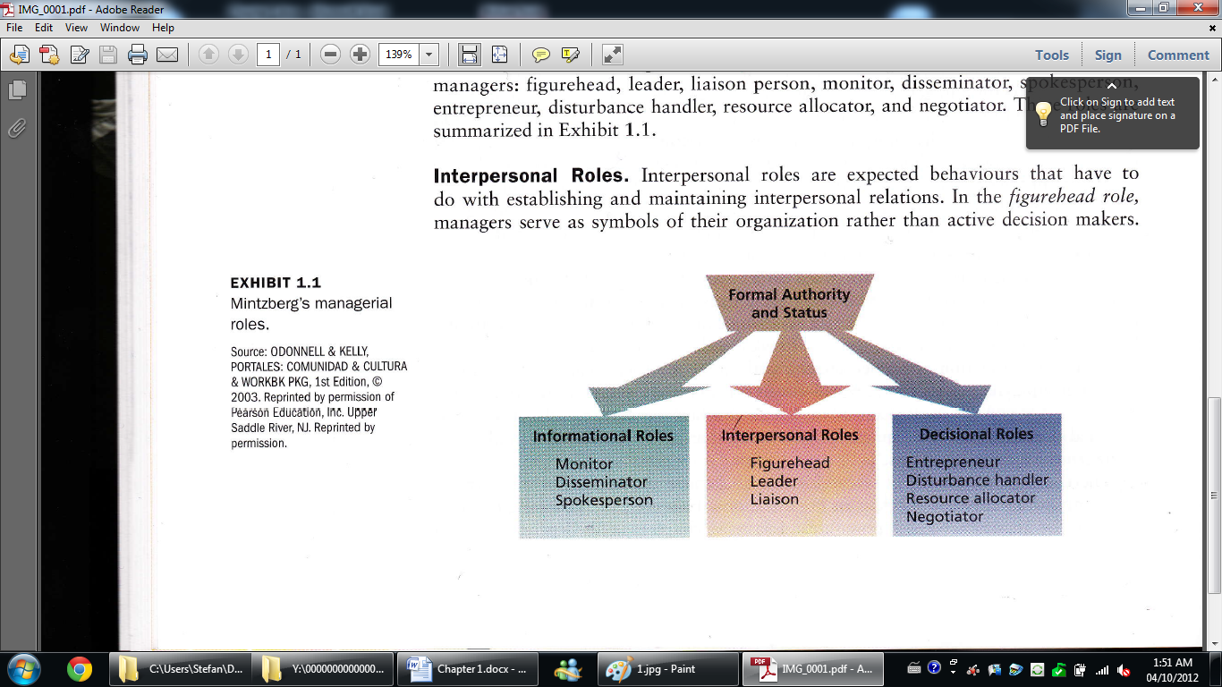
- Monitor Role – managers scan the internal and external environments of the firm to follow current performance and to keep themselves informed of new ideas and trends. EX. RnD head attends a professional engineering conference.
- Disseminator Role – managers send information on both facts and preferences to others. EX. RnD head summarizes what was learned at the conference in an email to employees
- Spokesperson Role – managers send messages into the organization’s external environment. EX. Drafting an annual report to stockholders or giving and interview to the press
Interpersonal Roles
- Expected behaviours that have to do with establishing and maintaining interpersonal relations
- Figurehead Role – managers serve as symbols of their organization rather than active decision makers. Ex. Making speeches, entertaining clients, signing legal documents
- Leadership Role – managers select, mentor, reward and discipline employees
- Liaison Role – managers maintain horizontal contacts inside and outside the organization. EX. Discussing a project with another department, establishing communication with an embassy delegate of a country in which the company wishes to expand to
Decisional Roles
- The various ways managers deal with decision making
- Entrepreneur role – managers turn problems and opportunities into plans for improved changes. EX. Suggest a new product or service that will please customers
- Disturbance Handler role – managers deal with problems stemming from employee conflicts, address threats to resources and turf
- Resource Allocation role – managers decide how to deploy time, money, personnel and other critical resources
- Negotiator role – managers conduct major negotiations with other organizations or individuals
Managerial Activities
- Routine Communication – the formal sending and receiving of information, meetings, handling paperwork
- Traditional Management – planning, decision making, controlling
- Networking – interacting with people outside the organization and informal socializing and politicking with insiders
- Human Resource Management – motivating and reinforcing, disciplining and punishing, managing conflict, staffing, training, employee development
- Managers who wish to be successful in the sense that they move up the corporate ladder need to do more networking and less human resource management
- Managers who wish to be successful in terms of unit effectiveness and employee satisfaction need to devote more time to human resource management and less time to networking
Managerial Agendas
- Agenda Setting
- Managers must gradually develop agendas of what they want to accomplish for the organization
- These agendas are often informal and unwritten, dealing with people issues rather than being a formal strategic plan
- Networking
- Managers must develop a wide formal and informal network of key people in and outside the organization
- This network provides managers with information and establishes relevant relationships
- Agenda Implementation
- Managers must utilize their network to implement their agenda by going anywhere in the network, up or down, in or out of the organization for help or favours
- Managers are not only limited by their formal powers, they often rely on a high degree of informal interactions with people over whom they wield no power
Managerial Minds
- Successful managers have noted that intuition often guides many of their actions
  - To sense that a problem exists
  - To perform well learned mental tasks rapidly
  - To synthesize isolated pieces of information and data
  - To double check more formal or mechanical analyses
- Good intuition is problem identification and problem solving based on a long history of systematic education and experience that enables the manager to locate problems within a network of previously acquired information
Contemporary Management Concerns
Diversity
- Demographics of North American population and workforce is changing and thus both the labor force and customers are becoming increasingly culturally diverse
- Due to increase movement of women into paid employment and immigration patterns (visible minorities are the fasted growing segment of the population
- Diversity of age is also an upcoming factor as with the elimination of mandatory retirement at 65, the workforce will primarily be composed of old workers
- To respond organizations are adopting new programs such as flexible work hours, compressed work days and benefit plans
- Employment Equity Act has contributed to organizations being more aware
- Globalization is also required managers to come into contact with other cultures; North American organizations need to understand how the workforce and customs differ
Employee-Organization Relationships
- Downsizing, restructuring and outsourcing has had a profound effect in workplace environment
- Companies have eliminated high paying manufacturing jobs, middle management and high-tech jobs
- Major structural changes has also changed the norm from of full time permanent work to temporary or contract work
- This results in employees having decreased levels of trust, morale, loyalty and satisfaction
- Key reasons for this include boredom, overwork, stress, concern for the future and lack of praise
- Absenteeism is on the rise, costing Canada $15 billion annually in lost productivity
- Potential solutions include creating a positive workplace environment with access to a gym, flexible hours, enriched maternity leaves and complementary breakfasts
Focus on Quality, Speed and Flexibility
- Correctly identifying consumer needs and satisfying them before, during and after the sale are seen as key competitive advantages. Emphasis on quality, speed and flexibility to achieve
- Quality tactics include extensive training, frequent measurement of quality indicators and preventing rather than correcting production errors
- Speed occurs in an external manifestation by prompt and timely service and in an internal manifestation by efficient use of channels of distribution
- Flexibility is required to rapidly respond to changing conditions as organizations operate in uncertain, turbulent and chaotic environments driven by technology and globalization
- High degree of employee involvement and commitment is necessary in order to achieve quality, speed and flexibility
- Potential solutions include managers giving employees more power to make quick decisions and promote teamwork between different departments
Talent Management
- Talent Management. An organization’s processes for attracting, developing, retaining and utilizing people with the required skills to meet current and future business needs
- 2 most important management challenges are
  - Recruitment of high quality people across multiple territories
  - Improving the appeal of the company culture and work environment
- Will become even harder as a shortage of skilled workers will occur when baby boomers retire
- OB provides the means for organizations to be designed and managed in ways that optimize talent attraction, development, retention and performance
- Solutions include providing opportunities for learning, improving job satisfaction, designing more meaningful jobs, providing recognition and monetary rewards and offering flexibility
Focus on Corporate Social Responsibility
- Corporate Social Responsibility. An organization taking responsibility for the impact of its decisions and actions on its stakeholders (shareholders, employees, consumers, community, government)
- CSR issues rage from community involvement, environmental protection, safe products, ethical marketing, employee diversity and global/local labor practises
- CSR has to do with how an organization performs its core functions of producing goods and providing services and that it does so in a socially responsible way
- OB issues include the treatment of employees, management practises and employment equity
- Green programs have a positive effect on employee engagement and motivation; employees are proud to be working for an environmentally responsible organization
- Green organizations are also more successful in attracting and retaining skillful employees

