Write-Up
a) Recommendation
b) Support – highlights of the analysis
c) High Level implementation
1) Performance Assessment
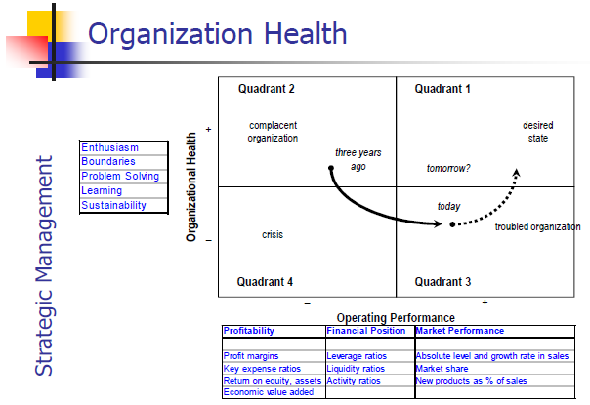
Conclusion: What is the time horizon? In which direction are they heading?

2) Direction (Mission/Vision)
Mission: Clear, compelling, activating; can be visualized
- ex. HP’s mission: “to make technical contributions for the advancement and welfare of humanity”
Vision: Clearly communicate purpose of the business
- reinforce the day-to-day actions
- provide direction for the strategy formulation
Vision Test: - desirable and feasible destination
- flexibility for management to get there
Values: Basic beliefs that guide behaviour
Core beliefs: reason for being; long term
- ex. Ford’s vision: democratize the automobile

3) Strategic Triangle
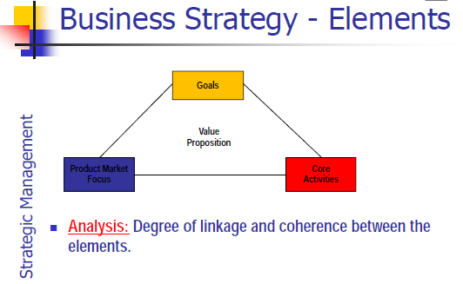
i) Goals
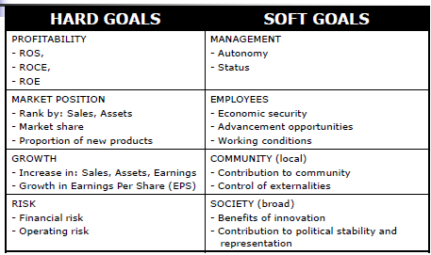
ii) Product/Market Focus - what is provided and to whom?
 | Existing | New
Existing | Market Penetration | Product Development
New | Market Development | Diversification

iii) Core Activities - activities within the firm that add value
- contributes directly to the value proposition
- need to distinguish between necessary activities and those that add value
iv) Value Proposition
- valued by the customers in the target market
- a differentiator; sets a product/service apart from competition within the target market
Competitive Advantage:
- a value proposition that is important to targeted customers, and difficult for competition to copy
Conclusion:
- Are the elements in the strategic triangle aligned? Do they complement and reinforce each other?
- Clarity, logical, coherence
- Does the value proposition resonate in the target market?

4) Value Chain/System
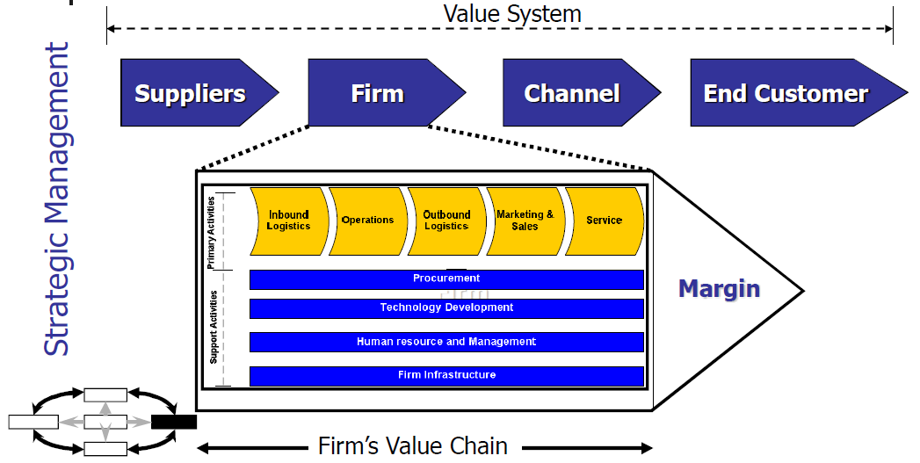
Value Chain – the primary activities from the industry value chain that have been integrated into the structure of an organization
- looks at the primary and support activities in each step
- looks at the areas where value is created
- profitability at each stage indicates power/importance of that stage
Conclusion:
- where does the economic profit lie in the value chain
- which activities do not contribute to the value creation

Value System – all the activities from raw materials to the consumer
- focus on the parts of the industry that return the most profit
- a firm performs a limited number of activities in the value system
Conclusion:
- is the firm doing things that could return no value
- can the firm forward or backward integrate?

5) Strategy (Path, positioning)
Companies can obtain strategic position in three ways (not mutually exclusive):
i) Variety-based positioning
- based on the choice of product or service varieties rather than customer segments
- can serve a wide array of customers but it will meet only a subset of their needs
- Example: Jiffy Lube – only do oil changes – faster and cheaper than other auto shops
ii) Needs-based positioning
- based on targeting a segment of customers
iii) Access-based positioning
- based on the importance of accessing the product/service
Generic Strategy:
- differentiation/focused differentiation
- low cost leadership/focused low cost leadership
6) Industry Analysis
- these factors do not have equal importance; some are more important than others in determining industry attractiveness
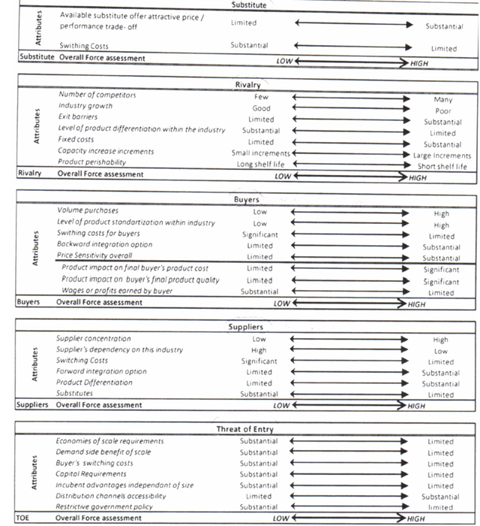

7) PEST Analysis
- look at changes and trends in the political, economic, social and technological areas of the industry
Conclusion:
- are they able to take advantage of any opportunities or reduce threats?

8) Resources (VRIO)
- examples of resources include culture, reputation and location
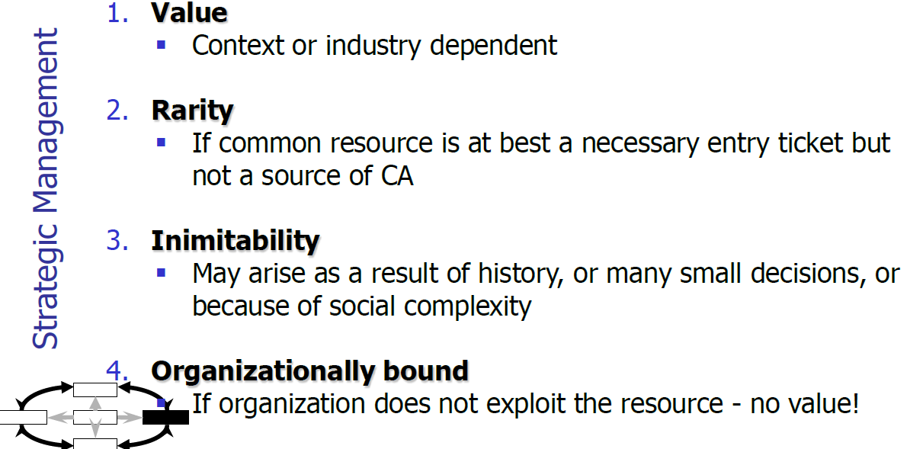
Conclusion:
- If a resource has been identified as a CA, is cost leadership, differentiation, or focus generic strategy the most suitable strategic path?
- What specific activities need to be supported to achieve a sustainable advantage?
- What opportunities exist for economizing on the use of resources?
- What are the possibilities for using existing assets more intensely and in more profitable ways?

9) Management Preferences
a) Basic Needs
- each person has a different mix of the following attributes: achievement, power, security, recognition
- basic needs are fairly stable and enduring
b) Beliefs
- opinion about competencies (of themselves and colleagues) and the right way of doing things
- a competent and comfortable manager will influence which strategic recommendations will be best supported
c) Job Context
- defines the roles of responsibilities
- performance assessment and rewards
- a strategic recommendation that would negatively impact the decision maker’s “job context” is unlikely to be supported by the decision maker

10) Organization
a) Organizational Structure
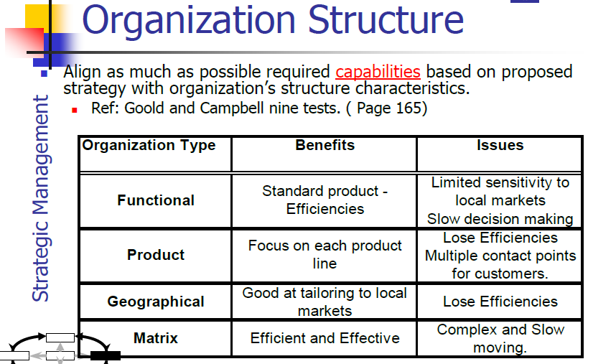
b) Management Processes
- three types: decision making, operating, performance and reward systems
c) Leadership Behaviours
- leader’s behaviour needs to be in sync with desired behaviour for the organization
d) Behaviour and Culture
- shared beliefs and expectations (values, attitudes)
- observable energy level, subordinates management, employees relations to one another
11) Diamond E
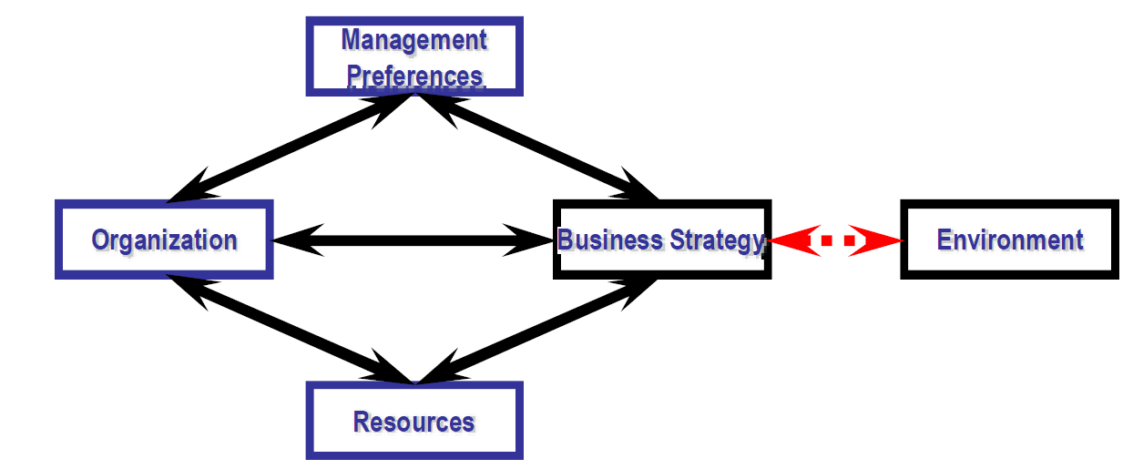
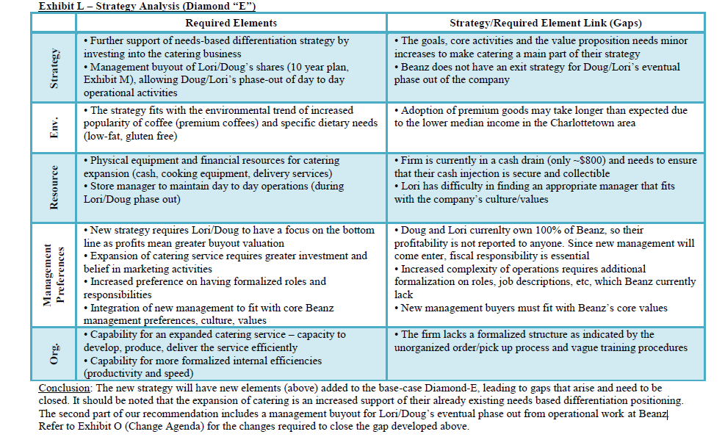

12) Day’s Five Tests: Evaluating Strategic Alternatives
1) How attractive is the market opportunity?
- market size and growth - cyclicality of demand
- current and future competitiveness - degree of fragmentation
- break even share - ease of channel access
2) How sustainable is the competitive advantage?
- how will the new strategy enhance these differentiation or costs advantages or create new advantages
- how difficult will it be for competitors to imitate those advantages and how long will it take them
- supply side barriers – distinctive capability, proprietary technology, economies of scale/scope
- demand side barriers – customer and channel relationships, brand equity
3) What are the prospects for successful implementation?
- does the business possess the necessary skills and resources
- do the implementers understand the strategy and are the committed to it
- does the strategy hold together
4) Are the risks acceptable?
- identify major environmental and internal uncertainties
- robust vs. fragile strategies
- understand assumptions – anchoring, selective perception, availability
5) Will the forecast financial results be achieved and increase shareholder value?

13) Financials
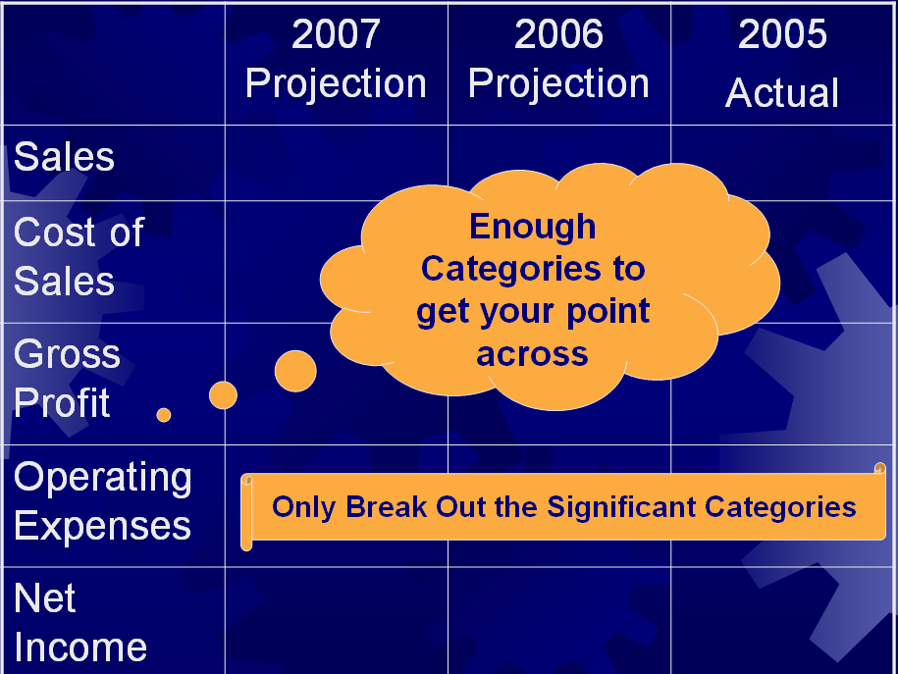

14) Change Agenda
- what needs to change or be added to implement the strategy?
- Identify all changes required in the following areas:
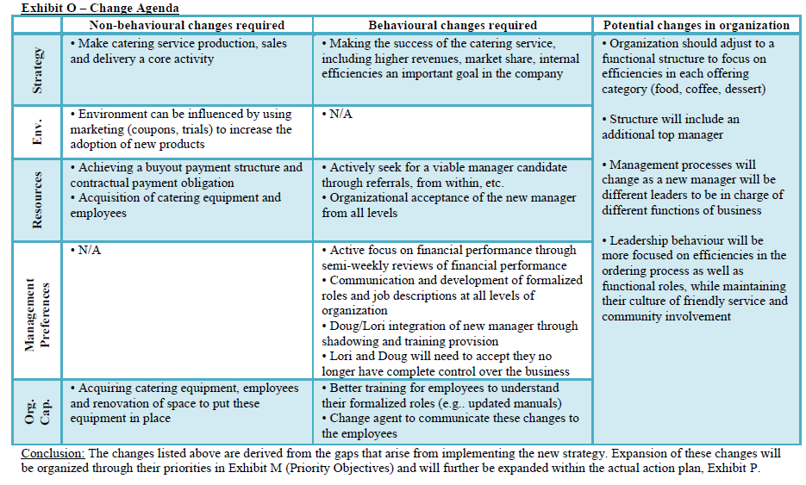

15) Starting Conditions
a) Urgency
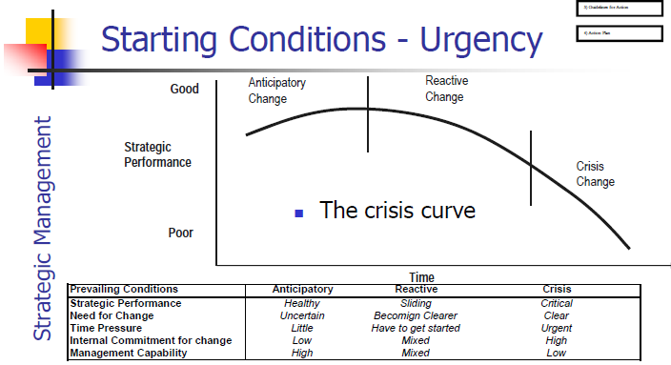
b) Organizational Readiness
- the commitment and capability of the individuals and groups who will be most instrumental to the change process
c) Personal Readiness
- the commitment and capability of the manager who is going to lead the change process

16) Guidelines for Action
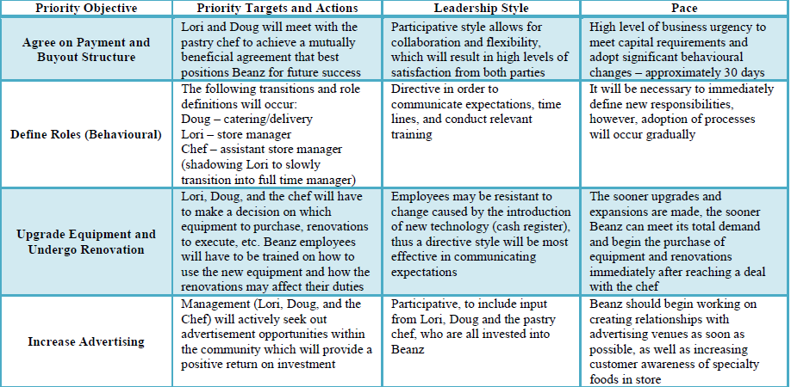

17) Implementation Plan
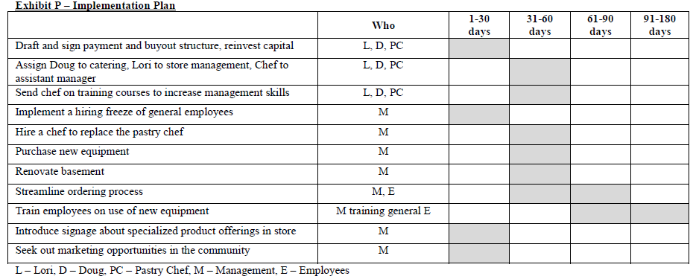

18) Scorecard Update
 | Objective | Measure | Target | Plan
Financial | - Become profitable by increasing sales and reducing expenses | - Net income, operating expenses | - Net income to increase to 5% of sales  - Reduce expenses to 25% of sales | - Increase sales revenue through catering and frozen dinners  - Hire a part-time accountant to analyze and reduce expenditures
Learning | - Employ an exceptional manager  - Maintain employee morale  - Staff training to have better operating procedures | - Employee retention and absenteeism | - Achieve yearly employee retention of >90% (excluding students that have finished school), maximum absenteeism of managers of 2.5% per year  - 12 hours of training per year per employee | - Provide appropriate training and support to all employees; ensure employees are aware of their duties and have the correct training and resources to be able to complete their work effectively
Process | - Increase efficiency and the effective use of resources | - Overtime work, # of overstaffed days, food waste | - Less than 10 hours of overtime paid monthly  - # of overstaffed days of less than 3 per month  - Less than 5% of food waste | - Utilize the accountant and manager to track the efficient usage of food and labour resources in order to locate areas of cost reduction
Customer | - Meet demands of all potential catering customers  - Maintain high levels of customer retention | - # of missed catering opportunities  - # complaints, repeat purchases, customer satisfaction | - Reduce # of missed catering opportunities to 2 per year  - No more than one complaint per month | - Increase growth to the catering operations by renovating the basement and employing a manager who is largely responsible for the catering division of the organization  - Provide customers the option of completing a short survey

