MIMM 466- Lecture 1: Evolving and Emerging viruses in a global perspective

Mindset 50 years ago: We will eradicate all infectious diseases
1948: US Secretary of State George Marshall- World now has the means to eradicate infectious diseases from earth
1963: Aidan Cockburn, advisor at WHO- in 100 years, all major infections will have disappeared
1969: US Surgeon General William Steward- The time has come to close the book on infectious diseases
Reality today:
- No eradication except Smallpox in 1979
- Emergence of : Ebola, AIDS, Plague, Hendra, Nipah viruses, SARS, Influenza, Viral encephalitis
- Increased: Malaria, Yellow Fever, Dengue
1996: Bill Clinton issued a fact sheet- “Addressing the Threat of Emerging Infectious Diseases”
1997: Set up of WHO theme, which was “Emerging Infectious Diseases- Global Alert, Global Response” with the lesson that in a global village, no nation is immune. So even if the infectious disease starts in Africa, we are all concerned.

In terms of human deaths, what is the most dangerous animal in the world?
Mosquitoes: 2-3 millions fatalities per year because it is a carrier.
Carrier of (partial list): Yellow fever, Dengue fever, Rift Valley Fever, Arboviral encephalitides: Japanese encephalitis, Eastern/Western Equine encephalitis, La Crosse encephalitis, St. Louis encephalitis, West Nile virus

Natural weapons of mass destruction placed on a “Richter” Scale. Viruses are among the top.
- HIV, Hepatitis, Measles, etc.

Virus evolution: constant change of a viral population in the face of selective pressures
Sources of diversity (how can you have a new species):
- Mutation
- Recombination and reassortment
- Selection
Emerging virus: Causative agent of a new and previously unrecognized infection in a population
- Manifestation of virus evolution
- Result of host-virus interaction on a larger scale
Viruses have co-evolved with animals. Even if today they are only found in humans, at one point they were also in animals. They have just evolved to not use the animal counterpart

Examples of emerging, re-emerging viruses
Virus | Family | Emergence factors
Dengue virus | Flaviviridae | Deforestation with increased contacts forest-rural-urban areas. Urban population density; open water storage favors mosquito breeding.
Ebola virus | Filoviridae | Likely bats to monkeys to humans in Africa.
Haantan virus  Junin virus  Machupo virus | Bunyaviridae  Arenaviridae  Arenaviridae | Agriculture techniques favor human contact with rodents (Africa, Asia, Americas).
Influenza virus | Orthomyxoviridae | Integrated pig/duck agriculture, spread by mobile population
Norwalk/gastroenteritis  Viruses (not really emergent viruses, but their spread is increasing in some parts of the world) | Caliciviridae | Fecal-oral route from contaminated water and food. Absence of clean water. Increased population density in areas with no sanitation
HIV (1980s) | Retroviridae | Chimpanzees-human contacts (Africa). Butchering chimp meat? + Human-human contacts: sexual, intravenous drug users
SARS (2003) | Coronaviridae | Likely bats to civet cats to humans (China) and to other humans through planes.
Hendra/Nipah/ viruses | Paramyxoviridae | Australia, Malaysia. From bats to horses or pigs to humans

Origin of major human infectious diseases
Stage | Transmission to humans | Examples
Stage 5: exclusive human agent | Only from humans | Measles, Mumps, Rubella, Smallpox, HIV (there are only 4 cases from monkeys)
Stage 4: Long outbreak | From animals, then there is transmission from human to human | Influenza,  Dengue and Yellow fever (spread from human to human via mosquitoes)
Stage 3: Limited outbreak | From animals, then there is limited transmission between humans | Ebola, Markburg, Monkey viruses
Stage 2: Primary Infection | Comes only from animal. No human to human spread | Nipah virus, Rabies, West Nile viruse
Stage 1: agents only in animals | None | -
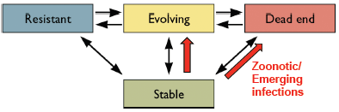
The dynamic spectrum of host-virus interactions
Stable interaction: Virus and host multiply and in the long run, both populations survive.
Ex. Measles, polio, HSV, smallpox in humans; SV40, monkeypox, SIV in monkeys; Dengue, yellow fever in insects; Influenza in several species
Evolving stage: characterized by instability and unpredictability
Ex. New host; smallpox and measles to native Americans; West Nile virus from old world to new world in 1999; mutation that increases virulence or spread: feline panleukopenia virus to canine parovirus by 2 mutations; reassortment of influenza virus.
- In the case of small pox, it was stable within the Europeans, but when it was passed to the Native Americans the mortality rate was 50%.
Resistant stage: host cells not susceptible or not permissive- no disease
Ex. Humans are not susceptible to rabbitpox myxoma virus
Dead end stage: One-way passage- The host dies or it survive does not passage. Most spectacular emerging diseases
by passage from stable host to another: Dengue, yellow fever, Marburg, Ebola, Lassa, Junin, Avian H5N1 flu… Geopraphical disturbance- deforestation, building roads, dams….
These are representative of zoonotic and emerging infections

Complex virus-host relationship
Arbovirus: means it is transmitted by insects. It is NOT a family of viruses
Infectious cycle of an Arbovirus:
- Mosquito infect birds and chickens. This can infect other bird species and other
mosquitoes. But when they go to horse or humans, we are considered dead-end hosts because we do not transmit.
Infectious cycle of the central European tick-borne flavivirus:
- Transmission from tick to rodents or tick to tick (via transovarial). The tick can then pass the virus to a goat. Humans then consume the milk of the goat. OR we can get from the tick directly
Phylogeny of 41 influenza A viruses
- Transmitted from reassortment of pigs and ducks. They can also infect whales, minks and humans.

Global Alert and Response (GAR)
Set up in 1997 by WHO
You can go to this site and follow the emergence of all the new infectious diseases.
Examples:
- September 2012- Novel Coronavirus infection. There was an update in November, and there was 9 cases. If it is not contained correctly, it may be the next big emerging infectious disease.
- 4 July 2012- Undiagnosed illness in Cambodia. On the 13th they figured out it was sever complications of Hand, foot and mouth disease cause by Enterovirus 71.
Currently the Influenza infection is an H3N2 strain. This strain was included in the vaccine for this year.

Virus in everyday life- 2012(CBC news article titles listed below)
Norwalk virus spreading on PEI
Influenza A virus appears in Thunder Bay
Outbreak of virus in SARS family has WHO on alert
Toronto mosquitoes with West Nile virus at record high
Quebec’s health authority warns of West Nile virus risks
Yellowknife toddler catching hand, foot and mouth virus

Dengue and dengue harmorrhagic fever virus: DENV
-it is a flavivirus
Arbovirus: transmitted by bites of mosquitoes (Female Aedes)
Symptoms:
DF: severe flu-like illness. You do not gain immunity because there are 4 different strains. Next time you catch it, it is worst and can become DHF.
DHF: Severe, hemorrhagic fever (41°c), facial flush, possible convulsions, enlargement of liver and circulation failure
Dengue is an emerging disease: Old disease, but an unprecedented increase in the geographic range, incidence and severity. Prior to 1981 there was no DHF in the Americas. Post 1981, there are in the Caribbean and South America
The four dengue viruses originated in monkeys and independently jumped to humans in Africa or Southeast Asia between 100-800 years ago.
- Geographically restricted until 1950
- DHF first documented 1950s in Philippines and Thailand
- 1981: Caribbean and Latin America
Transmission cycle:
- They are from Sylvatic origin. It is in stable situations in mosquitoes. They are in the forest, but they slowly get transmitted to the monkeys. If the monkeys and the mosquitoes stay in the forest away from humans it is ok, BUT that is not the case. There are rural zone of emergence, where humans, mosquitoes and monkeys live in the same area. Humans get infected in this zone. Then the humans go into cities. The mosquitoes in the city transmit it from human to human, which leads to urban dissemination.
Global burden:
- Global incidence has dramatically grown in recent decades
- Prior to 1970, 9 countries had DHF, now more than 100
- 2.5 billion people – 2/5 of the world’s population are now at risk
- 50 million dengue infections worldwide every year
- 500 000 with DHF, 2.5% die
- Tropical and sub-tropical climates
- Mostly in urban and semi-urban areas
Treatment:
- No specific treatment but maintenance of the patient’s circulating fluid volume can change the fatality rate from 20 to 1%
Immunization:
- No vaccine but progress is underway
- Main challenges are:
  - Vaccine must immunize against 4 strains
  - Limited understanding of the immunology
  - Lack of laboratory animal models
Prevention and control: (these prevention methods are valid for all things transmitted by mosquitoes)
- Combat the vector mosquitoes Aedes aegypti and Aedes albopictus
- In Asia and the Americas Aedes aegypti breeds primarily in man-made containers:
  - Earthenware jars, metal drums, concrete cisterns used for domestic water storage
  - Discarded plastic food containers
  - Used automobile tires
- In Africa, the mosquito also breeds extensively in natural habitats, tree holes and leaves
- In recent years, Aedes albopictus, has rapidly spread from Asia to all infected areas, mainly attributed to the international trade in used tires, a breeding habitat.
Practical measures: (integrated by WHO)
Environmental management and chemical methods:
- Proper solid waste disposal: plastic recycling programs
- Improved water storage practices: cover containers to avoid access to egg-laying female mosquitoes
- Insecticides to larval habitats
- Mosquito-eating fish and copepods (tiny crustaceans)
- Active monitoring and surveillance of the natural mosquito population
Global strategy:
- Selective integrated vector control with community participation
- Active disease surveillance with strong health information system
- Capacity building and training
- Vector control research

Yellow Fever Virus
- Like Dengue Fever, they are from Sylvatic origin. It is in stable situations in mosquitoes. They are in the forest, but they slowly get transmitted to the monkeys. If the monkeys and the mosquitoes stay in the forest away from humans it is ok, BUT that is not the case. There are humans in transition (emergence) zone, where humans, mosquitoes and monkeys live in the same area. Humans get infected in this zone. Then the humans go into cities. The mosquitoes in the city transmit it from human to human, which leads to urban dissemination.
- Approximate Global distribution of YF: Latin America and Africa
- There is a vaccine for YF
Filoviruses: Ebola and Marburg
Marburg-like viruses (1967):
- Marburg: infect humans, Severe hemorrhagic fever. In Africa
Ebola-like viruses (1976):
- Sudan Ebola
- Zaire Ebola humans, severe hemorrhagic fever, Africa
- Cote d’Ivoire Ebola
- Reston Ebola: Cynomolgus Monkeys, Severe hemorrhagic fever in monkeys. Attenuated or no disease in humans, antibodies in humans. Philippines
Transmission:
- Contact with blood or other body fluids of infected animals
Disease: Severe hemorrhagic fever
- Marburg: Death by severe blood loss and shock
- Ebola:
  - Multiple organ failure and shock leads to death
- Fatality in humans: 30-80% for Marburg; 50-90% for Ebola; 0% for Ebola-Reston
Natural Reservoir: Very likely fruit bats. It is not chimpanzees because they get sick and die from the virus

Parameters that favor emerging and re-emerging viral diseases?
- Deforestation, dams, road construction: loss of natural habitat for many animal species leading to increased contact between wild animals and humans. Butchering wild animals.
- Increase, uncontrolled urban population: slums, poor sanitation, absence of clean water, open waste disposal, poverty
- Decreased programs for insect controls. Open water storage. International trade for tires
- Increased travel, unwanted movement of populations due to economic, political problems, wars
- Global warming: ticks, mosquitoes adaptation to more areas, concomitant transport of viruses
What can we do?
Developed countries:
- Study diseases find treatments, vaccines
- Develop programs that integrate all parameters that contribute to the emergence of infectious diseases: Global health
- Fight against global warming: clean energy, alternative energies, less energy
- Develop sustainable products to decrease waste: every new product should be recyclable
Developing countries:
- Planned urban and agricultural development
- Develop programs for clean water: sanitary installations, clean closed water containers. Proper waste management
- Fight corruption to have stable, responsible govnerments
- Develop family planning to decrease birth rates: Men-Women equality; increased women’s education: less children per woman = better education for all
Everyone:
- Decrease deforestation
- Fair trade to decrease poverty

From a paper: Emerging zoonoses: crossing the species barrier
The ability of infectious disease agents to cross the species barrier has long been recognized for many zoonotic diseases… For all these diseases, the underlying theme is the growth of the human population, the mobility of that population and the efforts to keep that population nourished.

Book by Lester Brown
- Addresses the increase in the population. Will hit 10 billion in 2050.
- As land and water become scarce, competition for these vital resources intensifies. Access to land is a prime resource of social tension.
- Decreasing world population in developing countries should be of similar priority as treating infectious diseases, decreasing poverty and improving agriculture.
- If it is not done by birth control and family planning, it will be done by wars, famine and even more emerging, re-emerging diseases.
Summary:
Factors that contribute to emerging, re-emerging viruses
- Poverty - no waste management
- Poor sanitation - conflicts, wars
- Deforestation - Uncontrolled urban population
- Global warming - no insect control
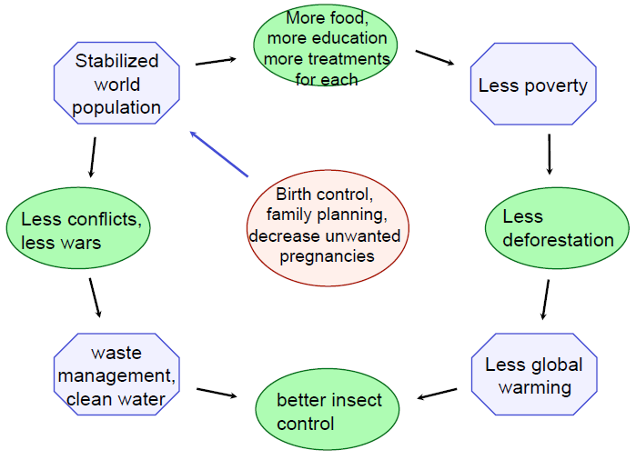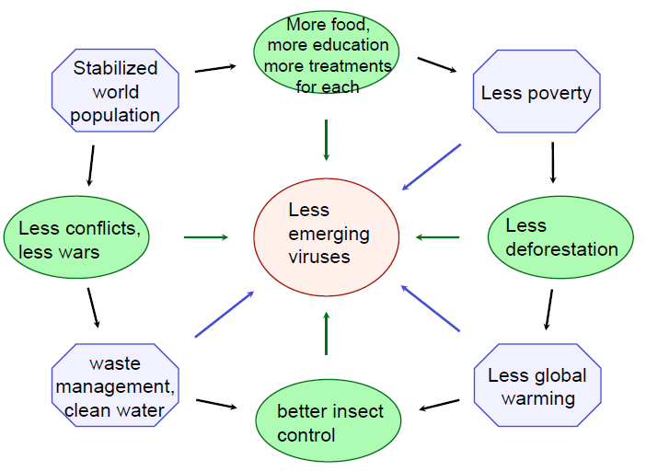

This thought is shared even by Bill Gates
2010: Bill and Melinda Gates Foundation
- Topics for Grand Challenges Exploration Round 5 are:
  - Create New Technologies to improve the health of Mothers and Newborns
  - Create new ways to protect against infectious diseases
  - Create new technologies for contraception
- They give funding for family planning

International meeting (something that the teacher attended or something along those lines)
“Viral pandemics can now be eradicated: do we want it?”
- HIV: No vaccine. Treatment: undetectable virus, transmission reduced by 96% but no cure. Objective: 0 transmissions by 2015?
2011-12: strategies towards an HIV cure
- HBV: Effective vaccine. Treatment but no cure
- HCV: No vaccine. Treatment (with side effects) can completely eliminate the virus. 10-15 promising new drugs in clinical trials
- Influenza: the 2009 pandemic has proven that effective vaccines can be made in a timely manner. Problem: population adherence
- HPV: new effective vaccine
Research paper:
Emerging Infectious Diseases in 2012: 20 years after the Institute of Medicine Report by Anthony S. Fauci
- The perpetual threat of emerging and re-emerging infectious diseases
- Greater awareness is an important counter measure
- Genomics. Proteomics facilitate diagnosis, prevention and treatment
- Scientific advances
- Growing optimism about the control of EIDS

