Linear programming  Tricky constraints:  - % Of total production x1/(x1+x2+x3)  - ‘x must be equal to 2/3y’ x-2/3y=0  - ‘x must be more than 5 times of y’ x-5y>=0  - Inventory constraint  Beginning inv. + production + overtime + sub contracting – demand – ending inv.  Graphic Method  Let A be # of units A produce Let B be # of units B produce;  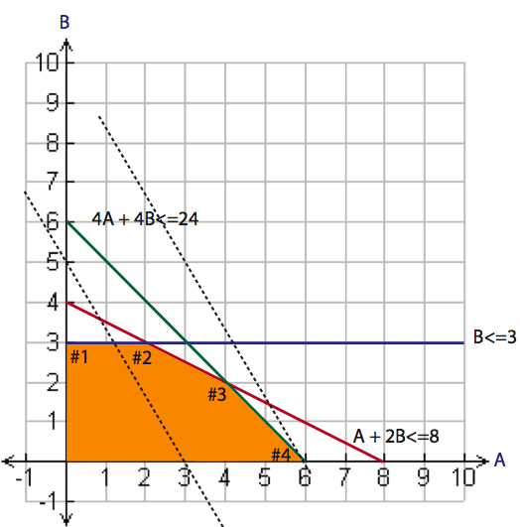  Max Profit = 5A + 3B Subject to A+2B <= 8; B<=3; 4A+4B<=24; A, B >=0  1) Assign variables to each axis  2) Graph each constraints  3) Determine feasible region  4) Calculate the cost at each (看点1-4)  - 看每个点，然后把(X,Y)代进 P = 5A+3B. 找不到明确的点就找出两个线的interaction点!!!!!!记得带入原式!!!!!!!!!!!哪个profit大就选哪个！  Optimal value = 最大那个点的 (X,Y) |  |  |  | Transportation model  - Balance model (supply = demand)  Let Xij be the # of units shipped from warehouse “I” to retailer “j”  (i=a,b,c; j=1,2,3)  MinZ = $40(Xa1)+$50(Xa2)+$60(Xa3)+$55(Xb1)+$40(Xb2)+  55(Xb3)+$65(Xc1)+$50(Xc2)+$35(Xc3)  Subject to: Xij>=0  - Imbalance model (supply ≠ demand) use dummy
  Let A = 0 | Let B = 0
  (1) A+2B<=8  B = 4  (2) 4A+4B<=24  B = 6  (3) B <= 3 | (1) A+2B<=8  A = 8  (2) 4A+4B<=24  A = 6  (3) B <= 3
  Supply constraints  Xa1+Xa2+Xa3=400  Xb1+Xb2+Xb3=300  Xc1+Xc2+Xc3=400 | Demand constraints  Xa1+Xb1+Xc1=600  Xa2+Xb2+Xc2=300  Xa3+Xb3+Xc3=200
Let x₁=#of TV Spots; Let x₂=#of Magazine Ads; Let x₃=#of SS Ads
MAX Exposures = 1300*x₁ + 600*x₂ + 500*x₃
300*x₁+150*x₂+100*x₃<=4000; 90*x₁+30*x₂+40*x₃<=1000
x₁ >=0, x₂ >=0, x₃ >=0 x₁<=5
how much could the total number of expected exposure unit ↑1000 to adv.
Budget
- Look at the Ad Budget Spent Row. The total number of expected
exposures could be increased by 3,000 (shadow price) for each additional
$1,000 added to the advertising budget. Notice that the units are in 1000
Your answer in part a would remain valid for how large of an increase in the
Advertising budget
- Look at the Ad Budget Spent Row. This shadow price remains valid for
increases of up to $1,000,000. (Again in thousands of dollars)
how much could the total number of expected exposure units be increased for
each additional $1000 added to the planning budget
- Look at the Planning Budget Row. The total number of expected exposure
units could be increased by 5,000 (shadow price) for each additional $1,000
added to the planning budget.
You answer would remain valid for how large of an increase in the planning
Budget?
- This remains valid for increases of up to $600,000.

Ex:
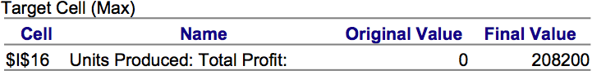
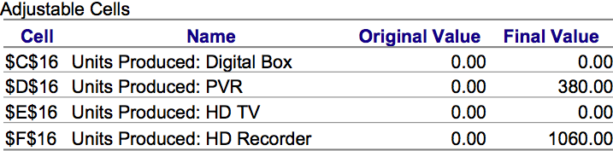
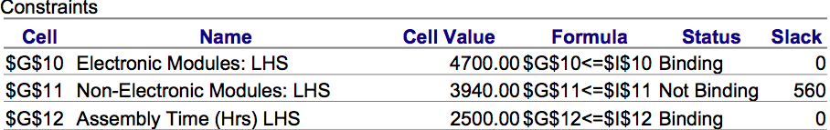
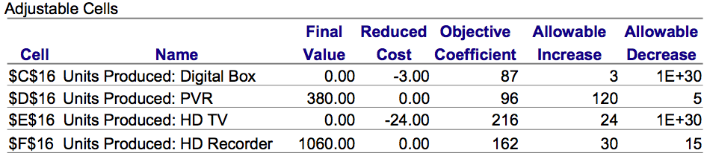
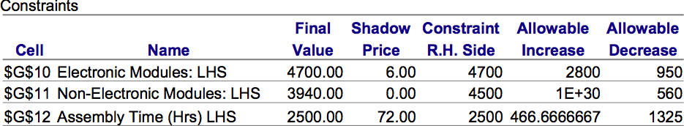
Max Z = 87X1+96X2+216X3+162X4
3 X1 + 4 X2 + 4 X3 + 3 X4 ≤ 4700 (electronic available)
2 X1 + 2 X2 + 4 X3 + 3 X4 ≤ 4500 (non-electronic available)
1X1+1X2+3X3+2X4≤2500 (assembly time available)
Determine the optimal value see the answer report adjustable
Cell of final value:
- Find X1, X2, X3, X4 and Z
Determine impact on production and optimal profit if the local
supplier decrease purchasing cost to 0.75
- Find C1 = 87(product price)+ 3 (electronic available constraint) * 0.75
- 同样算出C2,C3,C4 每个*fianal value add them all together
- 再减去原来的profit
In order to start producing HD TVs (that is having. X3 > 0), what
would need to happen to the unit profit and selling price of HD TV? Justify.
- X3 reduce cost = -24, profit inc. 24 216(unit $)+24
- selling price = 474 should produce
What is the shadow price for assembly time? If the assembly time available
were to be 2600 hrs instead of the current value, what would be the new
profit and what would happen to product mix?
- Assembly time = binding constraint with a shadow price = 72 (each assembly time would result in $72 worth of additional profit)
- (2600-2500)*72
If the availability of non-electronic modules increases by 500 units, what
effect will it have on the product mix? Why is its shadow price zero?
- Non binding not fully used purchase more add nothing on profit
If the available electronic modules were only 4000, how would it impact on
the total profit. What can you say about the product mix?
- Binding” with a “Shadow Price”=$6
- Profit decrease (4700-4000) * 6 (shadow price) = 4200

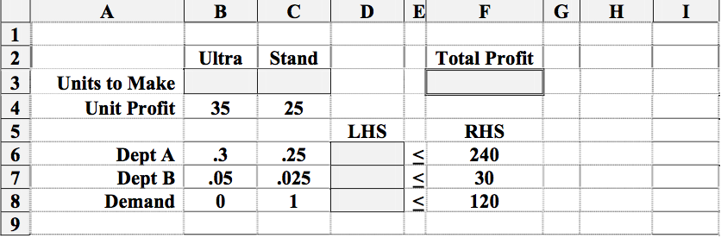
- Formula behind target cell: SUMPRODUCT (B3:C3, B4:C4)
- Formula behind left-hand side of department A:
SUMPRODUCT ($B$3:$C$3, B6:C6)
- Formula behind the changing cell for x: no formula
- Formula entered into add constraint dialog box: D6 <= F6
- Convex A linear programming maximizing problem for two variables has
a closed polygonal FSR. For the problem to have a solution, this polygon
must be
- The mathematical method (algorithm) used to solve linear programming
problem is called Simplex and was first proposed by G. Dantzig.
- If a change is made in only one of the objective function coefficients
the slope of the objective function line always will change

What if analysis
Answer report
- Target cell mini cost or maxi profit
- Adjustable cells optimal solution
- Constraints binding/not binding and amount of slack
Sensitivity report
- Adjustable cell given optimal solution and objective coefficient, allowable increase
and decrease an deduced cost
- Constraints given final value and shadow price, allowable increase and decrease
Hint
- Not binding constraints = not all resources are being used up slack>0, shadow
price = 0
- Biding constraint = all resources are being used up slack = 0, shadow price > 0
- Constraint has <= sign allowable ↓ = slack; allowable ↑ = unlimited
- Constraint has => sign allowable ↑ = slack; allowable ↓ = unlimited
- Variable in optimal solution had a value not “0”, the reduced cost will be “0” in this variable
- Variable in optimal solution had a value with “0”, the reduced cost will not be “0” in this
variable
- MAXI function: reduced cost = negative number (ie:-5); allowable inc. for the coefficient
for this variable = 5; allowable dec. = infinite
- MINI function: reduced cost = positive number (ie:3); allowable inc. for the coefficient
for this variable = infinite; allowable dec. = -3

