CHAPTER 5 SUMMARY- ELASTICITY & ITS APPLICATION
Elasticitya measure of the responsiveness of Qd or Qs to one of it’s determinants
- Price Elasticity of Demand
a measure of how much the Qd of a good responds to a change in the price of that good,
- computed as the % change in price (you will always obtain a –‘ve # for PED)
- Determinants of Price Elasticity
1) Availability of Substitutes – the more substitutes a good has, the more elastic its demand
2) Necessities vs Luxuries- necessities are inelastic, luxuries are elastic
3) Definition of the Market- narrow defined markets (ice cream) are more elastic than broadly define markets (food)
4) Time Span- goods have more elastic demand over longer time horizons
- Calculate PED
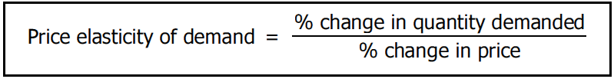
Or use Midpoint Method
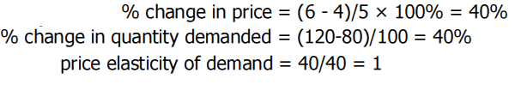
PED>1, elastic (consumers are responsive)
PED=1, unit elasticity
PED<1, inelastic (consumers are unresponsive)
**when elasticity = 0, demand is inelastic and is a vertical line**
**when elasticity is infinite, demand is elastic and is a horizontal line**
- TOTAL REVENUE
P> 1, P increases and TR decreases (vice-versa) -------------> demand is elastic
P= 1, P increases (decreases) and TR remains constant -------------> demand is unit elastic
P< 1, P increases and TR increases (vice-versa) -------------> demand is inelastic
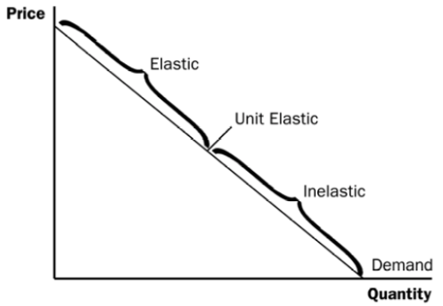
At points with a high price & a low quantity,
demand is elastic
At points with a low price & a high quantity,
demand is inelastic

- Income Elasticity of Demand
a measure of how much Qd of a good responds to a change in consumer’s income
- computed as the % change in quantity demanded divided by the % change in income
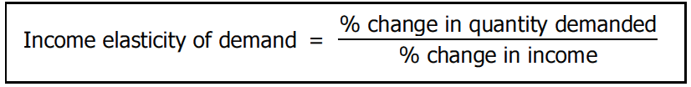
EXAMPLE
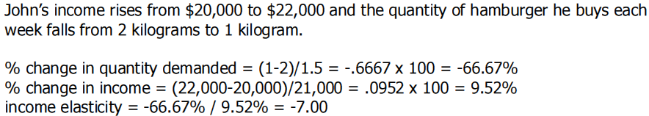
- Cross-Price Elasticity of Demand
a measure of how much the Qd of one good responds to a change in price of another good
- computed as the % change in the Qd of the first good, divided by the % change in the price of the second good
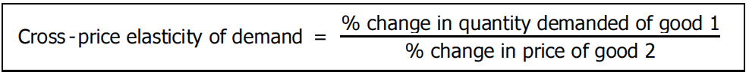
EXAMPLE
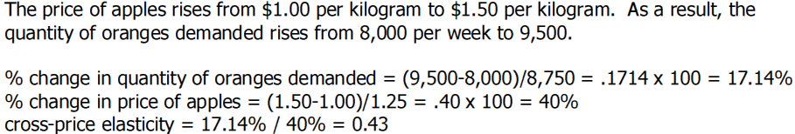

- Price Elasticity of Supply
a measure of how much the quantity supplied of a good responds to a change in price of that good
- computed as & change in Q. supplied divided by the % change in price

- Determinants of Price Elasticity of Supply
1) Flexibility of Sellers- goods are somewhat fixed in supply, thus inelastic ( beachfront property)
2) Time Span- supply is more inelastic in the short run than in the long run
- Calculate PES
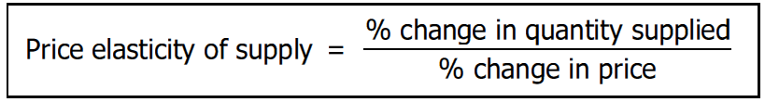
or use Midpoint Method:
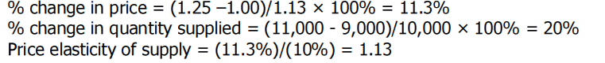
**when elasticity =0, supply is inelastic and is a vertical line**
**when elastic= infinity, supply is elastic and is a horizontal line **
SUPPLY INCREASES, Qd INCREASES, PRICE FALLS
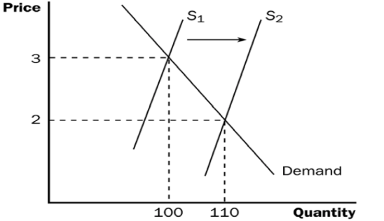
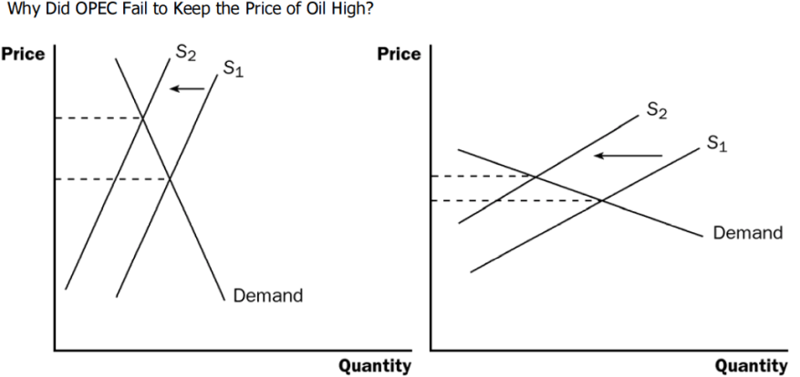
P<1
Elastic Demand the fall in price is smaller than the increase in Qd, total revenue rises
Eg: more revenue if prices fall
Inelastic Demand the fall in price is greater than the increase in Qd, total revenue falls
Eg: less revenue if prices fall
P>1

