MIS – final
Chapter 7
Granularity: extent of detail within the data and information. Coarse = highly summarized data or info. Fine = a lot of detail. Can be sent in different ways; spread sheet, word doc.
Data and Information
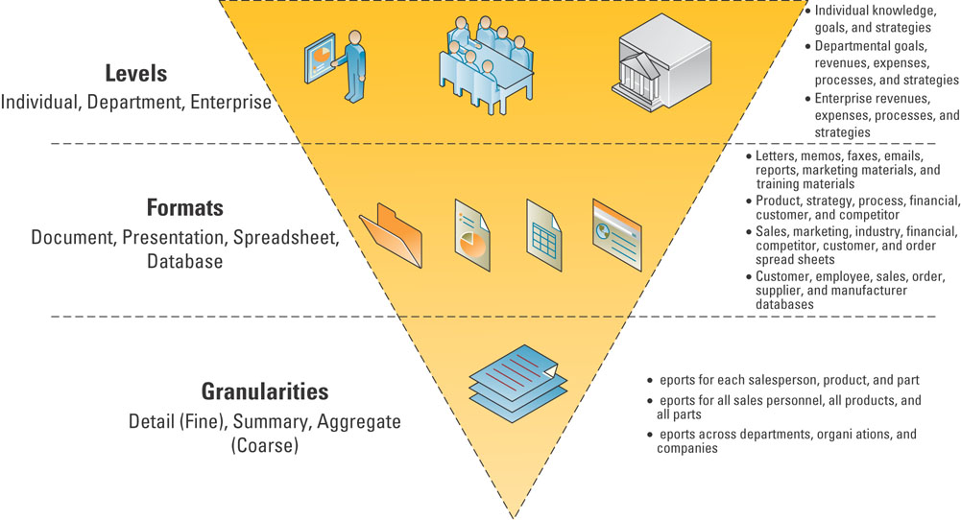
Date and information differ in level, format and granularity – it is important to understand a few additional characteristics that help determine the value of data and information.
- The value of transactional data and analytical information
  - Transactional data: primary purpose is to support daily operational tasks – all of the data contained within a single business process or unit of work – store this data in databases and use it when performing operational tasks and repetitive decisions (analyzing daily sales figures)
  - Analytical information: encompasses all organizational information – primary purpose is to support the performance of higher level analysis tasks. Used when making big decision (should build a new manufacturing plant or hire additional sales personnel?)
- The value of timely data and information
  - Time needed = weekly/monthly/daily data and information: depends on decision
    - Real-time data: immediate, up-to-date data
    - Real time information: immediate, up to date information (both above down fall = constantly changing)
    - Real time system: provides real time transactional data and/or real time analytical information in response to query requests
- The value of quality data and information
  - How we collect info and data that is of high quality
  - How we deliver this data so that its value can be realized
  - Accuracy: right info collected. Completeness: all values are complete – all filled in. Consistency: everything add up – make sense? Uniqueness: no duplicate customers – info only added once. Timeliness: info current with business requirements
  - The four primary sources of low-quality information include:
    - Online customers intentionally enter inaccurate information to protect their privacy
    - Data or information from different systems have different entry standards and formats
    - Call centre operators enter abbreviated or erroneous information by accident or to save time
    - Third party and external information contains inconsistencies, inaccuracies, and errors
Storing transactional data
- Stored in databases and can be retrieved to help make decisions
Relational Database fundamentals
- Relational database model – most popular - known as database: maintains data about various types of objects (inventory), events (transactions), people (employee) and places (warehouses)
- Hierarchical database model: data are organized into tree-like structure that allows repeating data using parent/child relationships, (one parent record with many children – branches out) in such a way that it cannot have too many relationships – cannot be used to relate to structures that exist in the real world
- Network database model: flexible way of representing objects and their relationships – allows each record to have multiple parent and child records – forming a lattice structure
- Relational database model: database that stores data in the form of logically related two-dimensional tables
- Entities, entity classes and attributes:
  - Entity: person, place, thing, transaction, or event about which data are stored
  - Entity class – known as table: collection of similar entities
  - Attributes – known as fields or columns – un sous groupe: characteristics or properties of an entity class
- Keys and relationships – identify the various entity classes(tables) in the database
  - Primary key: field that uniquely identifies a given entity in a table
  - Foreign key: in the relational database model is a primary key of one table that appears as an attribute in another table and acts to provide a logical relationship between two tables.
Relational Database Advantages
- Increase flexibility: handle changes quickly and easily, provide users with different views, have only one physical view: deals with the physical storage of information on a storage device, have multiple logical views: focuses on how users logically access information. (View data in alphabetical order = same physical data, different logical view)
- Increased scalability and performance: database must scale to meet increased demand, while maintaining acceptable performance levels
  - Scalability: refers to how well a system can adapt to increased demands
  - Performance: measures how quickly a system performs a certain process or transaction – needs to be able to take thousands of people at same time like e-bay
- Reduce Data Redundancy
  - Databases reduce information redundancy: the duplication of information or storing the same information in multiple places
  - Inconsistency is one of the primary problems with redundant information – finding what info is the most current
- Increased Data Integrity (Quality)
  - Data integrity: a measure of the quality of data
  - Integrity constraints: rules that help ensure the quality of data
  - Relational integrity constraints: rules that enforce basic and fundamental data constraints
  - Business critical integrity constraints: enforce business rules vital to an organization’s success and often require more insight and knowledge than relational integrity constraints.
- Increased data security
  - Have passwords, access levels and access controls to protect info
Database Management Systems
- DBMS: software through which users and application programs interact with a database
- Can access it directly DBMS to user or indirectly: User to a program to a DBMS
Data Driven Web Sites
- An interactive web site kept updated and relevant to the needs of its customers
- Example: what kind of colour, model, year, colour, price range = shows only what you’re looking for
7.2 DATA WAREHOUSING
- Key to data warehousing is to take data from multiple platforms and technologies and place them in a common locations. Transform transactional data into analytical information. Data warehousing provides the ability to support decision making without disrupting the day to day operations
- Definition: a logical collection of information – gathered from many different operational databases – that supports business analysis activities and decision-making tasks
- Compiles data from internal databases and external databases through ETL: extraction, transformation and loading. Extracts data from internal and external databases, transforms that data into information using common set of enterprise definitions and loads the information into a data warehouse. The data warehouse then sends subsets of the information to data marts
- Data mart: contains a subset of data warehouse information - more focused info
Multi-dimensional analysis
- Databases contain information in a series of two dimensional tables
- In a data warehouse and data mart, information is multidimensional; it contains layers of columns and rows
  - Dimension – a particular attribute or information
  - Cube: common term for the representation of multidimensional information
Information cleansing or scrubbing
- An organization must maintain high-quality data in the data warehouse
- Information cleansing or scrubbing – a process that weeds out and fixes or discards inconsistent, incorrect, or incomplete information (repetitive names - mistakes)
- The more complete and accurate an organization wants its information to be, the more it costs
- Accurate (correct) VS completeness (no blanks)
Business intelligence
- Definition: information that people use to support their decision making efforts
- Data mining: the process of analyzing data to extract information not offered by the raw data alone
  - Top perform data mining users need data-mining tools: uses a variety of techniques to find patterns and relationships in large volumes of information and infers rules that predict futures behaviour and guide decision making
  - Common forms of data-mining analysis capabilities include
    - Cluster analysis: a technique used to divide an information set into mutually exclusive groups such that the members of each group are as close together as possible to one another and the different groups are as far apart as possible
      - CRM systems depend on cluster analysis to segment customer information and identify behavioural traits
    - Association detection: reveals the degree to which variables are related and the nature and frequency of these relationships in the information
      - Market basket analysis: analyzes such items as web sites and checkout scanner information to detect customers’ buying behaviour and predict future behaviour by identifying affinities among customers’ choices of products and services
    - Statistical analysis: performs such functions as information correlations, distributions, calculations and variance analysis
      - Forecast: predictions made on the basis of time-series information – Christmas they sell more chocolate
      - Time-series information: time-stamped information collected at a particular frequency
Ready summary of key themes!

Chapter 8 – Helping organizations access, share and use information
Knowledge Management (KM): involves capturing, classifying, evaluating, retrieving and sharing information assets in a way that provides context for effective decisions and actions.
Knowledge management system (KMS): supports the capturing, organization and dissemination of knowledge (know-how) throughout an organization.
1 - Tactic Knowledge: the knowledge contained in people’s heads – email, instant message
2 - Explicit knowledge: consists of anything that can be documented, archived and codified often with the help of information systems.
Best practices for transferring or recreating tactic knoweldge:
Shadowing: less experienced staff observe more experienced staff to learn how their more experienced counterparts approach their work
Joint problem solving: by expert and novice working together on a project
Finding out how information flows through an organization: SNA – social networking analysis: a process of mapping a gorup’s contacts (whether personal or professional) to identify who knows whom and who works with whom – SNA provides a clear picture of how employees and divisions work together and can help identify key experts
Teams, partnership and alliances
- Are used to undertake new initiatives, address both minor and major problems, capitalize on significant opportunities
- They create teams, partnerships and alliances both internally with employees and externally with other organizations
- Core competency: an organization is its key strength, a business function that it does better than any of its competitors
- Information partnership: occurs when two or more organizations co-operate by integrating their information systems, thereby providing customers with the best of what each can offer
Collaboration systems
- An IT based set of tools that supports the work of teams by facilitating the sharing and flow of information
- Collaboration solves specific business tasks such as telecommuting, online meetings, deploying applications and remote project and sales management
- Two categories of collaboration
  - Unstructured collaboration (information collaboration): includes document exchange, shared whiteboards, discussion forums and e-mails.
  - Structured collaboration (process collaboration): involves shared participation in business processes such as workflow in which knowledge is hardcoded as rules
Content management systems
- Definition: provides tools to manage creating, storing, editing, and publishing information in a collaborative environment
- Includes:
  - Document management system (DMS), digital asset management system (DAM) – works with binary rather than text files – and web content management system (WCM) to publish
Workflow management systems
- Workflow: defines all the steps or business rules, from beginning to end, required for a business process
- Workflow management systems: facilitates the automation and management of business processes and controls the movement of work through the business process
- Two types of workflow systems:
  - Messaging based workflow systems: sends work assignments through an e-mail system
  - Database-based workflow system: stores documents in a central location and automatically asks the team members to access the document when it is their turn to edit the document
Groupware: software that supports team interaction and dynamics including calendaring, scheduling, and videoconferencing – can be used to communicate, cooperate, coordinate, solve problems, compete or negotiate
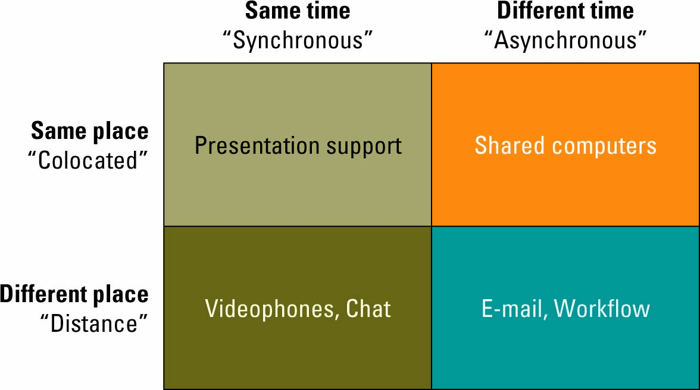
8.2 Enterprise portals
- Definition: are single point web browser interfaces used within an organization to promote the gathering, sharing and dissemination of information throughout an enterprise
- Web browser interface facilitates navigation of the enterprise portal via: search engine, hyperlinks to both internal and external resources
- Vertical enterprise portals: focus on accessing specific applications or business functions such as accounting or purchasing
- Horizontal enterprise portals: in contrast seek to integrate and aggregate information from multiple cross enterprise applications
The potential of enterprise portals
- Definition: facilitate knowledge creating, distribution and use – promote collaboration
- Portals must comprise three distinct areas to be effective
Factors affecting enterprise portal adoption and use
- None of the major factors are technical in nature
- Information politics surrounding the design and development of the portal, the system development process by which the portal was maintained, the information culture of the organization
Lesson |  | Description
Lesson #1 |  | - In terms of information politics, the human struggle over an enterprise portal’s content and functionality can lead to resultant designs that favour certain stakeholder groups rather than address end-user needs.
Lesson #2 |  | - In terms of the system development process, a perceived slowness in changes to an enterprise portal’s design or information content can lead to user dissatisfaction.
Lesson | Description
Lesson #3A | - With respect to information sharing, the provision of protected, secure areas in an enterprise portal to pre-defined individuals or groups can lead to greater exchange of documents and ideas.
Lesson #3B | - With respect to information overload, the filtering of information within an enterprise portal can lead to greater user acceptance of the system.
Lesson #3C | - With respect to information access, providing quick and universal access to an enterprise portal can lead to heightened usage.
Lesson #3D | - With respect to information control, offering a means to tailor the display and presentation of information on an enterprise portal can increase user satisfaction with the system.
Lesson #3E | - With respect to attitude towards using an enterprise portal, a positive perception towards and awareness of an enterprise portal’s functionality can lead to greater user adoption.

Read page 259 for specific definitions
Insight from computer supported cooperative work (CSCW) on adoption and use of Enterprise Portals: ensure that everyone benefits, create incentives for use, promote multiple perspectives, understand current work pratice

Chapter 9 – Information ethics and information privacy
- Advancements in technology make it easier for people to copy everything from music to pictures
- Technology continually poses new challenges for our ethics: the principles and standards that guide our behaviour toward other people
- Privacy: right to be left alone, have control over your own personal possessions and not to be observed without your consent
- Confidentiality: which is the assurance that messages and information are available only to those who are authorized to view them
- Issues affected by technology advances:
  - Intellectual property, copyright, fair use dealing (sometimes legal to use copyright info), pirated software, counterfeit software
Information ethics:
- Definition: concerns the ethical and moral issues arising from the development and use of information technologies and systems as well as the creation, collection, duplication, distribution and processing of info itself - with or without the use of comp technologies
- How they react to information – how they decide to share the info – individuals form the only ethical component of IS
- Information has no ethics: info will not sop itself from sending spam, viruses or highly sensitive information, information cannot delete or preserve itself
- Information ethics in the workplace
  - Systems that do not respect human dignity: not challenging, cant think, long wait times – get them more involved
  - Employee monitoring: checking what they surf online, reading emails – they see all: number of keystrokes, error rate and number of transactions processed – some find it unethical
  - Tracking people’s activites: key logger – how many clicks,
  - Protecting digital content: fair dealing: access copyright
Information Privacy
- Definition: concerns the legal right or general expectation of individuals, groups or institutions to determine for themselves when, and to what extent, information about them is communicated to others
- Varies widely between countries: Europe, US and Canada
- Canada:
  - PIPEDA: Personal Information Protection and Electronic Documents Act: is a federal act that applies to all organizations: GOALS = provide Canadians with a right of privacy for how their personal information is collected, used or disclosed by an organization
  - Types of personal information covered: pension and employment insurance files, medical records, tax records, security clearances, student loan application and military records
  - Exceptions: info given to journalists,
Developing information management policies
- Organizations strive to build a corporate culture based on ethical principles that employees can understand and implement
- E – policies: policies and procedures that address the ethical use of computers and Internet use in the business environment: example of policies: ethical computer use policy, information privacy policy, acceptable use policy, internet use policy, anti-spam policy and employee monitoring policy.
- Ethical computer use policy: contains general principles to guide computer user behaviour. Ensures all users are informed of the rules and by agreeing to use the system on that basis, consent to abide by the rules
- Information privacy policy: contains general principles regarding information privacy. Guidelines: adoption and implementation of a privacy policy, notice, choice and consent, information security
- Acceptable use policy: a policy that a user must agree to follow in order to be provided access to a network of internet. Usually includes nonrepudiation clause: a contractual stipulation to ensure that e-business participants do not deny (repudiate) their online actions
  - Email privacy policy: details the extent to which e-mail messages may be read by others
- Anti-spam policy: simply states that e-mail users will not send unsolicited e-mail (spam)
- Employee monitoring policy: explicit state how, when and where the company monitors its employees
9.2 Information Security
- Cost of downtime (fraud, tornado, fire, flood, flue season)
- Information security: the protection of information form accidental or intentional misuse by persons inside or outside an organization – e-business is risky: creates a lot of info security risks
The first line of defence – people
- 38% of security incidents happen from inside the organization:
  - Insiders: legitimate users who purposely or accidentally misuse their access to the environment and cause some kind of business-affecting incident – leaving password on sticky note
- Hackers often use “social engineering” to obtain passwords: using one’s social skills to trick people into revealing access credentials or other information valuable to the attacker
- Solution to reduce insiders issues:
  - Information security policies: identify the rules required to maintain information security
  - Information security plan: details how an organization will implement the information security policies
    - Steps to create:
      - Develop the information security policies, communicate the information security policies, identify critical information assets and risks, test and reevaluate risks, obtain stakeholder support
The second line of defence-technology
- Primary information technology security areas:
  - Authentication and authorization:
    - Authentication: a method for confirming users identities
    - Authorization: the process of giving someone permission to do or have something
    - The most secure type of authentication involves:
      - something the user knows such as a user ID and password (most common sucks though, identity theft: the forging of someone’s identity for the purpose of fraud. Phishing: a technique to gain personal information for the purpose of identity theft, usually by means of fraudulent e-mail.
      - something the user has such as a smart card or token
      - something that is part of the user such as a fingerprint or voice signature – best way
        - biometrics: the identification of a user based on a physical characteristic, such as a fingerprint, iris, face, voice, or handwriting
        - costly method
  - Prevention and Resistance
    - Downtime can cost form 100 to 1 million dollars per HOUR
    - Technologies available to help prevent and build resistance to attacks include
      - Content filtering
        - Organizations can use content filtering technologies to filter e-mail and prevent e-mails containing sensitive information form transmitting and stop spam and viruses form spreading
      - Encryption
        - Scrambles info into an alternative form that requires a key or password to decrypt the information
        - If there is an info security breach and the info was encrypted, the person stealing the info would be unable to read it
        - Public key encryption (PKE): an encryption system that uses two keys: a public key for everyone and a private key for the recipient
      - Firewalls
        - One of the most common defences for preventing a security breach
        - Hardware and/or software that guards a private network by analyzing the information leaving and entering the network
      - Detection and Response
        - If prevention and resistance strategies fail and there is a security breach, an organization can use detection and response technologies to mitigate the damage
        - Antivirus software is the most common type of detection and response technology
        - Hacker: people very knowledgeable about computers who use their knowledge to invade other people computers
        - Virus: software written with malicious intent to cause annoyance or damage
Chapter 10 – Systems Development and Project Management
- IS development problems often lead to high profile disasters
- IS do not work = organization does not work
- Systems failure/success: increase or decrease revenues, repair or damage to brand reputation, prevent or incur liabilities (find cancer = MRI or miss use of airplanes or cars = death), increase or decrease productivity
- Global IS dev: diff vocab,
Systems development lifecycle:
- Definition: the overall process for developing information systems from planning and analysis through implementation and maintenance
- Business need, find what satisfies the need, find benefits
  - Phase 1 Planning
    - Most important: involves establishing a high-level plan of the intended project and determining project goals
  - Phase 2 Analysis phase:
    - Involves analyzing end-user business requirements and refining project goals into defines functions and operations of the intended system
  - Phase 3 design
    - Involves describing the desired features and operations of the system including screen layouts, business rules, process diagrams, pseudo code and other documentation
  - Phase 4 development
    - Involves taking all of the detailed design documents from the design phase and transforming them into the actual system - designs to the physical
  - Phase 5 Testing
    - Involves bringing all the project pieces together into a special testing environment to test for errors, bugs, and interoperability, in order to verify that the system meets all the business requirements define in the analysis phase
  - Phase 6 implementation
    - Involves placing the system into production so users can begin to perform actual business operations with the system
  - Phase 7 Maintenance
    - Involves performing changes, corrections, additions and upgrades to ensure the system continues to meet the business goals
Systems development methodologies
- Methodology: a set of policies, procedures, standards, processes, practices, tools, techniques and tasks that people apply to technical and management challenges
- Software development methodologies:
  - Waterfall: a sequential, activity-based process in which each phase in the SDLC is performed sequentially from planning through implementation and maintenance – do one step after the other – the output of one becomes the input for the next phase
  - Agile software development methodologies
    - Smaller the project, greater the success rate
    - Iterative development: consists of a series of tiny projects
    - Agile methodology: aims for customer satisfaction through early and continuous delivery of useful software components developed by an iterative process with a design point that uses the bare minimum requirements.
    - Rapid application development methodology (RAD) – emphasizes extensive user involvement in the rapid and evolutionary construction of working prototypes of a system to accelerate the systems development process
      - The prototype is an essential part of the analysis phase when using a RAD methodology
      - Prototype: a smaller-scale representation or working model of the users requirements or a proposed design for an information system
  - Participatory Design
    - Definition: methodology promotes the active involvement of users in the information systems development process
    - Differs from the two above by who controls and does most of the design work
    - The people destines to use the system play a critical role in designing it
    - Basic tenets: the design process makes a difference for participants, implementation of the results from the design process is likely, it is fun to participate
Developing Successful Systems
- Primary principles for successful agile software development include:
  - Slash the budget: investing more money to try and save the project from failing
  - If it doesn’t work, kill it: is it doing what its suppose to do – requires
  - Keep requirements to a minimum: start with what must absolutely be done
  - Test and deliver frequently: test a piece of software
  - Assign non-IT executives to software projects: to see if they are meeting users needs
10.2 Project management
- Common reasons why IT projects fall behind schedule or fail: poor planning or poor project management, change in business goals during project, lack of support from business management, lack of resources, lack of support from IT management and change in technology during project
- FAIL: too complex make even more so by poor planning and unrealistic expectations, rushed due to increasing demanding market pressure and their scope becomes too unmanageable
Project Management Fundamentals
- Project: a temporary endeavor undertaken to create a unique product or service
- Project management: the application of knowledge, skills, tools and techniques to project activities in order to meet or exceed stakeholder needs and expectations
- Project management terms all mangers should know and understand
  - Project management institute PMI: develops procedures and concepts necessary to support the profession of project management – ethics, standards, accreditation
  - Project deliverable: any measurable, tangible, verifiable outcome, result, or item that is produced to complete a project or part of a project
  - Project milestone: represents key dates when a certain group of activities must be performed
  - Project manager: an individual who is an expert in project planning and management, defines and develops the project plan, and tracks the plan to ensure all key project milestones are completed on time
  - Project management office (PMO): internal department that oversees all organizational projects
Choosing strategic projects
- Which to invest time, energy and resources
- Project stakeholders: individual and organizations actively involved in the project or whose interests might be affected as a result of the project execution or project completion.
Understanding project planning
- Project charter: a document issued by the project initiator or sponsor that formally authorizes the existence of a project and typically includes:
  - Project scope: defines the work that must be completed to deliver a product with the specified features and functions. Defines the business needs, justification, requirements, and current boundaries for the project SMART
  - Project objectives: quantifiable criteria that must be met or the project to be considered success
  - Project constraints: specific factors that can limit options, they include budget, delivery dates, available skilled resources and organizational policies
  - Project assumptions: factors that are considered to be true, real or certain without proof or demonstration ex: hours in a work week
  - SMART: successful objective creations: specific, measurable, agreed upon, realistic and time frames
- Project plan: a formal, approved document that manages and controls project execution. Well defined project plan should be:
  - Easy to understand and read, communicated to all key participants, appropriate to the projects size, complexity, and criticality and prepared by the team, rather than by the individual project manager
  - Should include: description of the project scope, a list of activities, a schedule, time estimates, cost estimates, risk factors, resources, assignments and responsibilities
  - Two primary diagrams used in project planning
    - PERT (program evaluation and review technique chart) – graphical network model that depicts a project’s tasks and the relationships between those tasks (dependencies and critical paths are found in PERT charts)
    - Grantt chart: a simple bar char that depicts project tasks against a calendar
Managing Projects
- Project manager must focus on managing three primary areas to ensure success: people, communications and change
The challenges of outsourcing
- Contract length: difficulties in getting out of a contract, problems in foreseeing future needs, problems in reforming an internal IS department after the contract is finished
- Confidentiality
- Scope definition
Different forms of outsourcing
- Onshore outsourcing: the process of engaging another company within the same country for services
- Nearshore outsourcing: refers to contracting an outsourcing arrangement with a company in a nearby country, often this country will share a border with the native country
- Offshore outsourcing: is using organizations from developing countries to write code and develop systems, in offshore outsourcing the country is geographically far away
Success difficult to measure

Chapter 11 – Enterprise Architecture
- Definition: includes the plans for how an organization builds, deploys, uses and shares its data, processes, and IT assets - a proper one: decreases costs, increase standardization, promote reuse of IT assest and speed development of new systems = the right EA can make IT cheaper, strategic and more responsive – always change
- Primary business goals: reduce costs/improve productivity, improve customer satisfaction, create competitive advantage, generate growth, generate revenue streams, optimize the supply chain
- Enterprise architect EA: person grounded in technology, fluent in business, a patient diplomat and provides the important bridge between IT and the business
Enterprise Architecture Components
- Data architecture: identifies where and how important data, like customer records are maintained and secured – one backup or restore failure can cost an organization more than time and money some info can never be restored
  - Backup and Recovery:
    - Backup: an exact copy of a systems information
    - Recovery: the ability to get a system up and running in the event of a system crash or failure and includes restoring the information backup
    - Big organization = daily backups or perhaps even hourly to a storage server
    - Help in case of system failure
      - Fault tolerance: computer system designed so that in the event a component fails, a backup component or procedure can immediately take its place with no loss of service
      - Failover: a backup operational mode in which the functions of a computer component (such as a processor, server, network or database) are assumed by secondary system components when the primary component become unavailable through either failure or scheduled downtime – automatically offloading tasks to a standby system component so that the procedure is as seamless as possible to the end user
  - Disaster Recovery
    - Best practice include:
      - Monitor the quality of computer networks that provide data on power suppliers and demand
      - Make sure the networks can be restored quickly in the case of downtime
      - Set up disaster recovery plans
      - Provide adequate staff training, including verbal communication protocols so that operators are aware of any IT-related problems
    - Disaster recovery plan: a detailed process for recovering information or an IT system in the event of a catastrophic disaster such as a fire or flood
    - Hot site: separate and fully equipped facility where the company can move immediately after a disaster and resume business
    - Cold site: a separate facility that does not have any computer equipment, but is a place where employees can move after a disaster
    - Business continuity planning (BCP): a plan for how an organization will recover and restore partially or completely interrupted critical functions within a predetermined time after a disaster or extended disruption
  - Security: a good data architecture includes:
    - A strong data security plan, managing user access, up to date antivirus software and patches
Application Architecture
- Definition: determines how applications integrate and relate to each other
- Web service: contains a repertoire of Web-based data and procedural resources that use share protocols and standards permitting different applications to share data and services
  - Interoperability: the capability of two or more computer systems to share data and resources, even though they are made by different manufacturers
  - Event: detect threats and opportunities and alert those who can act on the information
  - Service: more like software products than they are coding projects, and must appeal to a broad audience, and they need to be reusable if they are going to have an impact on productivity
- Open systems: a broad, general term that describes non-proprietary IT hardware and software made available by the standards and procedures by which their products work, making it easier to integrate them
  - Allowing systems to seamlessly share info
  - Capitalize on enterprise architectures
  - Eliminate proprietary systems and promote competitive pricing
Infrastructure Architecture
- Solid Infrastructure architecture:
  - Flexibility: flexible enough to meet all types of business changes – able to handle multiple currencies even if they are not global yet – think of future
  - Scalability: how well an system can adapt to increased demands
  - Reliability: ensure that all systems are functioning correctly and providing accurate information
  - Availability: addresses when systems can be accessed by users
  - Performance: measures how quickly a system performs a certain process or transaction
Architecture Trends
- Architecture trends that are quickly becoming requirements for all businesses include:
  - Service oriented architectures, virtualization, grid computing and cloud computing
- Service oriented Architecture: SOA is a business driven IT architectural approach that support integrating a business as linked, repeatable tasks or services – helps business innovate by ensuring that IT systems can adapt quickly, easily and economically to support rapidly changing business needs – SOA is a way of thinking
  - Business Benefits
    - Services – a business task – check credit rating when opening new account
    - Interoperability – capability of two or more computers sharing of data and resources
    - Loose coupling – joining together or disassembling of services
Virtualization
- Definition: a framework of dividing the resources of a computer into multiple execution environments – able to work more efficiently to meet increased service levels
- System virtualization: the ability to present the resources of a single computer as if it si a collection of a separate computers, each with its own virtual CPU, network interfaces, storage and operating system
Grid Computing
- Definition: an aggregation of geographically dispersed computing, storage, and network resources, coordinated to deliver improved performance, higher quality of service, better utilization and easier access to data – enable communication across geographical dispersed environment – finding the weather or checking the stock market
Cloud computing
- A form of client/server computing operating over the Internet where the term “cloud” is used as a metaphor for the term “internet”
- G-mail: is an example of cloud computing where you use an internet browser on any client machine to manage your emails.

Chapter 12 – networks telecommunications, and mobile technology
Network Basics
- Telecommunication system: enables the transmission of data over public or private networks
- Network: a communications, data exchange, and resource sharing system created by linking two or more computers and establishing standards, or protocols so that they can work together
  - Networks range from small two-computer networks to the biggest network of all – the internet
  - Network benefits: ability to communicate and the ability to share
- Corporate digital networks include a combo of:
  - LAN local area network: designed to connect a group of computers in close proximity to each other such as in an office building, a school or a home – useful for sharing resources as files, printers, games
  - WAN wide area network: spans a large geographic area, such as a state, province or country – WAN often connects multiple smaller networks such as LAN or metropolitan networks
    - Metropolitan area network MAN: a large computer network usually spanning a city
Network enable data sharing
- The key advantage of providing data communication links between a company and its suppliers or customers is the sharing data
- Pertinent topics in this area include
  - Voice over IP: uses TCP/IP technology to transmit voice calls over long-distance telephone lines – skype has long been one of the most popular VoIP options for consumers – telephone can call a skype account
  - Networking business: order something online come to store to pick it up and end up buying more while in store.
  - Increasing speed of business: volume of data that can be transmitted per unit of time
    - Bandwidth: the difference between the highest and the lowest frequencies that can be transmitted on a single medium and it is a measure of the medium’s capacity
    - Baud: is the number of signals sent per second
    - Broadband: refers to high speed internet connections transmitting data at speeds greater than 200 kilobytes per second
  - Securing business networks: firm must identify users before giving them access to a corporate network
12.2 Mobile technology
- Mobile and wireless are often used synonymously but actually denote two different technologies
  - Mobile technology: means the technology can travel with the user, but it is not necessarily in real-time
  - Wireless technology: gives users a live (internet) connection via satellite or radio transmitters – no wires
  - Cellular phone: comes from depending on your location you change cells: each cell has a base station that consists of a tower and a small building containing radio equipment
Using cellular technologies in business
- Personal digital assistants (PDA): are small, handheld computers capable of entirely digital communications transmission – used before smarphones – like a PC before the internet
- Smartphone: combines the functions of a cellular phone and a PDA in a single device
- Bluetooth: a telecommunications industry specification that describes how mobile phones, computers and PDA’s can be easily interconnected using a short range wireless connections – bluetooth virtual keyboard
Using satellite technologies in business
- Location based services: LBS: wireless mobile content services that provide location-specific data to mobile users moving form location to location – tracking devise put on ppl, avoid traffic jams
- Global position systems (GPS): a constellation of 24 well-spaced satellites that orbit the Earth and make it possible for people with ground receivers to pinpoint their geographical location – uses satellites
- Geographic information system(GIS): designed to work with data that can be shown on a map – what is nearby, routing information
Using wireless technologies in business
- Wireless fidelity (Wi-fi): means of linking computers using infrared or radio signals: examples: cellular phones and pagers, GPS, Cordless computer peripherals, two way radios, satellite tv – wi fi in the sky – groud towers: instead of pointing to the ground they point up to the sky allowing for WiFi inside the cabin with air to ground antenna on the plane
- WiMAX: a telecommunications technology aimed at providing wireless data over long distances in a variety of ways – can give internet to the rural areas by connecting to a second tower (line of sight transmission) long range, low cost, wireless, high bandwidth (fast, provide service for a lot of ppl at same time), service
- Radio frequency Identification: RFIP: uses active or passive tags in the form of chips or smart labels that can store unique identifiers and relay this information to electronic readers
  - RFID tag: contains a microchip and an antenna, and typically works by transmitting a serial number via radio waves to an electronic reader, which confirms the identify of a person or object bearing the tag – shows exact location (on shelves, checkout, loading doors or shopping carts)
  - Tagged product – RFID reader – network – server – different data (Supplier and customer)

