– Get a new life form – Eukaryotes in an aerobic world – 2 billion years of single cell life. Only 2 lineages that will solve the solution of being a multicultural organism: 1. Green Algae BIKONTS that will become plants, 2. Coanocyte UNIKONTS (colar like cell) – will develop into Fungi and Animals.

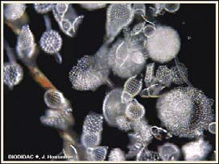Proterozoic Eon

BIO1130 Organismal Biology
1
Université d’Ottawa / University of Ottawa 2:25 PM

- For the longest time Fungi (Haploidic) was included with plants, but they are more related to animals because they are heterotrophic.
- Eukaryotes.

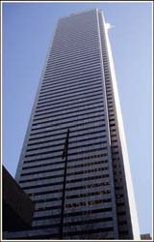Geological time scale and building height
(1floor – 60Ma, 72 floors, 12 feet/floor)

Major Eons (Ma)

Phanerozoic
    - (550 Ma to present time, top 9 floors’)

Proterozoic
• (2,500 – 550 Ma, 33rd -63rd)

Archaean
• (3,800 – 2,500 Ma, 12th – 33rd)

Hadean
• (4,500 – 3,800 Ma, 0-12th)

BIO1130 Organismal Biology
2
Université d’Ottawa / University of Ottawa 2:25 PM

- FOCUSED ON EUKARYOTES
- Evolutionary tree goes Bacteria branch to Archaea branch to Eukarya
- Archaea were most likely not Panspermia event (LUKA was most likely a BACTERIA).

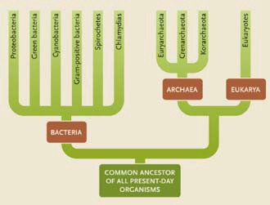Domains of life

Figure 21.15

3
2:25 PM

- Cell walls Cellulose (plants), Chitin (Fungi) and None (Animals).
- Nuclear envelope defines Eukarya – they also use multiple linear chromosomes instead of circular chromosomes.
- In evolution Eubactria share many similar characteristics with Archaea, which suggests that Eubacteria is in closest relation to the Archaea and then the Eukaryotes.
-

Archaea, Eubacteria & Eukarya
(Table 20.2)

4
 | Archaea | Eubacteria | Eukarya
Cell Wall | No peptidoglycan | Peptidoglycan | Cellulose, chitin or none
Plasma membrane | Branched with ether links | Unbranched with ester links | Unbranched with ester links
Operon genes | Yes | Yes | No
Translation | Complex RNA polymerases | Simple RNA polymerase | Complex RNA polymerases
Nuclear envelope | No | No | Yes
Circular Chromosome | Yes | Yes | No, multiple linear
DNA/histones | Yes | No | Yes
1st amino acid | Methionine | Formylmethione | Methionine  2:2

5 PM

Eukaryote autapomorphies (defines the group) summary of characteristics
- Nuclear envelope
- Endomembrane system
- Multiple chromosomes and diploidy
- Centrosomes

- Nuclear envelope - A part of the endomembrane system. It is a simple invagination of the plasma membrane that keeps invaginating until the two fuse up and you get two bi-lipid layers surrounding the nuclear material in the middle. Needs to have exit points called nuclear pores. Now we have a site that is set up for replicating the DNA and making a message.
- Message goes out through the nuclear pore into the cytoplasm where it will do all the other chemistry of life except DNA transcription (now the cytoplasm does not have to accommodate everything).

- Endoplasmic reticulum is an extension of the plasma membrane system that is there, and inside that membrane is the equivalent of outside space (whole secret passageway of space inside the cell that is inside the cytoplasm that we can move things around independent of the cytoplasm). Ribosome’s studded on the surface and proteins are placed in the space of the endomembrane system and they flow to things like Golgi Apparatus which package them into blobs move and fuse with the membrane system of the cell and secrete out proteins. Helps solve the surface to volume ration issues.

- Endomembrane system – have this series of back corridors that are not cytoplasmic that you can make something drop it into that environment and shuffle it around.

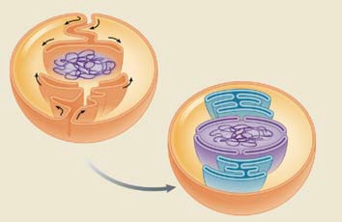Origin of the nuclear envelope

Cytoplasm

Nuclear region (Nucleoid)

Endoplasmic reticulum

Nuclear envelope

BIO1130 Organismal Biology
Figure 3.23
5

Université d’Ottawa / University of Ottawa 2:25 PM

- Origins of the Mitochondrion – Energy fuel system of the cell. – Originally big bacterial cells that ate other bacterial cells.

- When you get this bacterium that is engulfed in the cell that is going to digest it, some where along the line the bacterium was not digested. Engulfed in the cell wrapped in the membrane of the cell, it gets it’s the 3 carbon compound (pyruvate) from the cells cytoplasm and turns it into ATP. It reciprocates the ATP with the cell for provision of the 3 carbon compounds for food. Symbiosis between these two organisms. Cell advantage (Energy) and Bacteria advantage (3 carbon compounds for fuel).
- Endosymbiosis – second hallmark of the eukaryote cells.
- Mitochondrion – Inner membrane has petidoglycan components, Synthetic processes are all small ribosomes, and Genome is circular piece of DNA with no histones. Every single Mitochondrion can be traced back to this one event.

- Mitochondrial genetic material is passed through the Maternal line, because the only way a fertilized zygote gets mitochondrion is that if they are in the egg of a female and the parent transfers to the young. Female lineages throughout the world that can be traced through the mitochondrial DNA. Even a plants chloroplasts came this way but mitochondrion had to come first.

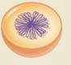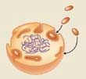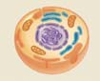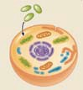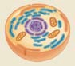Endosymbiosis of bacterial cells

Photosythetic
bacteria Chloroplast

Nuclear material (Nucleoid)

Aerobic bacteria

Nuclear envelope

Endoplasmic retic.

Developing endomembranes
Mitochondria

BIO1130 Organismal Biology
Figure 3.21
6

Université d’Ottawa / University of Ottawa 2:25 PM

- Moved toward Diplontic – in life cycle of eukaryotes some spend there whole life cycles as haploids, we as animals spend our whole life cycles as diploids and some that go back and forth between the two. The aspect they have in common is that to reproduce they make gametes through meiosis and fuse those gametes together to make a zygote.
- Big difference because we have chromosomes in pairs, when we go through meiosis we are not going to get all the maternal or paternal chromosomes back.
- You may if lucky end up pure maternal and pure paternal, or your more likely to get a mix. 2³ different variations you can get after the meiotic event and sex.

Eukaryote variability Random segregation

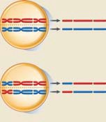
BIO1130 Organismal Biology
7
Université d’Ottawa / University of Ottawa 2:25 PM
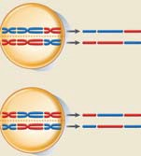
- As you increase the amount of chromosomes the chances increase dramatically – Human with 22 there is 4 billion ways those parental characteristics will mix. If you add Crossover you increase that variation up to the trillions (all genetic variation in Eukaryotes.

Eukaryote variability - Random segregation

Chromosomes | Combinations |  | Chromosomes | Combinations
3 | 8 |  | 25 | 33,554,432
6 | 64 |  | 30 - cow | 1,073,741,824
9 | 512 |  | 35 | 34,359,738,368
12 | 4096 |  | 40 | 1.099x1012
15 | 32,768 |  | 44 | 1.759x1013
20 - mouse | 1,048,576 |  | 50 | 1.125x1015
22 – human* | 4194304

BIO1130 Organismal Biology

Université d’Ottawa / University of Ottawa

8
2:25 PM

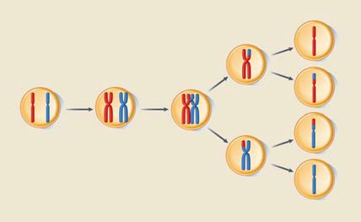Eukaryote genetic recombination Meiosis and crossing over (chiasmata)

Crossing over

Meiosis II

Tetrad

Meiosis I

Homologous pair

Sister Chromatids

Figure. 9.10
9
2:25 PM

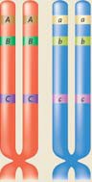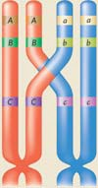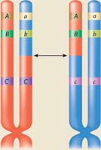Genetic recombination – Crossing over

BIO1130 Organismal Biology

Université d’Ottawa / University of Ottawa

Figure. 9.10

10
2:25 PM

- Centrioles – create spindle fibers that go between the centrioles and in mitosis and meiosis the chromosomes are going to line up on those spindle fibers and are going to get pulled to the opposite poles. Mitosis separates the chromosome pairs in Meiosis we separate the chromosome pairs then we separate the sister chromatids to get to the haploid stated.
- Centrioles – make cytoskeleton, which is all made out of tubulin. Tubulin – a series of nine triplets (always in pairs at right angles from each other) with a central core in the middle. (9(3)+1)
Centrosomes - Lay out the cytoskeleton, build microtubules, build spindle fibers for mitosis.
- Centriole contains the heritable information for structuring the cell. NO DNA OR GENETIC ELEMENTS. Self-replicating

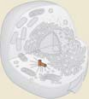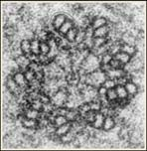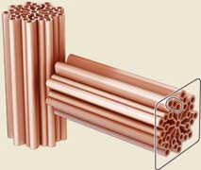Centriole

(Centrosomes or basal bodies)

BIO1130 Organismal Biology

Université d’Ottawa / University of Ottawa
Figure 2.23

11
2:25 PM

- Tubulin – Make microtubules (cytoskeleton elements) - Direct the assembly of the fibers by placing dimmers of tubulin in the cylindrical structure all made out of protein that grows. Main cytoskeleton is a tubulin cytoskeleton directed by the centrioles (spindle fibers) – Little molecular motors that crawl along the fibers.

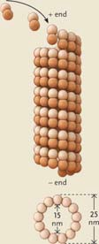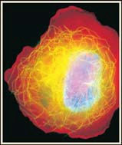Microtubules

Figure 2.18 & 19

BIO1130 Organismal Biology

Université d’Ottawa / University of Ottawa

12
2:25 PM

- Two molecular motors Dyenin and Kinesin – have two little feet that interact with the tubulin molecule crawl along by conformational change. Dyenin motors will move toward the centrioles and the Kinesin motors will move away. As they walk along, the opposite side the feet are carrying things (in Mitosis this is the attachment site to the centromere (kietosone) and pull it in opposite directions).
- Dyenin moves towards the centriole region and the Kinesin motor moves away.
- Explain how Eukaryote cells can be so big because they are a shuttle system moving things around, allow for faster production than simple diffusion. Have to be there for mitosis to separate chromosomes.

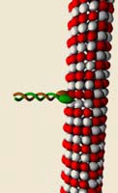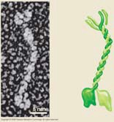Molecular motors

- Dyenin
- Kinesin
- Myosin

Figure similar to 2.20

BIO1130 Organismal Biology
13
Université d’Ottawa / University of Ottawa 2:25 PM

- Protein interact with the pairs, ATP changes the shape and the other foot is put on top and interacts with the tubulin making it ` walk along the length.
- Centriole is constantly building and destroying the microtubules (cytoskeleton).
- How the chromosomes are moved across the microtubules to the other end.

Kinesin/Dyenin motors
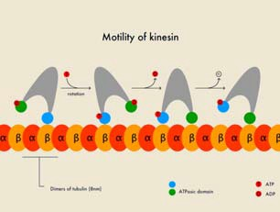
BIO1130 Organismal Biology
14
Université d’Ottawa / University of Ottawa 2:25 PM

- How did we get the first cell motility? First Eukaryote does not have a motile structure, no flagellum.
- Centriole was able to produce cytoskeleton elements (microtubules) and push against the cell membrane to deform the shape of the cell, Push on one end and absorb on the other you get movement - From microtubules that push against the plasma membrane, if the other microtubules disconnect on the other side of the cell and all the motors move towards the flagellum side of the cell (cell is going to move), motors are pulling everything along with it and the cell can cell gliding (does not equal amoeboid movement).
- These microtubules and the motors that run on them start to develop fingers and projections of cytoplasm and depending on how the motor moves on that projection you can wag it that means that you can create locomotion.
- Cells are self replicating – when they divide they get a daughter centriole and a paternal centriole and there is no DNA involved, it is a complex cell structure that self replicates and it contains information.
- When a cell divides the centriole has the information to position organelles in exactly the same place in every single cell. It is not just building a cytoskeleton, it is building a cytoskeleton that is coded for the position of all the organelles inside the Eukaryote cell and there is absolutely no genetic information involved in making this structure (Protien First World)
Centrosome – may be the first cause of motility.
- Over time there was an optimal structure that consisted of a series of microtubules, end up as the (9(2)+2) organization. Now you have a rod you can move back and forth and wave around.
Flagellum has a Basal Body – (9+2) structure

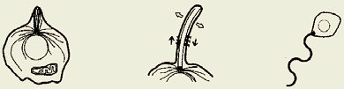Origin of cellular motility

BIO1130 Organismal Biology

Université d’Ottawa / University of Ottawa

15
2:25 PM

- First flagellum defines the Unikont
- Have a groove in the cell surface, flagellum lays in the groove
- Flagellum beats and pulls a water current that pulls in small bacteria and food particles and as they slide along the surface of the groove, they are phagocytosized into the cell, this is how it feeds. All the animal like ones are Unikonts
- Second Flagellum defines the Bikont – Basal body duplicates and creates a second Flagellum, it is waved at right angles and allows the cell to swim.
- Swam up into a water column where there was photosynthetic bacterium and it fed on the bacteria, it created a Symbiosis with the bacteria (chloroplast), instead of digesting it. All the photosynthetic Algae (second flagellum) are BIKONTS

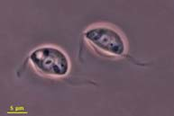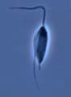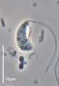  Unikont and bikont protists  BIO1130 Organismal Biology | 16
Université d’Ottawa / University of Ottawa 2:25 PM

- First protist was a Unikont to Bikont and separate into their groups.
- Bikonts are photosynthetic
- Unikonts are animal like

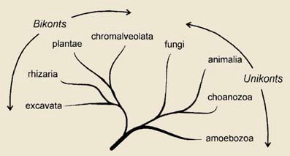Protist super groups

BIO1130 Organismal Biology

Université d’Ottawa / University of Ottawa

17
2:25 PM

- Bikonts go nuts, incorporation of a photosynthetic bacterium and we end up with a chloroplast. Was not a monophyletic events. There are chloroplasts that end up in the Red Algae (chlorophyll a) and a combination that end up in Green Algae (chlorophyll a-b).
- Red algae (eukaryote), which end up being swallowed by another Eukaryote cell (non-photosynthetic) and internalizes it and becomes photosynthetic (now you have 4 membranes associated with the chloroplast) 2nd endosymbiosis.
- Plastid – common name for all chloroplasts.

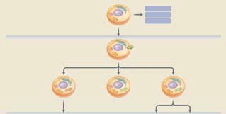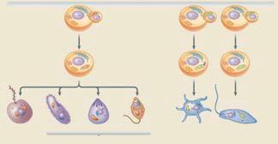Secondary endosymbiosis of eukaryote cells
Figure 22-31

Animals Fungi
Some protists

Red algae
Plastid
Plastid

Plastid

chorophyll a Green algae

Land plants
chlorophyll a & b

Non-photosynthtic eukaryote cell

Red algae

Multiple membrane plastid

Green algae

Multiple membrane plastid

Chlorarachniophytes

Heterokonts Ciliates Apicomplexans Dinoflagellates Euglenoids

18
2:25 PM

- Protists – common to all – in the oceans the photosynthetic are all primary producers (Phytoplankton) all arose from this and they have been powering the oceans ecosystem since then.
- Unikont develops into Fungi and all the animals.

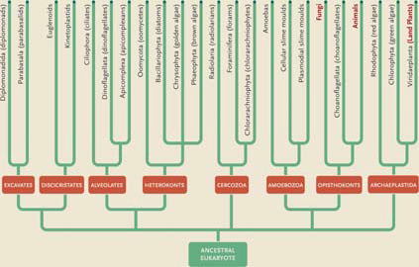Eukaryote taxa

Green plants

_{unkiont 1 green algal}

BIO1130 Organismal Biology

Figure 22.2

19
2:25 PM

- Primary producers (zooplankton) of the entire Ocean system, every single thing in the ocean has at the base of its food web a single cell phytoplankton (Single celled Protists). They in turn are munched on Zooplankton/protozoa very small (Primary Consumer).
- Whole system is based on Algae, why things we do to the ocean are so disturbing because these organisms are fragile.

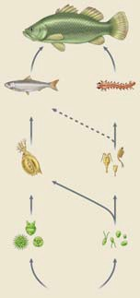Protists as primary Producers
Figure 47.9

Top predator

Fishes
Invertebrates

Zooplankton Primary consumers

Large Small

Phytoplankton (primary producers)
BIO1130 Organismal Biology

Large

Dissolved nutrients

Small

20
:25 PM

- Divide them up based on how they move.
- Both the Flagellar and Cilliar are derived from the same centriole

Protist locomotion

Flagellar
- Ciliary
- Amoeboid
- Parasitic

BIO1130 Organismal Biology
21
Université d’Ottawa / University of Ottawa 2:25 PM

Centriole – microtubular organizing unit that builds Cilia and Flagellum is called a BASAL BODY and it sits at the very bottom of the Flagellum. It will build microtubule filaments in a unique arrangement inside a plasma membrane to create a cylindrical object that is either a Flagellum or a Cilia (9(2)+2).
- 9+2 – Grows microtubules in doublets around the outside, and a doublet in the middle.
- Dyenin motor (side opposite to the feet) is glued to one micro-tubular doublets as it moves down (the other microtubule doublet with its feet) it will bend the structure. If it happening on both sides one after the other it will cause the flagellum to wave and wiggle. They could be attached on the outside alternatively and that would cause them to twist.
- Dyenin motors will disconnect to move back into original position.

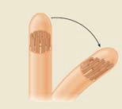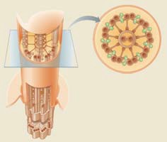Protist locomotion
Flagellar and ciliary movement
9+2 organization
Dyenin arms Microtubules

BIO1130 Organismal Biology
Figure 2.21 & 22
22

Université d’Ottawa / University of Ottawa 2:25 PM

- Flagellums are usually single (unikont) or two (bikont) in number.
- Power stroke, then they change structure to reduce water resistance, Recovery stroke by folding on itself to bring the flagellum back up (less resistance through the water) for another power stroke (called a planar bead). Rotational helicoid motion instead of the hook motor of bacteria like the breaststroke in swimming. Called a PLANAR BEAT
- Can also create a Helical/Spiral (like Skulling) beat by offsetting the Dyenin motors.

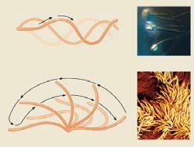Protist locomotion
Flagellar and ciliary movement (9(2)+2)

BIO1130 Organismal Biology
Figure 2.22

23

Université d’Ottawa / University of Ottawa 2:25 PM

- Usually hundreds of cilia – gets more complicated. They do not beat out of sink so you have a certain percentage generating power (Power stroke) and a certain percentage generating reverse (recovery stroke) and you sum up the vector of the two and you get continuous forward motion.
- Ciliates power stroke in one direction and recover in another direction (at 90 degrees from each other) so they don’t bang into each other.
- Go one step further by doing the power stroke in a synchronized motion – metacronal wave which is a very powerful swimming motion (like the wave in the stadium).

Protist locomotion Ciliary movement
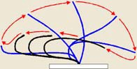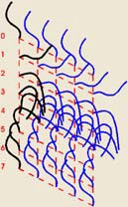
BIO1130 Organismal Biology
24
Université d’Ottawa / University of Ottawa 2:25 PM

- Using a myosin motor – walk along actin fibers that are polymerized. ATP that is going to be burnt to change the configuration of the two little knobby ends of the myosin to interact with actin to crawl along.
- Outer stiff ectoplasm (polymerized) and an inner fluid dimmers endoplasm.
- Tube of tooth paste – squeeze the toothpaste and lengthen the organism (squeezing of the myosin motors between the actin moving them forward.

- Anterior end where the cytoplasm is flowing of endoplasm (actin dimmers) when they reach the Hyaline Cap they polymerize, now we have the ectoplasm (fiber) which the myosin motor can crawl across. Can actually cause it to squeeze, will continue to do so depending on whether or not the actin is polymerized or not.

- Ectoplasm pushes the endoplasm forward, which polymerizes into ectoplasm. At the other end the ectoplasm actually turns back into endoplasm, End up with a dynamic flow of actin. Can move at any time and in any direction. It can also surround and engulf food. Motors and fibers that are strictly involved in movement of the cell (Myosin and Actin).
- Animals use a contractile vacuole (uses energy) that is part of the endomembrane system to pump out water to prevent from bursting. Fuses with the cell wall, contracts and squeezes the water out (Why animal cells don’t have cell walls). In the middle of this you still have the cytoskeleton that is going to move things around as the cytoplasm flows forward.
-Hyaline cap (creates the stimulus) causes a deflection of the endoplasm, which also causes polymerization.
- At the opposite end you have to disassemble to ectoplasm and turn into fluid, cause the myosin motors to fall off, as it moves forward it will bring cytoplasm along.
- Is a UNIKONT that has gotten rid of its flagellum.
- Amoeboid feed by Phagocytosis (larger particle), cytoplasm has to respond in multiple directions. Pinocytosis – nutrients are in a dissolved form (soluble form)

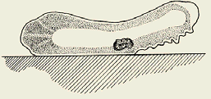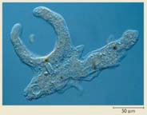Protist locomotion
Amoeboid movement (Pseudopods)

Ectoplasm Endoplasm

Hyaline cap

Direction of movement

BIO1130 Organismal Biology
25
Université d’Ottawa / University of Ottawa 2:25 PM

- Paramecium (a Ciliate) – has cilia all over it surface means there is reinforcing of the plasma membrane other wise it would rip from all the movement. Pelical – are the reinforcement as mesh, because of this mesh they cannot be like an amoeba and phagocytosis at any area, they can only do it in one location other wise they would risk tearing from the cilia movement. Cilia propel food into the vacuole space, which is called a CYTOSOME (Cell MOUTH). As the food vacuole forms it shifts into the cell Kinesin and Dyenin motors are move they cytoplasm around, and the food vacuole begins to move around the cell, it is first ACIDIC digestive condition, then it turns to alkaline digestion. It is excreted through the cytoproct (same as humans).

- Protozoa (animal like protists) live in water and don’t have cell walls have an organelle called a contractile vacuole – water pump connected to the endoplasmic membrane of the cell. Collects the water from in the cell, vacuole swell and through exocytose it releases the water to the outside (spend ATP).

- Two different nuclei – Macronucleus (bigger, polyploidy – more copies of the genome) and Micronucleus (smaller, I copy of diploid genome). High efficiency system – polyploidy - lots of gene copies to translate and make protein really quickly, but every time the genome is transcribed and translated it gets injured, have set aside one copy to be pristine for reproduction.

- Conjugation from micronucleus for reproduction of cell.

- Cilia can fuse together and make Cirrus – can now walk on or burrow in a substrate.

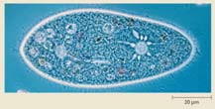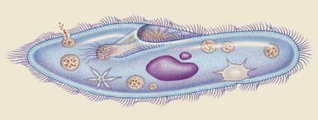Protist anatomy

Ciliate/PARAMECIUM

Forming food vacuole Emptying food
vacuole
Gullet Micronucleus

Cilia

Food vacuole

Contractile vacuole emptied

Macronucleus

Contractile vacuole filled

BIO1130 Organismal Biology

Figure 22.4
26

Université d’Ottawa / University of Ottawa 2:25 PM

- Haplontic – mostly haploid
- Alterations of generations (half and half)
- Diplontic
- Parasitic
- Diploid (2n)
- Haploid (n)
- Mitosis
- Meiosis
- Zygote

- Most of life is spent in diploid stage. (DIPLONTIC)
- Meiosis to haploid (GAMETES) – Zygote forms then Mitosis form new animal.

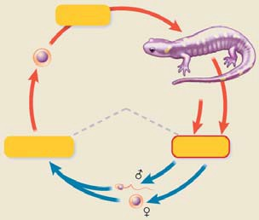Types of life cycles
Diplontic- Animals

Zygote (2n)

Mitosis

Diploid phase

Fertilization
Haploid phase

Meiosis

Figure. 9.9a

Gametes (n)

28
2:25 PM

- Mushroom – most of its life is in haploid state (HAPLONTIC)
- Spores (haploid) undergo mitosis to create more Haploid cells (Gametophte) - Role of gametophyte (HAPLOID) is to form gametes for reproduction.
- Short part of the lifespan (diploid) Zygote undergoes Meiosis to create 4 spores that are Haploid

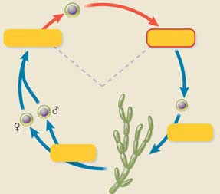Types of life cycles
Haplontic - Most fungi (and some algae)

Zygote (2n)

Fertilization

Gametes (n)

Diploid phase

Haploid phase
Meiosis

4 cells turn into multicellular structure.

Spore (n)

Mitosis

Mitosis

Figure. 9.9c

Gametophyte (n)

29
2:25 PM

- Half and half – PLANTS – ALTERATION OF GENERATION
- Fern (SPOROPHYTE Diploidactual structure not just a stage) is the product of a zygote (DIPLOID structure) – produces by meiosis a haploid produce spores. Spores undergo mitosis to make Gametophyte (haploid still) to produce Gametes for fertilization to produce the zygote (diploid). Zygote undergoes mitosis to produce (Diploid Sporophyte – Fern).

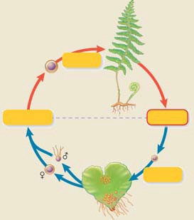Types of life cycles
Alternation of generations Plants (some fungi and algae)

Zygote (2n)
Mitosis SPOROHYTE

Diploid phase

Fertilization Meiosis
Haploid phase

Figure. 9.9b

Gametes (n)

Mitosis
Spore (n) Mitosis
Gametophyte (n)

30
2:25 PM

Nutritional strategies
- Ingestive - Animal-like protists
- Absorptive- Fungal-like protists
- Photosynthetic - Plant-like protists

BIO1130 Organismal Biology
31
Université d’Ottawa / University of Ottawa 2:25 PM

Types of life cycles

- Haplontic - Fungal-like protists

Alternations of
generations - Plant-like protists
- Diplontic - Animal-like protists

Parasitic

BIO1130 Organismal Biology
32
Université d’Ottawa / University of Ottawa 2:25 PM

- Parasitic – Malaria – Increase its number inside the host that it is in to make sure it can get to another host.
- Whole life cycle is controlled by a single celled protist called plasmodium, which causes Malaria
- Single cell protist will manipulate two multicellular organisms so that it completes its reproductive cycle.
- In hosts blood Gametocytes (two types) are ingested by mosquito -> Gametocytes – turns into Male Gamete and Female Gamete) -> create Zygote rests itself in stomach cells to undergo sporogony (to haploid) sporozoite -> mitosis to load up salivary gland of mosquito injects regurgitated fluid (saliva) into host -> swims in host to liver undergo shizogony (mitosis - increasing cell numbers) to produce Shizonts (diploid) -> into blood has 2 forms merozoites (free swimming) -> enters into RBC Trophozoite (able to feed on cells – Change into ) to feed on RBC’S

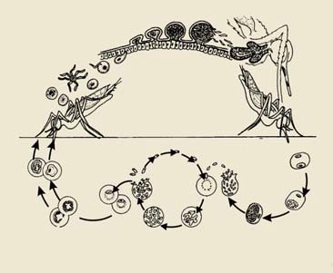Types of life cycles

Parasitic
Malaria Plasmodium sp.

Oocysts beneath stomach lining

Sporozoites migrate to
the salivary glands

Female gamete Male gamete

Sporogony

Ingestion of gametocytes

Mosquito's saliva infects human

Gametogony
RBCs

Liver

Schizogony
Gametogony

33
2:25 PM

- Bursting RBC in cycles continues – PLASMODIUM – can coordinate that all RBC’S burst at once reducing RBC count and causes fever, chills (sweating and cold), which mosquito’s are attracted to (taking the biology of the host to attract mosquitoes).
- Some trophozoites turn back into Merozoites, the others turn into micro or macro Gametocytes through Gamatogony.
- Gametogony undergo mitotic division to create gametes – some will be micros and some will be macros and the cycle will repeat itself.
- Malaria - Rideau Canal development, Malaria was a major killer of workers.
- Malaria – Natural selection to fixation (Darwinian) – has become immune to insecticides.
- Malaria – is 2nd biggest killer in sub-Saharan and Indian continent next to TB

- Crusades never concur the middle east, but never happened because of malaria. Until the development of coniine water or gin and tonic. Eventually you get coniine resistant malaria

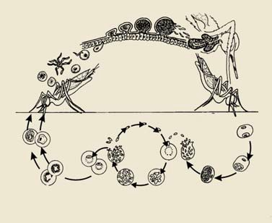Types of life cycles

Parasitic
Malaria Plasmodium sp.

Sporogony

Ingestion of gametocytes

Macrogametocyte

Microgametocyte

Merozoites

RBCs

Sporozoites enter liver cells
Liver

Gametogony

Trophozoite

Schizogony

Schizont

34
2:25 PM

