ARCHEAN EON
- Life in the form of bacterium (anaerobic) – no oxygen and life only occurs in the oceans. 1.3 billion years (1/4 planets life) with just bacteria life that has no ability to survive in the presence of oxygen. Just survives in the ocean.
- They look too similar to use morphology to define them.

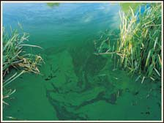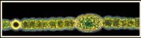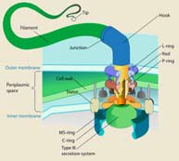Archean eon.

BIO1130 Organismal Biology
1
Université d’Ottawa / University of Ottawa 2:39 PM

- Accumulation of bacteria life that has no ability to survive in the presence of oxygen that is living in the aquatic environment.
- We cannot put the term species to bacteria so we are unable to estimate the total amount of them.

Geological time scale and building height
(1floor – 60Ma, 72 floors, 12 feet/floor)

- Major Eons (Ma)
  - Phanerozoic
    - (543 Ma to present time, top 9 floors)
  - Proterozoic
• (2,500 – 543 Ma, 33rd -63rd)
  - Archaean
• (3,800 – 2,500 Ma, 12th – 33rd)

Hadean
• (4,600 – 3,800 Ma, 0-12th)

BIO1130 Organismal Biology
2
Université d’Ottawa / University of Ottawa 2:39 PM

- 5 major kingdoms on the face of the planet. Based on morphology we distinguish these kingdoms through 2 criteria: 1. Bacterial of prokaryotes, 2. Eukaryotes with nuclei and organelles. Which accounted for 4 groups.

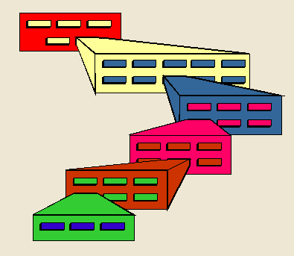Linnaeus – Taxonomic hierarchy

- Kingdoms
  - Animalia
  - Plantae
  - Fungi
  - Protista
  - Monera – prokaryotes

3
2:39 PM

KINGDOM Monera – (NO NUCLEAR ENVOLOPE) - were all prokaryotes.
KINGDOM PROTISTA - unicellular Eukaryotes cell (ones with nucleus, organelles and membrane) – Single cell organisms are called Protista
BIKONTS AND UNIKONTS ARE IN THIS GROUP
Protista (unicellular) - 2 subdivisions: 1. Autotrophic called Algae (Photosynthetic - could make glucose) 2. Heterotrophic called Protozoan’s (had to consume glucose to survive)

V  Kingdom Monera (includes all prokaryotes)  Kingdom Protista (includes several groups of unicellular eukaryotes)  BIO1130 Organismal Biology | 4
Université d’Ottawa / University of Ottawa 2:39 PM
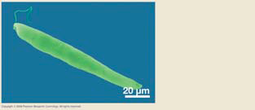
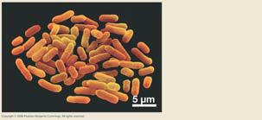
MULTICELLULAR FORM
- Kingdome Animalia – heterotrophic and had to consume food
- Kingdom Fungi – Couldn’t synthesis there food, but actually dissolve glucose to make their energy externally. Do all their digestion externally then digest the nutrients (called Saprophytic) and are Haplotic
- Kingdom Plantae – autotrophic and could make their food

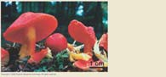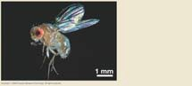  Kingdom Plantae  Kingdom Fungi  Kingdom Animalia  BIO1130 Organismal Biology | 5
Université d’Ottawa / University of Ottawa 2:39 PM

- As molecular techniques came along we could look into the genome of bacteria for the first time.
- There were two types of Protists – Monera was a composite of 2 very different types of bacteria.
- Tree of life got a new layer – Domains – All of the Eukaryotes were put into the Eukarya. The Monera (was a flaw) was separated into the Bacteria and the Archea (looked to be extremely primitive).
- Archea (primitive) – can live in high heat, deep cold (Thermophiles), don’t die with radiation, and live in extreme salt (Halophiles).
Domains – Archea, Bacteria, Eukarya
- Archea – problem – they live in the most weird conditions we have a hard time reproducing them in the lab to be able to study them.

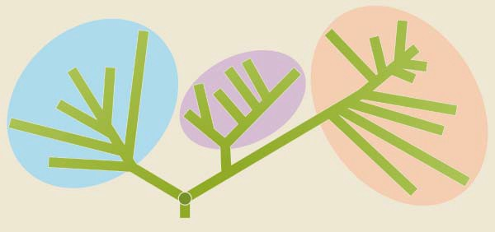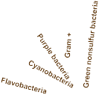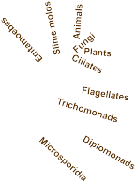Domains of life

Bacteria Eukarya
Archea

LUCA

BIO1130 Organismal Biology

Figure 3.20 and 18.16

6

Université d’Ottawa / University of Ottawa 2:39 PM

- Bacteria – most known about, because we cannot create a deep thermal ocean vent in the lab.

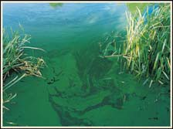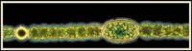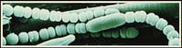Prokaryotes - Domains Bacteria and Archaea

Figure 20.17

BIO1130 Organismal Biology

CBC E. coli

7

Université d’Ottawa / University of Ottawa 2:39 PM

Both hold true to original Prokaryote characteristic of no nucleus (both)
Bacteria - Does not packaging the DNA in a histone package
Archea is packaging their DNA in a histone package just like the Eukaryotes.

Archaea, Eubacteria & Eukarya
(Table 20.2)
 | Archaea | Eubacteria | Eukarya
Cell Wall | No peptidoglycan | Peptidoglycan
Plasma membrane | Branched with ether links | Unbranched with ester links
Operon genes | Yes | Yes | no
Translation | Complex RNA polymerases | Simple RNA polymerase
Nuclear envelope | No | No
Circular Chromosome | Yes | Yes
DNA/histones | Yes | No
1st amino acid | Methionine | Formylmethione

This taxonomy is based on very limited morphology – and based off of very little information. There are thousands of branches on this tree.
Morphology – cannot express the underlying diversity.
Lacking in diversity. Bacteria are now seen as 25+, Archea is seen 9+ now.

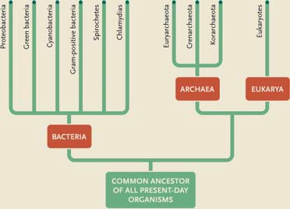Prokaryote diversity

Figure 20.15
9
2:39 PM

- Morphology is not enough, diversity in the group is not in appearance, its in the chemicals and proteins that make them up.
- E. coli O157H7- O157 is describing the variance in the cell wall of the bacteria (has to do with how virulent the bacteria is). These numbers distinguish deadly E. coli from non-deadly E. coli
- H7 – is the composition of the flagellum.
- We fingerprint them now with cell wall proteins and flagellum proteins. Linnaean naming composition fell apart.
Morphological diversity  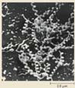  Size  - Shape  - Mobility Cocci  Metabolism  Spirillai  Figure 20.2  BIO1130 Organismal Biology | 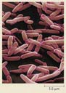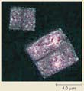  Bacilli  Squares
Université d’Ottawa / University of Ottawa | 10  2:39 PM

- Bacteria – cytoplasm that is surrounded by a cell membrane, inside is the nuclear material (single chromosome in a circular loop folded in on itself, but not packaged with major proteins) referred to as a nucleotoid because it has no membrane. It is suspended in the cytoplasm that is rich in Ribosomes to turn protein into certain components of the cell.
- Does it all in one environment – the cytoplasm has to support all the processes of DNA replication, message production, assemble protein on Ribosome, generating ATP, and metabolism.
- Really small – going to engage with the world through their plasma membranes (diffusion).
- Surface to volume ratio: Life is a bag of biochemistry, which has 2 important features: 1. The exchange with the outside environment, 2. Inside is where the chemistry is occurring (volume). If we were to count some kind of essential compound we need for life we could put many more of them in the volume then we could pack on the surface. If we have demand in the cell for a reaction, the supply is coming across the surface. As you increase the cell size you have more demand but the surface is not growing the surface proportionally, so you have limited supply for the chemical processes demand (not that the cell doesn’t grow). Everything inside must be supplied by the membrane and if there is nothing to change the cell membrane to increase the supply the cell cannot grow. In keeping the cell small that is the strategy of the bacteria, because you have no limitation or supply and demand. Some bacteria will infold to increase Surface Volume ratio, but still can only get so big.

- Peptidoglycan layer covers the outside: mixture of peptide protein and carbohydrate (DIMMERS)– protect cell against osmotic shock.
- Plasmid – small piece of extra DNA in cytoplasm.
- Flagellum – beat and move to propel cell
- Pili – can fuse with other bacteria to make a cytoplasmic bridge to exchange nuclear material. NO ORGANELLES EXCEPT BACTERIAL ORGANELLE THAT PRODUCE ATP

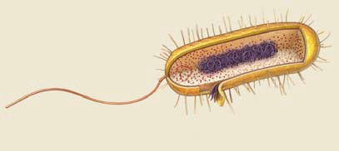Bacterial cells

Nucleoid
Cytoplasm

Pili Plamid

Flagellum

Ribosomes
Plasma membrane Capsule Peptidoglycan layer
Outer membrane

BIO1130 Organismal Biology
Figure 20.3

11

Université d’Ottawa / University of Ottawa 2:39 PM

NOT EFFECTIVE TO TELL GIVE YOU ANY PREDICTIVE NATURE OF THE BACTERIA.
- Gram (+) would be susceptible to penicillin as a treatment, stained the peptidoglycan layer
- Gram (-) not treatable with penicillin had a different organization – lipid layer, then peptidoglycan layer, then lipid layer. Because the outer lipid layer was blocking access the peptidoglycan layer was inaccessible to stain (didn’t stain). HARDEST TO KILL BACTERIA.
- Really about the proteins that make up the wall BUT IS NOT REALLY RELAVENT ANY MORE.

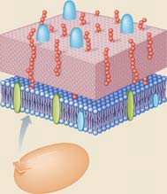Bacterial cell walls
Gram positive

Capsule
(may be present)

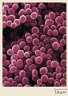
Peptidoglycan layer

Plasma membrane

Cytoplasm

BIO1130 Organismal Biology
Figure 20.6a

12

Université d’Ottawa / University of Ottawa 2:39 PM

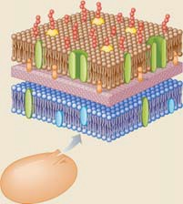

Bacterial cell walls
Gram negative

Capsule
(may not be present)

Outer membrane
Peptidoglycan
layer
Plasma membrane
Cytoplasm

BIO1130 Organismal Biology
Figure 21.6b

13

Université d’Ottawa / University of Ottawa 2:39 PM

Flagellum – made out of 40 proteins
- If the motor is sitting in a Gram (-) bacterium. Flanges embedded in the outermembrance, cell wall, and inner membrane.
So you have flange, flange, flange and a rod in the middle with a hook that is connected to the filament. The rod will turn, Proteins in the motor complex that will pump protons across the inner membrane to between the inner membrane and the cell wall (Periderm), the protons (Energy from low to high energy state), Protons build up, they will fall through the gradient and will take a protein and change its conformation. Proteins around the shaft and every time a proton flows through and changes the shape of the protein, it causes the shaft to twist. Hundreds of thousands of proteins around the shaft in the middle and each one nudge it in one direction and the shaft begins to spin and the hook spins the flagellum to create motility. 2000 to 10000 rpm (smallest motor in the world). Do not confuse Bacteria Flagellum from Eukaryote Flagellum

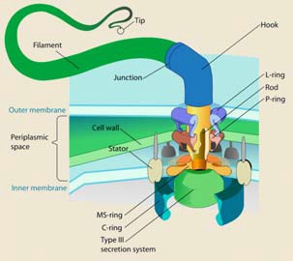Bacteria
Flagellum

BIO1130 Organismal Biology
14
Université d’Ottawa / University of Ottawa 2:39 PM

- Bacteria use exclusively mitosis for reproduction. Variance in genetics is caused my mutation.
- Bacteria are haploid throughout there whole life cycle.

Bacterial reproduction

Endospores and pilli
- Binary fission
- Horizontal gene transfer

Conjugation
  - Transformation
  - Transduction

BIO1130 Organismal Biology
15
Université d’Ottawa / University of Ottawa 2:39 PM

- Endospores are highly resistant and dormant stages of bacteria. Its capsules and cell walls have been modified so that it can withstand extreme conditions (ultraviolet radiation, ultraviolet or nuclear radiation, extremely high heat, extremely low temp). If they are dispersed and travel throughout the earth (really important for this, they dry up and will travel by wind) you will get very uniform distributions of bacteria. May be the form that came in during Panspermia
- Pilli – Exchange of genetic material between bacteria, hollow tube in which genetic material travels from cell to cell when they fuse together.

Bacterial reproduction
Endospores and Pilli

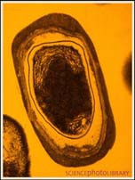

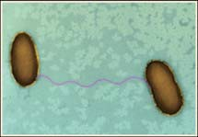

BIO1130 Organismal Biology
16
Université d’Ottawa / University of Ottawa 2:39 PM
- Binary Fission (bacterial reproduction - MITOSIS) – single circular chromosome starts to replicate attach to the cell membrane so that when we get cytokinesis and we generate a new cell wall we separate them from each other we get two identical cells. Building Identical clones in terms of cells. Genetic variation is very small through this process; this is not what drives the variation in this group.

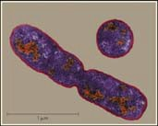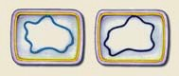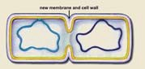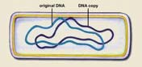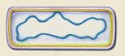Bacterial reproduction
Binary fission

1.

2.

3. 4.

Figure 20.10

BIO1130 Organismal Biology

Figure 8.3
17

Université d’Ottawa / University of Ottawa 2:39 PM

- Plasmid can be transmitted to another bacteria through the fusing of a pilli that creates a cytoplasmic bridge. Horizontal Gene Transfer - Plasmid (double stranded DNA) starts to replicate and sends the replicate through the pilli to the adjacent cell. As soon as that strand reaches the other cell it builds a complementary strand and we get two bacteria with plasmids. By the time you get the other bacteria, it will have a new genetic complex (new organism). Genes on the plasmid that is important for the bacteria to function (1st gene found on the plasmid was antibiotic resistance). If the first bacterium is resistant to a drug and comes in contact with the other cell and exchanges plasmid, the other bacteria will become resistant to the drug. Bacteria have no distinguishing feature so antibacterial resistance can go from E.coli to any other type of bacteria. PURE PLASMID

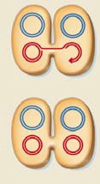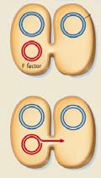Bacterial reproduction: Horizontal gene transfer
Bacteria conjugation plasmid transfer

Bacterial Chromosome

Plasmid

F+ cell F- cell

1. 2.

2. 4.
F+ cell F+ cell
BACTERIAL CONJUGATION- plasmid incorporate themselves into the genome of the bacteria. Transfer the genome of the bacterium. Plasmids can either exist independently in the bacterial cell, or they can open up the circular DNA of the bacterium and insert itself inside. Now you go from a bacterial that has a chromosome of its own and plasmid, to single chromosome, which is its own, plus the plasmid/chromosome combination. Occasionally the plasmid will step out and start to replicate, if this occurs when two cells are joined, sometimes there is a bubo and it takes a bit of the genome of the bacteria with it. Then it moves into the other cell and you have a plasmid with extra genetic material. Now we are transferring plasmid and genomic DNA, which increases genetic variation. PLASMID WITH GENOME (new individual)

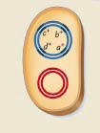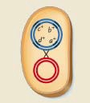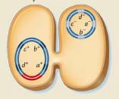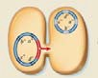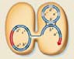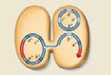Bacterial reproduction: Horizontal gene transfer
Bacteria conjugation gene transfer

a+ b+ c+ d+

1. 2. 3.

a+ b+ c+ d+

a- b-
c- d-

a+ b+ c+ d+

a+ b+ c+ d+

a- b-
c- d-

a+ b+ c+ d+

a- b-
c- d-

a+ b+

a+ b+ c+ d+
- b+ c- d-

a+ b-

4. 5. 6.

BIO1130 Organismal Biology
Figure 9.6b
19

Université d’Ottawa / University of Ottawa 2:39 PM

TRANSFORMATION – Bacteria can absorb bacterial genetic chunks from its environment and incorporate them in their genomes. It doesn’t just digest the chunks; it incorporates the genetic chunks in its DNA. 1.3 Billion years of horizontal gene transfer (swapping) makes it hard to know what is the ancestral species. Bacteria get all of their variability from the fact they swap pieces of there genetic material (plasmid, piece of genome, or the might eternalize old chunks of DNA into their genomes). Use the plasmid to create new variations.

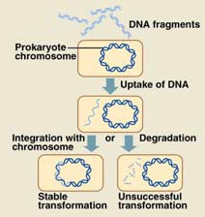Bacterial reproduction: Horizontal gene transfer
Transformation

BIO1130 Organismal Biology
20
Université d’Ottawa / University of Ottawa 2:39 PM

- Role of viruses can plan in TRANSJUNCTION - Bacterial Fugues (virus that eats bacteria) – Viruses are a protein container with a piece of DNA, and that DNA has everything the virus needs to completely hoodwink the bacterium infects.
- The virus inserts its DNA into the bacterial cell, and the first thing that DNA does is produce proteins to shut down the transcription of the bacterial DNA and destroy it. It will completely commandeer the structures (Ribosomes, DNA, Cytoplasm) inside the bacteria to replicate its own DNA and the material it needs to build a new virus case.
- When the time comes the protein pieces assemble and place inside them one piece of viral DNA (phage), then the bacterial cell lyses and the virus can move on to another cell (transmittion of DNA).
- Some times there may be a piece of the original bacterial DNA that did not get destroyed, when the virus assembles some times there can be bacterial DNA that gets assembled in it. Now we have a virus particle that contains DNA from the bacterium. When it goes to infect it shoots it into the cell and the bacterium goes oh look DNA and it sticks it in its own DNA and now its incorporated by horizontal gene transfer through transduction a piece of DNA from another bacterium.
- We know there are random genetics sequences that could have only happened by this type of happening.

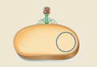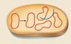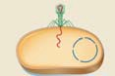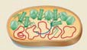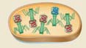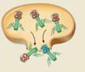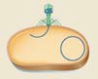Bacterial reproduction: Horizontal gene transfer
Transduction

1. 2. 3.

4. 5. 6. 7.

BIO1130 Organismal Biology
Figure 9.7
21

Université d’Ottawa / University of Ottawa 2:39 PM

- When we have organisms that grow they have to link carbon molecules together to make the energy and they have to have a source of carbon molecules (CO2 or Existing carbon bonds in a organic chemical C-C-C).
- CHEMO – means chemical change.
- Autotrophic (use CO2)
- Photoautotrophs – going to use light as energy – build carbon (glucose) – photons are harnessed to build high-energy intemediates that are made to build glucose.
- ChemoOrganotrophs – going to use ATP
- ChemoLithrotrophs – Obtain Energy via oxidation of inorganic compounds and carbon from CO₂
- Heterotrophs (use existing carbon bonds)
- Chemoorganoheterotrophs (animals and us) – we use chemical energy of ATP to stitch carbons together, but we get ATP by breaking particles apart (don’t confuse where we get the energy and how we break it down).
- ChemoLithroHeterotrophs – Energy via oxidization of minerals/inorganic materials (iron can go from 2+ to 3+, and will strip the high energy electron for energy) and Carbon from organic material
- Photoheterotrophs – get their energy from light and their carbon from existing carbon bonds.
- Three places we can get energy from 1. Light (sun), 2. High energy molecular compounds (ATP – Chemoorgano), 3. Inanimate minerals or metals (litho)
- We get energy from passing high energy electrons down a gradient of energy and pop protons across a membrane (as electrons move down the electron transport chain they are popping protons across to the outer membrane and they build up forming a concentration gradient, natural tendency now is to balance out. The protons balance out by falling through a hole in the middle of a molecule of ATP synthase and creates a conformational change and tacks a phosphate on ATP).

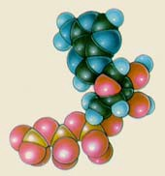Metabolic diversity in ATP production and carbon sources (Table 20.1 in part)

Autotrophic CO2

Photoautotrophs
    - Chemoorganotrophs
    - Chemolithotrophs
  - Heterotrophs C-C-C
    - Photoheterotrophs
    - Chemoorganoheterotrophs
    - Chemolithotrophic heterotrophs

BIO1130 Organismal Biology
22
Université d’Ottawa / University of Ottawa 2:39 PM

- All ways of building energy are characterized by the Redox reaction - if you gain an electron you are reduced – if you lose electrons you are oxidized (happens in all living systems)
- Conversion of NAD to NADH – to do that we need to have high-energy electrons and 2 protons, when we take away these high-energy electrons the protons will be released. Bacterial have found a way to gain high-energy electrons and use them to build gradients.

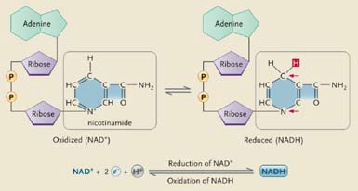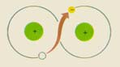Redox pair

Oxidized Reduced

BIO1130 Organismal Biology
Figure 6.6

23

Université d’Ottawa / University of Ottawa 2:39 PM

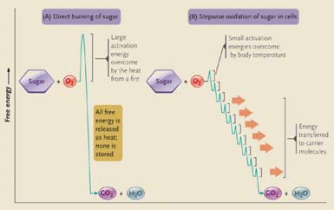Cellular respiration

BIO1130 Organismal Biology
Figure 6.5
24

Université d’Ottawa / University of Ottawa 2:39 PM

- Plants have to break down their own glucose to build their carbon backbones and carbon molecules. Sunlight makes NAD, which stitches the glucose together. It does not make ATP.
- Plants do not generate ATP from sunlight and is why they are not called organotrophs. Plants build a fuel then have to burn it.
- Bacteria can build high-energy electrons and photons from almost anything, (one reason why they can live in almost any environment.
- One that changes every thing is the one that starts producing oxygen as a waste product.
- If you can get high-energy electrons you can generate protons, if you can put them on one side of a membrane and create a gradient = you can create ATP (Energy comes from proton gradients IN ALL ORGANISMS).

Metabolic diversity

2 Fe
 |  | By products
Initial electron donor | Electron acceptor | From electron From electron donor acceptor
Sugar (us) | O2 | CO2 | H2O
H2 or organics | SO42- (Sulfate) | H2O or CO | H2S (hydrogen sulfide)
H2 | CO2 | H2O | CH4 (Methane)
CH4 | O2 | CO2 | H2O
S2- or H2S | O2 | SO42- (Sulfate) | H2O
Organics | Fe3+ | CO | 2+
NH3 (Ammonia) | O2 | - | H2O
NO2- (Nitrite) | O2 | NO3- (Nitrate) | H2O

NO2 (Nitrite)

BIO1130 Organismal Biology
25
Université d’Ottawa / University of Ottawa 2:39 PM

- Decomposition – Methanogen Bacteria in Landfills would metabolize the garbage into methane, the methane would build up in the dumps and ignite. They started to build landfills with hallow pipes, and used the pipes to pump that gas out of the landfill sights and used the methane as fuel. (Johnson and Johnson – used this to heat manufacturing plants. Oil spill in the gulf, oil was metabolized by bacteria into energy for them to live (oil was turned into bacterial energy) and residual oil disappeared.

Bacterial importance  Disease  - Nitrogen fixation  - Decomposition  - Unique biochemical pathways  - Extremophiles (Archea)  BIO1130 Organismal Biology | 26
Université d’Ottawa / University of Ottawa 2:39 PM

- Airborne – Tuberculosis – there is a form that is entirely resistant to any treatment (Darwinian fixation – treated it to the point where it has evolved by swapping DNA or Plasmids) Africa and World Health employee who got it and flew to Montreal.
- Arthropod – Lyme disease (tics) and Bubonic plague (black plague – black death wiped out half of Europe transmitted by a flee)
- Direct Contact – Anthrax (cattle, sheep – bottleneck of bison were susceptible to it (Wood Buffalo national park)) and Gonorrhea
- Food or Waterborne – Food Poisoning (salmonella), Listeriosis (Brooks Alberta, mapleleaf foods)
- They make headlines because of 1. RESISTANCE 2. We now know how to FINGERPRINT bacteria so we know what are bad and what is not.
Prokaryotes and humans  BIO1130 Organismal Biology | 27
  Transmission | Disease - Bacterium
  Airborne | Legionellosis - Legionella pneumophobia Diptheria - Corynebacterium diphtherium Tuberculosis – Mycobacterium tuberculosis
  Arthropod | Lyme disease – Borrelia burgdorfei  Bubonic plague – Yersinia pestis
  Direct contact | Gonorrhea – Neisseria gonoffhoeae  Anthrax – Bacillus anthracis
  Food or waterborne | Food poisoning – Salmonella enteritidis  Cholera – Vibrio cholerae  Listeriosis - Listeria monocytogenes
Université d’Ottawa / University of Ottawa 2:39 PM

NITROGEN FIXATION - Bacteria can take nitrogen out of the air and incorporate it into organic molecules (Amino Acids, Nucleic Acids)
- Only place nitrogen can come from is bacterium in the original stages of the earth.

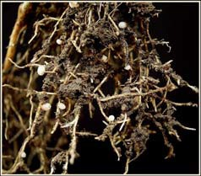Nitrogen fixation

Root
nodules

N2 + 8H+ + 8e− + 16 ATP 2NH3 + H2 + 16ADP + 16 Pi

BIO1130 Organismal Biology
28
Université d’Ottawa / University of Ottawa 2:39 PM

NITROGEN = NUCLEIC ACIDS FOR DNA/ PROTEINS AS WELL.
- Nitrogen is made by bacteria and absorbed by plants for growth. These plants are then eaten by animals. Nitrogen is the limiting factor for productivity on the planet (cant make protein or nucleic acids). If you fertilize plant they grow like crazy (artificial), to much of the nitrogen runs off into the water system causing algae to bloom like crazy and die, which decomposes and strips the oxygen out of the water creating a dead zone in lakes and river systems (Mississippi Basin).

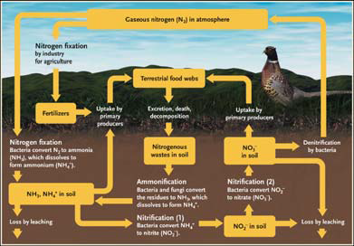Nitrogen cycle

29
Figure 46.14 2:39 PM

Extremophiles (live in extreme environments) – How does a plasma membrane maintain its integrity in such extreme conditions?
Problem – We cannot grow them in the lab to study easily in huge numbers.
- Halophiles – are able to survive in extremely salty conditions
- Thermophiles – are able to survive in extreme heat

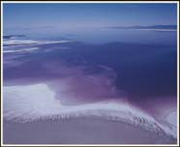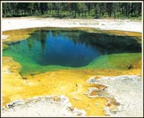Extremophiles (Archaea)

Halophiles Thermophiles

BIO1130 Organismal Biology
Figure 20.20

30

Université d’Ottawa / University of Ottawa 2:39 PM

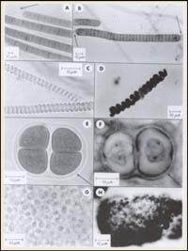Fossil bacteria

BIO1130 Organismal Biology
31
Université d’Ottawa / University of Ottawa 2:39 PM

- Cyanobacteria lived in the shallow parts of the ocean, these organisms would form bio-films or mats and carry out photosynthesis and die and new ones would grow on top. All of this would fossilize to make Stromatolites (in Australia they still exist today).

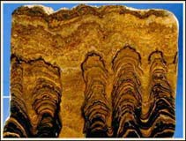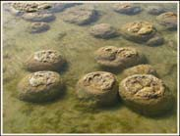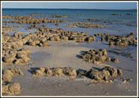

Stromatolites

© C Eeckhout

Figure 3.14

BIO1130 Organismal Biology
32
Université d’Ottawa / University of Ottawa 2:39 PM

Cyanobacteria – uses lights energy to build carbon chains, first photoautotrophs. These organisms are sufficiently successful in trapping and turning high-energy electrons to create protons that get pumped across the gradient. Splitting the molecule to do this is one of the most abundant/efficient forms of getting high-energy electrons. This organism can build organic material more efficient than any other and it grows like crazy – it oxidizes the minerals of the world.

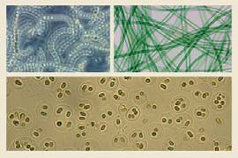Cyanobacteria and earth’s evolution

CO2 + H2O + light

(CH2O)n+ H2O + O2

BIO1130 Organismal Biology
33
Université d’Ottawa / University of Ottawa 2:39 PM

Archaean - Banded red is where water is rich in oxygen (oxidization causing rust), grey is where oxygen declines so you don’t have rusting. Cyanobacteria’s - oxygen is being taken up by minerals that need to be oxidized. Once that is complete it will build up in water till waters capacity is met and then it moves into the atmosphere. Miller experiment and until this time there was no oxygen in the atmosphere. Oxygen will grow until it is held in by our atmosphere (UV light reacts with oxygen and turns it into O3 which is ozone, which blocks ultraviolet light). Now other organisms can come up out of water.

Oxygenation of the planet  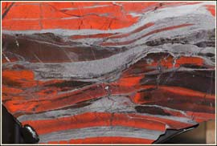  BIO1130 Organismal Biology | Figure 3.18
Université d’Ottawa / University of Ottawa | 34  2:39 PM

- Virus – NOT LIVING – we don’t know where they came from. Set of proteins that contain within them the genomic DNA for the virus. When it attacks the cell it injects its DNA. The DNA starts to make proteins and the first ones shut down and destroy the DNA system of the bacterium and take over and replicates its own genome and the proteins it needs. Then it reassembles itself and bursts out of the cell.
- Virus life cycle depends on the cell they couldn’t have come first. Organism that represents the absolute minimalist replicating structure you could have as the bacteria becomes so small that all we have is a genome packed inside of proteins and all you need is a living bacterial cell, take it over and use the bacterium life process for itself (virus would be a degenerate, defective, minimallized living cell that has created a special ability to be a packaged DNA and can find cells, invade them, carry out life’s process, escape the cell and not have the baggage of the cell.
- Self Replicating piece of DNA, maybe there was a minimal form that consisted of the replicating DNA existing in some kind of protective coating, live dependently and when cells evolved it managed to hook on them and perfect that independent existence by taking advantage of the cell.

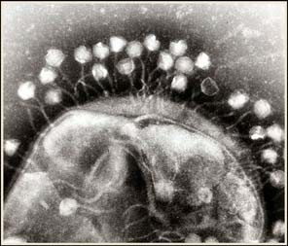Viruses

BIO1130 Organismal Biology
35
Université d’Ottawa / University of Ottawa 2:39 PM

- Viruses are defined by there MORPHOLOGY. All viruses consist of a protein matrix or a non-protein matrix that make a container surrounding it. Proteins are called CAPSID proteins form the case and inside it we have nuclear material or genome of the virus.
1. Enveloped - there is plasmid membranes that surrounds the DNA which was derived from the particular cell it grew in. HIV is enveloped and its envelope comes from our cells. (H1N1) Virus will synthesis proteins that it will put in that envelope, that will assist it in recognizing cells that it can effect and the proteins will assist in helping the virus invade the cell. Alpha Numeric fingerprint is describing the proteins in the Capsid and the proteins that our found in the envelope of the virus.
2. Non-enveloped – just the protein Capsid in either Helical, polyhelical, or complex envelope form.
Vaccine – raise large amounts of the proteins that are in the virus’s membrane, kill the virus off, create large amounts of antigen and you receive large amount of viral proteins, which triggers your body to make antigens to that so your immune system recognize it and destroy the virus.
DEVERSITY IS SEEN IN MORPHOLOGY OF CAPSID AND PROTEINS IN CAPSID AND ALSO BY GENETIC MATERIAL INSIDE.
- In DNA one strand has the codon for the real message, the other side is a mirror. SENSE AND NONSENSE SIDES.

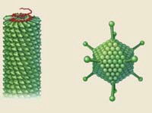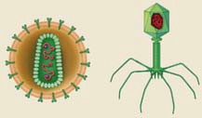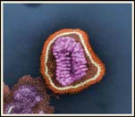Virus morphology

Helical

Polyhedral

Enveloped Complex
enveloped

H1N1 (influenza) an enveloped virus

BIO1130 Organismal Biology
Figure 21.1
36

Université d’Ottawa / University of Ottawa 2:39 PM

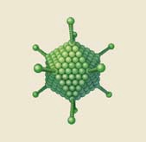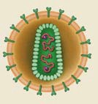Virus morphology

Nonenveloped virus

Enveloped virus

Viral enzymes

Genome (DNA or RNA) inside

Capsid (protein)

Genome (in this case, RNA)
Capsid (protein)

Envelope (phospholipid bilayer)

BIO1130 Organismal Biology
Figure 21.1
37

Université d’Ottawa / University of Ottawa 2:39 PM

PHAGE – carrier for the DNA molecule. Theses themselves are not cells (slide 40),

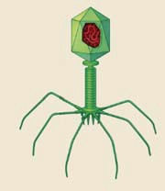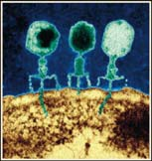Virus morphology

Viral DNA inside

Head

Capsid Protein

Sheath

Tail

Baseplate Recognition fibers

BIO1130 Organismal Biology

Figure 21.1 & 3
38

Université d’Ottawa / University of Ottawa 2:39 PM

Exchange of molecules across the cell (no cell membrane). Virus cannot make any of the products it needs to function (has no ribosome). Those processes have to be fueled but they can t (have not mitochondrion).

Viruses aren’t cells?

No cell membrane
- No ribosomes
- No mitochondria
- DNA (RNA) wrapped in a protein coat

BIO1130 Organismal Biology
39
Université d’Ottawa / University of Ottawa 2:39 PM

These same 6 stages happen in the life cycle of all viruses.
1. ENTRY – lands on, recognition proteins that help it bind to the cell, opens an opening in the cell often by inserting a protein into the cell and the RNA travels inside the cell through that protein.
2. Transcription and viral protein production – The RNA must start making proteins – the first proteins it makes shut down the transcription of the DNA and the genome of the Bacteria (enzymes to destroy the integrity of the genetic system of the cell that has been invaded).
3. Replication of Viral Genome – making copies of its genome, translates the messages that make the proteins for the casing.
4. Assembly of virions – casing seems to snap together and there is not understanding for this. It incases one piece of genome.
5. exit – Lyses out of the cell.
6. Transmission to new host

Viral phases in replication

- Entry
- Transcription and viral protein production
- Replication of viral genome
- Assembly of virions
- Exit
- Transmission to new host

BIO1130 Organismal Biology
40
Université d’Ottawa / University of Ottawa 2:39 PM

- Phages are numerous, because they are the leading participants in controlling the levels of bacteria in the world. Viruses are population control or predator of bacteria.

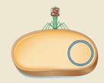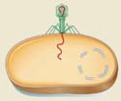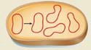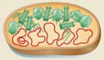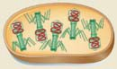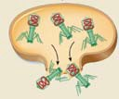Viruses – Replication

T-even phage Phage DNA

Replicated phage DNA

E. coli cell

Head units Tail units
Bacterial chromosome

Phage DNA

BIO1130 Organismal Biology

Figure 21.4
41

Université d’Ottawa / University of Ottawa 2:39 PM

- Lytic cycle – virus ruptures a cell and the virus is released
- Lysogenic cycle – viruses incorporate themselves in the genome of the hosts cell. Viral piece of DNA incorporates itself in the chromosome of the cell and replicates over and over (DORMANT). Ultimately it will excise itself out and start the Lytic Cycle.
- NOT LIMITED TO BACTERIA

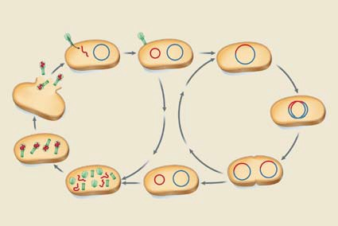Viruses – Replication

Virus particle

Viral genome Host-cell
genome

Viral genome

Host-cell genome

Lytic cycle Lysogenic cycle

Assembling virus particle

Virus particles

Figure 21.5

42
2:39 PM

- When the virus takes over the cell it places viral proteins in the membrane of its hosts cell, when the virus exits by BUDDING (exocytosis) it wraps itself in the membrane of the hosts cell that it was in that has the viral proteins. Now the virus has a mixture of proteins in its envelope that are similar to the host (1. can fuse to a host sell and send the whole virus particle inside) and proteins unique to the virus (2. specific that when a they find a host cell we are able to inject the virus particle back inside) TWO DIFFERENT WAYS.
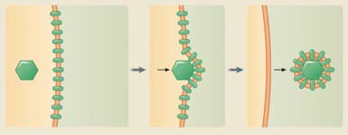

Viral replication
Exit host - Budding

Virus particle
Viral envelope proteins

Host cell cytoplasm
Host plasma membrane

Enveloped virus

BIO1130 Organismal Biology
Figure 21.2

43

Université d’Ottawa / University of Ottawa 2:39 PM

- Now the virus has a mixture of proteins in its envelope that are similar to the host (1. Can avoid being recognized by antigens) and proteins unique to the virus (2. can fuse to a host sell and send the whole virus particle inside)
- In Eukaryote cells you end up with another step where the virus has to get through the nuclear envelope to where the DNA is contained. Without getting into the nucleus it cannot replicate the virus.
- Latent virus – Virus’s that incorporate into the cell. Probably what we see of ancient latent viruses in our genome from years back.
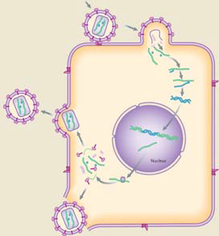

Viral replication

Viron

RNA

Budding

Nucleus
vRNA
vDNA

vDNA
Host DNA

vRNA

Cell rupture

Box 21.1
44
2:39 PM

Prions – 2 forms either NORMAL or ABERRANT – series of batted pleated sheets in a bunch of alpha helix’s, protein can change its shape (change number of batted pleated sheets) can be troublesome. That molecule has the ability to change a regular protein into an aberrant protein just by contact. The Aberrant form is sticky and starts to grow fibers from 2 ends, each time one end hits a protein it turns it into an Aberrant protein and it begins to branch. Now you have multiple growing points and get huge. The tissue then VACULEATES (massive knots of fiber) happening in the extracellular space between two cells and forming massive knots of fibers and you get these vacuole spaces. Manifests most damage in brain tissue and disconnects cells from each other and you get barren neural function (BSE or MAD COW DISEASE) – transmitted with no nuclear material being involved and is an extremely stable virus (withstands extreme conditions) all you need is one of the Aberrant proteins to enter the body and it will find proteins to convert and start a massive chain reaction. Started from feeding cattle animal bi-products (Britain had to kill 4 million cattle) now you get CONTAINS NO ANIMAL BIPRODUCT.
- In humans its called crushfeld jicobs disease.
- Disease that completely lacks any genetic component, Protein manages to self replicate itself in creating this disease pathogen (PROTEIN FIRST WORLD).
- Viroids – circular pieces of RNA (extremely small and stable), self-replicating first found in plants. It is a RNA silencer that blocks the messages of RNA into proteins – causes the death to cell. Then a animal form of animal viroid was found HEPITITUS D, which travels with Hepatitis B. Instead of just getting Hep B, you get Hep D, and it shuts down the RNA message.

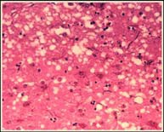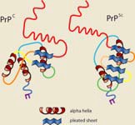Prions and viroids

- Bovine spongiform encephalopathy

Vacuoles

Vacuoles

Normal
Aberrant

Figure 21.6

BIO1130 Organismal Biology
Université d’Ottawa / University of Ottawa

45
2:39 PM

Prions and viroids evolve – they do change their genetic information, but they do not meet any of the other requirements for life.
Australia is where we profile the flue shot from.

What is life?
(Figure 3.3)

- Organized – with the cell as the fundamental unit
- Metabolizing - Capturing and releasing energy
- Self regulating - A delicate balance
- Reproduce – life from life
- Evolving - Adapting and changing
- Responding - Sensing and interacting with the surrounding world
- Growth – increase in size

BIO1130 Organismal Biology
46
Université d’Ottawa / University of Ottawa 2:39 PM

