Consists of 4 major eons – Oldest one 3.8 billion years HADEAN EON – will last about 800million years for the planet to stabalize to form the presence of the first life forms. Presence of first life form will change the appearance of the sedimentary rocks and things that are being laid down.

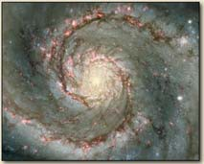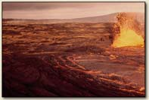Whirlpool galaxy M51

Hadean eon.

BIO1130 Organismal Biology
1
Université d’Ottawa / University of Ottawa 10:22 AM

- Hadean is followed by the Archaean. Archaean – 1.3 billion years the only thing that happens is life is going to live in the absence of oxygen in the ocean as bacteria (1/4 of the worlds history is anaerobic bacteria living in the ocean).
– Oxygen accumulates from life form that obtains high-energy electrons by the splitting of the water molecules into hydrogen (proton - drives life) and oxygen (waste). Becomes the dominant way of producing energy.
- Oxygen oxidizes ocean, air and land – at the end of the eon the earth rusts.
- Oxygen then builds up to high enough levels that we end up with prokaryotes/bacteria turning into eukaryote cells with all the organelles. Eukaryote cells are all we see in oceans for 2 million years.

Geological time scale and life forms
(Table 1.1 pg xii)

Major Eons
  - Phanerozoic (543 Ma to present time)
    - Multicellular organisms
  - Proterozoic (2,500 – 543 Ma)
    - Oxygen atmosphere, single celled aerobic organisms
– Archaean (3,800 – 2,500 Ma)
    - Anaerobic bacterial life, oxygen starts to accumulate
– Hadean (4,600 – 3,800 Ma)
    - Formation of the solar system and planet, ends with origin of life

BIO1130 Organismal Biology
2
Université d’Ottawa / University of Ottawa 10:22 AM

Phanerozoic – Massive jump to multi-cellular life

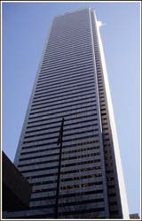Geological time scale and building height
(1floor – 60Ma, 72 floors, 12 feet/floor)

- Major Eons (Ma)
  - Phanerozoic
    - (543 Ma to present time, top 9 floors)
  - Proterozoic
• (2,500 – 543 Ma, 33rd -63rd)
  - Archaean
• (3,800 – 2,500 Ma, 12th – 33rd)

Hadean
• (4,600 – 3,800 Ma, 0-12th)

BIO1130 Organismal Biology
3
Université d’Ottawa / University of Ottawa 10:22 AM

First have of Phanerozoic – life is still in the ocean.
Paleozoic – very important

Geological time scale and life forms
(Table 1.1 pg xii)

 Major Era
– Phanerozoic (550 Ma to present time)
• Cenozoic (65Ma to present time)
– Dinosaurs disappear, mammals and birds
• Mesozoic (251-65 Ma)
– Flowering plants, dinosaurs, even more insects
• Paleozoic (543-251 Ma)
– Marine invertebrates, algae, “Cambrian explosion”, first land plants and insects.
– Proterozoic (2,500 – 543 Ma)
– Archaean (3,800 – 2,500 Ma)
– Hadean (4,600 – 3,800 Ma)

BIO1130 Organismal Biology
4
Université d’Ottawa / University of Ottawa 10:22 AM

Paleozoic – Marine invertabrates form, and first plants and animals move up on land.
Second half of Phanerozoic animals finally move up onto land.
Last part mass extinction dinosaurs disappear; and mammals and birds appear.

PCMPPAH Have All Purple People Planned Music Concerts.

Geological time scale and building height
( 1floor – 60Ma, 72 floors, 12 feet/floor)
 Major Era
– Phanerozoic
• Cenozoic
(65 Ma to present time, 72nd floor)
• Mesozoic
(251-65 Ma, 65th to 71st)
• Paleozoic
(543-251 Ma, 63th to 65th)
– Proterozoic (2,500 – 543 Ma)
– Archaean (3,800 – 2,500 Ma)
– Hadean (4,500 – 3,800 Ma)
Your life span = 0.0002 inches Human hair = 0.001 inches
BIO1130 Organismal Biology
5
Université d’Ottawa / University of Ottawa 10:22 AM

How a proper philanthropist packs money
IMPORTANT TO PUT THESE GEOLOGICAL TIME SCALES IN ORDER AND WHAT IS HAPPENING.

Material is being pulled together and collecting in space. Huge massive forces on huge scales.

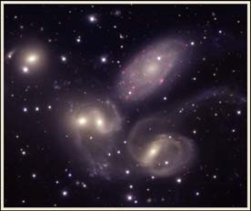Galaxies

BIO1130 Organismal Biology
6
Université d’Ottawa / University of Ottawa 10:22 AM

- Big bang theory – huge explosion and particulant matter is spewed across the universe.
- Certain material because of their large masses they were never pulled in to the sun.
- Same massing of materials were pulled together to form planets around the sun.
- 1st four were shielded by the Jupitor and Saturn from major debris flying through space.

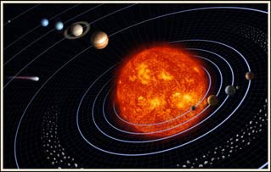

Our Solar system
Nat Geo Sun video

6. 5.
1. Mercury  2. Venus | 9. | 8. | 7.
3. Earth
4. Mars
5. Jupiter
6. Saturn
7. Uranus
8. Neptune
9. Pluto

4.
3.
1. 2.

BIO1130 Organismal Biology

© NASA

7

Université d’Ottawa / University of Ottawa 10:22 AM

- Particles from the asteroid were heavy metal. Nice Model proposes – Jupiter would cycle close to Saturn and as this happened they reversed the asteroids and caused the final bombardment of earth.

- Sun at the centre of solitary system – huge mass of planetarium material that is coagulating and coming together so fast that impacts have driven the heat up to the point of nuclear fusion, 4 Hydrogen molecules to form Helium (our sun), which creates a huge outflow of energy that we see as solar radiation, solar flares.

- Sun is also controlling planets spinning around it. Planets are nothing but solar material that coagulated into lumps but because of their orbits where never pulled in.

- Things closest to the sun are the heaviest planets. Further out planets are the frozen gas planets with less weight.

- Pluto got demoted so it is no longer a planet.

- The four in close, neighbors are much larger, any asteroids incoming, the two big planets Jupiter and Saturn took the hit from anything that would endanger earth, acting as a shield. Or it would get pummeled into the sun.

Order was not the way it was originally set up, as Jupiter and Saturn cause of their close proximity caused them to flip positions
causing them to spread the asteroids in the asteroid belt and mixed up all the asteroids that were there and sent gas asteroids
toward the sun and metal asteroids to the outside area of the solar system. Which caused a bombardment of asteroids on the planets with huge asteroid showers called the final bombardment – that stabilizes all the asteroids. Created all the craters on
the moon, made the earth from a planet that was solidifying, causing it to melt again and solidify over and over because of this
event.

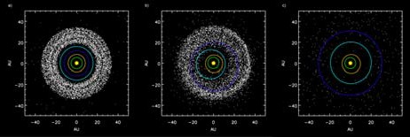Late heavy Bombardment The Nice Model

Jupiter
Uranus

Saturn

Neptune

8
10:22 AM

Planets are actually in a different place from where they started.
- Goldilaks zone or habital zone = area where water stays as a liquid form. (Green area on slide)
- Sun is enlarging in size. Interest of venus an mars being inhabitable.

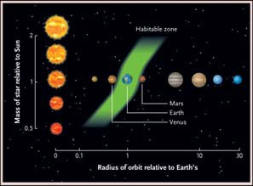Habitable zone

BIO1130 Organismal Biology
Université d’Ottawa / University of Ottawa
Figure 3.8

9
10:22 AM

- Until the last meteor bombardment we were building the solar system.
- Water is held in place because it is in goldilocks zone and the right size and mass that it can hold on to an atmosphere.
- Near the end of the Hadean eon - In the stabilizing it begins to cool. Gasses of water bought by meteorites (asteroids) begin to condense. Planet is big enough to keep water vapor in the atmosphere. As it moves into the atmosphere it cools and it turns to rain. Water from meteorites brought the carbon dust with it, melted and filling the terrestrial environment with water, which becomes the oceans.
- Planet goes through a whole series of vaporization.
- Planet starts to develop a crust with huge masses of water.
- Planet that is completely covered in water, no major landmasses. Smooth surface with a layer of water of the whole planet.

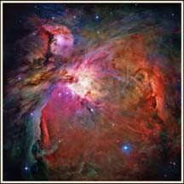Hadean eon

 Building phase
 Stabilizing phase

BIO1130 Organismal Biology
Orion nubula (NASA)

10

Université d’Ottawa / University of Ottawa 10:22 AM

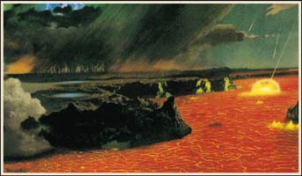Earth 4,000 Ma

Figure 3.7

BIO1130 Organismal Biology
11
Université d’Ottawa / University of Ottawa 10:22 AM

- Crusted rock on a molten core with large bodies of water. Hydrogen, carbon, and oxygen are now found on the earth.

- SPECIAL CREATION - Life was inoculated on the planet and it was suitable for every thing to be live there and it arrived by a
form of special creation. Extension of Oct 23, 4004 BCE concept.
- EXTRATERRESTRIAL ORIGINS (Panspermia) – life developed on another planet and arrived here from a frozen mass in an asteroid or meteorite (bacteria was able to survive in the frozen mass of a asteroid). The bacteria managed to survive re-entry into our planet and found life in the soup.
- CHEMICAL EVOLUTION - Compounds that are present on the planet are capable of undergoing evolution, increasing in complexity until they develop the kinds of chemicals we associate with the living world.

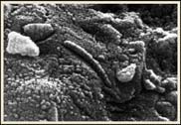Origins of life on earth

 Special creation
 Extraterrestrial origins (Panspermia)
 Chemical evolution

© NASA

BIO1130 Organismal Biology
12
Université d’Ottawa / University of Ottawa 10:22 AM

- How do we take water and a mixture of inorganic chemicals (from solubalization of minerals and rocks that form the earth or
chemicals resulted from venting from volcanic gassing) into the small organic molecules of life? Small organic molecules that are going polymerize together. (ORGANIC MOLECULES – STUDY OF LIFE) eg. Amino acids building protein chains, peptides building RNA or DNA, sugars binding together to form cellulose or glycogen.
- Lipids that are not soluble in water are going to interact and form some kind of membrane.
- One precondition – abundance of one compound (WATER)
- CELL – lipid bag in a aqueous core. Dissolved in the aqueous core are the complex macromolecules.
Origins of life on earth
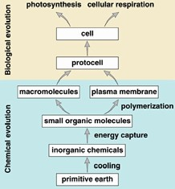
BIO1130 Organismal Biology
13
Université d’Ottawa / University of Ottawa 10:22 AM

- Water is a polar solvent with a (+) and (–) charge sticks to other water molecules like magnets. Polarity makes it a universal
solvent, life’s chemistry needs to be in solution to react with other compounds and chemicals.
-

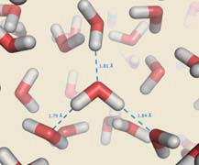Wacky water

 Cohesion, adhesion and surface tension
 Solvent properties
 Ice formation
 Temperature

BIO1130 Organismal Biology
14
Université d’Ottawa / University of Ottawa 10:22 AM

- Water as a polar solvent has an unequal distributions of electrons around it. Oxygen being larger sucks the electrons closer to
it. Causing electrons to have a slightly negative charge and the protons on the Oxygen molecule to have a slightly positive charge.
- Causing hydrogen bonding – the negative molecules will make an ionic bond with a adjacent molecule (bag of magnets).
-

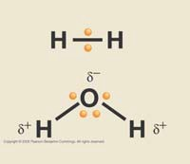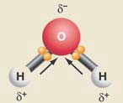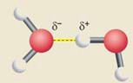Wacky water
Polar bonds and hydrogen bonding

Nonpolar covalent bonds

Polar covalent bonds

BIO1130 Organismal Biology
Figure F13

15

Université d’Ottawa / University of Ottawa 10:22 AM

SURFACE TENSION (example of cohesive property) - Water molecules on top have no molecules above to interact with so they have strong bonds with each other, plus bonds with the molecules underneath forming surface tension MAKING THEM HARD TO PULL APART.
- If you take a fine tube and put it in a beaker of water, the water in the tube rises. The water is creating a surface tension that is climbing the glass because it cannot interact with the neutral glass. It will pull the water with it to a certain height depending on the diameter of the tube.
- Plants – have to do 2 things 1. Collect light high up in the air, 2. Collect all water and nutrients from the soil. Developed micro
thin hollow (perfectly water proof so there is no interaction between the water and the walls of the tubes) tubes that connect
the leaves to the roots. Plant looses water through transpiration during photosynthesis, as it disappears it pulls water off of
the top of the tube and the cohesive property of the tube ensures that it pulls it in the roots to keep the supply going.
- Large trees spend absolutely no metabolic energy to get nutrients and water.

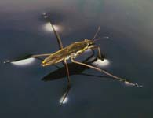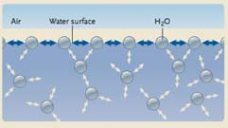Wacky water
Surface tension

Figure F-16

BIO1130 Organismal Biology
16
Université d’Ottawa / University of Ottawa 10:22 AM

-
- Because water is polar it can dissolve anything that has a charge on it (NaCl), Sodium atoms (+) Chlorine atoms (-) that work together in a perfect lattice. When dispersing a NaCl molecule in water, they separate evenly throughout the water so that every atom is completely separated. This also applies to the molecules of life – enzyme (protein) folds itself so its charges are on the outside so it is soluble in water. Nucleotides have charged side chains (soluble in water).
- Biochemistry of life is a water-soluble reaction.

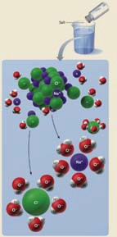Wacky water
Solvent properties

BIO1130 Organismal Biology
Figure F-17

17

Université d’Ottawa / University of Ottawa 10:22 AM

- If you can find a way to bring molecules together you can make things happen – that’s what an enzyme does.
- Enzyme – soluablized protein that has an active pocket that brings 2 things into the active pocket and because they are close together in a unique environment you can make a bond or break a bond.

- Molecules keep bouncing around inside the material until it has enough energy to shift to a vapor. Density decreases as it cools until it solidifies. Area will have fewer molecules as it is heated and more as it cools.
- 4°C – Cannot change the architecturally stable matrix of the molecules (interlocked into a perfectly predictable matrix), cannot change the matrix and it is puffed up from where it was at 5°C. Water becomes less dense at 4°C because of unique puffed up matrix and causes ice to floats, therefore ice forms on the top of the body of water forming a insulated covering over the water. That’s why oceans rarely freeze.
- When the earth was a giant ice ball, the water froze on the surface and below it was completely liquid water. In the liquid water life could still continue and could evolve from the volcanic gassing.
- Molecules at 4°C resist the Brownian motion stops – Lattice – affinity between the molecules resist the Brownian motion and instantly polymerize into this matrix (less dense so it floats).

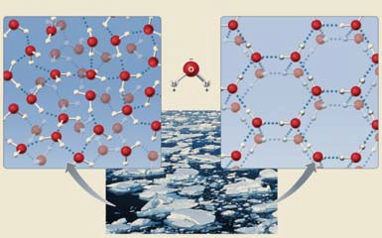Wacky water
Ice and water formation
4ºC near OºC

BIO1130 Organismal Biology
Figure F.15

18

Université d’Ottawa / University of Ottawa 10:22 AM

- Closest polar solvent is Ammonia, which is liquid at a very low temp and is very reactive (wouldn’t work well).
- Ammonia having the same hydrogen bonding has a specific heat is how much energy you have to supply to raise the temperature of a molecule 1°C higher.
- Nothing else on earth that has the same hydrogen bonding characteristics that create the same cohesiveness, surface tension, specific heats…
- Huge mass of water, of the right the size that it did not vaporize or disappear is a rare event. Water is the only thing that can
form life as we know it.

Wacky water
Temperature

Specific heats of some liquids (joules)
Liquids with high levels of hydrogen bonding
Ammonia (NH3) | 4.70
Water (H2O) | 4.18
Liquids with moderate levels of hydrogen bonding
Ethanol (CH3CH2OH) | 2.44
Ethylene glycol (HOCH2CH2OH) | 2.22
Liquids with low levels of hydrogen bonding
Benzene (C6H6) | 1.80
Zylene (C8H10) | 1.72
Sulfuric acid (H2SO4) | 1.40

19
10:22 AM

- Carbon – unique molecule because of its position in the periodic table. Perfectly symmetrical tetrahedral shape based on its orbitals (you can build phenomenally diverse things with this structure). Carbon is the only organic molecule that can be shaped to make anything.
- Life is based around H, C, N, O, P, and S (sulfur is coming from volcanic venting). SC NHOP
- Silicon has the same shape as carbon (universe is full of carbon), but is not as abundant, which is why it was not used for life.

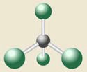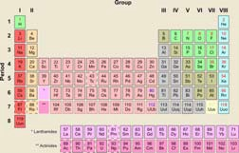Organic evolution

“Carbon is central to life…carbon atoms link in chains, bind with other atoms to make the array of organic chemicals that constitute life itself, from DNA to toenails” – Richard Fortey – Life

Carbon molecule

20
10:22 AM

- 1950 Miller-Urey - If we can create the same environment as the beginning of the earth with the same molecules, could we get nucleotides, DNA..
- Kreb cycle drives life = if we turn it the other way we can form life.
- Original earths atmosphere - high levels of methane’s (green house gasses: ammonia, hydrogen gas, water vapor) and lightning (created with electrodes and spark discharges; volcanic eruptions coincide with lightning and thunder). Refluxed (energized then cooled) this for a period of time. If we provide the same atmosphere and energy, we should be able to see small organic molecules/BIOMONOMERS (got 2,3 carbon units, cyclic sugars and all the building blocks) form. They did it again with C02 and cyanide and got the same results. The longer you fermented it, the inorganic molecules got more complex.
- Got everything you needed for lipids, sugars,… and so on.
- The earth was like this across its whole surface and it had 400 million years of doing this forming an organic chemical stew.
- The earth was like this across its whole surface for 400 million years (becomes a organic soup).

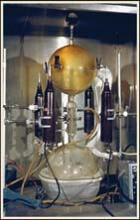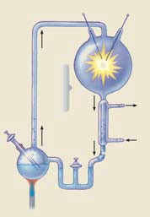Miller-Urey Apparatus

CH4 NH3 H2O H2

Gases
Electrodes

Spark discharge

Water out Condensor
Water in

Water droplets

Water and
organic compounds

Boiling water

Liquid water in trap

BIO1130 Organismal Biology

Figure 3.9

21

Université d’Ottawa / University of Ottawa 10:22 AM

- PREBIOTIC SOUP – found a way to get to the small organic molecules (fundamental units of DNA, Protein, and metabolism).
- Panspermia – this would be what the asteroid carrying the microbe (bacteria) fell into and turned into LUKA (Last Universal Known Ancestor).
- Special Creation – someone came along and threw bacteria into the soup.
- At the bottom of the sea, there are bacteria that can survive extreme freezing and heat. Magma is pouring up (black smokers) – dissolved gasses and high levels of heat, at these deep points of the ocean, extreme water pressure pushing down from above is squeezing these gasses from black smokers together so they have to get even hotter to break apart. Water can get to 104-107 before turning into a vapor. You have methane, hydrogen sulfite, ammonia gasses bubbling out (all the molecules in the Miller-Urey experiment without sparks). If you sample you find all the organic molecules of life along with bacteria that cannot live in oxygen. Bacteria that can survive extreme freezing and heat.
- Luka could still be surviving here, or this could be how the organic compounds were originally formed (2 plausible solutions).

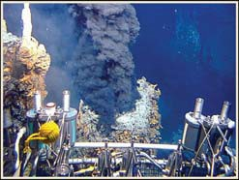Chemical evolution
Origins of organics (monomer)

 Prebiotic soups
 Hydrothermal vents
 Interstellar organics

Figure 3.10

BIO1130 Organismal Biology
22
Université d’Ottawa / University of Ottawa 10:22 AM

- Challenge – How do we make the polymers? Proteins (amino acids in chains), Carbohydrates, Nucleic Acids and nucleotides, which are water soluble.
- Lipids (insoluble in water/non-polar) are going to have to polymerize to form a plasma membrane, and molecules with water inside are going to have to form macromolecules.
- Carbohydrates have no catalytic power, need enzymes (not start of life).

- Problem - cannot get to the macromolecule level from small organic molecules (form Proteins from nucleic acids). EXPLAINED BELOW.

Chemical evolution
Biopolymers (macromolecules)

 Proteins
 Nucleic acids
 Carbohydrate
 Lipids

BIO1130 Organismal Biology
23
Université d’Ottawa / University of Ottawa 10:22 AM

- CENTRAL DOGMA – genetic information inside a cell is housed in DNA in a double stranded form with the second strand being the backup copy in the mirror of the message that is so critical for the cell to survive. Maintaining a genetic code in a copy and using the genetic copy to do the work that we have to do (mRNA).
- DNA contains the genetic information that codes for the catalysts that do the work inside the cell or build the structure in the cell.
- DNA – only gets touched occasionally to make a message, to start making a protein (working object).
- Separated the archive (DNA) from the worker (protein) with an intermediate (mRNA).
- How do we get DNA? from the organic molecules to a complex molecule.
- RNA was less complex, a strand of RNA that has the catalytic ability to make a copy of itself. Long strand of RNA folding on itself to order nucleotides in a sequence and make another copy of its self. Or a protein that folds on itself and in the pocket can make amino acids and build protein chains. (To see if either can replicate its self)
- You can reverse the central transcription step of the central dogma to create DNA (RNA TO DNA). (Discovery of HIV and Aids)
– Don’t need to look for DNA as our start point.

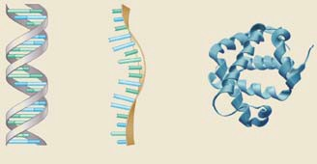Central Dogma of Biology 1. Replication
- Transcription
- Translation

1. 2. 3.

DNA RNA Protein
Figure 3.14
BIO1130 Organismal Biology
24
Université d’Ottawa / University of Ottawa 10:22 AM

- What came first DNA or Proteins?
- We now know that RNA strands can be catalytic – RNA strands contribute to the catalytic environments that make the peptide bonds.
- RNA catalytic features of ribosome: 1. First replicating polymer contained the RNA sequence, folded on itself and catalytically created a new version of its self. Supposition would be - Change occurs and some of the RNA molecules start assembling amino acids instead of nucleotides. RNA assembles a protein sequence that is capable of reforming the RNA molecule. RNA forms a protein (catalytic feature) that completes the tasks within the cell.
- Problem: RNA by itself is unstable, but if it reversed the central dogma and created DNA it would be a stable storage of the sequence that is used to do the catalytic work. (RNA IS BUILT FIRST)

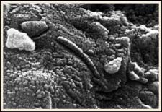Biotic chemistry (Polymers)

 Panspermia
 The RNA world

– Ribozymes
 Proteins first
 Clays

© NASA

BIO1130 Organismal Biology
25
Université d’Ottawa / University of Ottawa 10:22 AM

- Protein first world – proteins is the first replicating property. Catalytic function of a protein MAD COW DISEASE
- Mad Cow disease – protein that can alter other proteins to match its configuration and form (controller protein). Maybe first catalytic property was a protein, maybe in its structure it aligned up nucleic acids to make RNA strand, which becomes a DNA strand.
- Central Dogma – now has kinks in it that RNA or Proteins may come first.
- Biggest problem: one thing that has never happened, try and take amino acids and stick them together you get 1,2,3,4,5 then they all fall out of solution (precipitate). These polymers are not long enough to fold and optimize the charged surfaces on the outside to stay insoluble in water (Cannot spontaneously for polymers of a specific length).
PRIONS

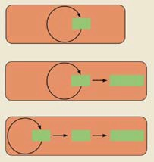Evolution of information flow from an RNA world

RNA

RNA

Protein

DNA
RNA

Protein

BIO1130 Organismal Biology
Figure 3.16

26

Université d’Ottawa / University of Ottawa 10:22 AM

- Clays – to get to the large molecules (long polymer chains that we cannot build spontaneously in aqueous solution), they get assisted by clays. Charged and organized array of the compounds that make clays are such that they align and bring into close proximity 10-15 nucleotides – Catalysis - taking two reactive components (amino acids) in such a close proximity and alignment that we increase the chance for spontaneous interaction, leading to the amino acids to create the first big peptide (which will fold).
- NO ONE HAS MADE THIS WORK YET BUT THIS NEEDS TO BE DONE. (They understand it, but have not been able to make it happen in an inorganic environment.

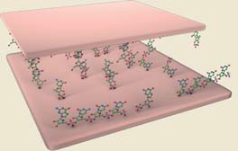Biotic chemistry (Polymers)

 Panspermia

Figure 3.12
 The RNA world

– Ribozymes
 Proteins first
 Clays

BIO1130 Organismal Biology
27
Université d’Ottawa / University of Ottawa 10:22 AM

- We have the solution now we need to wrap it in a plasma membrane.
- We have lipids, which form long chain fatty acids (NEED TO GET OIL DROPLETS SOLUBLE IN WATER)
- Oil droplet Microsphere - Soluablize oil drops in water – Shake well enough that oil droplets separate and are completely surrounded by water.
- Also will get Micelles (Aqueous content) that are not solid droplets of oil, but they form packaged inside of them a part of the environment that was there (aqueous core).

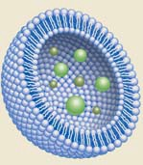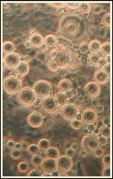Bubble hypothesis for cells

- Microsphere
- Micelles

(Liposomes)
- Protobionts
(Protocells)

BIO1130 Organismal Biology
Figure 3.13

28

Université d’Ottawa / University of Ottawa 10:22 AM

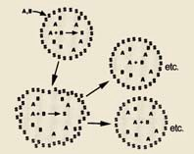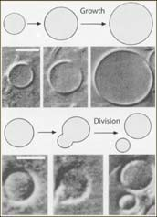Micelle replication

BIO1130 Organismal Biology
29
Université d’Ottawa / University of Ottawa 10:22 AM

- Protobiont - Lipids with polar heads and hydrophobic tails, the lipids inside the Micelle core when shaken up, form with the lipid wall and form a bi-lipid layer with an aqueous core.
- You can take a chemical reaction A + B = S (non-soluble). They took “S” and made a micelle with “S” as the outer boundary (lipid layer) and trapped inside was some “A” and “B”. They would connect with each other and form “S” and would incorporate itself in the bi-lipid outer layer. As it grew to a certain size it would duplicate itself. Now we have the organics inside the cell and the beginning of a cell.

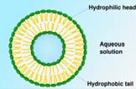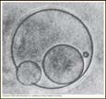Biological evolution:
Protobionts

BIO1130 Organismal Biology
30
Université d’Ottawa / University of Ottawa 10:22 AM

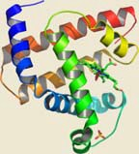- They took the components to make a lipid bi-layer (protocell), and shook it up in a mixture that contained phosphatase and amylase. The phosphatase and amylase are trapped inside, then they took the micelles (washed them) and put them inside a solution containing glucose phosphate (substrate to phosphatase). Glucose phosphate diffuses in and molecules of glucose stick to the amylase (starch). The phosphate builds up as the other product and eventually moves out of the cell (concentration gradient). Amylase forms small maltose product that starts to diffuse out of the cell. (SHOWS WE CAN CONTAIN ENZYMATIC ACTIVITY IN A BILIPID LAYER.

Biological evolution:  Protobionts Glucose-phosphate  Glucose-phosphate  Phosphatase  Starch  Phosphate Amylase  Maltose  Maltose  BIO1130 Organismal Biology | 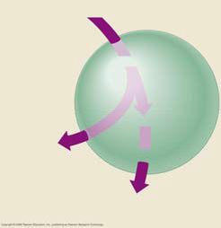
31
Université d’Ottawa / University of Ottawa 10:22 AM

- Organasists – magical essence was the genetic program and emergence

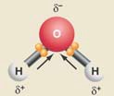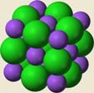What is life and emergence?

Organicists (1930) – vital force replaced by genetic program and the importance of emergence.
- Emergence - More than the sum of the parts

Water Sodium
chloride

BIO1130 Organismal Biology
32
Université d’Ottawa / University of Ottawa 10:22 AM

– in living systems the whole being more then the sum
of the original parts (NaCl) properties change dramatically when two atoms come together. Na (volatile, flammable metal that will explode in the presence of O₂), Cl₂ (normally a poisonous gas), but when you bring the two together the form salt. It
dissolves in water and the ions separate but they are not poisonous or flammable.
- Oxygen binding by proteins. Myoglobin has one iron in the center and can bind one molecule of oxygen.
- Hemoglobin – has 4 subunits that are very similar to Myoglobin, it binds 4 molecules of oxygen, but it does it infinitely faster if you had 4 molecules of Myoglobin. As soon as any oxygen is locked into any of those 4 positions it immediately entices the other 3 spots to fill with oxygen right away. If you had 4 molecules of Myoglobin and 1 molecule of Hemoglobin, the Hemoglobin would bind 4 molecules of O₂ quicker. (Emergence – more then a whole of its parts)
What is life and emergence?

Emergence - More than the sum of the parts
Myoglobin 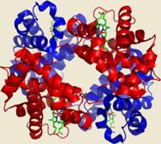
Hemoglobin
BIO1130 Organismal Biology
33
Université d’Ottawa / University of Ottawa 10:22 AM

What is life?
- Organized – with the cell as the fundamental unit (life is a highly organized structural entity (cell as fundamental unit and within the cell there is a highly organized structure of organelles.
- Self replicating - Life from life with a genetic program
- Metabolizing - Capturing and releasing energy – takes energy to keep the organized state (ATP)
- Self regulating - A delicate balance – There is checks to keep things in balance. The organization is controlled by the self regulating nature of the system.
- Reproduce – life from life – Living things make living things.
- Evolving - Adapting and changing – changes to the environment around it, eg. can find no food it will go looking for food and will sense it and find it (Sensing and interacting with the world).
- Responding - Sensing and interacting with the surrounding world
- Growth – increase in size - (Single cell organisms don’t actually grow, they grow but split)

