- Healthy Eating
  - Hunger: the feeling you get after not eating
  - Appetite: a learned psychological desire to eat whether or not we are hungry
    - Stimulations: cultural and social meanings attached to food, convenience and advertising, habit or custom, emotion comfort, nutritional value, social interaction, trends, ect
  - Eat to live: eating to maintain body functions
  - Live to eat: eating to satisfy out appetite and/or cultural needs
  - Recipe for weight gain: eating three large meals combined with a physically inactive lifestyle
  - Nutrition: science that investigates the relationship between physiological function and the elements of the food we eat
  - Nutrient: water, proteins, carbs, fats, vitamins, minerals
  - Canadian diet: high in fat and calories with typically large servings of red meat, potatoes and rich deserts
- Monitoring Calories
  - Calorie: unit of measure that indicates the amount of energy obtained from a particular food
    - Eaten in forms of protein, fats, carbs
    - No calories: water, vitamins, minerals
- Canadian food guide
  - 1. Promoted a pattern of eating to meet nutrient needs
  - 2. Promoted health
  - 3. Minimized the risk of nutrition related chronic disease
  - Obtain the minimum number of service before eating “extras”
- Digestive Process
  - Digestive process: process by which foods are broken down and absorbed or excreted by the body
    - Your mouth prepares the food by increasing saliva production.
      - Saliva: contains mostly water, which aids in chewing and swallowing, but it also contains important enzymes that begin the process of food breakdown.
        - Amylase: initiates the digestive process for carbs
    - Esophagus: food passes down it
      - 23-25 centimetre tube that connects the mouth to the stomach
      - peristalsis: a series of contractions and relaxations by the muscle lining your esophagus moves food
    - stomach: food mixes with enzymes and stomach acid
      - hydrochloric acid works with pepsin, to break down proteins
      - secretes enough mucus to protect the stomach lining from these harsh digestive juices
    - small intestine: 8 meter long coiled tube containing three sections: duodenum, jejenum, ileum.
      - Each section secretes digestive enzymes that contribute to the breakdown of proteins, fats, and carbs (with the help of liver (filters, bile) and pancreatic (insulin, glucagon) enzymes.
      - Nutrients are absorbed into blood stream and supply body cells with energy
      - Liver determines if nutrients are stored, sent to cells or organs, or excreted
      - Solid wastes consisting of fibre, water, and salts are dumped in large intestine where water and salt is reabsorbed and fiber passes through the anus
  - take 24 hours.
- Water
  - We could survive much logner without food than without water
  - Dehydration: abnormal depletion of body fluids
    - Causes health related issues within hours
    - Dead after a few days
  - 50-60% of our total body weight is water
  - bathes cells, aids in fluid and electrolyte balance, maintains pH balance, transports molecules and cells throughout the body
  - major component of blood
  - 6-8 glasses of water is necessary – we intake water through foods
  - athletes lose 1 to 2 litres of fluid per hour in hot, humid weather while excercising
  - if you wait till you are thirsty, you have waited to long
  - monitor color of urine
    - pale yellow: sufficiently hydrated
    - darker yellow: body needs fluids
- Proteins
  - Proteins: major components of nearly every cell, often reffered to as the “building blocks”
  - Next to water they are the most abundant substances
  - Development and repair of bone, muscle, skin, and blood cells
  - Key elements of the antibodies that protect us from disease
  - Aid in transport of iron, oxygen, nutrients
  - Involved in fluid, electrolyte, and acid-base balance (pH)
  - 4 calories of energy per gram of intake (4 cal/g)
  - 0.8g/kg of body weight per day, 12 to 20% of total energy intake
  - amino acids: composed of chains that link together like beads
    - 22 different amino acids are found in animal tissue
    - humans can not synthesize all of them
    - essential amino acids: 8 amino acids that the adult body cannot make adequately, must be obtained from food
    - complete proteins: found in foods that naturally contain the eight essential amino acids
      - quality of protein depends on the presence of amino acids in digestible form and in amounts proportional to body requirements
      - most common source is meats, poultry, seafood
    - incomplete proteins: proteins from plant sources that are missing one or two essential amino acids
      - must combine foods to eat all 8 essentials, for example, peanut butter on break
      - plant sources are legumes, grains, nuts and seeds, and vegetables
- Carbohydrates
  - Carbohydrates: supply us with energy , 4 calories per gram (4 Cal/g) needed to sustain normal daily activity
  - Metabolized more quickly and efficiently than proteins
  - Easily converted to glucose
  - preferred fuel for red blood and nerve cells
  - important role in functioning the internal organs, nervous system, muscles, and are the best energy for endurance athletes.
  - Simple carbohydrates: found primarily in fruits
    - Most common form is glucose. Simple sugars are converted to glucose to provide energy.
    - Fructose is another simple sugar found in fruits and berries
    - Classified as monosaccharades because they contain one molecule of sugar
    - Made up of disaccharides which are a combination of two monosaccharides or two molecules of simple sugar
      - most common form is table sugar, must be broken down into simple sugars first
    - monosaccharides: glucose, glactose, fructose
    - disaccharides: maltose, lactose, sucrose
  - Complex carbohydrates: found mostly in grains, cereals, dark green leafy vegetables, potatoes.
    - Made up of polysaccharides which are formed from the combination of long chains of saccharides.
    - Also must be broken down into simple sugars first before they can be utilized
    - Better half life for insulin
    - Two forms: starch and fibre
      - Starch: make up the majority of the complex carbs, obtained from flours, breads, pastas.
        - Stored in the muscles and liver in a polysaccharide form called glycogen.
        - Useful for a sudden burst of energy by breaking down glycogen to glucose
  - Free sugars: monosaccharides and disaccharides added to foods by the manufacturer or consumer.
  - If stuff is moved through the small intestine more rapidly, indigested disaccharides or unabsorbed monosaccharides will reach the colon which can result in diarrhea
- Fibre
  - Indigestible portion of plant foods that helps move foods through the digestive system and softens stools by absorbing water
  - Dietary fibre: nondigestible part of plants such as leaves, stems, and seeds
  - Functional fibre: nondigestible form of carbs with health benefits that are extracted from plants or manufactured
  - Total fibre: combination of dietary and functional fibre.
  - Insoluble fibers: associated with gastrointestinal benefits and reduce the risk of several forms of cancer
    - Attract water by clinging to it, thus facilitating passage of the contents of the large intestine for excretion
    - Main ones: lignin (in veggies), cellulose (in wheat)
  - Soluble fibres: absorb water and swell to form gels that trap nutrients such as glucose and slow their absorption in the blood
    - Food stays longer in the small intestines, giving “fullness”
    - Sources include oat bran, oatmeal, barley, legumes
  - 25 g/day for women and 38 g/day for men
- fats
  - fat is a source of essential fatty acids (omega – 3 and omega – 6)
  - maintenance of healthy skin and hair, insulation of the body organs against shock, maintenance of body temperature, proper functiontioning of the cells themselves
  - carry the fat soluble vitamins to the cells (Vitamin A, D, E, K)
  - 9 calories per gram (9 cal/g)
  - triglyceride: most common form of fat circulating in blood
    - 95% of total body fat
    - when we consume too many calories, the excess is converted into triglycerides, which are stored in obvious places in our bodies
  - cholesterol: remaining 5% of body fat is composed of this
    - can accumulate in inner walls of arteries, causing narrowing of the channel through which blood flows
  - saturated fats:
    - come from animal sources such as meats and dairy products,
    - solid at room temperature
    - those not able to hold any more hydrogen in their chemical structure
  - unsaturated fats:
    - come from plants and most vegetable oils
    - liquid at room temperature
    - have room for additional hydrogen atoms in their chemical structure
  - monounsaturated fats and polyunsaturated fats refer to the relative number of hydrogen atoms missing.
    - Peanut and olive oils are high in monounsaturated fats
    - Corn, sunflower oil are high in polyunsaturated fats
  - Trans fatty acids:
    - Produced by adding hydrogen molecules to liquid oil to make the oil solid
    - “partially hydrogenated” fats stay solid or semi solid at room temperature
    - change into irregular shapes at the molecular level, priming them to clog arteries
    - in margarines, commercially baked goods, deep fried
    - increase “bad” cholesterol and decrease “good” cholesterol
  - lipoproteins: High Density Lipoproteins /Low Ddensity Lipoproteins
- Vitamins
  - Vitamins: are potent, essential, organic compounds that promote growth and help maintain life and health
  - Help maintain life and health, nerves and skin, produce blood cells, build bones and teeth, heal wounds, convert food to body energy
  - Age, heat, other conditions can destroy vitamins in food
  - Fat soluble: they are absorbed through the intestinal tract with the help of fats
    - Vitamins A, D, E, and K
  - Water soluble: they are easily dissolved in water
    - Generally excreted and cause few toxicity problems
    - B complex vitamins and vitamin C
  - Vitamin supplements are unnecessary and in certain instances may even be harmful
- Minerals
  - Minerals: inorganic, indestructible elements that aid physiological processes in the body
  - Without minerals, vitamins could not be absorbed
  - Macrominerals:
    - Minerals that the body needs in fairly large amounts
    - Sodium, calcium, phosphorous, sulfur, chloride, magnesium, potassium
    - Over 5g in the body per day
    - 7 different kinds
  - Trace minerals:
    - only trace amounts of these minerals are needed
    - iron, zinc, manganese, copper, iodine, cobalt
    - less than 5g in the body
    - 15 different kinds
  - Sodium
    - Necessary for the regulation of blood and body fluids
    - Transmission of nerve impulses, for heart activity, for muscle contraction
    - Most common source is table salt
    - Link between sodium intake and hypertention (high blood pressure)
  - Calcium
    - Vital role in building strong bones and teeth contracting muscles, clotting blood, transmitting nerbe impulses, regulating heartbeat, balancing fluid within cells
    - Helps prevent osteoporosis
    - Recommended 1000 milligrams of calcium per day
    - Soft drinks may cause excretion of calcium because of the phosphoric acid added
    - More than half of our intake comes from milk
    - Vitamin D improves absorption of calcium
  - Iron:
    - Most common nutrient deficiency worldwide
    - Anemia: a problem resulting from the bodys inability to produce hemoglobin, the bright red, oxygen- carrying component of the blood
      - Blood cells receive less oxygen, and CO2 wastes are removed less efficiently
      - Results in the person feeling tired and run down
      - Immune system becomes less effecting, more illness
    - Iron toxicity: too much iron in the blood
    - Women suffer more from iron deficiency because they eat less than me n and because of blood loss from menstrual flows
    - Vitamin C increases absorption
    - Caffeine decreases absorption
  - Eating too much meat:
    - Men who eat red meat as a main dish five or more times a week are four times more likely at risk of colorectal cancer than men who eat red meat less than once a month
    - Heavy red mat eaters are more than twice as likely to get prostate cancer
    - High veggie and fruit dietary intake may lower the risk of lung cancer in smokers
    - For every three servings of veggies or fruit consumed per day, men can expect a 22% lower risk of stroke
  - Vegetarianism:
    - Vegans: avoid all foods of animal origin, including dairy &eggs
    - Lacto-vegetarians: eat dairy products but avoid flesh foods, more common
    - Ovo vegetarians: add eggs to their diet
    - Pesco vegetarians: eat seafood, dairy, eggs
    - Semi vegetarians: eat poultry, seafood, dairy, eggs
    - Better cholesterol levels, fewer bowel problems, lower risk of heart disease
    - At risk for calcium, iron, and zinc deficiencies
    - 4% of canadians
- Eating well as a student
  - Fast foods: eating on the run
    - High in sodium
    - Analyze nutritional items on menu
    - Limit mayo or sauces
    - Put on your own ketchup in moderation
    - Avoi lard based or other saturated fat products
    - Choose boiled rather than fried
    - Choose low fat skim milk or water instead of soft drinks
  - When funds are short:
    - Do not shop when hungry
    - Buy fruits and veggies in season for lower cost and nutrients
    - Shop at discount warehouses or food chains
    - Purchase meats in volume and freeze for future needs
    - Cook large meals and freeze smaller portions for later use
    - Buy canned or frozen fruits and veggies
  - Healthy eating in residence:
    - Eat small and frequent meals, don’t skip any
    - Watch out for emotional eating during exams
    - Watch out for social events
    - Alcohol has 7 cal/g
- Food borne illnesses
  - 10 000 reported cases per year, many unreported cases
  - food borne illnesses can be life threatening to those who are old, young, or with a compromised immune system
  - increase in food borne illnesses related to an increased in fruits, veggies, ect
  - contaminated by being watered with contaminated water, fertilized with “organic” fertilizers, or not subjected to same regulations
  - E coli:
    - Lethal bacterial pathogen
    - Can survive in cow manure for up to 70 days
    - Salts and preservatives are used to kill them
  - More than 30% of illnesses result in unsafe handling of food at home

Reducing illnesses:
    - Pick up packaged and canned foods first and frozen foods and perishables at the end
    - When shopping seafood, buy from markets that get their supplies from approved sources
    - Meat and seafood should be kept in the fridge for no more than two days
    - Leftovers should be eated within 3 days
    - Use a thermometer to ensure all meats are cooked
    - Thaw frozen foods in fridge and not at room temperature
    - Wash hands and surfaces before and after food preparations
- Food Allergies
  - 8% of children, and a smaller portion of adults are allergic
  - food allergies: occur when the body overreacts to normally harmless proteins, perceiving them as allergens
    - produces antibodies that activate immune cells knkown as histamine, triggering allergy symptoms
    - range from a case of hives or a body rash to swelling of certain body parts (especially lips), to pain, itchiness, diarrhea, nausea, vomiting
    - in extreme cases, irregularities in breathing and heartbeat is experienced, along with blood pressure fluctuations
  - most common is soybeans, legumes, nuts, shellfish, eggs, wheat, milk
  - cross reactivity:people are often allerging to a whole family of foods
  - food intolerance: occurs in people who lack certain digestive enzymes and suffer adverse effects when they consume substances they are intolerant to
    - ex: lactose intelarance
    - reactions to food additives, such as sulphites and MSG

- Obesity and Overweight
  - Overweight:
    - refers to a weight greater than expected for a specific height
    - usually determined from height-weight charts or calculating BMI
  - Obesity:
    - Excessive accumulation of body fat such that the individual is at increased risk of developing health problems
  - Weight by itself or in combination with health is not a valid indicator of obesity or fatness
  - Risks include chance of developing atherosclerosis, coronary artery disease, hypertention, colon cancer, ect
  - Poor body image and reduced self esteem
- Determining the right weight for you
  - Depends on your body structure and how your weight is distributed
  - BMI is obtained by dividing your weight by your height squared
  - A BMI range of 18.5 and 24.9 is considered a healthy weight
  - BMI over 25.0 is overweight and increases health risk
  - BMI greater than 30 is “obese”
    - 30-35 – obese class 1
    - 35-40 – Obese class 2
    - 40 and up – obese class 3
  - women have more fat levels related to their sex hormones, pregnancy and menopause
  - fat free mass: made up of all the bodys components other than fat, such as body water, muscle, bones, ect
  - minimal amount of fat is necessary for insulating the body, cushioning between parts of the body, and maintaining several body functions
  - low body fats can disrupt menstrual cycle
- 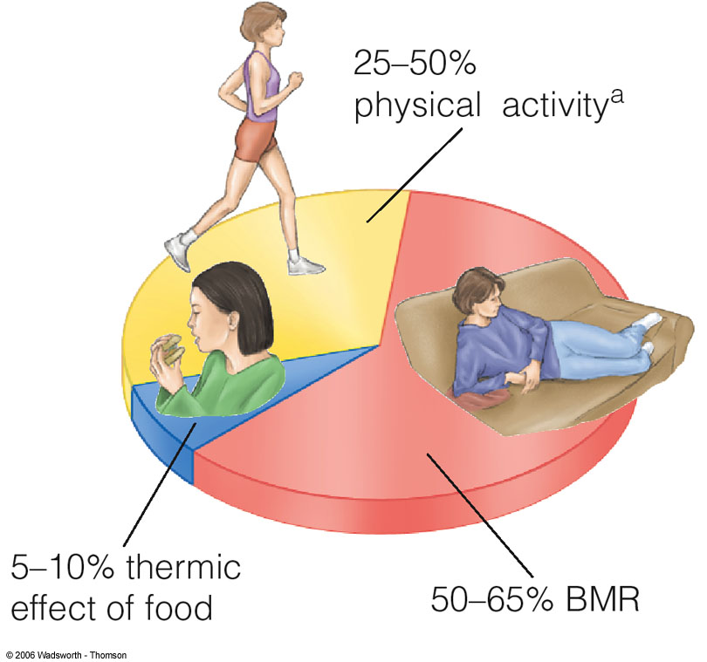
  - Thermic effect of food is where more energy is used to break it down rather than the energy it gives by consummation.
- Assessing your body fat content
  - Estimates of body fat are considered most important for the health related components of physical fitness
  - Dual energy X ray absorptiometry (DXA)
    - Measures bone mineral content and lean fat tissue
    - Requires a low radiation exposure from a low energy and high energy photon beam
  - Hydrostatic weighing:
    - Previously considered the gold standard for measuring body composition
    - Measures the amount of water a person displaces when completely submerged
    - Fat tissue has a lower density than muscle or bone, fat can be computed using a persons underwater and out of water weights
  - Air displacement plethysmography (ADP)
    - Total body volume is measured from air displacement which an estimate of body fat can be made
    - Major limitation is that density of fat and fat free mass is considered constant
    - Another limitation is that the bone mineral content and density varies throughout life
  - Skinfold measurements
    - Most commonly used method to estimate body fat
    - A person grasps fold of skin and the underlying tissue with the thumb and index finger and then a specially calibirated ins trument called a skinfold caliper is applied to take the measurement
    - Formulas can be used to predict total body fat
    - Errors can come from the failure to account for certain age, sex, and ethnic differences
  - Waist circumference
    - Assessing abdominal fat by measuring the grith (circumference), measurement at the superior border or top of the iliac crest or hip bones
  - Bioelectrical impendance analysis:
    - Involves sending a weak electrical current through the body
    - Based on the greater electrolyte and water content of fat free versus fat tissue
  - Ectomorph: very small joints
  - Endomorph: in contrast to ectomorph, very thick joints, more likely to hold onto body mass
  - Mesomorph: in between
  - Your somatotype is predetermined at birth

- 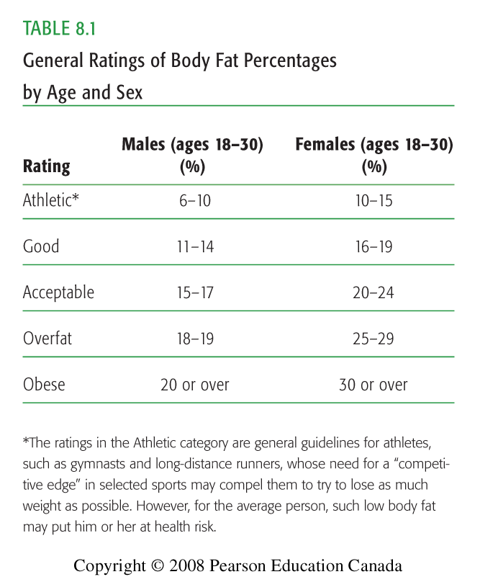

- Managing your weight
  - Calorie: unit of measurement that indicates the amount of energy obtained from a particular fat
  - A kilogram of body fat contains approximately 7500 calories
  - Basal metabolic rate: bare amount of ATP you need to fuel your body for bare existence. Anything more is for physical activity
  - Caloric output depends on:
    - The more you weigh, the greater the caloric cost of the physical activity
    - How intensely you participate in the physical activity
    - How long you do the physical activity
    - Body weight x intensity x time is the amount of calories burned
- Is dieting healthy?
  - Weight goals should be set to reduce health risks and address medical problems and help people improve their ability to perform daily tasks without stress or strain, rather than to achieve an “idea” weight or shape
  - Weight loss programs that promote qualitative rather than quantitative changes in food intake improve health and long term weight maintenance
  - More easily sustained than those that force people to severely restrict intake of calories or specific foods
  - Dieting contributes to the development of eating disorders
- Improving eating habits
  - Determinants include psychological state (whether or not we are hungry), food preferences, nutritional knowledge, perceptions of healthy eating, and psychological factors
  - Interpersonal environment created by our family and peers, the physical environment which determines food accessibility, economic and social environment, and the cultural milieu
  - Many people eat compulsively when stressed, when they have problems with relationships, smells of particular foods, or routines
- “miracle” diets
  - very low calorie diets (VLCD): related to health risks
    - deprive your body of food
    - body makes adjustments to save you from inevitable organ shutdown
    - first it depletes its energy reserves to maintain its supply of glucose
    - one of its first reserves that it turns to is lean protein tissue
    - weight loss rapidly occurs because of significant water loss
    - over time body begins to run out of liver tissue, heart muscle, blood, and so on. Only then will it turn to fat reserves
    - ketosis: body adapts to prolonged fasting or carbohydrate deprivation by converting boy fat to ketones, which can be used as fuel to some brain cells
    - side effects: blood sugar imbalances, cold intolerance, constipation, ect
- trying to gain weight:
  - monitor your physical activity
  - eat more eat more often. Spend more time eating, eat high calorie, nutrient dense foods
  - drink more of your calories. Instead of water, choose milk or juice
  - try to relax. “hurry syndrome”
- risk factors for obesity
  - when you take in more calories than you burn, you gain weight
  - shape and size of the individuals body is largely determined by the shape and size of the parents body
  - somatotype: classification of the individuals physique or body as a whole and is comprimized of three components:
    - endomorphy:
      - describes the relative fatness of the body. Roundness and soft appeal.
      - Large abdomen typically reported a history of weight problems beginning in childhood
    - Mesomorphy:
      - refers to the relative muscularity of the body
      - Have a tendency to gain weight later in life
    - Ectomorphy:
      - Relative linearity of the body
      - Tall with slender frames
      - Few difficulties with weight controle
  - Heredity plays a more subtle role, obesity has a stronggenetic determinant
  - It may be that our genes predispose us towards a certain satiety and feeding behaviors
- Endocrine influences: the hungry horomones
  - Many people attributed obesity to problems with their thyroid gland and resultant horomonal imbalances
  - Ghrelin: one horomone that researches suspect to play a role
    - Ghrelin levels are produced in stomach
    - Leptin and ghrelin are both believed to be influenced by a lack of sleep
  - <2% of obesity cases endocrine related (hypo or hyper thyroid)
  - setpoint theory:
    - A persons body has a setpoint of weight at which it is programmed to be comfortable.
    - If your setpoint is at 70 kilograms, you will gain and lose weight fairly easily within a given range around that setoint?
    - It is possible to raise ones setpoint over time by continually gaining weight and failing to engage in regular physical activity
    - Conversely, reducing caloric intake and being physically active over a long period of time may slowly decrease ones setpoint.
  - Hunger: inborn physiological response to nutritional needs
  - Appetite: a learned response to food tied to an emotional or psychological craving for food often unrelated to nutritional need
  - Satiety: people generally feel satiated or full when they have satisfied their nutritional needs and their stomach signals “no more”
  - In an obese person, it is possible that the monitoring system does not work properly and that the cues to eat are more frequent and intense than in people of a healthy weight
  - Others say that People who are healthy weight may send more effective messages to the hypothalamus
  - Adaptive theromogenesis: some people can consume lots of food without gaining weight because the appetite centre of their brains speed up metabolic activity to compensate for the increase consumption
  - Brown fat cells: specialized type of fat cells that may send signals to the brain which controls the thermogenesis response
  - Hyperplasia: increase in the number of fat cells, normally occurs during specific period of the growth process
    - Fat cells can also increase in numbers when an individual is under chronic positive energy balance and their current fat cells are “full”
  - Hypertrophy: fat cells have the ability to increase in size
  - Fat gain is tied to the number of fat cells in the body and the capacity of the fat cells to increase in size
- Metabolic rates and weight
  - Basal metabolic rate: the amount of energy the body requires at complete rest
  - BMR fluctuates considerably. The younger you are, the higher BMR you have
    - That’s because cells undergo rapid subdivision in young people, which requires energy
    - Highest during infancy, puberty, pregnancy
  - BMR ins influenced by body compositon
    - Muscle tissue is highly active even at rest, compared to fat
    - The more muscle tissue you have, the greater the BMR
    - Men have a higher BMR than women because they have a greater muscle mass
  - Yo-yo diets:
    - People repeatedly losing and gaining weight
    - Lower BMR in the process which fails the diet
    - When dieters begin to eat agai after the weight loss, their BMR is set lower, making it almost certain that they will regain the weight lost
    - May also have a negative effect on an individuals risk for heart disease
  - Weight bias:
    - Refers to negative attitudes that have a detrimental effect on interpersonal interactions and activities with individuals who are obese
    - Can lead to social isolation and a host of other problems
    - Higher rates of eating disorders, issues with self esteem, difficulties in obtaining health care, ect
- Eating disorders
  - Involve severe disturbances in eating behaviors, unhealthy efforts to control body fat and weight, as well as abnormal and unrealistic attitudes about ones body weight and shape
  - Individuals who develop this have low self esteem
  - 90-95% of all diagnosed cases occurring in women between age 15-24
  - Emigrants from cultures where eating disorders are rare are more likely to develop eating disorders when they move
- Anorexia nervosa
  - Obsession with controlled eating
  - Usually leads to self starvation motivated vy an intense fear of taining weight, along with an inability to see ones body the way it really is
  - First sign is failure to gain weight associated with normal growth rather than actual weight loss
  - 0.5-1% of females are diagnosed:
    - significant weight loss without any logical reason
    - inability to maintain a weight considered healthy for age and height
    - desire to be thinner
    - fear of becoming fat
    - distorted body image
    - weight and shape dictates how one fees about one self
    - reduction in eating, denial of hunger
  - starvation damages bones, muscles, organs, and immune, nervous, and digestive systems
  - lose their hair or develop excessive fine facial and body hair
  - menstrual hair stops as well
  - 10-15% die as a result of this disorder
- bulimia nervosa
  - cycles of binge eating and purging
  - purging behaviors include self induced vomiting, laxatives, ect
  - binge: rapid ingestion of a large amount of food at one time
  - body weight of individual is usually within a healthy weight range
  - acid in vomit causes tooth enamel to dissolve
  - calluses may also appear on outer fingers
- binge eating disorder
  - engage in recurrent binge eating but, unlike those with bulimia nervosa, do not purge
  - occurs in individuals who are obese, compulsive overeating
  - 1-3% of young females
- eating disorder not otherwise specified
  - when an individual can not be clearly diagnosed
  - still have obvious problems with their eating
    - purging after normal eating
    - chewing food repeatedly and then spitting it out
    - bing eating and purging without regularity
- disordered eating
  - wide range of abnormal eating behaviors
  - chronic restrained eating, compulsive eating, habitual dieting, irregular chaotic eating patterns where hunger and satiety are ignored
  - negative health implications for overall and emotional, spiritual, social, physical health
  - highly prevalent in our culture
- anorexia athletica
  - not recognized as a diagnosis
  - exercising beyong the requirements
  - being fanatical about weight and dietary intake
- treating eating disorders
  - likelihood of success being greatest when diagnosis is early and the individual acknowledges the need for treatment
  - often need to be individualized treatments and hospitalization
  - individual and group psychotherapy provide an opportunity to enhance self confidence, self esteem, and feelings of power and control
- body composition
- 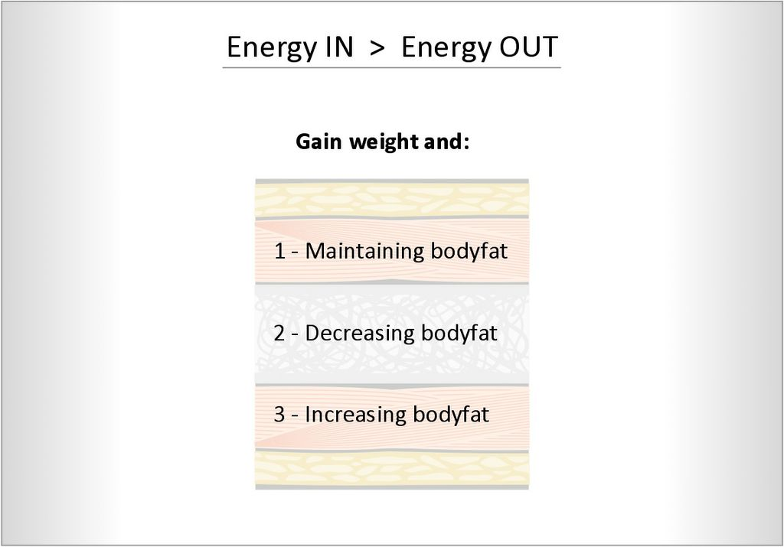
- 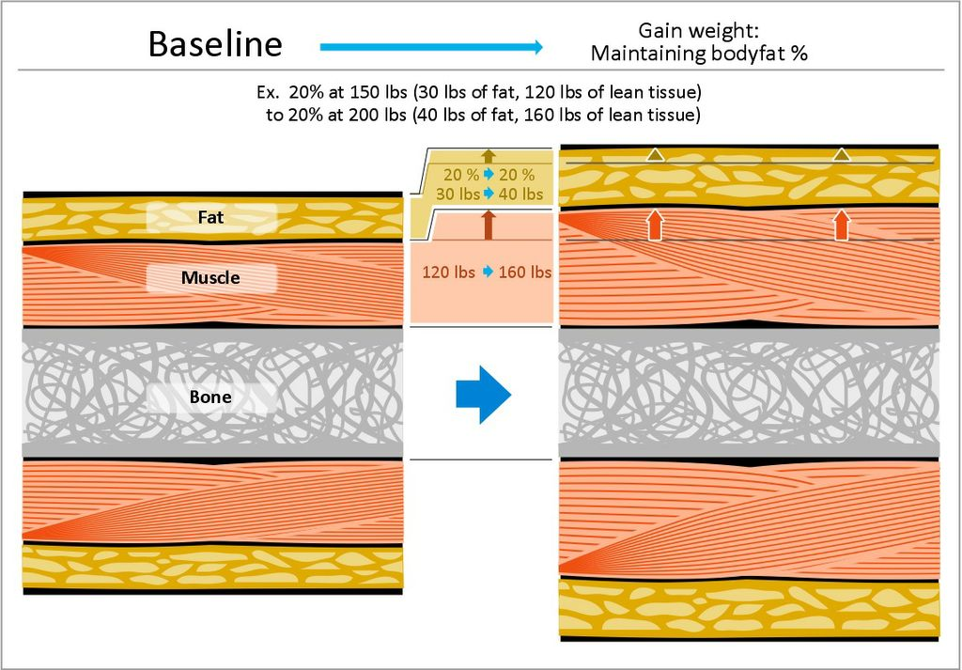
- 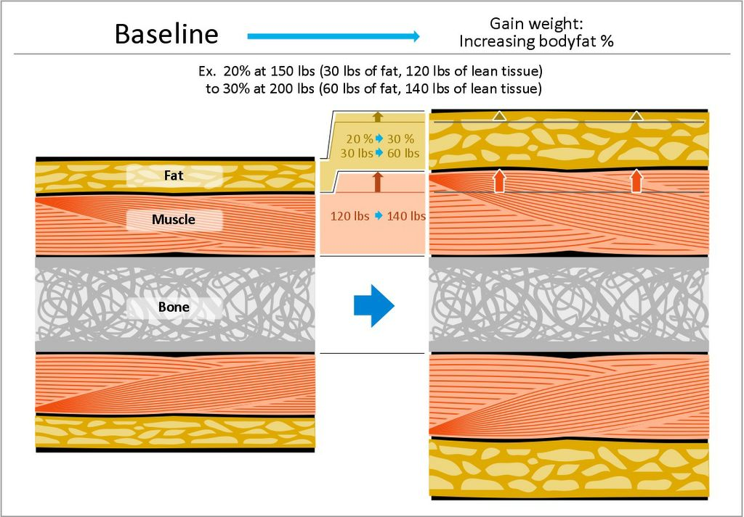
- 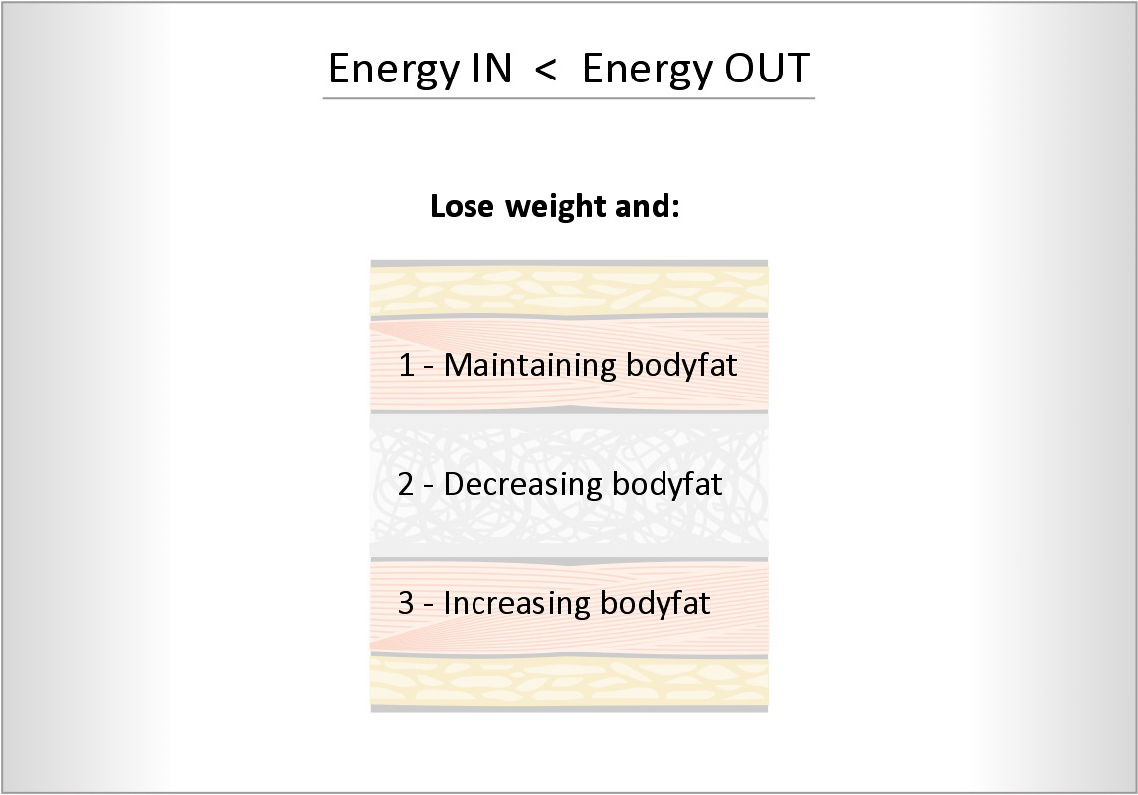
- 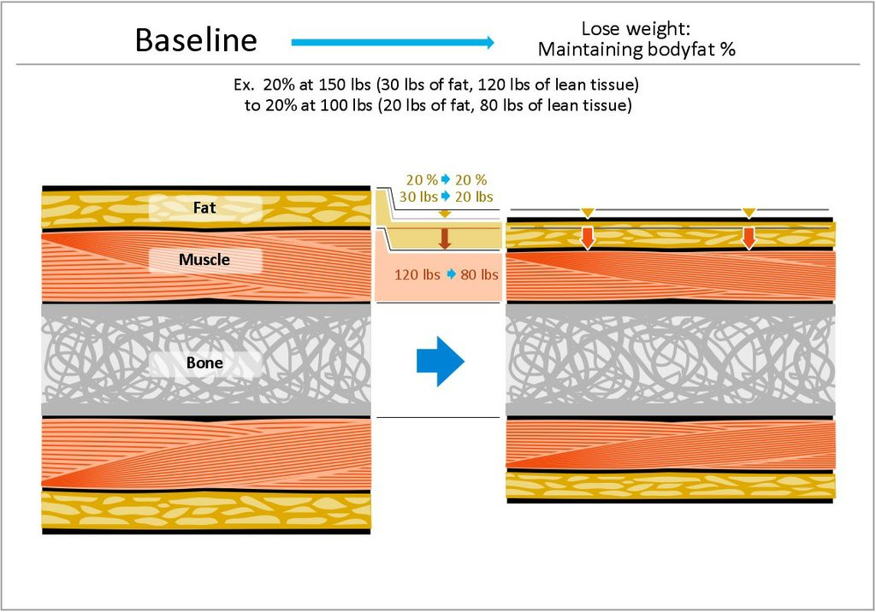
- 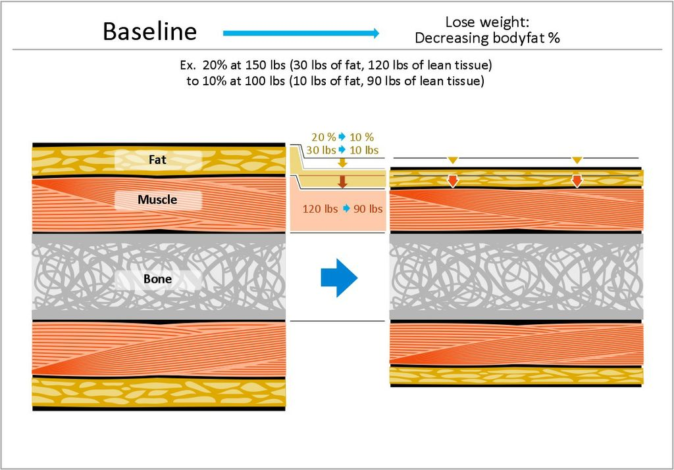
- 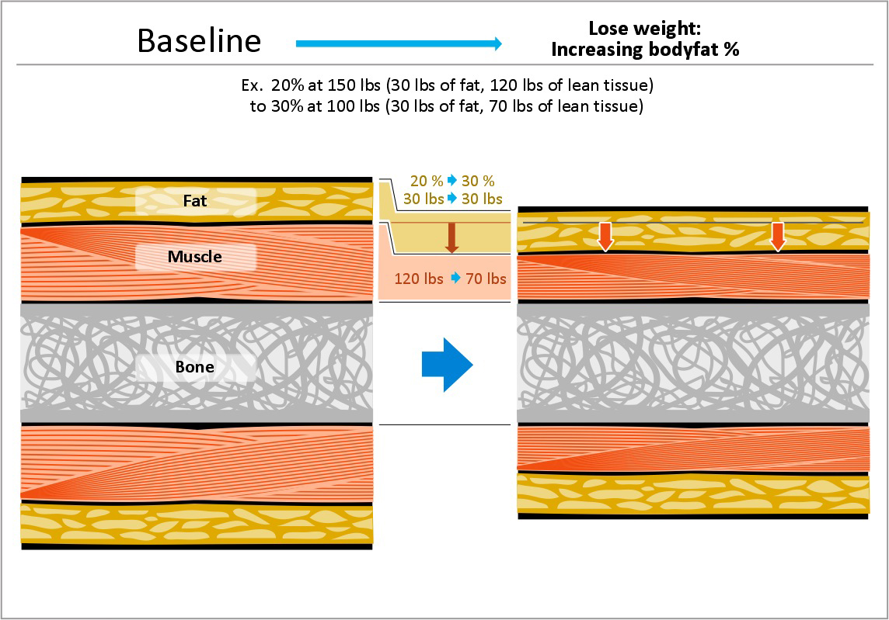
- 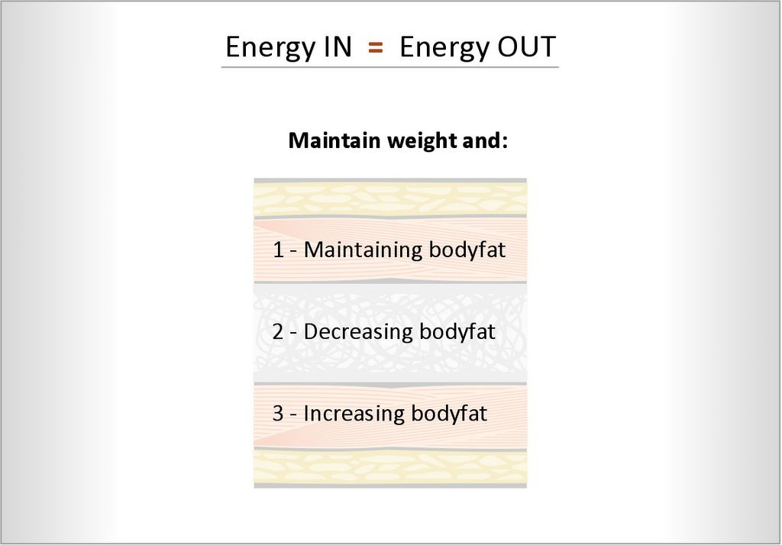
- 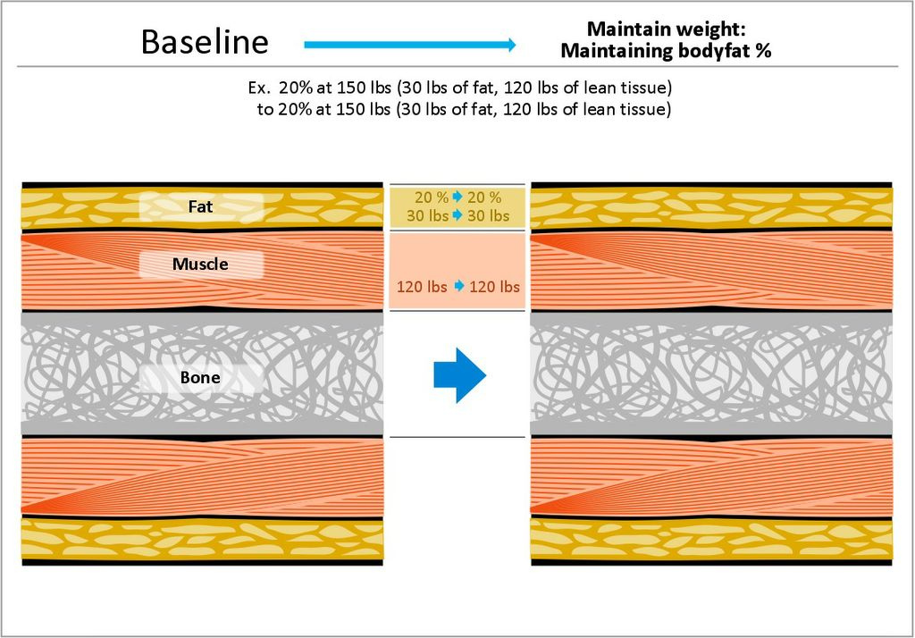
- 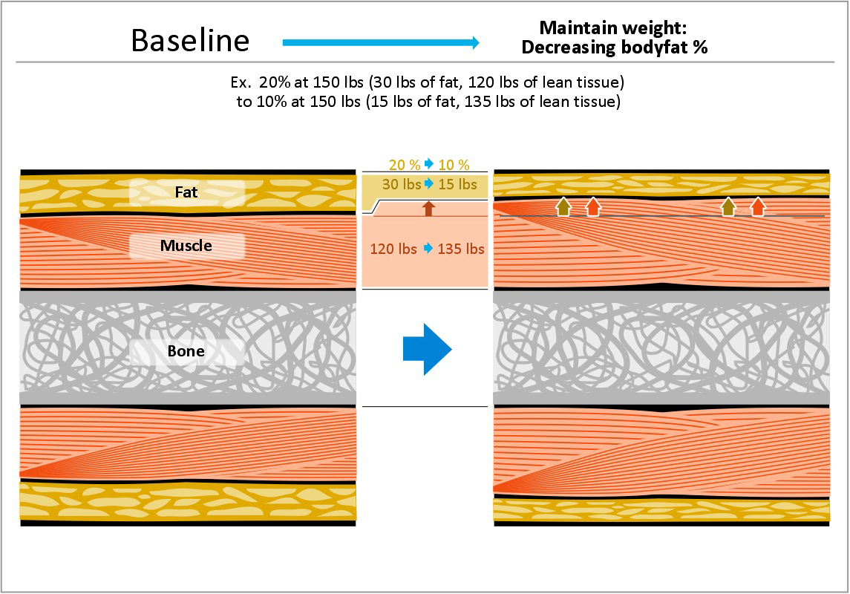
- 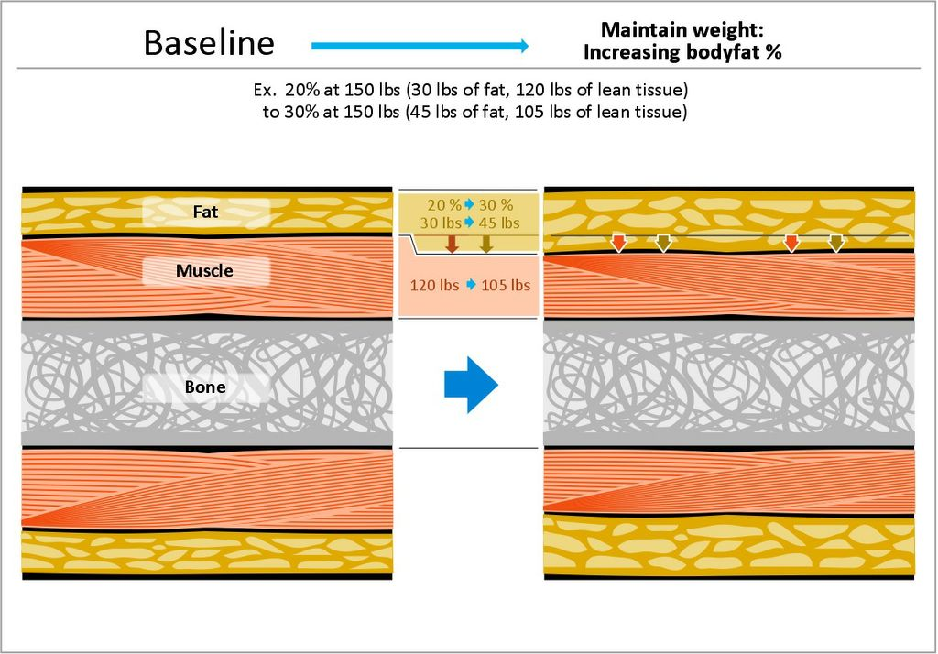

Physical activity for health
  - Physical activity: all body movements produced by skeletal msucles resulting in energy expienture
- Physical Activity for health
  - “there is irrefutable evidence of the effectiveness of regular physical activity in the primary and secondary prevention of chronic diseases such as cardiovascular disease, diabetes, cancer, hypertention, ect
- Physical activity for fitness
  - Exercise: planned, structured, repetitive bodily movements done to improve or maintain one or more components of physical fitness
    - Cardiorespiratory endurance
    - Muscular strength and endurance
    - Flexibility
  - Physical fitness: set of attributes that are eater health or performance related.
    - Health related: cardiorespiratory and muscle endurance and strength and flexibility
    - Performance related: perform moderate to vigorous intensity physical activity on a regular basis without undue fatigue with energy left over to handle physical or mental emergencies
  - light effort: light walking, easy gardening
    - body feeling warm and a slight increase in breathing rate
  - moderate level: brisk walking, cycling
    - feeling warmer and have a noticeable increase in breathing rate
  - vigorous level: jogging, playing basketball
    - makes you quite warm and breathing quickly
- Canada's Physical Activity Guide to Healthy Active Living: PHAC & CSEP
  - 60+ minutes of moderate intense activity, daily!
  - Participaction Canada, health promotion
  - ~50% Canadians are physically inactive
  - ~20% of teens sufficiently active for optimal growth and development
- improving muscular strength and endurance
  - agility, power, coordination, balance, speed, reaction time
  - muscoskeletal health: strength, endurance, flexibility
    - significantly impacts health and overall wellness
    - reduced risk for coronary heart disease and osteoporosis
  - muscular strength:
    - refers to the maximal amount of force a muscle or group of muscle is capable
    - one repetition maximum: determine the maximum amount of weight you can lift at once
  - muscular endurance:
    - defined as a muscles or group of muscles ability to exert orce repeatedly without fatiguing or the ability to sustain a muscular contraction
    - often measured from the number of curl ups or push ups an individual can do
- Principles of strength development
  - Tension principle:
    - Key to developing strength is to develop sufficient tension within a muscle
    - Use of external resistance such as weight lifting
  - Overload principle:
    - To increase strength, you must then regularly create tension in your muscles greater than what you are accustomed to
    - Forces your muscles to adapt by getting larger (hypertrophy), and stronger
    - If you create too great of an overload, you may experience muscle injury, muscle fatigue, or loss of strength
    - Once you reach your strength goal, no further overloading is necessary
    - Maintain that level of strength by continuing to engage in a regular total body resistance exercise program
  - Specificity of training principle:
    - Manner in which a specific body system responds to the physiological demands placed upon it
    - Must include exercises for all the major muscle groups
    - You get a very specific response to the exercises you do
    - Ensure that your overload is sufficient to increase strength and not only endurance
  - Recovery principle:
    - Allow 48 hours for the body to adapt to the resistance training undertaken
- Muscle contractions
  - Isometric muscle contraction:
    - Force is produced by the muscle without movement, do not create joint movement
    - Example: attempt to push a car, resistance training with trying to live a barrel that’s too heavy for you
    - Important because they maintain body stability
  - Concentric muscle contraction:
    - Force is produced while the muscle shortens
    - Joint movement is always produced
    - Example: Raising the body in a curl up
    - Usually it produced a movement in the direct opposite to the downward pull of gravity
    - If your resistance exercise program uses only concentric muscle action, you will need to perform atleast twice as many reptitions to achieve the same results as you would by using concentric-eccentric combinations
  - Eccentric muscle contraction:
    - Describes a muscles ability to produce force while lengthening
    - When movement is in the same direction as the pull of gravity
    - Example: lowering your body in a cirl up
- Improving your flexibility
  - Refers to the range of motion or the amount of movement possible, at a particular joint or series of joints
  - Iproving your range of motion through stretching exercises will enhance the efficiency of your movements as well as your posture
  - May enhance psychological well being
- Static stretching
  - Slowly and gradually lengthen a muscle or group of muscles
  - The end position is held for 10-30 seconds, then repeated 2-3 times
  - Your range of motion improves temporarily with each repetition, and when done regularly, it increases
  - Static stretching immediately prior to performance reduces the athletes efforts
- Ballistic stretching
  - form of passive stretching or dynamic stretching in a bouncing motion.
  - Ballistic stretches force the limb into an extended range of motion when the muscle has not relaxed enough to enter it.
  - It involves fast "bouncing" movements where a double bounce is performed at the end range of movement.
  - Ballistic stretching should only be used by athletes who know their own limitations and with supervision by their trainer.

PNF (contract-relax) stretching
  - set of stretching techniques commonly used in clinical environments to enhance both active and passive range of motion with the ultimate goal being to optimize motor performance and rehabilitation.
  - The literature regarding PNF has made the technique the optimal stretching method when the aim is to increase range of motion, especially in short-term changes.
  - Generally an active PNF stretch involves a shortening contraction of the opposing muscle to place the target muscle on stretch.
- Energy Pathway
  - ATP - CP (alactic system: anaerobic)
    - Up to first 15 seconds
    - Highest intensity, shortest duration
  - Glycolysis (lactic system: anaerobic)
    - 15 – 90 seconds
  - Glycolysis (aerobic)
    - 90 – 180 seconds
  - Oxidative (beta oxidation: aerobic)
    - 180 seconds+
    - lowest intensity, longest duration
- Types of Exercises
  - “Cardio” training (Aerobic threshold)
    - speed walking, light running, jogging, cross-country skiing, swimming, interval training
  - “Resistance” training (Anaerobic threshold)
    - Circuit-training, Plyometrics, Calisthenics, Bodybuilding, Weightlifting, Powerlifting
- Warm up and cool down
  - The length of your warm up is dependent upon how psycholoially prepared you are to move
  - If you are geared up and ready to go, the warm up may not take as long
  - Purpose is to gradually increase heart rate and core body temperature, improve joint lubrication, increase muscles elasticity
- Cardiorespiratory endurance
  - Spend a good portion of your exercise time developing your aerobic fitness
  - Activities include cross training more enjoyable than a long term participation in only one activity
    - Beneficial in that it strengthens a variety of muscles and reduces your risk of overuse injuries
  - Max HR: (220-age) x %intensity

Aerobic power
  - the highest peak oxygen uptake that an individual can obtain during dynamic exercise using large muscle groups during a few minutes performed under normal conditions at sea level.
  - limited by the central circulation.
  - stroke volume is one very important factor.
  - oxygen content of the arterial blood.
  - V02 max : maximal volume of oxygen that the body can deliver to the working muscles per minute.
  - excellent measure of physical fitness because it provides a metric of efficiency.
  - Lactate threshold: intensity of exercise at which lactate begins to accumulate in the blood at a faster rate than it can be removed.
  - This is problematic because as a result, unbuffered acid is added to the blood, a condition that makes you feel like you have to vomit and stop right away.
  - Aerobic exercise improves V02 max significantly.
  - much of this improvement results from an increase in the size of the heart.
- Graded Exercise Test
  - There are two primary ways we determine an individual’s aerobic capacity.
    - measure it directly, or we can estimate it.
    - Direct measurement of aerobic capacity, or maximal oxygen uptake, is the most accurate method but requires specialized equipment that is typically found only in labs or clinical research facilities.
  - A graded exercise test (GXT): is a test in which the intensity or workload is increased at predetermined stages, based on specific criteria.
  - To keep a cardiovascular fitness test submaximal, the intensity should not exceed 80% of heart rate reserve.
- 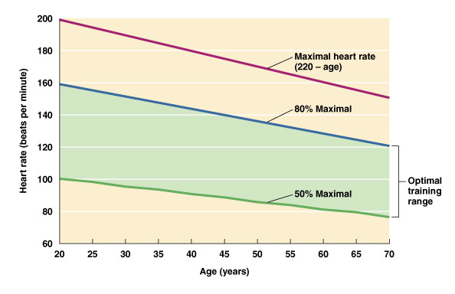
- fuel for physical activity
  - sugar, which is converted into glucose goes through glycolysis
    - where 2 ATP are gained
  - glucose is converted to two pyruvic acid molecules
  - if oxygen is present: aerobic metabolism
    - produces 36-38 ATP and Co2 + H2O
    - less intensity longer period of time more energy derive aerobic pathway
  - if oxygen is absent: anaerobic metabolism
    - lactic acid is produced
  - intensity and duration will dictate how much value youre getting per substrate
  - high intensity movements: clears your glycogen stores first
  - low intensity exercise: fats are used more
  - high intensity maximal exercise: only carbs are being used, fats aren’t being used anymore
  - carb diet: higher value
  - tryglyceride diet: lower value
  - do high intensity movement first, then low intensity long duration movements later to maximize the fuel being used. Efficiency of pathways and substrate use increases
  - when you have a good diet, more O2 is being consumed and less CO2 is being disposed of
  - high oxidative efficiency: fat burning
  - low oxidative efficiency: carb burning, double caloric expidenture (should increase exponentially in a realistic situation)
  - Scenario 1: brisk walking, 30 minutes @ 40% VO2 Max
    - Higher oxidative efficiency
    - Percentage of calories derived from lipids: 80%
    - 100 calories utilized
    - Absolute calories from lipids: 80 calories
  - Scenario 2: running, 30 minutes @ 80% VO2 Max
    - Lower oxidative efficiency
    - Percentage of calories derived from lipids: 40%
    - 200 calories utilized
    - Absolute calories from lipids: 80 calories
- Sound Fitness Program
  - Three variables to consider: frequency, intensity, duration
  - For healthy weight management, shift in body composition, anaerobic training is the priority
  - Macro plan:
    - Active 5 out of the 7 days
    - High intensity causes the body to break down
    - Different parts of the body every day
    - Very detail information about what kinds of reps to do
  - Micro plan:
    - use all of the muscles in a day with many repetitions
    - very detailed plan on how many reps to which muscles
    - Repetition: how many times can you do that full cycle over and over again
  - Cross training routine:
    - This is more active living
    - They might get micro benefits
    - They do things in groups and different environments
- Causes of fitness related injuries
  - Overuse injuries: occur because of cumulative, day after day stresses placed on the body
    - Common sites: leg, knee, shoulder, elbow joints
    - Osteoarthritis is a chronic overuse injury
    - Muscle stiffness and soreness, bone and joint pain, and whole body fatigue is a common sign
    - Plantar fasciitis:
      - On the foot that gives mobility to press down, absorbs shock.
      - Someone who runs a lot gets this common injury.
      - Plantar facia actually thickens and causes pain.
    - Runners knee:
      - lateral tilting of the patellar bone .
      - Patellar will actually shift, causing tremendous pain even behind the patella bone, and its arthritis because there is erosion, lots of friction and heat.
      - Women are more commonly affected than men because of their anatomical structure
  - Traumatic injuries: known as acute injuries, occur all of the sudden and violently, typically by accident
    - Broken bones, torn ligaments and muscles, contusions, lacerations
    - Unavoidable, should get it checked out
  - Treatment:
    - Rest, Ice, Compression, Elevation

Exercise in the heat
  - Increases your risk of a heat related injury
  - Heat stress results from an elevated core body temperature
  - Reduce the risk of dehydration by replacing fluids before, during, or after exercise
  - Wear clothing appropriately for the activity
  - Time yourself well, like running during the day when its not as hot
  - Heat cramps:
    - Easily prevented by adequate fluid replacement and a dietary intake that includes the electrolytes lost during sweating
  - Heat exhaustion:
    - Most often caused by excessive water loss because of intense or prolonged exercise or physical work in a hote and humid environment
    - Symptoms include nausea, headache, fatigue, dizziness,
    - Mild form of shock, in whih the blood pools in the arms and legs away from the brain and major organs of the body
  - Heat stroke:
    - Life threatening emergency condition with a 20-70% death rate
    - Occurs during vigorous exercise when the bodys heat production significantly exceeds its cooling capacity
    - Causes brain damage, permanent disability and death
    - Symptoms are dry, hot and usually red skin, very high body temperature, very rapid heart rate
    - Stop immediately, move to shade or a cool spot to rest, drink plenty of cool fluids such as gadorade for electrolytes
- Exercising in the cold
  - Heat loss is greater than its heat production
  - Hypothermia: potentially fatal condition resulting from abnormally low body core temperature
  - Prolonged vigorous exercise in 4-10C temperatures, particularly if there is rain, snow, or strong wind
  - Shivering is a contraction of every muscle in your body that is designed to increase your body temperature by generating heat
  - First stages symptoms include cold hands and feet, poor judgment, apathy and amnesia
  - Wear appropriate clothing to prevent excessive heat loss and don’t allow yourself to become dehydrated

