Lecture 13 – Genetic Variation

- dominant status of an allele describes its effect on the phenotype of heterozygotes… NOT whether the allele is helpful, harmful or neutral nothing to do with increasing fitness of individuals bearing that allele

CLICKER QUESTION
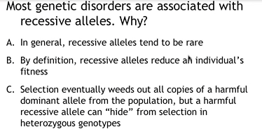
c) dominance status of allele is important on determining how thoroughly selection can affect frequency of allele

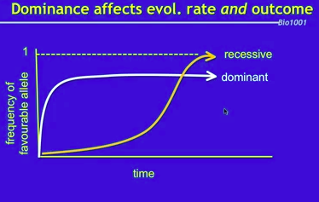
- greater expression of dominant alleles, recessive alleles hidden in heterozygotes

Other constraints on selection
Genetic correlations between traits: ex, beak lengths favoured towards long beaks, cannot single out beaks, pleotropic larger beaks = larger body
Fitness tradeoffs: ex, showy traits may be associated with fitness advantage increased mating success, but disfavoured in other way longer, brighter tail = easier for predators to catch, need to balance for maximum fitness mates vs. survival (stops from nicest, sexiest tail)
Time: population may adapt to past environment, new conditions may no longer apply, historically matching offspring to max insect population, but insects change peak abundance, birds do not adapt to new abundance
Available genetic variation: ex, very little genetic variation (cheetahs due to bottleneck effect), difficult to evolve to environmental change natural selection requires genetic variation

Why is genetic variation important?
Population level: affects evolutionary potential
Individual level: inbreeding = reduces fitness

Quantifying genetic variation
Of an individual: proportion of heterozygous loci, inbreeding coefficient using pedigrees
Of a population: proportion of polymorphic loci (more than one allele per locus)

Directional selection
- if in same direction, eventually would see a reduction in genetic + phenotypic variation (would compress)
- one end selected against (lower fitness)
- other end is fit
- causes a shift
- affected by the environment, can change direction

Spatial variation in selection
- directional selection in each habitat is maintained but in different directions
- selection pressures: spatially & temporally
- not all of deleterious traits are weeded out

Stabilizing selection
- intermediate phenotype individuals have higher fitness (eliminating extremes)
- mean value doesn’t change but lower variation
- in humans: birth weight (average is favourable)

Disruptive selection
- either end of extremes may be favoured
- opposite of stabilizing selection
- maintains multiple different alleles in population
- not necessarily seeing a shift (mean doesn’t change), but see increase in amount of total genetic variation
- dimorphism or polymorphism being established here

Negative frequency-dependent selection
- rare forms favored
- increase amount of genetic variation in population
- will eventually shift and not be rare

Positive frequency-dependent selection
- common forms favored
- decrease amount of genetic variation in population
- rare alleles eventually disappear

Overdominance
- heterozygote advantage
- maintains variation

Other forces: mutation
- random, spontaneous errors in DNA synthesis
- can be beneficial, harmful, or neutral
- source of all new genetic variation

Other forces: migration
- movement of alleles between populations
- effect on allele frequencies
- effect on genetic variation within a population

Other forces: genetic drift
- random deviations from expected results
- one allele becomes fixed, others lost
- effect on genetic variation within a population
- importance of population size
- bottlenecks and founder events

Other forces: nonrandom mating
- assortative/disassortative mating vs. inbreeding/outbreeding
- effect on genotype frequencies
- effect on allele frequencies

Hardy Weinberg Requirements:
- no mutation
- no migration
- mating must be random

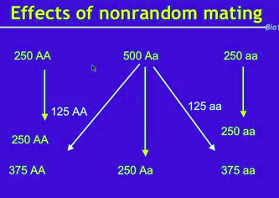

CLICKER QUESTION
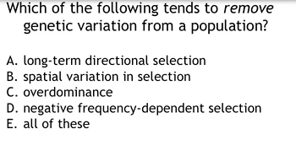
- long-term directional selection

Lecture 14 – Evolutionary forces and sex

Summary: evolutionary forces
- selection, mutation, migration, drift, nonrandom mating all take populations out of Hardy-Weinberg Equilibrium
- some generate heterozygote deficit, others generate heterozygote excess
- not all these forces necessarily result in evolution
- Overdominance
- nonrandom mating

CLICKER QUESTION
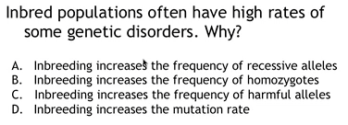
B) inbreeding increases the frequency of homozygotes

Dioecious
- sexual organisms can be dioecious (humans, most vertebrates)
- individual is either MALE or FEMALE
- two sexes housed in two DIFFERENT individuals, not both sexes

Simultaneously monoecious
- simultaneously hermaphrodites
- have functional eggs and sperm (ovaries & testes)
- one acts as male, one acts as female can switch roles
- chains: acts as male to one in front while female to one behind

Sequentially monoecious
- individual born one sex, at some point change sex at certain body size
- ex: clownfish born male, at certain size shuts down testes and reproduces as a female

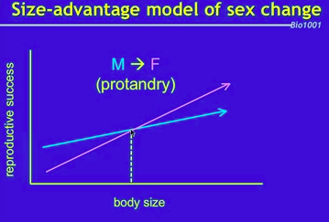
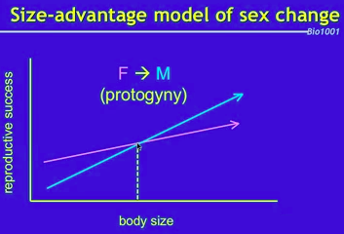

Why reproduce sexually?
Many reasons not to…
- finding, attracting, competing for mates
- sexually transmitted diseases
- cost of meiosis only transmit 50% of genes to next generation
- cost of males (“twofold cost of sex”)
- asexual (clonal) females should quickly outcompete sexual females, unless sex improves offspring quality

Mutational explanations for sex
- over time, asexual populations accumulate harmful mutations
- sex continually recreates genotypes with fewer (or more) harmful mutations
- Ruby in the Rubbish hypothesis some of your offspring will be worse off (more deleterious mutations) but chance that some will have an advantage

Ecological explanations for sex
- constant asexual; changing sexual
- sex in constant vs. changeable environments; the Lottery Principle chance of offspring with less deleterious mutations than offspring, at least some offspring will be well adjusted
- parasites place negative frequency-dependent selection (rare genotype advantage, easier to prey on most common genotypes) on host genotypes
- sex (producing diversity of offspring genotypes) favoured in parasite-rich environments (Red Queen hypothesis) must continually evolve to remain at par with natural enemies

Summary: sex is costly and inefficient, but incredibly successful
- Long-term advantage: purge harmful mutations
- Short-term advantage: hedge bets against a quickly changing environment (especially co-evolving parasites)

Lecture 15 – Sexual selection

Sex has important consequences
- sexual selection
- sexually dimorphic traits traits expressed by only 1 sex typically males usually costly to survival
- explains sexually dimorphic traits, and traits seemingly incompatible with natural selection

Intrasexual vs. intersexual selection
Intrasexual: competition between same sex, the winner gets the mate
Intersexual: female choice

Females often pickier than males eggs are energetically costly to produce, small # of sperm, females must invest more in offspring, therefore males compete for females (sperm is cheap anisogamy = unequal game size)

Selective forces on males vs. females
- in populations with a 1:1 sex ratio, same average fitness for males and females, average male has same amount of offspring as average female
- males have higher potential fitness, females have very low potential fitness, males can copulate with many females and have many children
- male fitness determined by total number of mating opportunities, females cannot increase fitness, limited by access to resources, cannot find more mates to increase fitness (one male produces more than enough sperm for one female)

Parental investment: whichever sex invests more in offspring is choosier sex. If both sexes invest heavily in offspring, both males and females compete.
In humans:
- long-term = both males + females compete
- short-term (1-night stand) = females are selective men have low standards

Summary: sexual selection
- happens because sex puts different selection pressures on males vs. females
- relative parental investment influences which sex competes and which chooses
- when both sexes invest a lot in offspring, both sexes experience sexual selection
- but still differ in short-term mating strategies, types of traits preferred, and the nature of jealousy

