Oxidation of 2-Methylcyclohexanol
PSL 3

Procedure:
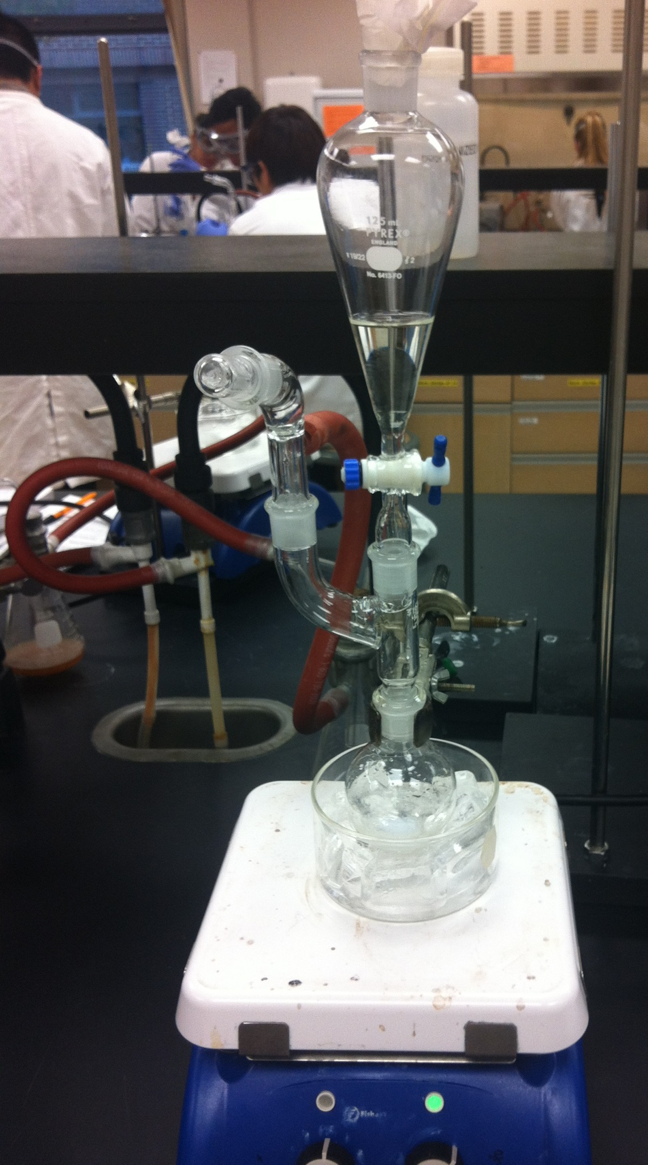
1g of 2-methylcyclohexanol was added to a 100mL round bottom flask with 2.1mL of glacial acetic acid. The apparatus in Figure 1 was assembled with 20mL of bleach in the separatory funnel. The bleach was added drop wise to the round bottom flask over 5 minutes. The solution was tested using KI paper and 4mL of bleach was added when the results showed no oxidizing agent was present. The ice bath was removed and the solution was allowed to come to room temperature while being stirred for 30 minutes, checking for the oxidizing agent with KI paper ever 5 minutes. 2mL of NaHSO3 was added to neutralize the solution. The neutralized solution was added to a separatory funnel with 20mL of DCM. The funnel was shaken vigorously, venting occasionally. The bottom layer was removed and the top layer was discarded. The bottom layer was added to the separator funnel again and washed with NaOH three times. Magnesium sulfate was added to dry the washed DCM solution. The solution was gravity filtered to remove the magnesium sulfate, and the filtrate was rotary evaporated for about 5 minutes. The final product was analyzed by IR spectroscopy.

Figure 1

Equations:

$$\frac{Actual Yield }{Theoretical Yield}×100\%=\% Yield$$

$$Mass of flask and product-Mass of flask=Final mass of product$$

Calculations:

Final Mass of ketone = 74.75g – 74.71g = 0.04g

% Yield = $\frac{0.04g}{0.982g} × 100\%=4\%$

$$1g C_{7}H_{13}O × \frac{1 mol}{113.1782g} × \frac{1 mol C_{7}H_{11}0}{1 mol} × \frac{14.1623g}{1 mol } =0.982g$$

Discussion:

Acetic acid acts as a catalyst in this reaction by turning the sodium hypochlorite into hypocholorous acid, which acts as the oxidizing agent.
DCM is a widely used solvent and is used to extract the ketone from the acetic acid and bleach in this experiment. DCM tends to extract small amount of acetic acid as well, which was then removed with NaOH.
An sp³ C-H stretch occurs at 2935 cm⁻¹ and a ketone stretch at 1710 cm⁻¹. These two stretches indicate 2-methylcyclohexanone is present. The IR spectrum also shows a small sp² stretch and OH stretch. This is an indication that not all of the 2-methylcycloheanol was oxidized into 2-methylcyclohexanone.

References:

Chemical Book. http://www.chemicalbook.com (Accessed October 29, 2012). (1)

Sigma Aldrich. http://www.sigmaaldrich.com (Accessed October 29, 2012). (2)

Summary:

Mass of product: 0.04g
% Yield: 4%

IR Spectra:
sp³ C-H stretch at 2935.4 cm⁻¹
sp² C-H stretch at 3057.2 cm⁻¹
OH stretch at 3401.4 cm⁻¹
Ketone stretch at 1710.8 cm⁻¹

