CHEMISTRY 1311- Darrin Richeson
What in the world isn’t Chemistry?
- Matter is the physical material of the universe.
- On the microscopic level, matter consists of atoms and molecules.
- As we know, molecules may consist of the same type of atoms or different types of atoms
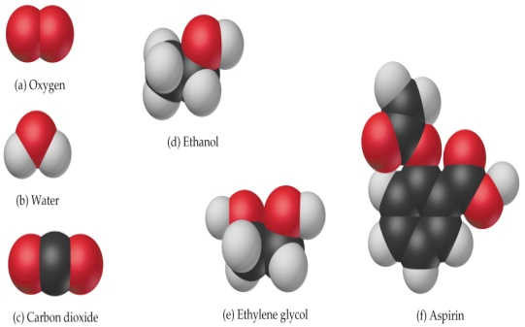We encounter chemistry in our everyday lives

- Conservation of Matter - A chemical equation must be balanced for mass. Lavoisier, 1743-1794

- Atomic Theory - A chemical equation must have the same number of atoms of the same kind on both sides. Dalton (1766 – 1844)

_{Law of Mass Conservation}
The total mass of substances present does not change during a chemical reaction.

Daltons Atomic Theory
- All matter is made of small, indestructible particles called “atoms”. One kind of atom cannot be converted into another kind.
- All atoms of a given element are identical and atoms differ for different elements.
- Compounds are formed when atoms of more than one element combine
- Atoms of different elements combine in simple, whole number ratios (e.g. 1:1 as in AB; or 1:2 as in AB₂)

What are Atoms?
Atoms are the basic unit of an element that can enter into chemical combination.
Dalton – Atoms are small and indivisible
– not quite!

- Atomic Structure
J.J. Thompson’s Experiment (1898 – 1903)
Z/m of the electron = 1.76 × 10⁸ C/g
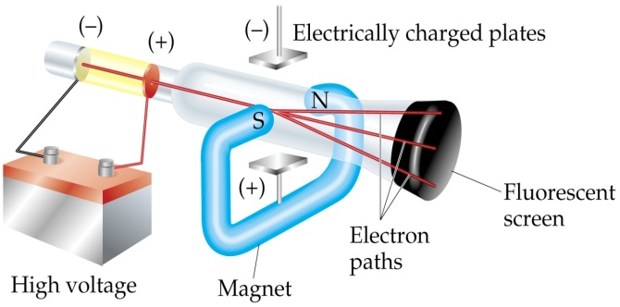

Observation | Conclusion
Ray bends in magnetic field | Ray consists of charged particles.
Ray bends toward positive plate in electric field | Ray consists of negative particles.
Ray is identical for any cathode | These particles are found in ALL matter.

Milliken’s Oil Drop Experiment (1909)
charge of the electron = -1.6022 x 10⁻¹⁹ C

Therefore: mass electron = (e⁻ charge)/(e⁻ charge-to-mass ratio)
= 9.10 x 10⁻²⁸ g (9.10939 × 10⁻²⁸ g)

Nuclear Model of the Atom (Rutherford: 1910)
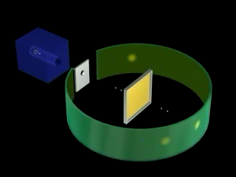
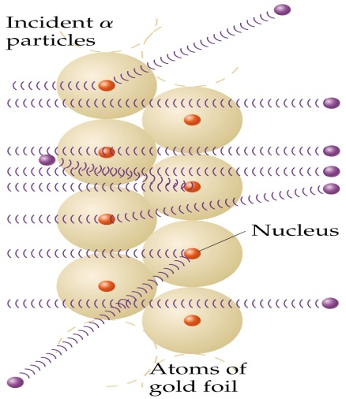

The Modern View of Atomic Structure
Nucleus
- nucleus contains protons and neutrons
- nuclear radius is 20,000 times smaller than the atomic radius!
(5 cm vs 1 km) 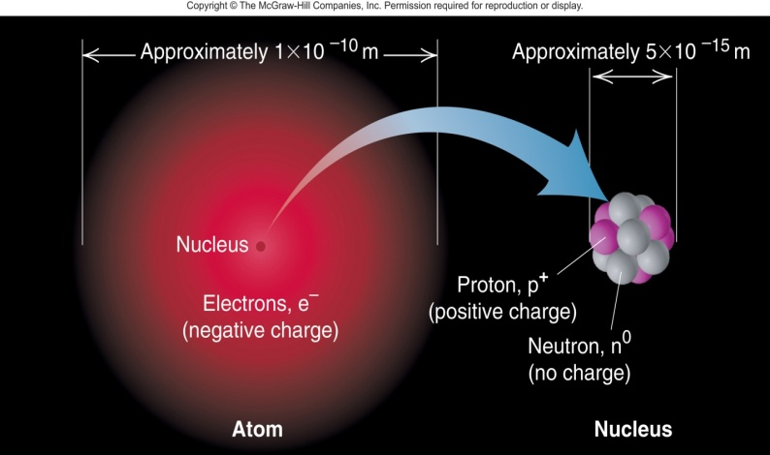
Particle Mass Charge
- Proton 1.67 x 10⁻²⁴ g 1.60 x 10⁻¹⁹ C
- Neutron 1.67 x 10⁻²⁴ g No charge
- Electron 9.11 x 10⁻²⁸ g -1.60 x 10⁻¹⁹ C
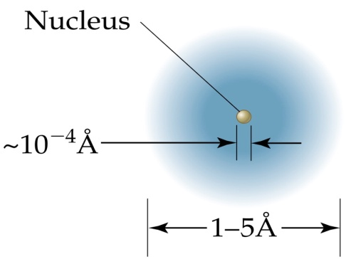

Mass of atom is mostly from nucleus, volume of atom is mostly from electron cloud.
Scale of Atoms
Useful units:
- 1 u (atomic mass unit) = 1.66054 x 10⁻²⁴ kg
- 1 pm (picometer) = 1 x 10⁻¹² m
- 1 Å (Angstrom) = 1 x 10⁻¹⁰ m =
100 pm = 1 x 10⁻⁸ cm

- The heaviest atom has a mass of only 4.5 x 10⁻²² g
and a diameter of only 4 x 10⁻¹⁰ m.
- Typical C-C bond length 1.54 Å (1.5 x 10⁻¹⁰ m)

Isotopes, Atomic Numbers, and Mass Numbers
- Atomic number Z = number of protons
- determines the number of electrons thus the element identity
- Atomic Mass - Σ of protons and neutrons
- By convention, for element X, we write _{Z}^{A}X.
- Isotopes have the same Z but different A (variable number of neutrons)
- No two elements have the same value of Z.
- In nature, elements occur as a mixture of isotopes

Atomic Weights
Remember that we must include the isotopes when calculating atomic weights.
In nature C: 98.892 % ¹²C + 1.108 % ¹³C.
Average mass of C:
(0.98892)(12 ) + (0.0108)(13.00335) = 12.011 amu.
What is the mass of a single C atom??
The Periodic Table
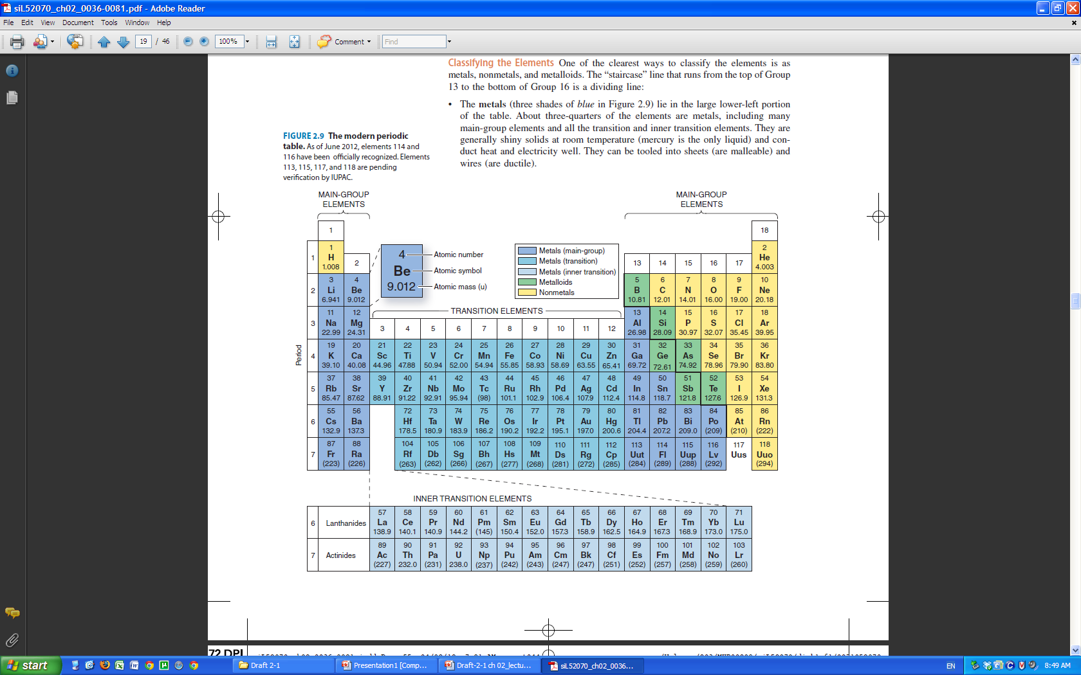
- Columns in the periodic table are called groups (numbered from 1 to 18).
- Rows in the periodic table are called periods.
- Metals are located on the left hand side of the periodic table (most of the elements are metals).
- Non-metals are located in the top right hand side of the periodic table.
- Elements with properties similar to both metals and non-metals are called metalloids and are located at the interface between the metals and non-metals
- Based on the reactions and properties of the elements and their compounds
- Reflects the underlying electronic structure of the elements

- Arranged in order of increasing mass, the periodic table looks like this.
- Because rows 6 and 8 are quite long, 14 of these elements are separated from the rest.
- They are called the lanthanides and the actinides. (WHY?)

Counting Atoms
- Recall that we must account for all of the atoms in a chemical reaction.
- Physically counting atoms is impossible.
- We must be able to relate measured mass to numbers of atoms.
  - using atoms by the gram
Avogadro’s number
The mole is an amount of substance that contains the same number of elementary entities as there are carbon-12 atoms in exactly 12 g of carbon-12.
1 atom of ¹²C = 1.992646 x 10⁻²³g
N_{A} = 6.02214199 x 10²³ mol⁻¹
Molar Mass
- The molar mass, M, is the mass of one mole of a substance.
- M (g/mol ¹²C) = A (g/atom ¹²C) x N_{A} (atoms ¹²C /mol ¹²C)
- Elements occur as a mixture of their isotopes. The molar mass of an element is the mass of 1 mole of the naturally occurring mixture of isotopes.
Thus: 1 mole of O = 15.9994 g
1 mole of H = 1.0079 g
1 mole of C = 12.011 g
“molecular weight and atomic weights”
numerical values of the molar mass
not actually weights!!
- Most elements are found on the earth as a mixture of isotopes in a constant ratio.
- A single atom of each isotope has a unique mass.
- Since we cannot deal with single atoms we think of a mole of atoms. How much does a mole of atoms of an isotope weigh?
- Let’s look at ¹³C….it has an atomic mass of 2.15928 x 10⁻²³ g, what is the mass of one mole of ¹³C?
Example;
Combining Several Factors in a Calculation—Molar Mass, the Avogadro Constant, Percent Abundance.
Potassium-40 is one of the few naturally occurring radioactive isotopes of elements of low atomic number. Its percent natural abundance among K isotopes is 0.012%. How many ⁴⁰K atoms do you ingest by drinking one cup of whole milk containing 371 mg of K?
- Want atoms of ⁴⁰K, need atoms of K,
- Want atoms of K, need moles of K,
- Want moles of K, need mass and M(K).

Convert strategy to plan
- Convert mass of K(mg K) into moles of K (mol K)
- m_{K}(mg) x (1g/1000mg) m_{K} (g) x 1/M_{K} (mol/g) n_{K}(mol)
- n_{K} = (371 mg K) x (10⁻³ g/mg) x (1 mol K) / (39.10 g K) = 9.49 x 10⁻³ mol K
- Convert moles of K into atoms of ⁴⁰K
- n_{K}(mol) x N_{A} atoms K x 0.012% atoms ⁴⁰K
- atoms ⁴⁰K = (9.49 x 10⁻³ mol K) x (6.022 x 10²³ atoms K/mol K) x (1.2 x 10⁻⁴ ⁴⁰K/K) = 6.9 x 10¹⁷ ⁴⁰K atoms

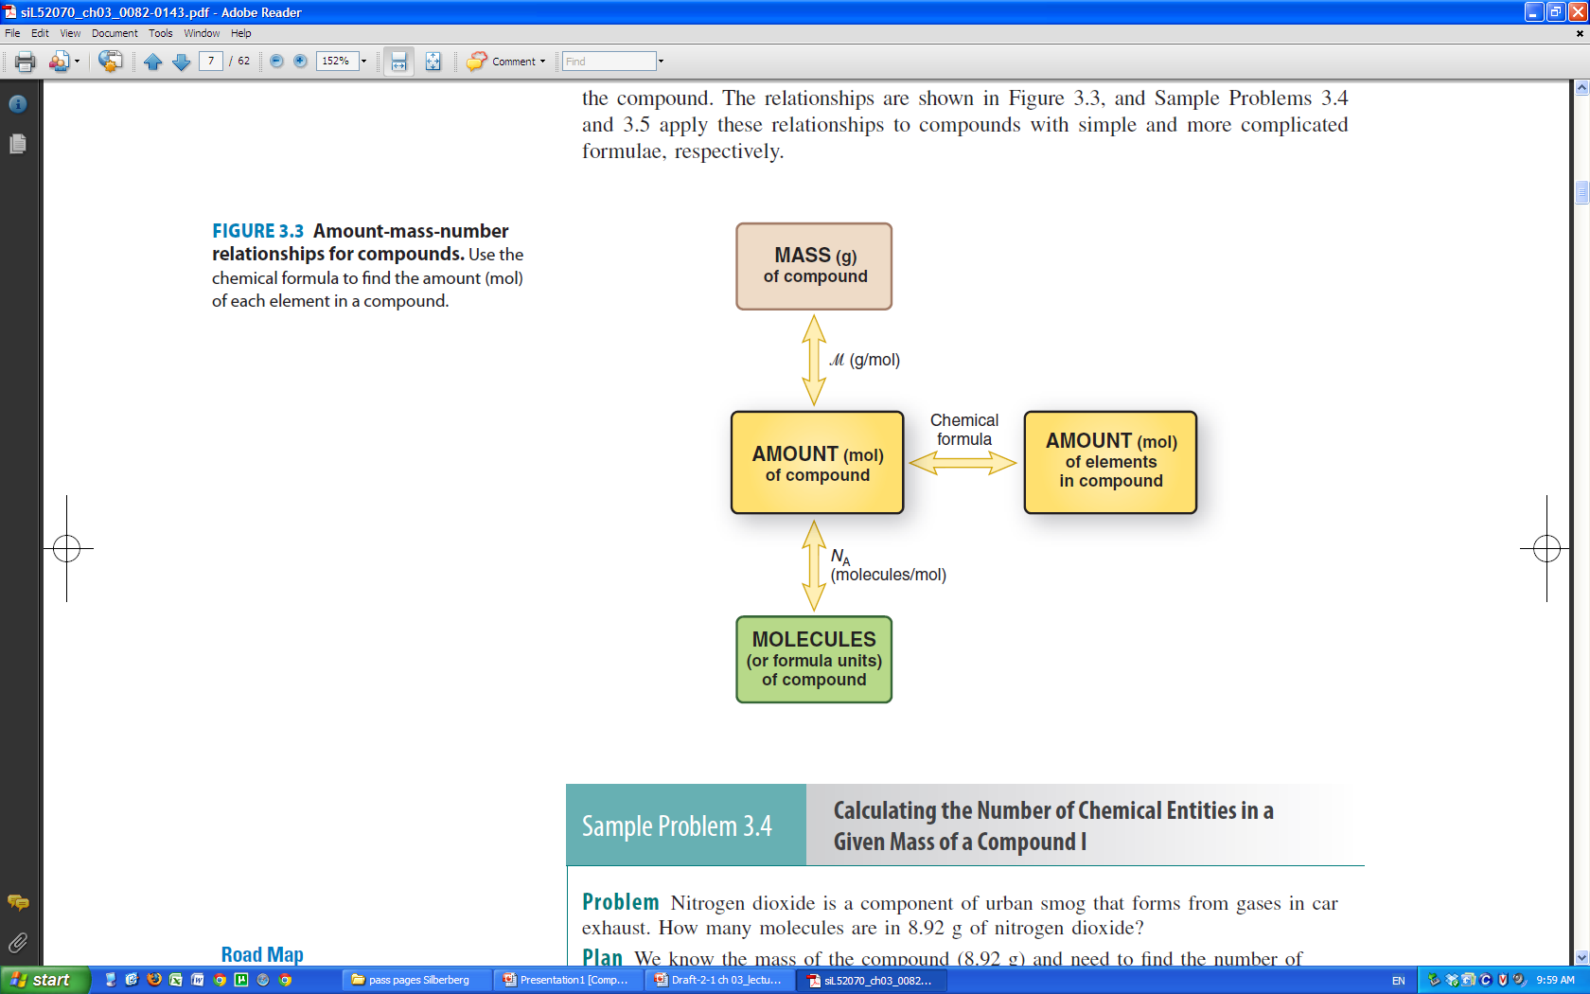

Molecules
Only the noble gases exist in nature as single atoms
The atoms of all other elements combine to form MOLECULES
e.g. H₂ a DIATOMIC molecule
H₂O a POLYATOMIC molecule
In a neutral atom or molecule # protons = # electrons

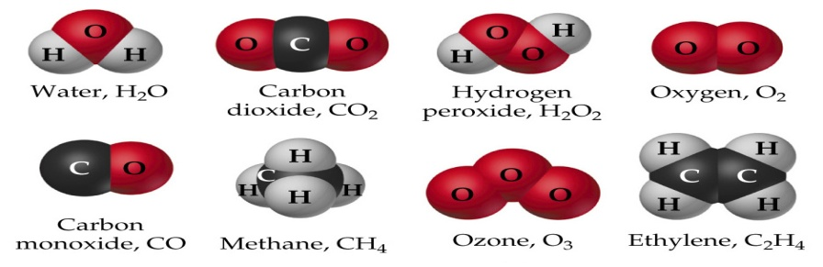
Molecular Mass/Molecular Weight
Molecular Mass
molecular mass= sum of atomic mass of each atom in the molecule(in atomic mass units= u)
Determine the molecular mass of H20;
2 atoms H X 1.008U = 2.016u
1 H atom
1atom O X 15.999u = 15.999u
1 O atom

Molecular mass= 1 molecule of H2O= 2.016u + 15.999u = 18.015u

Molar Mass of Molecules
mass in grams of 1 mole of the molecule
What is the molar mass of H₂O?
molar mass
1 mole H₂O = 2.016 g for two moles of H
+ 15.999 g for one mole of O = 18.015 g/mol
Molecular Mass: mass of one molecule 18.015 u
Molar Mass: mass of one mole of molecules 18.015 g/mol

---Glucose
Molecular formula C₆H₁₂O₆
Empirical formula CH₂O

Molecular Mass: Use the naturally occurring mixture of isotopes,
6 x 12.01 + 12 x 1.01 + 6 x 16.00 ₌ 180.18
Exact Mass: Use the most abundant isotopes
6 x 12.000000 + 12 x 1.007825 + 6 x 15.994915= 180.06339

Picturing Molecules
- Molecules occupy three dimensional space.
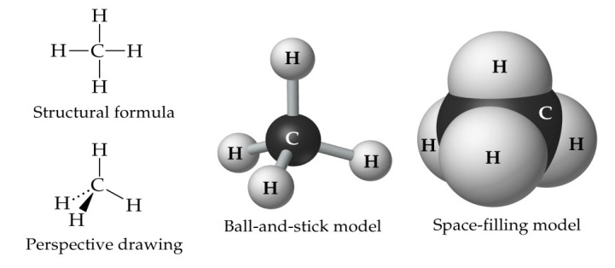
--Chemical formula – relative numbers of atoms of each element present
--Empirical formula – the simplest whole number formula
--Structural formula – the order and type of attachements
– shows multiple bonds
- may show lone pairs
- hard to show 3-d

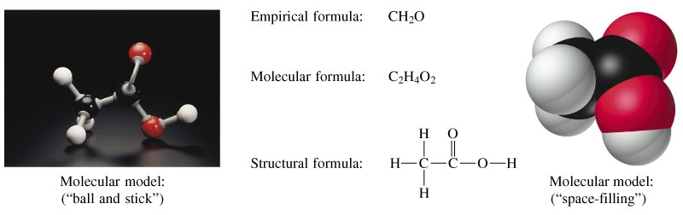
Inorganic Molecules
Some inorganic compounds for molecules
Sulfur and phosporous for example.
They come in various forms called allotropes – these are one allotrope of each

Ions

Atoms are electronically neutral they do not have a charge.
But an atom can lose or gain electrons (it cannot lose or gain protons…WHY NOT?)
An ION – is a particle with an unequal number of protons and electrons.

When an atom or molecule loses electrons, it becomes positively charged.
  - For example, when Na loses an electron it becomes Na⁺.
- Positively charged ions are called cations.
- When an atom or molecule gains electrons, it becomes negatively charged.
  - For example when Cl gains an electron it becomes Cl⁻.
- Negatively charged ions are called anions.
- An atom or molecule can lose more than one electron.
Ionic compounds
- Atoms of almost all elements can gain or lose electrons to form charged species called ions.
- Compounds composed of ions are known as ionic compounds.
- Whereas many metals form monatomic cations, only six nonmetallic elements commonly form anions
- Positive and negaive ions joined together by electrostatic forces
- Metals tend to lose electrons to form cations
- Non-metals tend to gain electrons to form anions
- Ionic solids formulae are reported as the formula unit – inappropriate to call it a molecular formula
Oxidation States
- Metals tend to lose electrons.
- Na → Na⁺ + e⁻

- Non-metals tend to gain electrons.
- Cl + e⁻ → Cl⁻
- Metals are electron sources
- Non-metals are electron sinks
- Sodium goes to the +1 oxidation state
- Chlorine goes tot eh –1 oxidation state
- We use the Oxidation State to keep track of the number of electrons that have been gained or lost by an element.
Determination of Empirical Formula Combustion Analysis
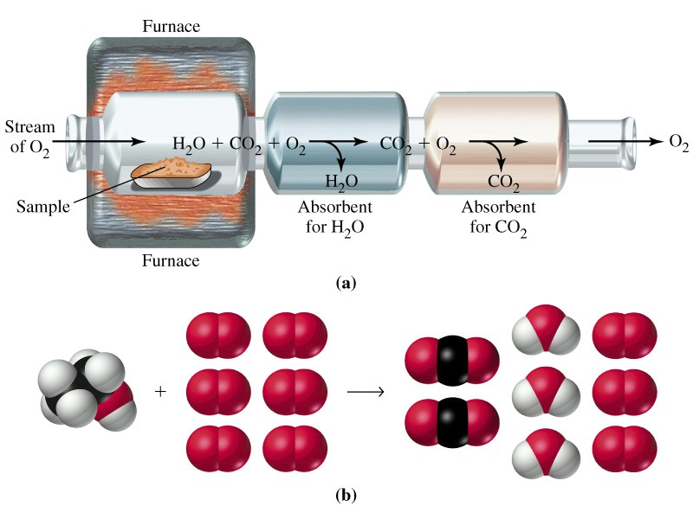
Water vapour absorbed by magnesium perchlorate
Carbon dioxide absorbed by sodium hydroxide.
The differences in mass of the absorbers before and after yiled the masses of water and CO₂ produced in the reaction
Combustion takes place in an excess of oxygen so you cannot measure oxygen. Oxygen CAN be analyzed separately but is usually determined by difference.

An Example of Determining the Empirical and Molecular Formulas of a Compound from Combustion Analysis Data.

Complete combustion of a 1.505 g sample of an unknown compound consisting of C, H and S yields 3.149 g CO₂, 0.645 g H₂O and 1.146 g of SO₂. What is the empirical formula for the unknown?

Step 1: Convert the mass of each product into moles of C, H and S.
3.149 g CO₂ x 1mol/44.010g CO₂ x 1mol C/1mole CO₂
= 0.07155 mol C
0.645 g H₂O x 1mol/18.02g H₂O x 2mol H/mol H₂O
= 0.0716 mol H
1.146 g of SO₂ x 1 mol/64.06 SO₂ x 1mol S/mol SO₂
= 0.01789 mol S

Step 2: Write a tentative formula
C_{0.07155} H_{0.0716} S_{0.01789} = C₄H₄S
0.07155 mol C = 0.859 g
0.0716 mol H = 0.0716 g
0.01789 mol S = 0.574 g
1.505 g
Example2
Determining the Empirical and Molecular Formulas of a Compound from Its Mass Percent Composition.
When an unknown compound is decomposed into its constituent elements, it is found to contain 71.65% Cl, 24.27% C, and 4.07% H by mass. What is the empirical formula for the unknown?

Step 1: Determine the mass of each element in a 100g sample.
71.65 g Cl, 24.27 g C and 4.07 g H in the sample.

Step 2: Convert masses to amounts in moles( molar mass)

Step 3: Write a tentative formula.
Cl_{2.021}C_{2.021}H_{4.04}
Step 4: Convert to small whole numbers.
Cl₁C₁H₂ or ClCH₂
Possible molecular formulas:
Cl₂C₂H₄ or Cl₃C₃H₆ or Cl₄C₄H₈ etc
We experimentally determine the molar mass to be 98.96 g/mol. Determine the molecular formula of the unknown
Empirical formula mass is 49.48 g/mol
This is half of the actual molar mass so the correct formula is
Cl₂C₂H₄

Naming Compounds
Binary Compounds of Metal/Nonmetal – (Ionic Compounds)
The metal element appears first and retains its elemental name.
The nonmetal element begins with a root derived from its element name and ends with the suffix –ide.
NaCl sodium chloride
MgBr₂ magnesium bromide
Al₂O₃ aluminum oxide

Nonmetallic Binary Compounds – (Covalent Compounds)
The element that appears first retains its elemental name.
The second element begins with a root derived from its element name and ends with the suffix –ide.
SO₂ sulfur dioxide
When there is more than one atom of a given element in the formula, the name of the element usually contains a prefix to specify the number of atoms present.
SO₃ sulfur trioxide
CO₂ carbon dioxide
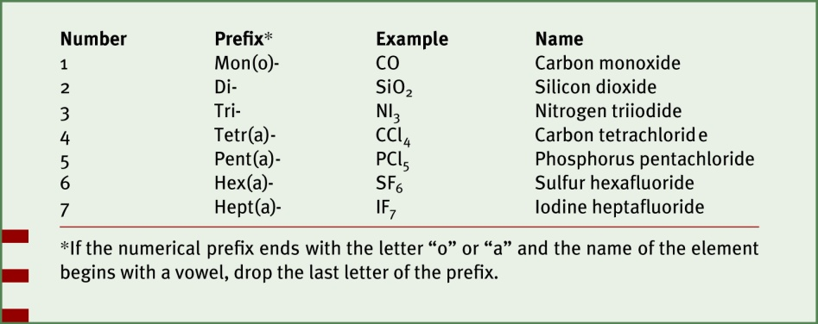
Polyatomic ions
- A molecule with a charge is termed a polyatomic ion
- These ions can form ionic compounds with other ions.
- Therefore, some compounds can have both ionic and covalent bonds
- Example: NaNO₃
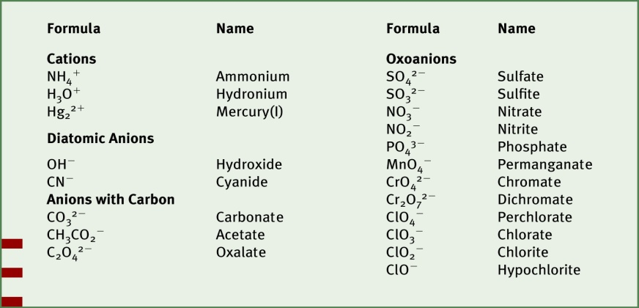Common polyatomic ions

Cations of Variable Charge
- When species involved form ions with more than one possible charge, it is necessary to state the charges of the compound.
- For example, copper forms compounds with Cu⁺ and Cu²⁺.
- To indicate the charge in the name, a Roman numeral is added in parentheses.
CuO = copper (II) oxide
Cu₂O = copper (I) oxide
- This convention is ONLY used if multiple possible charges exist for a cation.

