Lecture 2:
Robert Hooke (1635-1703)
- First Microscope (~30x power), drew nematodes, coined the term ‘cell’
Van Leeuwenhoek (1632-1723)
- Made magnifying lenses (500x power), first to observe single cell organisms (Animalcules)
Edward Jenner (1749-1823)
- Vaccination, used live cowpox to treat against small pox
Larrazo Spallanzani (1729-1799)
- Broth sterilized (by boiling) did not grow microbes (proof against spontaneous generation)
Louis Pasteur (1822-1895)
- Chirality of organic molecules, fermentation metabolism (brewers), swan necked flasks (no spontaneous generation)
Florence Nightingale (medical epidemiology)
Robert Koch (1843-1910)
- Specific microbes cause specific disease, Koch’s postulates (1. The microbe is found in all cases of the disease but is absent from healthy individuals, 2. The microbe is isolated from the diseased host and grown in pure culture, 3. When the microbe is introduced into a healthy, susceptible host, the same disease occurs, 4. The same strain of microbe is obtained from the newly diseased host)

Lecture 3:
Microorganisms are NOT necessarily microscopic, not always unicellular, undifferentiated nor cellular
Carle Woese (father of molecular phylogeny)
- Tree of Life, all but the animals and plants are microbial
- Used rRNA to build phylogenetic tree
- The nodes show a common ancestor to specific organisms that are no longer alive
Prokaryotes
- 70S ribosomes, cell walls, circular genome in compact nucleoid
- Difference between bacteria and archaea
  - rRNA sequences, membranes, cell walls
- Can be found in the most extreme environments (arctic lakes, mines, etc.)
Methanogens are the sole natural source of methane (CH₄)
Acidophiles usually oxidize hydrogen sulfide and elemental sulfur (H₂S SO₄²⁻)

Lecture 4:
Halophiles are archaea that live in extremely salty water, showing microbes can grow anywhere
Bacteria (and archaea) are symbionts of plants and animals, showing a biofilm are a collection of microbes on a particular object
Some microbes in cows help digestion of plant fibers; rumen is anaerobic and contains methanogens
Nitrogen-fixing plant symbionts (N₂ NH₄⁺)
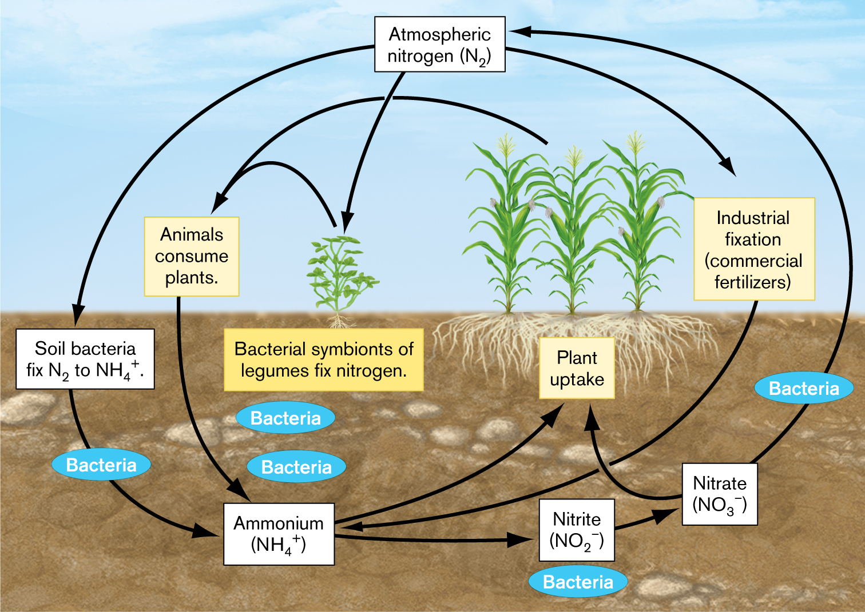
Figure 1 biogeochemical cycling: the Nitrogen cycle
“Earth’s ecology is microbial ecology”
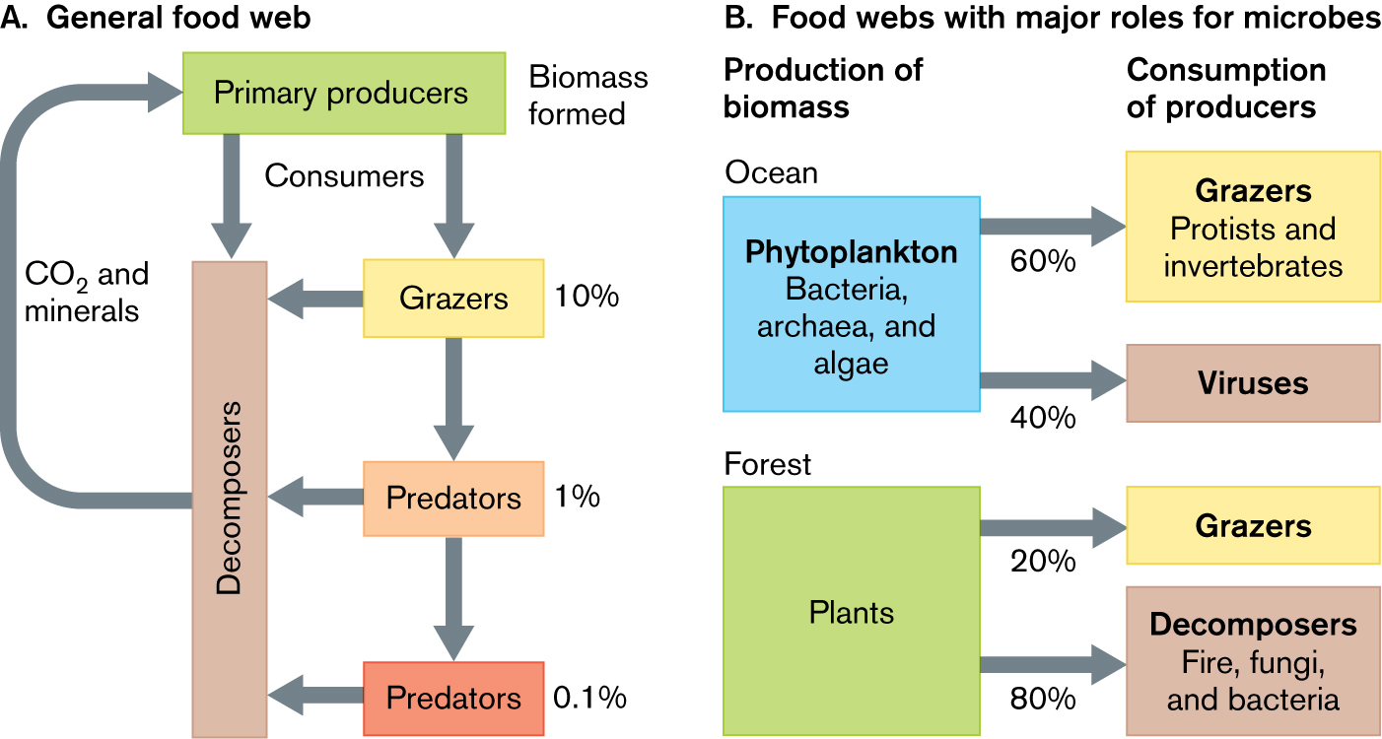
Figure 2 Carbon cycle
Grazers give back 90%, and Predators also 90%
Since microbes live in complex communities, one organisms waste can be another’s “treasure”

Lecture 5
A Virus is a particle that must infect a host cell, where it reproduces (all forms of life, even other viruses)
- Has genetic material (DNA or RNA), capsid (made by host), glycoprotein envelope (optional), surface proteins (attachment to host cells, determines which host the virus will take)
  - Once in the cell, will create a plasma membrane (tegument accessory inside) tail stick out
- can be useful, bacteriophage can control infections or biofouling (alternative to antibiotics or disinfectants), used in molecular cloning (as cloning vectors)
- delivery vehicles for gene therapy
- filamentous phage particles can be used to crystallize conducting nanowires
A virus infects the host cell and incorporates into its genome, where it then replicates its own DNA
Virus’ have a host range where they only infect a particular group of host species (most have narrow)
- narrow host range: smallpox, HIV (only humans)
- wide host range: West Nile, cucumber mosaic virus
Virus structures
- Icosahedral: 20 sides, Natural selection favors packaging most material in smallest number of repeating subunits
- Filamentous: genome is coiled into helical capsid (like tubes)
- Multiple helical packages: collection of several helical genome segments (the flu), enables virus to package different numbers of RNA segments into different virions (enables rapid evolution of new strains)
- Complex viruses: Icosahedral head + helical neck + spider legs
- Asymmetrical viruses: double stranded DNA genome stabilized by covalent connection of its 2 strands at each end, DNA enclosed by 2 envelopes, contain lots of accessory proteins
Viral Genomes, simple and efficiently packaged
- Due to size, the genome can be read many different ways, resulting in different proteins
- LTR: long terminal repeats – often a ‘signature’ of a viral incorporation even in a host genome
HERVs (Human Endogenous Retroviruses)
- 8% of human genome, remains of ancient viruses that once infected the germ line and incorporated themselves into our genome
- Psychosis and sclerosis patients show evidence of transcription of HERV genes, (MS patients respond well to interferon beta therapy (suppresses retroviral replication))
Viroid’s are ‘naked’ infection RNA molecules
Prions
- Only protein, aberrant proteins arising from the host cell, abnormal structure, interaction with normal form can cause aggregation and cause cell death

Lecture 6:
Prokaryotes all share certain traits:
- Thick, complex outer envelope
- Compact genome
- Tightly coordinated cell functions
Bacterium simple parts; cytoplasm, nucleoid, flagella, capsule, cell wall, ribosomes, cytoplasmic membrane, pili
Mollicutes (soft skin bacterium)
- Only have; DNA, ribosomes, cytoplasm, plasma membrane
- Advantages
  - Cheap, little energy to survive, small, can squeeze through spaces
- Disadvantages
  - Hard to maintain – usually need a eukaryotic host cell for safety, complicated diet, unattractive, amorphous blob
- Pneumonia, genitalium (mollicutes)
Gram positive (fuzzy)
- DNA, ribosomes, cytoplasm, plasma membrane, cell wall
- Cell wall made of peptidoglycan (sugars and amino acids)
- Advantages
  - Strong, guaranteed against osmotic lysis, different shapes, gram stained purple
- Disadvantages; must be kept away from lysozyme
- Staphylococcus aureus (coccus = round), Bacillus cereus (food poison, bacillus = rod-shaped)
- Teichoic acids found in Gram +
Gram negative
- DNA, ribosomes, cytoplasm, plasma membrane, thin cell wall, outer membrane
- Outer membrane made of lipopolysaccharides)
- Advantages
  - Defense against toxic molecules, periplasmic space (storage), guaranteed against osmotic lysis, gram stained red
- Disadvantages
  - Toxic if not handled correctly, bigger genome to make more complex double membrane
- E. coli, H. pylori
Extras for Gram Negative/Positive
- 1. An additional protective layer (5-25nm thick), crystalline layer of thick subunits (protein or glycoprotein), and highly ordered (oblique, square, hexagonal structures)
  - S layers can self-assemble (Both Gram +/-
- 2. Capsule (slime layer, Gram +/-), loosely bound polysaccharides, when stained they appear as halos around cells, can exist with S-layer (will be outside the S-layer), important role in pathogens for preventing phagocytosis/activation of innate immune system
  - Bacillus anthracis has large capsule outside S-layer, stain gives halo around cell
- 3. Thylakoids (only Gram - phototrophs), system of folded sheets of membranes (photosynthetic proteins and electron carriers inside), site of photosynthesis in chloroplasts and cyanobacteria
  - Maximize photosynthetic capability of cell
  - Prochlorococcus marinus (most plentiful organism on earth, makes ~50% of atmospheric O₂)
- 4. Carboxysomes (Gram -), has enzymes to fix CO₂, found in all cyanobacteria and some chemotrophs, polyhedral shape

Lecture 7:
Continued Extras on Gram +/- cells
- 5. Gas Vesicles
  - For aquatic bacterial cells, some aquatic heterotrophs
  - Layer of extremely hydrophobic protein
  - Used for buoyancy
- 6. Storage Granules
  - If present, store excess energy here during growth periods for later use
  - Stores energy informs of glycogen, PHB or PHA
    - PHB (a biodegradable plastic): water insoluble, biocompatible (non-toxic), high tensile strength and heavier than water
  - Some bacteria store sulfur in the granules or attached outside
- 7. Magnetosomes (Gram – aquatic species)
  - Fe₃O₄ (magnetite) membrane bound
  - Allows it to orient with Earth’s magnetic field (‘magnetotaxis’)
  - Very good at delivering targeted drugs in body
    - Small (25-55nm), uniform morphology, high purity, membrane (lipids/proteins)
- 8. Pili
  - Can be:
    - Long/short, flexible/brittle, curly/straight, singular/twisted together in rope-like bundles
  - Can be used in bacterial sex (conjugation)
  - Twitching motility
  - Gram – anchored in outer membrane, Gram + anchored in cell wall
  - Pathogens use their pili to attach to host cells
- 9. Stalks (prosthecate bacteria)
  - Gram - only, aquatic bacteria where extension is made from cytoplasm to outside the cell, secretes “holdfasts”, seeks out nutrients (particularly phosphates)
- 10. Rotary flagella
  - Rigid, long, helical proteins
  - Gram + in cell membrane, Gram - in outer membrane
  - Along with chemoreceptors helps to propel bacterium in optimal directions (runs and tumbles)

Lecture 8:
Archaea are NOT bacteria, but many live under extreme conditions, and can grow in a wider range of temperature and environmental conditions
- Thermophiles like >60C, hyperthermophiles like >90C, mesophilic 25C
- Psychrophiles, anaerobic heterotrophs, sulfate reducers or nitrite-reducing methanotrophs, live in deep permanently cold water
- Halophiles, live in conditions of high salinity, uses gas-filled vesicles to float
  - Phototrophic archaea
    - Don’t use chlorophyll and are not photosynthetic
    - Use a pump called bacteriorhodopsin (gives purple color)
    - Ion pump is coupled to ATP synthesis for cell
- Acidophiles, generates pH of 0, no cell wall, can be found in acid mine tailings
- Methanogens
  - Generate methane from CO₂ and H₂, etc.
  - Can live in your gut, need bacterial species to provide them with nutrients
  - Used to make ‘clean’ methane, meaning it is carbon neutral and not a greenhouse gas
  - More ecologically sound as a fuel than even ethanol
  - Cell wall similar to bacteria
    - Pseudomurein (instead of peptidoglycan) is used, which isn’t affected by lysozyme or penicillin
  - Useful in sewage treatment plants
- Archaeal cell membrane
  - Archaea use L-glycerol linked to side chains using ether links
  - Bacteria use D-glycerol linked to side chains using ester links
  - Repeating units of isoprene (linked together called isoprenoid)
  - Extremophiles use this to covalently attach to each other or other lipids
    - Strengthens the membrane, new shapes can form
  - Branched chain ether lipids are characteristic of archaeal membranes
- Lipid bilayers:
  - Eukaryotes and bacteria (normal)
  - Some bacteria
    - Lipid bilayer strengthened by hopanoids
  - Some archaea
    - Lipid layer strengthened by linking of the tail groups
- Extremophiles make enzymes with lots of stability, archaeal lipids make great vaccine adjuvants, archaea are a source of novel antibiotic classes

Lecture 9:
Classify organisms based on DNA sequence data
Knowing who our closest non-animal relatives are can be used to answer key questions (basis of cancer and aging), animals most closely related to choanoflagellates
Flagella set us apart from protists (prokaryote spins vs. eukaryote waves)
Fungi (eukaryotes)
- Reproduce using spores, heterotrophic, cell walls made of chitin
  - Chitin; beta-linked polymers of N-acetyl glucosamine, immense tensile strength (>steel), can penetrate even tough food sources
- Can recycle even substances that are hard to break down (e.g. lignin)
- Yeast (unicellular fungi)
  - Don’t use hyphae to obtain nutrients
  - Remain unicellular but may be dimorphic (mycelia depending on enviro conditions)
  - Used to make bread, wine, beer
  - “budding”
  - Mycelium
    - A branched mass of extending hyphae (white fuzz)

Lecture 10:
Genetic analysis has started to tease this all apart (classifying fungi based on looks)
Primary and Secondary endosymbionts
- Primary endosymbiosis: prokaryote + eukaryote = eukaryote
- Uptake of a proteobacterium by the ancestor of all eukaryotes
  - Became mitochondria
- Cyanobacterium by the ancestor of all plants
  - Became chloroplasts
- Secondary Endosymbiosis: eukaryote + eukaryote = eukaryote
- Some protists have taken up algae (a primary endosymbiont) to become secondary endosymbionts
Ameba’s (Amoebas)
- Look like lumps of jelly, have ectoplasm and endoplasm
- Highly controlled, complex motion (formation of pseudopod)
- Predator; use phagocytosis
Slime Molds
- Cellulose in their cell walls (not chitin), single celled communities of ameba’s (cellular, plasmodial)
- Radiolarians (amoebas with shells made of silica)
Alveolates
- Flattened vacuoles within their outer cortex
- Highly structured with cilia or flagella
- Predators, complex genetic system, sexual reproduction
- Phototrophic (dinoflagellates)
  - Possess 2 flagella (1 wrapped around cell body)
  - Secondary or tertiary algal symbionts
Algae
- Primary producers in most ecosystems
- Phytoplankton
- Primary/secondary symbiotic algae
  - Primary
    - Share lineage with plants
    - 2 major clades (chlorophyta = green algae, rhodophyta = red algae)
      - Red algae; photopigment phycoerythrin, absorbs in green—blue range, can colonize deeper waters than green algae, includes coralline algae
  - Secondary
    - Arose from ancestral protists that engulfed a primary algae
    - More than 2 membranes around chloroplast
    - Mixotrophic metabolism (autotrophs + heterotrophs)
    - Diatoms
      - Unicellular algae in lakes/oceans
      - A fifth of all photosynthesis on earth
      - Fix as much biomass as all the rainforests put together
      - Shell or frustule made of silica
    - Kelps
      - Brown algae that floats on the sea
      - Round gas bladders give buoyancy
- Cell membrane surrounded by cellulose and glycoproteins
- Chloroplast fills most of cell
- Contractile vacuole

Lecture 11:
Symbiotic relationships
- Positive
  - Mutualism (facultative or obligate) – both benefit and depend on each other
    - E.g. lichens (fungi+algae)
      - Fungus partner is a mycobiont
      - Algae partner is a photobiont
  - Protocooperation – both benefit but don’t depend on each other
    - E.g. mycorrhizae (fungus+roots of vascular plant)
      - Help create vanilla
  - Commensalism – one species benefits while other is unaffected
    - Beggiatoa oxidizes H₂S to elemental sulfur, promotes growth of others but does not benefit itself, host of this microbe benefits, can even break down polysaccharides that host cant
- Negative
  - Predation
  - Parasitism – one benefits, other harmed
  - Amensalism – one kills another
  - Competition
Although lichens live everywhere, they are bad with competing against vascular plants, thus they tend to either live on a plant (as epiphytes) or in places where plants cannot grow, even Mars and space!
- However, can be sensitive to air pollutants or hikers/bikers

Lecture 12:
Bdellovibrio likes to eat Gram - bacteria
Microbes prefer to live in communities (large numbers provide protection), can practice syntorphy
Communities can be good and bad
- Bad: marine biofouling, dental plaque (~400 different species, set up 3 stage process (pri-sec-tertiary)), damage indwelling medical devices, chronic infections
- Good: bioremediation, normal, animal-associated microbiota
Biofilms allow prokaryotes to behave as multicellular organisms
- Mixed species biofilms predominate, shows structures organization
- Quorum sensing ( chemical signaling between cells)
- 4 stages in biofilm development
  - Initiation, maturation, maintenance, dissolution
  - Form when nutrients are plentiful, then disassociate when they’re depleted
- Initiation
  - Different species receive different signals, twitching motility to seek out optimal spot on surface, then they stop moving and attach to surface
- Maturation
  - More cells bind to surface, quorum sensing helps new cells pick a spot, cells form a thick layer of polysaccharides and entrapped inorganic and organic molecules
- Maintenance
  - Adherent bacteria and matrix makes it a 3D form, quorum sensing used to make channels for water/nutrients
- Dissolution
  - Likely nutrient limitation, possibly cis-2-decanoic acid, single cells disperse from the biofilm structure
- Can move in different ways, rippling, steaming, detaching, seeding dispersal, rolling
Bacteria cooperate
- Tweet chemical signals to each other, sense environment, and decisions to enable survivability, can move as they grow within an environment
Human vs. bacterial social intelligence
- Bacteria score is based on genes which encode for communication and process information, decisions on offensive(toxic)/defensive(neutralizing) agents needed chemical warfare with other bacteria
Quorum sensing
- Chemical language to communicate between microbes, autoinducer accumulation to a certain concentration threshold where it will then induce a response

Lecture 13:
Microbial Growth
- Prokaryotes multiply through binary fission
  - Initiation, replication, termination
  - Bacterial DNA replication is semi-conservative (daughter gets one strand), and bidirectional (begins at fixed origin and proceeds in both directions)
- Vertical transmission, horizontal transmission
  - Binary fission – identical genome copies produced
  - Conjugation – bacterial sex
  - Transduction – bacteriophage-mediated
  - Transformation – taking up DNA from the environment
    - Take naked DNA left behind by other cells
    - Take plasmid DNA for continued autonomous replication of the plasmid in a new host, plasmid forced into the cell
      - Plasmids; extrachromosomal DNA, small, encode accessory functions, replication is autonomous, can be passed from cellcell through conjugation
- Bacterial growth
  - Worst case scenario – pathogens, food spoilage agents
  - Best case scenario – bioremediation agents, microbial production of drugs
  - If unlimited resources, bacteria will divide at a constant interval (generation time)
  - Clostridium perfringens – 10 minute generate time
  - Mycobacterium leprae – 14 days
  - 4 Phases
    - Lag phase – cells sense and adjust to new environment
    - Exponential (log) phase – early/late, early = cells growing at maximum rate possible (largest cells in this phase), slowing growth due to density (may be influenced my quorum sensing)
    - Stationary phase – cell numbers stop rising (little nutrients, lots of waste), become smaller, make stress response proteins, sporulate to survive
    - Death phase – no nutrients to live, cells die off
- Certain Gram + bacteria can form endospores, which is an alternate growth pathway that allow them to survive for long periods of time, when “done” enters a vegetative growth cycle
- Starvation response for cells that cant sporulate
  - Get smaller, cell wall thickens, glycogen stores are laid down, nutrient transporters and stress response proteins are expressed
- Some encoat themselves in fimbrial jackets (made of cellulose and fimbrial proteins) to protect against temperatures
- Some bacteria prefer rich media, whereas others can only survive in low concentrations (oligotrophs)
- Bacteriophage lifecycle
  - Host recognition and attachment
  - Genome entry
  - Assembly of virions
  - Exit and transmission
- Lytic cycle = bacteriophage takes over the bacterium and destroys the cell to release its progeny, # = burst size
- Lysogeny, site-specific recombination to make a prophage, can take host genome when it leaves and carry to new host (transduction)
- Slow release, phage particles reproduce without destroying the cell, constant supply of progeny virions are made
- CRISPR sequences are a bacteria and archaea cells immune system

Lecture 14:
Van Niel postulates:
- 1. Every molecule existing in nature can be used as a carbon or energy source by a microbe found somewhere in the biosphere
- 2. Microbes are found in every environment on Earth
Microbes give and take from the environment, but they depend on its genome and environmental factors
Carbon assimilation and dissimilation
- Assimilation is when an organisms requires an element to build into cells (producers)
  - Assimilate minerals into biomass
- Dissimilation is when an organisms break down organic nutrients to inorganic minerals (consumers)
Microplankton (20-200um), nanoplankton (2-20um), picoplankton (0.3-2um), femtoplankton (<0.3um)
In marine environments, the vast majority of carbon transfer occurs between microbes, and viruses help recycle nutrients do to the lysis breaking down about half of all microbial biomass
Regions of a marine habitat
- Neuston (top, 10um thick)
  - Air-water interface, highest [microbes]
- Euphotic zone (0-200m)
  - Phototrophs can grow because light can penetrate
- Aphotic Zone (200+)
  - No light, only heterotrophs and lithotrophs can grow
- Benthos (ocean floor), domain of ‘benthic organisms’
Thermocline and the biochemical oxygen demand (BOD)
- Thermocline is the depth where temperature drops and water density increases
  - Heterotroph population peaks (nutrients settle here from above to help population)
- Concentration of heterotrophs drives the BOD
  - BOD in low demand in open ocean so the O₂ levels are high, but changing due to humans

Lecture 15:
As you go farther into the soil
- Fungi, Actinomycetes, slime molds fungi (mycorrhizae), aerobic bacterial biofilms and filaments prokaryotic domain: lithotrophs, anaerobic heterotrophs endoliths (methanogens and lithotrophs)
Humus is the remaining phenolic material left after primary degradation of lignin
The rhizosphere is an area around the roots of a plant that is home to microbes which help protect from pathogens, in return they feed off nutrients from the plant
Endophytes grow within plant tissue (bacterial or fungal) in nodules to form a nitrogen fixing ‘organ’ for the host plant (leguminous plants)
Bacteria in non-sterile body sites are called commensal organisms
The consortium of colonizing microbes has been dubbed the human microbiota or microbiome
- Microbiota indicates the cell consortium
- Microbiome indicates the genetic potential of the consortium
Humans are 90% bacteria, 10% human, 100x more microbial genes associated with us than our human genes

Lecture 16:
Skin
- 10¹² microbes in moist areas
- Mostly Gram + bacteria (resistant to salt and dryness)
Mouth
- An infant’s mouth is colonized by non-pathogenetic Neisseria (Gram -), Streptococcus, Lactobacillus spp (Gram +)
- More grow when teeth appear, between gums and teeth and tooth enamel
- Oral and respiratory tract is most common site of infection
- Anaerobic bacteria survive in the mouth because they associate with facultative anaerobes
  - Prefer to use oxygen, unless it’s not present it will switch to anaerobic respiration
Nose and oropharynx
- Nostrils/nasopharynx dominated by Firmicutes and Actinomycetes (Gram +)
  - One will dominate the other, lots of pathogens in us but most work in symbiont with microbes (unless they are disturbed)
- Nasopharynx populated by S. aureus and S. epidermidis
- Oropharynx – similar composition of microbes to saliva
  - N. meningitides is in about 10% of people and causes no problems
Lungs
- Lots of microbes present (not sterile), mainly anaerobes, very difficult to examine a person’s lung
- Microbiota in diseases seem to be different for each condition and different to that of a healthy lung
Urogenital tract
- Kidneys and bladder normally pretty sterile
- Urethra may contain S.epidermidis and Enterobacteriaceae which can cause UTIs
- Vaginal microbiota can change during menstruation
Stomach
- Due to the low pH, few microbes survive, one is H. pylori
  - Survives at pH 1, burrows into mucus, can cause gastric ulcers
- Decreased stomach acidity (hypochlorydia)
  - Caused by malnourishment, caused deliberately now (through PPI use)
  - Can lead to intestinal disease (stomach acid is a key defensive barrier)
Intestine
- 10⁹- 10¹¹ per gm. of feces (1000 anaerobes to 1 facultative anaerobe)
- Most important microbial ecosystem in the body (in colon)
- Does as much metabolic work as the average liver

