University of Ottawa
Organic Chemistry Lab II
CHM2123
Section B

Experiment 1:
Separation and Purification of Natural Products

For: Luis Villegas
Due: September 24th, 2013
From: Anchal Joshi (7449898)
Lab Partner: Vi Nguyen (7390183)

Introduction
The purpose of this experiment was to use different techniques to extract and purify certain products in a chemical reaction. Processes such as extraction, recrystallization and thin layer chromatography (TLC) were done in order to yield a certain product. In part A of the experiment, extraction was used in order to isolate the caffeine in black tea leaves and then recrystallization methods were used to purify the extracted product. In part B, extraction was done in order to isolate the pigments in spinach leaves, as well as TLC to separate the pigments and determine which pigments are present in the leaves.
Part A - Extraction and Purification of Caffeine from Black Tea
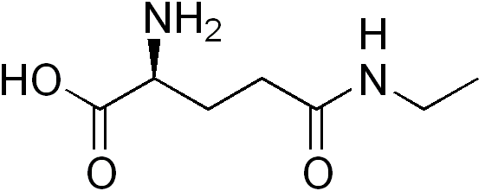
Tea leaves have been known for its medicinal properties from the caffeine and the activity of polyphenols. They are composed of polyphenols such as tannins, caffeine, theaflavin, catechin and theanine, as well as other plant material such as chlorophylls and cellulose. Caffeine is a very common substance found in coffee, tea, soft drinks, chocolate and many other goods. It can easily be synthesizes and isolated from natural sources. This experiment illustrates the isolation of a naturally occurring product from a plant material, caffeine from black tea.
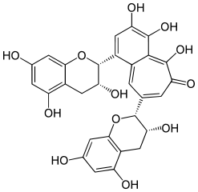
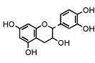

Figure 1. Polyphenols present in tea (Cathechin, Theaflavin, Theanine)

Caffeine (1,3,7-trimethylxanthine) is an alkaloid. It is used as stimulatory drug for the central nervous system, skeletal muscles and, respiratory and cardiac systems. Black tea contains approximately 30 to 75 mg of caffeine per 250mL cup. Like other alkaloids, such as morphine, cocaine and codeine, caffeine is known to have highly addictive properties.
The extraction of caffeine can easily be done with hot water, but many tannins dissolve into the aqueous layer therefore an organic solvent such as dichloromethane (CH₂Cl₂) is added. This allows caffeine to dissolve while leaving the polyphenols in the aqueous phase due to their weak acidity. Sodium carbonate (Na₂CO₃) is then added in order to keep the polyphenols in the aqueous phase and further isolating the caffeine. The caffeine is then recrystallized and TLC and melting point are then used to verify its purity.
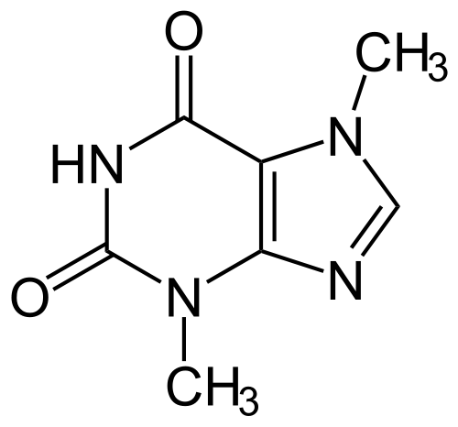

Figure 2. Structure of caffeine

Part B- Extraction of Carotenoids and Chlorophylls from Spinach
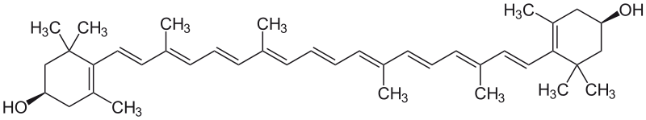
Plant leaves like spinach are composed of numerous pigments that can be put under two categories: carotenoids and chlorophylls. A carotenoid that is common among most green plants is Xanthophyll. Xanthophyll’s is the carotenoid responsible for the yellow pigmentation in spinach leaves. Lutein, beta-carotene, zeaxanthin and violaxanthin are some xanthophyll carotenoids that can be found in spinach leaves.

Zeaxanthin
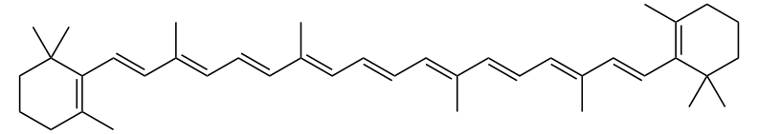
Beta-carotene
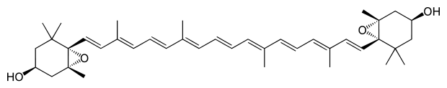
Violaxanthin

Figure 3. Structure of various carotenoids in spinach leaves
Green pigmentation comes from chlorophylls and there exists two types: chlorophyll a, which gives off a blue-green color, and chlorophyll b, which gives a green color.
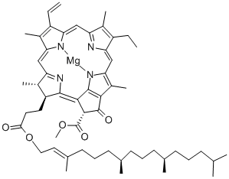
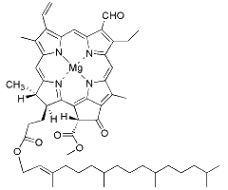

Chlorophyll a Chlorophyll b

Figure 4. Structure of chlorophylls in spinach leaves
When reacted with acid, chlorophylls form pheophytin a and pheophytin b, both grey pigments. Theses two pigments result in an olive color in vegetables.
In this experiment carotenoids and chlorophylls are extracted and isolated from fresh spinach leaves through liquid-liquid extraction. Then using TLC, the pigments will be identified by their variations in polarity.
Extraction
Extraction is method that allows the separation of a compound from a mixture due to the differences in solubilities of two immiscible solvents. This technique transfers a given compound from the original mixture to a different phase, the organic phase, leaving the impurities in another phase, the aqueous phase. For caffeine extraction, dichloromethane was used as an organic solvent to create these two phases allowing caffeine to dissolve into the organic phase, successfully extracting itself from the tea.
Recrystallization
Recrystallization is a technique used to purify a compound through the difference in solubilities of compounds in solvents with different temperatures. The crude product is dissolved in a hot solvent, which is then filtered to remove any insoluble impurities. The saturated solution is then allowed to cool which is when crystals begin to precipitate. Filtration of this solution then allows to obtain pure crystals.
Thin Layer Chromatography (TLC)
Purities of extracted compounds can be determined through thin layer chromatography (TLC). This method separates a solution into phases: the mobile phases and the stationary phase. The mixture is dissolved in the mobile phase and the solution passes over the stationary phase. Depending what the mixture contains, different components will have different affinities for the two phases, in turn allowing for the separation of the different compounds. In this experiment, silica gel is used as the stationary phase, and different developing solvents are used which act as mobile phases. The mobile phase allows the different components of a compound to travel along the plates by disturbing the original nature of the compound.

Experimental Procedures

Ref: pages 11-16 of the Organic Chemistry II lab manual

Modifications
Part A
- The organic layer was filtered into a 200mL beaker instead of a 125mL Erlenmeyer flask after the Na₂SO₄ was added.
- The melting point of the crystals was not determined due to the lack of time.
Part B
- The spinach leaves were pulped in the centrifuge tube then the sand and anhydrous Na₂SO₄ were added to the same centrifuge tube.

Observations

Part A: Extraction and purification of caffeine from black tea
Important Steps and Additions | Observations
Addition of Sodium Bicarbonate (Na₂CO₃) | Solution maintained a brown color.
Addition of Dichloromethane (CH₂Cl₂) | A separation of 2 layers, an aqueous and an organic layer, started to appear. The organic layer maintaining a brown color, while the aqueous layer was clear yet not transparent.
Addition of Sodium Chloride (NaCl) | Addition of sodium chloride helps distinguish the aqueous and organic layers more.
Addition of Dichloromethane (CH₂Cl₂) | The separation of the 2 layers became clearer than the first addition of dichloromethane. The aqueous layer maintaining its brown color and the organic layer became transparent.
Addition of Sodium Sulphate (Na₂SO₄) | Sodium sulphate was insoluble in the organic phase that contained the caffeine. It became “fluffy” and grew in size.
Heating of filtered organic solution | White powder appeared, crude caffeine.
Cooling of crude caffeine (after addition solvent and dissolution of crude caffeine) | White crystal started to precipitate.
Recrystallization of crude caffeine | Through recrystallization, white crystals were obtained with no signs of contamination.

Part B: Extraction of carotenoids and chlorophylls from spinach
Important Steps | Observations
Test Tube A | The solution divided itself into 2 phases: the organic layer and the aqueous layer. The organic layer was of an emerald green color and was about a third of the solution. The aqueous layer was lime green and was two thirds of the solutions.
Test Tube B | No observation. It is just the organic phase from test tube A.
Test Tube C | The solution separated itself into 2 layers. The organic layer from test tube A turned from emerald green to lime green with the addition of HCl. This layer is the organic layer of test tube C. The aqueous layer was transparent.

Results
Part A
Compound | Appearance | Mass (g) | Yield (%) | Literature Melting Point (°C)
Caffeine  (C₈H₁₀N₄O₂) | White crystals free of contaminants | 0.02 | 7.813 | 238
Note: the melting point of caffeine was omitted
** The TLC results for caffeine were obtained from Max Baratte (ID: 6597792), in the Monday labs

Legend
A: Crude Caffeine Sample
B: Caffeine Crystals
C: Authentic Caffeine

0 mm

A B C

Part B
Compound | Color | Rf values
Compound | Color | I)30:70 Hex:Ace. |  |  | II)70:30 Hex:Ace |  |  | III)50:25:50 Cy.hex:Hex:Ace
Compound | Color | A | B | C | A | B | C | A | B | C
Pheophytin a | Grey | - | - | - | - | - | 0.56 | - | - | 0.55
Pheophytin b | Grey | - | - | - | - | - | 0.48 | - | - | 0.47
Chlorophyll a | Blue-green | - | - | - | 0.45 | 0.44 | - | - | - | -
Chlorophyll b | Green | - | - | - | 0.42 | 0.42 | - | - | - | -
Xanthophyll | Yellow | - | - | - | 0.39 | 0.39 | - | - | - | -
Carotene | Yellow | - | - | - | - | 0.93 | - | 0.21 | 0.21 | -
(The spotting on the plate go from A to C, from left to right)
R_{f} values for 30:70 hexanes:acetone were all 1.

I) II) III)
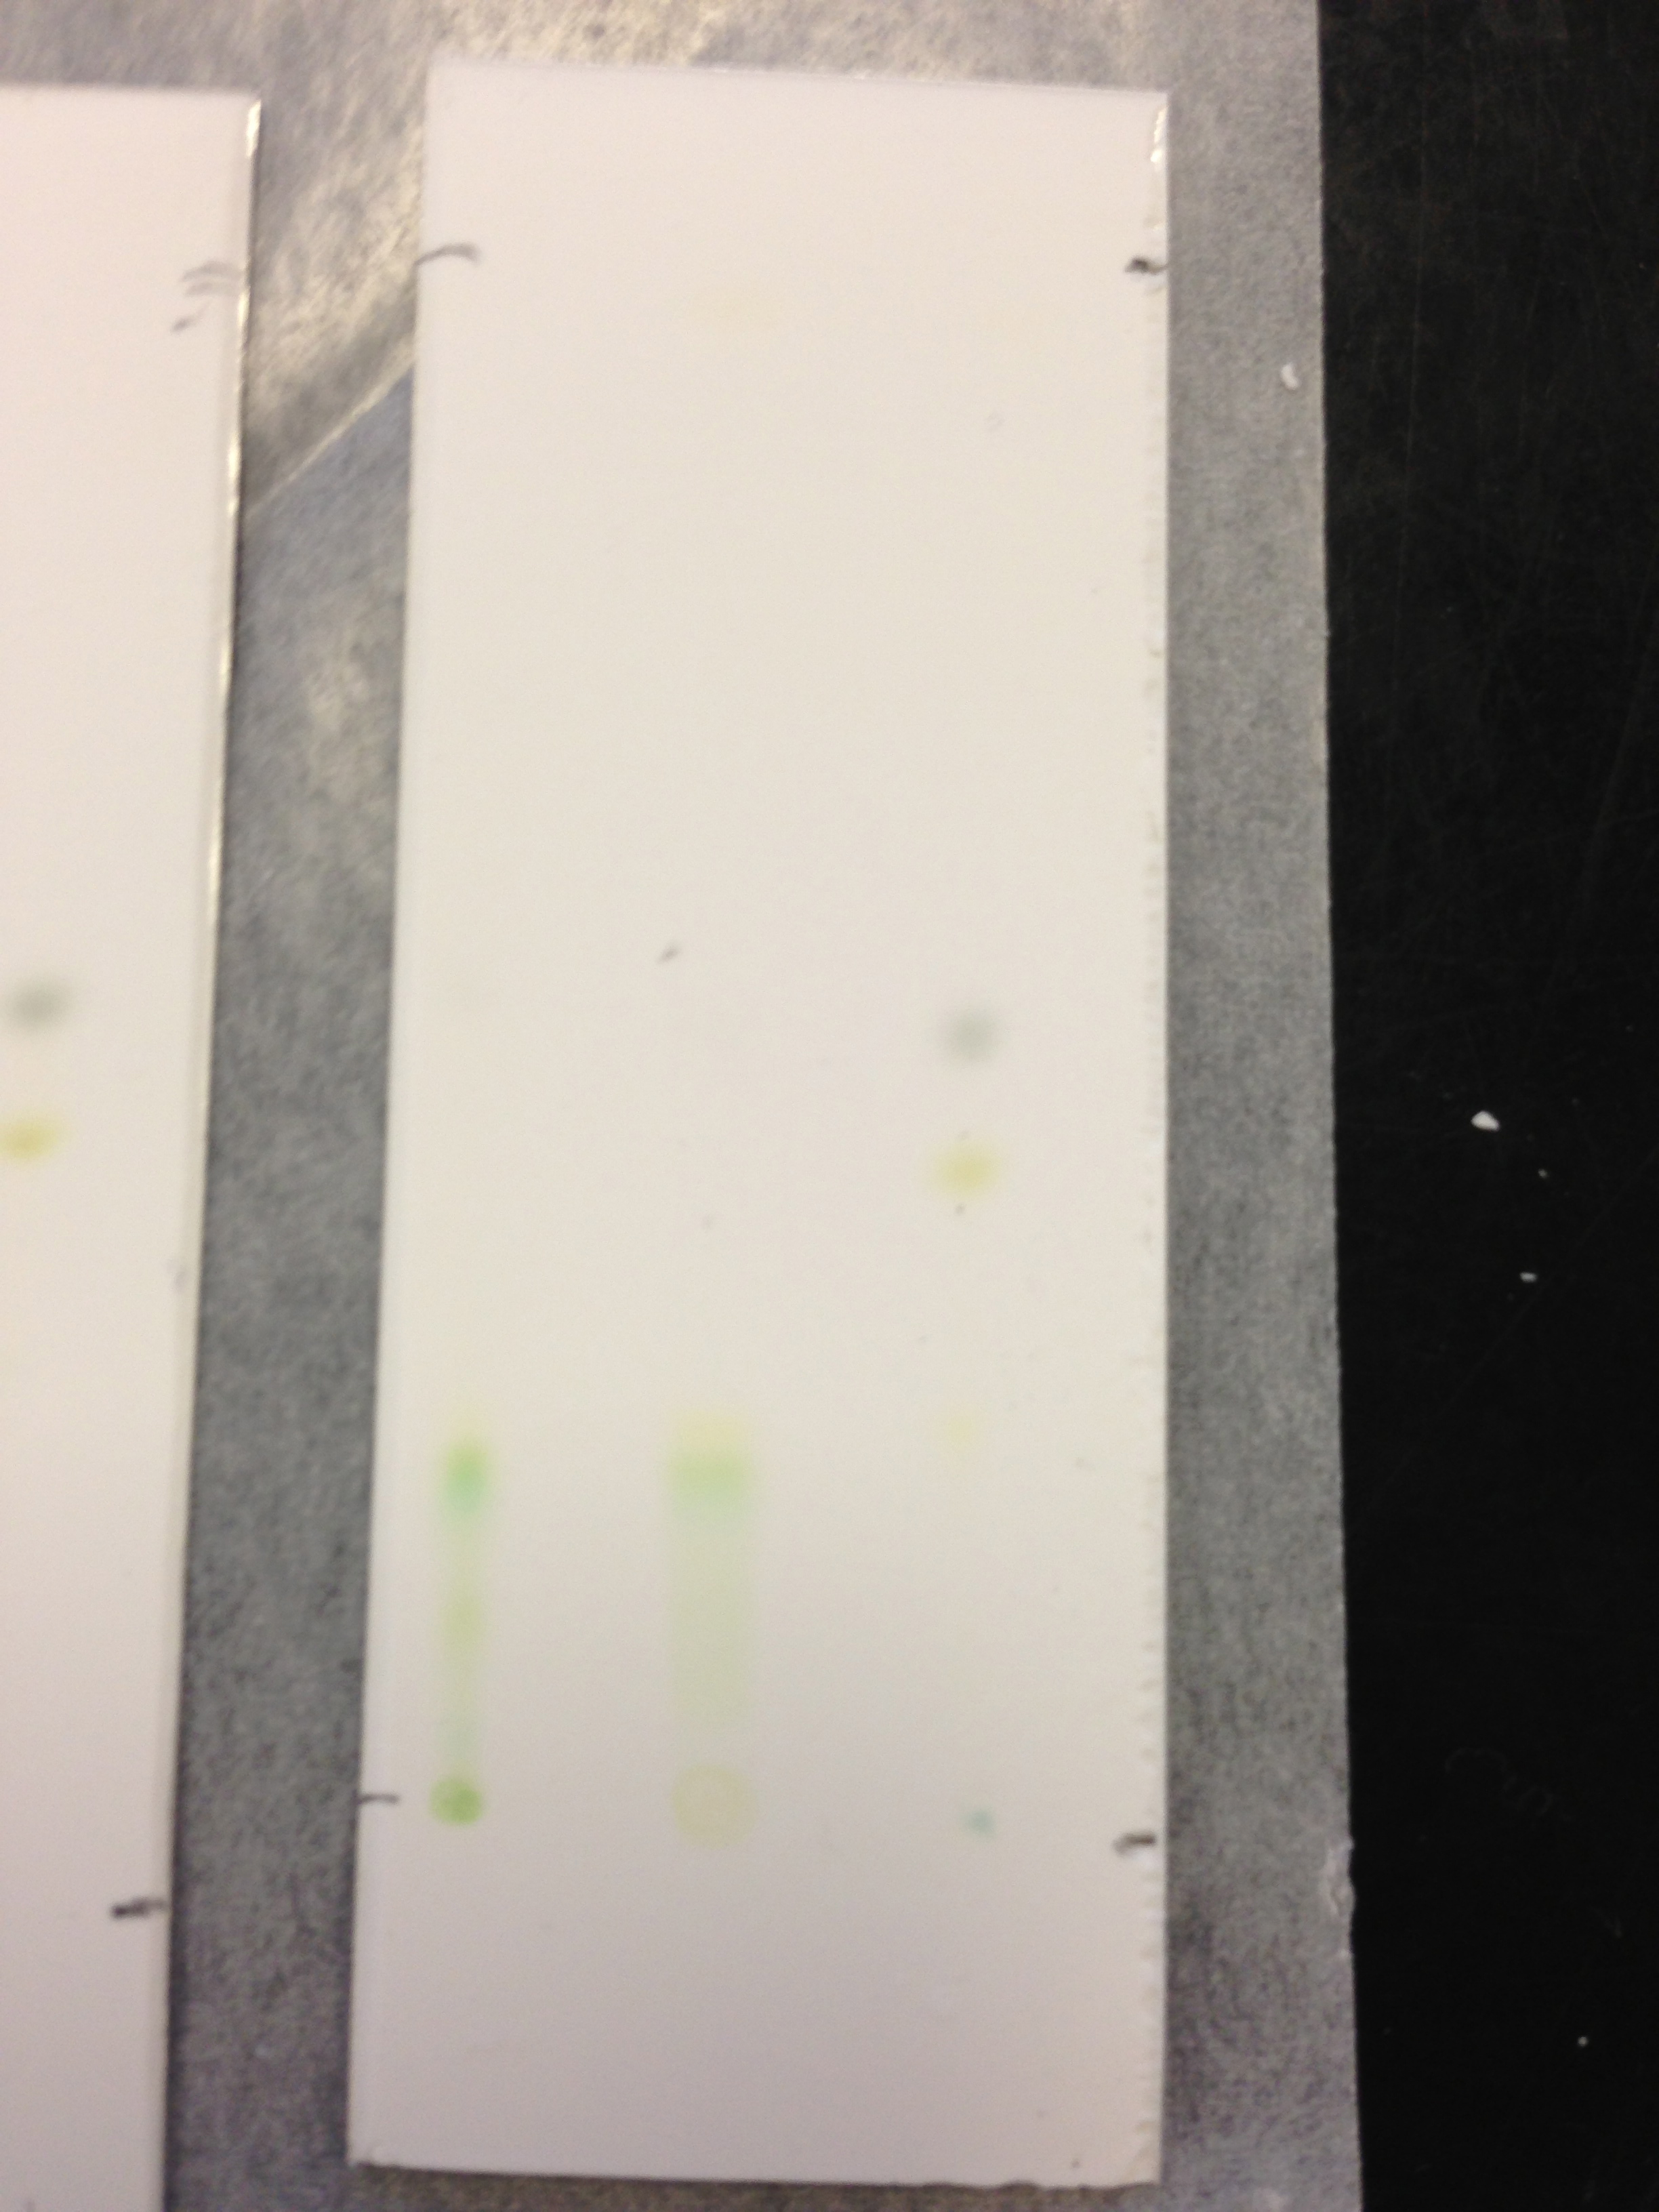
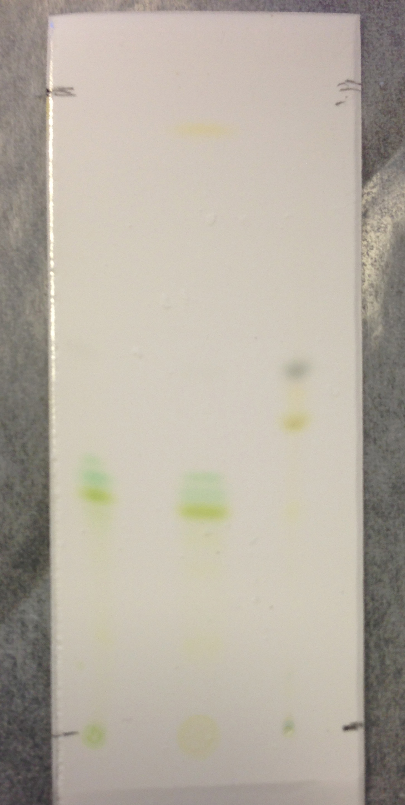
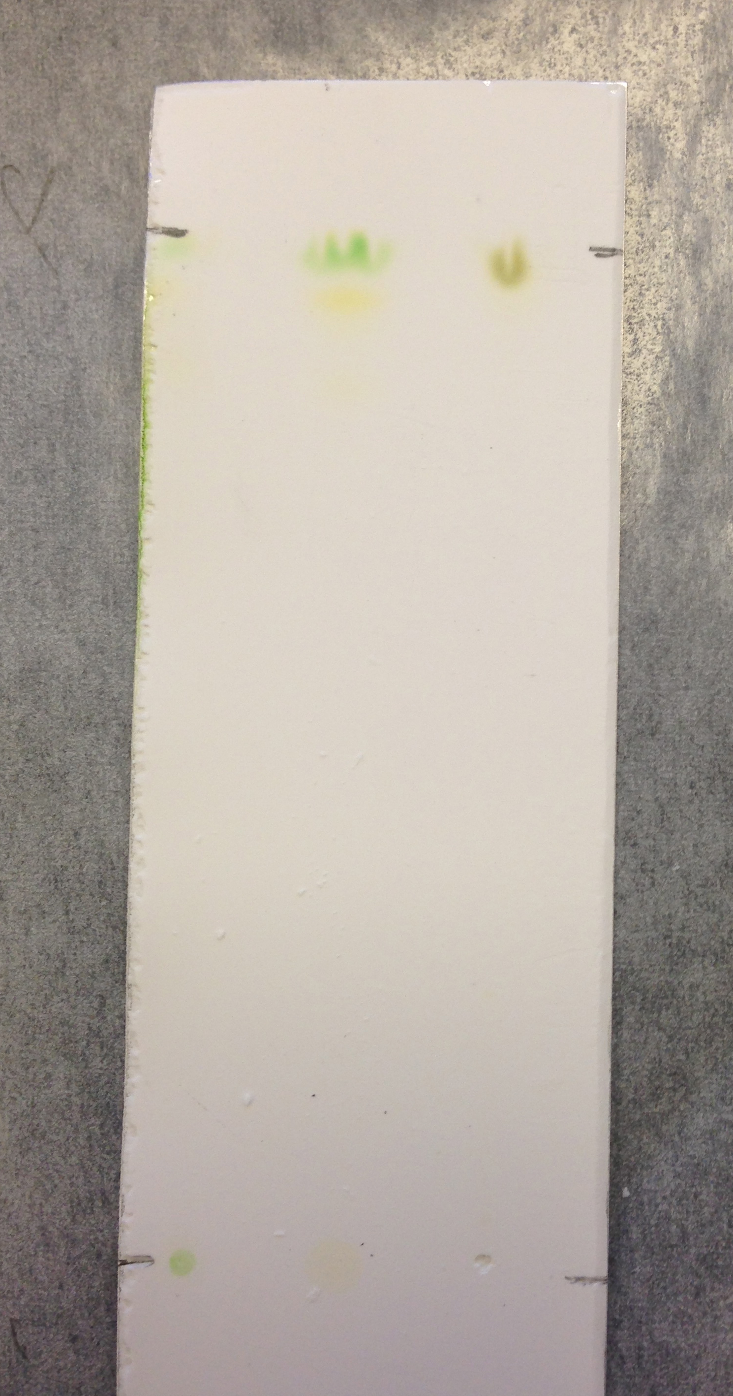

A B C
A B C
A B C

Calculations
$$R_{f}=\frac{distance travelled by compound from origin}{distance travelled by solvent from origin}=\frac{1.9cm}{4.9cm}=0.39$$

$$\% yield=\frac{quatity obtained (g)}{theoretical quantity (g)}×100\%=\frac{0.02g}{\left(6.64g×4\%\right)-(2×0.12)}=7.813\%$$

Flow diagram
Part A- Extraction of caffeine from Black Tea

Discussion
Part A- Extraction and Purification of Caffeine
An essential procedure in the extraction of caffeine is the addition of sodium bicarbonate as it aids in the separation of the organic and aqueous phases by deprotonating the acids, or the polyphenols. Dichloromethane and brine (NaCl) are then added to the solution creating the two visible phases in the separatory funnel. As mentioned in the introduction, the dichloromethane is used as the organic solvent, which allows the caffeine to dissolved into the organic layer and separating the rest of the solution into the aqueous layer. The brine creates tannin salts that remain in the aqueous layer allowing for a purer caffeine extraction. This process was repeated twice and the organic layer was removed from the bottom each time. Sodium sulphate is then added to the organic layer to remove any traces of water and any water soluble impurities before starting the recrystallization process. The recrystallization process is an important step because it removes any impurities that travelled throughout the previous steps. At the end of the experiment, white crystals were produced with no visible sign of impurities. Samples of crude caffeine and recrystallized caffeine were taken for TLC analysis but due to the lack of time, this procedure was omitted. This did not allow for analysis of the purity of the caffeine that obtained at the end of experiment. According to the TLC data received from Max Barrette, there seemed to be no visible movement of the compound in the solvent, in other words the R_{f} value was 1. This means that the compound travelled with the mobile phase the entire way through, creating no separations.
From the calculations, the percent yield of caffeine was determined to be 7.813%. The low yield can be explained by the possibility that emulsions may have occurred. This happens when the organic compounds in one liquid are mixed with a second liquid, both liquids being immiscible. During phase separation, a certain arbitrary amount separates. Part of the yield may also have been lost during the filtration, where some crystals remained in the solvent, as well as some product lost in the transfer of liquids.

Part B- Extraction of Carotenoids and Chlorophylls
By extracting the chlorophylls and carotenoids from spinach leaves, the polarities of different pigments were observed on the TLC plates. In this case, purity did not play much of a role since the purpose of this lab was to view the polarity of the compounds in the solvent and determine their R_{f} values in order to assign the correct pigments in the leaves. After running the TLC plates, it was determined that the polarity, from least to greatest, are pheophytin a, pheophytin b, chlorophyll a, chlorophyll b and xanthophyll. As mentioned in the introduction, pheophytins are derivatives of chlorophylls. They are produced when chlorophylls are put in contact with an acidic medium. This goes with our results since pheophytin a and pheophytin b were only present in the sample C, which was the organic layer from sample A mixed with hydrochloric acid (HCl). The organic layer of sample A contained chlorophyll a and chlorophyll b which were no longer present when HCl was added. Instead pheophytin a and pheophytin b were observed. Hence showing the transformation from chlorophyll to pheophytin. Chlorophylls and pheophytins have similar structures except that in pheophytins, the magnesium ion is replace with 2H⁺ ions, making pheophytins less polar than chlorophylls. As seen in the results table of the TLC’s, TLC (II), the solvent was a non-polar solvent since the hexane is in abundance over the acetone. This made the more polar compounds have a lower R_{f} value because they did not travel across the solvent, and the non-polar solvents travelled much faster in the non-polar solvent since non-polar solvents dissolved non-polar solvents. This result was reversed for TLC (III), where the polar solvents allowed the more polar pheophytins to travel along the plate compared to the non-polar beta-carotene.

Questions
- Ethyl acetate-H₂O is not a suitable solvent combination for re-crystallization because it is not immiscible, making it unsuitable for the recrystallization of caffeine.
- The sodium chloride removes the emulsions formed during the extraction by making the ionic properties of the aqueous layer stronger. It creates tannin salts allowing the 2 layers, the organic and aqueous layers, to be more visible. The tannin salts are found in the aqueous layer and the organic layer contains dichloromethane and caffeine with very little impurities.
- The tea is boiled for the extraction experiment to extract the caffeine from the leave into the water. Boiling the tea also gets rid of the compounds that are insoluble in hot water. It is then cooled so that the caffeine can furthermore be extracted by the dichloromethane since it has increased solubility in DCM than in water and the boiling point of dichloromethane is 39.6°C therefore the tea must be cooler so that it does not boil the DCM.
- Between caffeine and catechin, caffeine would have a higher R_{f} value since it is less polar thus making fewer bonds with the hydrogens in the stationary phase allowing it to travel further along the plate.
- Beta-carotene is a hydrocarbon making it very non-polar. Chlorophyll b contains a C-O, C-N and Mg-N bonds which are polar, making it a polar compound. Chlorophyll b contains an aldehyde (-OCH) where as chlorophyll a contains a methyl group (-CH₃), making chlorophyll b slightly more polar. Since 30:70 hexane:acetone is a non-polar solvent, beta-carotene will have a higher R_{f} value since “like dissolves like”.

6)
Legend
A
B
C: 2:1 of A:B

1cm 6cm 10cm
A B C

- Pheophytin has a higher R_{f} value than chlorophyll a because the chlorophyll is more polar than its derivative, phenophytin. The structure of pheophytin is similar to that of chlorophyll except that the magnesium ion is replaced by 2 hydrogen ions making it less polar than chlorophylls. Since phenophytin is less polar it interacts less with the hydrogen molecules in the TLC allowing it to travel further on the plate than the chlorophyll would hence retention factor of phenophytin is larger than that of chlorophyll.
- 4:1 hexane: ethyl acetate
  - Cyclohexenol would have a smaller R_{f} value because it more polar due to the hydroxyl group.
  - 1-octanol would have a smaller R_{f} value due to its polarity created by its linear structure giving it a maximized area for reactions to occur.
  - The first structure has a smaller R_{f} value since the attached methyl groups reduce the polarity of the second structure; there is no dipole moment.
  - The second structure has a smaller R_{f} value since the attached methyl group in the first structure reduces the polarity.
Note: higher polarity gives a smaller R_{f} value since it does not travel as far along the TLC plate.
1:4 hexane: ethyl acetate
- The reverse structures are favored for this solvent since the ratios of the solvents are reversed from 4:1 hexane: ethyl acetate.
9) If catechin had to be extracted instead of caffeine, the procedures would be reversed. Instead of using the organic layer, the aqueous layer would be used in order to isolate catechin. Different solvents and solutions as well as techniques would have to be used.
10) Compound A is less polar than B and would have a smaller R_{f} value because the alcohol in molecule A is a tertiary alcohol hence it is very hindered making it hard to interact with the hydrogens in the stationary phase (harder to H-bond). This allows compound A to travel further along the TLC plate.

Conclusion
The extraction of caffeine gave a percent yield of 7.813% of white crystals. The purity of the caffeine was not determined since a lack of time did not allow to determine the melting point and the TLC values of the crude and crystallized caffeine. The extraction of carotenoids and chlorophylls allowed to analyze how polarity plays a role in the analysis of TLC. The R_{f} values obtained allowed to determine the pigments in the spinach leaves, as well as showing which pigments were more polar. By observing the TLC plates, it can be said that the polarity in increasing order of the pigments is: beta-carotene, pheophytin a, phenophytin b, chlorophyll a, chlorophyll b and finally xanthophyll.

References
- Organic Chemistry Laboratory 2, University of Ottawa, Fall 2013,
Katherine McGilvray.
- Caffeine Melting Point “https://www.google.ca/search?q=melting+point+cafein&oq=melting+point+cafein&aqs=chrome..69i57j0l3.6771j0&sourceid=chrome&ie=UTF-8#q=melting+point+caffeine&spell=1”
- R_{f} values
http://www.google.ca/url?sa=t&rct=j&q=pheophytin%20a%20rf%20value&source=web&cd=10&cad=rja&ved=0CG4QFjAJ&url=http%3A%2F%2Fwww.upb.pitt.edu%2FuploadedFiles%2FAbout%2FSponsored_Programs%2FScience_In_Motion%2FChemistry_Labs%2Fchem014_Thin%2520Layer%2520Chromatography%2520of%2520Vegetables.doc&ei=8PpAUudE5NfKAabpgYgM&usg=AFQjCNGxP7XqxYtJRw0DMNywwdsBRxrT1Q&bvm=bv.52434380,d.aWc
- Boiling point of dichloromethane
http://www.google.ca/#q=boiling%20point%20of%20DCM

