CONCORDIA UNIVERSITY
COMPETITIVE THROUGH INNOVATION
A research report on CAE inc.
Name
4/15/2013

Submitted in compliance of COMM 212 course requirements.

COMM 212 Sec Z
Student ID:
EXECUTIVE SUMMARY

CAE is a world renowned company known mainly for flight simulator production and training. Originally founded and headquartered in Canada, CAE has expanded its business internationally over the past sixty years. The purpose of this report is to give an introduction to the company profile by explaining its core values, mission, global presence, general profile, and company history. Also, financial profile is an important key aspect of the company’s profit and challenges. The research starts by providing a general insight on the company’s main business areas, its international reputation and later discusses its mission and values to conclude by analyzing its financial aspect. Moreover, the research discusses the company’s competition in a national and international scale, advantages over this competition, and financial challenges faced by the company presently along with recommendations. The following analysis is based on research and official information sources from CAE and targets the above-mentioned aspects of the company in a high level. A deeper explanation emphasizes the structure of the company, the role of its financial department and requirements that an individual must fulfill to be part of the financial life at CAE by launching a successful career in corporate accounting. To conclude, the report points out the values of practicing finance at a company such as CAE.

Table of Contents
LIST OF FIGURES 3
1. INTRODUCTION 4
2. BUSINESS PROFILE 4
3. CAE SIMUFLITE 4
4. GLOBAL POSITION AND CLIENTS 5
5. COMPETITION 6
5.1. International Competitors 6
5.2. Local Competitors 7
6. MISSION 7
7. FINANCIAL PROFILE 8
7.1. Business Facts 9
7.2. Regional Financial Profile 10
7.3. Financial Challenges 11
8. POSITION REQUIREMENTS 11
9. FREQUENTLY ASKED QUESTIONS 12
9.1. Company Related Questions 13
9.2. Behavioral Questions 14
9.3. Questions to Ask to Employer 15
10. CONCLUSION 16
REFERENCE 17

APPENDIX A – JOB OFFER
APPENDIX B – STOCK PERFORMANCE NYSE
APPENDIX C – RESULTS OF FIRST QUARTER 2013

LIST OF FIGURES

Figure 1 - 5 year stock chart NYSE 8
Figure 2 - First Quarter 2013 Results 10
Figure 3 - Revenue Distribution FY2012 10

- INTRODUCTION
The following report gives an insight on CAE, a Canadian flight simulator maker in expansion. CAE is a company that serves a worldwide audience and it bases its business on innovation. Recently it has extended its business into other core markets and is investing in online learning and training. The report focuses on the financial aspect of the company and its role in the company’s drive.

- BUSINESS PROFILE
Founded in 1947, in St-Hubert, Quebec by an ex-Royal Canadian Forces officer named Ken Patrick with a mission to provide innovative solutions to the Canadian market and take advantage of a war trained team which was extremely innovative and technology intensive. CAE has become a world leader in aerospace simulation and training industry by offering full flight simulation solutions, ab-initio pilot courses, pilot and maintenance training, computer based and instructor led training for civil aviation’s business sector and for the military. With a total number of 8000 employees, of which 3000 in Montreal, Quebec only, CAE has widely established its business in 5 continents. Recently, the company has extended its business into other major areas of simulation such as healthcare and mining by purchasing and focusing most of its aviation resources into pilot training.

- CAE SIMUFLITE
Fort Worth, Texas is a well-known location for the aviation industry professionals. CAE among many other training companies has a training center located there which is one of the biggest one in North America and among the biggest one in the world. It hosts 6 CAE full flight simulators which run on a 24/7 schedule. The center trains pilots, maintainers and flight crews. Its internal financial center is the second most important after the company’s headquarters in Montreal serving financial needs of the local branch and a variety of customers.

- GLOBAL POSITION AND CLIENTS
National and international market has been the primary objective of CAE, which makes the company a global leader and a key player in developing the world’s first stimulator. The company has a strongly established and consolidated reputation mostly in the NATO countries, both in North America and Western Europe. The combined North American and European market provides a major share of the company’s annual profits. With a large number of employers, CAE has a widely extended business profile in 5 continents, and training facilities in more than 20 countries all over the world. Moreover, CAE counts a great number of costumers both military and civil in 190 countries, which includes other main operations in China, India, Middle West, Latin America and South Asia and Australia. In addition, CAE raised its global presence in 9 countries when the company purchased the Oxford Aviation Academy, the largest private educational institution for aviation, which offers ab-initio training for prospective pilots and crewmembers. Other core markets such as Mining and Healthcare include customers mainly in the North American military sector for healthcare. Whereas U.S Military is the main customer for health care stimulators, African, Australian and South American are regular customers for mining. CAE’s policy includes opening offices in the countries of interest in order to better serve and be closer to its clients worldwide. Global expansion is the vision of the management board, which focuses in the corporate investment strategy.

- COMPETITION
CAE has a stable global market position with a range of long-time customers and builds new customer relationships almost weekly. However, nothing prevents the other competitors from growing which remain a significant factor on CAE’s business thinking. In addition, CAE’s competitors range from newfound prospective start-ups to world-renowned aviation companies which run their own training centers. Competition’s effects have been felt more in the new core markets of CAE such as mining, healthcare and training services.

  - International Competitors
CAE’s biggest competitors from different sectors have a significant importance in different global markets. In Europe, the French giant Thales Group s.a., formerly known as Thomson CSF, is one of the world’s biggest providers of electrical systems for the aviation and defense industry. Thales Group s.a., which counts 8 times more employees than CAE globally, is a long run competitor for the position of the world’s biggest aerospace training and simulation provider. However, there is an important factor that distinguishes it from CAE such as the non-transparence of Thales’ business practices, which are subject to controversy in the market. On the other hand, being a fair player as CAE brings sustainable competitive advantages in winning most of the aerospace training and simulation bids in many European Union countries.
  - Local Competitors
In a local spectrum, other companies such as Mechtronix and L3 Mapps, whose simulations and training businesses are bringing light to new competitors for CAE, are constantly growing in size and importance. CAE adapts its business strategy and thinking by constantly evaluating other business competitors in their financial planning.

- MISSION
Creating partnership with its customers by providing a number of choices for the complexity of operations and coming up with new innovative, secure, and efficient modeling and solutions is a compelling vision in which CAE is systematically engaged. The company also points up 9 essential leadership tenets to motivate its employers and build up a cultural brand image all over the world.

- Deliver business results
- Show global mindset
- Act strategically
- Drive customer focus
- Demonstrate innovation and passion
- Live integrity
- Inspire achievement
- Act boundary less, build relationships
- Develop talent pipeline

As stated, one of the most important values of CAE is the focus that the company puts on its individuals, being the center of gravity for corporation’s image and business practices. CAE values its employees and customers and also gets involved in popular community causes by participating in marathons or competitions in order to collect donations for medical research or to raise money for local philanthropic organizations in Montreal area. It also promotes green energy and recycling through various internal programs for raising awareness among its employees.

- FINANCIAL PROFILE
CAE is a publicly traded company on both the Toronto stock exchange (TSX) and New York stock exchange (NYSE). The historical stock price ranges from 5-10 dollars per share in average.
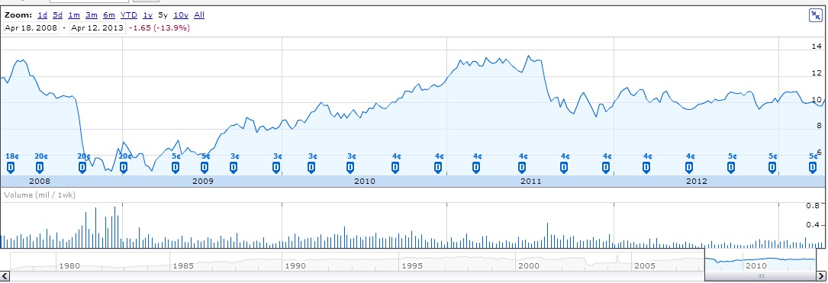
Figure 1 - 5 year stock chart NYSE
As other major corporations, its financial results and dividend earnings are published quarterly in a web conference between directors and main investors, and the financial planning is performed yearly. The most important shareholders and board of director members are concurrently notable investors in the field of aviation. Company stock is offered also as compensation to employees. Financial aspect is the most important internal player within the company, responsible for backing the company’s focus drive, planning and innovation. CAE’s core financial department is located in the Montreal headquarters of the company, led by Mr. Stephane Lefebvre. Structurally, the Chief Financial Officer plays a key role in budget planning of the company and in validating business technology and orientation. The financial organization within CAE is broken down into a number of sectors led by vice president or director roles that serve as business leaders in specific world regions, business leader for a specific company market orientation, and business leaders for different aspects of the financial profile such as accountancy, finance planning, information technology etc…

  - Business Facts
The company offers great careers for financial professionals in accountancy, finance, and business development. As any other major company in Canada its financial practices are regulated through many recognized professional programs and regulations. According to financial reports of 2012, the company has a market capital of nearly $ 2.6 billion and about $ 1.8 billion of annual revenue. Also, worldwide exportation brings 90% of annual revenues.
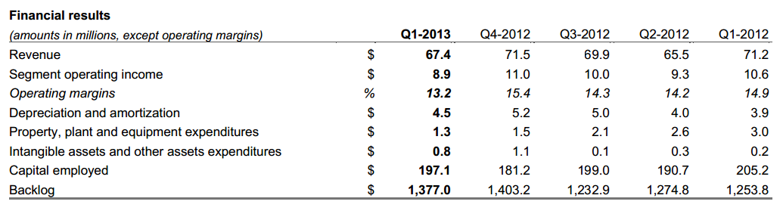
Figure 2 - First Quarter 2013 Results
Based on fiscal year 2012 revenue distribution, 49% of revenues come from the core defense business, 46% form civil aviation, and 5% from new core markets such as mining and healthcare. Predominantly innovative in nature, CAE is constantly concentrated in research and development by investing 10% of its total revenue that allows company to expand and exploit it capabilities into other prospective areas of simulation market.
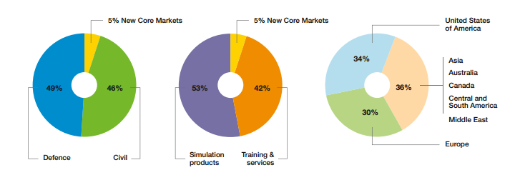
Figure 3 - Revenue Distribution FY2012

  - Regional Financial Profile
As mentioned, the regional financial center in Dallas is the second in importance after the headquarters. The center handles thousands of daily operations from internal issues and also deals with many clients in the Fort Worth area, which are individuals or other companies. Additionally, Dallas training center has a large number of employees and staff accountants that deal with payroll, source deductions, financial planning and specific legislative financial planning.

  - Financial Challenges
Regardless the fact of being a renowned company and a key factor in the simulation business, CAE’s business planning team does not take success for granted. One of the challenges is restoring of financial stability. Because CAE intended to diversify and bring their simulation experience in a new core market such as mining and healthcare, it bought two world-class companies such as METI and Datamine. Additionally, the acquisition of Oxford Aviation Academy has positioned CAE as a leader in training as well. However, these operations come up with a hidden cost, which is the cost of integrating and unifying business practices, consolidating the management team, and restructuring the vision of employees. Furthermore, these hidden costs tend to destabilize growth and make this expansion risky. CAE’s business planning team is putting major efforts to restore financial stability and continue experiencing a steady growth in proportion to the expanded size of the corporation. Another big challenge of this aerospace company is to increase the dividend value and moving from steady growth to steady market value, which would help to keep the trust factor of major shareholders at a satisfying level.

- POSITION REQUIREMENTS
Being part of the financial department in CAE means launching a successful career in the world of corporate finance due to CAE’s reputation as a world renowned company, well established in the global market. Financial professionals at CAE include financial analysts, payroll accountants, general accountants, financial managers, business development leaders and financial analysts. Satellite financial offices are present in the company’s training centers in order to decentralize financial functioning of the company and provide an immediate respond to local needs. Also, CAE Dallas is one of the biggest Training Centers of CAE divided into simulation and training divisions. Its financial division is the most important fraction of the financial aspect of the company after the headquarters. A staff accountant would play a key role in maintaining the financial reports of the company. Furthermore, the following responsibilities are part of the job role: Preparing and recording ledger entries, providing variance analysis, providing balance sheet reconciliations, preparing and analyzing budget, forecasting and handling invoices. A potential candidate must usually comes from an experienced background, having minimum five years of past experience in addition to possessing mathematical and software skills. The potential candidates also must possess the recommended soft skills required to work in a financial environment and have completed necessary certificates or be part of a regulated financial entity such as a professional order.

- FREQUENTLY ASKED QUESTIONS
Tips that would help generally prepare for the interview boil down to the following key notes:
- Know the Resume
- Don’t Memorize Solutions
- Talk out Loud

  - Company Related Questions
Q. What do you know about CAE?
A. CAE is a global leader in aircraft simulation and pilot training. Founded in Quebec from a war trained innovative team and operating in 190 countries worldwide as a key player in the aviation business.

Q. What do you think of Aerospace Business’s position in today’s economy?
A. Aerospace is one of the main sectors in today’s modern technology and industry. Many sectors of the industry such as commercial and business aviation, military and defense aviation and helicopter logistics rely on aerospace technological growth and stability and they are an important part of our global economy.

Q. Based on publicly available information, what is your opinion on CAE’s company growth strategy?
A. I am well aware of CAE’s success over the past year on the aerospace business and my opinion on the new business growth strategy is aligned with the company’s vision. I agree that by expanding in healthcare and mining as new core markets CAE will bring a new influence in the simulation aspect of those core markets and will play a key role in increasing the level of safety and minimizing training costs in mining and healthcare sector.

Q. What are the biggest advantages that CAE has, in comparison to its competitors?
A. I believe CAE is founded on innovation and spends a great deal of its revenue in keeping that innovative spirit alive by investing in research and development. Its biggest advantage is its position on the market and its strong reputation as a fair key player in the aerospace simulation business. It is true that some of its competitors might be bigger in size but since their business practices are not as transparent as CAE’s then I believe that CAE will always keep an advantageous distance from its competitors. (Discussing about Thales)

Q. Are you willing to relocate and what percentage of your time are you available to travel?
A. I am willing to relocate and I can adapt to a busy schedule and manage my time efficiently.

  - Behavioral Questions
Q. Could you tell us about the most challenging project you worked on during your career or academic studies?
A. I have worked on many projects during my career and my academic studies. As an example I would bring a project related to a Financial Planning course where our team had to plan for a hypothetic company growth in order to bring the business back on track and minimize expenditures.

Q. What have you learned from that experience?
A. I learned that no matter the project, efficient collaboration is a key for success.

Q. What was the most interesting part of that project?
A. The part where we had to cut out on different expenses and keep the employees morale still at an acceptable level.

Q. How would you manage a conflict in your team?
A. I would first approach the team member being in the center of such a conflict by discussing in general if any other non-work related issue is affecting his/her performance. I would bring up my opinions politely and try to reach a compromise.

Q. According to you what are some of your weaknesses?
A. Sometimes I focus too much in the details and that can affect my focus on more important parts of a project.

Q. What are, according to you, your strongest points?
A. Few strong points that I have identified are: team player, managing time efficiently and respecting deadlines.

  - Questions to Ask to Employer
Commonly during the end of an interview, the employer asks the applicant if they would like to pose any questions. This is an opportunity to ask questions to the prospective employer for matters that might be helpful in your prospective job. Example of questions would be as below:

Q. How many meetings do you have every week?

Q. What is the interaction like in the team?

Q. How does the team plan for challenges or prospective projects?

- CONCLUSION
In conclusion we can state that CAE is a world renowned company with a very well established business profile internationally. CAE is currently globally expanding into new core markets such as mining and healthcare, which are the latest ventures of the company. Its finance aspect is the main internal key player that supports the company’s structure and assures the company shares stability and growth. Furthermore, It offers great opportunities for financial professionals aware of the Canadian economic legislations and Canadian business practices. Practicing finance or accounting at CAE gives to prospective workers the possibility to indirectly participate in the company growth. Being exposed to complex financial situations will help potential employees to grow professionally, gain visibility in the job market, and complete major steps toward a successful career.

REFERENCES

[1] Laakman, (2010) Cracking the Coding Interview 4th edition, CareerCup LL[2] CAE Communications (2013), Corporate Information
Retrieved from http://www.cae.com/about-cae/
[3] CAE Communications (2012), CAE Annual Report
Retrieved from http://www.cae.com/investors/
[4] Mechtronix (2013), Company overview
Retrieved from http://www.cae.com/investors/
[5] L3 Mapps (2013), Copany Facts
Retrieved from http://www.mapps.l-3com.com/company.html
[6] Thales Group (2013), Aerospace
Retrieved from http://www.thalesgroup.com/Markets/Aerospace/What_we_do/
[7] S.Fontenelle (2008), Thales à la barre du tribunal, L’île de Ré
Retrieved from http://iledere.parti-socialiste.fr/2008/06/06/thales-a-la-barre-du-tribunal/

