ADM 1301 Study Notes

The Socioeconomy
- Business – Corporations, Partnerships, Proprietorships
- Government – federal, provincial, municipal
- Civil Society – communities, NGOs, charities, volunteers, ‘community’

Drivers of Change
- Demographics
- Technological advances
- Globalization

Integrity: the appropriateness of a corporation’s behavior and adherence to moral guidelines

Economic System: arrangement using means of production to meet the needs and wants of society

Capitalism: allows for private ownership of the means of production; assumes economic decision making is in the hands individuals or enterprises expecting to make a profit

Free Enterprise: characterized by ownership of private property; profit motive; competitive market system; limited involvement by government

Laissez-faire capitalism: minimum interference by the government in business affairs

Responsible enterprise: operating as a free enterprise but incorporating accountability

Stakeholder capitalism: corporations accept broader obligations beyond financial ones for shareholders

Two Doctrines
- Concession: incorporation was conferred by public act no by private agreements among people
- Freedom of association: takes more than a formal agreement to maintain a corporation

Factors influencing Attitudes
- Standard of living
- Decentralized decision making
- Allocation of resources
- Self-interest
- Inequities in society
- Business cycle
- Unemployment
- Media
- Innovation

Governance: the processes, structures, and relationships through which the shareholders, as represented by the board of directors, oversee the activities of the business enterprise

Three key players
- Owners/Shareholders – interested in ROI
- Board of directors – elected to represent shareholders’ interests
- Managers – oversee daily operations

Rights of Shareholders
- Secure ownership
- Transfer ownership
- Access corporate information
- Participation and voting in shareholder meetings
- Election and removal of board members
- Share in profits

Three Branches of Government (Westminster Model):
- Legislative -- The House of Commons & The Senate
- Focus on legislation
- Holding government to account
- Executive -- Prime Minister, Cabinet and the Public Service
- Government policy direction
- Program and service delivery
- Government administration
- Judicial -- independent of Cabinet, Parliament or of any other state institution
- Interpretation of the law and enforcement through the

HOC
- 308 seats, elected members
- Legislation and debates
Senate
- 105 seats, appointed by PM, last until they are 75
- Revise and investigate legislation
- Bills go through HOC to Senate, then back

Legislative Process:
- 1. HOC introduces bill 2. First reading 3. Second reading (bill is debated, then accepted, rejected, or ameded) 4. Third reading
- To the Senate
- Back to the HOC for the Royal Assent
- Becomes a Law

Public Policy Process
- Problem identification
- Setting the agenda
- Formulating the policy
- Implementing the policy
- Evaluating the policy

FUNDAMENTAL PRINCIPLES OF CAPITALISM
- Right of private property
- Individualism
- Equality of opportunity
- Competition
- Profit
- Work ethic
- Consumer sovereignty
- Role of government

Forms of capitalism
- Consumer
- Producer
- Family
- Frontier
- Employee
- Democratic
- People’s
- Stakeholder
- Creative
- State

Stakeholders: an individual, group who can influence and or is influenced by the achievement of an organization’s purpose
- Owners
- Employees
- Directors
- Customers
- Creditors
- Suppliers
- Service professionals
- Distributors
- Business organizations
- Competitors
- Joint-venture participants
- NGO’s
- Society
- Educational institutions
- Religious groups
- Charities
- Government
- Media

Mitchell, Agle and Wood Stakeholder Model
- Power – ability to produce an effect
- Legitimacy – validity of claims to stake
- Urgency – degree a claim demands immediate attention
- Latent – 1, Expectant – 2, Definitive – 3
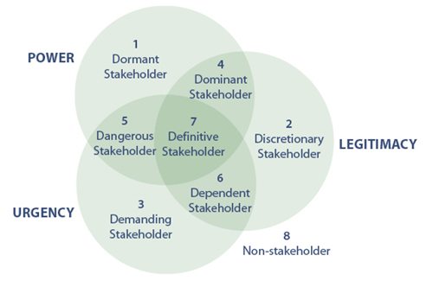

Civil Society
- Social Segment
  - Community, volunteer sector, civil society
  - The bonding force, social glue to unite diverse interests
  - Social Capital: the relationships, networks, norms that facilitate collective action
    - eg. PTAs, labour unions (formal); group gathering at a bar (informal);

Five roles of Civil Society
- Monitoring – keeping policy honest
- Advocacy – to support or not support policy
- Innovate – develop new things
- Service provider – fulfilling needs
- Capacity builder – support provided to other CS organizations

Civil Society Issues
- Segment fragmentation – different issues, missions; diversified
  - Challenges being heard by gov’t , getting on the agenda, partnering with gov’t and business
- Funding – a finite amount of money to be shared
- Attracting and retaining volunteers – age demographics
Bourdieu Types of Personal Capital
- Social – who you know
- Economic – what you have
- Cultural – what you know
- Symbolic – your status

Business Complaints about media
- Not knowledgeable enough
- Interested only in bad news
- Unable to place information in context
- Bias against business
- Lack insight
- Do not respect ‘off the record’

Media complaints about business
- Waffle on details, hide negative info, lying
- Excuse that they are only accountable to shareholders, not media
- They overreact to media processes

Think Tanks: policy development institution; organization that researches various issues confronting society (S,E,P)

Ethics
- Ethics, or moral philosophy, is the systematic endeavour to understand moral concepts and justify moral principles and theories.
- Ethics is concerned with values as fundamental beliefs – not what is, but what ought to be. In that sense, it is normative rather than descriptive.
- Good person: of moral excellence; upright; acting according to what ought to be
- Bad person: below standard or expectations, with respect to ethics or decency

Happiness according to Aristotle: living a good life, reaching potential, guided by reason

Business Ethics: applying ethics to business, businesses acting in a right or wrong way

Managerial Ethics: standards of behavior that guide managers in their work

Examples of Ethical implications in Business
- Owners – fair and accurate disclosure
- Employees – hiring, layoffs, wages, privacy, discrimination, honesty
- Consumers – dishonest advertising, product safety
- Competitors – industrial espionage
- Suppliers – kickbacks, gifts, bribes
- Government – legal compliance, lobbying
- Society – respect for environment, sponsorship

Four Categories of Moral Philosophies
- Consequentialism: evaluates the morality by looking at consequences
  - Egoism: action taken by individuals to further themselves, self-interest
  - Utilitarianism: action taken to maximize greatest good for largest amount of people
- Deontology: theory of duty
  - ‘doing the right thing’
  - My duty to act accordingly
  - Acting from sense of duty vs. concern for consequences
- Social Contract: ethics cannot be grounded on facts and human reason, bc we cannot agree
- Virtues Ethics: virtues are acquired and become part of character
  - What a good person would do is what is ethical

Other kinds of Ethical Thinking
- Ethics of Caring: do unto others as you want done to you
- Social Ethics: standards learned from experiences, media, education
- Transcendental ethics: absolute concepts of right and wrong which transcend all societies
- Tactical Ethics: ethics practiced out of convenience, improvement of self-interest

Source of Ethics
- Learned through family, religion, education, media, personal reflection and reason

Ethical Dilemma: situations where a decision must be made between two equally valid but mutually exclusive courses of action

Process:
- Frame the problem:
  - Salience with personal goals – How might my decision on this issue affect my personal goals?
  - Salience with personal norms – Will my decision on this issue be consistent with the way I would expect myself and others to behave in this situation?
  - Salience with personal beliefs – Will my decision on this issue be consistent with the way I would expect myself and others to view this situation?
  - Salience with personal values – Which of the above three moral standards are most important to me?
- Justice test: does it break any laws?
- Deontological test: do I think it is morally correct? Am I comfortable if this decision becomes the universal norm? does it respect the dignity of others?
- Consequentialism test: best outcome for the greatest number? Worse outcome for the fewest number?
- Ethical decision

Ethics and Values in Government
- DEPP values (democratic, ethical, professional, people

Determinants of Ethical Behaviour by rank
- Behavior of superiors
- Behavior of peers
- Ethical practices of the industry or profession
- Society’s moral climate
- Existence of formal policy

Statement of Values: description of beliefs, principles and assumptions about what is desirable and worth striving for in an organization

Code of Conduct: states what appropriate behavior is by outlining what is (un)acceptable

Code of Ethics: statement of values or principles that guide behavior by describing the general value system in an organization

Pagano Model of Ethical Decision making
- Is it legal?
- Benefit cost test: Greatest good for the greatest number?
- Categorical imperative: Do you want this to be the universal standard?
- Light of day: What if this went on tv?
- Do unto others
- Ventilation: Second opinion

Jasper Model
- End result ethics
  - Consider consequences
- Rule Ethics
  - Review applicable laws or rules
- Social Contract and Ethics of care
  - Consider norms or customs of organization, community or society within which the action will be taken
- Personalistic Ethics
  - Reflect on your own views, convictions regarding the matter

Corporate Social Responsibility

- The way a corporation achieves a balance among its economic, social, and environmental responsibilities in its operations so as to address shareholder and other stakeholder expectations.

CSR THEORIES

- Amoral View
  - Traditional view of business as merely a profit making entity
- Personal View
  - Corporations are like people and can therefore be held accountable for their actions
- Social View
  - Corporations are social institutions with social responsibilities

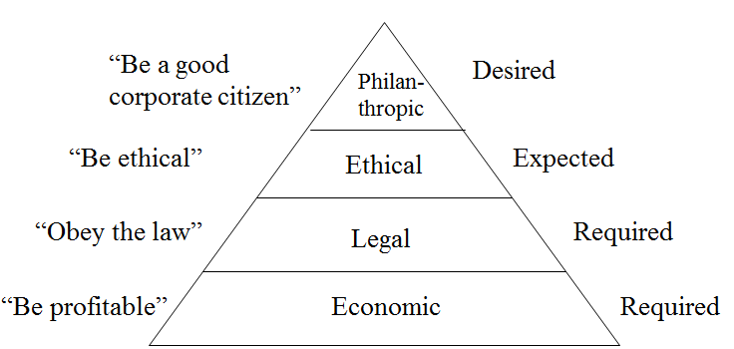
The Pyramid of CSR (Archie Carroll)

Carroll’s Four Part Definition: CSR encompasses the economic, legal, ethical, and philanthropic expectations that society has of organizations

CSR means going beyond economic (employees, shareholders) and legal (society, environment, employees, shareholders) responsibilities.

Contemporary CSR Concepts

- Corporate Sustainability (CS)
  - Compliance-driven: follow regulations
  - Profit-driven: focus on bottom line
  - Caring: go beyond legal compliance
  - Synergistic: well-balanced solutions
  - Holistic: fully integrated CS
- Reputational management
  - Effort to enhance a corporation’s image
  - Previous focus on media, public relations, crisis management
  - Today, focus on relationships with stakeholders
  - Reputations take a long time to form, can be destroyed quickly
- Social impact management
  - Evaluates 3 aspects of business
    - Purpose of business
    - Social context of business
    - Metrics: how perf is measured
- Triple-E Bottom Line
  - Evaluates a corporation’s performance according to a summary of the economic, social, and environmental value the corporation adds or destroys
  - Now forms the basis for corporate reporting of economic, ethical and environmental responsibilities
Corporate Philanthropy: effort to contribute to society socially through donations, voluntarism, and sponsorship of events.

Arguments For | Arguments Against
Means to express CSR to community | Funds given belong to shareholders
Promotes image of good citizenship | Social welfare is the job of the government
Business benefits from volunteer sector | Corporation may become accountable for actions of charity
Company’s success linked to community’s health | No guidelines, standards to measure, evaluate or monitor

Corporate Voluntarism: the time and talent employees commit to community organizations with support or consent from employers who recognize its value to society

Advantages | Disadvantages
Benefits employee morale | Possible employee resentment at coercion to participate
Good for community and organizations supported | Possible distractions from the job
Improves corporation’s local/national image | Cost in dollars and time
Helps employees integrate with community | Picking “winners” and “losers” (which to support)
Can contribute to team-building, employee retention, incentives | Objectives of voluntary organization could reflect poorly on corporation

Corporate Sponsorship: a partnership which has been established for mutual benefit between a business sponsor and an event or a non-profit.

Business-Government Relations

Jane Jacobs Model
- Guardian syndrome vs. commercial syndrome

The “Guardian” (Government)
- authority and rules (hierarchy & obedience)
- shunning of trade & coercion
- power as given
- public interest
- tradition
- protectors
- willing to take vengeance
- Risk averse

The “Commercial” (Industry)
- voluntary agreements, (negotiate, bargain)
- collaboration & exchange
- power as contested
- private interest
- innovation
- investors
- work ethic
- Risk-takers

WT Stanbury Model
- Factors affecting business
  - Nature of relationship between business and stakeholders
  - Extent of government intervention
  - Degree to which gov’t actions determine success or failure
  - Characteristics of members
  - Perceptions of the public
- Factors affecting government
  - Size of majority
  - Regional distribution of seats in legislature
  - Actions of other gov’ts
  - Behavior of the media
  - Allocation of powers between different levels of government
  - Action of opposition parties
  - Public opinions, attitudes and perceptions
- Two worlds: business & gov’t
- Different variables/processes/factors
- They clash in the policy arena
  - Business “lobbying” government
  - Government “regulating” business

Lobbying: an activity, directed at decision makers, carried out on behalf of special interests to influence public policy outcomes

The “Ask” Policy

Policy Rule | Context | Key Challenge
Good rules | The rule is acceptable but the interpretation is not | Getting the government to interpret the rule differently
Bad Rules | The existing rule is not acceptable | Getting the government to drop the rule
New Rules | You are proposing a new rule | Getting the government to adopt the new rule
Sad Rules | The current rule is obsolete and must be changed | Getting the government to change the rule

- The Lobbying Act states that lobbying will consist of any oral or written communication made to a public office holder

Types of Lobbyists
- Consultant: consultants who are paid to lobby on behalf of clients
  - They may be consultants in PR or marketing, lawyers, notaries, accountants
- In-House Lobbyists: salaried employees of corporations or non-profit organizations who lobby on behalf of their employer

What do Lobbyists Do?
- Informed of emerging legislation that could affect client
- Knowledgeable of position of key players on the issue
- Be credible with good contacts
- Understand the issue from several perspectives
- Understand public policy process
- Prepare client to lobby

Direct lobbying occurs through formal meetings, submission of policy papers, telephone calls, direct mail, email, litigation, appearance before parliament

Indirect lobbying occurs through advocacy advertising, funding think tanks

Advocacy Advertising
- any kind of paid public communication or message, from an identified source and in a conventional medium of public advertising, which represents information or a point of view bearing on a publicly recognized controversial issue
  - Designed to sell ideas, not products or services
  - Aimed directly at policy makers or at some segment of public opinion
  - Ultimate objective is to influence public opinion and public policy on an item that is of importance to the advertiser
- Targets:
  - Stakeholders
  - Politicians
  - Media influencers
  - Intellectual leaders
  - Politically aware people with influence

Think Tanks
- An organization or group of experts researching and advising on issues of society, science, technology, industry or business

Type of think tank | Funding  paradigm | How agenda is set | Nature of research
Academic | Endowments, grants, organizations, private individuals | Researchers play a large role | Idea-driven; long-term, future oriented. Disinterested. Distribute social science research findings to serve all humanity
Contract | Primarily government contracts | Government needs | Driven by government contractor needs; long-term future-oriented but findings distributed primarily to contract authority
Advocacy | Constituents play a significant role | Driven by ideology | Short-term focus; ideologically driven research with findings distributed to constituents

The Lobbying Strategy
- Frame the issue (strategic, operational or both?)
- Position the issue in the sector (important only to your firm or other firms in your sector?)
- Whom to lobby? (politicians, bureaucrats, or both?)
- Which lobbying approach? (direct, indirect?)
- How long?(Timing is key – how long will your lobbying effort last?)
- Resources? (people, organizations/collaborators, money)
- Contingency plan (what is plan B in the event of a sudden change in policy direction, Minister, Bureaucrats?)

Government Influence on Business
- Regulation – imposing constraints
  - Economic: to correct market imperfections
  - Social: to correct adverse effects of business on people
  - Political: to garner votes
- National Monopoly
  - When one firm can supply the entire market demand at a lower cost than two or more firms
  - Gov’t would regulate so output is not restricted to bolster prices
- Externalities
  - By-products of activities that affect the well-being of society not included in market price
  - Gov’t regulates so firms are responsible for their externalities
- Public Goods
  - Goods that generate social benefit that everyone enjoys and no one can be excluded from
  - Gov’t provides these goods, funded through tax dollars
- Social Regulation
  - Focuses on a firm’s impacts on people
- Political Reasons
  - For votes
  - In response to pressure from media, interest groups

- Non-regulatory forms of influence
  - Government ownership: crown corporations
  - Government subsidies: direct transfer of cash or indirect transfer of benefits to a recipient
    - Either increase supply or increase demand for a product
  - Tax Policy: encourage investment in some activities, but not others
    - Deductibility of operating expenses
  - Government procurement: government is a major purchaser of goods and services
  - International trade: negotiating international tariff laws

- Industrial policy
  - Any attempt by gov’t to apply a set of policies designed to improve the performance of the economy
    - Framework policies
    - Concertation-based strategies
    - Intervention

Civil Society’s Influence on Business

Drivers of importance of Civil Society
- Increasingly culturally diverse Canadian population introducing new demands that fall outside the purview of government or business (to improve)
- Information Communications Technology enables civil society to being instantaneous attention to its causes and issues (to inspire; to inform)
- Stakeholders expect business and government to engage with civil society (to improve)
- Complexity of civil society issues (to improve; to inspire; to inform)

Civil Society’s Tool Chest of Influence
- Publishing (print, online)
- Social network participation
- Lobbying (direct, indirect, advocacy)
- Media campaigns
- Demonstrations and protests

CS’s Supportive Influence
- Neutral broker between government and business
- Supplier of knowledge and skills (knowledge transfer)
- Source of workers
- Intimate knowledge of community (closer to stakeholders)
- Citizen engagement venue
- Social capital provider
- Building image and buffering media
- Alternative service delivery methods and new models of community engagement
- Cause-related marketing venue
- Awareness building
- Public policy test environment
- Distributor of information
- Point of entry for citizens to engage in policy debates

Collaboration

Boydell’s Dual Concerns Model

Collaborating
Compromising
Avoiding
Accommodating

Benefit of
Collaborating
Competing
Benefit to Other Party
Benefit
To You

Public-Private Partnerships (P3s)
- An agreement between a private and public partner
- Combine constitutional obligation of government economic acumen of business to create social value

Drivers of P3
- Social issues increasing in complexity
- Increased pressure for public sector to use taxpayers’ money with increased scrutiny and stewardship
- Significant investment required for building new, and upgrading existing infrastructure
- Changing demographics and changing lifestyle catalyzing the need for new approaches to service delivery – health care, recreation
- Need to innovate requires a blend of both private sector and public sector areas of expertise

Clusters: sets of competing and complementary industries and firms that are linked together by formal and informal relationships
- Produce and apply knowledge to innovate
- Innovation add economic and social value

Joseph Schumpeter
- Role of entrepreneur to stimulate investment and innovation, causing “creative destruction”
- “Creative destruction” occurs when innovation makes old ideas and technology obsolete

Four types of Innovation
- New products
- New processes
- New markets and industries
- New organizations

The vital cycle is about:
- Competitive clusters and supportive quality economic foundations
- Shared innovation and rapid learning
- Civic entrepreneurs and social capital
- Leaders and stakeholders forming alliances and partnerships, accepting a multi-stakeholder governance paradigm to develop innovative ways to extract new economic and social value

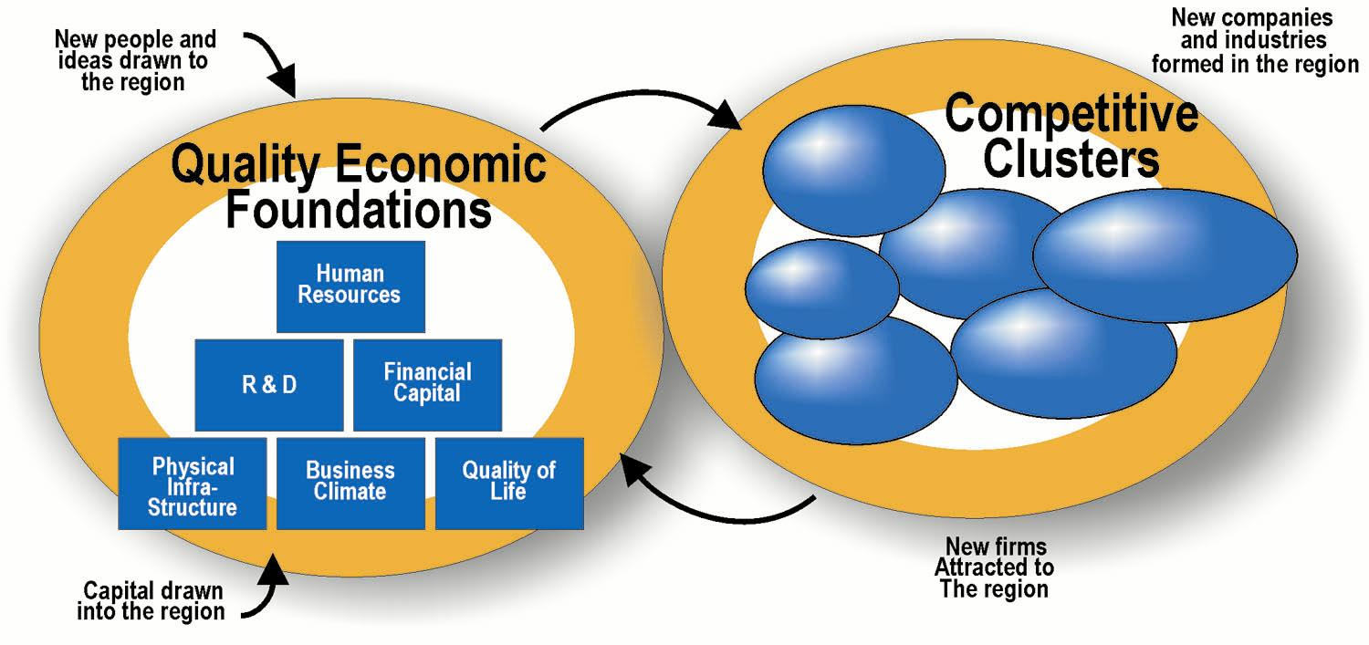

Competition and Collaboration: Michael Porter VIDEO
- Clusters increase the productivity of companies based in the area
- Clusters drive the direction and pace of innovation which underpins future productivity growth
- Clusters stimulate the formation of new businesses, which expands and strengthens the cluster itself

Life Cycle of Clusters
- Early stage clusters
  - Creation of knowledge
  - Small amount of firms
  - Research or knowledge based
  - Informal relationships
- Growth stage clusters
  - Knowledge products and processes
  - Increasing number of firms
  - International recognition
  - Attraction of rival firms
- Mature stage clusters
  - Decline in introduction of new firms
  - Increased consolidation
  - Employment growth rate slowing
  - Economic success
- Decline stage clusters
  - Reduction in employment, firms
  - Move away from product or alternative sites are available (low costs, opportunities)
- Renewal stage clusters
  - Build on capabilities of cluster
  - License new technology
  - Form alliances with other clusters
Culture
- A set of shared norms and values that form a sense of identity
- It is learned
- Forms basis for interpretation
- Anchors identity
- Involves diversity
- Fact of life
- Exerts powerful influence
- Is essential to understand

Hofstede Cultural dimensions
- Power distance – power distributed evenly
- Individualism – “I” vs, “We”
- Masculinity – assertiveness and competitiveness vs. modesty and caring
- Uncertainty avoidance – how well the unknown is tolerated
- Long-term orientation – patience and perseverance

Managing Cultural Differences Video
- Low context languages: those who say what they mean. Look at the words (USA, Germany, Scandinavia)
- High context languages: those using a lot of words where you must look. Meaning more subtle and circular. Look behind the words and at what is not said. More indirect (Japan, China, Thai, Korean)
- Be clear, state what you mean is a good skill

Barriers to Global Leadership Video
- Distance
- Cultural differences
- Working through technology
- Across time zones
- Complex management structures

Culture’s Effect on Business
- Cross-cultural teams of workers
- Increasing management complexity
- Recognition that North American management ways may not be appropriate everywhere

Culture’s Effect on Government
- Culturally driven stakeholder issues
- Diverse cultural backgrounds of elected officials and public servants
- More complex public policy issues with challenges in stakeholder engagement

Culture’s Effect on Civil Society
- Changes to both the composition and context of civil society
- Different ways to look at problems
- A greater networking capacity

Globalization
- The merging of previously domestic spaces and issues into one multifaceted and interconnected global village
  - Economic Globalization: integration of fragmented markets into a global economy
  - Political Globalization: change in power relationships. Multi-party governance system
  - Cultural Globalization: emergence of a worldwide cultural system

Drivers of Globalization
- Market
  - New markets
  - Alliances
  - Demand for products
- Cost
  - Source of inexpensive labour
  - Cheaper raw materials
  - New sources of capital
- Competition
  - Producing similar goods at lower costs
  - Can come from anywhere
- Government
  - Trade liberalization policies
  - Industry deregulation
  - Privatization
- Technology
  - Cross-border banking
  - Coordination of activities from anywhere
  - Homogenization of enabling technologies

Globalization issues
- Damage to environment
- Support for oppressive regimes
- Criticism of marketing practices (e.g., tobacco, pharmaceutical, baby formula, etc.)
- Arms trade
- Treatment of employees (e.g., sweatshops)
- Treatment of indigenous peoples
- Genetic modification of plants and animals
- Corruption and bribery

FOR | AGAINST
- Increases economic growth rate, prosperity and opportunity for all participants  - Increases civil liberties and reduces inequalities  - Leads to lower prices and better standards of living  - A cleaner world environment  - Rising standards  - Limits on international behaviour  - More job opportunities | - Increases the wealth of giant corporations and leaves developing countries poorer  - Harms the environment (pollution)  - Neuters government’s ability to govern  - Reduces standards, Homogenizes cultures  - Fuels income inequality between nations  - Causes problems that cannot be resolved by single nations  - Human rights violated, unfair working conditions, child labour

Institutions
- Organization for Economic Cooperation and Development (OECD)
  - Promotes economic globalization with a view to achieve the highest sustainable economic growth and employment, sound economic expansion, and to expand world trade
  - 30 of largest industrialized countries
- World Bank
  - Loans money to governments for structural adjustment and policy, and to private businesses for infrastructure and similar initiatives
- International Monetary Fund (IMF)
  - Fosters global monetary cooperation, secures financial stability, and facilitates international trade. Concerns itself also with the social impacts of these policies
- World Trade Organization (WTO)
  - Negotiates, implements and adjudicates global free trade agreements
- International Labor Organization (ILO)
  - Responsible for workers’ rights and work and employment-related issues
- UN Environment Program
  - Protection of environment
- UN Commission on Human Rights
  - Worldwide protection of human rights

Globalization Impact on Business
- Need to take into account different customs, laws, cultures, and governments
- Provides more markets, but also more competition
- Complicates governance
- Difficult to enforce infringements on intangible assets

Globalization Impact on Government
- Perceptions of loss of ability to govern
- Changes in industrial policy and the instruments available
- Changes in tax base and fiscal policies
- Greater transparency in the activities of government
- Increased number of stakeholders

Globalization Impact on Civil Society
- More available and accessible information
- Larger receptive audience
- Greater capacity to raise public awareness
- New sources of resources
- Greater network capacity

UN Global Compact
- Strategic policy initiative for businesses that are committed to aligning their operations and strategies with ten universally accepted principles in the areas of human rights, labour, environment and anti-corruption.

The Ten Principles
- Human Rights
  - Principle 1: Businesses should support and respect the protection of internationally proclaimed human rights; and
  - Principle 2: make sure that they are not complicit in human rights abuses.
- Labour
  - Principle 3: Businesses should uphold the freedom of association and the effective recognition of the right to collective bargaining;
  - Principle 4: the elimination of all forms of forced and compulsory labour;
  - Principle 5: the effective abolition of child labour; and
  - Principle 6: the elimination of discrimination in respect of employment and occupation.
- Environment
  - Principle 7: Businesses should support a precautionary approach to environmental challenges;
  - Principle 8: undertake initiatives to promote greater environmental responsibility; and
  - Principle 9: encourage the development and diffusion of environmentally friendly technologies.
- Anti-Corruption
  - Principle 10: Businesses should work against corruption in all its forms, including extortion and bribery.

Millennium Development Goals (MDGs)
- Agreed upon by 192 Countries in 2000
- To be achieved by 2015
  - Eradicate extreme poverty and hunger
  - Achieve universal primary education
  - Promote gender equality and empower women
  - Reduce child mortality
  - Improve maternal health
  - Combat HIV/AIDS, malaria, and other diseases
  - Ensure environmental sustainability
  - Develop a global partnership for development

