Professional liability: the legal challenges
- Those with specialized knowledge or skill will be held to a higher standard than that of the ordinary person
- Professionals with certification in their field held to the standard of their field of expertise
- Standard = the reasonably competent and diligent person in that field
- Specialists within fields of expertise are held to a higher standard than generalists
- The professionals, i.e. doctors, lawyers, accountants, etc. maybe held to an even higher standard and must avoid conflicts of interest
Liability of professionals
- liability may arise from three relationships, generating three different causes of action
  - the contractual relationship leads to a breach of contract cause of action
    - an agreement to provide professional services to a client contains a promise, whether stated expressly or not, to perform those services competently.
    - a breach of that promise is a breach of the contract, and the client ma sue for damages
  - the fiduciary relationship (highest standard) leads to breach of fiduciary duty and/or
    - define: a duty imposed on a person who stands in a special relation of trust to another
    - can arise even when the professional donates service free of share, no contract exist
    - Characteristics to determine who is a fiduciary
      - a fiduciary has the scope for the exercise of some discretion or power
      - a fiduciary can unilaterally exercise that power or discretion so as to affect the beneficiary's legal or practical interests
      - the beneficiary is peculiarly vulnerable to, or at the mercy of, the fiduciary holding the power or discretion
    - if a fiduciary duty is found to exist, the law imposes a wider range of obligations on the professional than is expressly stated in the contract or required under tort law. The professional must act honestly, in good faith, and only in the best interest of the client.
    - Steps to imposing liability for breach of fiduciary duty
      - establish that the relationship is one to which the duty applies (5 factor applicable to the fiduciary nature of a financial advisor: client relationship are vulnerability, trust, reliance, discretion, and standard expressed in a professional code of conduct)
      - determine if the professional's behavior breaches the fiduciary obligation
    - conflict of interest: a situation where a duty is owed to a client whose interests conflict with the interest of the professional, another client, or another person to whom a duty is owed
  - the duty of care owed in tort leads to a tort cause of action
    - third-party liability: liability to some other person who stands outside a contractual relationship (real estate agent and insurance agent)
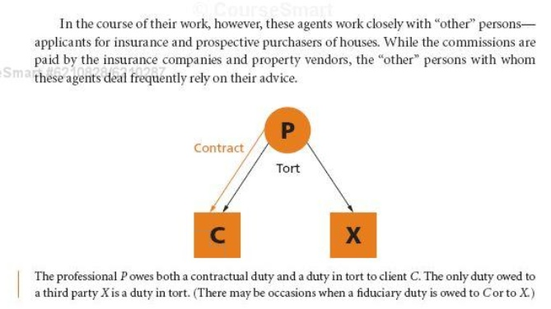
- Choosing a cause of action
  - affect
    - the rules governing the time limits for bringing an acton might make it advantageous to sue in tort
    - the amount of damages awarded in some cases
  - duty to account: the duty of a person who commits a breach of trust to hand over any profits derived from the breach
Tort liability for inaccurate statements
- misrepresentation
  - fraudulent misrepresentation: and intentional tort imposing liability for an incorrect statement made knowingly with the intention of causing injury to another
    - deceit: an intentional tort imposing liability when damage is caused by a false statement made with the intention of misleading another person
    - require at least some guilty knowledge or willful disregard for the falseness of the information
  - negligent misrepresentation: an unintentional tort imposing liability when an incorrect statement is made without due care for its accuracy, and injury is caused
    - this one does not; it involves owing a duty of care breaching the standard of care, and reliance on the statement, resulting in damage
    - test for negligent misrepresentation (Hercules Managemetn Ltd. v. Ernst & Young)
      - A statement is made
      - The statement is false
      - The maker of the statement must owe the hearer of the statement a duty of care
        - whether there is a sufficiently close relationship between the plaintiff and the defendant that, in the reasonable contemplation of the defendant, carelessness on its part may cause damage to the plaintiff.
        - limit the duty for public policy considerations- the extent of liability must be predictable
          - if the number of plaintiffs or magnitude of their losses are undeterminable, public policy concerns may cause a court to restrict the duty owed (however, liability is not restricted to financial information provided by professionals: accountants and bankers)
          - indeterminate liability: inability to be determined so that the magnitude of liability can't be reasonably predicted, anticipated, or planned for (auditor's report is to provide information in order to oversee the management. not for the purpose of guiding personal investment decision)
      - The hearer of the statement must act on the statement
      - The hearer of the statement must suffer a loss as a result of their acting on the statement
      - are there any policy considerations to consider that may limit the liability
- Economic loss in Tort law
  - [Hedley Byrne v Heller and Partner]
  - House of Lords articulated the principal that a party is able to sue for pure economic loss under tort law without recourse to contract law
  - disclaimer: an express statement to the effect that the person making it takes no responsibility for a particular action or statement
- The standard of care for professionals
  - a professional must exercise the same degree of skill and posses the same level of knowledge as is generally expected of members of that profession.
    - publish a code of conduct for their members
    - guidelines to be followed in particular types of work
  - omissions
    - the standard of reasonable care includes not omitting essential information.
    - providing partial or incomplete information in response to an inquiry can be negligent misrepresentation where the professional has a duty to the plaintiff to make the disclosure in question
  - reliance and detriment
    - reliance: acting in a certain way because one believed the information received.
    - detrimental reliance: the worsening of one's situation after acting upon false information
The role of professional organizations
- responsibilities and powers: important consequences
  - the right to discipline gives the organizations great power over individual members--expulsion or suspension for an extended period might destroy a member's means of livelihood
  - exclusivity gives these self-governing professions great power over the quality and cost of their service to the public, and there is consequently a strong public interest in the affairs of the organization
- codes of conduct
  - define: rules of a professional organization setting out the duties and appropriate standard of behavior to be observed by its members
- Discipline
  - maintain and improve standards
- conflict of duty towards clients, the profession, and the courts
  - privilege: the right of a professional to refuse to divulge information obtained in confidence form a client
Multi-disciplinary partnerships (MDPs)
- The main focus of the current debate on MDPs is on the combining of accountants and lawyers into a single firm.
Business related torts
- Inducing Breach of Contract:
  - where one party induces another party to breach his contract with a 3rd party
- Unlawful Interference with Economic Relations
  - where threats or other unlawful means are used to convince one party to cease doing business with another
- Product Defamation
  - where one party intentionally makes untrue or disparaging remarks about another's product in advertising their own product
- Passing-off
  - representing one's own product as that of another (trademark infringement)

