Assignment 1 Solution

Case 1 Solution –

1 (a)
Calculation of Mean
As we know that Mean = Sum of the observations / Number of Observations
So, Mean = (2347+2434+1636+1963+2358+1968+2683) / 7
= 2198.428571
= 2198.429
Calculation of Median
First we arrange all the monthly incomes in order – 1636, 1963, 1968, 2347, 2358, 2434, 2683
Since median is the middle number, our median in this case is = 2347
Calculation of Modal monthly income or Mode
As we know that mode of a set of observations is the value that occurs most frequently, or mode in this is none as all values occur only once.

1 (b)
Calculation of Range
As we know that Range = Largest observation – smallest observation
In this case, largest observation = 2683
Smallest observation = 1636
So, Range = 2683 – 1636 = 1047

1 (c)
Calculation of Standard Deviation
First we subtract mean from all the observations
2347 – 2198.429 = 148.571
2434 – 2198.429 = 235.571
1636 – 2198.429 = -562.429
1963 – 2198.429 = -235.429
2358 – 2198.429 = 159.571
1968 – 2198.429 = -230.429
2683 – 2198.429 = 484.571
Then we square and add these values
= 22073.34204 + 55493.69604 + 316326.38 + 55426.81404 + 25462.90404 + 53097.52404 + 234809.054
= 762689.7143
Then we calculate Variance = 762689.7143 / 6 (6 is the value of n – 1 and we know n = 7)
Variance (s²) = 127114.9524
Standard Deviation = √s²
= √127114.9524
= 356.5318392 = 356.532

1 (d)
Calculation of Variance
As we have already calculated Variance in 1 (c), Variance (s²) = 127114.9524 = 127114.952

Calculation of Coefficient of Variation
As we know that Coefficient of Variation = Standard Deviation / Mean
In this case, cv = 356.532 / 2198.429
= 0.162175808 = 0.162
cv as percentage = 0.162 x 100 = 16.20 %

Interpret the significance of cv
This coefficient provides a proportionate measure of variation, any change in standard deviation would result a 16.20% in change and vice versa.

Case 2 Solution
1 (a)
Calculation of Mean for Income
As we know that Mean = Sum of the observations / Number of Observations
So, Mean = 1348+1354+1361+1394+1399+1405+1425+1426+1426+1430+1430+1431+1439+1442+1445+1446+1450+1456+1458+1459+1461+1470+1485+1490+1537 / 25
= 35889 / 25
= 1435.56
Calculation of Mean for # of rooms occupied
Mean = 15+16+19+21+23+23+27+29+30+34+37+38+38+39+39+42+43+44+44+45+47+47+51+54 +61 / 25
= 36.24

Calculation of Median for Income
All values arranged in order – 1348, 1354, 1361, 1394, 1399, 1405, 1425, 1426, 1426, 1430, 1431, 1439, 1442, 1445, 1446, 1450, 1452, 1456, 1458, 1459, 1461, 1470, 1485, 1490, 1537
Since Median is the middle number, in this case Median = 1442

Calculation of Median for # of rooms occupied
All values arranged in order – 15, 16, 19, 21, 23, 23, 27, 29, 30, 34, 37, 38, 38, 39, 39, 42, 43, 44, 44, 45, 47, 47, 51, 54, 61
Median = 38

Calculation of Mode for Income
All values arranged in order – 1348, 1354, 1361, 1394, 1399, 1405, 1425, 1426, 1426, 1430, 1431, 1439, 1442, 1445, 1446, 1450, 1452, 1456, 1458, 1459, 1461, 1470, 1485, 1490, 1537
As we know that mode of a set of observations is the value that occurs most frequently, in this case our mode is 1426

Calculation of Mode for # of rooms occupied
All values arranged in order – 15, 16, 19, 21, 23, 23, 27, 29, 30, 34, 37, 38, 38, 39, 39, 42, 43, 44, 44, 45, 47, 47, 51, 54, 61
Mode = 23, 38, 39, 44, 47

1 (b)
Calculation of Variance for Income
First we subtract mean from all the observations, then square all the values and add them
Income Deviations |  | Income Deviations Squared
16.44 |  | 270.2736
-74.56 |  | 5559.1936
-9.56 |  | 91.3936
34.44 |  | 1186.1136
20.44 |  | 417.7936
-5.56 |  | 30.9136
-81.56 |  | 6652.0336
6.44 |  | 41.4736
-41.56 |  | 1727.2336
23.44 |  | 549.4336
-36.56 |  | 1336.6336
22.44 |  | 503.5536
101.44 |  | 10290.0736
-10.56 |  | 111.5136
9.44 |  | 89.1136
3.44 |  | 11.8336
-87.56 |  | 7666.7536
14.44 |  | 208.5136
-4.56 |  | 20.7936
10.44 |  | 108.9936
49.44 |  | 2444.3136
-30.56 |  | 933.9136
25.44 |  | 647.1936
54.44 |  | 2963.7136
-9.56 |  | 91.3936
 | Total | 43954.16

Variance = 43954.16 / 24 (24 is the value of n – 1 and we know n = 25)
Variance (s²) = 1831.4233

Calculation of Variance for # of Rooms occupied
Rooms Occupied Deviation |  | Rooms Occupied Deviation Squared
-13.24 |  | 175.2976
10.76 |  | 115.7776
-15.24 |  | 232.2576
2.76 |  | 7.6176
0.76 |  | 0.5776
-7.24 |  | 52.4176
-13.24 |  | 175.2976
7.76 |  | 60.2176
8.76 |  | 76.7376
-20.24 |  | 409.6576
-6.24 |  | 38.9376
5.76 |  | 33.1776
17.76 |  | 315.4176
-9.24 |  | 85.3776
-2.24 |  | 5.0176
-21.24 |  | 451.1376
-17.24 |  | 297.2176
1.76 |  | 3.0976
7.76 |  | 60.2176
10.76 |  | 115.7776
6.76 |  | 45.6976
1.76 |  | 3.0976
14.76 |  | 217.8576
24.76 |  | 613.0576
2.76 |  | 7.6176
 | Total | 3598.56

Variance = 3598.56 / 24 (24 is the value of n – 1 and we know n = 25)
Variance (s²) = 149.94

Calculation of Standard Deviation for Income
Standard Deviation = √s²
= √1831.4233
= 42.79513212 = 42.795

Calculation of Standard Deviation for # of rooms occupied
Standard Deviation = √s²
= √149.94
= 12.24499898 = 12.245

Calculation of Range for Income
As we know that Range = Largest observation – smallest observation
In this case, largest observation = 1537
Smallest observation = 1348
So, Range = 1537 – 1348 = 189

Calculation of Range for # of rooms occupied
As we know that Range = Largest observation – smallest observation
In this case, largest observation = 61
Smallest observation = 15
So, Range = 61 – 15 = 46

2.

Calculation of Coefficient of Correlation between variables

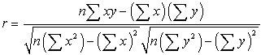

n = 25, ∑xy = 1305937, ∑x = 35889, ∑y = 906, ∑x² = 1288020321, ∑y² = 820836

Once we plugin all the numbers in to the formula we get Coefficient of Correlation (r) = 0.422978
Coefficient of Correlation (r) as percentage = 42.30 %

What does this tell you?
Since the Coefficient of Correlation is less than .5, we can say that it is positive but a weak correlation.

Case 3 Solution

3 (a)
Joint and Marginal Probability Table
Gender | Current Smoker | Former Smoker | Never Smoked | Total | Marginal Probability
Male | 0.088 | 0.200 | 0.113 | 0.40 | 0.4 | P(Male)
Female | 0.075 | 0.113 | 0.413 | 0.60 | 0.6 | P(Female)
Total | 0.163 | 0.313 | 0.525 | 1
Marginal Probability | 0.1625 | 0.3125 | 0.525 | 1 | 1
 | P(Current Smoker) | P(Former Smoker) | P(Never Smoked)

3 (b)
P (A) = 7000/80000
= 7/80 = 0.0875
P (B) = 6000/73000
= 6/73 = 0.082
P (B) out of total 80,000 = 6000/80000
= 6/80 = 0.075

Since 0.082 ≠ 0.075, Gender and Smoking Habit are dependent events.

3 (c)
Total Current Male Smokers = 7,000
Total Current Smokers = 13,000

Probability out of total current smokers = 7000/13000
= 7/13 = 0.538461538 = 0.54
As percentage = 54%

Case 4 on next page

Case 4 Solution
Age Group | 18-24 | 25-34 | 35-44 | 45-54 | 55-64 | 65 or older | Total
Number of Customers that Agree | 68 | 165 | 208 | 153 | 68 | 37 | 699
Number of Customers that Disagree | 42 | 96 | 79 | 51 | 20 | 13 | 301
Total Number of Customers in Group | 110 | 261 | 287 | 204 | 88 | 50 | 1000
Total Number of Customers (All Groups) | 1000 | 1000 | 1000 | 1000 | 1000 | 1000 | 1000
Probability for this Age Group (Agree) | 0.6181818 | 0.6321839 | 0.724738676 | 0.75 | 0.7727273 | 0.74 | N/A
Probability as percentage | 61.82% | 63.22% | 72.47% | 75% | 77.27% | 74% | N/A
Probability out of total customers (Agree) | 0.068 | 0.165 | 0.208 | 0.153 | 0.068 | 0.037 | 0.699
Probability as percentage | 6.80% | 16.50% | 20.80% | 15.30% | 6.80% | 3.70% | 69.90%

This sample’s probabilities are consistent with the recent market report that is based on past research which indicated that 30.10% of all customers disagree that higher price and quality is more important than less quality for cheaper price.

As on the table we can see that a total of 69.90% customers agree, which means 30.10% disagree (= 100 - 69.90).

Case 5 on Next Page

Case 5 Solution
- Compare the Performance of funds managed by those who have an MBA to those who do not have an MBA
 | - Without MBA | - With MBA
Total Returns | -769.78 | -355.27
Number of Managers | 820 | 1211
Average Return or Mean | -0.938756098 | -0.293369116

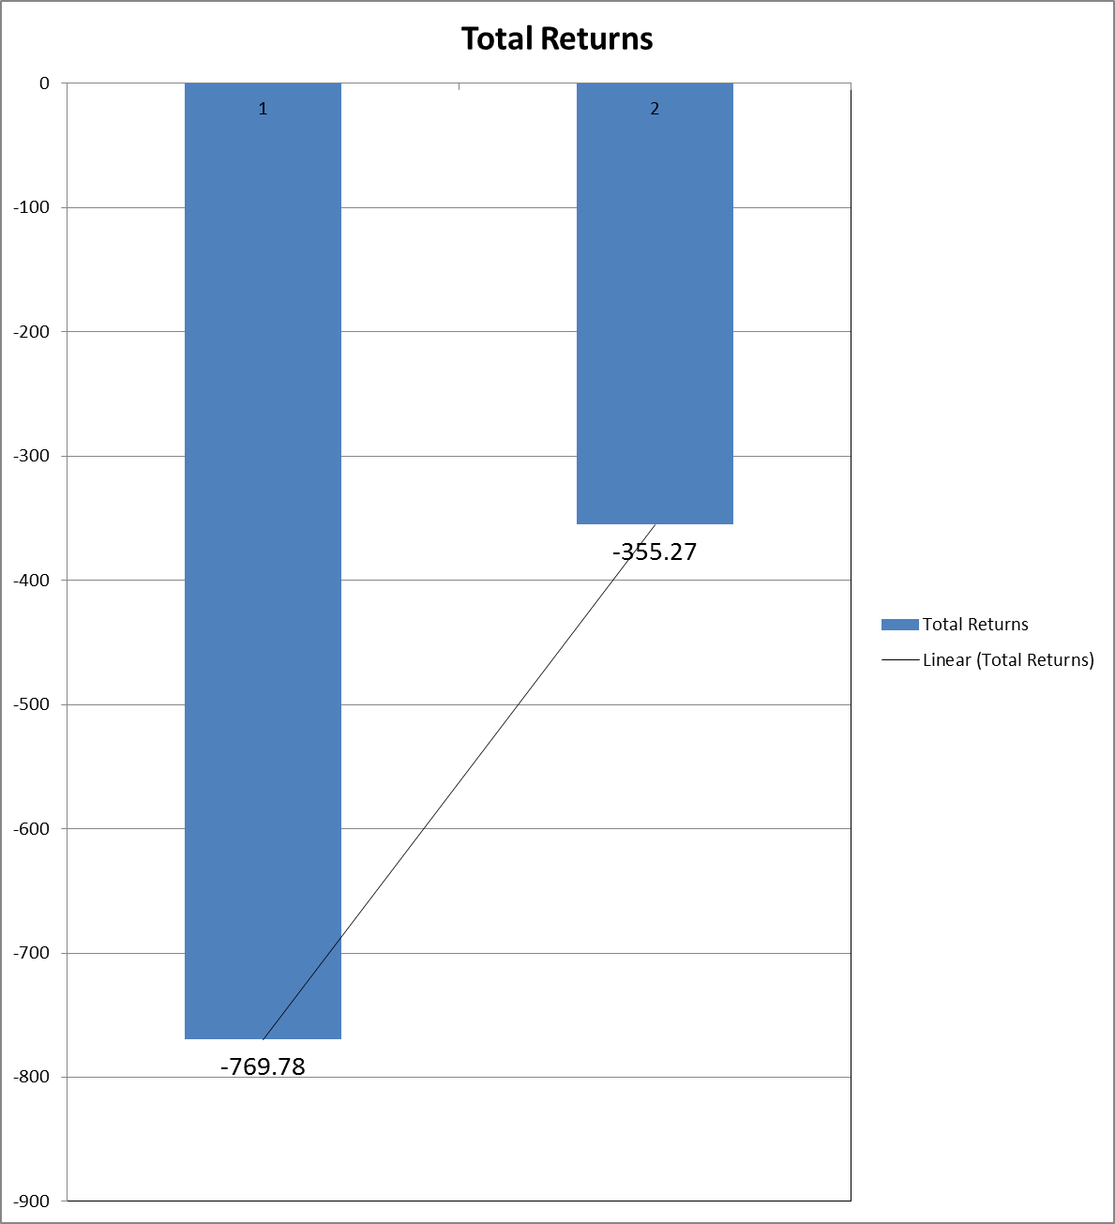
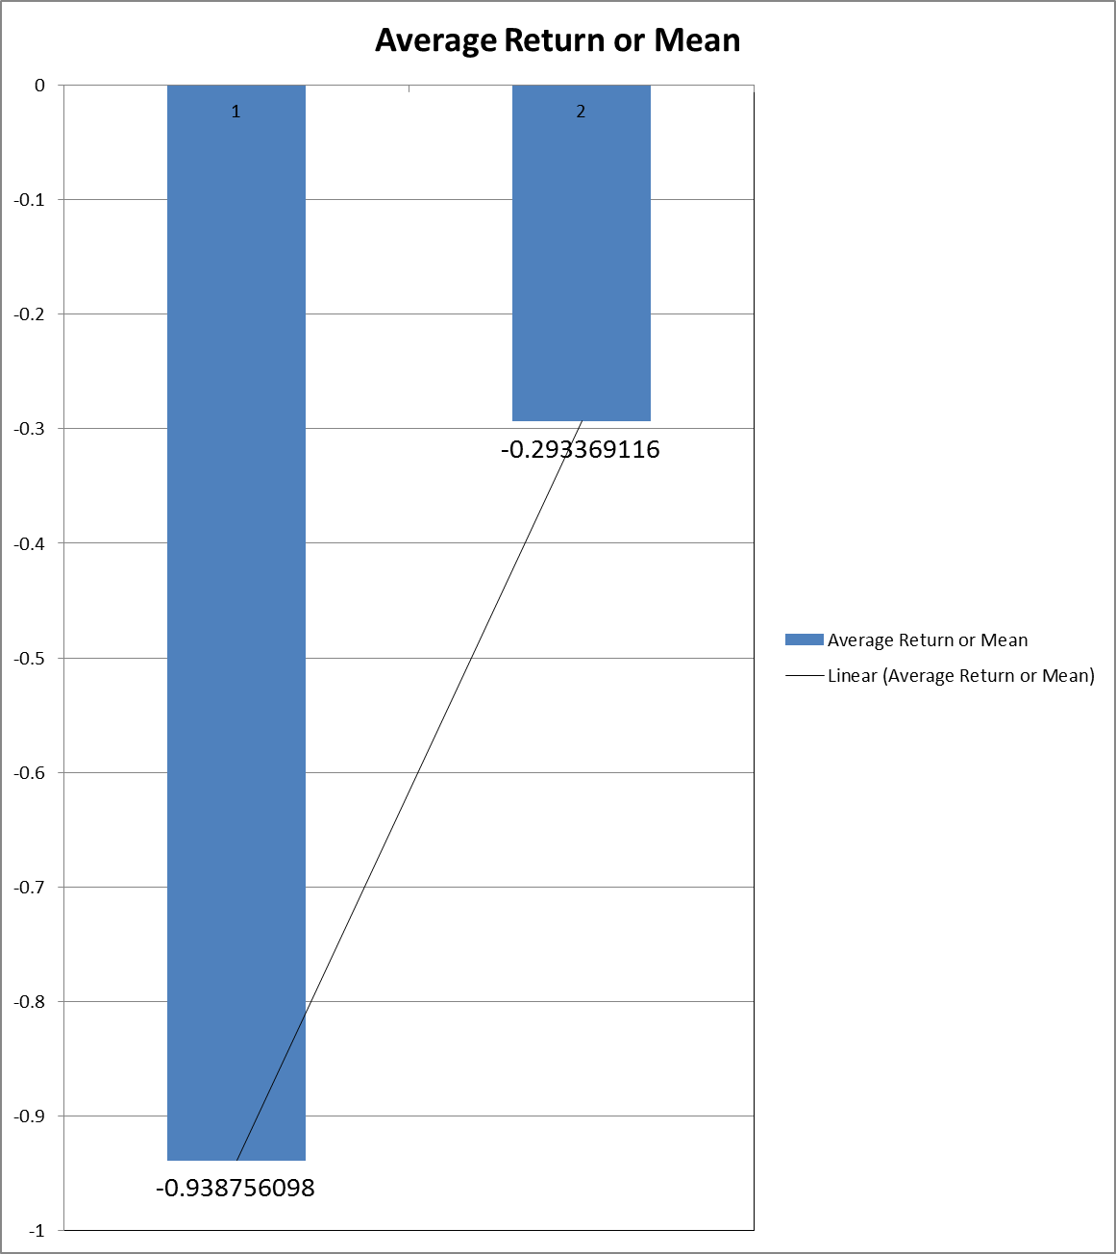
These charts are based on total returns and average returns, Bar 1 showing returns for managers without an MBA and Bar 2 showing returns for managers with an MBA.

Comment on the distributions
Looking at these charts, we can clearly see that managers with an MBA perform better than managers without an MBA.
2(a)
Use appropriate numerical descriptive statistics to describe the Performance of funds managed by managers who have an MBA to those who do not have an MBA.

MBA | Managers without an MBA | Managers with an MBA
Total Returns | -769.78 | -355.27
Number of Managers | 820 | 1211
Average Return or Mean | -0.938756098 | -0.293369116
Median | -1.05 | -0.5
Range | 48.14 | 62.6
Mode | -7.67, -6.38, -6.22, -6.11, -5.44,  -4.24, -3.76, -2.69, -1.37, 0.71, 1.39, 4.31 | 2.44

2(b)
Use appropriate numerical descriptive statistics to compare the performance of funds based on the years a manager has been in charge, more specifically - compare two groups – Managers with less than 5 years tenure to Managers with 5 and more years’ experience.

Experience | Less than 5 Years | 5 or more Years
Total Returns | -552.74 | -572.31
Number of Managers | 1189 | 840
Average Return or Mean | -0.464878049 | -0.681321429
Median | -0.65 | -0.715
Range | 62.6 | 53.88
Mode | 2.44 | -5.44, -5.09, -4.84, -4.24, -1.81, -1.33, 0.52, 2.87, 3.52, 5.91

2(c) Comment on the results found in a) and b).
As we can see from the results found in 2(a) and 2(b), Managers with an MBA perform much better than the once who don’t have an MBA. Average returns for the managers who have more than 5 years of experience are better than the less experienced managers.
3.

Use the appropriate graphical and numerical technique to describe the relationship between rate of return and the SAT score of students where the manager received his/her undergraduate degree

Total Returns | -1125.05 |  | Total SAT scores | 2317124
Total number of students | 2029 |  | Total number of students | 2029
Average or Mean | -0.554484968 |  | Average or Mean | 1142.002957
Range | 62.6 |  | Range | 1005
Median | -0.66 |  | Median | 1142

The relationship between SAT score and rate of return is scattered all around the graph, it’s hard to explain as many managers with high SAT score have low rate of returns and many managers with low SAT score have a high rate of return. Most managers are clustered between -10 to 10%.

Continue to next page


