Homeostasis
- Ability to maintain relatively stable internal conditions even though the outside world changes continuously.
- Dynamite state of equilibrium or balance in which internal conditions vary, but always within relatively narrow limits.
- Communication within the body is achieved by the nervous and endocrine system, which use neural electrical impulses or blood borne hormones as their information carriers.
- Some thyroid and steroid hormones are unspecifically bound to proteins
- Hormone- receptor binding is the first step in initiating hormone action
- # of target cell receptors may differ depending on the needs
- Down regulation of receptors: some receptors are internalized, taken by the cell and destroyed
- Too little hormones: more receptors to catch hormones (up regulation)

Homeostasis
- Condition in which the body’s internal environment remains relatively constant, within physiological limits
- Walter Cannon, 1929, coined the term “homeostasis” as a dynamic state of equilibrium or a balance

Body’s internal environment:
- Extracellular Fluid (two components)
- interstitial fluid: intercellular or tissue fluid immediately surrounding the cells
- blood plasma: the liquid portion of blood, brings nutrients and oxygen
- Intracellular fluid: the fluid inside the cells
Internal Environment of cells
- An organism is known to be in homeostasis when its inter environment contains an optimal concentration of fluid of closely regulated volume, pressure, temp, and composition including; nutrients, gases, electrolytes and water.
- There are many sorts of nutrients that must be transported through the body constantly such as water and oxygen
- Homeostasis generally refers to constant (but dynamic) internal environment during unstressed conditions resulting from many regulatory responses
- Maintenance of homeostasis = health
Physiological imbalance of homeostasis = results in disease or death
- Steady state: is a condition where certain bodily functions have attained dynamic constancy at a level different from homeostasis
- a balance has been achieved between the demands placed on the body and the body’s response to those demands
- does not necessarily mean that the internal environment is completely normal
- After running for a while, heart rate will increase, however as time passes, your heart rate will begin to stabilize due to your oxygen consumption. Heart rate is known to PLATEAU.
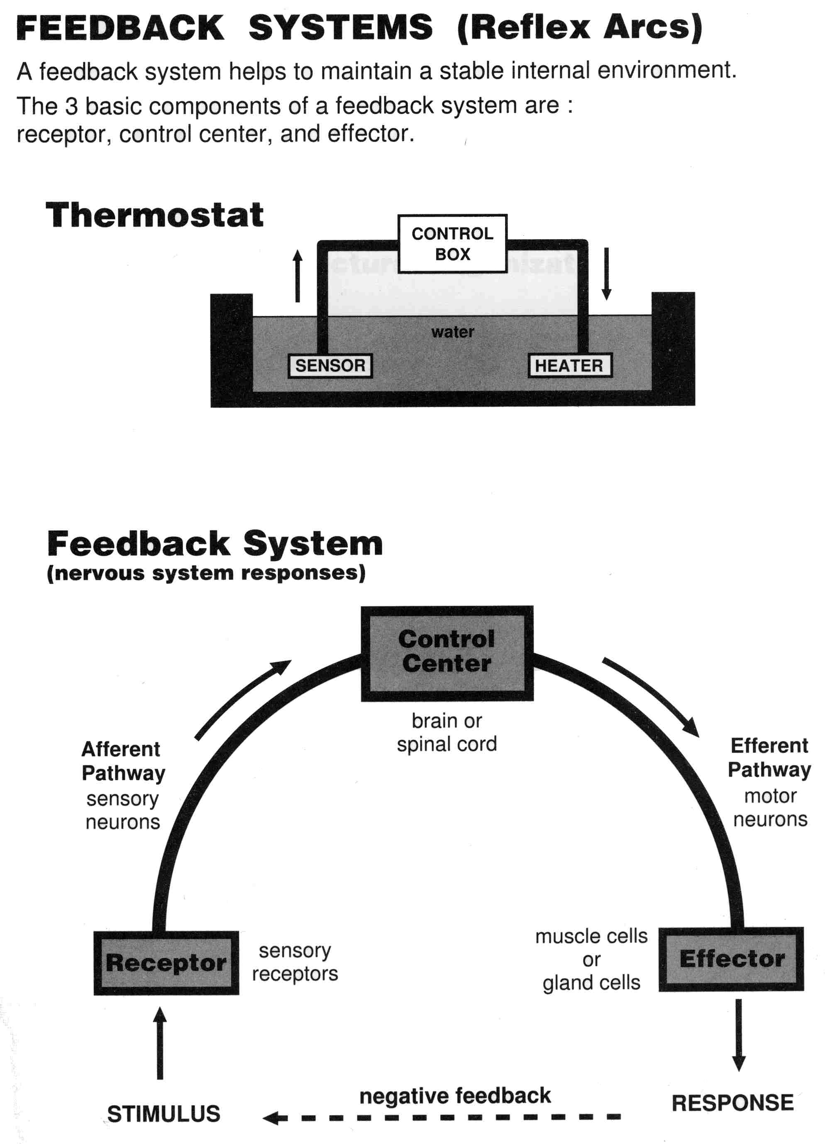
- Reflex arc: the sequence of events that occur in feedback system during a homeostatic response
The reflex arc has 3 components:
- Receptor- senses change (stimulus) & sends info (afferent pathway) to:
- Control center - determines set point for variable maintenance; analyzes info & determines correct response
- Effector - provides means for response (output along efferent pathway)
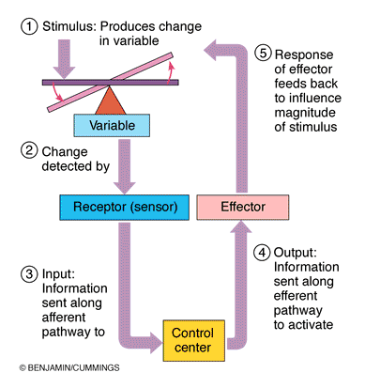
- Negative feedback: responses of a biological control system that oppose the initial stimulus.
- the output shuts off the original stimulus or reduces its intensity.
- causes the variable to change in a direction that is opposite to that of the initial change, returning it to its “ideal” value.
- example: control of blood volume by antidiuretic hormone (ADH)
- one hormone regulating a process
- process regulated in opposite direction by 2 different hormones
- product control of hormone secretion
**goal: to prevent sudden and/or severe changes
- Positive feedback (feed-forward control) - response of mechanism enhances original stimulus → output is further stimulated
- Change occurs in same direction as original response goal to be attained
- Example: blood clotting, oxytocin and smooth muscle contraction

Coordination of body functions by chemical messengers
- Endocrine glands (ductless glands): well-vascularized glands that release hormones directly into the blood or the lymph.
- Autocrines: chemicals that exert their effect on the same cells that secrete them.
- Paracrine: act locally but affect cell types other than those releasing the paracrine chemicals.
- Endocrine system consists of: a host organ, a chemical messenger (hormone) and a target or receptor organ
- Neurotransmitters: are released at synaptic junctions and act locally to control cell function
- Neurohormones: secreted by neurons, reach the blood and influence function of distant target cells

Hormones
- Can be classified as either amino acid based or steroids
- Steroids are synthesized from cholesterol
- Eicosanoids are biologically active lipids that are released by nearly all cell membranes.
- Given hormones influences activity on certain tissue cells known as the target cell. Hormones will alter the cell activity of the target cell, either by increasing or decreasing the rates of normal cellular process.
- Hormonal stimulus
- alters plasma membrane permeability or membrane potential, or both, causing the opening or closing of ion channels
- stimulates synthesis of proteins or regulatory molecules such as enzymes within the cell
- activates or deactivates enzymes
- induces secretory activity
- stimulates mitosis
- Water-soluble hormones (all amino acid and peptide hormones)
- acts on receptors in the plasma membrane coupled via regulatory molecules known as G proteins to one or more intracellular second messengers which mediate the target cell’s response.
*must be in plasma membrane b/c they cannot enter the cell*
- Lipid-soluble hormones (steroid and thyroid hormones)
- act on intracellular receptors, directly activating genes.
*found inside the cell b/c they can enter the cell*
- Second messengers: generated when a hormone bins to a receptor on the plasma membrane.

Cyclic AMP signalling mechanism
- involves the interaction of three plasma membrane components to determine intracellular lvls of cyclic AMP—a hormone receptor (cAMP), a signal transducer (G protein), and an effector enzyme (adenylate cycase)
1. The hormone (first messenger) binds to its receptor
2. Hormone binding causes the receptor to change shape, allowing it to bind a nearby inactive G protein. G protein is activated as the guanosine diphosphate (GDP) bound to it is displaced by high energy compound guanosine trisphosphate (GTP)
3. Activated G protein binds to effector enzyme adenylate cyclase. Hydrolysis of GTP (bounded to G protein) to GDP will occur eventually, causing the G protein to become inactive again.
4. If activated, the G protein will generate the second-messenger cAMP from ATP.
5. cAMP will trigger a cascade of chemical reactions beginning with the activation of protein kinase A. (triggers response to target cell)
- each activated adenylate cyclase generate large numbers of cAMP molecules, and a single protein kinase can catalyze hundreds of reactions.
- Sequence of reactions by cAMP molecules depend on the type of target cell. The specific protein kinase it contains, and the substrate that is available within the cell for phosphorylation.
- cAMP is degraded rapidly by the intracellular enzyme phosphodiesterase

PIP-calcium signal mechanism
- intracellular calcium ions act as the final mediator
1. Hormone binding to receptor causes it to change shape.
2. Receptor binds to G protein, which is activated when GTP binds, displacing GDP
3. Activated G protein then binds to and activates phospholipase C (the effector enzyme)
4. Phospholipase C cause the splitting of the plasma membrane known as PIP₂ (phosphatidyl inositol bisphosphate) into two molecules; diacylglycerol (DAG) and inositol triphosphate (IP₃)
*both molecules act as second messengers*
5. DAG activates protein kinase C, which in turn triggers responses of target cell. IP₃ will trigger the release of Ca²⁺ from the endoplasmic reticulum and other intracellular storage sites
6. Ca²⁺ will take on a second messenger role by either directly altering the activity of specific enzymes and plasma membrane Ca²⁺ channels, or by binding to intracellular regulatory protein calmodulin. Once bound, enzymes are acitivated, amplifying cellular response.

Steroid Hormone Mechanism Action
- diffuse into target cells where they bind to intracellular receptor that is activated by coupling
- hormone diffuses through the plasma membrane and binds to a receptor-chaperonin complex
- once bound, chaperonin dissociates from the receptor and the activated hormone-receptor complex then makes its way to the nuclear chromatin, where hormone receptors will bind to a region of DNA- initiating transcription of a certain gene.
- Messenger RNA formed is then translated on the cytoplasmic ribosomes, synthesizing specific protein molecules.
- Water soluble hormones (peptides and catecholamines) are dissolved in plasma and transported by it to the target tissues
- Steroid and thyroid hormones circulate in blood mainly bound to plasma proteins

Target cell specificity
- For target cells to respond to a hormone, the cell must have specific protein receptors on its plasma membrane for hormone to bind
- Hormones are molecular triggers
- Target cell activation by hormone-receptor interaction depends on 3 factors:
1. Blood levels of the hormone
2. Relative numbers of receptors for that hormone on or in the target cells
3. Affinity (strength) of the bond b/w hormone and receptor.
Location:
- in or on the surface of cell membrane (protein, peptide, and catecholamine hormones)
- in the cytoplasm (steroid homones receptors)
- in the cell nucleus (thyroid hormones receptors

- Upregulation: number of receptors, usually in response to decreased concentration of the hormone (for some time)
- Downregulation: number of receptors, usually in response to desensitization to the effect of the hormone (prolonged exposure to high hormone levels)

Half-Life, Onset, and Duration of hormone activity
- Hormones are potent (powerful), that exert profound effects on their target organs at very low concentrations
- Hormones circulate blood in two forms: free or bounded to a protein carrier
- Concentration of circulating hormone in blood at any time reflects:
1. Its rate of release and 2. The speed at which it is inactivated and removed from the body
- Blood level of hormone depends on:
- quantity and rate of synthesis
- rate of degradation/clearance from blood
- availability of transport proteins
- Half-life: length of time for a hormone’s blood level to be decreased by half.
- Time to onset of hormone action variable:
- enzyme activation - rapid (minutes)
- enzyme synthesis - hours to days

Interaction of Hormones at target cells
- Permissiveness: situation when one hormone cannot exert its full effects without another hormone being present.
- Synergism: occurs in situations where more than one hormone produces the same effects at the target cell and their combined effects are amplified.
- Antagonism: occurs when one hormone opposes the action of another hormone

Control of Hormone release
- Endocrine glands are stimulated to manufacture and release their hormones by 3 types of stimulus:
- Humoral stimuli: secretion of hormones occurs in direct response to changing blood levels of certain critical ions and nutrients.
- Neural stimuli: in a few cases, nerve fibres stimulate hormone release
- Hormonal stimuli: Releases of hormones from endocrine glands are in response to hormones produced by other endocrine organs.

Major endocrine organs
- Pituitary gland (hypophysis): seat in the sella turcia of the sphenoid bone. Secretes at least 9 hormones
- Posterior pituitary: is composed largely of pituicytes (glia-like supporting cells) and nerve fibers. It release neurohormones received ready-made by the hypothalamus.
- Anterior pituitary (adenohypophysis): is composed of glandular tissue and it manufactures and releases a number of hormones.

Pituitary-hypothalamic relationship
- Hypothalamus is a collecting center for information regarding the internal well-being of the body:
It receives information from different sources including:
Pain signals
Changing temperature
Depressing or exciting thoughts
Olfactory stimuli
Concentration of nutrients, electrolytes and water in the body, etc.
- Hypothalamus is neural; it produces a number of releasing factors (RF) which travel to anterior pituitary via hypothalamic-hypophyseal portal system (blood vessels)
- Almost all secretion by the pituitary is controlled by the hypothalamus
- anterior pitutary is controlled by the hypothalamic releasing or inhibiting hormones (factors)
- posterior pituitary receives nerve signals from the hypothalamus
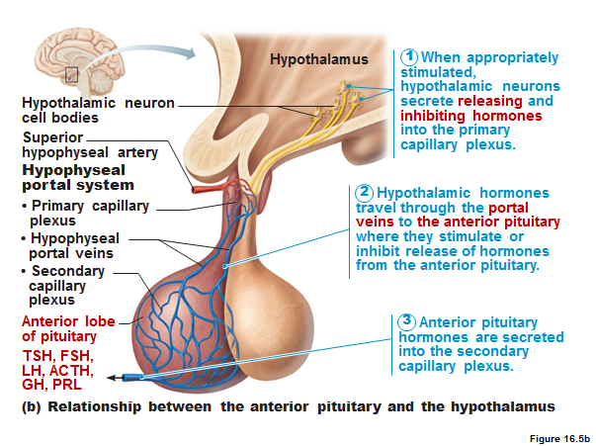
- Hormones stimulate other endocrine organs to release their hormones
- Hypothalamic hormones stimulate the release of most anterior pituitary hormones
- Anterior pituitary hormones stimulate targets to secrete still more hormones
- Hypothalamic-pituitary-target endocrine organ feedback loop: hormones from the final target organs inhibit the release of the anterior pituitary hormones and the hypothalamic hormones
- The hypothalamus (a) regulates the hormonal output of the anterior pituitary via releasing and inhibiting hormones and (b) synthesizes two hormones that it exports to the posterior pituitary for storage and later release.
- No direct neural connect b/w anterior lobe and the hypothalamus; but there is a vascular connection.
- Tropins or tropic hormones: hormones that regulate the secretory action of other endocrine glands and affect their target cells via a cyclic AMP second-messenger system. *except for growth hormone*

Growth hormones
- Produced by cells called somatotrophs of the anterior lobe.
- Major targets are the bones and skeletal muscles.
- stimulation of epiphyseal plates lead to long bone growth.
- stimulation of skeletal muscles promotes increased muscle mass.
- Most growth-promoting effect of GH are mediated indirectly by insulin-like growth factors (IGFs) also known as somatomedins, a family of growth-promoting proteins produced by the liver, skeletal muscle, bone and other tissues.
- IGFs stimulate uptake of amino acids from the blood and their incorporation into cellular proteins throughout the body; and stimulate uptake of sulphur into cartilage matrix.
- Secretion of GH is regulated chiefly by two hypothalamic hormones with antagonistic effects: Growth hormone-releasing hormone (GHRH)- stimulated GH release, while growth hormone-inhibiting hormone (GHIH) (somatostatin)- inhibits it.
- GHIH also blocks the release of thyroid-stimulating hormone and inhibits the release of virtually all gastrointestinal and pancreatic secretions.
- Hypersecretion
-In children results in gigantism that results from excessive GH production during the period of active growth
-In adults results in acromegaly that results from GH excess ensuing after epiphyseal fusion has occurred
- Hyposecretion
-In children results in pituitary dwarfism

Thyroid-Stimulating Hormone
- Thyroid stimulating hormone (TSH) or thyrotropin, is a tropic hormone that stimulates normal development and secretory activity of the thyroid gland.
- TSH is released from cells of the anterior pituitary called thyrotrophs, triggered by the hypothalamic peptide thyrotropin-releasing hormone (TRH).
- promotes growth of many tissues including cartilage and bone growth (increased protein synthesis - increase number and size of the cells)
- regulates metabolism (GH enhances body protein, uses up stored fat and conserves CHO)

Adrenacorticotropic hormone (corticotropin)
- is secreted by the corticotrophs of the adenohypophysis.
- Stimulates the adrenal cortex to release corticosteroid hormones, most importantly glucocorticoids that help the body resist stressors
- ACTH release levels peak during the morning, shortly before awakening.
- ACTH release is elicited by hypothalamic cortocotropin-releasing hormone (CRH)

Gonadotropins
- Follicle-stimulating hormone (FSH) and luteinizing hormone (LH) are gonadotropins that regulate the function of the gonads (ovaries and testes)
- FSH stimulates gamete (sperm or egg) production and LH promotes production of gonadal hormones.
- Gonadotropin is released by the adenohypophysis, which is prompted by gonadotropin-releasing hormone (GnRH)

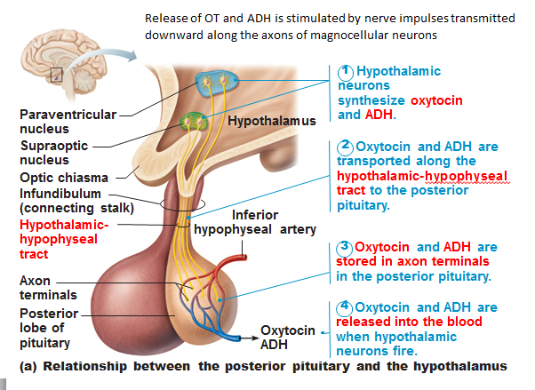
The posterior pituitary and hypothalamic hormones
- Hormones are produced by the magnocellular neurons in the hypothalamus
- These hormones pass to the posterior pituitary via axons (axoplasm) of the neurons
The posterior pituitary contains
- the axon terminals of magnocellular neurons
- glial-like cells (pituicytes) that act as a supportive structure for the axons

Oxytocin
- Strong stimulant of uterine contraction, released in larger amounts during childbirth
- Released from the neurohypophysis
- Oxytocin acts via the PIP-Ca²⁺ second-messenger system to mobilize Ca²⁺, allowing stronger contractions to occur.
- Plays a role in sexual arousal and orgasm when the body is already primed for reproduction by the sex hormones.
- In non-sexual relationships, oxytocin is thought to promote nurturing and affectionate behaviour, known as “the cuddling hormone”

Prolactin
- is a protein hormone structurally similar to GH.
- Produced by lactotrophs, stimulates the gonads of some animals and is considered a gonadotropin
- Effect in humans is to stimulate milk production by the breasts
- PRL release is controlled by hypothalamic releasing and inhibiting hormones
- Dopamine or prolactin-inhibiting hormone prevents prolactin secretion.
- a brief rise in levels of prolactin before the menstrual period partially accounts for the breast swelling and tenderness.
- During pregnancy, PRL blood levels rise dramatically near the end of pregnancy, making milk production in the breast possible.

Antidiurectic Hormone (ADH)
- Substance that inhibits or prevents urine formation
- Prevents wide swings in water balance, helping the body avoid dehydration and water overload.
- Osmoreceptors continually monitor the solute concentration of the blood
- when solutes threaten to become too concentrated, the osmoreceptors transmit an excitatory impulse to the hypothalamic neurons, which synthesizes and releases ADH.
- ADH targets the kidney tubules via cAMP, tubules respond by reabsorbing more water from the forming urine and returning it to the bloodstream.
- Pain, low blood pressure, and drugs such as nicotine, morphine and barbiturates may cause the release of ADH
- Drinking alcohol inhibits ADH secretion and causes copious urine output
- ADH is also inhibited one excessive amounts of water is consumed.
- ADH deficiencies result to diabetes insipidus, a syndrome marked by the output of huge amounts of urine and intense thirst.

The thyroid gland
- Located in the anterior neck, on the trachea just inferior to the larynx
- Largest pure endocrine gland in the body
- Walls of the internal gland is composed of follicles, which are largely formed by cuboidal or squamous epithelial cells called follicle cells, which produce the glycoprotein thyroglobulin.
- Central cavity of the thyroid stores colloid , amber-colour, sticky material consisting of thyroglobulin molecules with attached iodine atoms.
- Thyroid hormone (TH): referred to as the body’s major metabolic hormone.
- composed of two iodine-containing amine hormones, thyroxine T4, and triidothyronine T3.
- T4 is the major hormone secreted by the thyroid follicle; T3 is formed at target tissues by conversion of T4 to T3.
- Calorigenic effect: body’s ability to increase basal metabolic rate and body heat production due to the stimulation of TH.
Synthesis
- Process begins when TSH, secreted by the anterior pituitary binds to follicle cell receptors.
1. Formation and storage of thyroglobulin: after being synthesized on the ribosomes, thyroglobulin is transported to the golgi apparatus, where sugars are attached and molecules are packed into vesicles. Vesicles move to apex of the follicles cell, where they discharge their contents into the follicle lumen and become a part of the stored colloid.
2. Iodide tapping: follicles cells must accumulate iodides from the blood. Once iodide is trapped inside the follicle cell by means of active transport, iodide then moves into the follicle lumen and is disposed via facilitated diffusion.
3. Oxidation to iodine and iodination: iodides are oxidized (removal of electrons) and converted to iodine I_{2.} Once formed, iodine is attached to tyrosine amino acids that form part of the thyroglobulin colloid. Attachment of one iodine to a tyrosine produces monoidotyrosine (MIT or T1); attachment of two iodine produces diiodotyrosine (DIT or T2).
4. Coupling of T2 and T1: enzymes in the colloid link T1 and T2 together. Two linked DITs produce a T4; coupling of MIT and DIT produces T3.
5. Colloid endocytosis: hormone secretion requires the follicle cells to reclaim iodinated thyroglobulin by means of endocytosis and combine the vesicles with lysosomes.
6. Cleavage of the hormones for release: in the lysosomes, hormones are cleaved out of the colloid by lysosomal enzymes. The hormones then diffuse from the follicle cells into the bloodstream.
- TSH levels are lower during the day, peak just before sleep, and remain high during the night.

Calcitonin
- Polypeptide hormone produced by the parafollicular cells of the thyroid gland.
- Its effects is to lower blood Ca+ levels
- Excessive blood levels of Ca+ act as a humoral stimulus for calcitonin release.
- Calcitonin regulation of blood Ca+ levels is short-lived but rapid.

The parathyroid hormones
- Parathyroid hormone (PTH): the protein hormone released of these glands, is the single most important hormone controlling the calcium balance of the blood.
- PTH released is triggered by declining blood Ca+ lvls and inhibited by rising blood Ca+ lvls.
- PTH increases Ca+ blood lvls by targeting 3 organs: the skeleton, the kidneys, and the intestines.
- PTH release (1) stimulates osteoclasts to digest some of the bony matrix and release ionic calcium and phosphates into the blood; (2) enhances reabsorption of Ca+ by the kidneys; and (3) promotes activation of vitamin D, thereby increasing absorption of Ca+ by intestinial mucosal cells.

The adrenal glands
- Adrenal medulla: part of the sympathetic nervous system.
- Adrenal cortex: encapsulating the medulla and forming the bulk of the gland, is a glandular tissue derived from embryonic mesoderm.
- steroid hormones synthesized by the adrenal cortex are collectively called corticosteroids.
- Zona glumerulosa produces mineralocorticoids
- Zona fasciculate are the metabolic hormones called glucocorticoids
- Zona reticularis cells produce small amounts of adrenal sex hormones, or gonadocorticoids
- Mineralocorticoids: essential function is the regulation of the electrolyte concentrations in extracellular fluids, particularly Na+ and K+
- Aldosterone: most potent and accounts for more than 95% of the mineralocorticoids produced. Maintains sodium ion balance
- ACTH: when a person is severely stressed, the hypothalamus secretes more corticotropin-releasing hormone (CRH).
- Atrial natriuretic peptide (ANP): a hormone secreted by the heart when blood pressure rises, fine-tunes blood pressure and sodium-water balance of the body.
- major effect is to inhibit renin-angiotensin mechanism
- Glucocorticoids: influence the energy metabolism of most boy ells and help us to resist stressors
- activity on target cells is to modify gene activity
- READ PAGES 629-639
Nervous system
3.2.1. Compare the autonomic and somatic nervous systems
Autonomic nervous system (ANS): system of motor neurons to smooth and cardiac muscle glands to allow responses usually without our awareness
- shunt blood to more needy areas
- speed/slow heart and respiratory rates
- adjust blood pressure, body temperature
- increase/decrease gastric secretions
3.2.1.1. Using a flowchart, indicate the positions of the autonomic and somatic nervous systems in the structural organization of the nervous system as a whole
- 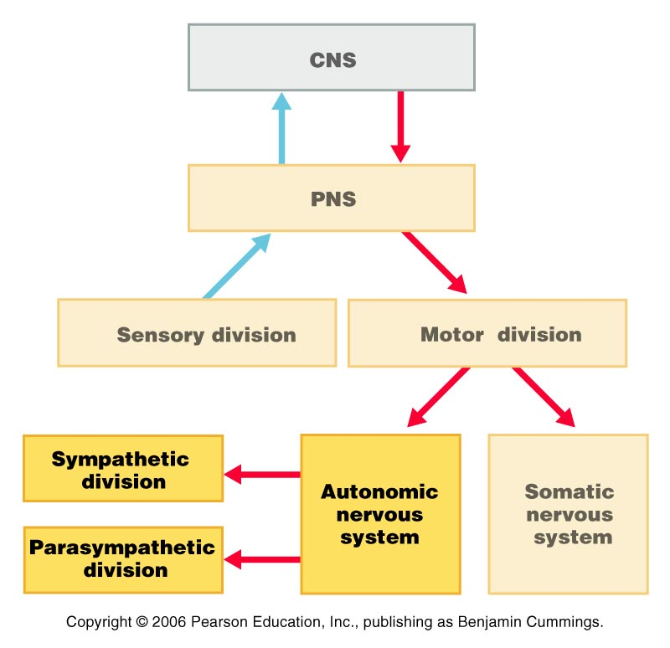
- The somatic and sympaptetic NS differ in:
-Efferent pathways (and their neurotransmitters)
-Effectors
-Target organ responses to neurotransmitters
3.2.1.2. Compare the autonomic and somatic nervous systems in terms of effectors, pathways, use of ganglia
- Effectors
- somatic nervous system stimulates skeletal muscles,
- somatic nervous system, the motor neuron cell bodies are in the CNS, and their axons extend in spinal or cranial nerves all the way to the skeletal muscles they activate.
- fibers are typically thick, heavily myelinated
--------
- ANS innervates cardiac and smooth muscle and glands
- ANS uses a two-neuron chain
- cell body of the first neuron, the preganglionic neuron, resides in the brain or spinal cord.
- its axon, the preganglionic axon, synapses with the second motor neuron, the ganglionic neuron, in an autonomic ganglion outside the CNS.
- axon of the ganglionic neuron, called the post-ganglionic axon, extends to the effector organ. 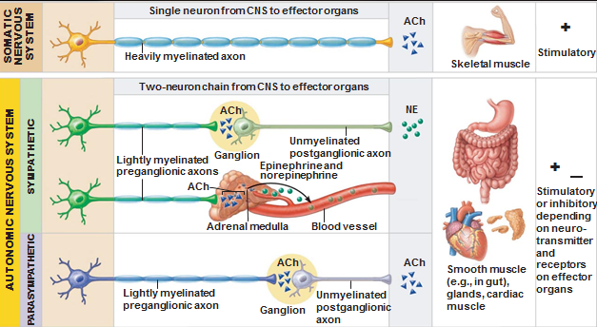
- Neurotransmitters effects
- somatic motor neurons release acetylcholine (Ach) at their synapse with skeletal muscle fibers always excitatory
- norepinephrine (NE) released onto visceral effector organs by postganglionic autonomic fibers are secreted by most sympathetic fibers, and Ach released by parasympathetic fibers.
3.2.2.1. Distinguish between the parasympathetic and sympathetic divisions of the autonomic nervous system in terms of the types of processes regulate
Autonomic Nervous System Division:
- The ANS consists of two divisions, the parasympathetic and sympathetic, which normally exert antagonistic effects on many of the same target organs.
- The parasympathetic division (resting-digesting system) conserves body energy and maintains body activities at basal levels.
- Parasympathetic effects include pupillary constriction, glandular secretion, increased digestive tract motility, and smooth muscles activity leading to elimination of feces and urine.
- The sympathetic division prepares the body for activity and is called the fight-or-flight system.
- Sympathetic responses include dilated pupils, increased heart rate, increased blood pressure, dilation of the bronchioles of the lungs, increased blood glucose levels, and sweating. During exercise, sympathetic vasoconstriction shunts blood from the skin and digestive viscera to the heart, brain, and skeletal muscles.
- Function of ANS - shunt blood to more needy areas, speed/slow heart and respiratory rates, adjust blood pressure and body temperature, increase/decrease gastric secretions

Parasympathetic (Craniosacral) Division:
- Parasympathetic preganglionic neurons arise from the brain stem and from the sacral region of the spinal cord.
- Preganglionic fibers synapse with ganglionic neurons in terminal ganglia located in or close to their effector organs.
- Preganglionic fibers are long and postganglionic fibers are short.
- Cranial fibers arise in the brain stem nuclei of cranial nerve and synapse in ganglia of the head, thorax, and abdomen. The vagus nerves serve virtually all organs of the thoracic and abdominal cavities.
- Cranial Fibers/Nerves:
  - Oculomotor nerves (III) – innervate smooth muscles in the eyes that cause the pupils to constrict and the lenses to bulge. Preganglionic axons are found in the accessory oculomotor nuclei in the mid-brain. The cell bodies of the ganglionic neurons are in the ciliary ganglia within the eye orbits.
  - Facial nerves (VII) –convey motor impulses to skeletal muscles in the face; transmit motor impulses to lacrimal glands (tear), nasal and palatine glands, and submandibular and sublingual salivary glands; pterygopalatine ganglia and submandibular ganglia
  - Glossopharyngeal nerves (IX) – originate in the inferior salivatory nuclei of the medulla and synapse in the otic ganglia; course to and activate the parotid salivary glands anterior to the ears.
  - Vagus nerves (X) – provide fibers to the neck and to nerve plexuses that serve virtually every organ in the thoracic and abdominal cavities. Send branches to the cardiac plexuses supplying fibers to the heart that slow heart rate, the pulmonary plexuses serving the lungs and bronchi, and the esophageal plexuses supplying the esophagus. Arise mostly from the dorsal motor nuclei and called intramural ganglia
- The location of the ganglia is in visceral effector organs.
- Active in non-stressful situations such as resting and the digestive system.
- Keeps the body’s energy use low while regulating “housekeeping” activities (elimination of feces and urine)
- It’s the “D System” – digestion, defecation, diuresis
- If you were to go running after eating a meal, the body will put digestion on hold in order to help your muscles. The body thinks you are in fight-or-flight mode and will put muscles as a priority instead of digesting the food.
Sympathetic (Thoracolumbar) Division:
- Preganglionic sympathetic neurons arise from the lateral horns of the spinal cord from the level T1 through L2 (the thoracolumbar region of the spinal cord).
- Preganglionic fibers are short and postganglionic fibers are long.
- The location of ganglia is close to the spinal cord.
- The “fight or flight system”
- Also important during exercise: increased heart rate, rapid deep breathing, cold sweaty skin, dilated eye pupils
- The “E system” – exercise, excitement, emergency, embarrassment
- SNS only regulates the adrenal medulla, sweat glands, erector pili muscles of skin, kidneys (increase blood pressure), most blood vessels, thermoregulatory responses to heat
- Metabolic effects: increases metabolic rate of body cells, raises blood glucose levels, stimulates mobilization of fats, increases mental alertness, increases speed/strength of muscle contraction
(For an overview of the subdivisions of the ANS, refer to page 528 figure 14.3)

3.2.2.2 Define: sympathetic (vasomotor) tone, parasympathetic tone
SNS and vascular tone: blood shunting possible via vasoconstriction/vasodilation;
alpha and beta blocking drugs alone or in combination to treat hypertension
PNS & tone: heart, smooth muscle of GI & urinary tracts- can be overridden by SNS

Visceral Reflexes:
- Visceral reflex arcs have the same components as somatic reflexes. The main difference is that visceral reflex arcs have two neurons in the motor pathway.
- Visceral pain afferents travel along the same pathways as somatic pain fibers, contributing to the phenomenon of referred pain.
- Cell bodies of visceral sensory neurons are located in dorsal root ganglia, sensory ganglia or cranial nerves, or autonomic ganglia. Not found in spinal nerves or any autonomic nerves.

(For the steps of the visceral reflex, refer to page 534 figure 14.7)

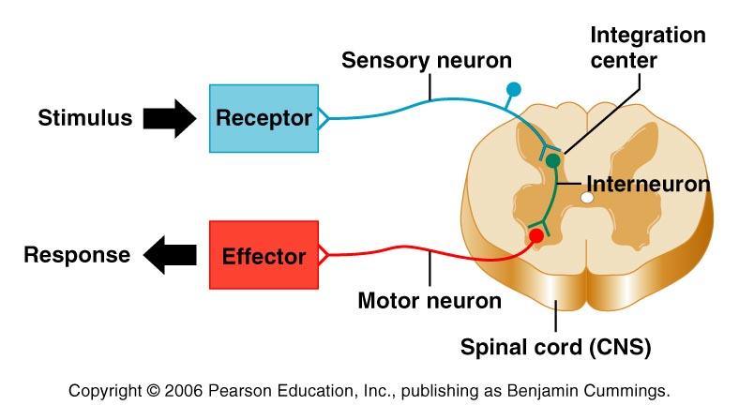
Somatic Reflex:

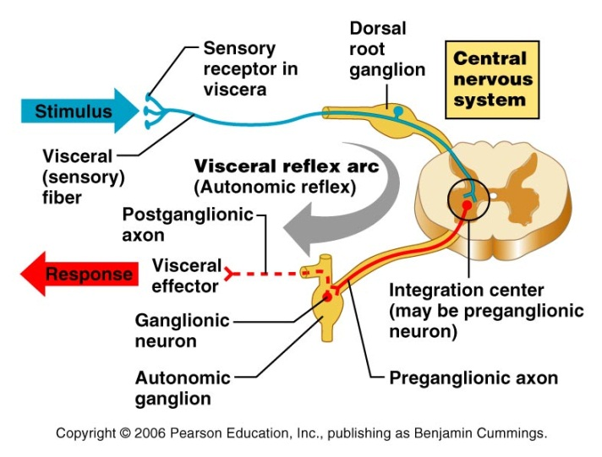
Visceral Reflex:

Neurotransmitters and Receptors:
- Two major neurotransmitters, ACh and NE, are released by autonomic motor neurons. On the basis of the neurotransmitter released the fibers are classified as cholinergic or adrenergic.
- ACh is released by all preganglionic fibers and all parasympathetic postganglionic fibers. NE is released by all sympathetic postganglionic fibers except those serving the sweat glands of the skin and some blood vessels within skeletal muscles.
- Neurotransmitter effects depend on the receptors to which the transmitter binds. Cholinergic (ACh) receptors are classified as nicotine (gives immediate response) or muscarinic (slower). Adrenergic (NE) receptors are classified as alpha (α1 or α2) or beta (β1, β2, or β3).
- Cholinergic Receptors:
  - Nicotinic
- Always stimulatory
- found on sarcolemma of skeletal muscle, all ganglionic ANS neurons, the hormone-producing cells of adrenal medulla
  - Muscarinic
- Inhibitory or stimulatory
- found on all effector cells stimulated by postganglionic cholinergic fibers (parasympathetic stimulation) and a few sympathetic targets (eccrine sweat glands, some blood vessels of skeletal muscle)
- Adrenergic Receptors:
  - Effects of NE or E can be either excitatory or inhibitory and depends on which subclass of receptors predominates on the target organ

3.2.2.4. List the 3 levels of regulation of the ANS, giving specific examples
Regulation of the ANS Function:
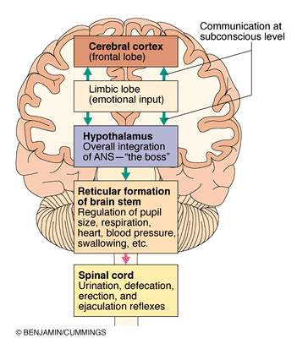
1. Hypothalamic Controls
- Hypothalamus = main integration centre of ANS
- Medial and anterior region -> parasympathetic
- Lateral and posterior areas -> sympathetic
- Hypothalamus contains centres of coordinate heart activity, blood pressure, body temperature, water balance, other endocrine activity; also centre that help mediate emotions and biological drives
2. Brain Stem and Spinal Cord Controls
- Motor centres in ventro-lateral medulla (eg. Cardiovascular centre -> heart rate, blood vessels; also GI, repiratory centres)
- Vagus nerve afferents convey sensory information
3. Cortical Controls
- E.g mediation and biofeedback allow some conscious control over visceral activities
- E.g during mediation, can lower heart and breathing rates, oxygen use and metabolic rate
- Biofeedback to improve management of migraine headaches, stress and cariac function

Homeostatic Imbalance of ANS = hypertension

Ch. 17 Blood
Blood exits the heart by arteries, which branch out to tiny capillaries. They diffuse across the capillary walls which leads oxygen and nutrients to leave the blood and enter the body tissues. Carbon dioxide and waste move from the tissues to the bloodstream. Oxygen diffident blood leaves the capillary beds and flow into the veins which return to the heart.
The major components of whole blood
Blood is a specialized type of connective tissues and contains:
- Living blood cells called formed elements
- The formed elements are suspended in nonliving matrix called blood plasma
If you place a blood sample into a centrifuge you will see that the heavier formed elements are packed down thanks to centrifugal force and the less dense plasma remain on top.
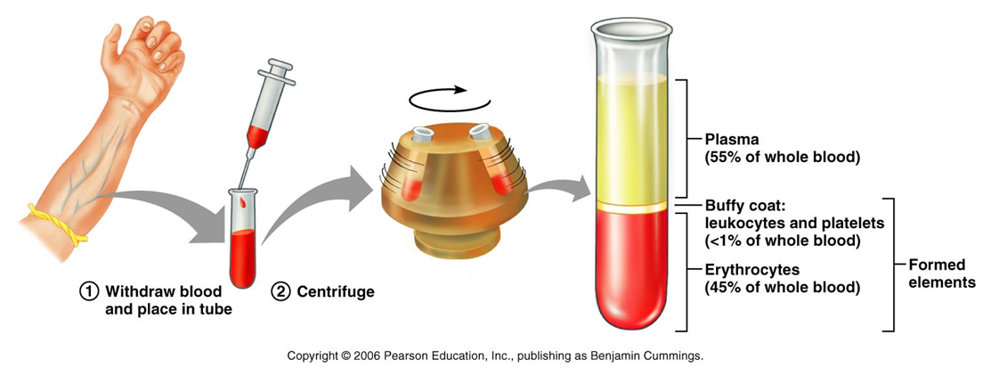
- Blood is slightly alkaline (pH=7.35-7.45)
- Temperature =38 ͦ(somewhat higher than body temp.)
Functions of blood
Transport ( distribution):
- O2 from lungs and nutrients from the digestive track
- Metabolites waste from cells to elimination sites. ( to lungs for the elimination of Co2, to the kidneys for disposal of nitrogenous wastes in urine.)
- Hormones from the endocrine organs to target organs
Regulation:
- By absorbing and distributing heat throughout the body and to the skin surface to encourage heat loss, blood helps regulate body temp.
- Many blood proteins and other bloodborne solutes act as buffers to prevent excessive or abrupt changes in blood pH.
- Salts and blood proteins act to prevent too much fluid loss from the bloodstream into the tissue spaces. This allows the fluid in the blood vessels to remain ample to support efficient blood circulation.
Protection:
- Preventing blood loss with the use of blood clots. (platelets and plasma proteins)
- Prevent infection, drifting along the blood are antibodies, complement proteins and white blood cells, all which help protect the body from viruses.
Blood plasma
Made mostly from water, 90%, blood plasma contains many other types of proteins ect in the blood.
Plasma proteins are most abundant plasma solutes, accounting for 8% of the volume of the plasma. With the exception of hormones and gamma goblins, most plasma proteins are produced in the liver. Plasma proteins are not used as fuel or metabolic nutrients.
Albumin accounts for 60% of plasma protein. Acting as a carrier to shuttle certain molecules through the circulation, important blood buffer, and is major blood protein contributing to the plasma osmotic pressure sodium also helps with osmotic pressure. Respiratory system and kidneys are called into action to restore plasma’s normal, slightly alkaline pH.
Formed elements
There are three types formed elements erythrocytes, leukocytes and platelets. Some unusual feature they have to offer are: two of the three aren’t true cells, erythrocytes have no nuclei or organelles and platelets are cell fragments, leukocytes are the only true cells. There are more erythrocytes than the others.
Erythrocytes
Structure and basic characteristics
Also known as red blood cells (RBCs) , they are small biconcave cells that lack nucleus and organelles. Contain protein spectrin that helps RBC to be flexible, change shape and squeeze through narrow capillaries. They have a huge surface area for gas exchange and high hemoglobin content. Anaerobic metabolism allows them to create ATP but even though they are carrying the oxygen they do not consume any of it.
Hemoglobin
Hemoglobin is what makes cells red and they bind easily and reversibly with oxygen. They are made up of four protein globin subunits, each bound to the iron binding red heme pigment. Each iron atom can combine reversibly with one molecule of oxygen (4 per Hb molecule; each RBC contains 250 million Hb molecules!!). Each globin molecule is made of 2α(alpha) and 2β(beta) polypeptide subunits. Hemoglobin carrying o2= oxyhemoglobin. Hemoglobin carrying CO2= carbarminohemoglobin.O2 combines with heme group, but CO2 combines with globin part.
RBC standard values
Things you need to know from the chart
Count of red blood cells
The hemoglobin number
Hematocrit
Number of reticulocytes

Red blood cell production= hematopoiesis= hemopoiesis
Red blood cells are continuously renewed by division of cells in red bone marrow ( reticular connective tissue bordering on large capillaries called blood sinusoids)
The production of RBCs requires:
Functional hematopoietic stem cells ( pleuripotent, at this stage can develop to any body cell type.)In the network of the sinusoids there are immature blood cells, macrophages, fat cells and reticular cells( which secrete fibers). The blood cells mature and migrate through the thin walls of the sinusoids and enter the bloodstream. Red marrow is found in the bones of axial skeleton and gridles, and in the proximal epiphyses of the humerus and femur.
Each blood cell goes through a process in which it turns into that cell.
Hemocytoblast or hematopoietic stem cell : stem cell the beginning of it, they are located in red marrow
Proerytgriblast: committed cell, this is when the hemocytoblast go into a certain pathway they become commited to that pathway and cannot turn back. This commitment signaled by the membrane surface receptors for specific growth factors and hormones that “push” the cell towards specialization.
Myeloid stem cell: descendant of a hemocytoblast
Early (basophilic) erythroblasts: they produce large numbers of ribosomes. During this phase the cell divides many times. When the hemnoglobin is synthesized and iron accumulates as the early erythroblast turns into late eryrthroblast and then normoblast. The color of the cell changes as the ribosomes are masked by the pink hemoglobin. When normoblast have accumulated almost all of the hemoglobin it ejects its’ organelles. The nuclear functions ends and the nucleus degrades and is pinched off which allows the cell to collapse inwards and eventually leads to the bioconcave shape. The name of the cell is reticulocyte ( young erythrocyte) still contains clumps of ribosomes. The entire process takes 15 days. The reticulocytes almost fills to bursting point with hemoglobin and enters the bloodstream. After 2 days of the degradation of the ribosomes it becomes a mature erythrocyte.
Reticulocytes account for 1-2% of all erythrocytes in the healthy body. Reticulocytes count allows us to estimate the rough index that the RBC are forming. Above or below this percent range means that there is an abnormal rates.
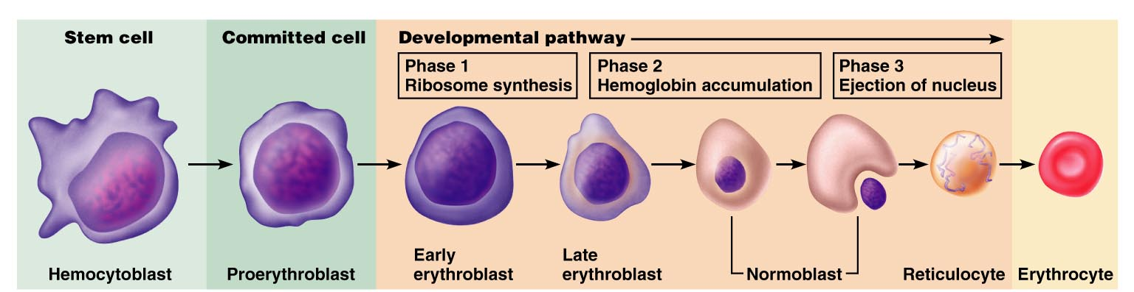
Erythropoetin (EPO) mechanism for regulating erythrocytes
Having too little erythrocytes can cause tissue hypoxia (oxygen deprivation) whereas having too many makes blood too viscous. To maintain a homeostatic range new cells are produced at a rate of 2 million per second in a healthy person.
Erythropotein is a glycoprotein hormone. Normally small amounts of this hormone circulates around the blood and sustain red blood cell production at a reasonable rate. Kidneys are very important for the production of the EPO and the liver also helps production as well. When certain kidney cells become hypoxic( not enough oxygen) oxygen enzymes are unable to carry out their normal functions of degrading an intercellular signaling molecule called hypoxia-inducible factor (HIF). As HIF accumulates it accelerates the synthesis and release of erythropoietin.
Drop in normal blood oxygen levels that trigger EPO formation can result from:
- Reduced number of red blood cells due to hemorrhage or excessive RBC destruction
- Insufficient hemoglobin per RBC( as in iron deficiency)
- Reduced availability of oxygen, as might occur at high altitudes or during pneumonia.
If there are too many erythrocytes or excessive oxygen in the bloodstream it can lower the production of erythrocytes. It is not the number of erythrocytes in the blood that control the rate of erythropoietin, actually control is based on their ability to transport enough oxygen to meet demands.
Athletes and EPO abuse: can increase hematocrit from 45% to 65%; but increased viscocity plus dehydration during race can -> clotting, stroke, heart failure.
When cell o2 falls, oxygen “sensor” in kidney and liver ( a heme protein) -> stimulates transcription of EPO. Kidney produces 85%- 90% of EPO. Other stimulators of EPO are catecholamines, androgens and alkalosis.
Raw materials in erythropoiesis are usual nutrients structural materials amino acid,lipids,carbohydrates.
Life cycle of RBC
Most hemoglobin degradation-in the macrophages of the spleen and iron is reused. Heme is reduced to bilirubin and eventually converted to urobilinogen metabolised by bacteria to stercobillin an excreted in feces. (look at diagram on p.641)
Bilirubin is a yellow pigment that is released to the blood and binds to albumin for transportation.
Iron uptake, incorporation into hemoglobin and storage
Iron is transported by transferrin and stored inside cells as protein-iron complex ferritin and hemosiderin.
The most common areas of iron storage in our bodies: liver, bone marrow, intestinal mucosa and spleen. If the body does not need iron, it is stored in the mucosal cells die and are slough.
Iron absorption in controlled by intestinal cell in response to changing body stores of iron.
65% of the bodies iron is stored in hemoglobin rest is stored in spleen ,liver and very little in bone marrow. Heme= iron and globin = amino acids.
Since iron on its own in toxic it is stored cells are protein-iron complexes such as ferritin and hemosiderin.
During transportation iron is loosely connected to transport protein called transferrin.
Heme iron is better absorbed than non-heme iron
Vitamin B12 and folate are necessary for synthesis of nucleic acids and nuclear maturation of the RBC
Vitamin B12 requires intrinsic factor for effective absorption. (Intrinsic factor is a glycoprotein that is necessary for absorption of B12)
Heme iron( in hemoglobin and myoglobin) found in :
- Organ meats ( liver, heart, kidney)
- Red meat ( beef, pork, veal and lamb)
- Fish ( clams, oysters, sardines)
- Poultry
None-heme iron (all iron found in vegetables, grains and supplements):
- Legumes ,dry fruits, enriched cereals and pasta
- Dark green leafy vegetables, eggs
Practical dietary strategies to meet iron needs
- Eat hem rich foods
- Enhance the absorption of non-hem iron ( include vitamin c at the same meal
- Be aware that some foods interfere with non-hem iron absorption (excess bran, strongly brewed tea, oregano
- Take iron supplements when advised too.
Erythrocyte disorders
Anemia is a condition in which the blood cannot carry a lot of oxygen , the oxygen levels are too low to support normal metabolism. Symptoms include paleness, cold, fatigued and short of breath.
- An insufficient number of red blood cells. Conditions that are concerned with a low red blood cell count (blood loss), excessive RBC destruction and bone marrow failure.
Hemorrhagic anemia: when there is a significant amount of blood loss. Ex stab by a knife.
Hemolytic anemia: erythrocytes rupture or lyse, prematurely.
Aplastic anemia: destruction or inhibition of the red marrow by certain drugs or chemicals, ionizing radiation or viruses. Destruction of marrow impairs formation of all formed elements; anemia is just one sign of it.
- Low hemoglobin content; when hemoglobin molecules are normal, but erythrocytes contain few than usual number, nutritional anemia is always suspected
Iron- deficiency anemia: usually a secondary result of hemorrhagic anemia, but also results from inadequate intake of iron- containing food and impaired iron absorption. If there is a chronic hemorrhage that is the cause you may need a red cell transfusion.
Microcytes: small pale blood cells that are a result from iron-deficiency anemia.
Athlete’s anemia: when athlete’s exercise vigorously their blood volume expands and can increase by as much as 35% over time. Since this increase in volume dilutes the blood components, when a test for iron content of the blood would show that this person has iron-deficiency anemia. It is reversed as blood components return to physiological levels within a week or two after normal levels of activity.
Pernicious anemia: when you have a deficiency in B12, this type of anemia is more of a problem for strict vegetarians and in the elderly. Treatment is injections into the muscle of B12 or an application of a B12 gel (Nascobal) to the nasal lining once a week.
Intrinsic factor: substance produced by the stomach mucosa (membrane of the stomach), that must be present for vitamin B12 to be absorbed by intestinal cells. Most cases seen the intrinsic factor is deficient.
Macrocytes: caused when erythrocytes grow but do not divide, creating large pale cells.
- Abnormal hemoglobin is a result of a genetic basis abnormality.
Β-Thalassemias: most common to people from the Mediterranean ancestry, such as Greeks and Italians. One of the globin chains is absent or faulty and the erythrocytes are thin, delicate and deficient in hemoglobin. Depending on how sever it is blood transfusions may be required.
Sickle-cell anemia: destruction caused by abnormal hemoglobin, hemoglobin s (HbS),occurs when there is a change in one of 146 amino acid in a beta chain from a globin molecule. The alteration caused the beta chain to bind under low oxygen condition, which result in forming stiff rods so that the hemoglobin S becomes shape and spiky. This causes the blood cell to become crescent shaped when they are reviled of their oxygen molecule or when oxygen levels in the blood are low such as exercising or other actives that increase metabolic rate.
These erythrocytes rupture easily and tend to clog up small blood vessels which leads’ to less oxygen and in result leaves the person grasping for air. They are also in extreme pain and are prone to infections, strokes and bone and chest pains.
Treatment is a blood transfusion for extreme cases, or they use an inhaled nitric oxide to dilate blood vessels.
Fetal hemoglobin (HbF) does not sickle therefor they are using this as a method to prevent RBC’s from sickling. Clotrimazole, reduces sickling by blocking ion channels in the RBC membrane, keeping ions and water inside the cell.
Polycythemia: abnormal amount of erythrocytes that increase blood viscosity, causing it to sludge or flow sluggishly.
Polycythemia vera : bone marrow cancer, characterized by dizziness and an exceptionally high RBC count. (8-11 million) the hematocrit may be as high as 80% and blood volume may double causing the circulation to be impaired.
Secondary polycythemias: less oxygen is available or EPO increases. Secondary poly that is present in people living in high altitudes is a normal physiological response to atmospheric pressure.
Blood doping: when athletes competing in aerobic events take some of their red blood cells out and then inject them with the blood a few days before the event. The erythrocytes are quickly replaced by erythropoietin mechanism is triggered shortly after blood removal.
Folate deficiency anemia
Folate, from the Latin “folium” meaning leaf.
Involved in metabolism of DNA, amino acids and their derivatives
Often works together with vitamins B12 and B6 and produces deficiency syndromes often identical to vitamin b12 deficiency.
Folate is need to form all new cells including RBC
Folate deficiency can result from:
- Insufficient intake and/or absorption(e.g., alcoholism, Crohn’s disease, anorexia, bulimia)
- Increased requirement, ) pregnancy, lactation)
- Insufficient utilization due to other factors such as vitamin B-12 deficiency
Megaloblastic anemia caused by folate or vitamin B12 deficiency
This occurs when blood cells are unable to divide, leaving large immature red blood cells. Either a folate or vitamin B12 deficiency may cause this. Measurements of blood form both vitamins are taken to help find out what caused the anemia.
Vitamin B12
Vitamin B-12 is need for the production of red blood cells ( helps in recycling of folate coenzymes), for the maintenance of the sheets surrounding and protecting never fibers.
Found mainly in animal products and fortified cereals and milk.
About 50% of vitamin B-12 is absorbed by healthy adults
Pernicious anemia( pernicious means “leading to death” and autoimmue disorder related to decrease production of the intrinsic factor, needed for transport and absorption of vitamin B 12
Decreased absorption of vitamin B12
Absorption can be interrupted by :
- Absence of: R protein, pancreatic proteases, or intrinsic factor produced in the stomach as well as defective binding of the intrinsic factor
- Absence of much or all the stomach and ileum
-bacterial overgrowth
-tapeworm infestation
-some ulcer medications (e.g., omeprazole)
-chronic malabsorption (Crohn’s disease, AIDS)

Hemostasis

Blood homeostasis is regulated by a complex system of activators and inhibitors that maintain blood fluidity and prevent blood from leaving vascular compartment
Hemostasis: when blood vessel walls break and a whole series of reactions are set into action.
Hemostasis involves:
- vasospasm
- Platelet plug formation
- Development of fibrin clot
- Clot retraction
- Clot dissolution
Blood loss at the site is permanently prevented when fibrous tissue grows into clot and seals the hole in the blood vessel.
Mechanism of hemostasis
- Platelets ( produced in bone marrow about 30% stored in the spleen and released when needed)
- Von willenbrand factor ( produced by vessel’s endothelium) and plasma clotting factors ( synthesised in the liver, use vitamin K)
- Naturally occurring anticoagulants(ex. Plasminogen converted to slasmin when activated) that digest the fibrin of the clots and present inappropriate clots formation, antithromin 3, proteins S&C etc.
- Inherent properties of blood vessels themselves ( smoothenes of the endothelium), vascular neural reflexes and humoral factors ( cause vessel smooth muscle contractions, when needed)
Platelets
Platelets: they are bits of megakaryocyte membrane containing cytoplasm and various organelles but no nucleus; covered with glycocalyx
Megakaryocyte: are extremely large cells.
In blood smears you will see that each platelet will have blue stained outer region and an inner area that contains granules that stain purple. These granules have an impressive array of chemicals that act in the clotting process of hemostasis, this includes serotonin, Ca2+, a variety of enzymes, ADP, and platelet- derived growth factor (PDGF).
Platelets circulate for 8-9 days. When they are not involved in the clotting process they degrade in about 10 days. They are always in circulation but are inactive thanks to molecules ( nitric oxide, prostacyclin) secreted by endothelial cells lining the blood vessel.
Their production is stimulated by the protein thrombopoietin made continuously by the kidneys, liver, muscle and bone marrow; it causes proliferation and maturation of megakaryocytes.
They bind through thrombopoietin; when platelets count falls, thrombopoietin is available to stimulate bone marrow production.
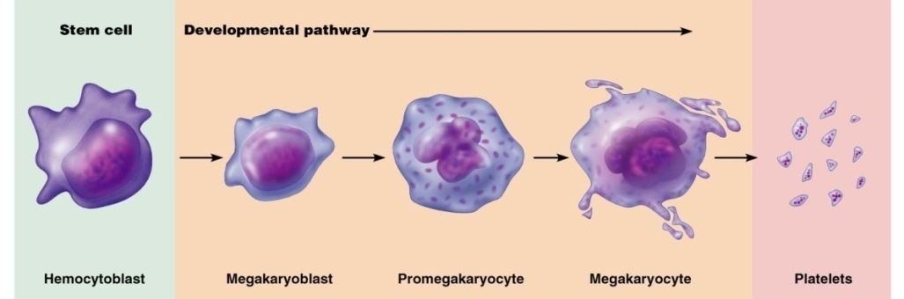
Hemostasis stage 1 (vascular spasm)
The injury to a blood vessel causes smooth muscle in the wall to contract. This sudden movement reduces the flow of blood from the rupture. Both local nervous reflexes and local humoral factors such as thromboxane A2 (TXA2), which is released from platelets, contribute to the vasonstriction.
Hemostasis stage 2 ( formation of platelet plug)
The exposure of collagen stimulates platelets to swell, become spiky and sticky leading them to stick to the exposed collagen and lead to degranulation (the release of chemicals)
Serotonin: enhances vascular spasm (stimulated by thromboxane A2)
APD: attracts more platelets (stimulated by thromboxane A2)
PGI2( prostacyclin): produced by endothelial cells; inhibits platelet aggregation.
Hemostasis stage 3 (blood coagulation)
Coagulation: when platelets are reinforced by fibrin threads that act as molecular glue for the aggregation of the platelets.
Procoagulants or clotting factors: when blood becomes a liquid to gel that involves a three step process with a series of substances. The plasma proteins that are synthesized occur in the liver. They are numbered I to XIII, these numbers where solely based on their discovery not order. Vitamin K is not directly involved in coagulation it is a fat soluble vitamin that is necessary for the synthesis of the four clotting factors.
The three clotting factors:
- Phase 1: two patheways to prothormbin activator. A complex substance called prothrombin activator is formed.
- Phase 2: common pathway to thrombin. Prothrombin activator converts a plasma protein called prothrombin into thrombin, an enzyme.
- Phase 3: common pathway to fibrin mesh, thrombin catalyzes the joining of fibrinogen molecule presenting plasma to a fibrin mesh, which traps blood cells and effectively seals the hole until the blood vessel can be permanently repaired.
Summary of hemostasis stages 1,2 and 3
2 pathways to prothrombin activator:
- Intrinsic pathway: associated with endothelium rupture and exposure of collagen causing clotting of blood outside body- slower pathway to factor X and PA
- Extrinsic pathway: clotting of blood associated with body and blood vessel damage which leads to release of tissue factor and bypass many steps of intrinsic pathway- faster pathway to x and PA.
- Look page650 for diagram
Hemostasis stage 4 (clot retraction and repair)
Occurs within 20-60 min; plaetelts conract (contain actomyosin), exerting pull on surrounding fibrin stands
Serum squeezed from clot and ruptured edges of blood vessles pulled closer
PDGF released during degranlation stimulates smooth muscle and fibroblasts to dvide and rebuild wall; endothelial cells multiply to fill gap in linning
Hemostasis stage 5 (clotting dissolution or lysis)
The slow release of a very powerful activator called tissueplasminogen activator (t-PA) from injured tissuees and vascular endothelium converts plasminogen to plasma
Fibrynolysis begins within 2 days and contiunes until clor dissolved
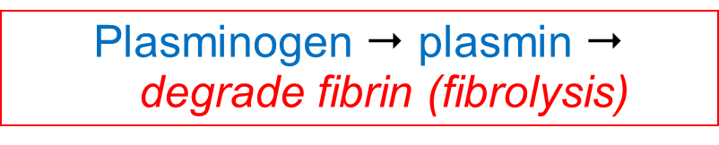
Clot formation requires:
- Blood normally flows in a way that washes away procoagulants as thrombin forms, adsorbed onto fiber threads( limits clot size)
- Anithrombin III( in plasma) inactivares any escaping thrombin
- Antithrombin III and protein c( liver) inactivate many intrinsic pathway procoagulants
- Heparin ( basophils and mast cells) enchances activity of anithrombin II
- Smooth endothelial lining of undamaged blood vessesl( also endothelial- derived heparin and prostacyclin
Factors limiting clot growth/formation
Once clotting process has begun than it will contiune until the the clot has fully formed. There are two mechanisms that help prevent clots from becoming unnessearly large:
- Swift removal of clotting factors
- Inhibition of activated clotting factors.
Clot formation is rapidly moving blood is curbed because the activated clotting factors are diluted or washed away. For the same reasons , further growth of the clot is stoped when it comes in contact with normally flowing blood.
Thrombin not attached to fibrin is quickly inactivated by antithrombin III, a protein present in plasma. Antithrombin and protein C: protein produced in liver, also blocks the activity of of other inrinsic pathways procoagulants.
Heparin: natural anicoagulant contained in basophil and mast cell granules, also found on the surface of endothelial cells. It blocks thrombin by enchancing the activity of tithrombins III.
Disorders of hemostasis
Two major disorders of hemostasis are at opposite poles.
- Thromboembolic disorders: resulted from conditions that cause undesirable clot formation
Bleeding disorders arise from abnormalities that prevent normal clot formation
- Disseminatedintravascular coagulation (DIC) involes both widspread clotting and severe bleeding
Thromboembolic conditions
Thrombus: clot development on a unbroken blood vessel.
Embolus: when a thrombus breaks away from the vessel wall and floats freely in the bloodstream.
When a embolus reaches a spot where the blood vessel is too narrow it will block that passageway.
Embolism: obstruction of the vessel caused by a embolus blocking a vessel.
Wafarin: drug use for prevention of a stroke.
Dissemainted intravascular coagulation
DIC is a situation in which widespread clotting occurs in intact blood vessels and the residual vlood becomess unavle to clot.blockage of bloof flow accompanied by servere bleeding follows.
Bleeding disorderes
The most common causes are platlets deciciency ( thrombocytopenia)
Thrombocytopenia: condition where the number of plateles are differcent.
Thrombocytpsis: increased count of platelets.
- Primary
- secondary
Impaired liver function: liver is unable to synthesize it’s usual supple of procoagulants, abnormal, and oftien severe bleeding occurs.
Hemophilia
Characteristics of the hemorrhages:
- They are induced by a minor cause and are exaggerated
- They have no tendency for spontaneous arrest
- They start over at the time of the loss of the blood clot
External bleeding: Hemorrhages from skin lesions are interminable; hemorrhages in the natural cavities are frequent
Interstitial bleeding: hematomas and hemarthroses are common
Hemarthroses (that can be absent with the mild forms) can occur in all the major joints (knees, elbows, ankles) causing an intense pain and, without appropriate treatment, lead to progressive destruction of the cartilages and joints
Treatment
Administration of concentrates of the coagulation factors ( injections must be frequent, every 8 to 12 hrs, due to their short life span)
Disorders of coagulation
Genetic: a group of diseases transmitted in a recessive fashion; associated with sex chromosome X; affects boys only (hemophilia C exception)
Transmitted by women apparently healthy (female hemophilia is very rare); it is observed in daughters of a hemophiliac father and a carrying mother, or in women presenting a deletion of the normal chromosome X)
Signs and symptoms: easy bruising, serious bleeding episodes, in particular hemarthroses (joint hemorrhage) in the case of severe hemophilia
Etiology: lack or abnormal function of factor VIII (hemophilia A) or factor IX (hemophilia B)
Human blood groups
RBC plasma membranes bear highly specific glycoproteins at their external surfaces. These glycoproteins serve as antigens, which are anything the body perceives as a foreign.
Agglutination: clumping of foreign cells; induced by cross linking of antigen –anitbody complexes.
Humans have 30 varieties of naturally occurring RBC antigen.
ABO blood groups: are based on the presence or absence of two agglutinogen, type A and type B.
Rh blood groups: there are 50 types of Rh agglutinogens, each of which is called the Rh factor. Only three of these, the C,D, and E antigens, are fairly common. R positive means that you carry the D antigen.
Blood may contain anti-A or anti-B antibodies (agglutinins) that act against transfused RBCs and ABO antigens not normally present
Anti-Rh anribodies form if an Rh negative individual receives Rh positive blood.
Second exposure to Rh positive will result in a typical transfusion reaction.
Anti-A or anti-B form in the blood at about 2 months of age.
Other blood groups (MNS, Duffy, Kell, and Lewis) are usually weak aggutinogens,
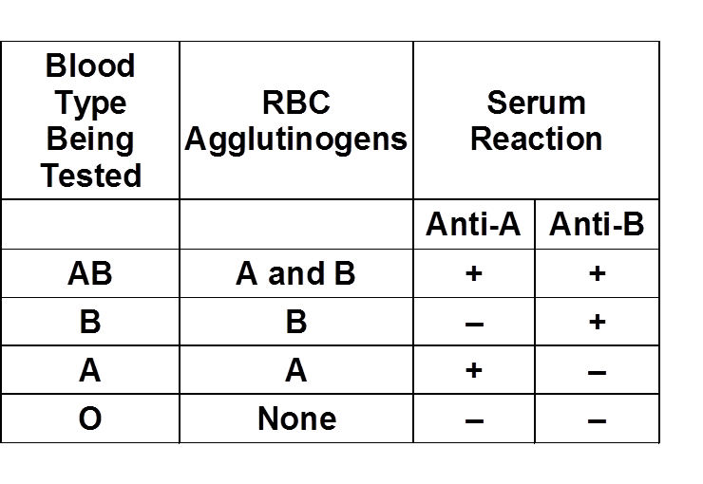
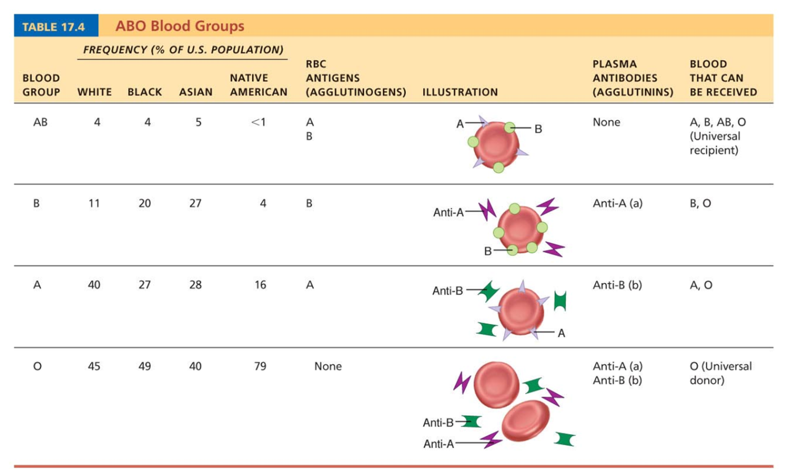
Hemolytic disease of the newborn or erythroblastosis fetalis: when the mother has Rh negative and is pregnant with Rh negative baby the mothers anti bodies will cross through though the placenta and destroy the babies RBCs.
Transfusion reactions: aggltination and hemolysis
Transfusion reaction: when a donner’s red blood cells are attacked by the recipitents plasma agglutinins.
When the red blood cells clog smal blood vessles throughout the body and begin to rupture but are destroyed by fagocytosis, and there hemoglobin is released into the blood stream.
These events can lead to two problems:
- The oxygen-carrying capability of the tranfused blood cells is disruptured
- The clumping of the red blood cellsin small vessels hinders blood flow to the tissues beyode this point.
4.2 – The Heart
4.2.1 Describe the internal and external anatomy of the heart
4.2.1.1 Describe the size, location and orientation of the heart in the thoracic cavity – page 663 and figure 18.1 page 662
Size:
- About the size of a fist
- Hollow, cone-shaped
- Mass of between 250-350 grams (less than a pound)
Location:
- Enclosed within the mediastinum (the medial cavity of the thorax)
- Extends obliquely (diagonally) from the second rib to the fifth intercostal space
- Rests superior of the diaphragm, anterior to the vertebral column, posterior to the sternum
- 2/3 of mass lies on the left of the midsternal line, balance projects to the right
Orientation:
- Flat base (posterior surface), about 9cm wide, directed toward the right shoulder
- Its apex points inferiorly toward the left hip
- 5th and 6th ribs down, below left nipple, you can feel the apical impulse, due to the apex of your beating heart gets into contact with the chest wall

4.2.1.2 From external to internal, list the 3 coverings of the heart and describe their tissue composition and functions – pages 663-664 and figure 18.2 page 663
Pericardium:
- Double-walled sac
- Tough, connective tissue
Outer Fibrous Pericardium:
- Loosely fitting superficial part of pericardium
- Tough, dense connective tissue layer
1. Protects heart
2. Anchors it to surround structures
3. Prevents overfilling of the heart with blood
Inner Serous Pericardium:
- Thin, slippery, two-layer serous membrane
- Parietal layer lines the internal surface of the fibrous pericaridum
- At the superior margin of the heart, the parietal layer attaches to the large arteries exiting the heart
- Then, turns inferiorly and continues over the external heart surface as the visceral layer (epicardium "upon the heart") = integral part of heart wall
- Pericardial Cavity: located between the parietal and visceral layers, fluid that reduces friction between the two membranes

Layers of the Heart:
Epicardium:
- Superficial, visceral layer of the serous pericardium

Myocardium:
- Middle layer, "muscle heart"
- Composed mainly of cardiac muscles, forms bulk of heart
- Layer that contracts
- Branching cardiac muscle cells tether to one another by crisscrossing connective tissue fibres and arranged in spiral or circular bundles
Endocardium:
- Third layer, "inside the heart"
- Glistening white sheet of endothelium (squamous epithelium) that rests on a thin connective tissue layer
- Lines the heart chambers and covers the fibrous skeleton of the valves
- Linings of the blood vessels leaving and entering the heart
Connective Tissue Fibres:
- Fibrous skeleton of the heart
- Reinforce myocardium internally and anchor cardiac muscle fibres
- Additional support for vessels and valves (avoid becoming stretched due to the continuous stress of the blood pulsating through them)
- Fibrous skeleton limits the direct spread of action potentials across the heart to specific pathways

4.2.1.3 Locate the following on diagrams that show both the external and internal anatomy of the heart: left & right atria and ventricles, aortic arch, superior and inferior vena cava, pulmonary trunk, left & right arteries and veins, coronary sinus, atrioventricular groove, anterior-posterior interventricular sulcus, pectinate muscles, fossa ovalis, trabeculae, papillary muscles – pages 665-667 figure 18.4 B, D and E(not in notes)

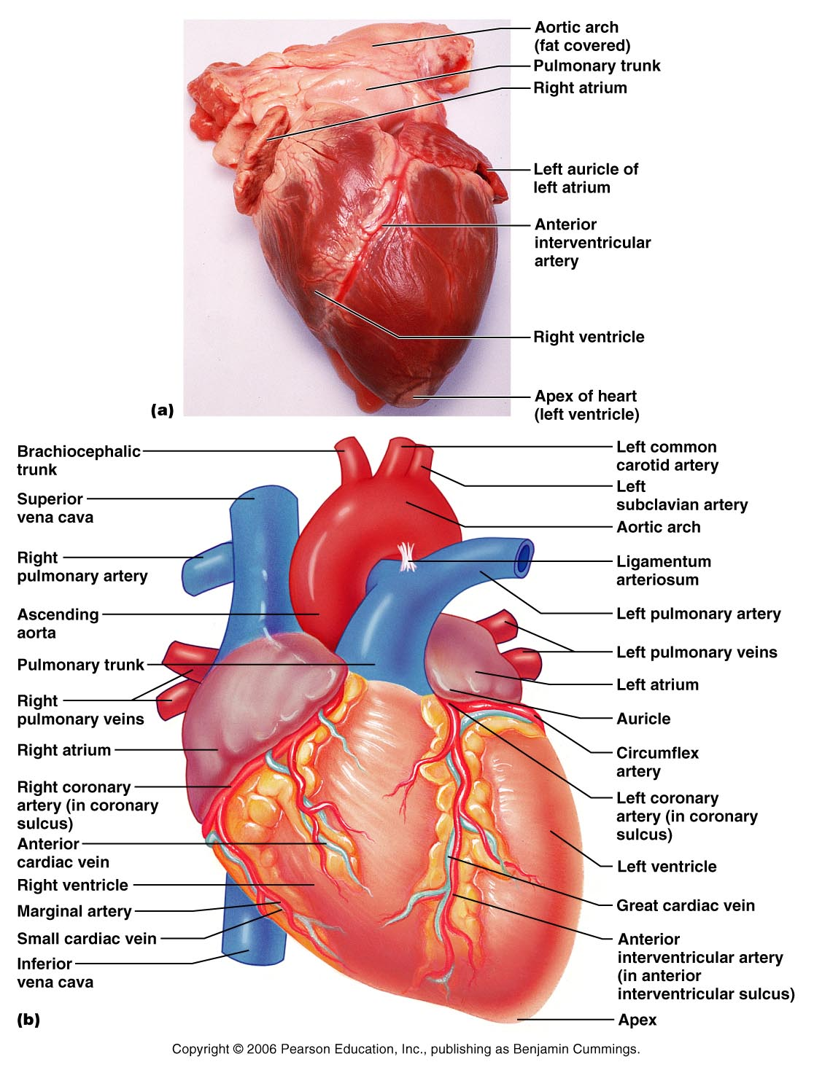

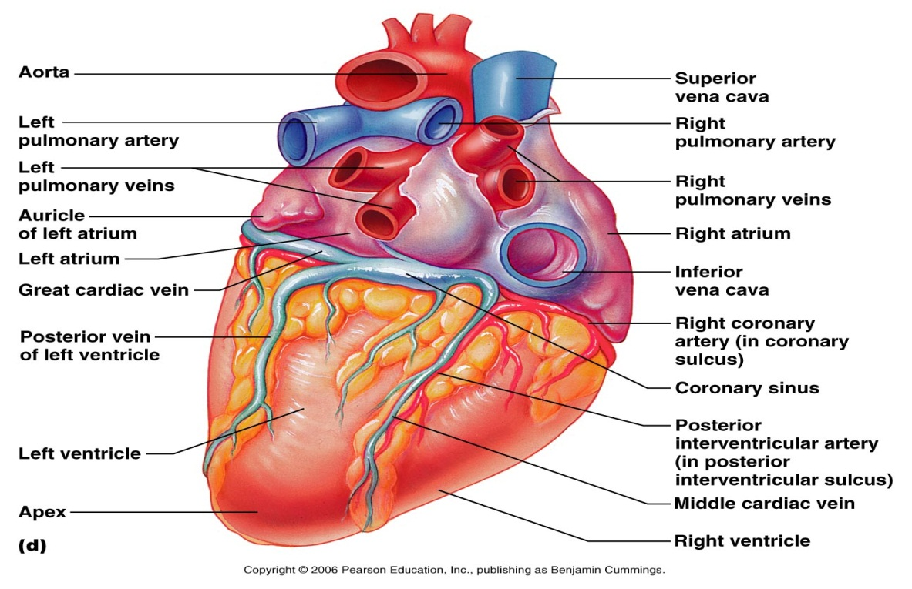

4.2.2 Trace the pathway followed by the blood in both the pulmonary and systemic circuits – pages 668-669, figure 18.5 page 668
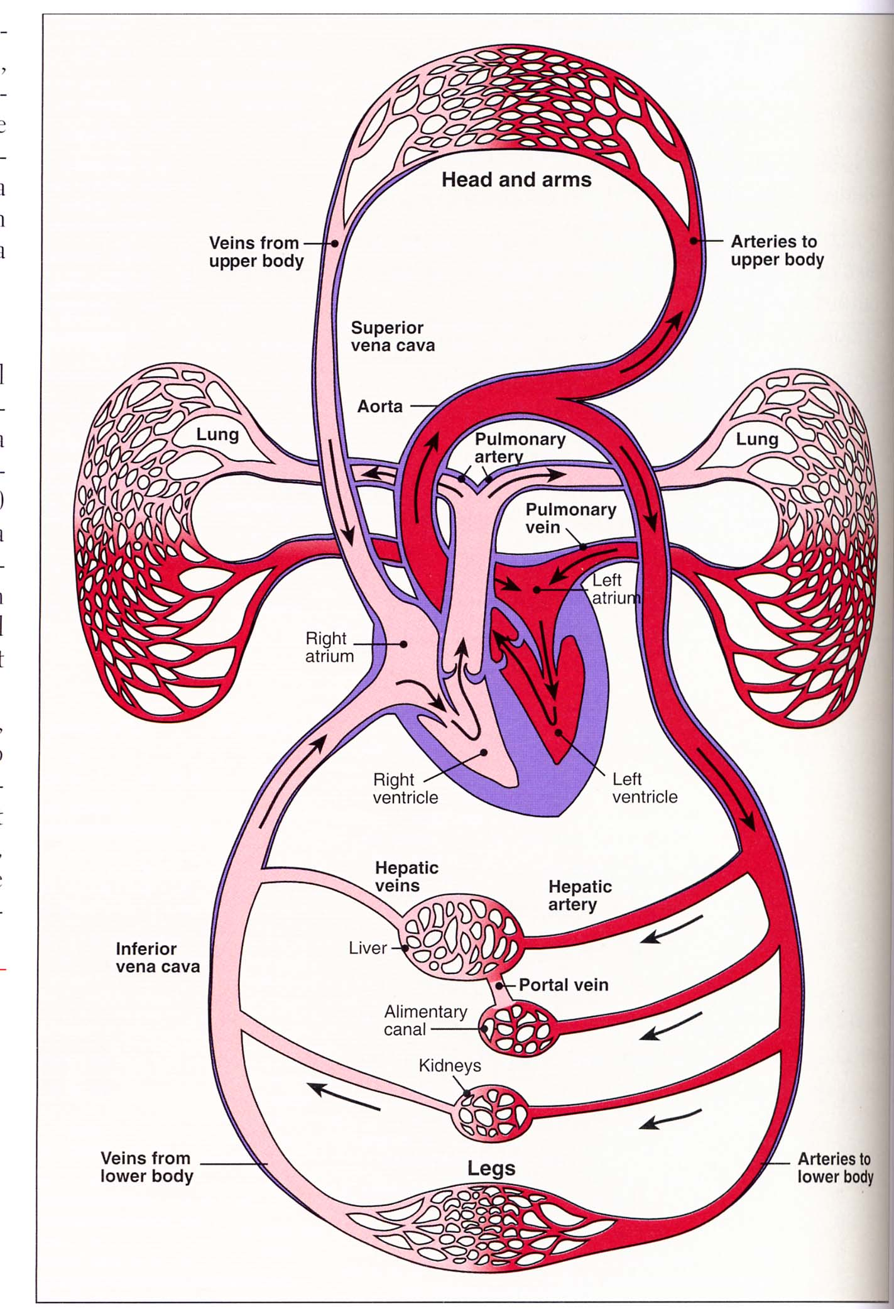
4.2.2.2 Distinguish between the pathways followed for the pulmonary and systemic circuits in terms of oxygenation of the blood, workload and its effect on the structure of ventricular wall - figure 18.6 page 699

Pulmonary Circuit: the blood vessels that carry blood to and from the lungs, serve for gas exchange
- The right side of the heart is the pulmonary circuit pump
- Served by the right ventricle, is a short, low-pressure circulation
- Blood is returning from the body, oxygen-poor and carbon-dioxide rich
- Enters right atrium then passes into the right ventricle = pumps it to the lungs via the pulmonary trunk
- Blood unloads carbon dioxide and picks up oxygen, the oxygenated blood is brought back through the pulmonary veins to the left side of the heart
- **unique pathway = elsewhere in the body, veins carry oxygen-poor blood to the heart, and arteries transport oxygen-rich blood from the heart. OPPOSITE OCCURS FOR THE PULMONARY CIRCUIT
- The right ventricle 3 times smaller than the left ventricle, cavity is flattened into a crescent shape

Systemic Circuit: the blood vessels that carry the functional blood supply to and from all body tissues
- The left side of the heart is the systemic circuit pump
- Associated with the left ventricle, long pathway through the entire body, with five times more friction/resistance of blood flow
- Freshly oxygenated blood leaving the lungs is returned to the left atrium and passes into the left ventricle = which pumps to aorta
- Blood is then transported via smaller systemic arteries to body tissues
- Gases and nutrients are exchanged across the capillary walls
- Once blood becomes oxygen-poor, and loaded with carbon dioxide, returns to the right side of the heart through the systemic veins
- Enters the right atrium through the superior and inferior vena cava
- Walls of left ventricle are three times as thick as those of the right ventricle, and the cavity is nearly circular, can generate much more pressure than the right and is a far more powerful pump

4.2.2.1 Trace the pathway followed by a red blood cell from its entry into the heart via the inferior vena cava to its exit from the heart via the aorta; this pathway should include all the valves in the order in which they are encountered
4.2.3 Describe the organization of the coronary circulation
- Coronary circulation arises from the aorta = provides blood supply to the heart
- Shortest circulation in the body
- Heart requires about 5% of the body's total blood supply

4.2.3.1 Identify the main arterial and venous components of the coronary circulation and indicate those areas of the heart, which they supply or drain – page 669, figure 18.7 page 669
- Coronary arteries provide an intermittent, pulsating blood flow to the myocardium (deliver the blood when the heart is relaxed but are compressed when the ventricles are contracting)
- Supplied by the right and left coronary arteries, both arising from the base of the aorta and encircling the heart in the coronary sulcus
- The left coronary artery runs toward the left side of the heart and then divides into its major branches: anterior interventricular artery and the circumflex artery
- Anterior interventricular artery: supplies blood to the interventricular septum and anterior walls of both ventricles
- Circumflex artery: supplies the left atrium and the posterior walls of the left ventricle
- The right coronary artery courses to the right side of the heart, two new branches: right marginal artery and posterior interventricular artery
- Right marginal artery: serves the myocardium of the lateral right side of the heart
- Posterior interventricular artery: runs to the heart apex and supplies the posterior ventricular walls
- Near apex of the heart, anastomoses merges with the anterior interventricular artery = right coronary artery supplies the right atrium and nearly all the right ventricle
- The venous blood is collected by the cardiac veins whose paths roughly follow those of the coronary arteries
- Veins join together to form an enlarged vessel = coronary sinus = empties the blood into the right atrium
- Coronary sinus: three large tributaries
1. Great cardiac vein: in the anterior interventricular sulcus
2. Middle cardiac vein: in the posterior interventricular sulcus
3. Small cardiac vein: runs along the heart's right inferior margin
- In addition, several anterior cardiac veins empty directly into the right atrium anteriorly
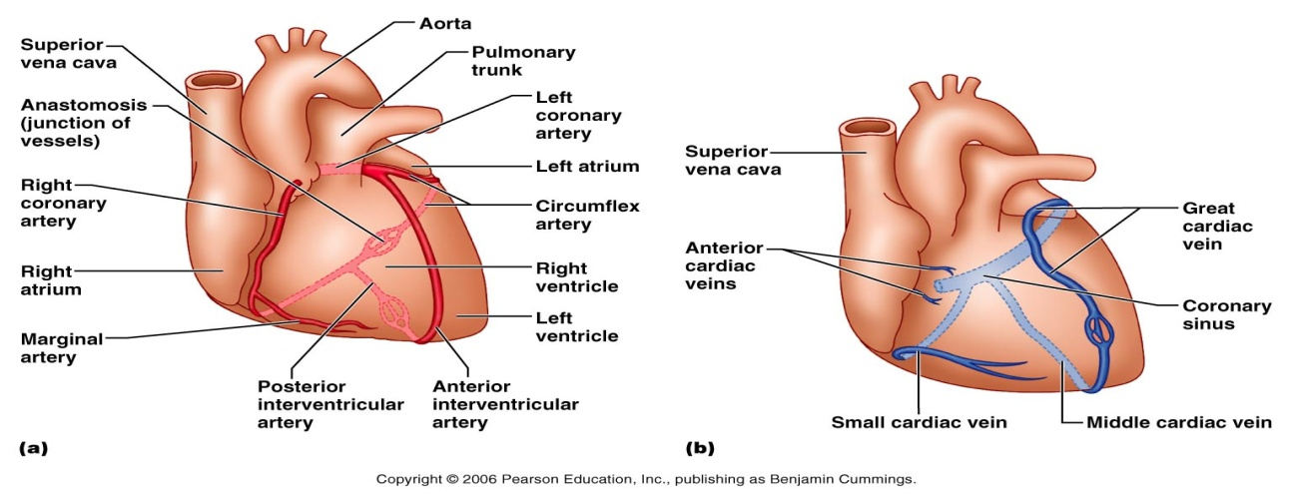

4.2.3.2 Define anastomosis and justify the presence of anastomoses in the coronary circulation – page 669, figure 18.7 page 669
Anastomosis: A union or junctions of nerves, blood vessels, or lymphatics
- Add additional collateral routes for blood delivery to the heart muscle, but not robust enough to supply adequate nutrition when a coronary artery is suddenly occluded (blocked)

4.2.4 Compare the physiological properties of cardiac muscle cells with those of skeletal muscle cells – page 673, + mostly slides
- Striated muscle fibers with myofibrils, contracts by the sliding filaments mechanism = cardiac cells are short, fat, branched and interconnected (as opposed to long, cylindrical, multinucleate muscle fibers)
  - actin and myosin
- Sarcolemma with T-tubules
- Sarcoplasmic reticulum with calcium
- Action potentials that initiate muscle contraction

- Cardiac: fibers contain one or at most two large, pale, centrally located nuclei
- Intercellular spaces are filled with a loose connective tissue (endomysium), containing numerous capillaries
- This matrix is connected to the fibrous skeleton, acts as both a tendon and an insertion, giving cardiac cells something to pull or exert force against
- Skeletal: independent of one another both structurally and functionally
- Plasma membrane of the adjacent cardiac cells interlock like the ribs of two sheets of corrugated cardboard at dark-staining junction (intercalated discs) = intercala means insert
- These discs contain anchoring desmosomes and gap junctions
- Desmosomes: prevent adjacent cells from separating during contraction
- Gap junction: allows ions to pass from cell to cell, transmitting current across the entire heart
- **myocardium behaves as a single coordinated unit (functional syncytium) = since the cardiac cells are electrically coupled by the gap junctions

4.2.4.1 Compare and contrast cardiac versus skeletal muscle in terms of morphology, function, energy requirements and metabolism
Function: (from slides)
- Means of stimulation – autorhythmicity vs. motor nerve ending stimulation
- Skeletal muscle fibres must be stimulated to contract by a nerve ending, but some cardiac muscles are self-excitable
- Organ vs. Motor unit contraction
- Skeletal: all cell are given a motor unit, which are stimulated and contracted at the same time. Impulses do not spread form cell to cell
- Cardiac: heart either contracts as a unit or doesn't contract at all = due to gap junctions (electrically tie all cardiac muscle cells together in a contractile unit)
- Length of absolute refractory period
- Cardiac: absolute refractory period lasts approximately 250 ms, nearly as long as the contraction
- Skeletal: short absolute refractory period lasts approximately 1-2ms, contraction lasts 15-100ms

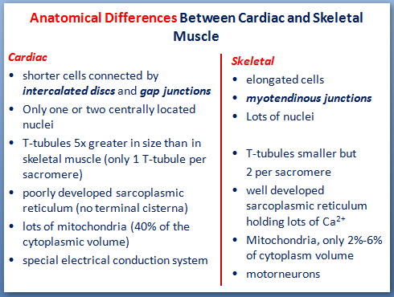
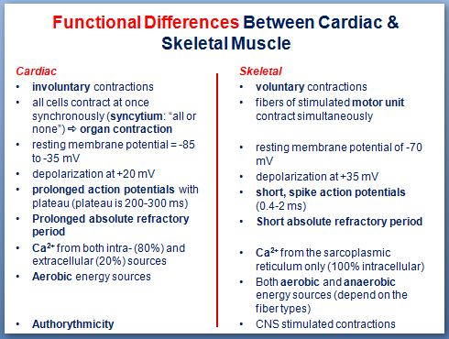

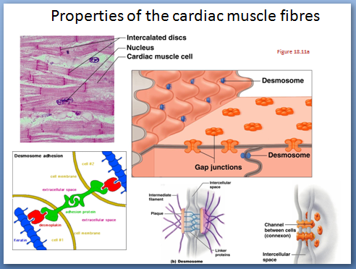
4.2.5 Compare the electrical properties of contractile cardiac muscle cells with those of autorhythmic cardiac muscle cells (from slides)
Cardiac muscle contains two types of cells:
1. Myogenic cells (1-2%) - self-excitable (automaticity)
2. Contractile cells
- Myogenic cells
Myogenicity: is the property of spontaneous depolarization and impulse generation
Autorhythmicity: the natural rhythm of spontaneous depolarization
- ability of cardiac muscle tissue to contract on its own
- does not require neural or hormonal stimulation
- Autorhytmic cells have minimal contractility
- Control/coordinate activity of contractile cells
2. Contractile cells
- 98–99% of the heart
- Produce the heart beat
- Unequal distribution of ions (polarized)
- have stable resting potential
- Contract in response to impulse from the conduction system
Heart contraction stimulated by action potentials:
action potential = signal; muscle twitch = response

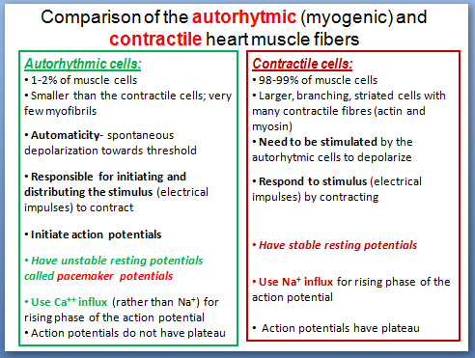

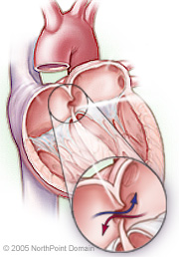
Patent foramen ovale:
- Patent foramen ovale (PFO) is a condition in which a foramen ovale in the atrial septum fails to seal after birth
- Complications - can lead to a heart attack or stroke by allowing a paradoxical embolus (travelling blood clot) to enter the bloodstream and lodge in a coronary artery or an artery in the brain
- Treatment - anticlotting drugs or surgery

Heart Valves – page 670, figure 18.8 page 671, figure 18.9 page 672, figure 18.10 page 673
- Blood flow is unidirectional; enforced by 4 heart valves composed of dense connective tissue covered by endothelium
Atrioventricular Valves (AV): located at each atrial-ventricular junction, prevent backflow into the atria when the ventricles are contracting = tricuspid valve & mitral valve
- Tricuspid Valve: right atrium to right ventricle, three flexible cusps
- Mitral Valve (bicuspid): left atrium to left ventricle, two flaps
- Chordae tendinae "heart strings": attached to AV valve, flap are tiny, white collagen cords = anchor the cusps to the papillary muscles protruding from the ventricular walls, in their closed position
- When the ventricles contract, compressing the blood in their chambers, the intraventricular pressure rises, forcing the blood superiorly against the valve flaps. = result: the flap edges meet, closing the valve

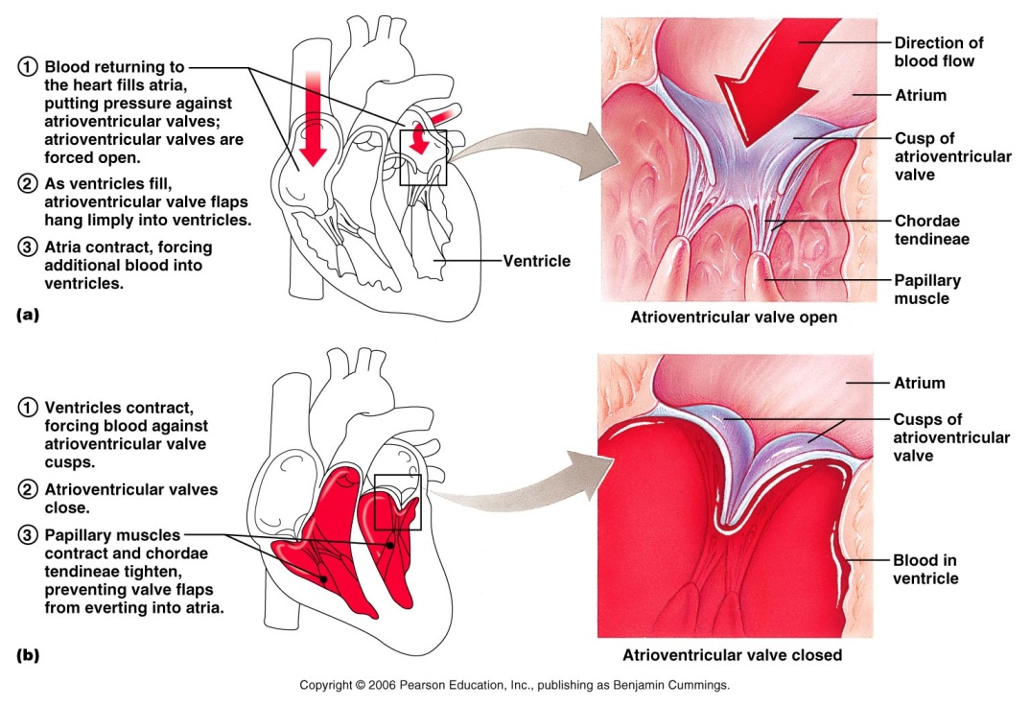

Semilunar Valves (SL): guard the bases of the large arteries issuing from the ventricles and prevent backflow into the associated ventricles.
- paired; from ventricles to either pulmonary or systemic circuits;
- prevent blood from flowing back into the heart
- pulmonary semilunal valve = right ventricle to pulmonary artery
- aortic semilunar valve = left ventricle to aorta
- when the ventricles are contracting and intraventricular pressure rises above the pressure in the aorta and pulmonary trunk, the SL valves are forced open and their cusps flatten against the arterial walls as the blood rushes past them
- once the ventricles relax, the blood flows backward towards the heart, it fills the cusps and closes the valves
- There are no valves at the entrance to the vena cava and pulmonary veins

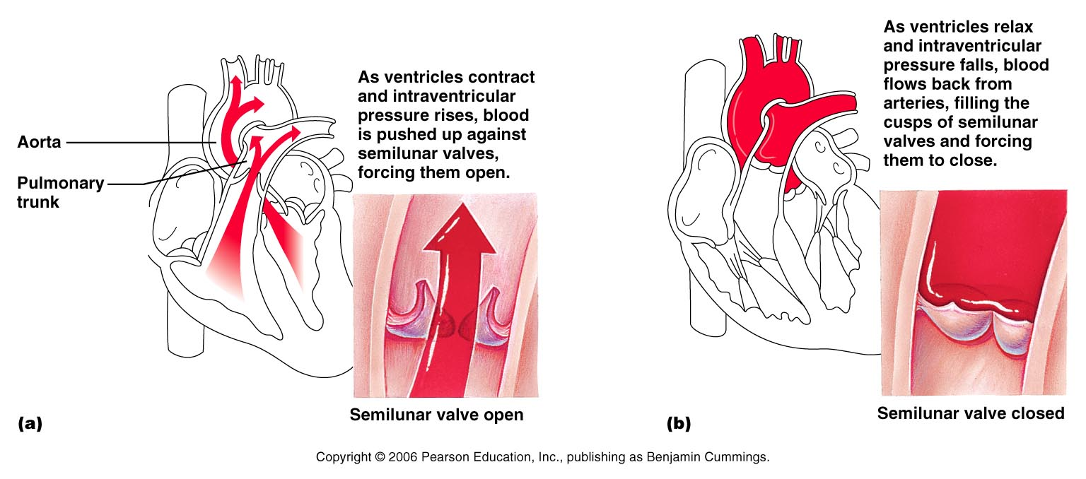
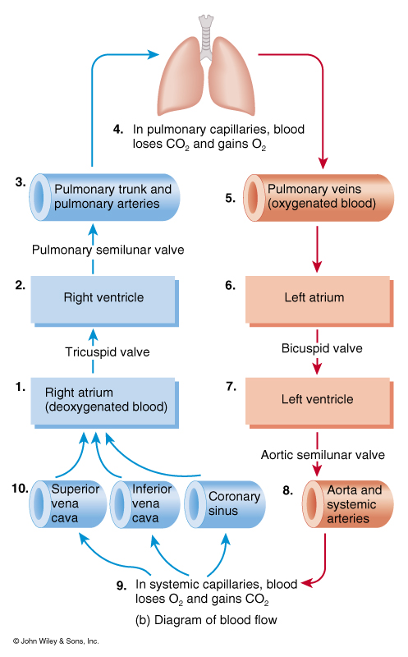

Mechanism and Events of Contraction
- Phase 0 - rapid upstroke (fast depolarization; overshoots 0); brief opening of voltage-gated fast Na⁺ Na⁺ rushes in
- Phase 1 - dip; Na⁺ channels close; Na⁺ pumping out begins. Causes the rising phase of the action potential (reversal of the membrane potential from -90 mV to nearly +30 mV)
- Transmission of the depolarization wave down the T tubules causes the sarcoplasmic reticulum to release Ca++ into the sarcoplasm
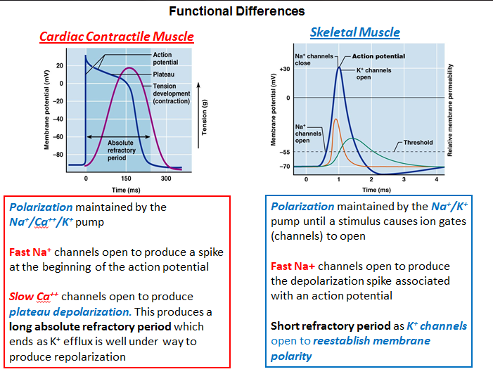
- Phase 2 - plateau; Ca⁺⁺ in (slow channels) and Na⁺ out balancing membrane potential at ~0mV . Keeps cell depolarized b/c few K+ channels are opened.
- Phase 3 - repolarization (permeability to Ca⁺⁺ declines; K⁺ permeability increases and K⁺ moves out to repolarize membrane
- Phase 4 - resting (Ca⁺⁺ pumped back into SR; K⁺ permeability decreases)
The Intrinsic Conduction System
- Consists of noncontractile cardiac cells specialized to initiate and distribute impulses throughout the heart.
- Autorhythmic cells: have an unstable resting potential that continuously depolarizes, drifting slowly toward threshold. also called pacemaker potentials or prepotentials, initiate the action potential that spread throughout the heart to trigger its rhythmic contractions.
- At threshold of approzimately -40 mV, Ca++ channels open, allowing an influx. Ca++ produces the rising phase of the action potential and reverses the membrane potential
- Sinoatrial Node: located in the right atrial wall, just inferior to the entrance of the superior vena cava.
- the SA node typically generates impulses about 75 times/minute.
- known as the heart’s pacemaker.
-SA node depolarizes and the resulting impulse spreads across the atrial myocardium and through the internodal fibers to the AV node.
- its characteristic rhythm, sinus rhythm determines heart rate
Main differences:
- Cardiac muscle - Polarization maintained by the Na⁺/Ca⁺⁺/K⁺ pump versus Skeletal Muscle – polarization maintained by the Na⁺/K⁺ pump
- Cardiac muscle - plateau depolarization maintained by Slow Ca⁺⁺ channels - lack of plateau in skeletal muscle
- Cardiac muscle - long absolute refractory period versus short absolute refractory period in skeletal muscle
- Cardiac muscle – longer duration of the action potential (about 200 ms) versus shorter duration (1-2 ms) in skeletal muscle

- Atrioventricular Node: from the SA node, depolarization wave spreads via gap junctions throughout the atria and via the intermodal pathway to the AV node.
- at AV node, impulse is delayed by 0.1s, allowing the atria to respond and complete their contraction before the ventricles contract.
-AV node conducts the impulse slowly
- Atrioventricular bundle (bundle of His): from the AV node, the impulse sweeps to the atrioventricular bundle
- AV bundle is the only electrical connection b/w the atria and the ventricles.
- balance of the AV junction is insulated by the nonconducting fibrous skeleton of the heart
- Right and Left bundle branches: conduct the impulses through the interventricular septum
- Purkinje Fibers: complete the pathway through the interventricular septum, penetrate into the heart apex, and then turn superiorly into the ventricular walls.
- depolarizes the contractile cells of both ventricles.
*total time b/w initiation of an impulse by the SA node and depolarization of the last of the ventricular muscle cells is approx. 0.22 s in a healthy human heart.
* SA node normally drives the heart at a rate of 75 beats/minute
* AV node depolarizes only about 50 times/minute
* AV bundle and purkinje fibers depolarize at the rate of only about 30 times per minute.
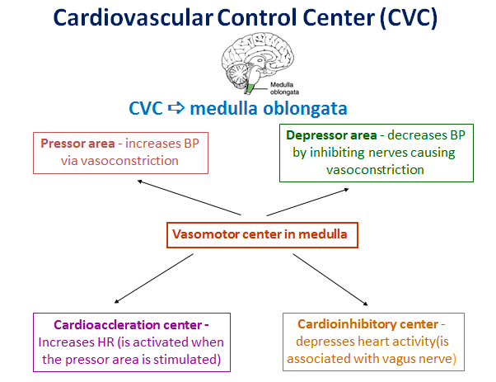
- Ectopic focus: an abnormal pacemaker which may appear and take over the pacing of heart rate, or the AV node may become the pacemaker.
Extrinsic Innervation of the Heart
- Cardiac center are located in the medulla oblongata.
- Cardioacceleratory center innervates SA and AV nodes, heart muscle, and coronary arteries through the sympathetic neurons
- Cardioinhibitory center inhibits SA and AV nodes through parasympathetic fibers in the vagus nerve
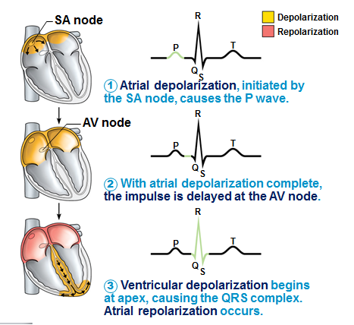
- Electrocardiography: record of electrical activity of the heart
-It is a composite of all the action potentials generated by nodal and contractile cells at a given time
- 12 leads; 3 bipolar (measure voltage difference); 9 unipolar
- P wave: lasts about 0.08 s and results from movement of the depolarization wave from the SA node though the atria (atrial depolarization)
- QRS complex: results from the ventricular depolarization and precedes ventricular contraction. (ventricular depolarization)
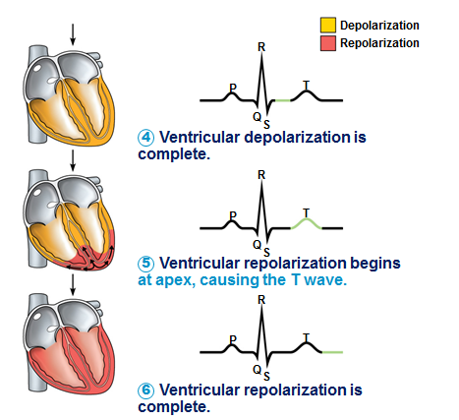
- T wave: caused by ventricular repolarization and typically lasts 0.16 s.
* atrial repolarization (takes place during ventricular excitation)is normally obscured by the large QRS complex
- P-Q interval: the time from the beginning of atrial excitation to the beginning of ventricular excitation (atrial depolarization and contraction)
- S-T segment: action potential in plateau. Entire ventricular myocardium is depolarized.
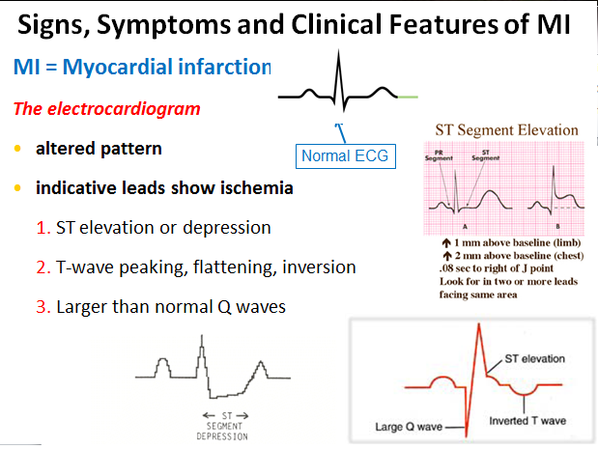
- Q-T interval: lasting 0.38 s, period from the beginning of ventricular depolarization through ventricular repolarization.

Heart Sounds
- Are associated with the closing of heart valves. “lup-dup”
- Quiescent period: the pause between the “lup-dup”, heart relaxation
- First sounds: occurs as the AV valves close, signifies the point when the ventricular pressure rises above atrial pressure (beginning of ventricular systole). Sound tends to be louder and longer
- Second sound: a short sharp sound that occurs when the SL valves close at the beginning of ventricular relaxation (diastole).
- Heart murmurs: abnormal heart sounds most often indicative of valve problems.
Cardiac Cycle
- All events associated with the blood flow through the heart during one complete heartbeat.
- Systole: the period of ventricular contraction and ejection of blood (0.3 s)
- Diastole: the period of ventricular relaxation, during which the ventricles fill with blood (0.5 s)
1. Ventricular filling: mid-to-late diastole
- pressure in the heart is low, blood returning from the atria and the open AV valves into ventricles. 80% of ventricular filling occurs.
- atrial contraction occurs. slight rise in atrial pressure, which propels residual blood out of the atria into the ventricles end diastolic volume
2. Ventricular systole
- as atria relaxes, ventricles contract; ventricular pressure rises rapidly, causing the closing of AV valves.
- isovolumetric contraction phase: the split second that the ventricles are completely close chambers and the blood volume in chambers remain constant.
- ventricular pressure rises until it final exceeds a higher pressure than in the arteries. This causes the SL valves to be forced open and blood is expelled from the ventricles into the aorta and pulmonary trunk known as ventricular ejection phase
3. Isovolumetric relaxation: early diastole
- blood remaining in their chambers (end systolic volume) are no longer compressed.
- ventricular pressure drops rapidly, and the blood from the aorta and pulmonary trunk backflow towards the heart, closing the SL valves.
- dicrotic notch: brief rise in aortic pressure caused by the backflowing of blood, rebounding off the closed valve cusps.
- Quiescent period - all chambers are at rest and filling
- the AV valves are open, the semilunar valves are closed
- Atrial Systole - pushes the last 20% of blood into the ventricles
- Atrial Diastole - atria relaxed, begin filling
- Ventricular Systole – ventricles contract
- the AV valves close, causing the first heart sound, the semilunar valves open permitting ventricular ejection of blood into the arteries
- Ventricular Diastole - the ventricles relax
the semilunar valves close first producing the second heart sound the AV valves open allowing ventricular filling
- End diastolic volume: amount of blood that collects in the ventricles at the end of diastole
End systolic volume: volume of blood remaining in the ventricle after it has contracted
Cardiac Output
- Amount of blood pumped out by each ventricle in 1 minute.
- Cardiac output = stroke volume x heart rate CO (L/min) = SV (L/beat) x HR (beats/min)
- Stroke volume: the volume of blood pumped out by one ventricle with each beat. The difference b/w end diastolic volume and end systolic volume
- Frank-Starling law of the heart: increased myocardial stretch (preload) leads to an increase in stroke volume
- Cardiac reserve: difference b/w resting and maximal cardiac output
- Preload (affects EDV): the degree to which cardiac muscle cells are stretched just before they contract.
Factors affecting preload:
- Venous return
- Blood volume
- Posture
- Skeletal muscle and thoracic pump
- Venous tone (SNS dependent)
- Duration of diastole
- Heart rate
- Venous return: the amount of blood returning to the heart and distending its ventricles
- Optimal length: the sarcomere length that provides for optimal overlap of thick and thin filaments
* resting cardiac cells are normally shorter than optimal length
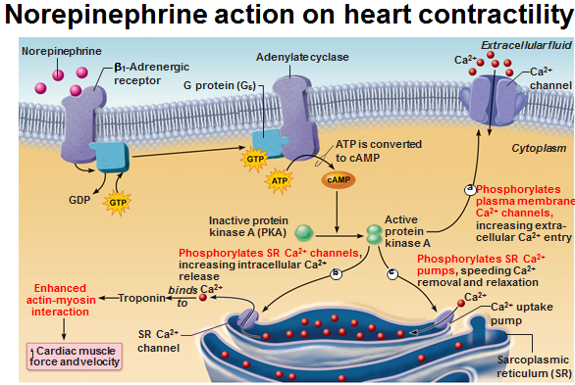
- Contractility (affects ESV): defined as the contractile strength achieved at a given muscle length.
- due to a greater Ca++ influx into the cytoplasm from the ext. fluid and the sarcoplasmic reticulum.
1. PKA phosphorylates Ca²⁺ channels in plasma membrane promoting entry of Ca²⁺ from the extracellular space
2. PKA phosphorylates also SR Ca²⁺ channels, causing SR to release more Ca²⁺
3. It phosphorylates SR Ca²⁺ uptake pumps thus shortening the removal time of Ca²⁺ from the sarcoplasm and speeding relaxation
Factors increasing contractility (positive inotropic agents):
- The availability and rate of intracellular Ca²⁺ influx into the cytoplasm
- Sympathetic stimulation (norepinephrine and epinephrine) of c-AMP dependent Ca²⁺ entry to the cells
- The hormones: thyroxine, glucagon and catecholamines
- Digitalis and other positive inotropic agents
- Afterload: the resistance the heart meets as it attempts to pump blood to the circulation
- is it the back pressure exerted on the aortic and pulmonary valves by arterial blood
Factors affecting afterload:
- Increased intrathoracic pressure
- High tension exercises involving
- upper-body muscle mass (greater mass - greater afterload)
- Static exercises involving a dynamic motion (e.g., shoveling of snow)
- Arteriosclerosis
- Anatomical impedance
- Sympathetic and parasympathetic impulses
Heart Rate
- Parasympathetic nervous system: decreases diastolic depolarization rate by making cells more permeable to K⁺; makes diastolic potentials more negative e.g.at SA node: ACh from PSN >> opens K⁺ channels >> slows rate of depolarization >> extends duration of repolarization (hyperpolarization) >decrease in heart rate
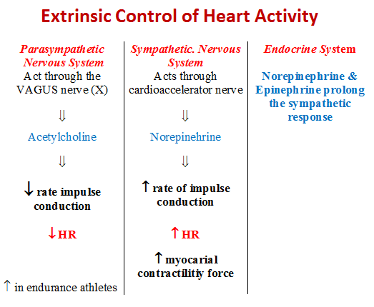
- Sympathetic nervous system: increases depolarization & repolarization rates
- releases norepinephrine; increased firing, shorter relaxation, faster heartbeats
- enhances Ca²⁺ entry into contractile cells
- Atrial (Bainbridge) reflex: a sympathetic reflex initiated by increased venous return and increased atrial filling.
- Chemical regulation: the hormones epinephrine and thyroxine increase heart rate
- Intra- and extracellular ion concentrations must be maintained for normal heart function
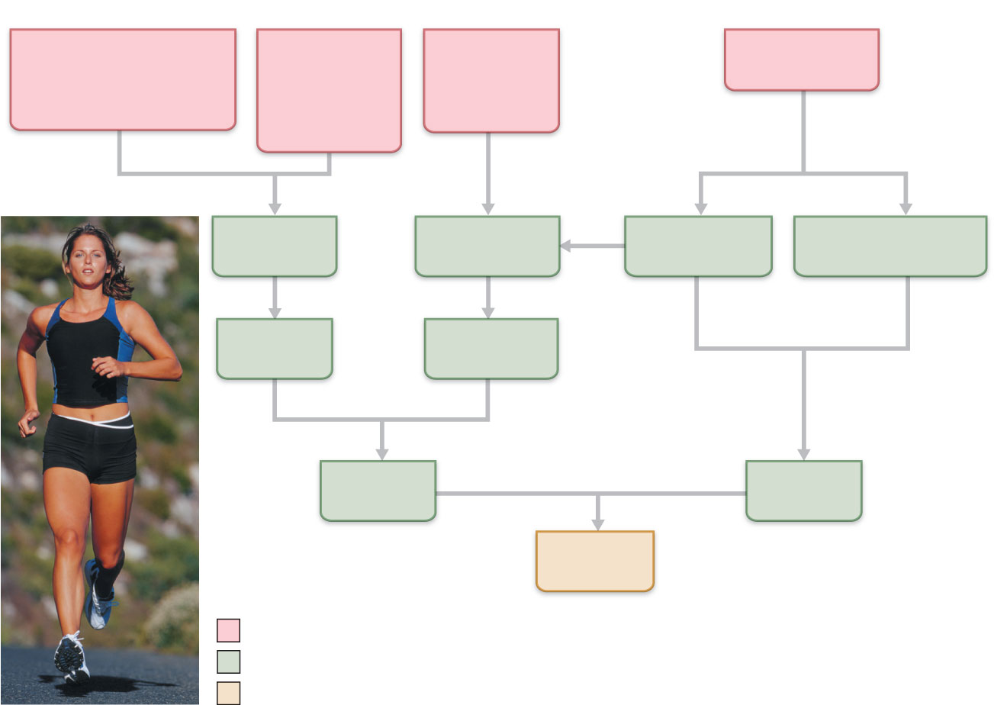

Blood Vessels & Dynamics
- Blood vessels are dynamic structures that pulsate, constrict, relax and even proliferate
Compare and contrast the structure of the walls of arteries, capillaries and veins
- Arteries carry blood away from the heart (branch, diverge, or fork)
- Veins carry blood toward the heart (join, merge, and converge)
- Capillaries are the only ones that directly serve cellular needs
Tissue layers:
- Tunica interna - primarily endothelial cells (simple squamus) –directly in contact with blood
- Basement membrane separates it from tunica media
- Endothelium underlain by looser connective tissue
- Tunica media (TM) – concentric layers of smooth muscle cells; gap junctions
- Elastic fibres are interspersed among smooth muscle cells (provide elasticity)
- Vasoconstriction: reduction in lumen diameter as the smooth muscle contracts
- Vasolidation: increase in lumen diameter as the smooth muscle relaxes
- Bulkiest layer in arteries, which are responsible for maintaining blood pressure and continuous blood circulation
- Tunica externa (TE) – longitudinally oriented collagen and elastic fibres; in arteries, a layer of external elastic lamina separates TE from TM
- Vasa vasorum – nourish the more external tissues of the blood vessel wall
**the walls of arteries and veins are composed of the tunica intima, the tunica media, and the tunica externa. Capillaries are composed of only the endothelium and a basement membrane.**
**tunica media is thick in arteries, thin in veins, tunica externa is thick in veins, thin in arteries**
- Arteries – carry blood away from the heart
- Arterioles – small vessels; carry blood from arteries to capillaries (all three tunics)
- Capillaries – microscopic vessels that connect arterioles and venules (tunica intima)
- Venules – small vessels that drain blood from capilarries to veins
- Veins – carry blood from venules to the heart
Compare the 3 types of arterial vessels
- Elastic arteries– aka conducting arteries, large conductive arteries near the heart; inactive in vasoconstriction, pressure reservoirs- smooth out pressure flunctuations; recoil helps maintain pressure & blood flow.
- Muscular arteries – medium size distributing arteries; deliver blood to specific organs; more smooth muscle vs. elastic tissue. More active in vasoconstriction and less distensible.
- Arterioles—smallest of the arteries, blow flow to capillary bed depend on arteriole diameter (varies in response to changing neural, hormonal and local chemical influences)

Define microcirculation and compare the three types of capillaries
- Pericytes: stabilize the capillary wall
- Capillaries: exchange of materials b/w the blood and the interstitial fluid
- 1. Continuous capillaries: abundant in skin and muscles. Uninterrupted lining; tight junctions are usually incomplete and leave gaps of unjoined membrane: intercellular clefts allow limited passage of fluids, small solutes; found in lungs, smooth muscle, skeletal muscle, connective tissue
- Fenestrated capillaries: similar but endothelial cells riddled with pores (fenestrations) increased permeability to fluids/small solutes than continuous capillaries. Found in villi of small intestine, endocrine organs, kidney (active absorption or filtration)
- 3. Sinusoidal capillaries: highly modified, leaky; large, irregular lumen, usually fenestrated; fewer tight junctions and large intercellular clefts for passage of proteins, RBCs; found in liver, spleen, bone marrow, parathyroid gland and anterior pituitary gland. Blood flows more slowly through the sinusoid cannels, allowing time for it to be modified.
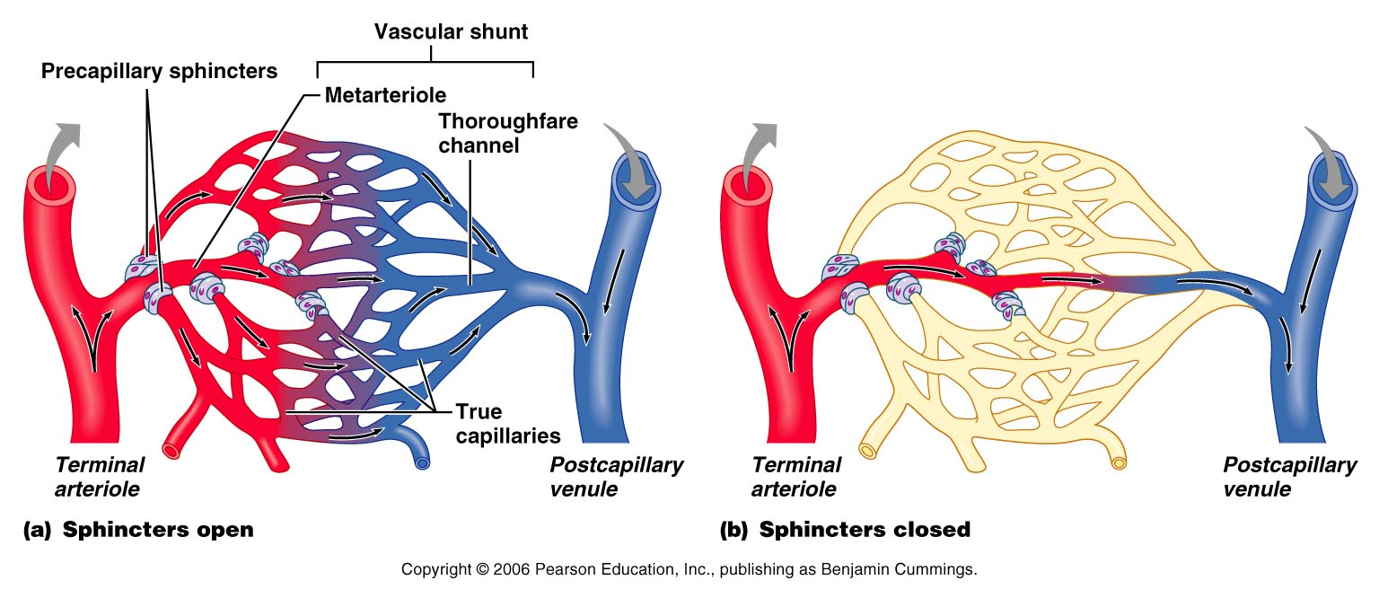
- Microcirculation -flow of blood from an arteriole to a venule through a capillary bed
- Capillary beds consists of two types of vessels :
1) vascular shunt: a short vessel that directly connects the arteriole and venule at opposite ends of the bed
2) true capillaries: the actual exchange vessels
- Metarteriole: a vessel structurally intermediate between an arteriole and a capillary
- Thoroughfare channel: intermediate between a capillary and a venule joins the postcapillary venule that drains the bed.
- Precapillary sphincter: surrounds the root of each true capillary at the metarteriole and acts as a valve to regulate blood flow into the capillary.
- when precapillary sphincters are relaxed (open), blood flows through the true capillaries and takes part in exchanges with tissue cells.
- when the sphincter are contracted (closed), blood flows through the shunt and bypasses the tissue cells.
- sensitive to stretch and chemical stimulators such as O₂, increased CO₂, pH,
adenosine, lactic acid and nitric oxide (NO)
Describe the structure and functions of the venules and veins
- Venules: formed when capillaries unite.
- Postcapillary venules: consists entirely of endothelium around which a few pericytes congregate. Extremely porous and fluid and white blood cells move easily from the bloodstream through their walls.
- Veins: formed by joined venules. Can accommodate a fairly big amount of blood volume: 65% (known as the capacitane vessels and blood reservoirs).
- Venous valves: formed from folds of the tunica intima. Most abundant in veins of the limb. Absent in veins of the ventral body cavity.
- Varicose veins: veins that have become tortuous and dilated b/c of incompetent (leaky) valves.
- Arterial anastomoses: interconnections between blood vessels; allow alternate pathways (collateral channels) for blood flow.
Define blood flow, blood pressure, resistance, peripheral resistance
Explain the factors that affect resistance and justify the importance of arterioles in the control of peripheral resistance
- Blood flow: the volume of blood flowing through a vessel or a group of vessels during a specific period of time.
Flow = Pressure Gradient = Δ P
Resistance R
- Blood Pressure: the force per unit area exerted on a vessel wall by the contained blood. Systemic arterial blood pressure in the largest arteries near the heart.
(BP = CO x TPR); TPR = total peripheral resistance; CO = cardiac output (HR x SV)
- Peripheral Resistance: frictional force that impedes blood flow. Most friction is encountered in the peripheral (systemic) circulation.
R = . Viscosity of Blood x Length of Tube
(Diameter of Lumen)⁴
Points of resistance:
- Blood viscosity: internal resistance to flow that exists in all fluids and is related to the thickness or “stickiness” of a fluid.
- Length of vessels: the longer the vessel, the greater the resistance.
- F = (P₁ - P₂) πR⁴ , where P - pressure, R – radius
8 LN L- length, N - viscosity
Define systolic and diastolic arterial pressure, pulse pressure and mean arterial pressure
- Systolic BP - the highest force with which blood pushes against arterial walls as a result of ventricular contraction
- Diastolic BP - the lowest force of blood in arteries during ventricular relaxation
- Arterial blood pressure reflects two factors:
1) how much the elastic arteries close to the heart can be stretched (compliance and distensibility)
2) the volume of blood forced into them at any time.
- Pulse pressure: difference b/w systolic and diastolic pressures. Indicates vigour of contraction of ventricle and provides info on elasticity of aorta and major arteries.
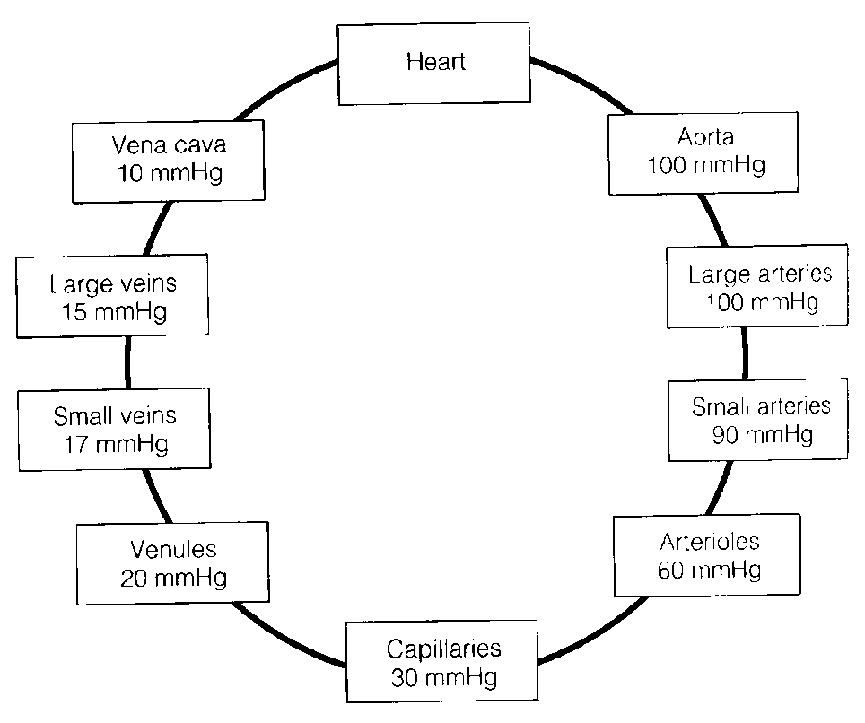
- Mean arterial pressure (MAP): pressure that propels the blood to the tissues.
MAP = DBP (diastolic BP) + pulse pressure/3
Identify and justify the value for mean capillary blood pressure
- Low capillary levels are desirable because
1) capillary are fragile and high pressures would rupture them, and 2) most capillaries are extremely permeable; lots of exchange at low blood pressure.
Express blood pressure in terms of cardiac output and peripheral resistance
- F= ΔP or CO= ΔP or ΔP= CO x R
R R
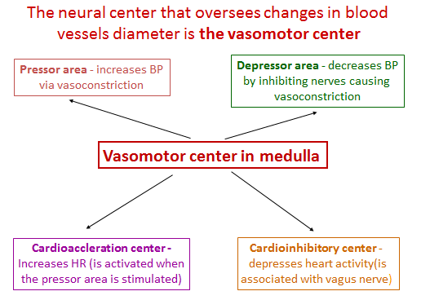
Describe the short-term neural and chemical mechanisms for the regulation of blood pressure
- Short-term control: counteracts moment-to-moment flunctuationg in blood pressure by altering peripheral resistant (and CO)
- Neural controls of peripheral resistance are directed at two main goals; 1) maintaining adequate MAP by altering blood vessel diameter. 2) altering blood distribution to respond to specific demands of various organs.
- most neural controls operate via reflex arcs involving baroreceptors, afferent fibers, vasomotor center of the medulla, vasomotor fibers and vascular smooth muscle.
- Vasomotor center: neural center that oversees changes in the diameter of blood vessels- a cluster of neurons in the medulla.
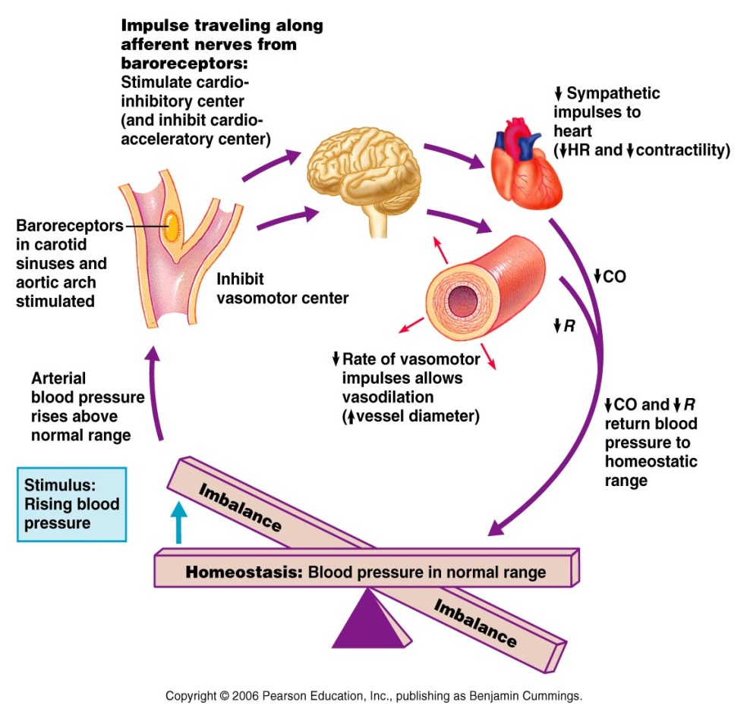
- Cardiovascular centre: integrates blood pressure control by altering cardiac output and blood vessel diameter.
**nonrepinephrine is a potent vasoconstrictor, and acetylcholine causes vasodilation**
- Baroreceptors: pressure-sensitive mechanoreceptors that respond to changes in arterial pressure and stretch.
- When stretched, baroreceptors inhibit vasomotor centers by sending rapid impulses, resulting in the vasodilation of arterioles and veins and a decline in blood pressure.
- the function of rapidly responding baroreceptors is to protect the circulation against short-term (acute) changes in blood pressure.
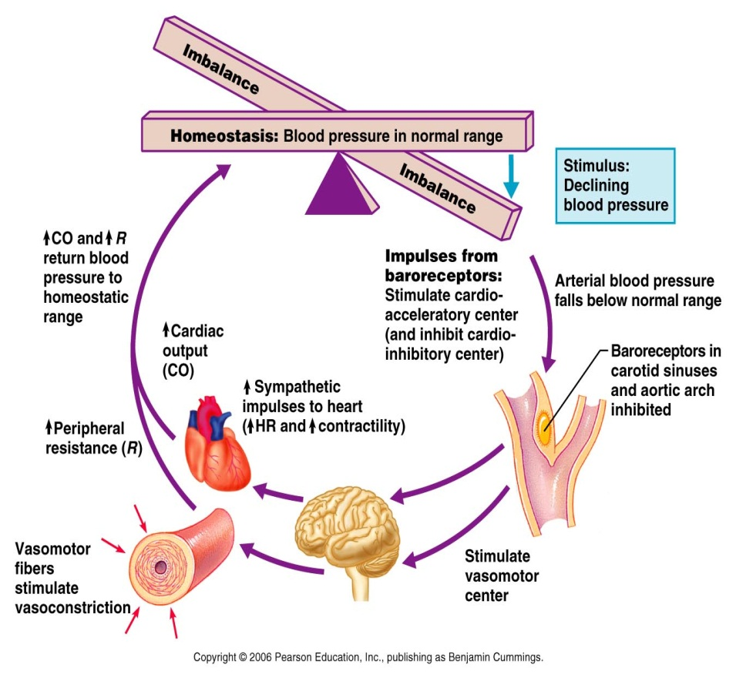
- Chemoreceptors: transmits impulses to the cardio acceleratory center, increasing cardiac output, and to the vasomotor center, which causes reflex vasoconstriction.
- Located close to aortic and carotid barorecepetors in aortic and carotid bodies
- Monitor blood-borne substances (O₂, CO₂, [H⁺])
- Increase respiration in order to increase CO₂ output and O₂ intake
Increase BP by sending afferent signals via glossopharyngeal (IX) and vagus (X) nerves to the cardiovascular acceleratory center in response to ↓[O₂] or ↑[CO₂] or ↑ [H⁺]
- A decline in MAP initiates reflex vasoconstriction and increases cardiac output, causing blood pressure to rise.
- Sympathetic stimuli result in:
- Vasodilation of blood vessels in the heart and skeletal muscles, thus, increased blood flow to these organs
- Vasoconstriction of blood vessels in the skin and abdominal organs
- Vasoconstriction of veins
- Most postganglionic sympathetic neurons release norepinephrine (noradrenaline) which combines with α -adrenergic receptors on smooth muscle in blood vessel walls, causing vasoconstriction
- Blood vessels of the heart and skeletal muscle contain β-adrenergic receptors; sympathetic stimulation of these receptors causes vasodilation
-This control system ensures that the heart and the active skeletal muscles receive adequate blood flow during stress
Sympathetic
- ↑ HR (β₁ receptors)
- ↑ Cardiac contractility (β₁ receptors)
- Vasodilation of coronary arteries (β₂ receptors) and skeletal muscle arteries
- Mild vasodilation of pulmonary vessels (β₂)
- Vasoconstriction in abdomen, kidneys and skin blood vessels muscle (α)
- Vasodilation in muscle and skin (cholinergic)
Parasympathetic
- ↓ HR
- ↓ strength of atrial contraction (vagal innervation of atria but not ventricles)
- modest vasodilation of coronary arteries

- Parasympathetic stimuli
- Cause vasodilation of blood vessels in the digestive tract and reproductive organs, by releasing acetylcholine, which inhibits smooth muscle contraction
- Adrenal medulla hormones: epinephrine increases cardiac output and promotes generalized vasoconstriction (except in skeletal and cardiac muscle where it causes vasodilation)
- Atrial natriuretic peptide (ANP): causes blood volume and blood pressure to decline, anatgonizes aldosterone and prods the kidneys to excrete more sodium and water from the body causing blood volume to drop. Generalizes vasodilation
- Antidiuretic hormone (ADH, vasopressin): stored by the hypothalamus and stimulates the kidneys to conserve water. When blood pressure falls to dangerously low levels, ADH is released to help restore arterial pressure by causing vasoconstriction.
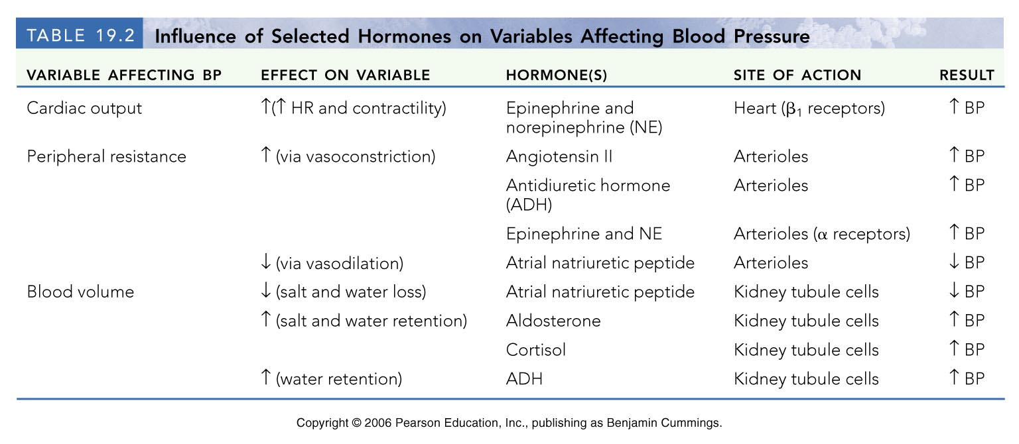
- Angiotensin II: renin acts an enzyme, ultimately generating angiotensin II, which stimulates vasoconstriction, promoting a rapid rise in systemic blood pressure.--> also stimulates the release of aldosterone and ADH.
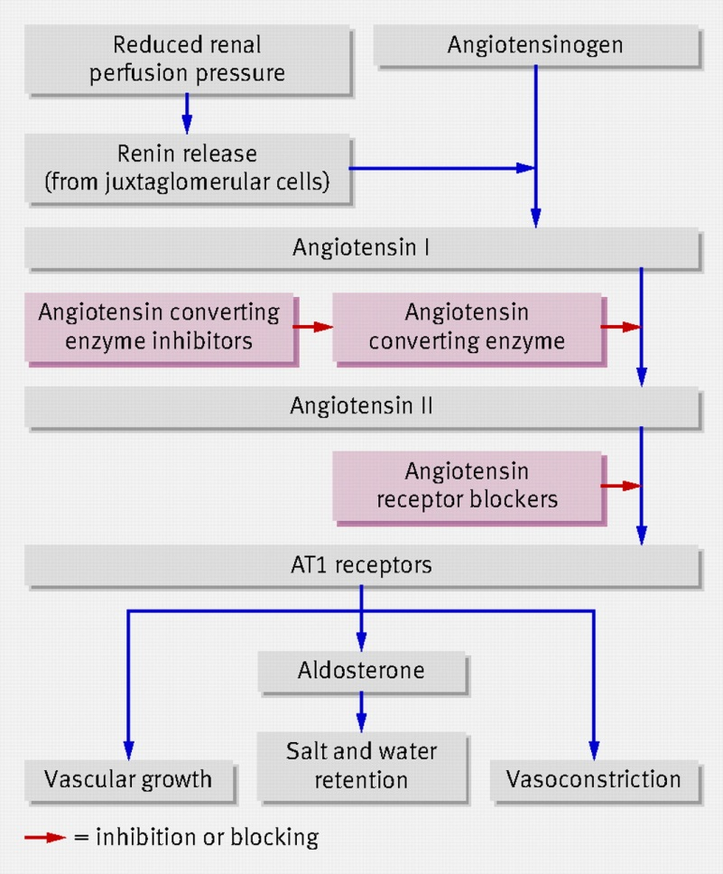
Describe the role of the kidneys in the long-term regulation of blood pressure
- Direct renal mechanism: alters blood volume independently of hormones.
- Indirect renal mechanism: renin angiotensin mechanism. Angiotensin II is a potent vasoconstrictor, increasing blood pressure by increasing peripheral resistance stimulates the adrenal cortex to secrete aldosterone; a hormone that enhances renal absorption of sodium, and prods the posterior pituitary to release ADH promotes water reabsorption
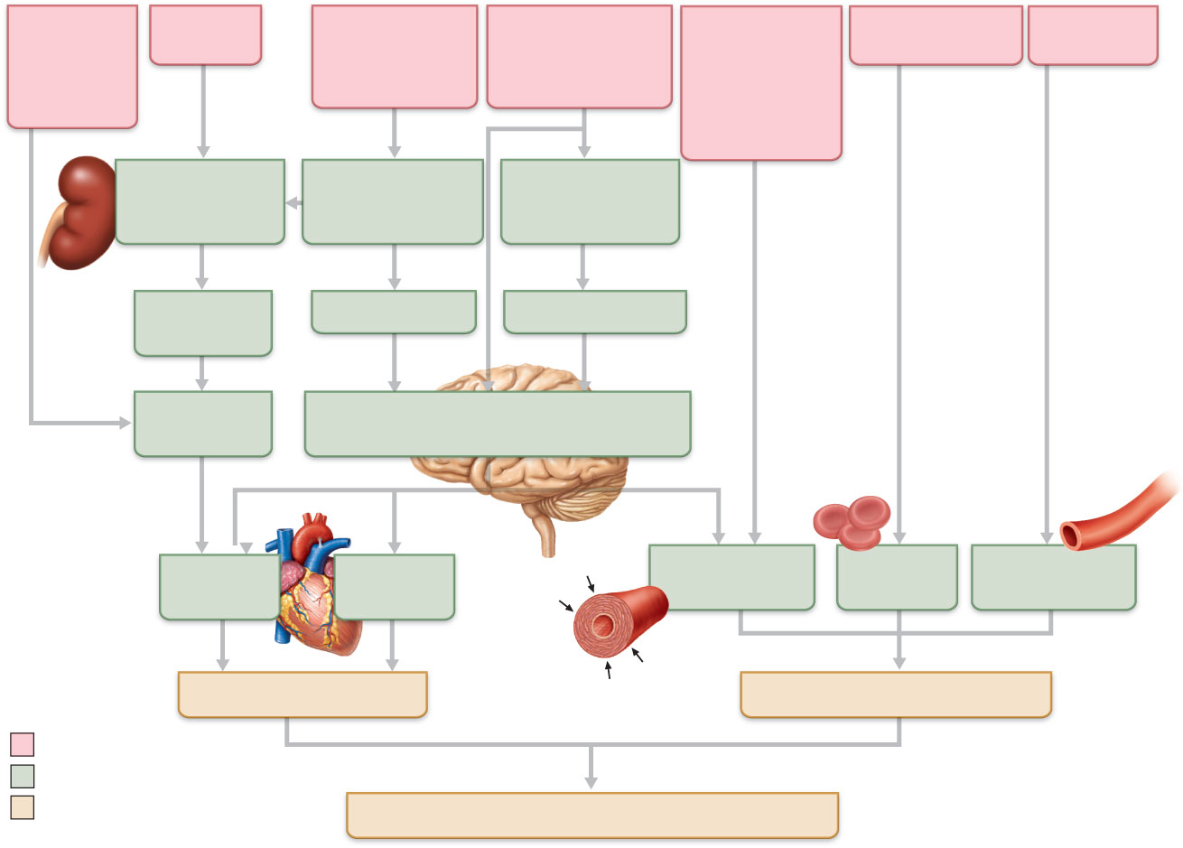
- Arterial Pulse: Produced when the left ventricle forces blood against the wall of the aorta. The impact creates a pressure wave along the branches of the aorta and the rest of the arterial walls
- Auscultatory method: the blood pressure cuff or the sphygmomanometer is wrapped snugly around the arm just superior to the elbow and inflated until the cuff pressure exceeds systolic pressure.
- Systolic pressure: first point at which a small amount of blood is spurting through the constricted artery
- Diastolic pressure: point at which the sound first disappears
Blood pressure during exercise
- Systemic BP is affected mostly by increased CO
- There is a linear in systolic BP with levels of exercise (Max systolic BP should not > 260 mm Hg)
- Diastolic BP either remains unchanged or slightly*
- Pulse pressure usually with the intensity of exercise
- BP reaches a steady-state during sub-maximal steady-state exercise
- With prolonged exercise systolic BP will start decreasing, diastolic will remain constant ( in systolic BP reflects dilation of vessels)
- Resistance exercise BP, it may temporarily reach 480/350 mm Hg
- Tissue perfusion: is involved in 1) delivery in oxygen and nutrients, removal of wastes from tissue cells, 2) gas exchange in lungs, 3) absorption of nutrients from the digestive tract and 4) urine formation in the kidneys.
Define and explain the mechanisms of auto regulation with regard to local blood flow
- Autoregulation: Local adjustment of blood flow to a given tissue metabolism due primarily to chemical (metabolic) and physical factors in that area
Local factors causing vasodilation include:
- Decreases in O₂ or nutrient levels
- Increases in CO₂ levels in that area
- Decrease in pH
- Increases in adenosine, lactic acid, cAMP, cGMP, K⁺, heat, inflammatory chemicals and nitric oxide (NO) powerful vasodilator which acts via a cyclic GMP second-messenger system.
- Reactive hyperemia: dramatically increased blood flow into a tissue that occurs after the blood supply to the area has been temporarily blocked; results from the myogenic response and from an accumulation of metabolic wastes in the area during occlusion.
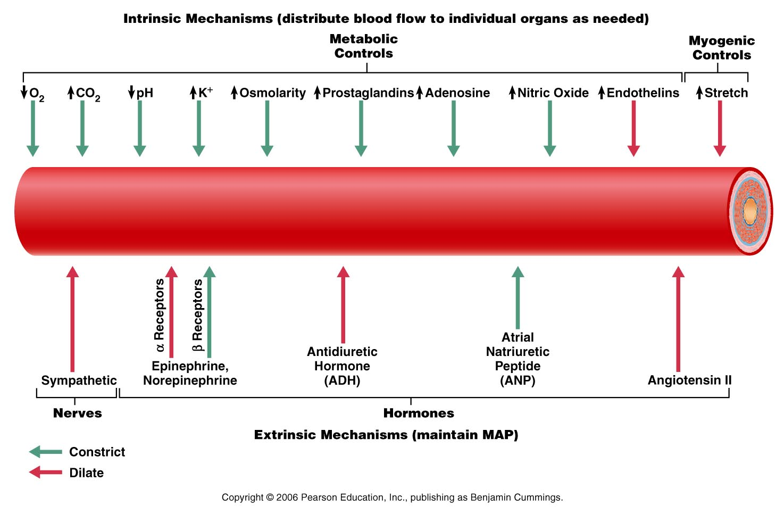
- Angiogenesis: # of blood vessels in the region increases, and existing vessels enlarge; occurs throughout the body in people who live in high altitudes areas, where the air contains less oxygen.
Explain the forces that act to influence capillary exchange
- Diffusion: passive process; movement always occurs along a concentration gradient
1. lipid-soluble molecules diffuse through the lipid bilayer of the endothelial cell plasma membranes.
2. small water-soluble solutes, such as amino acids and sugars pass through fluid-filled intercellular capillary clefts or fenestrations.
3. Some larger molecules such as proteins are actively transported in pinocytosis vesicles or caveolae.
- Bulk flow: filtration and absorption: a movement of a fluid (liquid or gas) from a region of high pressure to one of lower pressure (passive process)
- As blood flows through a capillary, the blood hydrostatic pressure (BHP = HP) tends to push fluid out through the capillary pores
- The blood colloid osmotic pressure (BCOP = OP) tends to pull water from the interstitial fluid into the capillary; force opposing hydrostatic pressure, created by the presence in a fluid of large non-diffusible molecules that are unable to cross the capillary wall.
- There is a very small interstitial fluid osmotic pressure (IFOP) that tends to move fluid out of the capillaries into the interstitial fluid
- NEF = the difference between BHP and BCOP;; Net filtration pressure (NFP) – shows direction of fluid movement
- NFP (net filtration pressure) = [HP_{C} – Hp_{if}] – [OP_{C} – OP_{if}]
- Example: when HP_{C} = 35 mmHg at the arterial end of capillary and 17 mmHg at the venous end; OP_{C}=26mmHg and OP_{if} =1 mmHg; unlike HP, OP does not vary from one end of capillary to the other
Thus, net osmotic pressure that pulls fluid back to capillary is
OP_{C} – Op_{if} = 26 mmHg – 1mmHg = 25 mmHg
NFP = (35 - 0) – (26 – 1) = 10 mmHg
**fluids will leave the capillary if net HP > net OP, and fluids will enter the capillary if net OP > net HP**

Respiratory System
Describe the structures of each one of the components of the conduction and respiratory zones
- The two systems that supply O₂ and eliminate CO₂ are the cardiovascular and respiratory systems
- The respiratory system provides gas exchange, intake of O₂ and eliminates CO₂
- The cardiovascular system transports the gases in blood between the lungs and the cells
- Failure of either system disruption of homeostasis and rapid death from O₂ starvation and build-up of wastes
Four processes of respiration
1. Pulmonary ventilation: movement of air into and out of lungs so that the gases there are continuously changed and refreshed
2. External respiration: movement of oxygen from the lungs to the blood and of carbon dioxide from the blood to the lungs
3. Transport of respiratory gases: transport oxygen from the lungs to the tissue cells of the body, and of carbon dioxide from the tissue cells to the lungs
4. Internal respiration: movement of oxygen from blood to the tissue cells and of carbon dioxide from tissues cells to blood
Functions:
1. Transportation of O₂ (to our body)
2. Transportation of CO₂ (from our body)
- Transportation involves four processes
- Pulmonary ventilation movement of air in and out of lungs (external respiration)
- Pulmonary diffusion exchange of gases between blood & air of alveoli (external respiration)
- Transport of O₂ and CO₂ via blood (internal respiration)
- Capillary gas exchange (internal respiration)
3. The control of blood acidity
4. Oral communication
5. Olfaction (smell)
6.1.2. List 5 functions of the nose; describe the external and internal structures of the nose and nasal cavities; localize and indicate the function of the 4 pairs of nasal sinuses
- Respiratory zone: site of gas exchange; composed of the respiratory bronchioles, alveolar ducts and alveoli
- Conducting zone: passageways; cleanses, humidifies an warms incoming air; nose, nasal cavity, pharynx, larynx, trachea, bronchi, bronchioles, terminal bronchioles
- The nose:
a) provides an airway for respiration
b) moistens and warms entering air
c) filters and cleans inspired air
d) serves as a resonating chamber for speech
e) house the olfactory receptors (smell)
- skin covering dorsal/lateral aspects of nose is thin; contains many sebaceous glands
- Air enters nasal cavity via external nares (nostrils) - divided by midline nasal septum (cartilage and bone) and nasal vestibule; air then goes via internal nares to nasopharynx
- roof of nasal cavity is formed by ethmoid & sphenoid bones of skull
- floor of nasal cavity formed by palate (anterior is hard; posterior is soft)
- vibrissae (the hairs in vestibule) filter coarse particles (dust, pollen)
Nasal cavity is lined by two types of mucosa:
- olfactory mucosa: receptors for sense of smell
- respiratory mucosa: pseudostratified ciliated columnar epithelium with goblet cells and lamina propria with mucous glands secreting mucus & serous glands secreting watery fluid with enzymes
- Sticky mucus entraps dust, bacteria, etc; antibacterial lysozyme and defensins (natural antibiotics) help get rid of microbes
- Respiratory mucosa - cilia move contaminated mucus posteriorly to pharynx
- Nasal mucosa richly supplied with sensory nerves irritants trigger sneeze reflex
- Cold air slows cilia runny nose
- Plexuses of capillaries and veins warm up incoming air
- Conchae (turbinates): Three scroll-like elevations on nasal cavity increase the surface area of the respiratory membrane (help condition the incoming air more efficiently)
- Meatuses: A series of groovlike passageways formed by conchae. Ducts from the paranasal sinuses and the nasolacrimal (tear) ducts drain secretions into meatuses
- Air is filtered, heated, moistened; the dust and other particles are entrapped by mucus and cilia move mucus to the pharynx, where it is swallowed
- The paranasal sinuses are air filled spaces in the maxillary, frontal, ethmoid, and sphenoid bones of the skull
- Small openings allow mucus to drain into nasal cavities
- Sinuses reduce the weight of the skull, warm and moisture the air (together with nasal cavity) and serve as resonant chambers for voice production
- Sinus headache: passageways connecting sinuses to nasal cavity blocked air in sinus absorbed partial vacuum
6.1.3. Describe the structure of: Pharynx, larynx, trachea, bronchial tree
- The pharynx (throat): funnel-shaped muscular passageway that connects the nasal cavity and mouth superiorly to the larynx and esophagus inferiorly.
- nasopharynx: serves only as an air passageway; pseudostratified ciliated epithelium takes over the job of propelling mucus where the nasal mucosa leaves off. Pharyngeal tonsil; traps and destroys pathogens entering the nasopharynx in air.
- oropharynx: stratified squamous epithelium; accommodates increased friction and greater chemical trauma accompanying food passage. Two tonsils; palatine and lingual.
- laryngopharynx: serves as a passageway for food and air and is lined with a stratified squamous epithelium.
- Larynx: voice box
- provides a patent (open) airway and to act as a switching mechanism to route air and foo into the proper channels; protects the vocal cords.
- laryngeal prominence (adam’s apple): marks the fusion point of two cartilage plates that form the thyroid cartilage
- arytenoid cartilage anchors the vocal chords
- Epiglottis: elastic cartilage, almost entirely covered by a taste bud-containing mucosa. Known as the guardian of the airways.
**Superior portion of the larynx is lined by stratified squamous epithelium, below the vocal folds is the pseudostratified ciliated columnar epithelium that acts as a dust filter “clearing our throat”**
- Speech = intermittent release of expired air + opening & closing of glottis
- Length of vocal cords & size of glottis altered by action of laryngeal muscles that move arytenoid cartilages
- Loudness of voice: force of air across vocal cords
- Laryngitis: inflammation of vocal cords ⇒ vibration impaired
- Valsalva’s maneuver: glottis closed & abdominal muscles contract to increase intra-abdominal pressure when defecating, forcibly emptying bladder, lifting heavy load, etc.
- Trachea (windpipe):
- mucosa: contains the same goblet-containing pseudostratified epithelium that occurs in the respiratory tract; rests on a thick lamia that has rich supply of elastic fibers
- submucosa: connective tissue layer deep to the mucosa, contains seromucous glands that help produce the mucus “sheets” within the trachea.
- adventitia: layer of connective tissue reinforce internally by 16 to 20 C-shaped rings of hyaline cartilage. Contraction of the trachealis muscle decreases the trachea’s diameter, causing expired air to rush upward from the lungs with greater force action helps to expel mucus found in the trachea.
- Heimlich maneuver: procedure in which air in the victim’s lung is used to “pop out”, or expels an obstructing piece of food.
- Bronchial tree: site where conducting one structures give way to respiratory zone structure
6.2. List and describe the structure of each one of the components of the respiratory zone of the respiratory system
- There are about 23 orders of branching air passageways in the lungs; conducting network within the lungs is known as the bronchial or respiratory tree.
- As the conducting tubes of the main bronchi becomes smaller…
1. Support changes occur: cartilage rings are replaced by irregular plates of cartilage; elastic fibers are found in the tube walls throughout the bronchial tree
2. Epithelium type changes: muscosal epithelium thinks as it changes from pseudostratified columnar to columnar and then to a cuboidal in the terminal bronchioles; cilia amounts are sparse and mucus produce cells are absent in bronchioles.
3. Amount of smooth muscles increases: increase in smooth muscles in the bronchioles allows them to provide substantial resistance to air passage under certain conditions
6.2.1. Describe the structure of the respiratory bronchioles, alveoli and alveolar sacs
- Respiratory bronchioles: branch from the terminal bronchioles; the lining gradually changes from ciliated cuboidal to squamous epithelium
- Alveolar ducts: walls consist of diffusely arranged rings of smooth muscle cells, connect tissue fibers, and out pocketing alveoli.
- Alveolar sacs: terminal clusters of alveoli
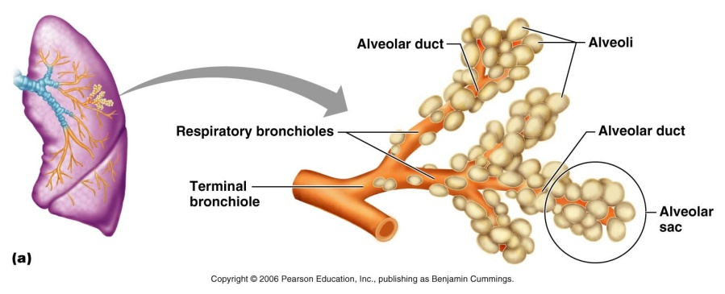
- Alveoli - saccular regions lined with squamous epithelium – allow exchange of gases
** Alveolar capillaries are the only location where gases are exchanged between the lungs and the blood **
6.2.2. Define: respiratory membrane (relate structure to function), type I and type II cells, alveolar pore, and alveolar macrophage
- Alveoli is mainly compose of think squamous epithelial cells; called type I alveolar cells
- Type I cells are attached by special junctions (desmosomes and occluding junctions) that prevent the leakage of tissue fluid into the alveolar space
- Type II cells: cuboidal.
- type II cells have well developed Golgi apparatus and secrete alveolar fluid = surfactant that coats the gas exposed alveolar surfaces
- type II cells can divide and regenerate alveolar lining
- Alveoli features:
1) they are surrounded by fine elastic fibers of the same type that surround the entire bronchial tree
2) open alveolar pores connecting adjacent alveoli allow air pressure throughout the lung to be equalized and provide alternate air routes to any alveoli whose bronchi have collapsed due to disease
3) remarkably efficient alveolar macrophages crawl freely along the internal alveolar surfaces
6.3. Describe the gross structure of the lungs and the pleural covering
- Paired lungs occupy entire thoracic cavity except mediastinum
- Each lung suspended in own pleural cavity; connected to mediastinum by vascular & bronchial attachments (= root)
- Costal surface = anterior, lateral & posterior lung surfaces in close contact with ribs
- apex, base; also hilus blood vessels enter & leave lungs
- Left lung is subdivided by the oblique fissure, whereas the right lung is divided by both oblique and horizontal fissures.
- lobule: smallest subdivision seen with naked eye; hexagon ~ size of pencil eraser; supplied by terminal bronchiole
- Pulmonary arteries bring blood to be oxygenated
- Pulmonary veins return oxygenated blood to the heart
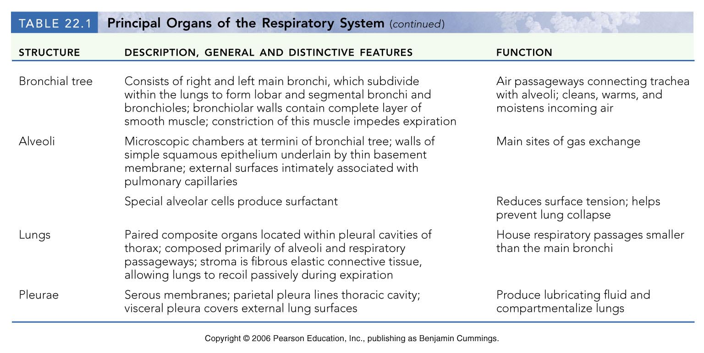
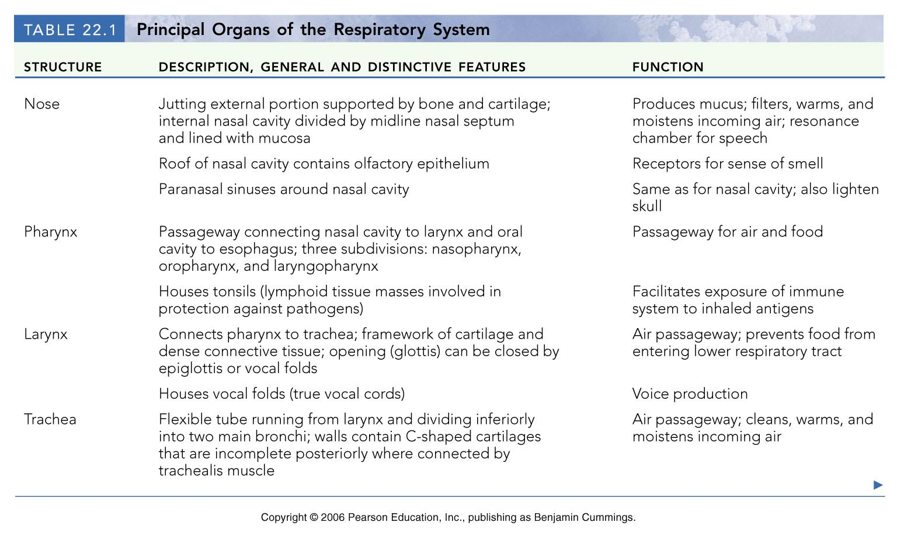
- Bronchial arteries provide oxygenated systemic blood to lungs bronchial veins pulmonary veins
** Innervation primarily parasympathetic (constriction) + some sympathetic (relaxation of the air tubes **
- The pleurae: thin, double-layered serosa
- Pleural cavity: covers the thoracic wall and superior face of the diaphragm, small potential space between parietal and visceral pleura; contains plural fluid (lubricant)
- Pleural fluid: serous secretion that fills pleural cavity lungs slide easily during breathing; surface tension keeps pleurae from separating
- Pleurisy: inflammation of the pleurae, often results from pneumonia; pleurae becomes rough, resulting in friction and stabbing pain with each breath.
6.4 Define the following terms: intrapulmonary, intrapleural and transpleural pressures and explain their variations during pulmonary ventilation
- Respiratory pressures are always described relative to atmospheric pressure (Patm); which is the pressure exerted by the air (gases) surrounding the body.
- Intrapulmonary pressure (P_{pul}) = pressure in the alveoli (increases and decreases with breathing) but it always eventually stabilizes with the atmospheric pressure
- Intrapleural pressure (P_{ip}) = pressure in the pleural cavity, also fluctuates with breathing but is always ~ 4 mmHg lower than P_{pul}
- Transpleural pressure = intrapulmonary - intrapleural pressure
- keeps the lungs from collapsing
- The lung collapsing forces related to the lung’s natural tendency to recoil and the surface tension of the alveolar fluid are opposed by the natural elasticity of the chest wall that pulls the thorax outwards
- The net result is the negative P_{ip}
- Any condition that equalizes P_{ip} with the intrapulmonary (or atmospheric) pressure causes collapse of the lungs (lungs are in separate pleural cavities thus one can collapse & not the other)
- Pulmonary ventilation is a mechanical process that depends on volume changes in the thoracic cavity
- Volume changes lead to pressure changes and pressure changes lead to flow of gases
6.4.2. State Boyle’s Law and associates this relationship with the process of inspiration and expiration
- Boyle’s Law: The volume of a confined gas is inversely proportional to the pressure exerted on the gaps (at constant temperature)
P₁V₁=P₂V₂ P = pressure of gas; V = its volume
- Thus, pressure and volume change in opposite directions (i.e., for a given quantity of gas at a given temperature, the gas volume will increase if the pressure is decreased)
- Inspiration (inhalation): pressure outside > pressure inside
- Inspiration depends on: changes in the positioning and shape of the diaphragm an Action of the intercostal muscle
- quiet inspiration: inspiratory muscle; the diaphragm and external intercostal muscles
- forced inspiration: thoracic volume is further increased by activity of accessory muscles
- Expiration: pressure inside > pressure outside
- Expiration in healthy people is a passive process during rest that depends mainly on muscle elasticity
- forced expiration: active process produced by the contraction of abdominal wall muscles
- The major nonelastic source of resistance to gas flow is friction or drag.
Flow = Pressure Gradient = Δ P
Resistance R
- Gas flow changes inversely with resistance; however, usually insignificant in healthy people
- **The greatest resistance to gas flow is in the medium-sized bronchi!!!!**
- Parasympathetic stimulation, inhaled irritants, histamine: constrict bronchioles
- Sympathetic: dilates bronchioles
- Surface tension: unequal attraction between molecules
- Because water has a very high surface tension, if there was only water coating the film of alveoli, the alveoli would collapse.
- Surfactant (produced by type II alveolar cells) – a detergent-like mixture of phospholipids, proteins and ions important for the reduction of surface tension
6.6.2. Outline the factors that influence passageway resistance and lung compliance
- Lung compliance: lungs distensibility to stretch; measure of the change in volume that occurs with a given change in the Trans pulmonary pressure.
Compliance = Δ VL
Δ (P_{pul} – P_{ip})
- compliance depends on the distensibility of lung tissue and by alveolar surface tension
- compliance is diminished by any factor that:
- reduces natural resilience of lungs (eg: fibrosis)
- increases surface tension of alveolar fluid
- impairs flexibility of thoracic cage (ossification of costal cartilages with aging)
6.7. Describe how lung volumes and capacities are measured
6.7.1. Define each of the 4 respiratory volumes and 4 respiratory capacities
- Tidal volume: volume of air inhale or exhaled in one normal breath
- Inspiratory reserve volume: amount of air that can be inspired forcibly past the tidal volume
- Expiratory reserve volume: amount of air that can be evacuated from the lungs after tidal expiration
- Residual volume: air that remains in the lung after expiration which helps keep the alveoli patent and to prevent lung collapse
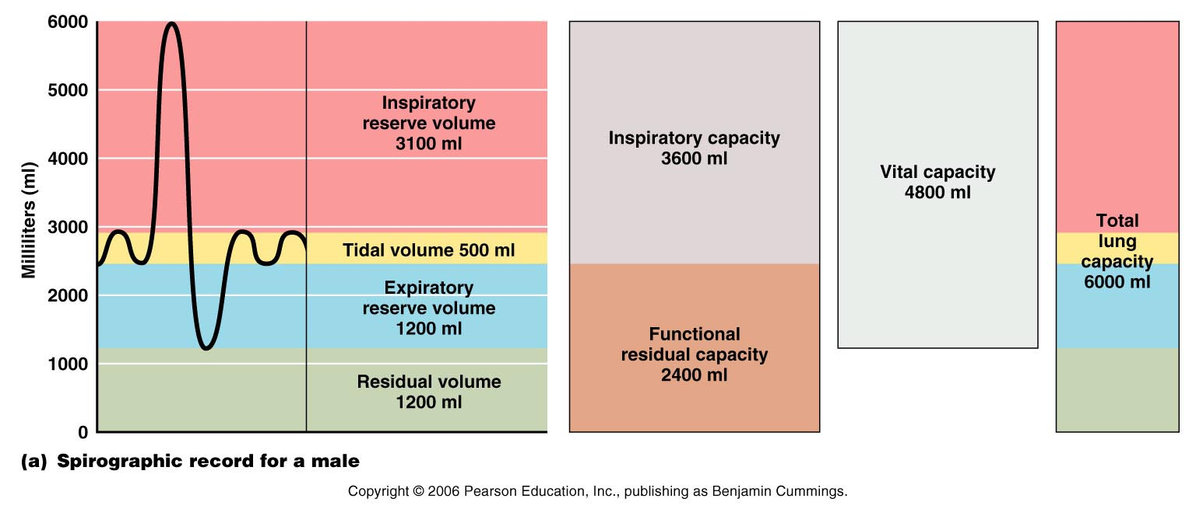
- Inspiratory capacity: total amount of air that can be inspired after a tidal expiration; the sum of tidal volume and inspiratory reserve volume
- Functional residual capacity: combined residual volume and expiration reserve volume; represents the amount of air remaining in the lungs after a tidal expiration.
- Vital capacity: total amount of exchangeable air; sum of TV, IRV and ERV
- Total lung capacity: sum of all lung volumes and is normal around 6000mL
6.8. Define dead space and indicate its importance in minute ventilation and alveolar ventilation
- Dead space: inspired air that fills the conducting respiratory pathways but never contributes to gas exchange in the alveoli.
- Spirometer: device used for quantifying lung volumes and assessing pulmonary function
- Spirometry: the measurement of human lung volumes and functional capacities with a spirometer.
- Minute ventilation: total amount of gas that flows into or out of the respiratory tract in 1 minute.
- The amount of air taken in during a 1 minute period is known as the minute respiratory volume or MRV
- MRV is calculated simply by multiplying the tidal volume (TV) per breath by breaths per minute, or breathing frequency (f)
MRV (ml/min) = TV (ml/breath) x f (breaths/min)
- Alveolar ventilation: amount of air reaching the alveoli per minute
- Takes into account volume of air wasted in dead space areas & measures flow of fresh gases in and out of alveoli/unit time
AVR (ml/min) = frequency (breaths/min) x (TV-dead space)(ml/breath)
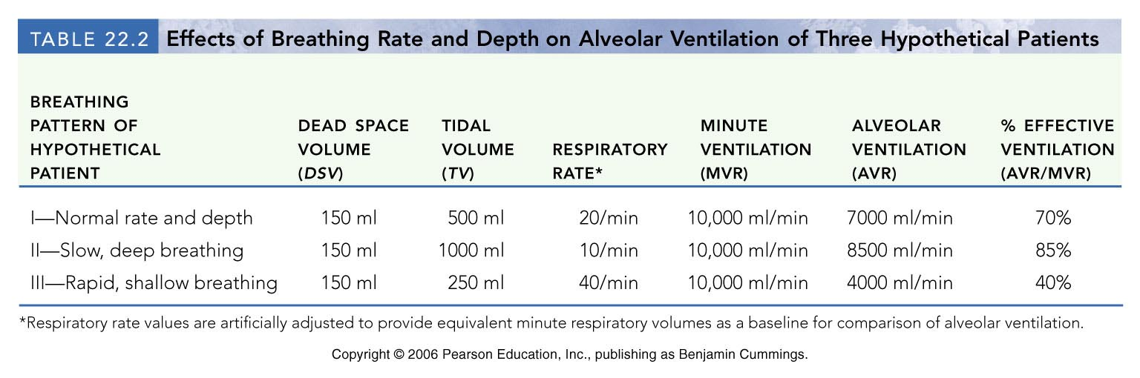

6.10. State Dalton’s Law
- Dalton’s law of partial pressure: states that each gas in a mixture of gases exerts its own pressure, as if other gases were not present
- The total pressure of a mixture of gases = the sum of partial pressures of the individual gases in that mixture (partial pressure of each gas is directly proportional to its % in mixture)
6.11.1. State Henry’s Law and use it to justify the movements of different gases from the atmosphere into the blood
- Henry’s Law: states that when a gas is in contact with a liquid, that gas will dissolve in the liquid in proportion to its partial pressure
- At equilibrium, the gas partial pressure in 2 phases are the same
- The direction and amount of movement of gas is determined by its partial pressure in the 2 phases
- How much gas will dissolve in a liquid at any given partial pressure also depends on gas solubility and on the temperature of the liquid ( temperature = solubility)
6.12. List and describe 3 factors that influence the exchange of oxygen and of carbon dioxide at the level of the lungs (external respiration)
- Partial pressure gradients and gas solubility: there exist a steep oxygen partial pressure because the O2 of venous blood is lower than that found in the alveolar causes the rapid diffusion of O2 from the alveoli into the pulmonary capillary blood
- CO₂ is 20 times more soluble in plasma than oxygen
- CO₂ diffuses in equal amounts with oxygen
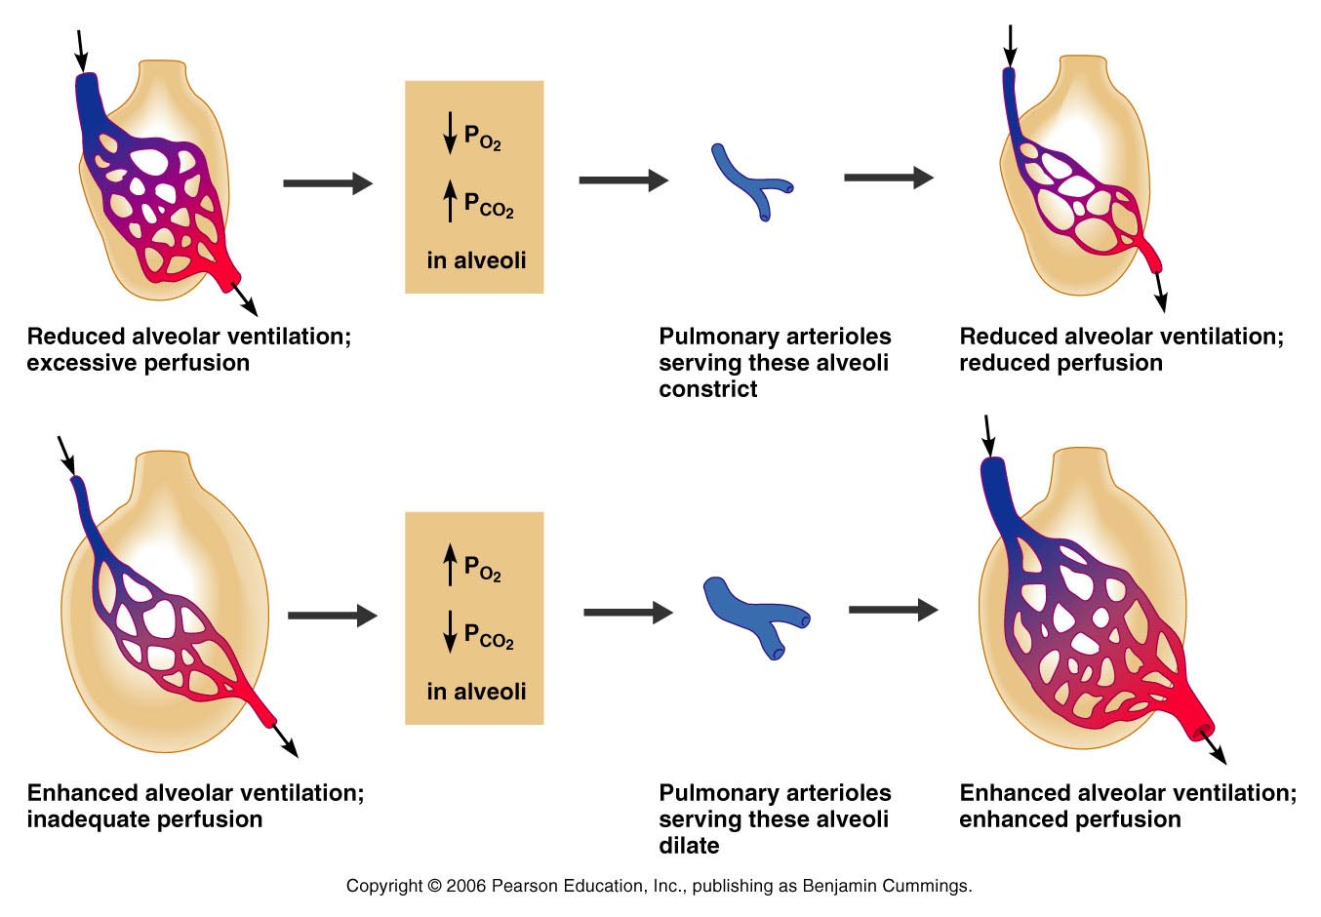
- Ventilation-perfusion coupling: the synchronization of alveolar ventilation and pulmonary perfusion
- In alveoli where ventilation is poor, PO₂ is low terminal arterioles constrict and redirect the blood to the areas where PO₂ is higher; in alveoli where ventilation is max arterioles dilate
- Changes in alveolar PO₂ affect diameter of pulmonary blood vessels; changes in alveolar PCO₂ cause changes in the diameter of bronchioles
- Ventilation and perfusion are never completely coupled in every alveolus because:
- gravity causes regional variations in both blood and air flow in the lungs
- the occasional alveolar duct plugged with mucus creates unventilated areas
- The greater the surface area of the respiratory membrane, the more gas can diffuse across it in a given period of time
- Diffusion of gases via membranes depends on:
- pressure difference across the membrane
- thickness of the membrane
- diffusion coefficient of the gas
- Diffusing capacity is the volume of a gas that diffuses through a membrane each minute per mmHg pressure gradient
- **gas exchange that occur b/w the blood and the alveoli and b/w the blood and the tissue cells take place by simple diffusion; driven by the partial pressure gradients of O2 and CO2
6.14. Describe completely the transport of oxygen in the blood
- Molecular oxygen is carried in blood in two ways; bound to haemoglobin within red blood cells (98.5%) and dissolved in plasma (1.5%)
- Oxyhemoglobin: haemoglobin-oxygen combination (HbO2)
- Reduced- haemoglobin (deoxyhemoglobin): haemoglobin that has released oxygen (HHb)
HHb + O₂ HbO₂ + H
6.14.3. Distinguish between saturated and partially saturated hemoglobin
- Fully saturated: occurs when all four heme groups are bound to O2
- Partially saturated: when 1-3 heme are bound to O2
- Under normal resting conditions arterial blood Hb is 98% saturated and venous blood is ~ 75% saturated
- At rest: 100 ml of systemic arterial blood contains ~ 20 ml of O₂ (20 vol% = volume percent)
6.15. Explain the oxygen-hemoglobin dissociation curve and the physiological factors that influence oxygen-hemoglobin binding
- Factors affecting dissociation of O2 from haemoglobin
- PO2 - dissociation
- PCO2 - dissociation
- pH ( H⁺ ions in blood) - dissociation
- temperature - dissociation
- 2,3-diphosphoglycerate* - dissociation
* All of these factors affect Hb saturation via modification of Hb’s 3-dimentional structure and thereby affinity for O₂*
- Bohr effect: both declining blood pH (acidosis) and increasing P_{CO2} weakens the Hb-O2 bond
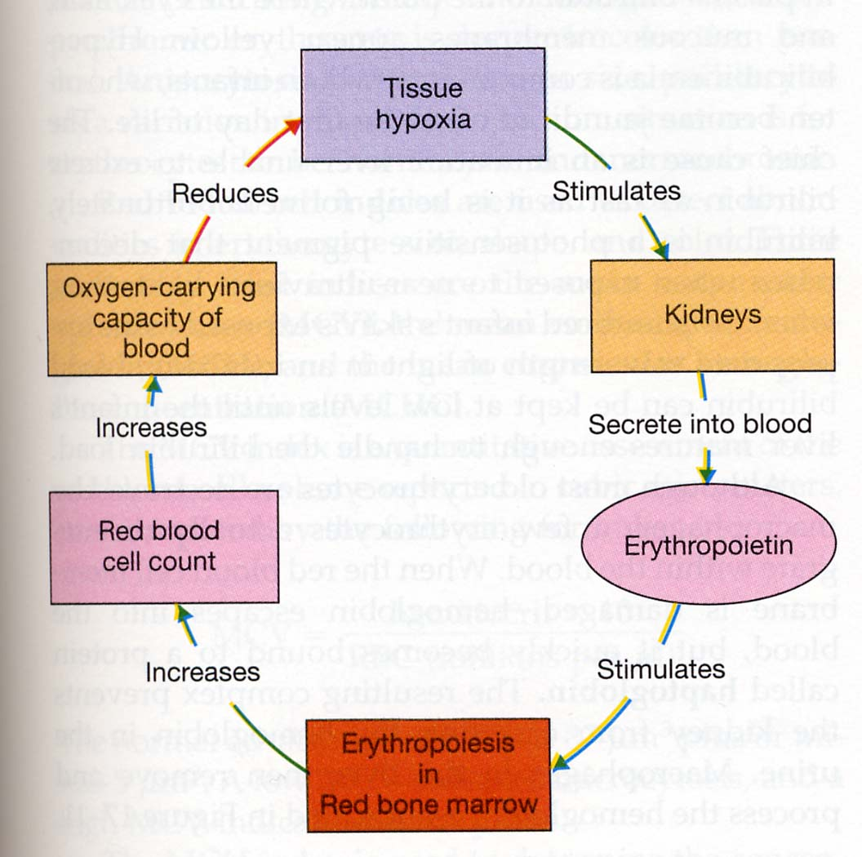
- If not enough oxygen is present in the air (low partial pressure of O₂) the body is adapting by increasing the number of red blood cells (RBC):
- erythropoetin secretion – polycythemia ( RBC)
- hemoglobin content (after several days to weeks)
- in 2,3-BPG production which switches hemoglobin curve to the right (more pronounced in trained individuals)
- Anemic hypoxia: reflects poor O2 delivery resulting from too few RBCs or from RBCs that contain abnormal Hb.
- Ischemic (stagnant) hypoxia: results when blood circulation is impaired or blocked.
- Histotoxic hypoxia: occurs when body cells are unable to use O2 even though adequate amounts are delivered.
- Hypoxemic hypoxia: indicated by reduced arterial P_{O2}
- Carbon monoxide poisoning: unique type of hypoxemic hypoxia carbon monoxide tries to compete with O2 for binding to heme sites.

6.16. Describe completely the 3 ways in which carbon dioxide is transported in the blood
- Dissolved in plasma (7-10%)
- Chemically bound to haemoglobin (20%): in this form, CO2 is carried in the RBCs as carbaminohemoglobin. Note that CO2 only binds to the globin part and does not compete with O2 for the heme binding site.
- As bicarbonate ion in plasms (about 70%): primary way of transport

6.16.2. Explain the chloride shift
- Chloride shift: once HCO3- moves quickly from RBCs into the plasma to be carried to the lungs, chloride ions move from the plasma into the RBCs to counterbalance the rapid outrush of anions produced by HCO3-; process occurs via facilitated diffusion through an RBC membrane protein

6.17.1. Explain completely (use an equilibrium equation) the influence of CO2 levels on blood pH
- The amount of carbon dioxide transported in the blood is markedly affected by the degree of oxygenation of the blood
- Haldane effect: the lower PO₂ and lower Hb saturation with O₂; the more CO₂ can be carried in blood
- displacement of CO₂ from the blood by O₂ leads to unloading of CO₂ at the lungs
- in the pulmonary circulation, the situation is reversed—uptake of O2 facilitates release of CO2. As Hb becomes saturated with O2, the H+ released combines with HCO3- helping to unload CO2 from the pulmonary blood
Main buffers in the body:
- Carbonic acid-bicarbonate buffer system: important in resisting shifts in blood pH.|
- if hydrogen ion concentration in blood rises, excess H+ is removed by combining with HCO3- to form carbonic acid. If H+ concentration is low, HCO3- dissociates, releasing hydrogen ions
- Phosphates (H₂PO₄⁻, HPO₄⁻⁻) inside cells, kidneys
- Proteins (the most plentiful) mostly intracellular but also in blood, e.g., hemoglobin
- Ventilation is a major regulation of blood pH
- affects pH by changing the CO2 content of the blood.
- breathing - CO₂ builds up in blood; decreased pH
- breathing - CO₂ is eliminated from the blood; increase pH
Describe how respiration is controlled by the nervous system
- 1. Ventral respiratory group (VRG): Basic rhythm-generating and integrative center (inspiratory and expiratory neurons)
- 2. Dorsal respiratory group (DRG): Integrates input from the peripheral stretch and chemoreceptors and communicates it to VRG
- Pontine respiratory center: influences and modifies the activity of medullary neurons (VRG); interact with the medullary respiratory centers to smooth the respiratory pattern (smooth out transition between inspiration and expiration and vice versa)
- Inspiratory depth: determined by how actively the respiratory center stimulates the motor neurons serving the respiratory muscles.
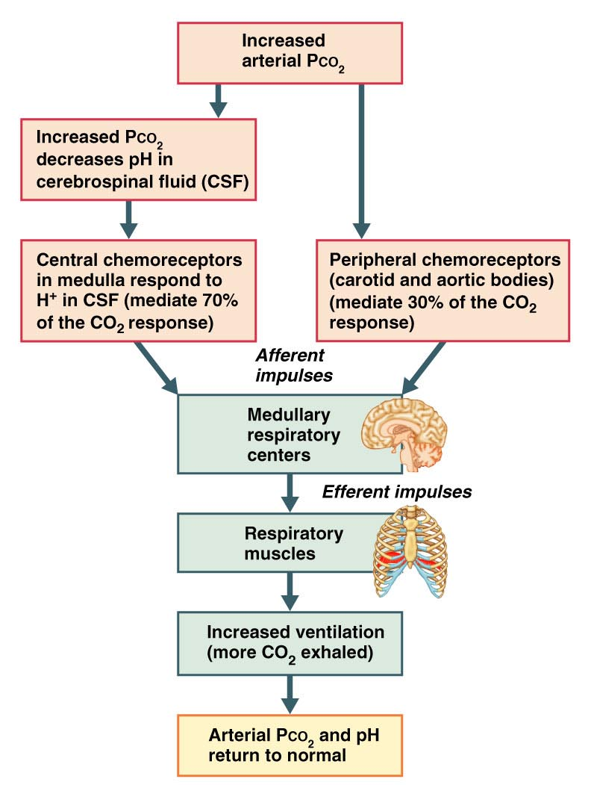
- Respiration rate: determined by how long the inspiratory center is active or how quickly it is switched off
- Chemical factors: changing levels of CO2, O2 and H+ in the arterial blood (with rising lvls of CO2 being the most powerful respiratory stimulant)
- sensors that respond to these chemical changes are called chemoreceptors
- Influence of Pco₂:
- If Pco₂ levels rise (hypercapnia), CO₂ accumulates in the brain
- CO₂ is hydrated; resulting carbonic acid dissociates, releasing H⁺
- H⁺ stimulates the central chemoreceptors of the brain stem
- Chemoreceptors send impulses to the respiratory regulatory centers that increase the depth and rate of breathing
- arterial Pco₂ by 5 mmHg = 2 x alveolar ventilation
- Hypocapnia: low CO2 levels in the blood; causes cerebral blood vessels to constrict, reducing brain perfusion and producing cerebral ischemia.
- When arterial PO₂ falls below 60 mm Hg, it becomes the major stimulus for respiration (via the peripheral chemoreceptors)
- carotid bodies are the main oxygen sensors
- Hyperventilation may lead to:
- Decrease in alveolar PCO₂ = hypocapnia (from 40 to e.g., 15 mmHg)
- Decrease in ventilatory drive (due to CO₂ and pH)
Indicate the effects of the following factors on respiration: Hering Breuer reflex, hypothalamus, cortex
- Hering Breuer Reflex
- Stretch receptors in visceral pleurae & conducting passages stimulated when lungs inflate strongly
- They send inhibitory impulses to medullary respiratory centres to terminate inspiration and allow expiration
- Lungs recoil, stretch receptors become quiet; inspiration initiated again
- Reflex thought to be more protective (overstretching of lungs) than a feature of normal regulation because threshold in humans is very high

Discuss the mechanisms controlling respiration during intense exercise
- When exercise starts and progresses from mild to maximal:
- airway resistance – bronchodilation (sympathetic stimulation)
- end-respiratory volume
- intra-abdominal pressure that lengthens the diaphragm and places it in more advantageous position
- tidal volume by encroaching on both inspiratory and expiratory volumes
- breathing frequency
- maximal volume does not reach the maximum achieved during tidal breathing (decreased inspiratory and expiratory time)
- Hypoxemia occurs during maximal exercise when arterial PO₂ falls to < 75 mmHg, saturation of hemoglobin to < 90%.
- Probable causes - insufficient red blood cells transit time in pulmonary capillaries, decreased ventilation/perfusion ratio, a decrease in lung diffusion capacity etc. (the reason still unclear)
- Black or drown: 50 mm Hg



