Prologue
- What is psychology? The science of behaviour and mental processes
- Aristotle, a naturalist and philosopher, theorized about psychology’s concepts. He suggested that the soul and body are not separate and that knowledge grows from experience.
-Wundt and psychology’s first graduate students studied the “atoms of the mind” by conducting experiments at Leipzig, Germany, in 1879. This work is considered the birth of psychology as we know it today. (Their machine measured the lag time b/w people’s hearing a ball hit a platform and their pressing a telegraph key.)
Structuralism: Introduce by Wundt’s student Edward Bradford Titchener.
- discover the structural elements of mind
- method of introspection (looking inward), method of training others to report how they felt based on experience when looking at certain objects
Functionalism: Philosopher-psychologist William James
- thought everything within the body worked because it was adaptive
- focused on how our mental an behavioral processes function- how they enable us to adapt, survive and nourish (under the influence of evolutionary theorist Charles Darwin)
Sigmund Freud
- emphasized the ways emotional responses to childhood experiences and our conscious thought processes affect our behaviour.
*1920 – psychology defined as: the science of mental life
* 1920’s to 1960’s, psychology was defined as : the scientific study of observable behavior” known as behaviorism. (the view that psychology should be an objective science that studies behavior without reference of mental processes.
Humanistic psychology (Abraham Maslow & Carl Rogers): emphasized the importance of current environmental influences on our growth potential, and the importance of having our needs for love and acceptance.
Cognitive Neuroscience: study of brain activity linked with mental activity
-explores the ways we perceive, process and remember information.
Nature-nurture issues: the controversy over the relative contributions of biology and experience
Plato assumed that character and intelligence are largely inherited and that certain ideas are inborn.
Aristotle countered that there is nothing in the mind that does not first come in from the external world through the senses.
John Locke compared to the mind as a blank sheet of paper on which experiences are written on.
Natural Selection (by Charles Darwin): nature selects the traits that best enable the organism to survive and reproduce in certain environments (adaption).
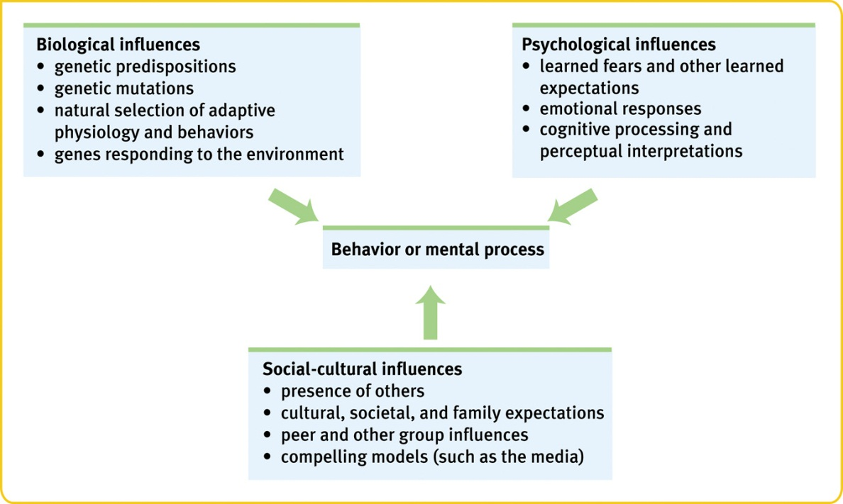

A clinical psychologist (Ph.D.) studies, assesses, and treats troubled people with psychotherapy.
Psychiatrists on the other hand are medical professionals (M.D.) who use treatments like drugs and psychotherapy to treat psychologically diseased patients.
Chapter 1
- Hindsight-bias: After learning the outcome of an event, many people believe they could have predicted that very outcome.
- Hindsight bias and overconfidence often lead us to overestimate our intuition.
- Theory: an explanation that integrates principles and organizes and predicts behaviour or events.
- Hypothesis: testable prediction, implied by a theory.
- Critical thinking: examines assumptions, discerns hidden values, evaluates evidence an assess conclusions. Thinking that does not blindly accept arguments.
- Surveys: the way to collect the most data. Asks peoples to report their behaviour or opinions.
- Factors that affect surveys are: wording of questions (wording effect) and random sampling.
- Naturalistic Observation: Observing and recording the behaviour of animals in the wild and recording self-seating patterns in a multiracial school lunch room constitute naturalistic observation
- no control
- correlation does not mean causation
- Correlation: measure of the extent to which two factors vary together, and thus how well either factor predicts the other.
- Scatterplot: graph of clustered points that represent the values of two variables. The slope of the points suggest the direct relationship b/w the two variables.
- Illusory Correlation
- the perception of a relationship where no relationship actually exists. ie. Parents conceive children after adoption
- Experimentation is the backbone of psychological research.
- manipulate the factors of interest
- controlling other factors
- Double-Blind Procedure
- drug evaluation where patients and experimenter’s are unaware of which patients had the real treatment and which patients had the placebo treatment.
- experimental group: the one that receives the treatment in an experiment
- control group: group that is not exposed to the treatment
- exp. And control group contrast and serves as a comparison for evaluating the effect of the treatment.
- Independent variable
- factor manipulated by the experimenter. The effect of the independent variable is the focus of the study.
- when examining the effects of breast feeding upon intelligence, breast feeding is the independent variable
- influences the dependent variable
- Dependent variable
-factor that may change in response to an independent variable.
- intelligence would be the dependent variable in breastfeeding
- Experimental
- the thing we want to test out
- cause and effect
- Variable is anything that can vary, experiments aim to manipulate the independent variable, measure the dependent variable and control all other variables.
- Measures of Central Tendency
- mode: most frequently occurring score in a distribution
- mean: arithmetic average of scores in a distribution obtained by adding the scores and then dividing by the number of scores that were added together
- median: the middle score in a rank-ordered distribution (the best way to calculate mean of measurement)
- Standard deviation: computed measure of how much scores vary round the mean
- All deviations scores around the mean will equal 0
- Normal Curve
- symmetrical, bell-shaped curve that describes the distribution of many types of data (normal distribution). Most scores fall near the mean.
- Making inferences
- statistical statement of how frequently an obtained result occurred by experimental manipulation or by chance.
- Statistical significance: indicates the likelihood that a result will happen by chance
- Just because I find that something statistical different, it doesn’t mean it is clinical different.
- ** 3 scientific attitudes: curiosity, scepticism, humility

Chapter 2
- Biological psychologists: expand our understanding of sleep and dreams, depression and schizophrenia, hunger and sex, stress and disease
Neural Communication
- Neurons: building blocks aka nerve cells
- Sensory Neurons: carry messages from the body’s tissue and sensory organs inward to the brain and spinal cord for processing.
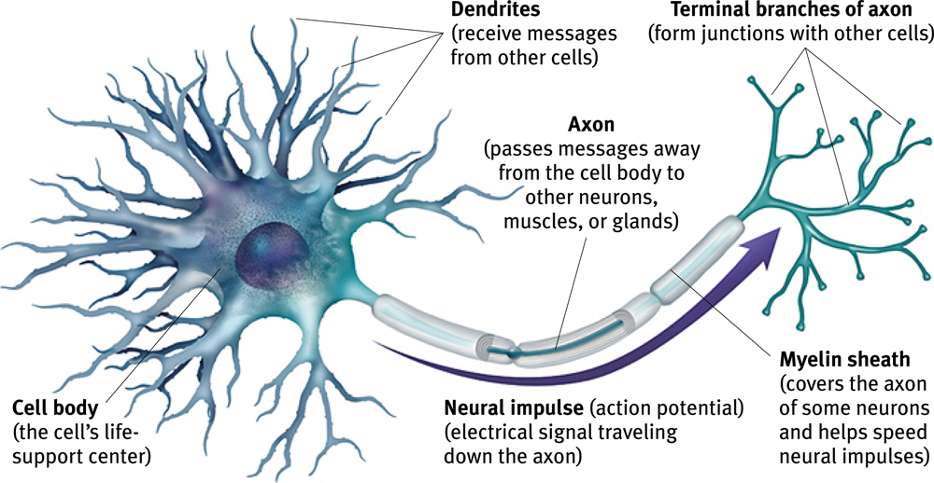
- Motor Neurons: neurons that carry outgoing information from the brain and spinal cord to corresponding muscles and glands
- Interneurons: neurons within the brain and spinal cord that communicate internally b/w the sensory and motor neurons
- Dendrites: receive information and conduct it toward the cell body
- Axon: passes the message along the other neurons or to muscle of glands.
*axons speak, dendrites listen
- Myelin Sheath: insulates the axons of some neurons and helps speed their impulses.
*if myelin sheath degenerates, multiple sclerosis results (loss of communication between muscles and loss of muscle control
- Neurons transmit messages when stimulated by signals from our senses or when triggered by chemical signals from neighbouring neurons.
- Action potential: occurs when neurons fire an impulse, a brief electrical charge that travels down its axon
- Interior fluid the axon membrane has more -ve charged ions
- Fluid exterior the axon membrane has more +ve charged ions
- Axon is selectively permeable
- Depolarization: the rush of charged Na+ ions rushing into the cell, causing the mV to be positive
- Refractory period: neuron pumps the +ve charged sodium ions back outside, so it can fire again
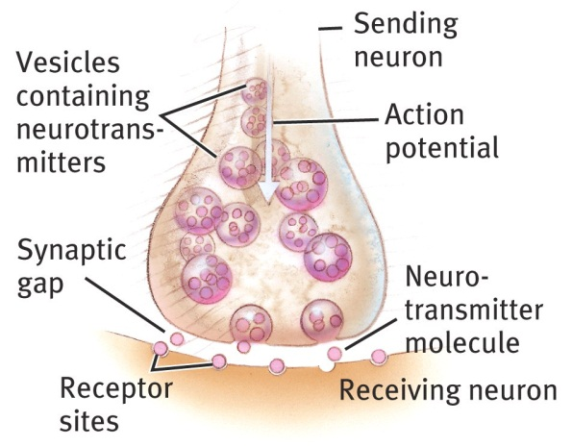
- Threshold: level of stimulation required to trigger a neural impulse.
*increasing lvl of stimulation above threshold will not increase the neural impulse’s intensity
*all-or-none principal: all neurons will fire, or they won’t fire at all.
*strong stimulus may trigger more neurons to fire, however the speed or strength of the action potential will not change. (squeezing the trigger harder on a gun won’t make the bullet go faster)
- Synapse: junction b/w the axon tip of the sending neuron and the dendrite or cell body of the receiving neuron. The tiny gap at the junction is called the synaptic cleft. *meeting point for neurons
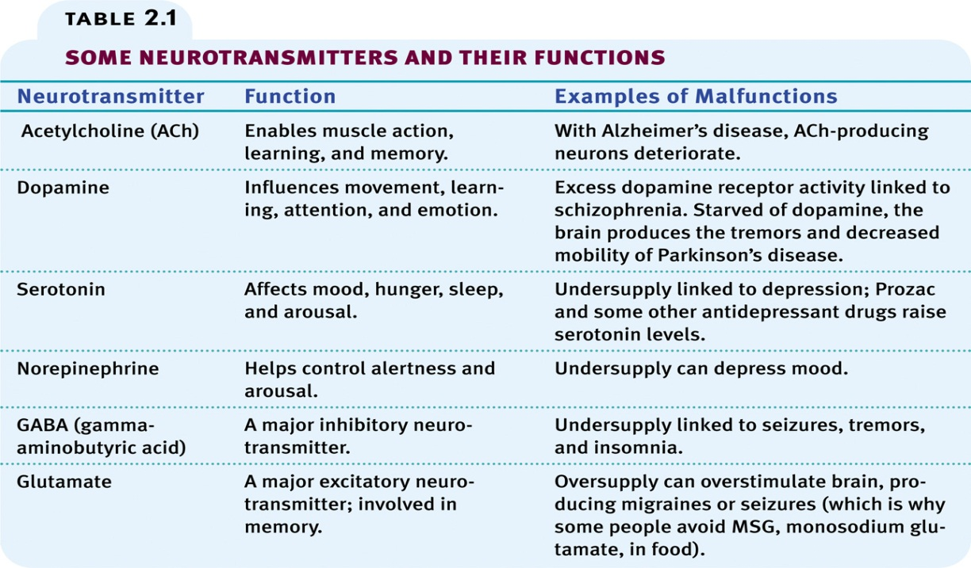
- Neurotransmitters: chemical messenger released when an action potential reaches the knoblike terminals at an axon’s end.
*neurotransmitters cross the synaptic cleft and bind to receptor sites on the receiving neurons (key fits in a lock). Neurotransmitters can be either excitatory or inhibitory.
- Reuptake: neurotransmitter’s reabsorption by the sending neuron.
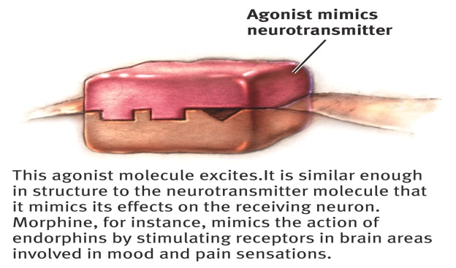
- Agonist molecule: similar to a neurotransmitter and may mimic its effect and block the neurotransmitter’s reuptake.
- Antagonist molecule: blocks a neurotransmitter’s functioning. Act like natural neurotransmitter to occupy its receptors site and block its effect. 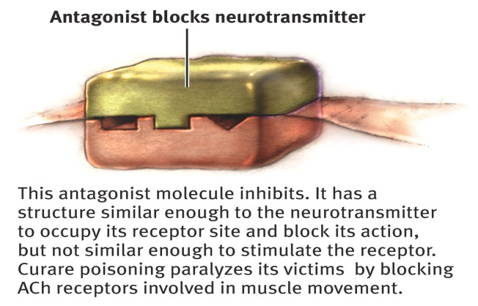
The Nervous System
- Body’s speedy electrochemical communication network consisting of all the never cells of the peripheral (sensory and motor neurons that connect CNS to body) and central nervous system (brain & spinal cord)
- Peripheral:
somatic nervous system
- division of peripheral system that controls the boy’s skeletal muscles
autonomic system
- controls our glands and the muscles of our internal organs.
- sympathetic arouses (fight or flight): increased heartbeat, dilating pupils, increased blood pressure, making you alert and ready for action
parasympathetic relaxes: conserves energy, decrease heart rate etc
Central Nervous System
- Spinal cord: information highway connecting the PNS to the brain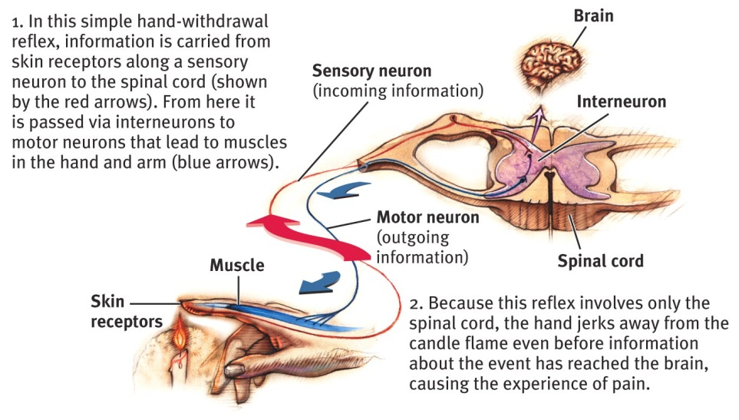
Endocrine System
- Glands that secrete another form of messengers known as hormones – which travel through the bloodstream and affect other tissues, including the brain.
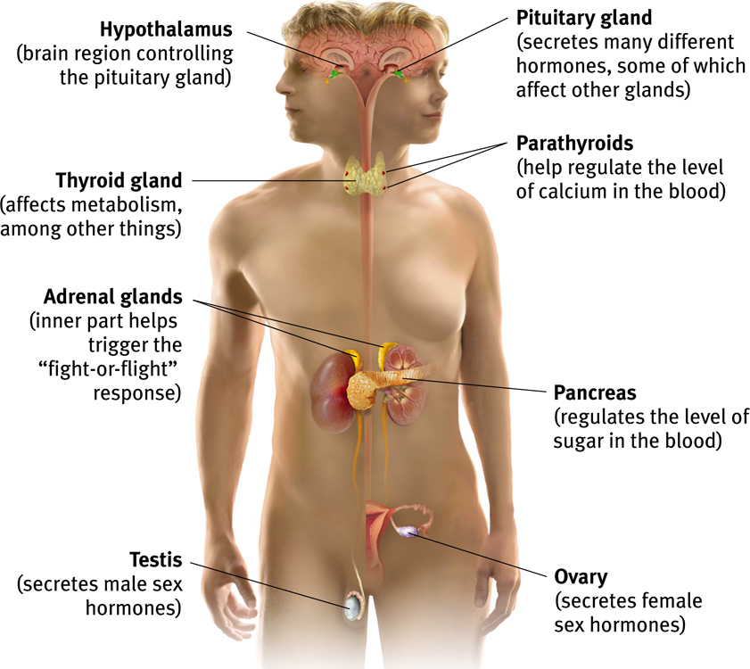
- In the endocrine system, chemical messages are sent slower than messages sent in the CNS and PNS.
- Pituitary gland: pea-sized structure, located in the brain where it is controlled by the adjacent brain area known as the hypothalamus. Gland releases hormones that influence growth, and its secretions also influence the release of other hormones from other endocrine glands. Known as the master gland, whose master is the hypothalamus
- Brainpituitaryother glandshormonesbrain (intimate connection of the nervous and endocrine system
The Brain
- Electroencephalogram (EEG): amplified recording of the waves of electrical activity that sweep across the brain’s surface. Waves are measured by electrodes placed on the scalp.
- Neuroimaging Techniques
- PET (position emission tomography): depicts brain activity by showing each brain area’s consumption of its chemical fuel, glucose (sugar).
- MRI (magnetic resonance imaging): head is put in a strong magnetic field, which aligns the spinning atoms of the brain molecules. Brain is then exposed to a radio wave pulse that momentarily disorients the atoms, when repositioning of the atoms occur, they release signals that provide a detailed picture of the brain’s soft tissues. Shows brain anatomy
- fMRI (functional MRI): technique for revealing blood flow, and therefore brain activity by comparing MRI scans. Shows brain function.
- The brainstem: begins where spinal cord swells slightly after entering the skull (known as the medulla which is the base of the brainstem and is responsible for controlling heartbeat and breathing). The oldest and central part of the brain responsible for autonomic survival functions.
* pons are found just above the medulla and helps coordinate movements
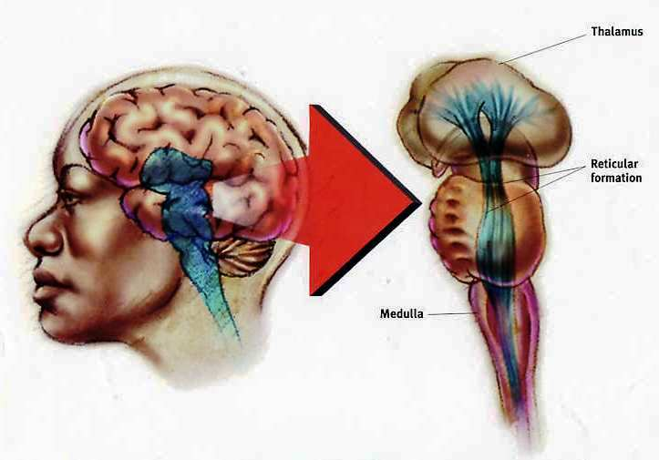
- Reticular formation: finger-shaped network of neurons that extends from the spinal cord right up to the thalamus. Controls arousal.
- The thalamus: joined pair of egg-shaped structures acts as the brain’s sensory switchboard. Receives information from all the senses (except smell) and routes it to a higher brain region that deals with hearing, seeing, tasting and touching. Directs messages to the sensory receiving areas in the cortex and transmits replies to the cerebellum and medulla.
- The cerebellum: the “little-brain” at the rear of the brainstem. Functions include processing sensory input and coordinating movement output and balance. Helps us judge time, modulate our emotions and discriminate sounds and textures.
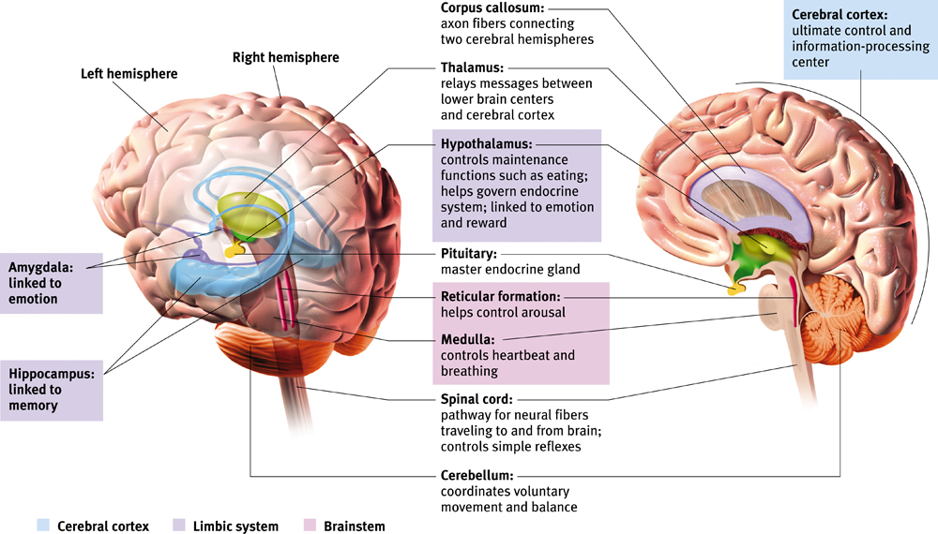
- The limbic system: two halves of the brain. Neural system consisting of the hippocampus, amygdala and hypothalamus, located below cerebral hemispheres. Associated with emotions and drives.
- The amygdala: two lima bean-sized neural clusters in the limbic system linked to emotion. Influences aggression and fear.
- The hypothalamus: important link in the chain of command governing bodily maintenance. Influences hunger, regular thirst, body temperature and sexual behaviour.
- Cerebral cortex: thin surface layer of interconnected neural cells. Acts as the brain’s “thinking crown”.
Structure of the cortex
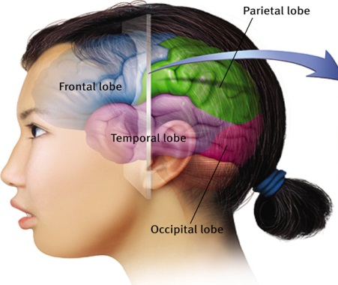
- Glial cells: “glue cells” cells that support, nourish and protect neurons. May also play a role in learning and thinking
- Each brain hemisphere is divided into four lobes that are separated by prominent fissures. These lobes are the frontal lobe (forehead), parietal lobe (top to rear head), occipital lobe (back head) and temporal lobe (side of head).
- Motor cortex: area at the rear of the frontal lobes that control voluntary movements.
- Sensory cortex: area at the front of the parietal lobes that registers and processes body touch, and movement sensations.
- Associated areas: not involved in primary motor or sensory functions; but involved in higher mental functions such as learning, remembering, thinking and speaking.
- Plasticity: brain’s ability to modify itself after some type of damage, and to change, especially during childhood.
- Corpus callosum: wide band of axon fibers connecting the two hemispheres and carrying messages b/w them.
- Split brain: condition resulting from surgery that isolates the brain’s two hemispheres by cutting the fibers that connect them.

Chapter 6
- Sensation: process by which our sensory receptors and nervous system receive and represent stimulus energies from our environment.
- Perception: process of organizing and interpreting sensory information, enabling us to recognize meaningful objects and events.
- Bottom up processing: analysis that begins with the sensory receptors and works up to the brain’s integration of sensory information.
- Top down processing: construction of perceptions drawing on our experience and expectation.
- Threshold: dasd
- Psychophysics: study of relationships b/w the physical characteristics of stimuli
- Absolute threshold: minimum stimulation necessary to detect a particular light, sound, pressure, taste or odour 50% of the time.
- Signal detection: theory of when we are able to predict weak signals. Detection of these weak signals depends on an individual’s experience, motivation, expectation and level of fatigue.
- Subliminal stimulation: below one’s absolute threshold for conscious awareness.
- Priming: activation of certain associations that predispose one’s perception, memory or response.
- **sometimes we feel what we do not know and cannot describe. Much of our information processing occurs automatically, out of sight, off the radar screen of our conscious mind.
- Difference threshold (the just noticeable difference): minimum difference a person can detect b/w any two stimuli half the time.
- Weber’s Law: for their difference to be perceptible, two stimuli must differ by a constant proportion- not a constant amount.
Stimulus | Constant (k)
Light | 8%
Weight | 2%
Tone | .3%
- Sensory adaption: our diminishing sensitivity to an unchanging stimulus. After constant exposure to a stimulus, our nerve cells fire less frequently.
-Freedom to focus on informative changes in our environment without being distracted by the constant chatter of uninformative background stimulation.

Vision
- Transduction: ability tic invert one sort of energy to another. Ex. Our eyes are able to receive energy light and transform it into neural message that our brain then processes into what we consciously see.
- Wavelength: the distance from one wave peak to the next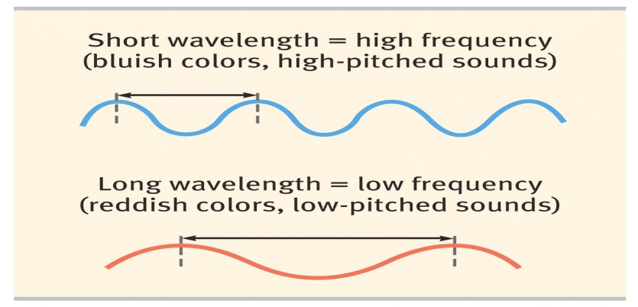
- Hue: is the dimension of color determined by the wavelength of the light.
- Intensity: amount of energy in light waves, determined by wave’s amplitude (height))

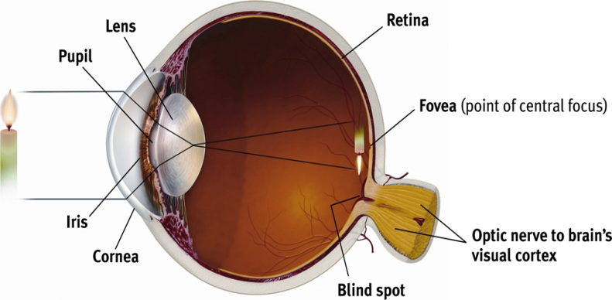
The eye
- Light enters the eye through the cornea, which protects the eye and bends light to provide focus. The light then passes through the pupil, a small adjustable opening surrounded by the iris, a coloured muscle that adjusts light intake. The iris dilates or constricts in response to light intensity an even to inner emotions. Behind the pupil is a lens that focuses incoming light rays into an image on the retina, a multilayered tissue on the eyeballs’ sensitive inner surface that contains receptor rods and cones in addition to layers of other neurons (bipolar, ganglion cells) that process visual information. The lens focuses rays by changing its curvature in a process known as accommodation – process by which eye lens changes shape to focus near or far objects on the retina. 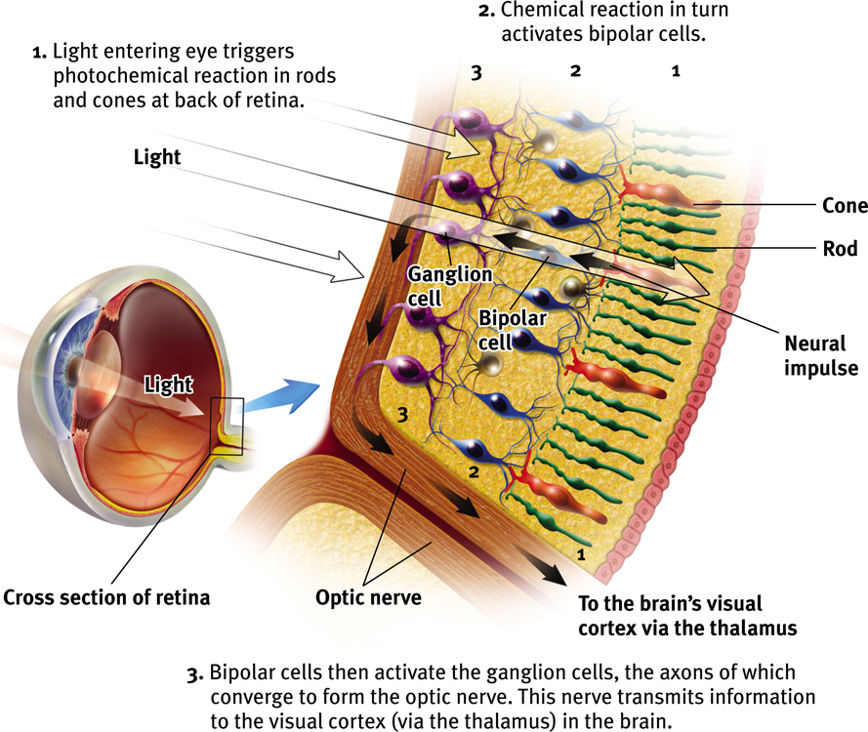
- Rod: retinal receptors that detect black, white and gray. Necessary for peripheral and twilight vision when cones don’t respond. Provide special sensitivity to faint light.
- Cones: retinal receptor cells that are concentrated near the centre of the retina and that function in daylight. They detect fine details and give rise to color sensations.
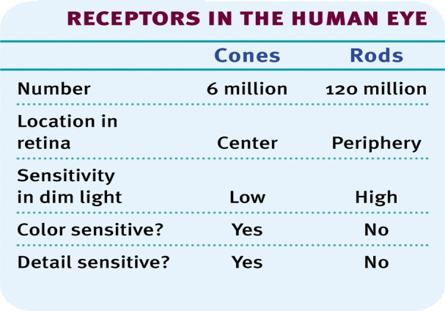
- Optic nerve: nerve that carries information to your brain from your eye. It connects to the thalamus in the middle of the brain, and the thalamus connects to the visual cortex.
- Blind spot: where the optic nerve leaves the cell, causing it to have no receptor cells located in that area.
- Fovea: retina’s area of central focus, area where eye cones cluster.
***Bipolar cells receive messages from photoreceptors and transmit them to ganglion cells, which converge to form the optic nerve.
- Feature detection: nerve cells in the brain that respond to specific features of the stimulus, such as shape, size, angle or movement. 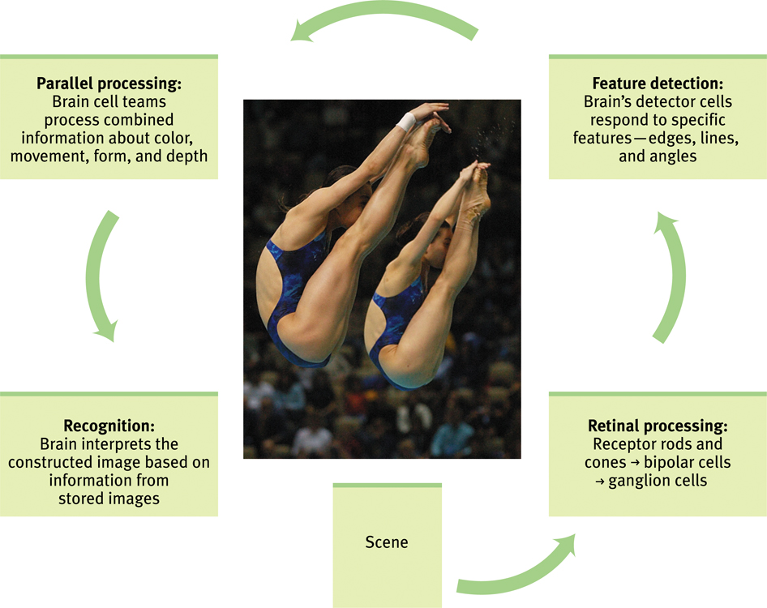
- Parallel processing: doing many things at once. The brain divides a visual scene into subdivisions such as color, depth, form, movement, etc.
- Youth Helmholtz trichromatic (three colour) theory: implies that cones do their colour magic in teams on three. The retina contains 3 different colour receptors; red, blue and green- which when stimulated in combination, can produce the perception of any colour.
- After imaging: after staring at a certain primary colour such as green for a long period of time then looking at a blank white sheet of paper, the colour seen on the white paper will be the opponent colour of red. Process known as Ewald Hering’s opponent-process theory.
Red-green, yellow-blue, white- black.
- Colour processing occurs in two stages:
1. The retina’s red, green and blue cones respond in varying degrees to different colour stimuli.
2. Their signals are the processed by the nervous system’s opponent process cells, heading towards the visual cortex.

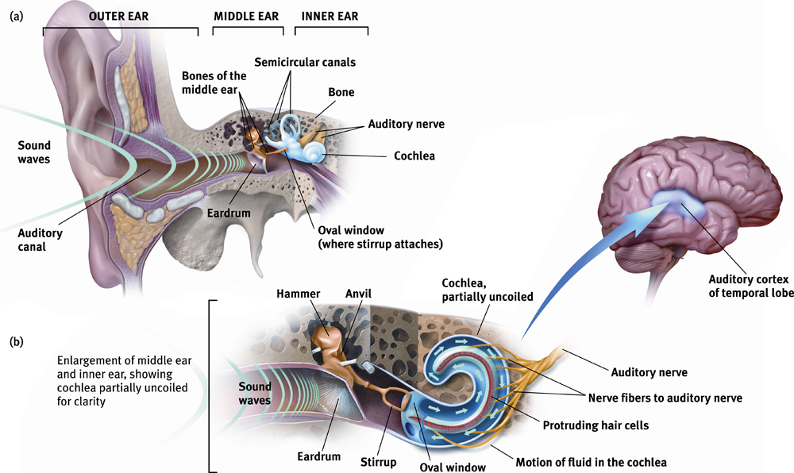
Hearing
- Audition: the sense of act of hearing.
- How does the ear transform sound energy into neural messages?
- Enters the auditory canal, goes to eardrum and vibrates, then to the bone and vibrates
- Frequency: number of complete wavelengths that pass a joint point in a given time
- Pitch: tone’s experiences highness or lowness; depends on frequency.
- The visible outer ear channels the sound waves through the auditory canal to the eardrum, a tight membrane that vibrates with the waves. The middle ear then transmits the eardrum’s vibration through a piston made of three tiny bones (the hammer, anvil, and stirrup) to the cochlea (that transforms sound vibrations to auditory signals); a snail-shaped tube in the inner ear (contains the cochlea, semicircular canals and vestibular sacs). The incoming vibrations cause the cochlea’s membrane (oval window) to vibrate, jostling the fluid that fills the tube. This motion causes ripples in the basilar membrane, bending the hair cells lining its surface. Hair cell movement triggers impulses in the adjacent nerve cells, whose axons converge to form the auditory nerve, which sends neural messages (via thalamus) to the temporal lobe’s auditory cortex.
- * brain can interpret loudness from the number of activated hair cells
- Place theory: theory that we hear different pitches because different sound waves trigger activity at different places along the cochlea’s basilar membrane. This theory however, was not able to explain how we are able to hear low-pitched sounds.
- Frequency theory: theory that the brain reads pitch by monitoring the frequency of neural impulses traveling up the auditory nerve matches the frequency of a tone, enabling us to sense its pitch.
- Volley principle: neural cells can alternate firing. Neurons cannot fire faster than 1000 times per second, so to hear a frequency above 1000 waves per second, neurons fire by rapid succession so they can achieve a combined frequency.
- Conduction hearing loss: hearing loss caused by damage to the mechanical system that conducts sound waves to the cochlea.
- Sensorineural hearing loss (nerve deafness): caused when there is damage to the cochlea’s hair cell receptors or their associated nerves.
- Cochlear implant: bionic ear. Device for converting sounds into electrical signals and stimulating the auditory nerve through electrodes threaded into the cochlea.

Touch
- Kinesthesis: your sense of the position and movement of your body parts.
- Vestibular sense: monitor’s your head’s position and movement. Sense of balance. A semicircular sac, which connects the canal to the cochlea, contains a fluid that moves when your head rotates or tilts, found in the vestibular sacs.
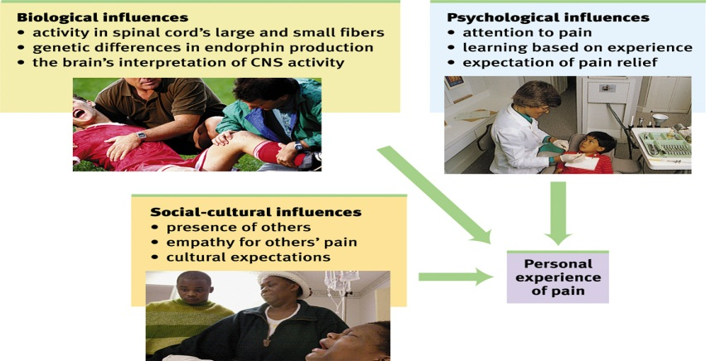
- Pain: body’s way of telling you something has gone wrong. Only pressure has identifiable receptors. All other skin sensations are variations of pressure, warmth, cold and pain.
- There are different nociceptors- sensory receptors that detect hurtful temperatures, pressure or chemicals.
- Gate control theory: theory that the spinal cord contains a neurological “gate” that blocks pain signals or allows them to pass on to the brain.
- Small fibers activate and open the gate, while large fibers activity close the gate, blocking pain signals and preventing them from reaching the brain.
- Pain can be controlled by a number of therapies including, drugs, surgery, acupuncture, exercise, hypnosis, and even thought distraction.
- Taste
- Tastes exist for more than just our pleasure: pleasurable taste attracted our ancestors to energy, or protein-riched foods that enabled for survival. Aversive tastes deterred them from new foods that might be toxic.
- Taste is a chemical sense. Inside each little bump in our tongue lies 200 or more taste buds, each containing a pore that catches food chemicals.
- Taste receptors reproduce themselves every week or two. As you grow older, the # of taste buds decreases and so does their taste sensitivity.
- Sensory interaction: principle that one sense may influence another. Smell + texture + taste = flavour.
Taste | Indicates
Sweet | Energy source
Salty | Sodium essential to physiological processes
Sour | Potential toxic acid
Bitter | Potential poisons
Umami | Proteins to grow and repair tissue

Smell
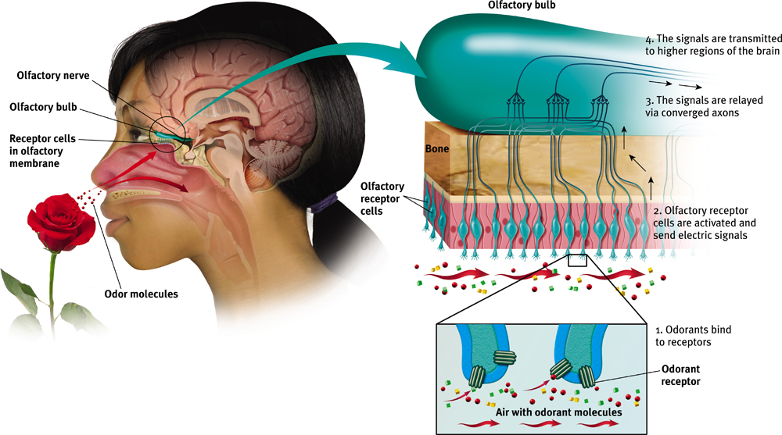
- We smell something when molecules of a substance carried in the air reaches a tiny cluster of 5 million or more receptor cells at the top of our nasal cavity.

Perception
- Gestalt: an organized whole. Our tendency to integrate pieces of information into meaningful wholes.
- **Our mind does more than register information about the world**

Form perception
- Figure-ground: organization of the visual field into objects that stand out from their surroundings
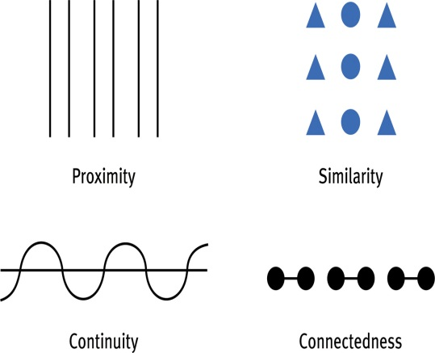
- Grouping: the perceptual tendency to organize stimuli into coherent groups
- After distinguishing the figure from the ground, our perception needs to organize the figure into a meaningful form using grouping rules.
- proximity: we group nearby figures together
- similarity: we group similar figures together
- continuity: we perceive smooth, continuous patterns rather than discontinuous one
- connectedness: we perceive each set of two dots and the line between them as a single unit
- closure: we fill in gaps to create a complete, whole object

Depth perception
- Ability to see objects in 3-dimensions although the image that strikes the retina is 2-dimensional; allows us to judge distant.
- Visual cliff: laboratory device that is used on infants and animals to test depth perception
- Binocular cues: depth cues, such as retinal disparity, those depend on the use of two eyes.
- Retinal disparity: by comparing images from the retinas in the two eyes, the brain computes distance- the greater the disparity b/w the two images, the closer the object
- Monocular cues: depth cues, such as interposition and linear perspective, available to either eye alone
- relative height: we perceive objects higher in our field of vision as farther away
- relative size: if we assume two objects are similar in size, most people perceive the one that casts the smaller retinal image as farther away
- interposition: if one object partially blocks our view of another, we perceive it as closer.
- linear perspective: parallel lines appear to converge with distance, the more they converge, the greater their perceived distance
- light and shadow: nearby objects reflect more light to our eyes. Shading produces a sense of depth consistent with our assumption that light comes from above.
- relative motion: as we move, objects that are actually stable may appear to move.

Motion perception
- phi phenomenon: an illusion of movement created when two or more adjacent lights blink on and off in quick succession
- Our brain constructs our perceptions

Perceptual Constancy
- Perceiving objects as unchanging even as illumination and retinal images change
(having consistent shape, size, lightness & colour)
- Size constancy: we perceive objects as having a constant size, even while our distant from them varies
- Lightness constancy: we perceive an object as having a constant lightness even while its illumination varies
- perceived lightness depends on relative luminance- the amount of light an object reflects relative to its surroundings.
- Color constancy: perceiving familiar objects as having consistent color, even if changing illumination alters the wave-lengths reflected by the object

Perceptual Interpretation
- Size-Distance relationship: something may seem bigger because of distance cues when it is further away
- Perceptual Interpretation:
- Immanuel Kant- maintained that knowledge comes from our inborn ways of organizing sensory experience
- John Locke- argued that we learn to perceive the world through our experiences
- Sensory deprivation and restored vision: after cataract surgery, blind adults were able to regain sight, these individuals could differentiate figure and ground relationships, yet had difficulty distinguishing a circle and a triangle
- Facial recognition: after blind adults had regained sight, they were able to distinct features but were unable to recognize faces
- Sensory deprivation: Kittens raised without exposure to horizontal lines later had difficulty perceiving horizontal bars
- Perceptual adaptation: Visual ability to adjust to an artificially displaced visual field
-Psychologist George Stratton invented an optical head gear that flipped left and right and up and down to prove how quickly humans can adapt and readapt to changes is visual perception
- Perceptual set: A mental predisposition to perceive one thing and not the other.
- people perceive an adult and child pair as looking more alike when told they are parent – child
-once we have formed a wrong idea about reality, we have a harder time seeing the truth
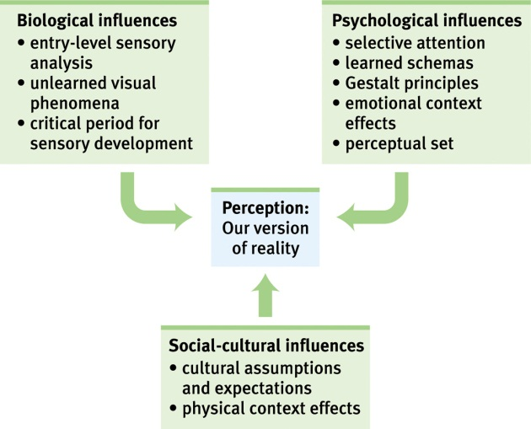
- Context effects: context can radically alter a perceptions, partly because of our different set
- Cultural context: context instilled by culture also alters perception
- Perception: is influence by biological, psychological and social-cultural influences also by emotion and motivation
-Ex. Walking destinations look farther away to those who are fatigued by prior exercise
-if rewards are linked to a specific stimulus people are more likely to see it
- Human factors psychology: a branch of psych that explores how people and machines interact and how machines and physical environments can be made safe and easy to use
- ESP: the controversial claim the perception can occur apart from sensory input, this includes telepathy, clairvoyance and precognition
- telepathy: mind-to-mind communication- one person sending thoughts to another or perceiving another’s thoughts
- clairvoyance: perceiving remote events- such as sensing a friend’s house is on fire
- precognition: perceiving future events- such as a political leader’s death or sporting event outcome
- Parapsychology: the study of paranormal phenomena including ESP and psychokinesis

Chapter 3 Consciousness and the two tracked mind
- Forms of consciousness:
- some occur spontaneously- daydreaming, drowsiness, dreaming
- some are physiologically induced- hallucinations, orgasm, food or oxygen starvation
- Some are psychologically induced- sensory deprivation, hypnosis, meditation
- Cognitive neuroscience: interdisciplinary study of the brain activity linked with our mental processes (thinking, memory, language and perception)
- Dual processing: the principle that information is often simultaneously processed on separate conscious and unconscious tracks
- Visual perception track: enables us to “create the mental furniture that allows us to think about the world”
- Selective attention: our conscious awareness processes only a small part of all that we experience. We intuitively make use of the information we are not consciously aware of. Ex at a cocktail party your ability to attend to one voice out of many
- Selective inattention: you are blind to all but a tiny sliver of the immense array of visual stimulus
- Inattentional Blindness: refers to the inability to see an object or a person in our midst when our attention is directed elsewhere. Ex Simon and Chabris showed that half of the observers failed to see the gorilla-suited assistant in the ball passing game.
- Change blindness: failing to notice changes in the environment. Ex two-thirds of individuals giving directions failed to notice a change in the individual asking for directions
- Sleep: the irresistible tempter to whom we inevitably succumb
- Biological rhythms and sleep:
- Cardiac rhythms occur on a 24 hour- cycle and include sleep and wakefulness (our biological clock”, it can be altered by Light which triggers the suprachiasmatic nucleus to decrease melatonin from the pineal gland and increase it at nightfall. Also your temp rises in the morning and falls at nighttime
- Sleep: periodic, natural, reversible loss of consciousness
- When an individual closes his eyes but remains awake, his brain activity slows down to a large amplitude and slow, regular alpha waves (9-14 cps). A meditating person exhibits an alpha brain activity.
- Sleep stages: about every 90 minutes we pass through a cycle of five distinct sleep stages;
Start: awake but relaxed: close eyes but remain awake, brain activity starts to slow down, contains alpha brain waves
Sleep stages 1-2: light sleep, brain waves are high amplitude slow theta waves (5-8 cps)
Sleep stages 3-4: During deepest sleep, brain activity slows down, there are large amplitude slow delta waves (1.5-4 cps)
Stage five: REM sleep- after deepest sleep, the cycle starts moving back towards stage one, brain waves are low amplitude fast beta waves (15-40 cps), Rapid Eye Movement occurs during this stage (dreaming)
- REM sleep is also called paradoxical sleep, with the body internally aroused and externally calm
* with every new cycle sleep stage four decreases and duration of REM sleep increases*
- Why do we sleep?
- we spend 1/3 of our lives sleeping, if an individual were to remain awake for several days, their immune function and concentration deteriorates, and risk of accidents increases
- Sleep deprivation includes: fatigue and subsequent death, impaired concentration, emotional irritability, depressed immune system, and greater vulnerability
*Accidents- frequency of accidents increases with loss of sleep
- Sleep theories:
- Sleep protects, sleep helps recover us, sleep helps us remember, sleep feeds creative thinking, and sleep may play a role in the growth process.
- Sleep disorders:
-Insomnia: a persistent inability to fall asleep
-Narcolepsy: overpowering urge to fall asleep that may occur while talking or standing up
-sleep apnea: failure to breathe when asleep
- Children are most prone to:
- Night terrors: The sudden arousal from sleep with intense fear accompanied by physiological reactions (e.g., rapid heart rate, perspiration) which occur during Stage 4 sleep.
- Sleepwalking: A Stage 4 disorder which is usually harmless and unrecalled the next day.
-Sleeptalking: A condition that runs in families, like sleepwalking.
- What we dream: Manifest content- a Freudian term meaning the story line of dreams
- Negative emotional content
-failure dreams
-sexual dreams
- Why we dream:
-For wish fulfillment
-Information processing
-physiological function
-Activation-synthesis theory
-Cognitive development
- Hypnosis: a social interaction which one person suggests to another that certain perceptions, feelings, thoughts or behaviors will spontaneously occur
-the power resides in the subjects openness to suggestion
- Hypnotic ability: the ability to focus attention totally on a task, to become imaginatively absorbed in it, to entertain fanciful possibilities
- Social Influence Theory: Hypnotic subjects may simply be imaginative actors playing a social role.
- Divided Consciousness Theory: Hypnosis is a special state of dissociated (divided) consciousness (Hilgard, 1986, 1992).
- The hypnotized state:
-social influence theory: subjects may simply be imaginative actors playing a social role
-divided consciousness theory: hypnosis is a state of dissociated consciousness

Drugs and consciousness:
- Psychoactive drug: a chemical substance that alters perceptions and mood
- Drug tolerance: the continued use of a psychoactive drug produces tolerance, with repeated exposure to a drug, the drug’s effect lessens. Thus it takes greater quantities to get the desired affect
- Withdrawal: upon stopping the use of a drug after an addiction, users may experience the undesirable effects of withdrawal
- Dependence: absence of a drug may lead to a feeling of physical pain, intense cravings and negative emotions
- Misconceptions about drugs:
-addictive drugs quickly corrupt
-addiction cannot be overcome voluntarily
-addiction is not different than repetitive pleasure-seeking behaviours
- Three groups of psychoactive drugs are: depressants, stimulants, and hallucinogens
- Depressants: reduce neural activity and slow body functions
-Alcohol: effects motor skills, judgment and memory, and increases aggressiveness while reducing self-awareness
-Barbiturates: depress the activity of the CNS, reducing anxiety but impairing memory and judgment. Ex seconal, amytal
-Opiates: opium and its derivatives depress neural activity, temporarily lessening pain and anxiety. Highly addictive
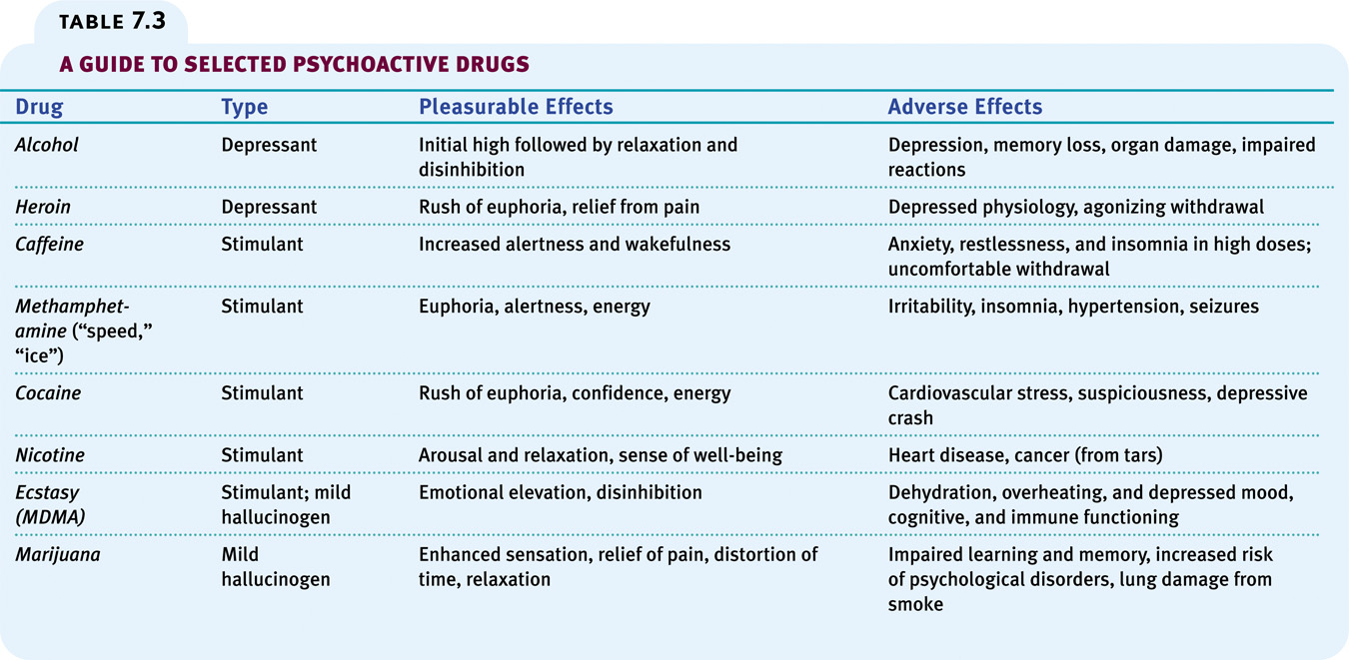
- Stimulants: excite neural activity and speed up body functions
-Caffeine and nicotine: increase heart rate and breathing rates and other autonomic functions to provide energy
-Why do people smoke: it is socially rewarding, is a result of genetic factors, takes away unpleasant cravings, and nicotine itself is rewarding
-cocaine: induces immediate euphoria followed by a crash. Can be smoked injected or sniffed.
-Ecstasy: is a stimulant and mild hallucinogen. It produces euphoric high and can damage serotonin producing neurons, which results in a permanent deflation of mood and impaired memory
- amphetamines: drugs that stimulate neural activity, causing speeded-up body functions and associated energy and mood changes
- methamphetamine: a powerfully addictive drug that stimulates the central nervous system, with speeded-up body function; overtime, appears to reduce baseline dopamine levels
-Hallucinogens: are psychedelic drugs that distort perceptions and evoke sensory images in the absence of sensory input. LSD ( lysergic acid diethylamide) and THC (delta-9-tetrahydrocannabinol)
- LSD: (lysergic acid diethylamide): powerful hallucinogenic drug that is also known as acid.
- THC (delta-9-tetrahydrocannabinol): is the major active ingredient in marijuana (hemp plant) that triggers a variety of effects, including mild hallucinations.
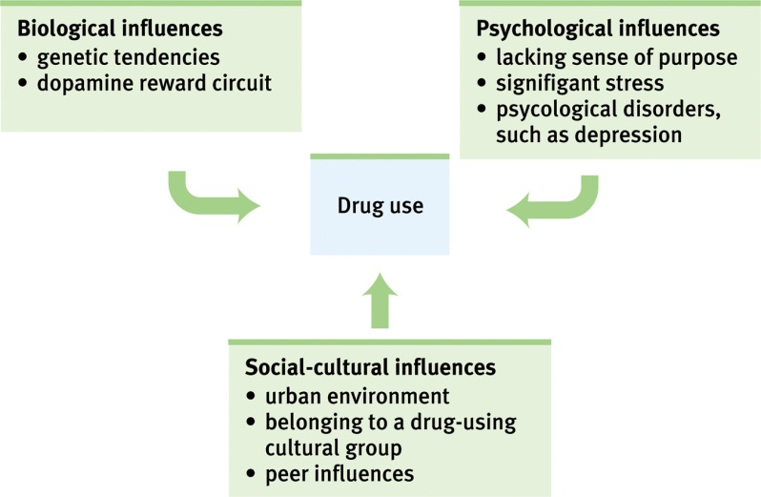
- Influences on drug use:
-biological: genetics
-Psychological: lacking sense of purpose, stress, and disorders such as depression
-Social-cultural influences: environment, cultures, and peer influences
- Marijuana use: use by teenagers is directly related to the “perceived risk” involved with the drug
- Influence for drug prevention and treatment:
-education about the long term costs
-efforts to boost peoples self esteem and purpose
-attempts to modify peer associations and teaching refusal skills
- Near death experiences: an altered state of consciousness reported after a close brush with death; often similar to drug-induced hallucinations.

Chapter seven: Learning
- Learning: is a relatively permanent change in an organisms behaviour due to experience
- We learn by association- our minds naturally connect events that occur in sequence
- Associative learning:
- learning to associate one stimulus with another Ex. Lightening before thunder, we learn that the stimulus lightening means that the stimulus thunder will be right behind it so we prepare for it
-Learning to associate a response with a consequence. Ex. A seal learns that when they balance a ball on their nose they will get a fish!
- observational learning: by watching others, we learn new behaviours
Classical conditioning
- Ivan Pavlov created a basis for later behaviourists like John Watson **in classical conditioning the learner does not know they are learning**
- Behaviourism: the view that psychology (1) should be objective science that (2) studies behaviour without reference to mental processes.
- Pavlov’s experiments:
-Unconditioned stimulus: something that you don’t have to teach because it is already known by nature ( food for a dog)
-Unconditioned response: something they do in response to a stimulus that you don’t have to teach them ( salivating to food)
-Neutral stimulus: something they don’t know to respond to so they have to teach them (a tone)
-Conditioned stimulus: stimulus that was once neutral but was taught to get a response for (tone knows how to make the dog salivate because it was paired up with food)
-Conditioned response: their response to the newly conditioned stimulus (salivating to the tone)
** an experimenter sounds a tone just before delivering an air puff to your blinking eye, after several repetitions, you blink to the tone alone.
US= airpuff; UR= blink to air puff; CS= tone after procedure; CR= blink to tone
- Acquisition: association between a neutral stimulus and an unconditioned stimulus takes place, the cs has to come half a second before the us for acquisition to occur
- Extinction: when the US(food) does not follow the CS(tone) the CR(salivation) begins to decrease and eventually causes extinction, it does not pair
- Spontaneous recovery: after a rest period, en extinguished CR(salivation) spontaneously recovers, but if the CS(tone) persists alone, the CR becomes extinct again
- Stimulus Generalization: tendency to respond to stimuli similar to the CS ex, when taught to respond to a touch on the leg the dog will often respond slightly if touch on the arm or belly
- Stimulus discrimination: learned ability to distinguished between a conditioned stimulus and other stimuli that do not signal an unconditioned stimulus ex two different tones
- Pavlov and Watson underestimated the importance of cognitive processes and biological constraint.
- Cognitive processes: behaviourists suggested that animals learn the predictability of a stimulus, meaning they learn expectancy or awareness of a stimulus
- Biological constraints: learning is constrained by an animal’s biology ex creatures that hunt by sight will be more effected if you use sight with learning
* even humans can develop classically to conditioned nausea..they connect the waiting room with feelings of nausea
- Pavlov’s legacy: isolating elementary behaviors from more complex ones through objective scientific procedures
- Applications of classical conditioning: 1- former crack cocaine users should avoid cues associated with previous drug use, 2- through classical conditioning, a drug that affects the immune response may cause the taste of the drug to invoke the immune response
- Watson used classical conditioning procedures to develop advertising
Operant Vs. Classical conditioning:
- -classical forms associations between two stimuli (lightening before thunder), involves respondent behaviour that occurs as an automatic response to certain stimuli
- Classical conditioning involves respondent behavior that occurs as an automatic response to a certain stimulus. Operant conditioning involves operant behavior, a behavior that operates on the environment, producing rewarding or punishing stimuli.
-operant on the other hand forms an association between behaviours and the resulting events (seal balancing ball), involves a behaviour that operates on environment, producing rewarding or punishing stimuli. Organisms associate their own actions with consequences.
- Skinner’s experiments: extended from Thorndike’s thinking of law and effect: this law states that rewarded behaviour is likely to occur again, skinner developed the operant chamber to study operant conditioning, the chamber comes with a bar or key that an animal manipulates to obtain a reinforce like food or water
- Shaping: is the operant conditioning procedure in which reinforces guide behaviour towards the desired target behaviour through successive approximations
- Types of reinforces: any event that strengthens the behaviour it follows
- Positive reinforcement: add a desirable stimulus ( give food when they do it right). Strengthens the response.
- Negative reinforcements: remove an aversive stimulus (stopping shock when they do it right), increasing behaviours by stopping or reducing negative stimuli. When removed after a response, strengthens the response.
-Primary reinforcements: an innately reinforcing stimulus like food or drink when we are hungry or thirsty
-Conditioned reinforcements: (secondary) a learned reinforcement that gets its reinforcing power through association with the primary reinforce like learning that money can buy us food when we are hungry
-immediate reinforce: a reinforcement that occurs instantly after a behavior (getting food right after pressing a button)
-delayed reinforcement: a reinforcement that is delayed in time for a certain behavior ( a paycheck after two weeks of work)
* reinforcement is any consequence that strengthens behaviour.*
- Reinforcement schedules:
- Continuous reinforcement: reinforces the desired response each time it occurs
-Partial reinforcement: reinforces a response only part time (shows greater resistance to extinction later)
- Ratio schedules:
-fixed ratio schedule: reinforces a response only after a specified number or responses. Ex every five tests that get marked they get 50 dollars
-Variable ratio schedule: reinforces a response after an unpredictable number of responses. Ex gambling
- Interval Schedules:
-Fixed interval: reinforces a response only after a specified time has elapsed. Ex you get paid after every two weeks of work
-Variable interval: reinforces a response at unpredictable time intervals. Ex pop quiz, you would not know when to be prepared so you are always preparing
*Fixed and Variable ratios are most efficient*

Punishment
- usually leads to negative effects, it results in unwanted fear, conveys no information to the organism, justifies pain to others, causes unwanted behaviors to reappear in absence, causes aggression towards the agent and causes one unwanted behavior to appear in place on another
-Positive punishment: administer an aversive stimulus. Ex spanking
-Negative punishment: withdraws a desirable stimulus. Ex cannot hang with friends for a bit
- - Punished behaviour is suppressed, not forgotten
- punishment teaches discrimination
- punishment can teach fear
- physical punishment may increase aggressiveness by modeling aggression as a way to cope with problems.

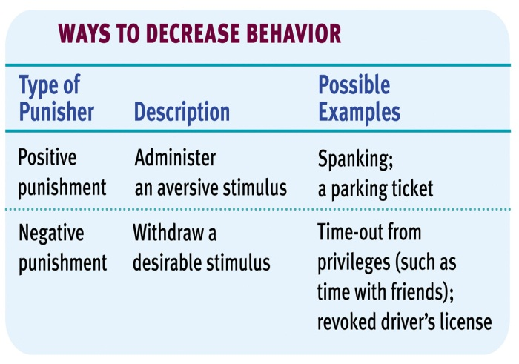
Extending skinners understanding:
- believed that external influences shaped behavior, focuses less on inner thought processes and biological underpinnings
- Cognition and operant conditioning: rats tend to develop cognitive maps these maps are based on latent learning
- Intrinsic motivation: the desire to perform a behavior for its own sake
- Extrinsic motivation: the desire to perform a behavior due to promised rewards or avoid threat punishments
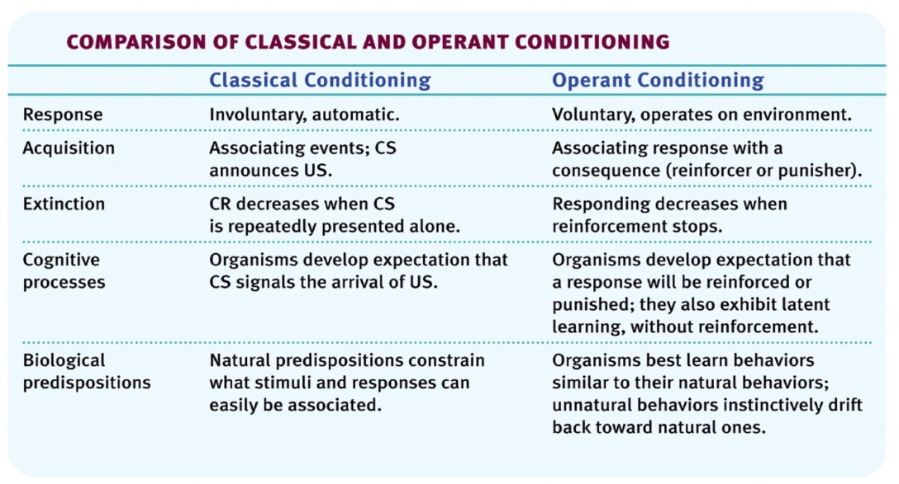
- Biological predisposition: biological constraints predispose organisms to learn associations that are naturally adaptive. Ex teaching a pigeon to flap his wings for food is hard because they naturally peck for food
- Skinners legacy: argued that behaviors were shaped by external influences instead of inner thought and feelings
- Applications of operant conditioning: In school, at work, and at home

Learning by observation
- learn through imitating and observing others: Imitation onset- learning by observation begins early in life
- Mirror neurons: frontal lobe neurons that fire when performing certain actions or when observing another doing so. Brain’s mirroring of another may enable empathy and imitation
*our brain’s mirror neurons underlie our intensity social nature*
- Bandura’s bobo doll experiment: indicated that individuals learn through imitating others who receive rewards and punishments, unfortunately this shows that antisocial models may have antisocial effects, fortunately prosocial models may have prosocial effects
- children in elementary school who are exposed to violent television, videos and video games express aggression, only when they notice good guys beating bad guys and get rewards they are more likely to imitate but if they see bad guys getting punished for beating they are more likely to not imitate it.

Chapter eight: Memory
- Memory: is the basis for knowing your friends, your neighbours, the English language, the national anthem, and yourself. If memory was inexistent then everyone and everything would be strangers.
- the persistent of learning over time through the storage and retrieval of information
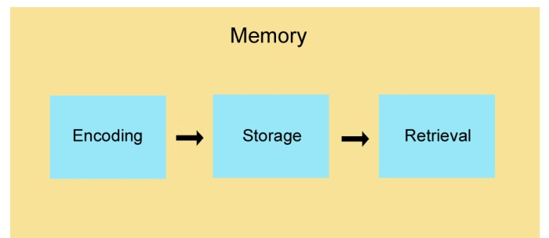
- The phenomenon of memory: any indication that learning has persisted over time. It is our ability to store and retrieve information
- Process of memory
1. Get information into our brain (encoding)
2. Retain that information (storage)
3. Get it back out (retrieval)
- Studying memory:
- information processing models: Encoding-> storage-> retrieval
- Atkinson’s three stage model:
1. We first record to-be-remembered info as a fleeting sensory memory
2. We process the info into a short-term memory bin, where we encode it through rehearsal
3. Info then moves along into the long-term memory for later retrieval
*modifications of Atkinson’s model- some information skips the first two stages and enters long term memory automatically and we select information that is important to us and actively process it into our working memory (short term)
- Working memory: newer understanding of short term memory that involves conscious, active processing of incoming auditory and visual-spatial information and of information retrieved from long term memory

Encoding
- automatic processing: process information effortlessly such as: Space-where things are, Time- not events that occur throughout the day, and Frequency- effortlessly keep track of how many things and what happens to you
-Space: While reading a textbook, you automatically encode the place of a picture on a page.
-Time: We unintentionally note the events that take place in a day.
-Frequency: You effortlessly keep track of things that happen to you.
- effortful processing: novel information to memory requires effort just like learning a concept from textbook, without effort it won’t stick.
Rehearsal: conscious repetition of information to either maintain it or to encode it for storage
- Spacing effect: better retaining information better when we rehearse overtime, spacing it out
- Serial position effect: recall is better for first and last items on a list, but poor for the middle

What we encode
- Encoding meaning: processing the meaning of verbal information by associating it with what we already know or imagine
- Visual encoding: mental pictures are a powerful aid to effortful processing. * Mnemonics: imagery is at the heart of many memory aids
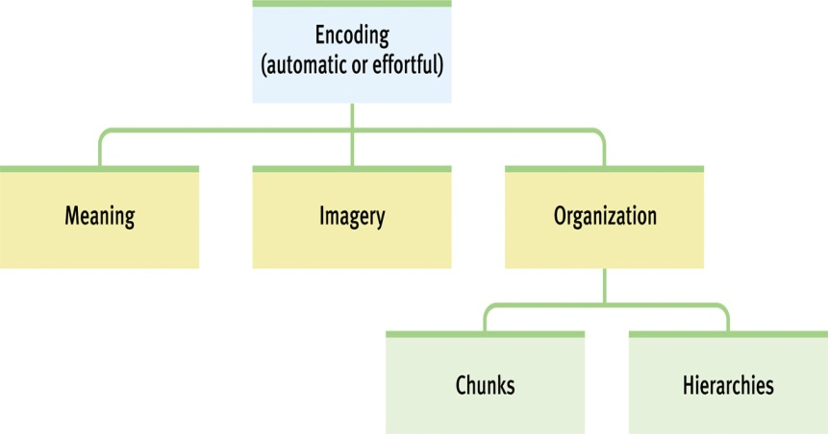
- Mnemonics: Imagery is at the heart of many memory aids. Mnemonic techniques use vivid imagery and organizational devices in aiding memory.
- Organizing information for encoding: breaking down information into broad concepts and further subdividing them into categories and subcategories.
- Chunking: organizing items into a familiar, manageable unit (acronyms are a way of chunking)
- hierarchy: info broken down into broad concepts and further subdivided etc..
- Storage: retaining information. Three stores of information are: sensory memory, working memory, and long term memory
- Sensory memory: capacity is enormous, but we can only hold onto the information for about 0.25 seconds, which means items cannot be rehearsed. Any delay and we lose all sensory memory, longer the delay the greater the memory loss.
- Iconic memory: a momentary sensory memory of visual stimulus; a photographic or picture-image memory lasting no more than a few tenths of a second
- Echoic memory: a momentary sensory memory of auditory stimuli; if attention is elsewhere, sounds and words can still be recalled within 3 or 4 seconds
- Working memory: the new name for short term memory, it has a limited capacity of about seven plus or minus two slots and a short duration about 20 seconds. The capacity or working memory may be increased by chunking.
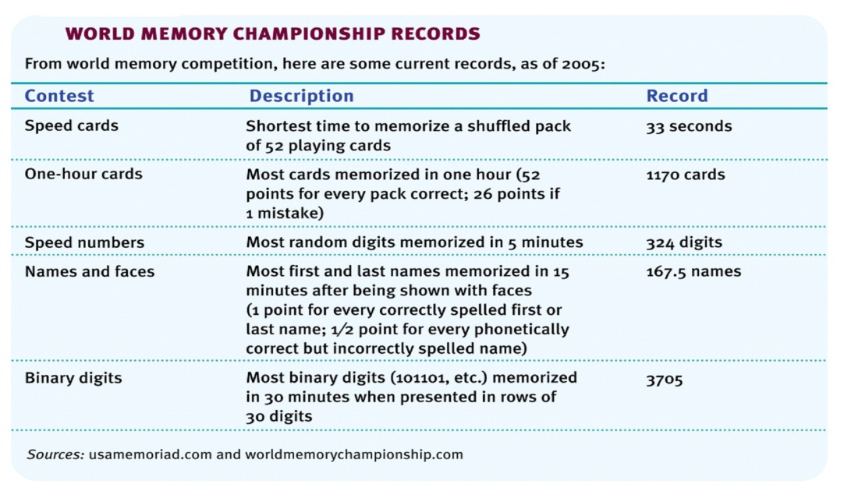
- Long term memory: essentially unlimited storage can hold onto memory for years.
-synaptic changes- showed that serotonin release from neurons increased after conditioning
-Long term potentiating- refers to synaptic enhancement after learning, an increase in neurotransmitter release
- Stress hormone and memory: heightened emotions make for stronger memories.
-Flashbulb memories: are clear memories of emotionally significant moments or events, are vivid but not all details may be correct
- Long-Term Potentiation (LTP): refers to synaptic enhancement after learning (Lynch, 2002). An increase in neurotransmitter release or receptors on the receiving neuron indicates strengthening of synapses.
- Heightened emotions (stress-related or otherwise): make for stronger memories.
- Flashbulb memories: are clear memories of emotionally significant moments or events
- Storing explicit memories: refers to facts and experiences that one can consciously know and declare. Processed in the hippocampus
*Anterograde Amnesia- after losing the hippocampus in surgery a patient can remember everything before the operation but cannot make new memories, they are unable to make new declarative memories (explicit) but can form new memories that are procedural (implicit) 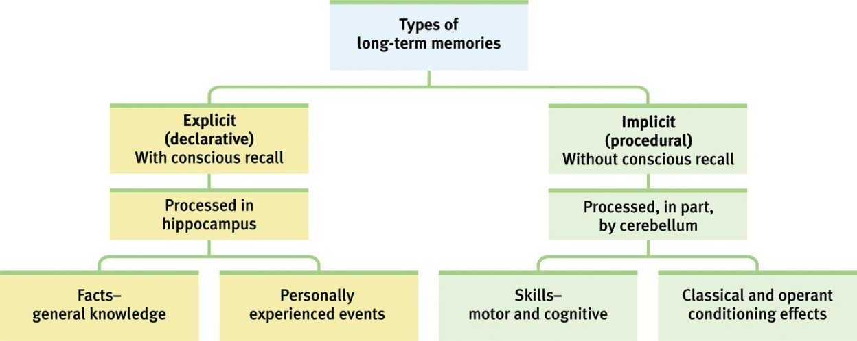
- Storing implicit memories: involves learning an action while the individual does not know or declare what she knows. Is processed in the cerebral cortex
- Measures of memory:
-recognition: the person must identify an item amongst other choices. Ex a multiple choice test
-recall: the person must retrieve information using effort. Ex a fill in the blank test
-relearning: the individual shows how much time is saved when learning material for the second time
- Retrieval cues: memories are held in storage by a web of associations. These associations are like anchors that help retrieve memory
- Priming: to retrieve a specific memory from the web of associations, you must first activate on of the strands that leads to it
- Context effects: scuba divers recall more words underwater if they learned the list underwater, while they recall more words on land when learned on land
- Déjà vu: current situations may trigger retrieval of an earlier similar experience
- Moods and memories: we usually recall experiences that are consistent with our current mood. Emotions or moods serve as retrieval cues
- Forgetting: an inability to retrieve information due to poor encoding, storage or retrieval
-encoding failure (absent-mindness): we cannot remember what we do not encode
-storage decay (transience): poor durability or stored memories leads to their decay
-retrieval failure (blocking): although the information is retained in the memory store, in cannot be accessed. (tip of the tongue)
- Interference: learning some new information may disrupt retrieval of other information
- Retroactive interference: sleep prevents this. There for it leads to better recall. The disruption effect of new learning on the recall of old info.
- Proactive interference: the disruptive effect of prior learning on the recall of new info.
- Motivated forgetting: people knowingly revise their memories
- Repression: a defense mechanism that banishes anxiety-arousing feelings, thoughts, and memories from consciousness
*forgetting can occur at any memory stage, we filter, alter, or lose much information during these stages
- Memory construction: we filter or fill in missing pieces of information to make our recall more coherent
- Misinformation effect: incorporating misleading information into one’s memory of an event
*eyewitnesses reconstruct their memories when questioned about the event*
- Source amnesia (source misattribution): attributing an event to the wrong source that we experienced, heard, read or imagined
*children eyewitness recall- can be unreliable if leading questions are posed, if the interviews are neutrally worded the accuracy of their recall increases*
- Memories of abuse: early childhood sexual abuse results in repressed memories, some question such beliefs and think that such memories may be constructed
- Constructed memories: research shows that if false memories are implanted
- Improving memory:
-study repeatedly
-make material meaningful
-activate retrieval cues
-use mnemonics devices
-minimize interference
-sleep more
-test your knowledge

