Achieving Entrepreneurial Greatness:
- The ultimate message is clear: Great companies can be built and all the capital, technology, and latest information available cannot substitute for hard work and determination.
- The entrepreneur creates the culture in his or her own new venture.
- These ideals are at the very heart of the difference between good and great entrepreneurs and the enterprises they create.

Leadership and Human Behaviour:
- Mclelland's Theory of Motivation: People are motivated by three principal needs: (1) the need for achievement, (2) the need for power, and (3) the need for affiliation.
- Need for Achievement: The need to excel for measurable personal accomplishment.
- Need for Power: The need to influence others and to achieve an "influence goal."
- Need for Affiliation: The need to attain a relationship with someone else.

Converging on The Entrepreneurial Mind:

Desirable and Acquirable Attitudes, Habits, and Behaviours:
- The ability to respond positively to challenges and learn from mistakes.
- Personal initiative.
- Great perseverance and determination.

Six Dominant Themes:
- Commitment and Determination: Tenacious and decisive, able to recommit/commit quickly, competitive, persistent, etc.
- Leadership: Self-starter; high standards but not a perfectionist, team builder, shares the wealth, honest and reliable, etc.
- Opportunity Obsession: Has intimate knowledge of customer's needs and wants and is obsessed with value creation and enhancement.
- Tolerance of Risk, Ambiguity, and Uncertainty: Calculated risk take, risk minimiser, risk sharer, tolerates stress and conflicts, etc.
- Creativity, Self-Reliance, and Adaptability: Non-conventional, open-minded, lateral thinker, restless with the status quo, able to adapt, quick learner, etc.
- Motivation to Excel: Goal-and-results oriented, high but realistic goals, drive to achieve and grow, low need for status and power, etc.

Demystifying Entrepreneurship:
- Entrepreneurship is a way of thinking, reasoning, and acting that is opportunity obsessed, holistic in approach, and leadership balanced.
- Entrepreneurship can occur and fail to occur in firms that are old and new; small and large; fast and sow growing; in the private, not-for-profit, and public sectors; etc.

Classic Entrepreneurship:
- The classic expression of entrepreneurship is the raw start-up company, an innovative idea that develops into a high growth company.
- Entrepreneurship requires the skill and ingenuity to find and control resources, often owned by others, in order to pursue the opportunity.

Entrepreneurship = Paradoxes:
- An opportunity with no or very low potential can be an enormously big opportunity. A great example of this is Apple.
- To make money, you first have to lose money.
- To create and build wealth one must relinquish wealth.
- To succeed, one first has to experience failure. It is a common pattern that the first venture fails; yet the entrepreneur learns and goes on to create a highly successful company.
- Entrepreneurship requires considerable thought, preparation, and planning, yet is basically an unplannable event.
- For creativity and innovativeness to prosper, rigour, and discipline must accompany the process.
- Entrepreneurship requires a bias toward action and a sense of urgency, but also demands patience and perseverance.
- The greater the organization, orderliness, discipline, and control, the less you will control your ultimate destiny.
- Adhering to management best practice, especially staying close to the customer that created industry leaders in the 1980s, became a seed of self destruction and loss of leadership to upstart competitors.
- To realize long-term equity value, you have to forgo the temptations of short-term profitability.

Smaller can mean Higher Failure Odds:
- Most estimates place the failure rate for start-ups at 50% in the first few years.
- Studies indicate that failure rates are high, and although the majority of the failure occur in the first two to five years, it may take considerably longer for some to fail.
- However, most smaller enterprises that cease operations simply do not meet our notion of entrepreneurship.
- They do not create, enhance, or pursue opportunities that realize value.

Threshold Concept:
- The odds for survival and a higher level of success increase steadily as the firm size increases.
- The successful threshold is roughly $50,000 to $100,000 of sales per employee annually.

Promise of Growth:
- Odds for survival increase substantially for those enterprises that grow.
- The enterprises that grow early in their life have a higher chance of survival.

Venture Capital Backing:
- Another notable pattern of exception to the failure rule is found for businesses that attract start-up financing from successful private venture capitalist.

Timmons Model:

Value Creation – The Driving Forces:
- A core, fundamental entrepreneurial process accounts for the substantially greater success pattern among higher potential ventures.
- (1) It is opportunity driven, (2) It is driven by a lead entrepreneur and an entrepreneurial team, (3) It is resource parsimonious and creative, (4) It depends on the fit and balance among these, (5) It is integrated and holistic, and (6) It is sustainable.

Change the Odds – Fix it, Shape it, Mould it, and Make it:
- The process starts with opportunity (not money), strategy, networks, teams, or the business plan.
- The shape, size, and depth of the opportunity establishes the required shape, size, and depth of both the resources and team.
- The lead entrepreneur's job is to carry the deal by taking charge of the success equation all with an eye towards Sustainability (for the environment, community, and society).
- Opportunity: At the heart of the process is the opportunity. Successful entrepreneurs know that a good idea is not necessarily a good opportunity.
- Is there market demand? Where does the opportunity take place in the current market structure? Are margin analysis's in your favor?
- Resources – Creative and Parsimonious: The most common misconception among untried entrepreneurs is that you first need to have all the resources in place, especially the money, to succeed with a venture.
- Bootstrapping: Doing more with less resources. The necessary approach is to minimize and control the resources, not necessarily own them.
- The Entrepreneurial Team: The team is a key ingredient in the higher potential venture. If you find a good team, they can always change the product.
- Most problems lie with the wrong people, not the wrong idea.
- Importance of Fit and Balance: Rounding out the model of the three driving forces is the concept of fit and balance between and among the forces.

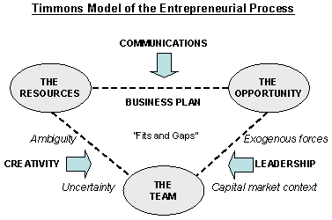

Opportunity through a Zoom Lens:

New Venture Realities:
- Most new ventures are works in process and not works of art.
- Most business plans are obsolete at the printer.
- Speed, adroitness of reflex, and adaptability are crucial.
- The key to succeeding is failing quickly and recouping quickly.
- Success is highly situational, depending on time, space, context, and stakeholders.
- Starting a company is a lot harder than it looks, but you can last a lot longer and do more than you think if you do not try to do it solo, and you don't give up prematurely.

When is an Idea an Opportunity?
- The Essence – Four Anchors:
- They create or add significant value to a customer or end-user.
- They do so by solving a significant problem, removing a serious pain-point, or meeting a significant want or need – for which someone is willing to pay a premium.
- They have robust market, margin, and money making characteristics that will allow the entrepreneur to estimate and communicate sustainable value to potential stakeholders.
- They are a good fit with the founders and management team at the time and market place – along with an attractive risk-reward balance.
- A superior opportunity has the qualities of being attractive, durable, and timely and is anchored in a product or service which creates or adds value for its buyer or end-user – usually by solving a very painful, serious problem.

Drivers of Opportunities:
- Regulatory changes: Airline, insurance, telecommunications, medical, etc.
- 10-fold change in 10 years or later: Moore's Law – computer chips double productivity every 18 months.
- Reconstruction of Value Chain: Superstores, and internet sales and distribution of services.
- Proprietary or Contractual Advantage: Technological innovation (patent, license, contract, etc.)
- Management
- Entrepreneurial Leadership: New vision and strategy.

The Role of Ideas:

Ideas as Tools:
- Finding a good idea is the first step in the process of converting an entrepreneur's creativity into an opportunity.
- The new business that simply bursts from a flash of brilliance is rare. Usually a series of trial-and-error iterations is necessary before a crude and promising product or service fits what the customer is willing to pay.

The Great Mousetrap Fallacy: It is often assumed that success is possible if an entrepreneur can just come up with a new idea. The truth is that ideas are inert and, for all practical purposes, worthless.
- Ideas are infinite, but resources simply are not.

Pattern Recognition:

The Experience Factor:
- Nobel laureate Herbert Simon wrote extensively about patter recognition. He described the recognition of patterns as a creative process that is not simply logical, linear, and additive but intuitive and inductive as well.
- It involves the creative linking, or cross-association, of two or more in-depth "chunks" of experience, know-how, or contacts.
- It takes 10 years or more for people to accumulate "50,000 chunks" of experience that enable them to be highly creative and recognize patterns.

Creativity: Enhancing and retaining creativity is a vital tool in pattern recognition. Societal constructs emphasize the use of logical or rational trains of thought.

Screening Opportunities:

Industry and Market Issues:
- Market: Higher potential businesses can identify a market niche for a product or service that meets an important customer need and provides high value-added or value-created benefits to customers. The product/service eliminates or drastically reduces a major nuance for customers.
- Lower potential opportunities are unfocused regarding customer need, and customers are unreachable and/or have brand or other loyalties to others.
- Being able to expand beyond a one-product company can make for a lower potential opportunity.
- Market Structure: Evidenced by the number of sellers, size distribution of sellers, whether products are differentiated, conditions of entry and exit, number of buyers, cost conditions, and sensitivity of demand to change in price is significant.
- Industries that are highly concentrated, that are perfectly competitive, or that are mature or declining are typically unattractive.
- Market Size: An attractive new venture sells to a market that is large and growing. One where capturing a small market share can represent significant and increasing sales volume.
- However, a market can be too large. A multibillion-dollar market may be too mature an stable, and such a level of certainty can translate into competition from fortune 500 firms and, if highly competitive, into lower margins and profitability.
- Growth Rate: An attractive market is large and growing where capturing a good share of the increase is less threatening to competitors and where a small market share can represent significant and increasing sales volume.
- Market Capacity: Another signal of the existence of an opportunity in a market is a market at full capacity in a growth situation – a demand that the existing suppliers cannot meet.
- Cost Structure: Attractive opportunities exist in industries where economies of scale are insignificant (or work to the advantage of the new venture).

Economics:
- Profits after Tax: High and durable gross margins usually translate into strong and durable after-tax profits. Attractive opportunities have potential for durable profits of at least 10-15% and often 20% or more.
- Time to Breakeven and Positive Cash Flow: Attractive companies can attain this in two years.
- ROI Potential: Very attractive opportunities have the potential to yield a return on investment of 25% or more per year.
- Capital Requirements: Ventures that can be funded and have capital requirements that are low to moderate are attractive. Realistically, most higher-potential business' need significant amounts of cash to get started.
- Internal Rate of Return Potential: The most attractive opportunities often have the promise of – and deliver on – a very substantial upside of 5 to 10 times the original investment in 5 to 10 years.

Harvest Issues:
- Value-Added Potential: New ventures based on strategic value in an industry, such as valuable technology, are attractive.
- Exit Mechanisms and Strategy: Attractive companies that realize capital gains from the sale of their businesses have, or envision, a harvest, or market mechanism.

Competitive Advantage Issues:
- Variable and Fixed Costs: An attractive opportunity has the potential for being the lowest-cost producer and for having the lowest marketing and distribution costs.
- Degree of Control: Attractive opportunities have potential for moderate-to-strong degree of control over prices, costs, and channels of distribution. Fragmented markets.
- Markets with a market leader with a overall share of 20% is attractive. Over 40% is unattractive.
- Entry Barriers: Having or being able to gain proprietary protection, regulatory advantage, or other legal or contractual advantage, such as exclusive rights to a market or with a distributor is attractive.

Gathering Information:

Finding Ideas:
- Existing Businesses: Purchase an ongoing business.
- Franchises: Franchising is another way to enter an industry, by either starting a franchise operation or becoming a franchisee.
- Patents: Patent brokers specialize in marketing patents that are owned by individual inventors, corporations, universities, or other research organizations to those seeking new commercially viable products.
- Product Licensing: A good way to obtain exposure to many product ideas.

Industry and Trade Contacts: Trade shows, customers, distributors and wholesalers, competitors, former employers, professional contact, consulting, and networking.

Idea Generation Guide:
- Generate a list of as many new venture ideas as possible.
- Expand your list if possible.
- Ask at least three people who know you well to look at your list, and revise your list to reflect any new ideas emerging from the exchange.
- Jot down insights, observations, and conclusions that have emerged about your business ideas or your personal preferences.

Developing the Business Plan:
- The business plan for a high potential venture reveals the business's ability to:
- Create or add significant value to a customer or end-user.
- Solve a significant problem, or meet a significant want or need for which someone will pay a premium.
- Have robust market, margin, and moneymaking characteristics: large enough, high growth, high margins, strong and early free cash flow, high profit potential, and attractive realizable returns for investors.
- Fit well with the founders and management team at the time, in the market space, and with the risk-reward balance.

Do's and Don'ts:
- DO:
- Involve all of the management team in the preparation of the business plan.
- Make the plan logical, comprehensive, readable, and as short as possible.
- Demonstrate commitment to the venture by investing a significant amount of time and some money in preparing the plan.
- Articulate what the critical risks and assumptions are and how and why these are tolerable.
- Disclose and discuss and current or potential problems in the venture.
- Identify several alternative sources of financing.
- Spell out the proposed deal – how much for what ownership share – and how investors will win.
- Be creative in gaining the attention and interest of potential investors.
- Remember that the plan is not the business and that an ounce of can-do implementation is worth two pounds of planning.
- Know your target investor group and what they really want and what they dislike.
- Let realistic market and sales projections drive the assumptions underlying the financial spreadsheets, rather than the reverse.
- DONT:
- Have unnamed mysterious people on the management team.
- Make ambiguous, vague, or unsubstantial statements.
- Describe technical products or manufacturing processes using jargon or in a way that only an expert can understand.
- Spend money on developing fancy brochures, elaborate presentations, etc.
- Waste time writing a plan when you could be closing sales and collecting cash.
- Assume you have a done deal when you have a handshake or verbal commitment but no money in the bank.

The Dehydrated Business Plan: Usually runs from four to ten pages, but rarely more. It covers key points, such as those suggested for the exec. summary. It is used by busy entrepreneurs who cannot find enough slack time to produce an appropriate plan.

A Closer Look at the What:
- Segmenting Information: An overall plan for the project, by section, needs to be devise and needs to include priorities – who is responsible for each section, due date for a first draft, and the due date for the final draft.
- Creating an Overall Schedule: Create a more specific lists of tasks, identify priorities and who is responsible for them. Determine when they will be started, and when they will be completed. Then review the list for realism, timing, and priorities.
- Creating an Action Calendar: Tasks on the do list then need to be placed on a calendar. When the calendar is complete, the calendar needs to be re-examined for conflicts or lack of realism.
- Doing the Work and Writing the Plan: The necessary work needs to be done and the plan written. It is important to have the plan reviewed by a lawyer to make sure it contains no misleading statements, unnecessary information, and caveats.

The Entrepreneurial Domain:

Converging on the Entrepreneurial Leader:
- Conventionally it is thought that entrepreneurs are not good managers and vice-versa.
- There are three ways founders have to adapt: (1) shift from creation to exploitation, (2) shift from passionate commitment to dispassionate objectivity, and (3) shift from direct personal control over organizational actions to indirect impersonal control.
- Study of 54 Fortune 1,000 Corporations' Founders:
- If the firm grows relatively slowly, and the founder is capable of some adaptation, then the firm can become quite large.
- Founders with scientific or engineering backgrounds remain in control of the companies for shorter periods than do founders whose academic focus was business.
- The founder's tenure will typically be longer in family-dominated firms.

Principal Forces and Venture Modes:
- Venture Modes: Areas influenced by certain principal forces and characterized by ways of acting.
- Managerial Domain: Lifestyle, mom and pop ventures that can transform to mature, bureaucratic dinosaurs. Low change/uncertainty, and low entrepreneurship.
- Entrepreneurial Domain: Higher potential, growth-minded ventures. High growth, high change, and most entrepreneurial.
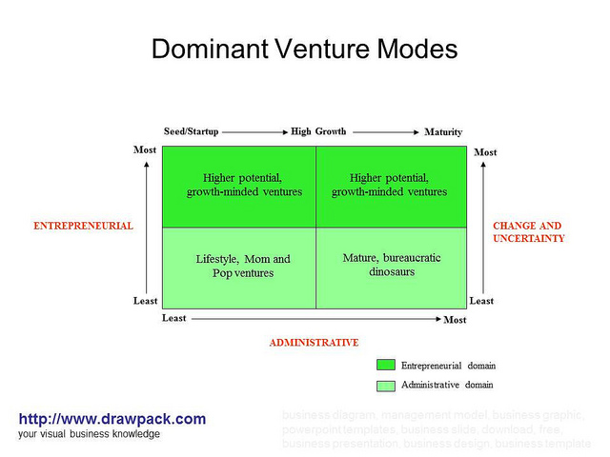

Principle Driving Forces:
- Top Left: Creativity, collaboration within the firm, opportunity focus, and resource requirements expand. The organization is informal/fluid.
- Top Right: Rejuvenators and innovators, opportunity focus, resource ownership, and capital gain. The organization is formalized.
- Bottom Left: Few owners, a specific product, and burdensome resource requirements. The organization is too rigid or nonexistent.
- Bottom Right: Administrator/trustees, product focus, resource ownership, and quarterly profits. The organization is formalized.

Stages of Growth: (Looks like a Product Life Cycle graph)

A Theoretical View:
- The R&D Stage: Sometimes referred to as the nascent stage, is characterized by a single aspiring entrepreneur, or small team, doing the investigation and due diligence for the business idea. The nascent stage can be as short as a few months or can last years.
- The Start-Up Stage: Usually covers the first two to three years but perhaps as many as seven. It is characterized by the direct drive, energy, and entrepreneurial talent of a lead entrepreneur and a key team member or two.
- Here the critical mass of people, market and financial results, and competitive resiliency are established, while investor, banker, and customer confidence is earned.
- The level of sales reached varies widely, but typically ranges from $2 to $20 million.
- High Growth Stage: The length of time it takes as well as the magnitude of change occurring during this period varies greatly. This stage is the most difficult challenge for the founding entrepreneur when they find it is necessary to let go of control.
- Maturity/Stability Stages: The key issue for the company is no longer survival; rather, it is one of steady, profitable growth.

Crucial Transitions
 | Start-Up | High Growth | Maturity/Stability
Sales | 0 - $5 million | $5 - $15 million | $10 - $15 million+
Employees | 0 to 20 – 25 | 25 – 75 | 75 – 100+
Core Management Mode | Doing | Managing | Managing Managers

Managing for Rapid Growth:
- Compounding of Time and Change: In the high growth stage, change, ambiguity, and uncertainty seem to be the only things that remain constant. Change creates higher levels of uncertainty, which, in turn, compound to shrink time.
- Nonlinear and Nonparametric Events: Entrepreneurial leadership is characterized by bunches of progression and stepwise leaps.
- Counterintuitive, Unconventional Decision Making.
- Fluid Structures and Procedures: Inevitably out of date, changes frequently, and the organizational structure usually is flat.
- Entrepreneurial Culture: More concerned with evidence, competence, knowledge, and logic of arguments affecting a decision than the status given by a title or the formal position of the individual doing the arguing.

Competence and Skills:

Skills in Building Entrepreneurial Culture:
- Leaders need interpersonal skills that involve:
- The ability to create, through management, a climate and spirit conductive to high performance, while rewarding work well don and encouraging innovation, initiative, and calculative risk taking.
- The ability to understand the relationship among tasks and between the leader and followers.
- The ability to lead in those situations where it is appropriate.
- Leadership, Vision, and Influence: Successful entrepreneurs are skillful in creating clarity out of confusion, ambiguity, and uncertainty.
- Helping, Coaching, and Conflict Management: The most effective leaders are very creative and skillful un handling conflicts, generating consensus decisions, and sharing their power and information.
- Teamwork and People Management: Another form of entrepreneurial influence has to do with encouraging creativity and innovation, and with taking calculated risks.

Other Necessary Competencies:
- Marketing: Market research and evaluation, planning, pricing, sales management, direct selling, service management, distribution management, product management, and new product planning.
- Operations/Production: Manufacturing management, inventory control, cost analysis and control, quality control, production scheduling and flow, purchasing, and job evaluation.
- Finance: Raising capital, managing cash flow, credit and collection management, short-term financing alternatives, public and private offering, bookkeeping, and accounting.
- Entrepreneurial management: Problem solving, communications, planning, decision making, project management, negotiating, managing outside professionals, and personnel admin.
- Law and Taxes: Corporate and securities law, contract law, law relating to patents and proprietary rights, tax law, real estate law, and bankruptcy law.
- Information Technology: Information systems knowledge, B2B, B2C, merchandising tools, and telecommunications.

The Importance of the Team:
- There is a strong connection between the growth potential of a new venture (and its ability to attract capital beyond the founder's resources from private and venture capital backers) and the quality of its management team.

Forming and Building Teams:

Anchoring Vision in Team Philosophy and Attitudes:
- The most successful entrepreneurs seem to anchor their vision of the future in certain entrepreneurial philosophies and attitudes.
- Cohesion: Members of a team believe they are all in this together, and if the company wins, everyone wins, and vice-versa.
- Rewards, compensation, and incentive structures rest on building company value and return on capital invested, not matter how small or sizeable.
- Teamwork: A team that works as a team may be the single most distinguishing feature of the higher-potential venture.
- Integrity: Hard choices and trade-offs are made regarding what is good for the customer, the company, and value creation, rather than being based on purely utilitarian or Machiavellian ethics or narrow personal or departmental needs and concerns.
- Commitment: Play for the long haul.
- Harvest Mind-Set: The eventual capital gain is viewed as the scorecard rather than a monthly paycheque.

Filling the Gaps:
- Successful entrepreneurs search out people and form and build a team based on what the opportunity requires, and when.
- The Founder: A key step in forming a team is for the lead entrepreneur to assess his or her entrepreneurial strategy.
- Relevant industry, market, and technological expertise? Relevant personal and business strengths? Networks and contacts?
- The Opportunity: What is needed in the way of a team depends on the lead entrepreneur and the opportunity, and how fast he or she plans to proceed.
- Clearly defined the value added and the economics of the business? Critical success variable in the business? Access to critical external relationships? Competitive advantage and strategy?
- Outside Resources: Gaps can be filled by accessing outside resources, such as boards of directors, accountants, lawyers, consultants, and so forth. Generally, if the resource is a onetime or periodic effort, then an alternative such as using consultants makes sense.

Additional Considerations:
- Values, Goals, and Commitment: In successful companies, the personal goals and values of team members align well, and the goals of the company are also championed by the team.
- Definition of Roles: Maintaining a loose, flexible, flat structure with shared responsibility and information is desirable for utilizing individual strengths, flexibility, rapid learning, and responsive decision-making.

Rewards and Incentives:

Slicing the Founder's Pie:
- First, start with a philosophy and set of values that boil down to this great principle: Share the wealth with those who help to create the value and thus the wealth.
- Second, the ultimate goal of any venture-capital-backed company is to realize a harvest at a price 5 to 10 times the original investment and up.
- Finally, the single most important thing is that is succeeds.

The Reward System: Includes both the financial rewards of a venture and the chance to realize personal growth and goals, exercise autonomy, and develop skills in particular venture roles.

Critical Issues:
- Differentiation: Different team members rarely contribute the same amount to the venture, and the reward system needs to recognize the differences.
- Performance: Reward needs to be a function of performance (as opposed to effort).
- Flexibility: Regardless of the contribution of any team member at any given time, the probability is high that this will change.

Considerations of Value:
- Idea: The originator of the idea needs to be considered.
- Business Plan Preparation: Preparing an acceptable business plan, in terms of dollars and hours expended, needs to be considered.
- Commitment and Risk: Some members could be more adversely affected by the venture's performance than others. This factor must be considered.
- Skills, Experience, Track Record, or Contacts: If a member brings experience in critical fields to the new venture, they must be considered.
- Responsibility: The importance of a team member's role to the success of the venture needs to be considered.
- Stock-Vesting Agreement: An agreement between venture and team member used to guard against the event that some portion of the stock has been earned and some portion will remain unearned, as when a team member quits or dies; the venture places the stock purchased by team members in escrow to be released over a two- or three-year period.

Four Components of a Business Model:

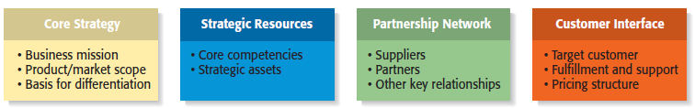

Venture Financing – The Entrepreneur's Achilles' Heel: There are three core principles of entrepreneurial finance: (1) more cash is preferred to less cash, (2) cash sooner is preferred to cash later, and (3) less-risky cash is preferred to more-risky cash.

Critical Financing Issues:
- Creating Value: Who are the constituencies for whom value must be created or added to achieve a positive cash flow and to develop a harvest option?
- Slicing the Value Pie: Tax consequences of each venture structure? legal process? risk capital?
- Selling the Idea and Covering Risk.

Determining Capital Requirements:

Financial Strategy Framework: Opportunity --> Business Strategy <--> FInancial Requirements <--> Sources of Finance/Structure <-->Financial Strategy <--> Opportunity
- The Opportunity: Leads and drives the business strategy, which in turn drives the financial requirements, the sources and deal structures, and the financial strategy.
- Financial Requirements: (1) Asset Needs – facility, equipment, R&D, etc. (2) Operating Needs – Working capital for operations.
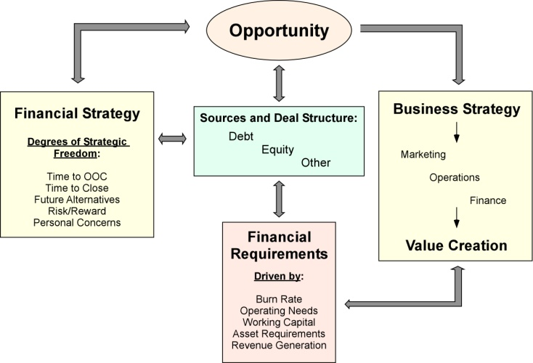

Free Cash Flow – Burn Rate, OOC, and ITC:
- Burn Rate: Measure of how fast a company will use up its shareholder capital.
- OOC: When the company will be out of cash.
- TTC: Time to Close the financing and have the cheque clear.

Financial Life Cycles:
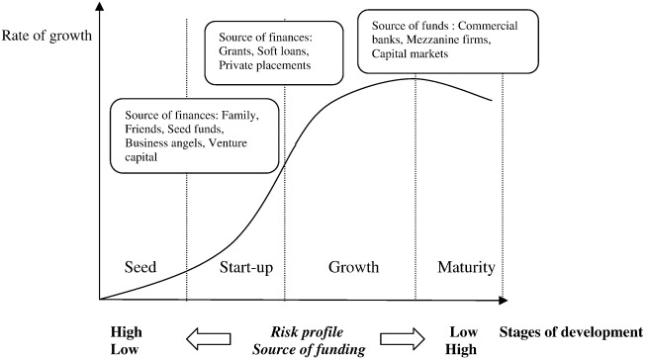

Angels and Informal Investors: Informal investors, or business angels, who invest personal funds directly in someone else's small business.
- Typically angels invest at seed stage and early stages (average investment is $100,000).
- The single largest source of external equity capital for small firms.
- Profile: Average age of 50, high income/net-worth, well-educated, business experience, engaged in the business, local and personal networks, and syndicated.

Venture Capital: Capital that is supplied to entrepreneurs in business with high growth potential in hopes of achieving a high rate of return on investment funds.

Institutional Venture Capital:
- 97% Turndown Rate: Based almost entirely on the perception that the management team is not up to the task of commercializing what may be a good product or innovation.
- Types:
- Private Independent VCs: Obtain capital from financial institutions.
- Corporate Subsidiaries: Obtain capital from parent companies and institutions.
- Labour-Sponsored: Obtain capital from tax-incented individuals.
- Government (Business Development Bank of Canada): Leading as a development bank, BDC pays special attention to start-ups, innovators, fast growth companies, etc.
- Hybrid: Combination of the above.

The VC Decision Process: 6 stages (at least 6 weeks – 3 months).
- Deal Origination: Fund conception, raising capital for investment, generate deal flow (often cold calls from firm to VCs).
- Screening: VC determines if firm fits with VC policies.
- Evaluation: Analysis of the venture based on VC's investigation of material taken at face value.
- Due Diligence: Detailed check of financial position of the firm and its principals. This includes audits of financial statements, credit checks, references on managers, etc.
- Negotiation
- Post-Investment Activity
- Usually begins with a Telephone Call (from firm seeking capital). VC Investment Manager examines the Business Plan. If acceptable (most are not), VC manager meets with the principals of the firm. VC Manager follows up meeting by trying to gain a sense of the Potential of the product/industry (face value). If VC manager wants to pursue the investment--> Proposal.
- Proposal Letter: States that "based on what the firm has presented," the VC institution would consider making a deal. Firm must sign off on a promise not to shop the deal around and advance "earnest money" to the VC to demonstrate commitment.

Other Sources of Capital:

Mezzanine Capital: Capital that is between senior debt financing and common stock. It is generally unsecured, with a fixed coupon and maturity of 5 to 10 years.
- Advantages: The variables that comprise the capital are all flexible to suit the needs of both the issue and the investor.
- Disadvantages: Acts like debt (insurance payments, and the principal loan must be paid back). Firms seeking Mezzanine Capital must be financially stable/profitable and possess positive cash flows. Focuses on middle-spectrum of businesses.

Initial Public Stock Offerings: Commonly referred to as an IPO, it raises capital through provincially registered and underwritten sales of the company's shares.
- Advantages: (1) Raise more capital with less dilution, (2) improve the balance sheet or eliminate debt, (3) Access other suppliers of capital, (4) Improve credibility with customers, (5) and achieve liquidity for owners/investors.
- Disadvantages: (1) Legal, accounting, and administrative costs, (2) A large amount of management effort, time, and expense are required to comply with regulations and reporting requirements, (3) and management can become more interested in stock price than operations.

Asset-Based Financing: Leases (operating & capital), conditional sales contracts.
- Innovative, flexible, and allows for competitive and flexible financial terms.
- Has the ability to: (1) raise funds from international markets and institutions at low cost through Securitization – Capital sources from institutions, (2) Mitigate risk by specialized knowledge of product markets.
- Accounts for 20% (approximately) of financing in Canada.

Sources of Debt Capital:
- Trade Credit: An agreement where a customer can purchase goods on account (without paying cash), paying the supplier at a later date.
- A major source of short-term funds for small businesses. Represents 30-40% of the current liabilities of non-financial companies.
- Commercial Bank Financing: Canadian chartered banks that prefer to lend to existing businesses that have a track record of sales, profits, satisfied customers, and a current backlog of orders.
- Primary source of debt capital for existing businesses.
- Most loans are for one year or less.
- Commercial Finance Companies: Aggressively seek borrowers, then lend money to companies that do not have positive cash flow, but are considered viable risks.
- Lend against the liquidation value of assets that it understands, knows how and where to sell, and whose liquidation value is sufficient to repay the loan.
- Advantage – It will make loans that a bank will not.
- Factoring: Accounts receivable financing. Receivables are sold at a discounted value, to a factor.
- Leasing Companies: An agreement where the lessor receives lease payments to cover its ownership costs. The lessee is responsible for maintenance, insurance, and taxes. Some finance leases are conditional sales or hire purchase agreements.

