A&P 1 Exam 3 Name ________________________________________________
Russo

T/F

1) In myelinated axons the voltage-regulated sodium channels are concentrated at the nodes of Ranvier.
Answer: TRUE
Diff: 2 Page Ref: 406; Fig. 11.15

2) A postsynaptic potential is a graded potential that is the result of a neurotransmitter released into the synapse between two neurons.
Answer: TRUE
Diff: 2 Page Ref: 410-411

3) Large-diameter nerve fibers conduct impulses much faster than small-diameter fibers.
Answer: TRUE
Diff: 2 Page Ref: 405-406

4) The nodes of Ranvier are found only on myelinated, peripheral neuron processes.
Answer: FALSE
Diff: 2 Page Ref: 392-393

5) Unipolar neurons have axons structurally divided into peripheral and central processes.
Answer: TRUE
Diff: 2 Page Ref: 394; Tbl. 11.1
6) A stimulus traveling toward a synapse appears to open calcium ion channels at the presynaptic end, which in turn promotes fusion of synaptic vesicles to the axonal membrane.
Answer: TRUE
Diff: 3 Page Ref: 407-410

7) If bacteria invaded the CNS tissue, microglia would migrate to the area to engulf and destroy them.
Answer: TRUE
Diff: 3 Page Ref: 389

8) The overlapping functions of the nervous system are sensory input, integration, and motor output.
Answer: TRUE
Diff: 1 Page Ref: 387

9) The autonomic nervous system is under voluntary control; whereas, the somatic nervous system is involuntary.
Answer: FALSE
Diff: 1 Page Ref: 387
10) Axon diameter and degree of myelination determine nerve impulse conduction velocity.
Answer: TRUE
Diff: 1 Page Ref: 406

11) The action potential is caused by permeability changes in the plasma membrane.
Answer: TRUE
Diff: 2 Page Ref: 400

Multiple Choice

12) Which of the following describes the nervous system integrative function?
A) senses changes in the environment
B) analyzes sensory information, stores information, makes decisions
C) responds to stimuli by gland secretion or muscle contraction
Answer: B
Diff: 1 Page Ref: 387
13) The period after an initial stimulus when a neuron is not sensitive to another stimulus is the ________.
A) resting period
B) repolarization
C) depolarization
D) absolute refractory period
Answer: D
Diff: 1 Page Ref: 405

14) Which of the following is not characteristic of neurons?
A) They conduct impulses.
B) They have extreme longevity.
C) They are mitotic.
D) They have an exceptionally high metabolic rate.
Answer: C
Diff: 1 Page Ref: 390

15) The part of a neuron that conducts impulses away from its cell body is called a(n) ________.
A) axon
B) dendrite
C) neurolemma
D) Schwann cell
Answer: A
Diff: 1 Page Ref: 390-391

16) Which ion channel opens in response to a change in membrane potential and participates in the generation and conduction of action potentials?
A) mechanically gated channel
B) voltage-gated channel
C) leakage channel
D) ligand-gated channel
Answer: B
Diff: 1 Page Ref: 396

17) The substance released at axon terminals to propagate a nervous impulse is called a(n) ________.
A) ion
B) cholinesterase
C) neurotransmitter
D) biogenic amine
Answer: C
Diff: 1 Page Ref: 414

18) A neuron that has as its primary function the job of connecting other neurons is called a(n) ________.
A) efferent neuron
B) afferent neuron
C) association neuron
D) glial cell
Answer: C
Diff: 2 Page Ref: 395

19) Saltatory conduction is made possible by ________.
A) the myelin sheath
B) large nerve fibers
C) diphasic impulses
D) erratic transmission of nerve impulses
Answer: A
Diff: 1 Page Ref: 405
20) Select the correct statement regarding synapses.
A) Cells with gap junctions use chemical synapses.
B) The release of neurotransmitter molecules gives cells the property of being electrically coupled.
C) Neurotransmitter receptors are located on the axons terminals of cells.
D) The synaptic cleft prevents an impulse from being transmitted directly from one neuron to another.
Answer: D
Diff: 2 Page Ref: 407-408

21) Neuroglia that control the chemical environment around neurons by buffering potassium and recapturing neurotransmitters are ________.
A) astrocytes
B) oligodendrocytes
C) microglia
D) Schwann cells
Answer: A
Diff: 1 Page Ref: 389
22) Schwann cells are functionally similar to ________.
A) ependymal cells
B) microglia
C) oligodendrocytes
D) astrocytes
Answer: C
Diff: 1 Page Ref: 390

23) Immediately after an action potential has peaked, which cellular gates open?
A) sodium
B) chloride
C) calcium
D) potassium
Answer: D
Diff: 2 Page Ref: 401

24) When a sensory neuron is excited by some form of energy, the resulting graded potential is called a(n) ________.
A) postsynaptic potential
B) excitatory potential
C) action potential
D) generator potential
Answer: D
Diff: 2 Page Ref: 399
25) Which of the following is not true of graded potentials?
A) They are short-lived.
B) They can form on receptor endings.
C) They increase amplitude as they move away from the stimulus point.
D) They can be called postsynaptic potentials.
Answer: C
Diff: 2 Page Ref: 399-400

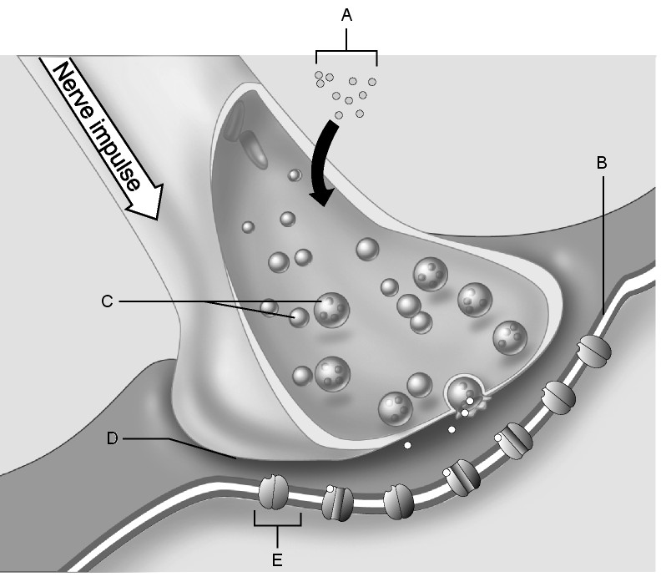

Figure 11.2

Using Figure 11.2, match the following:

26) Ion channel.
Answer: E
Diff: 1 Page Ref: 409; Fig. 11.17

27) Synaptic vesicles.
Answer: C
Diff: 1 Page Ref: 409; Fig. 11.17
28) Calcium ions.
Answer: A
Diff: 3 Page Ref: 409; Fig. 11.17

29) Postsynaptic membrane.
Answer: B
Diff: 1 Page Ref: 409; Fig. 11.17

30) Synaptic cleft.
Answer: D
Diff: 1 Page Ref: 409; Fig. 11.17

Matching Questions

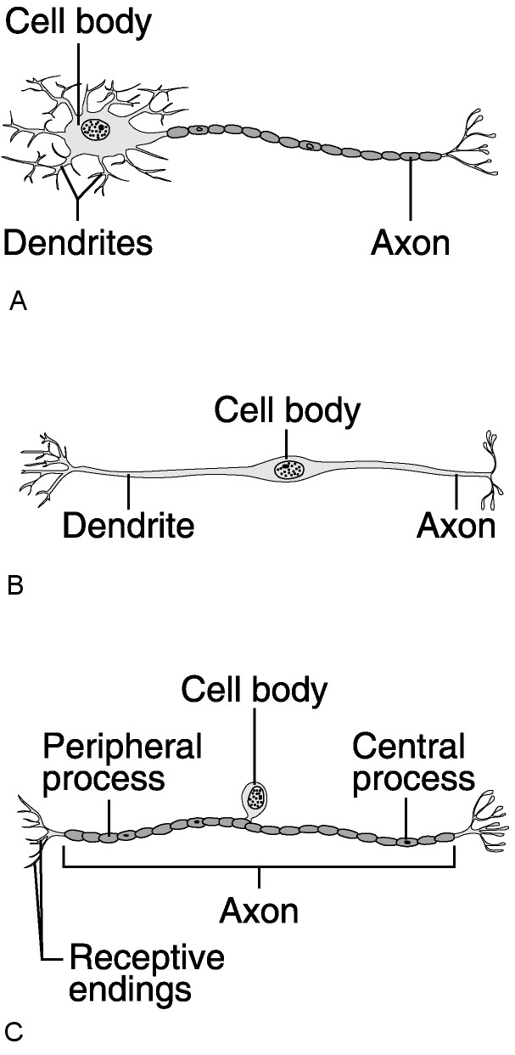

Figure 11.1

Using Figure 11.1, match the following:

31) Which neuron would connect to a muscle?
Answer: A
Diff: 1 Page Ref: 394-95; Tbl 11.1

32) Which neuron would be found in the retina of the eye?
Answer: B
Diff: 1 Page Ref: 394-95; Tbl 11.1

33) Which neuron is a sensory neuron found in a reflex arc?
Answer: C
Diff: 1 Page Ref: 394-95; Tbl 11.1

34) Which neuron is never myelinated?
Answer: B
Diff: 1 Page Ref: 394-95; Tbl 11.1
35) Which neuron is rare?
Answer: B
Diff: 1 Page Ref: 394-95; Tbl 11.1

36) In a reflex arc, which neuron has its cell body inside the spinal cord?
Answer: A
Diff: 1 Page Ref: 395,422;Tbl 11.1

37) Which neuron is common only in dorsal root ganglia of the spinal cord and sensory ganglia of cranial nerves?
Answer: C
Diff: 1 Page Ref: 395; Tbl. 11.1

38) Which is by far the most common neuron type?
Answer: A
Diff: 1 Page Ref: 395; Tbl. 11.1

Match the following:

A) Maximal stimulus
B) Tetanus
C) Multiple motor unit summation
D) Muscle tone
E) Wave summation

39) The stimulus above which no stronger contraction can be elicited, because all motor units are firing in the muscle.
Diff: 1 Page Ref: 296

40) Determined by alternating motor units of a muscle organ even when the muscle is at rest.
Diff: 2 Page Ref: 298

41) Continued sustained smooth contraction due to rapid stimulation.
Diff: 2 Page Ref: 295

42) The situation in which contractions become stronger due to stimulation before complete relaxation occurs.
Diff: 2 Page Ref: 294

43) How a smooth increase in muscle force is produced.
Diff: 2 Page Ref: 296

Answers: 39) A 40) D 41) B 42) E 43) C
True/False Questions

44) Once a motor neuron has fired, all the muscle fibers in a muscle contract.
Answer: FALSE
Diff: 2 Page Ref: 293

45) The thin filaments (actin) contain a polypeptide subunit G actin that bears active sites for myosin attachment.
Answer: TRUE
Diff: 2 Page Ref: 281

46) The force of muscle contraction is controlled by multiple motor unit summation or recruitment.
Answer: TRUE
Diff: 1 Page Ref: 296

47) Eccentric contractions are more forceful than concentric contractions.
Answer: TRUE
Diff: 2 Page Ref: 297-298

48) A motor neuron and all the muscle cells that it stimulates are referred to as a motor end plate.
Answer: FALSE
Diff: 1 Page Ref: 286, 293

Multiple Choice

49) What is the role of tropomyosin in skeletal muscles?
A) Tropomyosin is the chemical that activates the myosin heads.
B) Tropomyosin serves as a contraction inhibitor by blocking the myosin binding sites on the actin molecules.
C) Tropomyosin serves as a contraction inhibitor by blocking the actin binding sites on the myosin molecules.
D) Tropomyosin is the receptor for the motor neuron neurotransmitter.
Answer: B
Diff: 2 Page Ref: 281

50) The strongest muscle contractions are normally achieved by ________.
A) increasing stimulus above the threshold
B) increasing stimulus above the treppe stimulus
C) increasing the stimulation up to the maximal stimulus
D) recruiting small and medium muscle fibers
Answer: C
Diff: 2 Page Ref: 296
51) Which of the following would be recruited later in muscle stimulation when contractile strength increases?
A) motor units with the longest muscle fibers
B) many small motor units with the ability to stimulate other motor units
C) large motor units with small, highly excitable neurons
D) motor units with larger, less excitable neurons
Answer: D
Diff: 3 Page Ref: 296

52) Excitation-contraction coupling requires which of the following substances?
A) Ca2+ and ATP
B) Ca2+ only
C) ATP only
D) ATP and glucose
Answer: A
Diff: 2 Page Ref: 289; Fig. 9.11

53) What produces the striations of a skeletal muscle cell?
A) a difference in the thickness of the sarcolemma
B) the arrangement of myofilaments
C) the sarcoplasmic reticulum
D) the T tubules
Answer: B
Diff: 1 Page Ref: 281; Tbl. 9.1

54) During muscle contraction, myosin cross bridges attach to which active sites?
A) myosin filaments
B) actin filaments
C) Z discs
D) thick filaments
Answer: B
Diff: 1 Page Ref: 289
55) Which of the following surrounds the individual muscle cell?
A) perimysium
B) endomysium
C) epimysium
D) fascicle
Answer: B
Diff: 1 Page Ref: 278; Fig. 9.1

56) What is the functional role of the T tubules?
A) stabilize the G and F actin
B) enhance cellular communication during muscle contraction
C) hold cross bridges in place in a resting muscle
D) synthesize ATP to provide energy for muscle contraction
Answer: B
Diff: 1 Page Ref: 284

57) What is the role of calcium ions in muscle contraction?
A) form hydroxyapatite crystals
B) reestablish glycogen stores
C) bind to regulatory sites on troponin to remove contraction inhibition
D) increase levels of myoglobin
Answer: C
Diff: 1 Page Ref: 289-293

58) Which of the following is the correct sequence of events for muscle contractions?
A) motor neuron action potential, neurotransmitter release, muscle cell action potential, release of calcium ions from SR, ATP-driven power stroke, sliding of myofilaments
B) neurotransmitter release, muscle cell action potential, motor neuron action potential, release of calcium ions from SR, sliding of myofilaments, ATP-driven power stroke
C) muscle cell action potential, neurotransmitter release, ATP-driven power stroke, calcium ion release from SR, sliding of myofilaments
D) neurotransmitter release, motor neuron action potential, muscle cell action potential, release of calcium ions from SR, ATP-driven power stroke
Answer: A
Diff: 2 Page Ref: 285-286; Fig 9.7

59) The sliding filament model of contraction involves ________.
A) actin and myosin sliding past each other and partially overlapping
B) the shortening of thick filaments so that thin filaments slide past
C) actin and myosin lengthening in order to slide past each other
D) the Z discs sliding over the myofilaments
Answer: A
Diff: 2 Page Ref: 285

60) What part of the sarcolemma contains acetylcholine receptors?
A) motor end plate
B) end of the muscle fiber
C) part adjacent to another muscle cell
D) any part of the sarcolemma
Answer: A
Diff: 1 Page Ref: 286

Xtra Credit (1 point each)

1) Which of the following is false or incorrect?
A) An excitatory postsynaptic potential occurs if the excitatory effect is greater than the inhibitory effect but less than threshold.
B) A nerve impulse occurs if the excitatory and inhibitory effects are equal.
C) An inhibitory postsynaptic potential occurs if the inhibitory effect is greater than the excitatory, causing hyperpolarization of the membrane.
Answer: B
Diff: 3 Page Ref: 410-411

2) In what way does the interior surface of a cell membrane of a resting (nonconducting) neuron differ from the external environment? The interior is ________.
A) positively charged and contains less sodium
B) negatively charged and contains less sodium
C) negatively charged and contains more sodium
D) positively charged and contains more sodium
Answer: B
Diff: 3 Page Ref: 397

3) After nervous stimulation stops, what prevents ACh in the synaptic cleft from continuing to stimulate contraction?
A) calcium ions returning to the terminal cisternae
B) the tropomyosin blocking the myosin once full contraction is achieved
C) acetylcholinesterase destroying the ACh
D) the action potential stops going down the overloaded T tubules
Answer: C
Diff: 2 Page Ref: 286

4) Which of the following statements is most accurate?
A) Muscle tension remains relatively constant during isotonic contraction.
B) T tubules may be sliding during isotonic contraction.
C) The I band lengthens during isotonic contraction.
D) Myofilaments slide during isometric contractions.
Answer: A
Diff: 3 Page Ref: 297-298
5) What is the primary function of wave summation?
A) produce smooth, continuous muscle contraction
B) increase muscle tension
C) prevent muscle relaxation
D) prevent muscle fatigue
Answer: A
Diff: 2 Page Ref: 294

