What is psychology?

Definition of psychology (mind, brain, behavior)
- The science of behavior (what we do) and mental processes (sensations, perceptions, dreams, thoughts, beliefs and feelings) that occur within the brain.
  - Ultimate Goal => Understand human behavior
  - The mind and the brain is ultimately the same thing. You cannot have the mind without the brain. The brain is the organ, all the hormones and chemicals, it is a structure. The psychological awareness of the brain/thinking is the mind. The function is the mind.
  - Why do we do the things we do?

Past Conceptions of Abnormal Behavior

Ancient Societies: The Stone Age

Theory
- Deviance and the supernatural (mysticism)

Treatment
- Exorcism (the attempted expulsion of an “evil” spirit)
- Trephination (an operation removing a circular section of the bone of the skull)
  - Various of reasons why these procedures happened. Some thought it was to release an evil spirit, others thought it was a real medical surgery. To relieve pressure from migraines or war injuries.

Ancient Egypt

Theory
- “Wandering Uterus”. Women becoming very anxious, suffering from paralysis, blindness, deafness. They were suffering because the uterus would become detached, they thought of it like an animal, wandering around her body looking for food. It could attach itself to the woman’s heart.

Treatment
- They’d use smelling salts to looer the animal back to it’s proper place. They thought women were “hysterical”. They thought women semen on it’s own was poisonous and would cause hysteria. It occurred mostly in virgins and widows. Afterwards they started advertising vibrators.

Psychology’s Roots

Prescientific Psychology
- Is the mind connected to the body or distinct?
- Are ideas inborn or is the mind a blank slate filled by experience?
- Nature vs Nurture
- Nativism vs Empiricism
  - The real question is now is it more nature or nurture?

The Rise of Psychology as a Science

Philosophical roots of psychology:

Descartes (1596-1650): Dualism
  - You can actually will the body to do something…

Hobbes (1588-1679): Materialism
  - The mind the body is all based on physical laws. Even consciousness is due to laws of nature.

Locke (1632-1704):Empiricism (tabula Rosa)
  - Even knowledge is sensory thoughts. Everything is materialistic. Tabula Rosa means we are born with a blank slate. With the proper nature you could mold a person.

Biological Roots of Psychology:

Muller (1801-1858): doctrine of specific nerve energies

Flourens (1774-1867): experimental ablation
  - Taking out parts of the brain (of animals) and seeing what it would destroy. They would take a certain part of the brain out and the animal wouldn’t be able to walk or see or fly, etc.

Broca (1824-1880): localization of language
  - The brain is lateralized. Damage to the left hemisphere will cause damage to the right side of the body. If you had a stroke in the left hemisphere you may not be able to produce speech and be paralyzed on the right hand side.

Helmholtz(1821-1894): located the mind within the brain (RTs)
  - He studied the reaction times (RT) of the brain. Measure how fast people could calculate something or process complex information. People can respond to things in different amounts of time. This now means psychology is a science.

Weber(1795-1878): Psychophysics
  - Tries to relate physical stimuli and mental phenomena. Full of natural and physical laws.

Parts of the Brain
- Frontal Lobe
  - Judgment, logic, motor, planning, executive functions; are all things that could be affected if the frontal lobe is damaged.
- Parietal Lobe
  - Receives sensory input for touch and body position.
- Occipital Lobe
  - Receives information from the visual fields.
- Temporal Lobe
  - The part of the brain that deals with hearing. Addition hearing. If your temporal lobe is damaged you might experience deafness and loss of memory.

Lateralization of Function
- Left Side
- Right Side

Current Fields of Psychology
- Biological
  - Physiological
  - Psychophysiology
  - Behavior genetics
- Clinical
  - Behavior analysis
  - Personality
  - Neuropsychology
- Cognitive Psychology
  - Emphasizes internal mental processes
- Social
- Developmental psychology
  - Social/mental development of children
- Cross-cultural
- Evolutionary
  - The gradual development of something

What is a “paradigm”?
- A cognitive set
  - Interpret information
- A way of thinking about something
  - A worldview underlying the theories and methodology of a particular subject.
- It determines what evidence you seek and how you interpret it

Major Paradigms in the Development of Psychology

Structuralism: Wundt, Titchner
  - What is the structure of the mind? Trying to come up with the basics structures of the mind.
- Wilhelm Wundt
  - Added two key elements to make psychology a science
    - Carefully measured observations
    - Experiments
  - Opened the first psychology lab at the university of Liepzig
- Titchener
  - Aimed to determine the basic elements, or the structure, of conscious mental experience.
  - Thought that consciousness could be reduced to its basic elements.
  - Introspection

Functionalism: Darwin, James
  - Functionalism focused on how behavioral processes function how they enable organism to adapt, survive and flourish
  - Study of the mind is function of behavior, not the individual parts

Gestalt Psychology: Wertheimer School
  - Individuals perceive objects and patterns as whole units, and therefore the whole perceived is more than the sum of its parts
  - Developed as a direct response to Structuralism
  - Mind is not the sum of its parts, it’s bigger than that
  - Must look at organized wholes (ex. Song, painting, insight)
  - Gestalt = unified form (Holistic)

Behaviorism: John B. Watson
  - Studied behavior that was observable and measurable and there, objective and scientific
  - Reward vs punishment
  - When you reinforce an action, it’s actually rewarding. When you ignore or withhold rights, you are punishing.
  - E.L. Thorndike: Law of Effect
    - Responses that lead to “satisfying” consequences are more likely to be repeated than responses that lead to “unsatisfying” consequences.
  - Subject should be behavior, not the mind (S-R psychology)
  - Goal is to understand environmental conditions that cause behavior
  - Unobservable events not of interest (thoughts, feelings, beliefs)

The Psychodynamic Perspective: Freud
  - A school of thought united by a concern with the dynamics or interaction of forces lying deep within the mind.
  - The depth Hypothesis:
    - Almost all mental activity takes place unconsciously
  - Interpretation
    - Revealing the hidden, intrapsychic motives (when something traumatic as a child happened and you can remember it, doesn’t mean that it won’t cause actions later on in life
  - The Id:
    - Pleasure principle
  - The Ego:
    - Reality Principle
  - The Superego
    - The “conscience”
    - Morality principle
    - Defense mechanisms

Humanism Psychology: Abraham Maslow & Carl Rogers
  - This subfield focuses on the uniqueness of human beings and their capacity for choice, growth, and psychological health.
  - The perspective purports that human beings are innately good
  - Humanists developed theories and treatments to help people to feel accepted and to reach their full potential

Cognitive Psychology
  - Often uses information-processing approach to study mental processes such as memory, problem solving, reasoning, language and other forms of cognition.
  - It recaptured the field’s early interest in mental processes and made them legitimate topics for scientific study
  - Puts the O in S-R

A New Biological Revolution is Energizing Research
  - Brain Chemistry
  - The Human Genome
  - Watch the Working Brain

The Neuropsychological perspective

The Brain
  - Structures, neurochemistry and genes
  - Biological reductionism (reduce problems to their smallest parts)
  - Very popular now; high tech (Zeitgeist)

The Big Issue in Psych: Nature vs. Nurture
  - To what extent are our traits already in place at birth (nature)? And to what extent do our traits develop in response to our environment/experience (nurture)?

Three Levels of Analysis

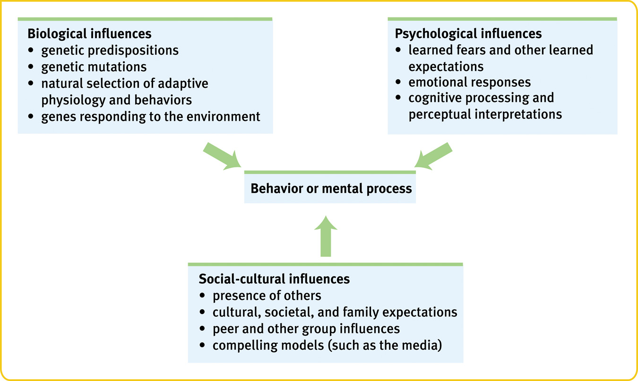

Psychiatry:
  - A branch of medicine dealing with psychological disorders
  - Practiced by physicians who sometimes use medical (for example, drug) treatments as well as psychotherapy

Outline
- The scientific method in psychology
- Ethics
- Understanding research results

The Scientific Method In Psychology Main Issues
- Goals
  - Description
  - Explanation
  - Prediction
  - Control
- Identifying the problem
  - What question do you want to pursue?
  - Hypotheses vs. Theories
    - An hypothesis is a statement of what you think should happen in your experiment.
    - A theory is a set of integrated statements that organizes/predicts results and is more encompassing than an hypothesis
    - Operational definition
- Research methods
  - The Research Process
  - 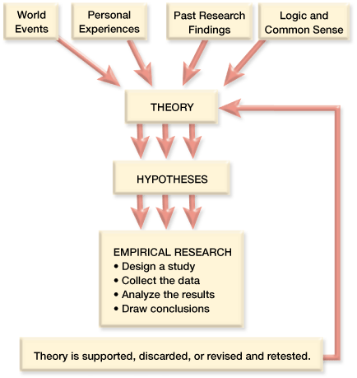
  - Descriptive studies
    - Naturalistic Observation
      - Observing and recording behavior in naturally occurring situations without trying to manipulate and control the situation
    - Case Study
      - Psychologists study one or more individuals in great depth in the hope of revealing things true of us all
    - Survey
      - A technique for ascertaining the self-reported attitudes or behaviors of a particular group, usually by questioning a representative, random sample of the group.
  - Correlation studies
    - A descriptive study that looks for a consistent relation between two phenomena [Variables occur naturally]
    - Correlation Coefficient
      - A statistical measure of how strongly two variables are related to one another
      - A correlation can range from -1.0 to +1.0 . Number indicates strength and sign indicates direction.
    - Graphing Correlations: The Scatter Plot
      - How to construct a scatter plot
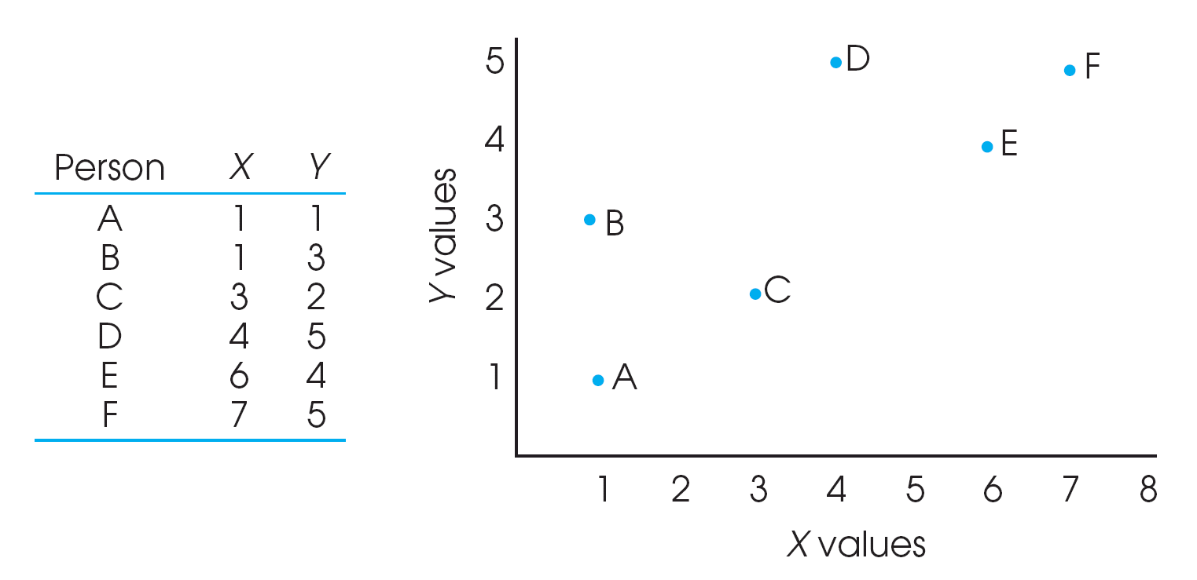
- Draw 2 axes and label both variables
- Mark the axes using the full range of values
- Plot by placing a dot that corresponds to each person’s pair of scores
  - *note that the scatterplot allows you to see the relation between X and Y. Providing a visual description

*Note that the scatterplot allows you to see the relation between X and Y. Providing a visual description.

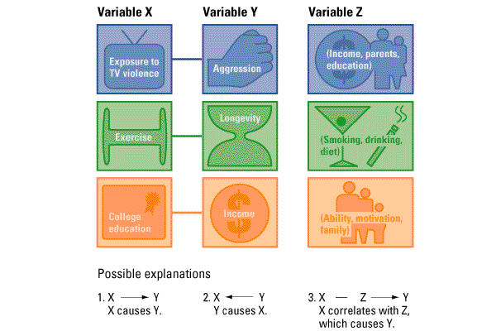
    - Naturally Occurring
      - Start with 2 variables, (X,Y) where X and Y are correlated:

-X may cause Y

-Y may cause X

-Z may cause X and Y
      - Correlations show relational patterns, not causes.

  - Evaluating the findings
  - Keeping the enterprise ethical
  - Experiments
    - A research method in which the investigator varies some factors, keep others constant and measures the effects on randomly assigned subjects
    - PopulationSampleIndependent variableDependent Var.

Random assignment

Other Ind. VariableDependent Variable

-Experiment Variables
    - Independent Variable: A variable that an experimenter manipulates
    - Dependent Variable: A variable that an experimenter predicts will be affected by manipulations of the ind. variable.
- Correlational vs. Experimental Studies

Correlational Studies
    - Cannot infer causation
    - Can only state that there is a relation between the variables of interest
    - May be due to a third unknown variable

Experimental Studies
    - Can infer a causal relation between the two variables of interest
    - May be due to a third unknown variable

-Experimental Method Concerns Overview
    - Selection bias
    - Confounding variables
    - Experimenter/participate bias
    - Placebo effect
    - Reliability & Validity
- Methods of Control
  - Experimental Condition: A condition in which the treatment is present
  - Control Condition: A condition in which the treatment is absent
  - Random Assignment: Assigning subjects randomly to the different groups in the experiment
- Designing an experiment

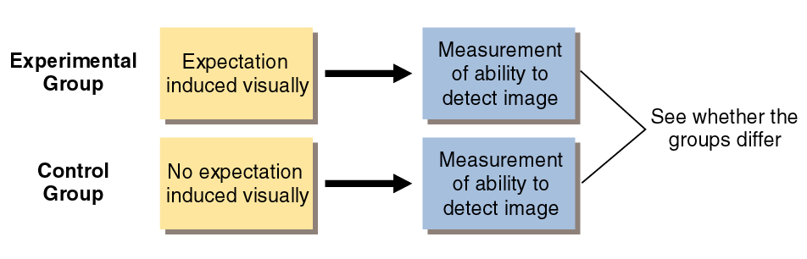
- Conducting an experiment

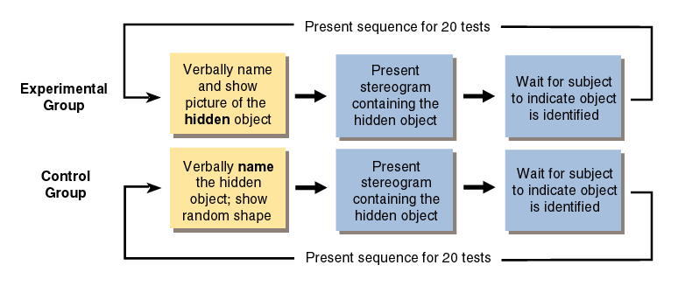
- Random Assignment
  - In order for experiments to have experimental and control groups composed of subjects similar in characteristics that may effect their results, random assignment should be used.
  - Each individual participating in the study has the same probability as any other of being assigned to a given group.
- Confounding of Variables
  - We must control our independent variables
  - Sometimes an unexpected variable is also introduced
  - An inadvertent alteration of more than one variable during an experiment is called a confound.
- Experiment Effects Demand Characteristics
  - Unintended changes in subjects behavior due to cues inadvertently given by the experimenter
  - Social desirability: response set
  - Strategies for preventing experimenter effects include single and double-blind studies
- Minimizing the Effects of Expectations
  - Single-Blind Procedure: The subject is unaware
  - Double-Blind Procedure: Both the subject and the experimenter are kept unaware as to which treatment is being administrated
  - Placebo Effect: A substance that looks like a drug or other active substance but is actually on inert or inactive substance
- Performing an Experiment
  - Reliability of Measurements: The repeatability of a measurement or will you get the same result twice?
  - Validity of Measurements: The extent to which a test measures or predicts what it is supposed to.
- Generalization
  - Can you apply your results to the population from which you took your sample from?
  - What does your experiment mean in the real world?
- Ethics
  - Research with Human Participants
    - Requires compliance with the following principles:
    - Informed consent

an ethical principle that research participants be told enough to enable them to choose whether they wish to participate
    - Confidentiality

to keep their information private
    - Minimal Risk

to protect them from harm/discomfort
    - Debriefing

the post experimental explanation of a study, including its purpose and any deceptions, to its participants.
  - Research with Animals

-As animals cannot give informed consent, we must comply with the following principles
    - Is this an important research topic?
    - Have we minimized harm to the animal?
    - Are the animals receiving the best possible care?
    - Are the animals being treated humanely?

- Understanding Research Results
  - Descriptive Statistics

What are the results?
  - Measures of Central tendency
    - Mean: the arithmetic average of a distribution, obtained by adding the scores and then dividing by the number of scores
    - Median: the middle score in a distribution; half the scores are above it and half are below it.
    - Mode: the most frequently occurring score(s) in a distribution
  - Measures of Variability
    - Variance
    - Standard deviation: a computed measure of how much scores vary around the mean score.
  - Inferential Statistics
    - Statistical procedures that allow researchers to draw inferences about the statistical meaning of a study’s results
    - The most commonly used inferential statistics are significance tests
  - Are the results significant?
    - Statistical analyses: the way in which we determine statistical significance
    - Statistical significance: the probability that an observed relation or difference between 2 or more variables is not due to chance.

(Alpha levels 5% -- p< .05 or p> .05)

Main Points

The Nervous System

Neurotransmission

Study of the Brain (Methods)

Major structures of the brain
  - Subcortical Structures and Function
  - Organization of the Cortex

The Nervous System
- The Central Nervous System(CNS) is the brain and the spinal cord. The CNS makes decisions for the body.
- The Peripheral Nervous System (PNS) is “the rest” of the nervous system. It gathers and sends info to and from the rest of the body.
  - Peripheral nervous system has two different types.

Automatic (controls self-regulated action of internal organs and glands).
    - Sympathetic (arousing)
    - Parasympathetic (calming)

Somatic (controls voluntary movements of skeletal muscles).

Neurons and Neuronal Communication:

The Structure of a Neuron

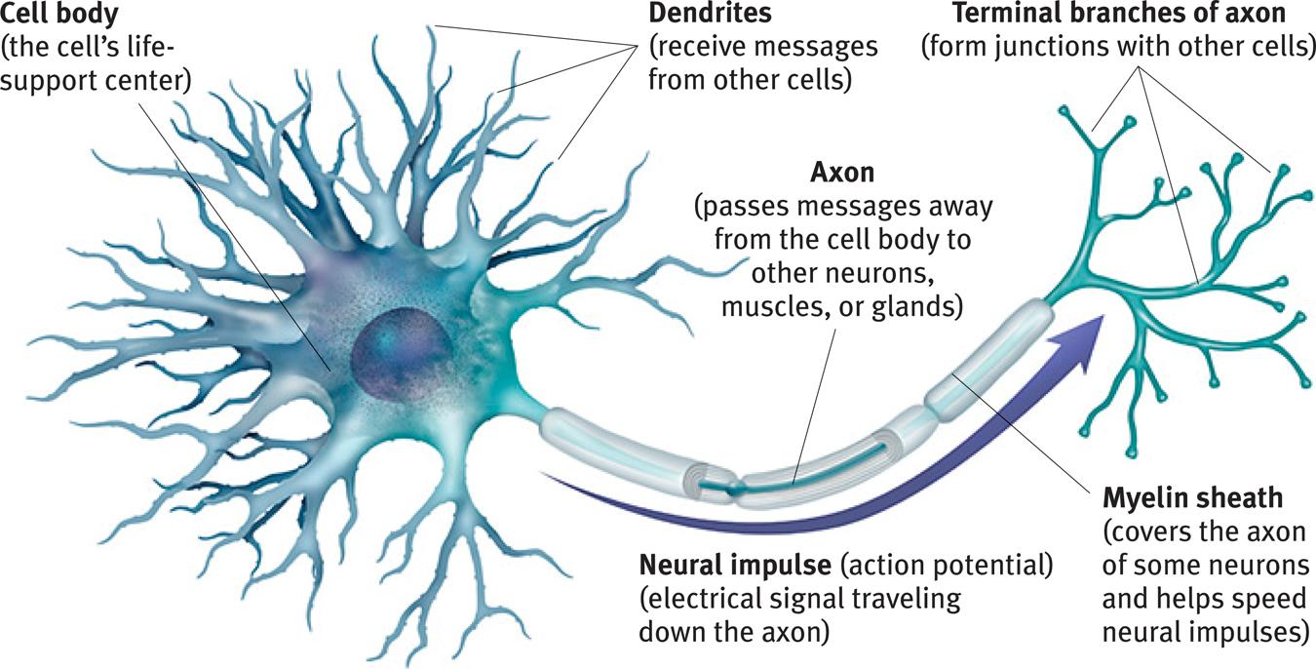

*Dendrites listen, axons speak.

*There are billions of neurons throughout the body.

Major Neurons

[when leaving the CNS: Efferent vs. Afferent coming into the CNS]
- Sensory Neurons: Being information to the central nervous system
- Interneurons: Associate sensory and motor activity in the central nervous system
- Motor Neurons: Send signals from the brain and spinal cord to muscles

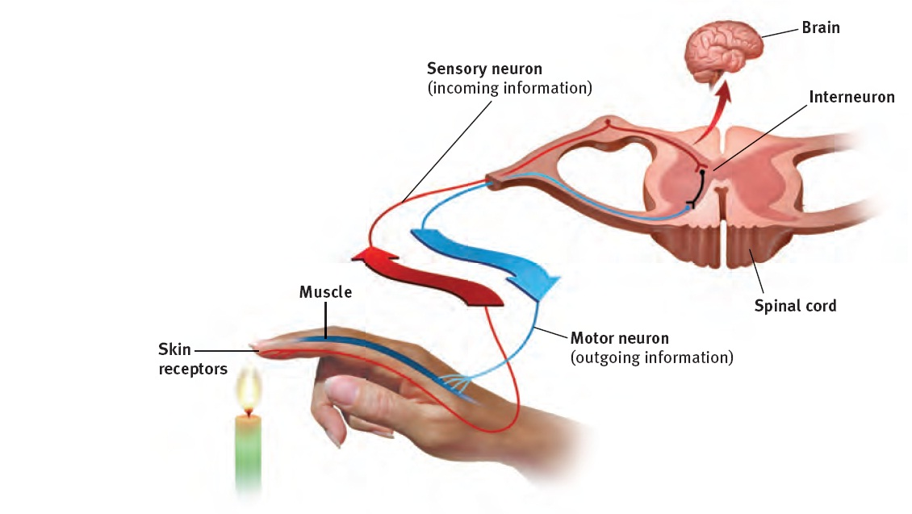
Your spines interneurons trigger your hand to pull away from a fire before you can say “OUCH!” – This is an example of a reflex action.

Neural Transmission (Synapse)

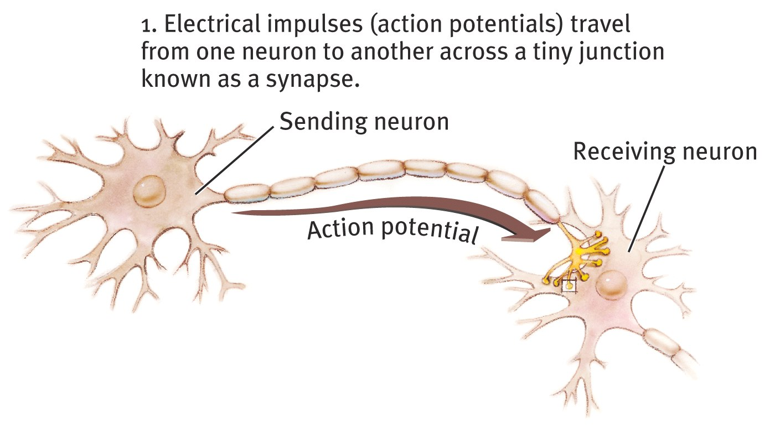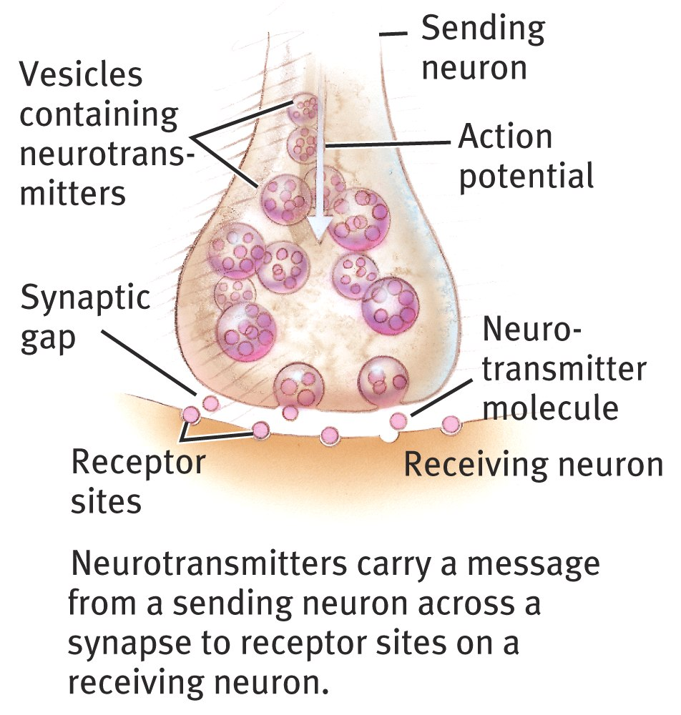

The Firing of a Neuron
- Resting Potential
  - This is the cell at rest (-70 millivolts)
  - Depolarization occurs and it goes from -70 to a positive state
- Action Potential
- Ion channels (open/close) and ion transporters regulate (pump) the number of ions inside and outside the axon.
- Myelin Sheath: The fatty tissue layer that surrounds the axons of some neurons, it enables greater transmission speed

Reuptake
- Neurotransmitters in the synapse are reabsorbed into the sending neurons through the process of reuptake. This process applies the brakes on neurotransmitter action.

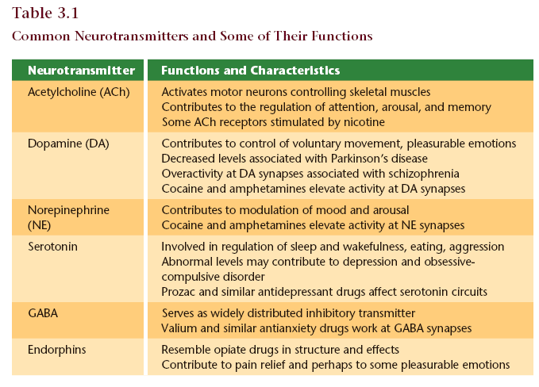
  - Serotonin pathways
    - Networks of neurons that communicate with serotonin help regulate mood
  - Dopamine pathways
    - Networks of neurons that communicate with dopamine are involved in focusing attention and controlling movement

Neurotransmitters & Drugs
- Specific neurotransmitters work at specific synapses – Lock and Key mechanism
- Agonist – mimics neurotransmitter action
  - This agonist molecule excites. It is similar enough in structure to the neurotransmitter
  - Fills the receptor site and activates it, acting like the neurotransmitter
- Antagonist – opposes action of a neurotransmitter
  - Fills the lock so that the neurotransmitter cannot get in and activate the receptor site

Methods of Studying the Brain

EEG (electroencephalogram)
  - Is an amplified read-out of the waves of electrical activity that sweep across the brain’s surface. These waves are measured by electrodes places on the scalp.

CT (computed tomography) Scan
  - A series of x-ray photographs taken from different angles and combined by computer into a composite representation of a slice through the body; also called CAT scan

PET (positron emission tomography) Scan
  - A visual display of brain activity that detects where a radioactive form of glucose goes while the brain performs a given task

MRI (magnetic resonance imaging)
  - A technique that uses magnetic fields and radio waves to produce computer-generated images that distinguish among different types of soft tissue; allows us to see structures within the brain

Controls of Behavior
- The Cerebral Cortex
  - The intricate fabric of interconnected neural cells that cover the cerebral hemispheres. It is the body’s ultimate control and information processing center.

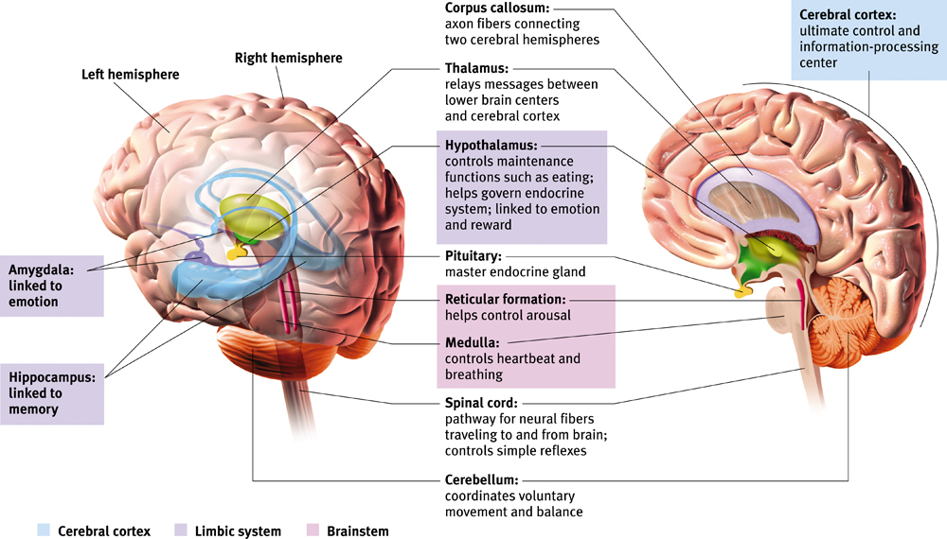
- The Limbic System

This neural system sits between the brain’s older parts and its cerebral hemispheres. The limbic system’s hypothalamus controls the nearby pituitary gland.
  - Hypothalamus:
    - This small but important structure helps keep the body’s internal environment in a steady state.
    - An important link the command chain governing bodily maintenance.
    - Influencing hunger, thirst, body temperature, sexual behavior.
  - Amygdala: two lima-bean-sized neural clusters in the limbic system; linked to emotion.
    - Linked to aggression and fear
  - Hippocampus
    - Processes conscious memories.
    - Loss or damage to the hippocampus can cause loss of the ability to form new memories of facts/events.

- Lobes of the Brain

Frontal Lobe
  - Speaking
  - Muscle movements
  - Making plans/judgments
  - Motor skills

Occipital Lobe
  - Receives visual information

Parietal Lobe
  - Receives sensory for touch and body position

Temporal Lobe
  - Auditory/hearing
  - each receiving information primarily from the opposite ear

Specialization & Integration
- Hearing words – auditory cortex and Wernicke’s area
- Seeing words – visual cortex and angular gyrus
- Speaking words – Broca’s area and motor cortex

Hemispheric Asymmetry

Left hemisphere Right hemisphere

Thoughts and logic Feelings and intuition

Details – “trees” Big picture – “forest”

Language: words and definitions Language: tone, inflection,

Linear and literal context

Calculation Inferences and associations

Pieces and details Perception

Wholes, including the self

Split-Brain Patients
- “Split” = surgery in which the connection between the brain hemispheres (corpus callosum) is cut in order to end sever full-brain seizures.

Divided Consciousness
- When looking at a word (for example) and the word is separated by a dot and then the word disappears (the word HE-ART) you see the word “art” and you can say “art” and you can point with your left hand to the word “he”.

Sensory Processing
- Vision
- Audition
- Gustation
- Olfaction
- The Somatosenses

- Transduction: Process by which sensory receptors convert energy into neural impulses
- Sensory receptors detect and respond to various stimuli (modality specific)
- Anatomical & Temporal Coding

Psychophysics: Measuring Sensation

Absolute Threshold
- The different between not being able to perceive a stimulus and being able to just barely perceive it.
- The minimum amount of sensory stimulation that can be detected 50% of the time.

- Sensory: A single candle flame from 30 miles on a dark, clear night
- Hearing: The tick of a watch from 20 feet in total quiet
- Smell: 1 drop of perfume in a 6-room apartment
- Touch: The wing of a bee on your check, dropped from 1cm
- Taste: 1 tsp. of sugar in 2 gallons of water

*anything subliminal is below the level of threshold

Signal Detection Theory
  - A psychophysical theory that divides the detection of a sensory signal into a sensory process and a decision process.

Difference Threshold
- The ability to detect the smallest increase or decrease in a physical stimulus that is required to produce the “just noticeable difference” (JND) in sensation that is detectable 50% of the time.
- Weber’s Law: to perceive as different, two stimuli must differ by a constant minimum percentage
  - light intensity – 8%
  - weight – 2%
  - tone frequency – 0.3%
- Sensory adaption: diminished sensitivity as a consequence of constant stimulation

Vision

Electromagnetic Energy
  - When you look at something with colour, what hits your eyes are not particles of colour but pulses of electromagnetic energy that your visual system perceives as a certain colour.
  - What we see as visible light is but a thin slice of the whole spectrum of electromagnetic energy, ranging from imperceptibly short gamma waves to the long waves of radio transmission

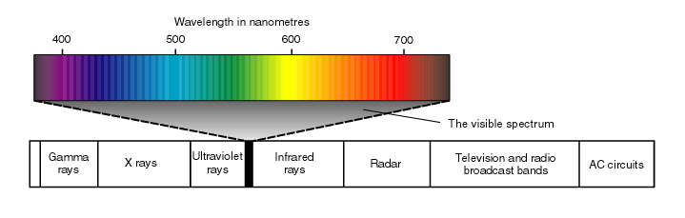
  - Two physical characteristics of light help to determine our sensory experience of them. Light’s wavelength – the distance from the peak of one wave of light to the peak of the next – determines its hue (the colour we experience, such as the tulip’s red petals or green leaves). Intensity, the amount of energy in light waves (determined by a wave’s amplitude, or height), influences brightness.

The Eye and its Function

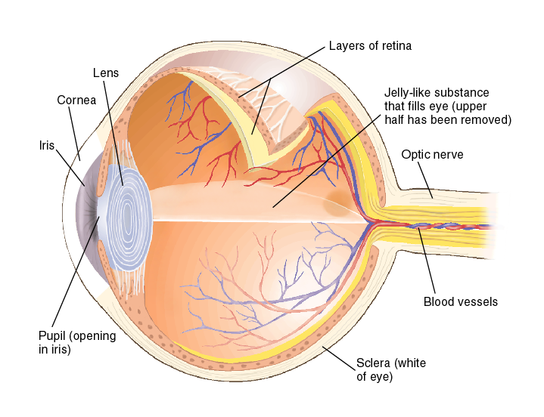
Light rays (from a candle) enters the eye through the cornea then passes through the pupil and lens. The curvature and thickness of the lens change to bring nearby or distant objects into focus on the retina. Rays from the top of the candle strike the bottom of the retina and those from the left side of the candle strike the right side of the retina. The candle’s image on the retina thus appears upside-down and reversed.

An Eye on the World
- Retina
  - Neural tissue lining the back of the eyeball’s interior, which contains the receptors for vision
- Rods
  - Visual receptors that respond to B&W; dim light
- Cones
  - Visual receptors involved in colour vision. Most humans have three types of cones (red, blue, green)

Receptors in the Human Eye

 | Cones | Rods
Number | 6 million | 120 million
Location in Retina | Center | Periphery
Sensitivity in dim light | Low | High
Color sensitive | Yes | No
Detail sensitive | Yes | No

The Retina
- Light sensitive inner surface of the eye, containing the receptor rods and cones plus layers of neurons that begin the processing of visual information
  - Light entering the eye triggers photochemical reaction in rods and cones at back of retina.
  - Chemical reaction in turn activates bipolar cells.
  - Bipolar cells then activate the ganglion cells, the axons of which converge to form the optic nerve. The nerve transmits information to the visual cortex in the brain’s occipital lobe.

Trichromatic Theory

-Young (1802) & Von Helmholtz (1852) both proposed that the eye detects three primary colours only. (red, blue, green)

-All other colour are made by combining these three colours

Opponent Process Theory
- A theory of colour vision which holds that pairs of colours are opposing or antagonistic
- Certain ganglion cells increase firing rate to signal one colour, and decrease to signal the opposing colour
- So colour based on neural excitation – inhibition
  - Red—Green
    - Red: red-green ganglion cell is excited
    - Green: red-green ganglion cell is inhibited
  - Yellow—Blue
    - Yellow: yellow-blue ganglion cell is excited
    - Blue: yellow-blue ganglion cell is inhibited
- Because certain cells are inhibited by a colour, they have a burst of activity when it is removed.
- Visual phenomenon called an afterimage

Defects in Colour Vision
- Protanopia: Red cones filled with green photo-pigment
- Deuteranopia: Green cones filled with red photo-pigment
- Tritanopia: Lack of blue cones

Audition

Cochlea: a coiled, bony, fluid-filled tube in the inner ear; sound waves traveling through the cochlear fluid trigger nerve impulses.

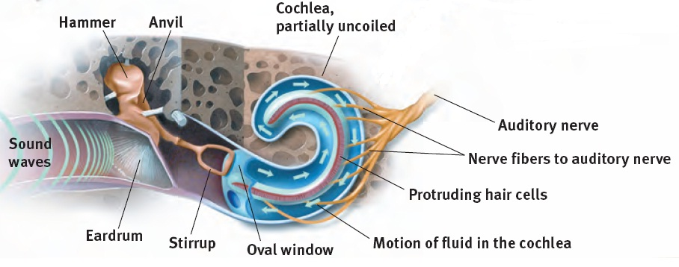
The Middle & Inner Ear
- Conduction Hearing Loss: when the middle ear isn’t conducting sound well to the cochlea
- Sensorineural Hearing Loss: when the receptor cells aren’t sending messages through the auditory nerves

Preventing Hearing Loss
  - Exposure to sounds that are too loud to talk over can cause damage to the inner ear, especially the hair cells
  - Structures of the middle and inner ear can also be damaged by disease
  - Prevention methods include limiting exposure to noises over 85 decibels and treating ear infections

Theories of Hearing

Place Theory: Each individual pitch is determined by the particular place along the basilar membrane that vibrates the most (Middle-High Freq.)

Frequency Theory: The hair cell receptors vibrate the same number of times per second as the sounds that reach them (Lo Freq.)

Auditory Localization
- Sounds from different directions are not identical as they arrive at left and right ears
  - Loudness
  - Timing
  - Wave Phase
- The brain calculates a sound’s location by using these differences.

Detecting and Localizing Sounds:

Relative Loudness:

High frequency won't vibrate as much as low frequency

Gustation & Olfaction

Five Qualities of Taste
- Sweet: energy source
- Sour: potential toxic acid
- Umami: (savoriness) proteins to grow and repair tissue
- Bitter: potential poisons
- Salty: sodium essential to physiological processes

Receptors and the Sensory Pathway
- Smell and taste work together for a person to taste “flavor”

Olfaction: The Sense of Scents
- Airborne chemical molecules enter the nose and circulate through the nasal cavity.
  - Vapors can also enter through the mouth and pass into nasal cavity.
- 5 million receptors on the roof of the nasal cavity detect these molecules.

Smell and Memories
- The brain region for smell (in red) is closely connected with the brain regions involved with memory (limbic system). That is why strong memories are made through the sense of smell.

The Somatosenses

The Skin Senses
- Pressure
  - Stroking adjacent pressure spots creates a tickle
  - Repeated gentle stroking of a pain spot creates an itchy sensation
- Warmth
  - Stimulating nearby cold and warm spots produces the sensations of hot [warmth+cold = HOT]
- Cold
  - Touching adjacent cold and pressure spots triggers a sense of wetness, which you can experience by touching dry, cold metal. [warmth+cold = HOT]
- Pain
  - Pain is your body’s way of telling you something is wrong
  - The rare people born without the ability to feel pain may experience severe injury or even die before early adulthood

The Vestibular Sense
- The sense of the body movement, position, including the sense of balance.

Biological Factors in Pain Perception

Gate-Control Theory
- This theory hypothesizes that the spinal cord contains a neurological “gate” that blocks pain signals or allows them to pass on to the brain.

The “gate” is opened by the activity of pain signals travelling up the small nerve fibers and is closed by activity in larger fibers or by information coming from the brain. Stimulating large nerve fibers in the spinal cord through acupuncture, massage or electrical stimulation seems to close that gate.

Endorphins
- These hormones can be released by the body, to reduce pain perception.

